**PRIOR TO START OF SESSION (at least 10 minutes before!):**

* Make sure to have all forms.
* Have cash ($12) and a payment record sheet ready on the inside pocket of clipboard

**MRI Room**

* Make bed (flat sheet + pillowcase, plus extra flat sheet for participant)
* Other things to have ready:
  + Earbuds, painters tape, head padding
* Make sure right button box is connected:

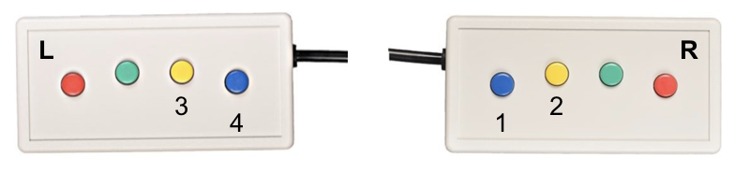

**Electronics Rack**

* Configure matrix in separate steps: Set → Choose inputs and outputs (table below) → Set

|  |  |  |  |
| --- | --- | --- | --- |
| **Top Row** | **Bottom Row** | 1 = current design box  3 = projector output  7 = monitor, keyboard  8 = second screen | 2 = Mac  3 = projector |
| 1, 7 | 4 |
| 3, 5, 8 | 5 |

* Turn eye tracker monitor on (power on top PC and projects to monitor 6)
* Turn on projector
* Make sure current design is set to 090 (scanner trigger “=”)
  + *If you need to change:* Press nob, change mode YES, mode select, 090

**Tesla**

* If you have to login, use password “XXXX”
* Register participant, if needed.
* Protocol # XXXXX
* Chartstring: XXXXXX
* Copy session ID # to screening form

**Stimulus Computer**

* Login to account using Mac 10.11
* *\*If needed*\* hold the ALT key while restarting the computer.
* Login to jukebox server: **smb://[path to jukebox server]**
* Change directory: **cd [path to experiment stimulus code]**
* IMPORTANT - Switch the screens, so that fullscreen mode works on second monitor:
* System preferences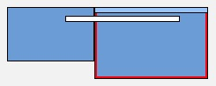
* Displays → Arrangement
* Change the location of the white bar

**Introduction**

* Ask the participant to turn his/her phone off.
* Inform participant that you will be reading from a script to keep things standardized
* Introduce the participant to scanning buddy

Hello! Thank you for coming in today! For today’s experiment, you will be presented with a series of images. We will also be taking a couple of brain images before and after the task, which will allow us to better observe the brain data. For this reason, today’s experiment will be approximately an hour long.

**Image Sample and Consent Forms**

As I just mentioned, you will be viewing a lot of images and before I obtain your consent to continue on with this experiment, I want to show you a sample of the types of images that will be involved in the experiment. **Please be warned that some of these images may be more unpleasant (or negative) than others. Can I show you the image sample?**

* Show Image Sample: All of these images come from a published database. As you can see, the images range from very negative to neutral. According to them, this (point to the top left image) is the most negative image. You won’t see any of these images again but I want to make sure you know the full breadth of the range of images you might see. Are you okay with these images?

**I want to remind you that you are free to withdraw from the experiment at any point in my without penalty. You would just have to let me know.** Here is the consent form for this experiment. Also, I wanted to provide this sheet a paper for you that has information about our study. You don’t have to take it with you, but I want to provide it here.

* fMRI Consent Form *(and study info sheet, that subject doesn’t need to keep)*
* *If asked about consent form during test:* The consent form is intentionally general because the experiment spans across many days (ie. first session and a maximum of 7 days before the subsequent sessions)
* While they are filling out consent form: Set up nature documentary w/ captions

**MRI Screening Form**

Thank you for filling out the consent form. I want to take a moment to elaborate on the fMRI part of this experiment since there is another form that you will complete shortly. To begin, have you ever gotten an MRI before, either here or at a hospital or somewhere else?

The MRI is a tool that allows us to measure the brain activity of an individual as they perform various mental tasks. The MRI does this by using a very powerful magnet that is 60,000 times more powerful than the earth’s magnetic field. That’s a lot! Which means that we have to be very careful about making sure you don’t have any metal, inside or on you, when we put you into the scanner. For this reason, I am going to have you fill out this screening form to see if you are eligible to being put inside the MRI scanner. You will find a wide range of questions like if you’ve ever done work with metals without protective eyewear (because then you might have small metal flakes in your eyes, which means that it probably wouldn’t be a good idea to place you in the scanner. Another question you might be asked is if you are wearing athletic clothes that use fancy metal threads, because these threads might overheat in the magnet and cause discomfort or pain.

The MRI is a non-invasive and safe way to do really amazing brain imaging, but your safety is of utmost importance to us and it is for this reason that I need you to carefully read through this screening form and answer each question.

> **If they have done an MRI experiment before**: I know that you have gone through this form before, but I just want to emphasize that you should closely read the screening form to make sure that you can be scanned.

* MRI Screening Form

Thank you! I’ll just review your screening form just to make sure that you are still eligible to be scanned.

* Review MRI screening form and ascertain if the participant is eligible to be scanned.

**Introduction to fMRI session**

Before we continue on to the experiment, I want to ask that you use the bathroom just because I don’t want to take you outside of the scanner part way through the scan. I ask all my participants to use the restroom before we begin, even if you don’t feel like you have to use the bathroom. May I show you to the restroom?

* Walk participant to the bathroom
* **While they are in the bathroom:** Place participant’s info onto Tesla.
* Remember to wait in an area where the participant can easily see you once returning from the bathroom!

**MRI Safety**

**Noise:** There are a few more things I want to go over about the scanner before I go into detail about the task you will complete inside the scanner. First, the MRI scanner is really loud when it’s turned on. To protect your ears, **I am going to give you some single use earplugs.** I will also give you a headband that has some extra padding around the ears. You will put all of those things once we get into the scanner room.

**Intercom System + Squeeze Ball:** We will also be able to communicate with each other throughout the experiment via an intercom system. However, we can only talk to each other when the scanner is not running. **If you need to get my attention for something that is an urgent matter while the scanner is running, you should press the squeeze ball (which I will point out to you when we go into the scanner room).** But only do this if it’s urgent, not if it’s something that can wait until the run is over. If you press the squeeze ball, I will immediately turn off the scanner and talk to you via the intercom.

**Staying Awake & Engaged:** Next, I want to emphasize the importance of you staying awake and engaged throughout the entire task. There is an eye-tracker inside the scanner that I will have turned on so that I can verify that your eyes are open. If your eyes are closed for 15 minutes then I can probably assume that you fell asleep, right? I am not recording your eye-tracking data, it will just give me a live feed of whether your eyes are open or not. **It costs $500/hour to run the MRI machine so it’s important for our participants to do their best and stay awake during the scan.**

**Motion:** So what exactly does the MRI do? Basically, what we are doing is taking a bunch of pictures of your brain every 1.5 seconds and stitching them together. **Furthermore, we are taking these pictures on a mm-by-mm resolution.** For this reason, if there is any movement then the image becomes very blurry, which compromises the quality of the data. This is why it’s also important for our participants to be as still as possible. Even little things that you may not even realize that can cause head movement. Moving your feet can cause slight movement in your head. **Therefore, once we get in the scanner room it’s very important that you are situated and are as comfortable as possible before we begin the scan, and then that you do your very best to not more your feet, etc.** To help you get a sense of whether you move your head, I am going to put a strip of painters tape across your forehead. It’s not supposed to hold your head in place but it’ll provide you with some **tactile feedback** so that you can get a sense of when you’re actually moving your head. Is this okay?

**PNS:** Finally, I want to tell you about something called peripheral nerve stimulation, or PNS. In essence, **the magnet gradient might stimulate nerves or muscles which might translate to some light tingling or mild muscle twitching.** **If this happens, I want you to know that it’s not an indication that something is wrong.** If this happens, you might notice that the twitching is in sync with the scanner pulses and it will stop as soon as the scan stops. If it’s too bothersome, press the squeeze ball and I will stop the scan. **However, if it’s not too bothersome, don’t press the squeeze ball and we’ll continue the scan uninterrupted.** You can just let me know at the end, when you return to this room, so that I can keep track of the protocols that tend to give people this tingling sensation. The best way to avoid PNS is to not cross your arms or legs. This can create something that we call “loops,” that make PNS more likely.

**Task Overview**

I am now going to give you an overview of what you will do inside of the scanner.

1. First, I am going to run a quick 30-second scan of your brain. The point of this scan is to get a quick picture of where your brain for alignment.
2. Next, I will take a very detailed anatomical image of your brain. It will take about 6 minutes to get this single image. During this time, I’ll place a nature documentary from Youtube on the screen. Just as a reminder, you should stay still during this very important scan.
   1. Don’t overthink it. Try not to clench your jaw.
   2. You should just breathe normally and remain relaxed.
3. Then, we’ll do a task that I like to call the localizer task. I’ll be using that data to localize areas of the brain that care about different categories, such as scenes and common objects. In this task, images will quickly appear one after the other in groups of 10. There will also be a momentary pause before another 10 images appear.
   1. Your job for this task is to pay attention to the images by fixating on a black circle that will be in the center of the screen. Whenever an image appears twice in a row, you will press a button. To give you feedback on whether the computer has registered your button press, the black circle in the center of the screen will briefly turn white.
   2. For this task, **there will be 3 runs**, with each run being about 6 minutes long.
4. Finally, at the very end, I will take 3 more 30-second scans and then I’ll take you out. For these scans, you can just lie back and relax.

Does all of this make sense? Are you ready to begin?

**PNI Clothing Guidelines + Acquisition Computer**

Does all of this make sense? Are you ready to begin? *[Pause]* Great! As I set up some information on the computer, I’d like you to look through the PNI MRI clothing guidelines and make sure that you remove all metallic items from your person.

***While participant is removing metallic objects, on the SKYRA ACQUISITION COMPUTER:***

* Patient Registration:
* **Last Name and BIDS ID:** SubjID_StudyName (e.g. 1001_TNT)
* **Date of Birth, Sex, Height, Weight:** real, from screening form
* **Patient position:** Head first — Supine
* ‘Exam’
* Load scan sequence:
* NormaL → NormaL_Brooks → TNT → TNT_onlyLocalizer

***Make sure correct scan sequence is loaded!***

* **Body Part:** Brain

**Check of Metallic Objects**

* If hair is pulled back:
  + Before we start the scan, please take out your ponytail just to make sure that you can lie comfortably in the scanner.
* Have the participant take their shoes off!
* **Wand participant (check pockets, wrists, and necklaces)**, lead them to the scanner room.
* Set participant up in the bore.

***\*\*\*\*\*\*\*\*\*\*\*\*\*\*\*\*\*\*\*\*\*\*\*\*\*\*\*\*\*\*\*\*\*\*\*\*\*\*\*\*\*\*\*\*\*\*\*\*\*\*\*\*\*\*\*\*\*\*\*\*\*\*\*\*\*\*\*\*\*\*\*\*\*\*\*\*\*\*\*\*\*\*\*\*\*\*\*\*\*\*\*\*\*\*\*\*\*\*\*\*\*\*\*\*\*\*\*\*\*\*\*\*\****

***IMPORTANT: Always maintain a line of communication with the participant!!***

***\*\*\*\*\*\*\*\*\*\*\*\*\*\*\*\*\*\*\*\*\*\*\*\*\*\*\*\*\*\*\*\*\*\*\*\*\*\*\*\*\*\*\*\*\*\*\*\*\*\*\*\*\*\*\*\*\*\*\*\*\*\*\*\*\*\*\*\*\*\*\*\*\*\*\*\*\*\*\*\*\*\*\*\*\*\*\*\*\*\*\*\*\*\*\*\*\*\*\*\*\*\*\*\*\*\*\*\*\*\*\*\*\****

**Anatomical Scans**

**INTERCOM:** Hi [Name] are you doing ok? **Can you see the entire screen? If not, you should move the mirror so that you can see it.** The first scan will be able 30 seconds.

To start the experiment: Press upper right checkmark, then play button on the bottom.

* Make sure before starting scan, turn OFF talk button
* If participant cannot hear you, put the volume up immediately.
* **Anatomical Scout (0:12)**
* **Be aware that two dialog boxes will pop up to confirm before beginning each scan.**

**INTERCOM:** The next scan will take about 5 and a half minutes. In the meantime, I am going to show you a nature documentary.

* **MPRAGE (5:20)**
* Center the FOV (aka the yellow box), located in the brain image farthest to the right
* **Checkmark all the worker people! (because the copy references occur automatically)**

**INTERCOM:** Great! I need a couple minutes to set up the main task of the experiment so you can relax for now but we will start shortly. Okay?

* Align to **top of AC and bottom of PC**, making sure to get all of temporal and occipital lobes:

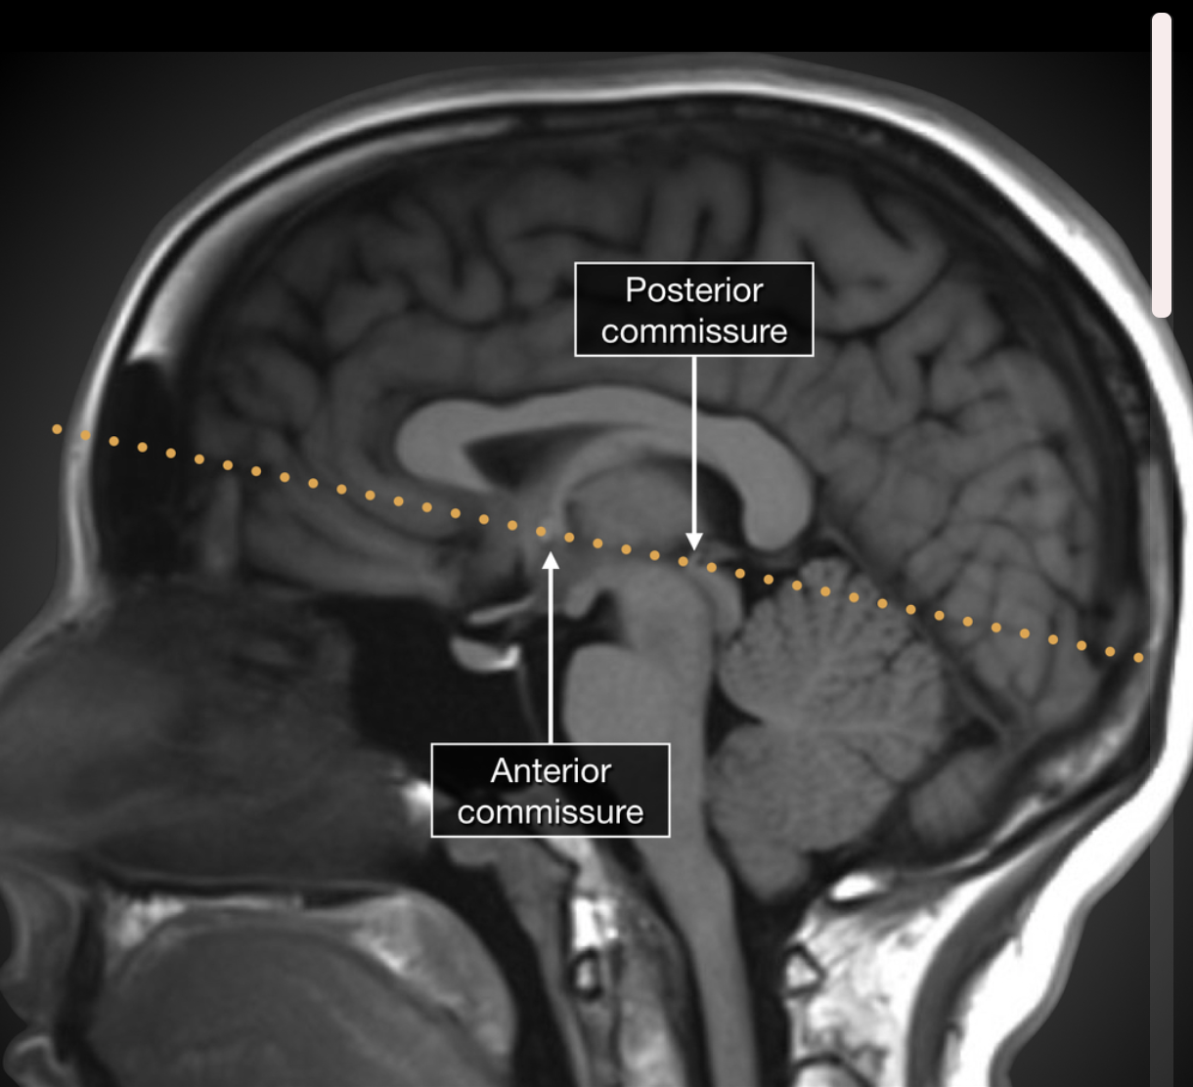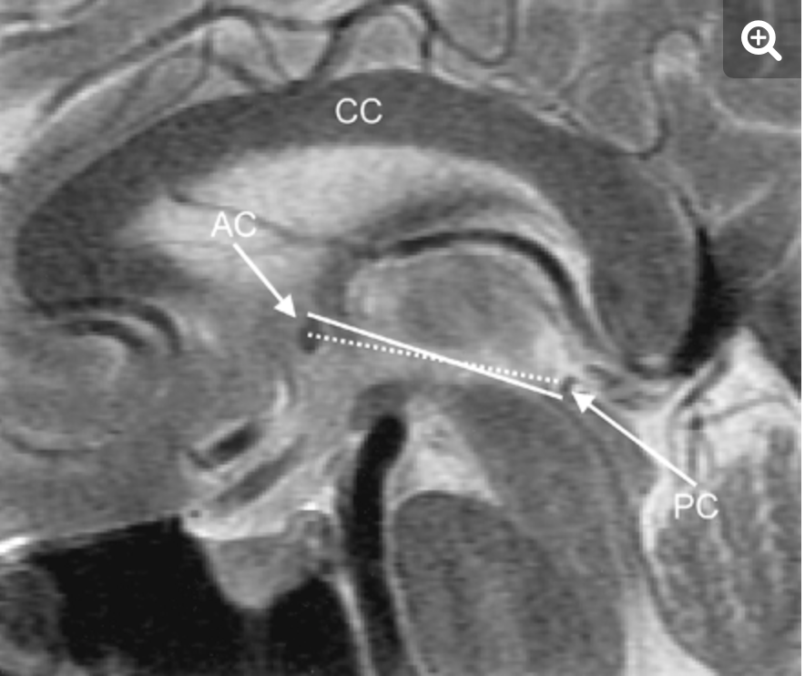

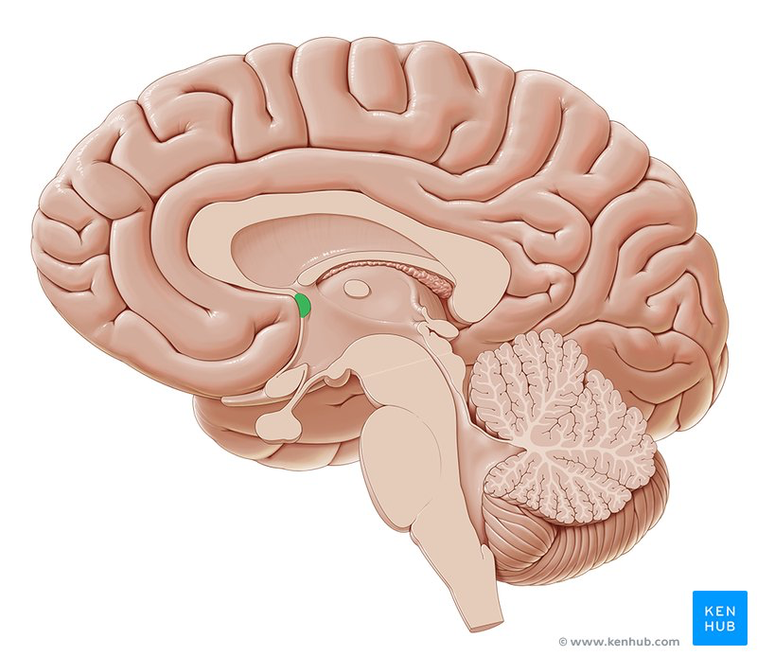

For PC, look for a white oval like structure surrounded by black, and then go right in front of that. For AC, you are looking for a white bulb like structure right under the front part of the corpus callosum.

* Left cartoon shows AC.

**Localizer Task**

**INTERCOM:** Are you ready to continue? We are now ready to start the first run of the localizer task. And as a reminder, pay attention to the images that appear on the screen and press the left button whenever you see two images repeat back-to-back. Are you ready to begin?

**<<< Before every run of the localizer, remember to run the python stimulus script! >>>**

* **3 Localizer Runs (6:19)**
* Skyra Computer: **python phase5-localizer-fMRI.py [SUBJ #] [RUN #]**
* During Run 1, look for anomalies on MPRAGE using the 3D window.
  + Press the magic folder button --> drag *T1 file onto 3D window

**\*\*\* Between each run of the localizer, remember to ask the participant:**

* **Great! Are you doing ok [Name]?**
* **You’re doing a great job so far.**
* **Alright, next we will be running Run [NUMBER __ ] of the localizer task.**
* After Run 1:
  + Check the EPIs using the Viewing window for motion and encourage the participant to not move, as needed.
    - Magic folder button --> drag Run 1 onto viewing window.
  + Set the phase encoding direction for the second field map scan sequence:   
    A>>P and set rotation to 180 degrees.

*After Run 3 of localizer:*

**INTERCOM:** Wonderful! We are almost done. You are doing a great job! I am going to run 3 more 30-second scans. You can just relax and I’ll get you out of there soon. Ready?

* **Field Map - AP (0:41)**

**REMINDER: Between every field map, still keep communication with the participant.**

**INTERCOM:** Alright, so we will be running our second 30 second run. Just to let you know, it will take the scanner a minute to warm up!

* **Field Map - PA (0:41)**

If you haven’t already: change the phase encoding direction: A>>P, hit 3 dots, set rotation: 180 degrees

* **FLASH (0:29)**
* Take participant out of the scanner. Ask them if they experienced PNS, any other comments.
* Pay participant.
* Remember to walk participant out of the MRI suite!

**Sending Data to Conquest and Cleaning Up**

* Copy fMRI data:
* Magic Folder Button → Select Whole Folder → Transfer → Send To Conquest
* Turn off the projector, put head coil back on, put the chain back on, close patient on screen.
* Switch back windows on the computer.

**====================================================================**

**Other Important Miscellaneous Things**

Power off button (does NOT turn off magnetic field) – flood, fire, electrical accident, malfunction of the table stop button

Table stop button – risk of injury due to the movement of the patient table bed (on top of intercom or on sides of the patient bed toward the magnet bore; after risk has been eliminated, unlock the table by turning button on the side of the patient bed clockwise until it releases, then simultaneously press the table up/inward and table down/outward buttons on the scanner.

RF Door Release Button – If there is no power to RF Door, then turn this knob to disengage seal

**Quench emergency:**

* Turn on emergency exhaust switch (if subject is pinned down)
* Buddy holds door wide open
* I will quench and remove subject from the magnet
* I will call Public Safety - 911 (from the campus phone) or 609-258-1000 from cell phone
* Buddy will call someone on the Emergency Contact List

**Non-quench emergency:**

* I will push Power OFF button (if emergency is fire, flood, shock, etc.)
* I will get subject out of the scanner
* Buddy will call Public Safety
* Buddy will contact someone on Emergency Contact list
* I will wait for emergency personnel and screen them before entering the magnet room (if necessary)

***Don’t scan if oxygen level falls below 18.5%***