# About Us

## Our Contributors

*Meet the outstanding individuals responsible for bringing you the most compelling stories across the globe.*

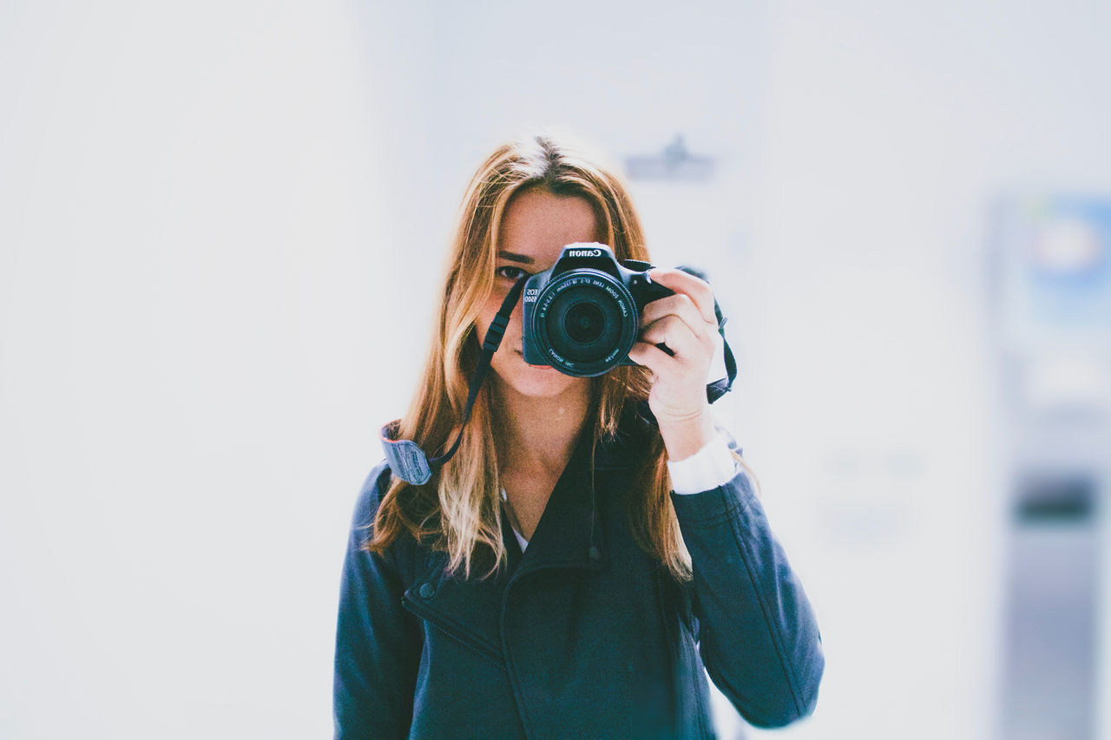

### Stacey Roswells

##### Artist | Photographer | Traveler

Facebook

Twitter

Instagram

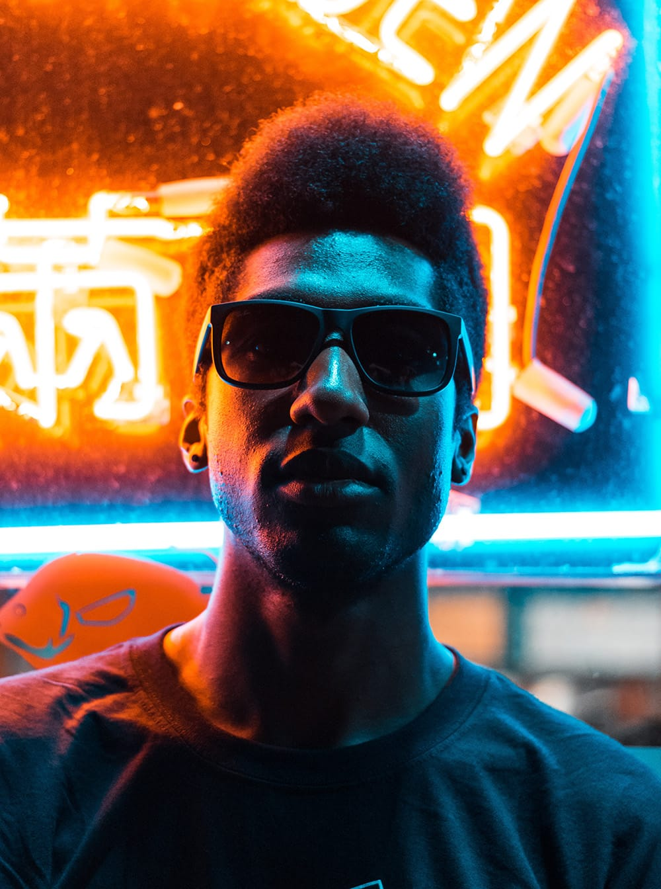

### Jake Hammer

##### Influencer | Writer

Facebook

Twitter

Instagram

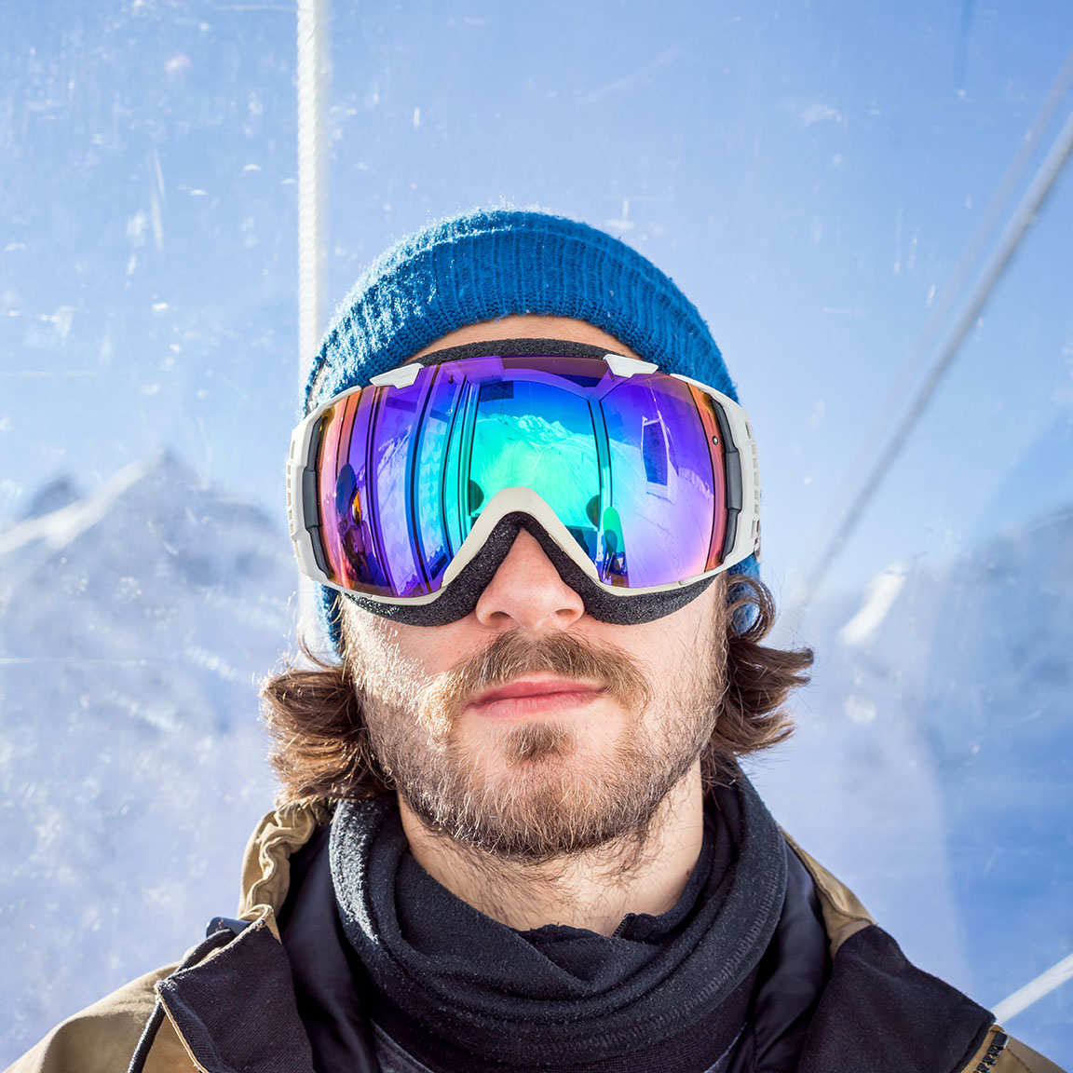

### Ian Provo

##### Photographer

Facebook

Twitter

Instagram

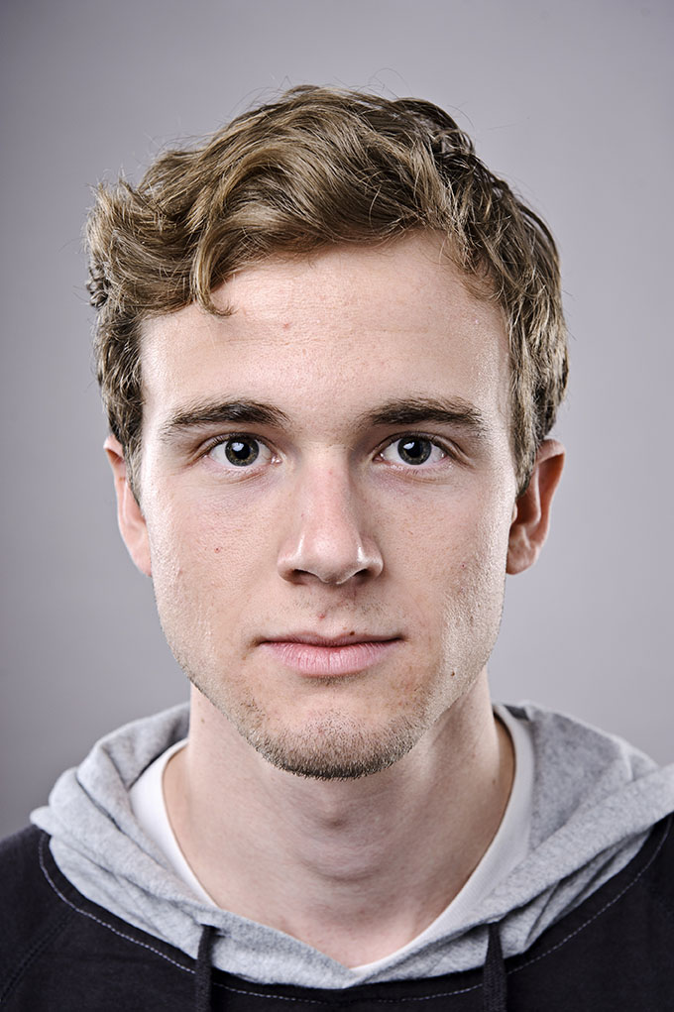

### Jacob Wester

##### Skater | Writer

Facebook

Twitter

Instagram

## WKND Guides

*Meet our extraordinary travel guides. When you travel with a certified WKND guide you gain access to attractions and perspectives not found on the pages of a guide book.*

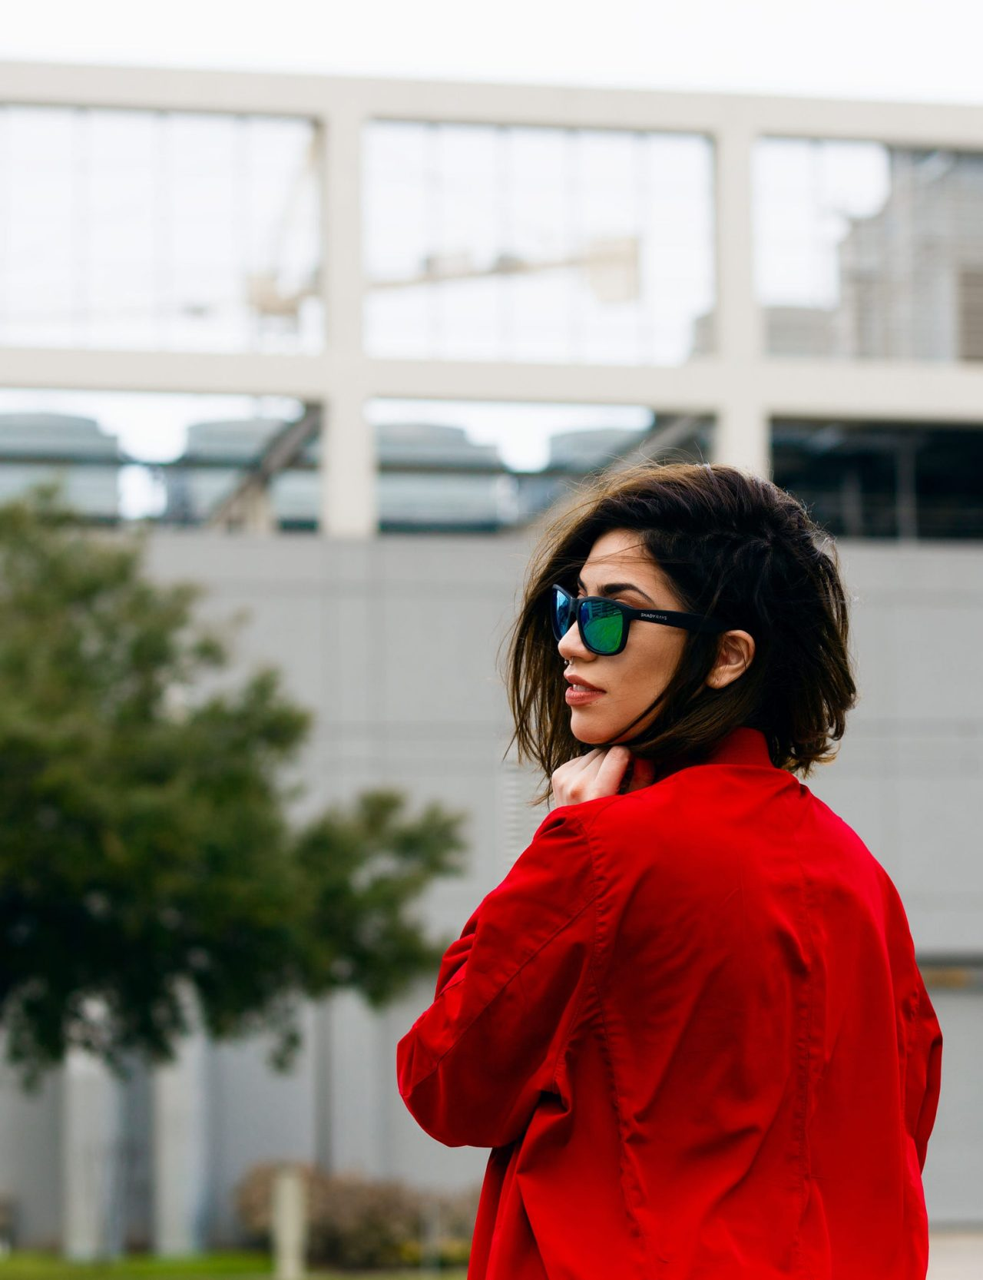

### Sofia Sjöberg

##### Photographer | Youtuber

Facebook

Twitter

Instagram

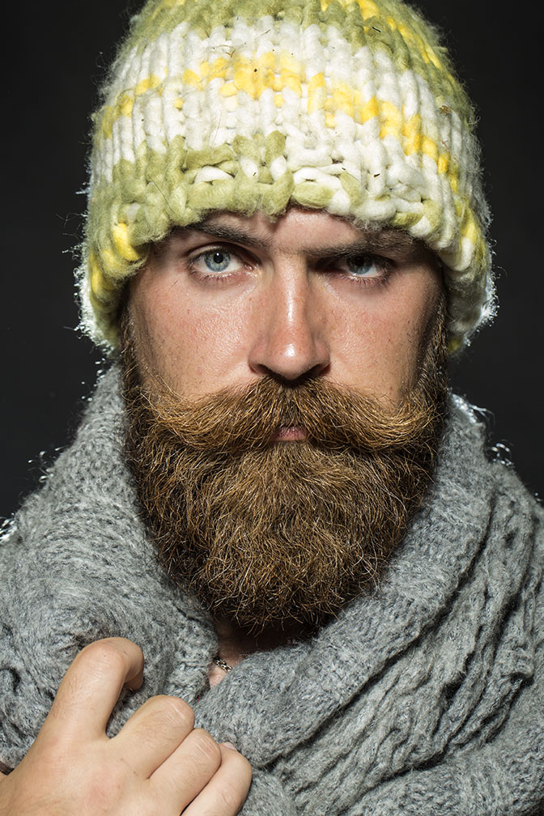

### Justin Barr

##### Artist | Rock Climber

Facebook

Twitter

Instagram

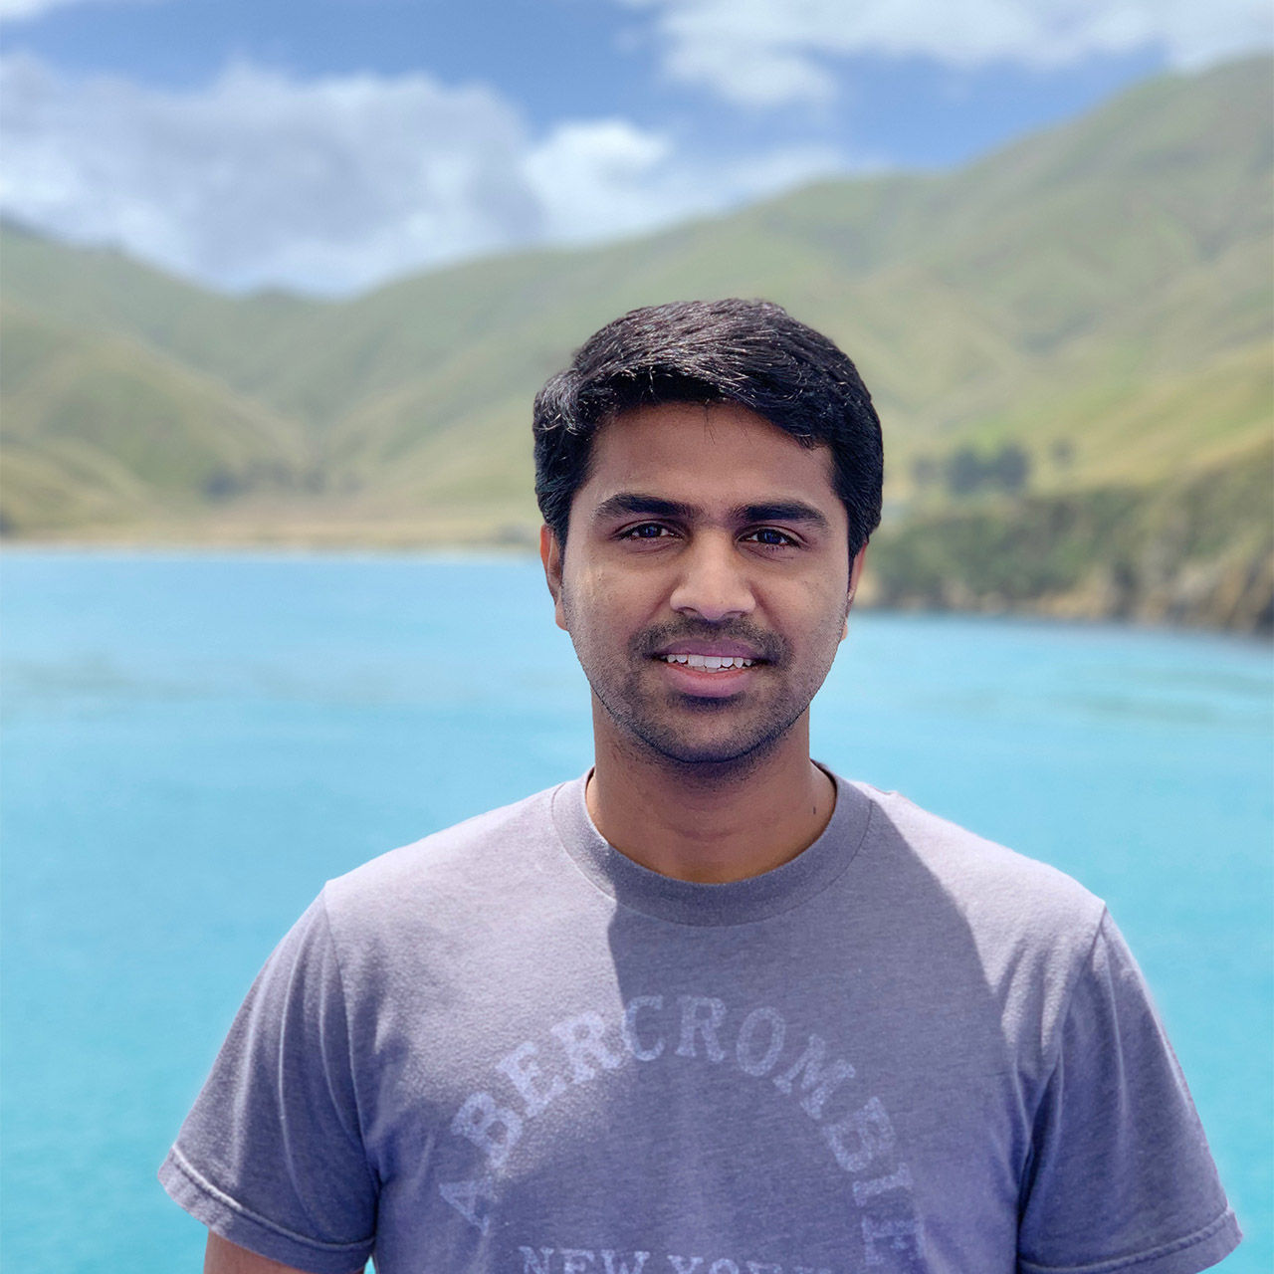

### Kumar Selveraj

##### Photographer | Surfer

Facebook

Instagram

Twitter

| Metadata | |
| --- | --- |
| Title | About Us |
| Description | WKND is a collective of outdoors, music, crafts, adventure sports, and travel enthusiasts that want to share our experiences, connections, and expertise with the world. |