Hurricane Dorian evacuation -   
Process diagram and summary

SYSEN 5460

Aidan Antonienko, AA2562

Luisa Gutierrez, LFG37

Antonio Trevisani, ADT74

Hyung Uk Jee, HJ386

LFG37

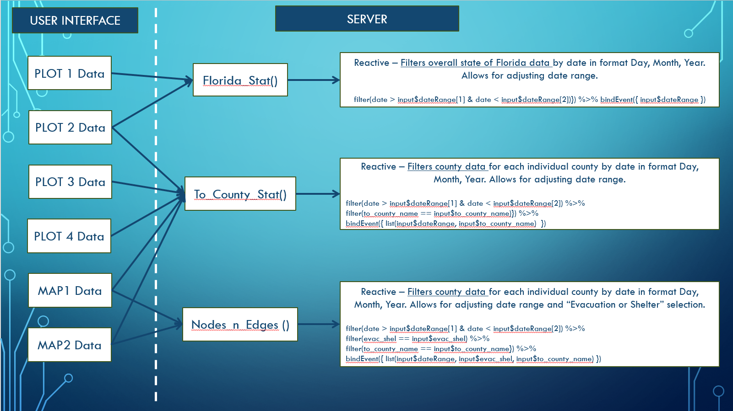**PROCESS DIAGRAM (REACTIVE DIAGRAM)**

**Summary of App**

The overall data for hurricane Dorian includes the states of Florida, Georgia, and Alabama. In order to simplify it, we focused on the state of Florida which makes up the majority of the total data.

**Plot 1:** Appears under the “Overview” page – utilizes “Florida_Stat()” and it is further filtered by county in order to indicates the top 10 places people evacuated to between a chosen data range.

**Plot 2:** Appears under the “Overview” page – utilizes “Florida_Stat()” and “To_County_Stat()” and it is further filtered by county in order to indicate evacuation rates over time for a selected county compared with the state of Florida between a chosen data range.

**Plot 3:** Appears under the “Spatial Maps” page – utilizes “To_County_Stat()” to visually identify the primary counties people evacuated to and the distance traveled to the selected county.

**Plot 4:** Appears under the “Spatial Maps” page – utilizes “To_County_Stat()” and it is further filtered to identify the rainfall intensity across counties of origin and the distance traveled to the selected county.

**Map 1:** Appears under the “Spatial Maps” page – utilizes “To_County_Stat()” and “Nodes_n_Edges()” to geographically identify the distance traveled between counties of origin to a selected county.

**Map 2:** Appears under the “Spatial Maps” page – utilizes “Nodes_n_Edges()” and it is further filtered to identify the social vulnerability index (SVI) for the counties of origin based on the selected county.