A server is a central repository where information and computer programs are held and accessed by the programmer within the network. **Web server** and **Application server** are kinds of the server which employed to deliver sites

**Web Server**

**A computer system that hosts websites (websites is collection of webpages)**

Runs web server software - Apache https, Internet information services

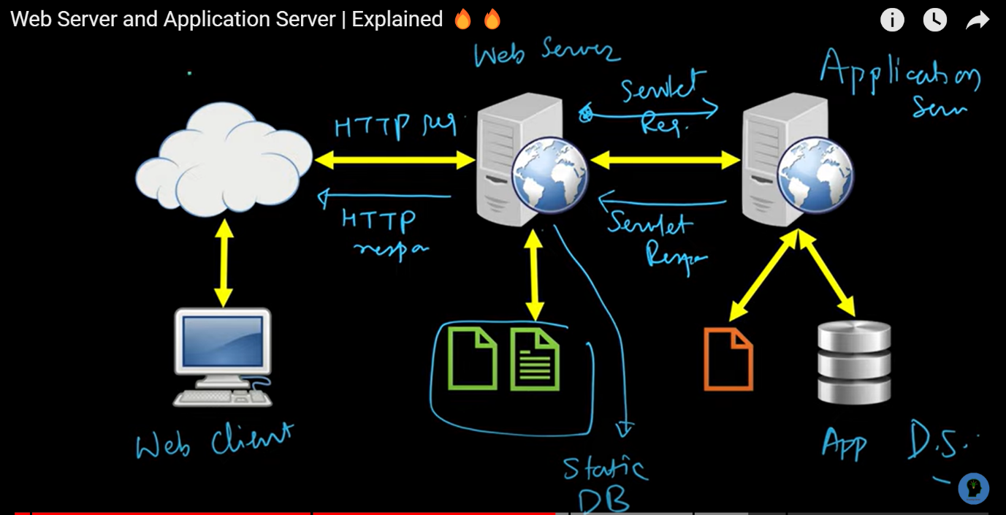

Processed which required intense operation which can not be handled by web server are handled by application server

Server application

Server specifically designed to run applications includes both hardware and software that provide environment for programs to run ,used for running web applications, processing data sent from another server

**Difference between web server and application server:**

|  |  |  |
| --- | --- | --- |
| **S.NO** | **Web Server** | **Application Server** |
| **1.** | **Web server encompasses web container only.** | **While application server encompasses Web container as well as EJB container.** |
| **2.** | **Web server is useful or fitted for static content.** | **Whereas application server is fitted for dynamic content.** |
| **3.** | **Web server consumes or utilizes less resources.** | **While application server utilize more resources.** |
| **4.** | **Web servers arrange the run environment for web applications.** | **While application servers arrange the run environment for enterprises applications.** |
| **5.** | **In web servers, multithreading is supported.** | **While in application server, multithreading is not supported.** |
| **6.** | **Web server’s capacity is lower than application server.** | **While application server’s capacity is higher than web server.** |
| **7.** | **In web server, HTML and HTTP protocols are used.** | **While in this, GUI as well as HTTP and RPC/RMI protocols are used.** |
| **8.** | **Processes that are not resource-intensive are supported.** | **Processes that are resource-intensive  are supported.** |
| **9.** | **Transactions and connection pooling is not supported.** | **Transactions and connection pooling is supported.** |
| **10.** | **The capacity of fault tolerance is low as compared to application servers.** | **It has high fault tolerance.** |
| **11.** | **Web Server examples are Apache HTTP Server , Nginx.** | **Application Servers example are JBoss , Glassfish.** |