**Information Technology Center**



**ITC Billing System (ITCBS)**

**Technical Requirements Specification**

**Version: 6.0 Date: 07/11/16**

**Document History and Distribution**

**1. Revision** **History**

|  |  |  |
| --- | --- | --- |
| **Revision #** | **Revision Date** | **Description of Change Author** |
|  |  |  |

**2. Distribution**

**Recipient Name Recipient Organization Distribution Method**

Table of Contents

1. Introduction 1

1.1 Purpose 1

1.2 Scope 1

1.3 Definitions, Acronyms, and Abbreviations 1

1.4 References 2

1.5 Product Overview 2

2. Specific Requirements 2

2.1 External Interface Requirements 2

2.1.1 User Interfaces 2

2.1.2 Hardware Interfaces 3

2.1.3 Software Interfaces 3

2.1.4 Communication Protocols 4

2.1.5 Memory Constraints 4

2.1.6 Operation 4

2.1.7 Product Function 4

2.1.8 Assumptions and Dependencies 5

2.2 Software Product Features 5

2.3 Software System Attributes 5

2.3.1 Reliability 5

2.3.2 Availability 6

2.3.3 Security 6

2.3.4 Maintainability 6

2.3.5 Portability 6

2.3.6 Performance 6

2.4 Database Requirements 6

3. Functional Requirements 7

3.1 Use Cases 7

3.1.1 Use Case: Login 7

3.1.1.1 Use Case Specification 7

3.1.2 Add Job Request 9

3.1.3 Use Case: Edit Job Requests 10

3.1.4 Use Case: View Job Request 12

3.1.5 Use Case: Search Job Request 13

3.1.6 Use Case: Generate Statement of Account 16

3.1.7 Use Case: Edit Statement of Account 18

3.1.8 Use Case: View Statement of Account 19

3.1.9 Use Case: Print Reports 20

3.1.10 Use Case: Log out 21

3.2 Database Schema 22

# 1. Introduction

**1.1 Purpose**

This software requirement specification serves as an overview and provides a complete description of all the functions and specifications of the ITC Billing System of the Information Technology Center, University of the Philippines, Los Baños.

This document will serve as the baseline for the developers on the implementation of the design and development of the software. This allows users to know what to expect in the software. This also serves as he guide for the testers on the evaluation of the software’s features and specifications.

**1.2 Scope**

The project aims to create a unified and online billing system for UPLB ITC. This includes the filing of job requests by the users, viewing the job requests filed and scheduling the job requests. The project can also track the job request and it can also generate bills and reports regarding the job request done.

## 1.3 Definitions, Acronyms and Abbreviations

|  |  |
| --- | --- |
| **Acronym** | **Meaning** |
| ITC | Information Technology Center |
| UPLB | University of the Philippines Los Baños |
| ITCBS | Information Technology Center Billing System |
| SRS | Software Requirements Specification |
|  |  |
|  |  |

*Table 1. Acronyms used and its respective definition*

|  |  |
| --- | --- |
| **Term/Phrase** | **MeaningSomeone who avails the services of**  **UPLB ITC.** |
| Client | Someone who avails the services of  UPLB ITC. |
| Technician | User that has the ability to update(set the priority level of a certain job and mark job request as done), edit and cancel job requests, add materials and generate bill. |
| Administrator | User that has the ability to view job requests(set the priority level of a certain job), edit and cancel job request, add materials and generate bill. |
| Super Administrator | User that has the ability to file, view, update(set the priority level of a certain job and mark job request as done), edit and cancel job requests, add recommended materials, generate bill, generate report and create account. |
| Job Request | A form that includes the details of the service that the client has availed. |
| Bill | A form that includes the total amount and job requests  a client has to pay. |
| User | Client, Technician, Administrator, Super Administrator |

*Table 2. Terms and Phrases used and its respective definitions*

* 1. **References**

**1.4.1 Applicable Documents**

1. **2015 ITC Billing System** (ITCBS) Software Requirements Specification *Version 5.0*

**1.5 Product Overview**

The ITC Billing System (ITCBS) integrates the billing system for UPLB ITC’s System Administration, Network Administration and Technical Support sections. It caters to the need of the ITC team of a common system in managing job requests.

# 2. Specific Requirements

## 2.1 External Interface Requirements

**2.1.1 User Interfaces**

User interface is defined to make an ease for the user to use the system. User needs to log in to the system first to be able to access the system. Upon logging in, the user will first be directed to the home page which shows the updates and announcements. Based on the type of account the user logs in, whether as a Client, Technician, Administrator or Super Administrator, the user can access the site with specific limitations per user type. The Client can only file job request and view his job requests. The Technician can set the priority level of a certain job, edit and cancel job requests, add materials and generate bill. Administrator is the user who can view job requests, set the priority level of a certain job, edit and cancel job request, add materials, generate bill and report. The Super Administrator has the ability to file, view, update (set the priority level of a certain job and mark job request as done), edit and cancel job requests, add recommended materials, generate bill, generate report and create account.

**2.1.2 Hardware Interfaces**

ITC billing system is a web-based system that needs a server to handle the web application and its database. Any computer owned by the ITC team which has an access to the Internet will be able to use the system. The system will use printers for producing a hard copy of the job request forms and statement of account. There is no specific kind of printer required to use in the system and the printer driver must be installed depending on the kind of printer used. The USB port will also be used to connect the printer into the computer.

**2.1.3 Software Interfaces**

The system uses the standard web development tools to be able to create the system. No necessary external tools will be needed.

1. **Code Igniter** framework will be used for the development of the system.

2. **MariaDB** *Version 10.0.25 wi*ll be utilized by the system to manage the database. The tables to be used will be well defined for the system to access the database easily and quickly.

### 2.1.4 Communication Protocols

Since ITC billing system is a web-based system that could be reached through the Internet and mainly accessed using a web browser Hypertext Transfer Protocol (HTTP) will be used for data communication between the system and the users.

### 2.1.5 Memory Constraints

For the users’ side, the computers they are using in their office are well advanced to handle the operations that they need to do in the system. The system will take up to some kilobytes depending on the browser it is being accessed. For the least amount, it may take up to 64MB of the memory. For the server side, the university has already one which is used to handle multiple user requests for its main site.

**2.1.6 Operation**

The users (Technician, Administrator, Super Administrator) can entertain request from client within office hours from 8am to 5pm, Mondays-Fridays. They can update the job request and generate the bill for printing. Since the system to be developed is to be deployed locally, the site can only be accessed within the offices. Requests may only be encoded and processed within office hours.

**2.1.7 Product Function**

The system will keep record of all the services requested from the ITC. The system will generate a printed version of the job requests and bills for each service done.

**2.1.8 Assumptions and Dependencies**

The system assumes that there will only be four types of users of the system, the Super Administrator, Administrator, Technician and the Client. Each user type has its own access levels.

Users from each type have a predefined interface for their convenience. Each user must also use the latest version of the browser that they are using. The users (Super Administrator, Administrator, Technician) must update the job request forms and bills frequently so that the system will be able to update the database.

**2.2 Software Product Features**

The software product must be able to do the following:

1. The user can see the recent job requests and be able to view the details of each job request.

2. The user can add, edit and cancel job request whenever they have to. This includes the updating of the job request whether it is already done or still on-going.

3. The system can generate job request forms and a viewable record of accepted jobs.

**2.3 Software System Attributes**

**2.3.1 Reliability**

The system must be able to recover from a serious error. It will also post warning messages if there will be errors encountered or during maintenance.

**2.3.2 Availability**

The system will be available online and in the ITC office.

**2.3.3 Security**

In order to use the system, the user must log-in first using his account. The password entered by the user when his account was encrypted using SHA1 so that the user will be the only one who knows his password.

**2.3.4 Maintainability**

The system will comply with the w3c web standards. The coding convention should be well-documented.

**2.3.5 Portability**

ITC billing system will be able to run on any operating system as long as it has a web browser on its latest version.

**2.3.6 Performance**

The system must be able to handle requests and usage of the user swiftly and at ease. Considering some possible constraints like Internet connection speed, server and computer hardware, web browser and etc., the ITCBS’s services should still cater the needs of the user.

**2.4 Database Requirements**

The system will use MariaDB Version 10.0.25 as its database. The system will have its own database which will be used for storing and tracking Job Requests and current funds.

**3. Functional Requirements**

**3.1 Use Cases**

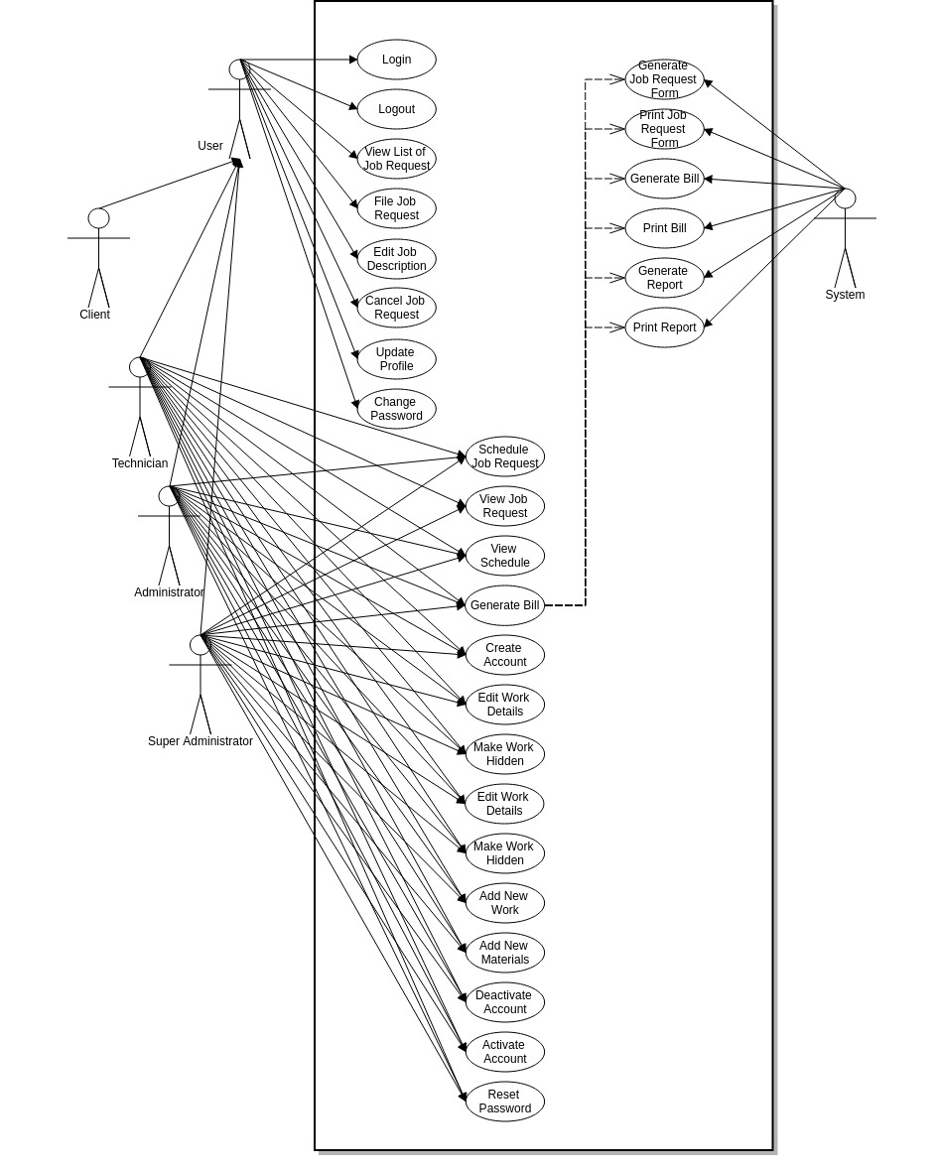

**3.1.1. Log In**

**3.1.1.A Use Case Specification**

|  |  |
| --- | --- |
| Description | The Users enters his/her username and password. |
| Goal | To allow only valid administrators and users to use the system. |
| Preconditions | The system is online. |
| Assumptions | You are connected to a network. |
| Frequency | Every time the user needs to use the system. |
| Flow of Events | Main Flow:  1. The Users enter his/her username and password  2. The Users click the Log In button. |
|  | 2. System Authentication.  **A) Alternate Flow: Authentication fails.**  A1) Prompt “Invalid Credentials”.  A2) Return to step 1 of the Main Flow. |
| Post conditions | The Users can now access and use the system. |
| Actors | Users (Super Administrator, Technician, Administrator, Client) |
| Included Use Cases | None |
| Extended Use Cases | None |
| Notes |  |

#### 3.1.1.B Activity Diagram

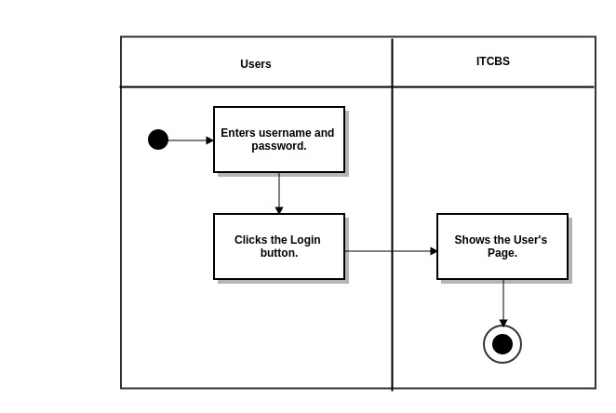

**3.1.1.1 Job Requests**

**3.1.1.1.1 View List of Job Requests**

**3.1.1.1.1.1 View (According To Status)**

**3.1.1.1.1.1.A Use Case Specification**

|  |  |
| --- | --- |
| Description | The User views job requests according to its status |
| Goal | To view job requests according to its status |
| Preconditions | The system is online. |
| Assumptions | You are connected to a network. |
| Frequency | Every time the user needs to use the system. |
| Flow of Events | 1. The User clicks the Job Request tab.  2. The User clicks the Job Request status (PENDING, CANCELLED, PROCESSING, PROCESSED) |
| Post conditions | The User can view the job request according to its status. |
| Actors | Users (Super Administrator, Technician, Administrator) |
| Included Use Cases | None |
| Extended Use Cases | None |
| Notes |  |

**3.1.1.1.1.1.B Activity Diagram**

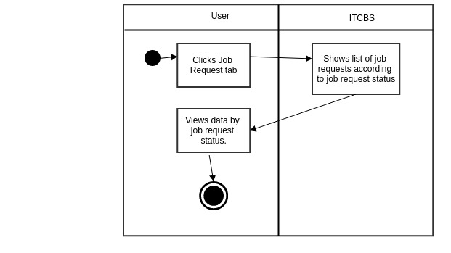

**3.1.1.1.1.2 Search Jobs**

**3.1.1.1.1.2.A Use Case Specification**

**3.1.1.1.1.2.B Activity Diagram**

**3.1.1.1.1.3 View Job Requests**

**3.1.1.1.1.3.1 Work(s) Done**

**3.1.1.1.1.3.1.A Use Case Specification**

**(***Refer to Section* ***3.1.1.2.1.1.A***  *Use Case Specification)*

**3.1.1.1.1.3.1.B Activity Diagram**

(*Refer to Section* ***3.1.1.2.1.1.B*** *Activity Diagram)*

**3.1.1.1.1.3.2 Materials Used**

**3.1.1.1.1.3.2.A Use Case Specification**

**(***Refer to Section* ***3.1.1.2.1.2.A***  *Use Case Specification)*

**3.1.1.1.1.3.2.B Activity Diagram**

(*Refer to Section* ***3.1.1.2.1.2.B*** *Activity Diagram)*

**3.1.1.1.1.3.3 Change Priority**

**3.1.1.1.1.3.3.A Use Case Specification**

**(***Refer to Section* ***3.1.1.2.1.3.A*** *Use Case Specification)*

**3.1.1.1.1.3.3.B Activity Diagram**

***(****Refer to Section* ***3.1.1.2.1.3.B*** *Activity Diagram)*

**3.1.1.1.1.3.4 Mark as Done**

**3.1.1.1.1.3.4.A Use Case Specification**

(*Refer to Section* ***3.1.1.2.1.4.A***  *Use Case Specification)*

**3.1.1.1.1.3.4.B Activity Diagram**

**(***Refer to Section* ***3.1.1.2.1.4.B*** *Activity Diagram)*

**3.1.1.1.1.4 Edit Job Description**

**3.1.1.1.1.4.A Use Case Specification**

|  |  |
| --- | --- |
| Description Description | The User edits the job description. |
| Goal | To edit the job description. |
| Preconditions | The User should be logged-in. |
| Assumptions | You are connected to a network.  You are already on the Job Request Tab. |
| Frequency | Every time the user wants to edit the job description. |
| Flow of Events | Main Flow:  1. The User clicks the Job Request tab.  2. The User clicks View List of Job Requests..  3. The User clicks Edit Job Description  4. The User enters the new job description in the text area.  5. The User clicks the Edit button. |
| Post-conditions | The job description will be updated with the edited version in the database. |
| Actors | Client, Technician, Administrator or Super Administrator |
| Included Use Cases | None |
| Extended Use Cases | None |
| Notes |  |

**3.1.1.2.1.4.2 Activity Diagram**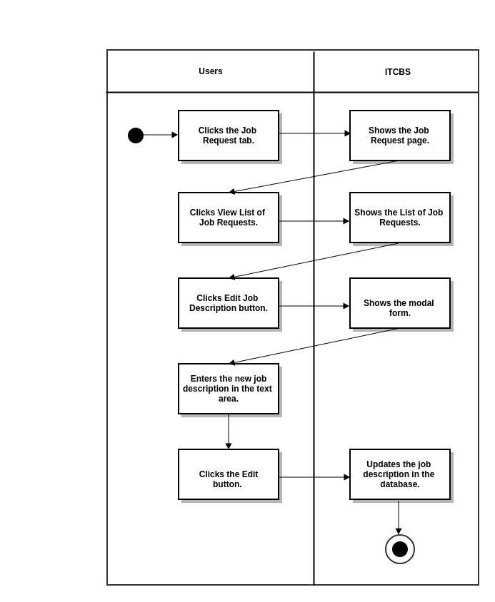

**3.1.1.1.1.5 Cancel Job Request**

**3.1.1.1.1.5.A Use Case Specification**

|  |  |
| --- | --- |
| Description | The User cancels the job request. |
| Goal | To cancel the job request. |
| Preconditions | The User should be logged-in. |
| Assumptions | You are connected to a network.  You are already on the Job Request Tab. |
| Frequency | Every time the user wants to cancel his/her job request. |
| Flow of Events | Main Flow:  1. The User clicks the Job Request tab.  2. The User clicks View List of Job Requests..  3. The User clicks Cancel Job Request  4. The User clicks the YES button. |
| Post-conditions | The job request will be cancelled. |
| Actors | Client Technician, Administrator or Super Administrator |
| Included Use Cases | None |
| Extended Use Cases | None |
| Notes |  |

**3.1.1.1.1.5.B Activity Diagram**

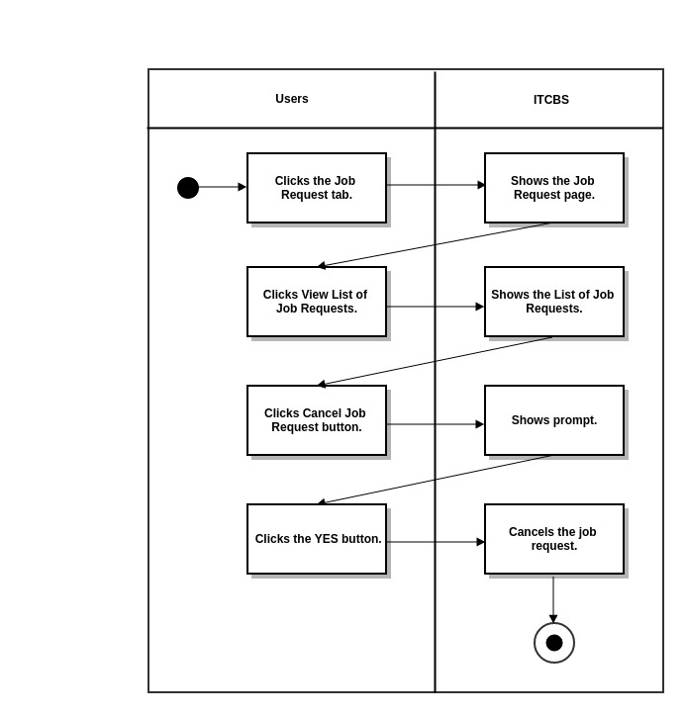

**3.1.1.1.2. File A Job Request**

**3.1.1.1.2.A Use Case Specification**

|  |  |
| --- | --- |
| Description | The User creates a new job request. |
| Goal | Insert some information about a job request to the database. |
| Preconditions | The User should be logged-in. |
| Assumptions | You are connected to a network.  You are already on the Job Request Tab. |
| Frequency | Every time the user wants to file a job request. |
| Flow of Events | Main Flow:  1. The User clicks the Job Request tab.  2. The User clicks File A Job Request.  3. The User inputs required and necessary information.  4. The User clicks the Submit button. |
| Post-conditions | The User adds new job request to the database and updates the number and list of job requests in the Job Requests tab. |
| Actors | Client, Technician, Administrator or Super Administrator |
| Included Use Cases | None |
| Extended Use Cases | None |
| Notes |  |

**3.1.1.1.2.B Activity Diagram**

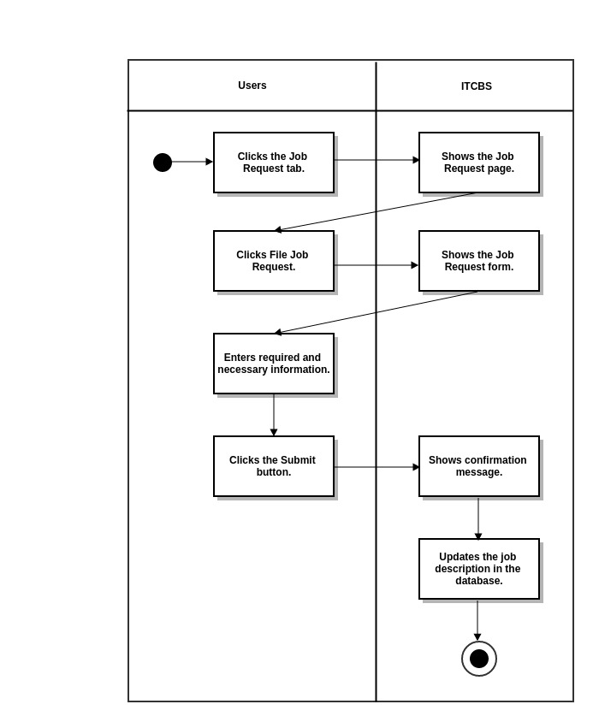

**3.1.1.2 View Schedule**

**3.1.1.2.1 View Job Requests**

**3.1.1.2.1.1 Work(s) Done**

**3.1.1.2.1.1.A Use Case Specification**

|  |  |
| --- | --- |
| Description | The User (Technician, Administrator or Super Administrator) inputs the works done for the problem to be solved. |
| Goal | To insert what are the works done for the problem. |
| Preconditions | The Users should be logged-in. |
| Assumptions | You are connected to a network.  You are already on the View Schedule Tab. |
| Frequency | Every time the user wants to add what are the works done for the job request. |
| Flow of Events | Main Flow:  1. The User clicks the View Schedule tab.  2. The User clicks View Job Requests button.  3. The User clicks the Work(s) Done button.  4. The User enters what are the works done for the problem. |
| Post-conditions | The User adds what are the works done for the job request to the database. |
| Actors | Technician, Administrator or Super Administrator |
| Included Use Cases | None |
| Extended Use Cases | None |
| Notes |  |

**3.1.1.2.1.1 B Activity Diagram**

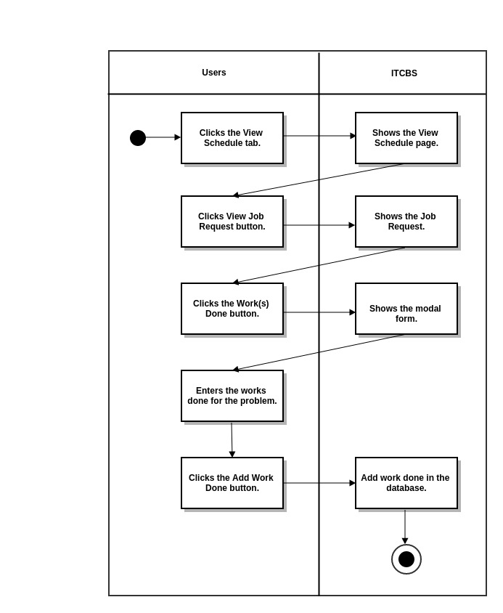

**3.1.1.2.1.2 Materials Used**

**3.1.1.2.1.2.A Use Case Specification**

|  |  |
| --- | --- |
| Description | The User (Technician, Administrator or Super Administrator) inputs the materials used for the job request. |
| Goal | To add the materials used. |
| Preconditions | The User should be logged-in. |
| Assumptions | You are connected to a network.  You are already on the View ScheduleTab. |
| Frequency | Every time the user wants to add the materials used for the job request. |
| Flow of Events | Main Flow:  1. The User clicks the View Schedule tab.  2. The User clicks View Job Request button.  3. The User clicks Add Materials Used button.  4. The User selects material and input total number of units .  5. The User clicks the Add Material button. |
| Post-conditions | The User adds materials used in the database. |
| Actors | Technician, Administrator or Super Administrator |
| Included Use Cases | None |
| Extended Use Cases | None |
| Notes |  |

**3.1.1.2.1.2.B Activity Diagram**

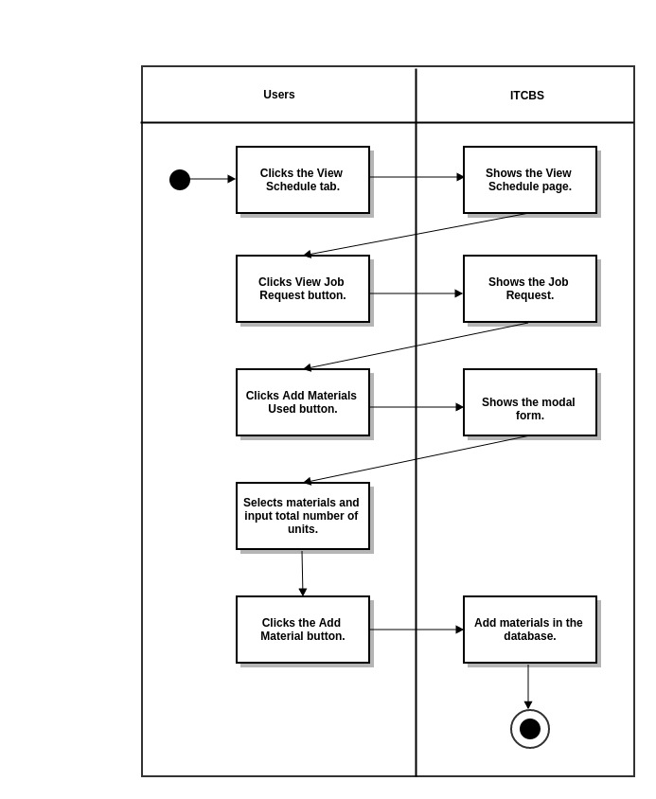

**3.1.1.2.1.3 Change Priority**

**3.1.1.2.1.3.A Use Case Specification**

|  |  |
| --- | --- |
| Description | The User changes the priority of the job. |
| Goal | To change the priority of the job. |
| Preconditions | The User should be logged-in. |
| Assumptions | You are connected to a network.  You are already on the View Schedule Tab. |
| Frequency | Every time the User wants to change the job request’s priority. |
| Flow of Events | Main Flow:  1. The User clicks the View Schedule tab.  2. The User clicks View Job Request button.  3. The User clicks Change Priority button.  4. The User selects priority (Normal, Urgent or Very Urgent) .  5. The User clicks the Update Priority button. |
| Post-conditions | The user changes the job’s priority and views it in the View Schedule tab. |
| Actors | Technician, Administrator or Super Administrator |
| Included Use Cases | None |
| Extended Use Cases | None |
| Notes |  |

**3.1.1.2.1.3.B Activity Diagram**

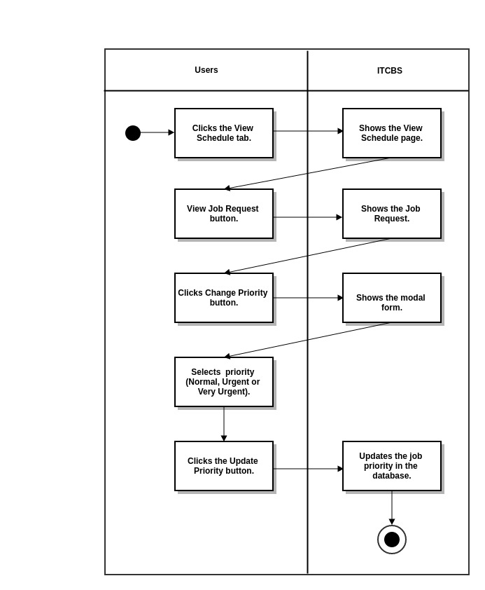

**3.1.1.2.1.4 Mark as Done**

**3.1.1.2.1.4.A Use Case Specification**

|  |  |
| --- | --- |
| Description | The User (Technician or Super Administrator )marks the job as done.) |
| Goal | To mark the job as done. |
| Preconditions | The User should be logged-in. |
| Assumptions | You are connected to a network.  You are already on the View ScheduleTab. |
| Frequency | Every time the Technician finishes the job. |
| Flow of Events | Main Flow:  1. The User clicks the View Schedule tab.  2. The User clicks the View Job Request button.  3. The User clicks the Mark as Done button. |
| Post-conditions | The User marks the job as done and removes it in the view schedule tab. |
| Actors | Technician or Super Administrator |
| Included Use Cases | None |
| Extended Use Cases | None |
| Notes |  |

**3.1.1.2.1.4.B Activity Diagram**

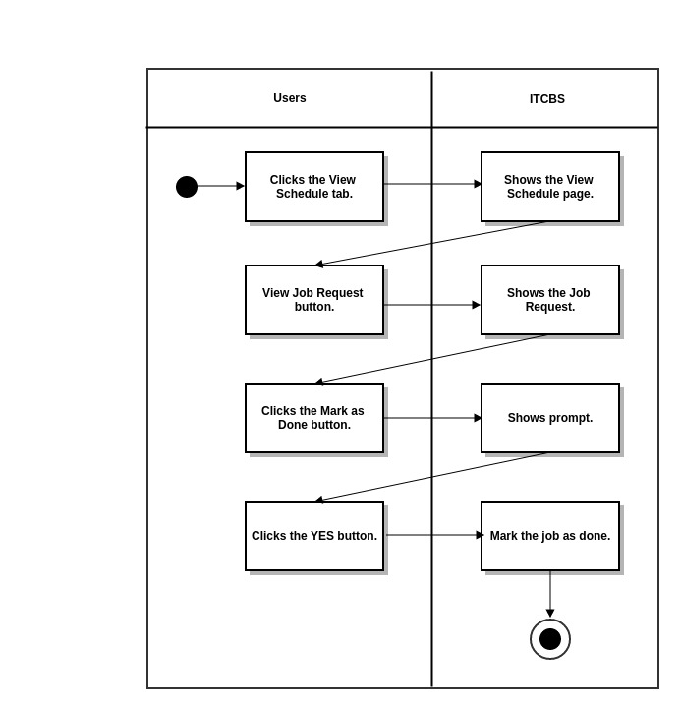

**3.1.1.3 Generate Bill**

**3.1.1.3.1 Generate Bill**

**3.1.1.3.1.A Use Case Specification**

|  |  |
| --- | --- |
| Description | The User (Technician, Administrator or Super Administrator) generates the bill for the works done for job request. |
| Goal | To generate the bill for the works done for the job request. |
| Preconditions | The Users should be logged-in. |
| Assumptions | You are connected to a network.  You are already on the Generate Bill Tab. |
| Frequency | Every time the User wants to generate the finished job’s bill. |
| Flow of Events | Main Flow:  1. The User clicks the Generate Bill Tab.  2. The User clicks the Generate button. |
| Post-conditions | The User sees the Bill or amount to be paid. |
| Actors | Technician, Administrator or Super Administrator |
| Included Use Cases | None |
| Extended Use Cases | None |
| Notes |  |

**3.1.1.3.1.B Activity Diagram**

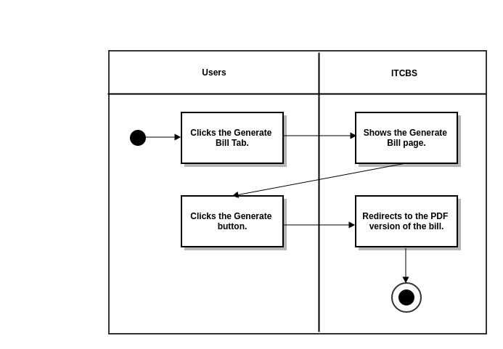

**3.1.1.3.2 Generate Job Request Form**

**3.1.1.3.2.A Use Case Specification**

|  |  |
| --- | --- |
| Description | The User (Technician, Administrator or Super Administrator) generates the job request form for the finished job request. |
| Goal | To generate the job request for the works done for the job request. |
| Preconditions | The Users should be logged-in. |
| Assumptions | You are connected to a network.  You are already on the Generate Bill Tab. |
| Frequency | Every time the User wants to generate the job request form for the finished job request |
| Flow of Events | Main Flow:  1. The User clicks the Generate Bill Tab.  2. The User clicks the Job Request Form button. |
| Post-conditions | The User sees the Job Request Form |
| Actors | Technician, Administrator or Super Administrator |
| Included Use Cases | None |
| Extended Use Cases | None |
| Notes |  |

**3.1.1.3.2.B Activity Diagram**

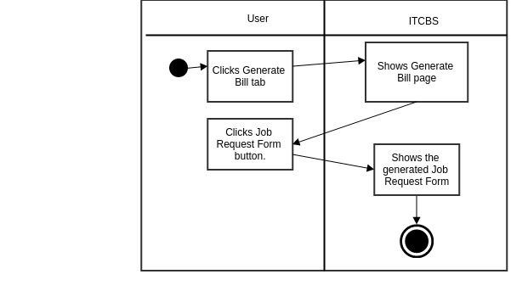

**3.1.1.4 Manage Application**

**3.1.1.4.1 User Logs**

**3.1.1.4.1.1 View By Log In/Log Out/Job Actions**

**3.1.1.4.1.1.A Use Case Specification**

|  |  |
| --- | --- |
| Description | The User (Super Administrator) views the User Logs by Log In, Log Out and Job Actions Logs |
| Goal | To view the User Logs by Log In, Log Out and Job Actions Logs |
| Preconditions | The Users should be logged-in. |
| Assumptions | You are connected to a network.  You are already on the Manage Application Tab. |
| Frequency | Every time the User wants to view the User Logs |
| Flow of Events | Main Flow:  1. The User clicks the Manage Aplication Tab.  2. The User choose the User Logs Menu. |
| Post-conditions | The User sees the User Logs by Log In, Log Out and Job Actions Logs |
| Actors |  |
| Included Use Cases | None |
| Extended Use Cases | None |
| Notes |  |

**3.1.1.4.1.1.B Activity Diagram**

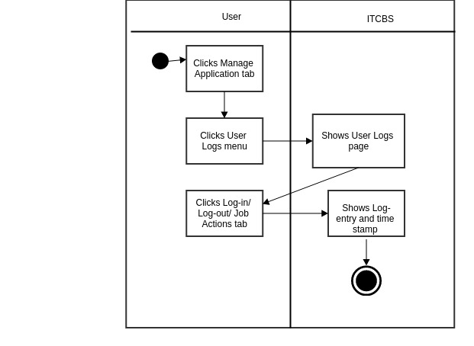

**3.1.1.4.1.2 View by User**

**3.1.1.4.1.2.1 Use Case Specification**

|  |  |
| --- | --- |
| Description | The User (Technician, Administrator or Super Administrator) views accounts by user type. |
| Goal Goal | To view accounts according to their user type. |
| Preconditions | The User should be logged-in. |
| Assumptions | You are connected to a network.  You are already on the Manage Application Tab. |
| Frequency | Every time there is a need to view accounts according to their user type. |
| Flow of Events | Main Flow:  1. The User clicks the Manage Application Tab.  2. The User clicks the Manage Accounts.  3. The User clicks the “user type” (SuperAdmin, Admin, Technician, Client) |
| Post-conditions | The User views user accounts according to its type. |
| Actors | Technician, Administrator or Super Administrator |
| Included Use Cases | None |
| Extended Use Cases | None |
| Notes |  |

**3.1.1.4.1.2.2 Activity Diagram**

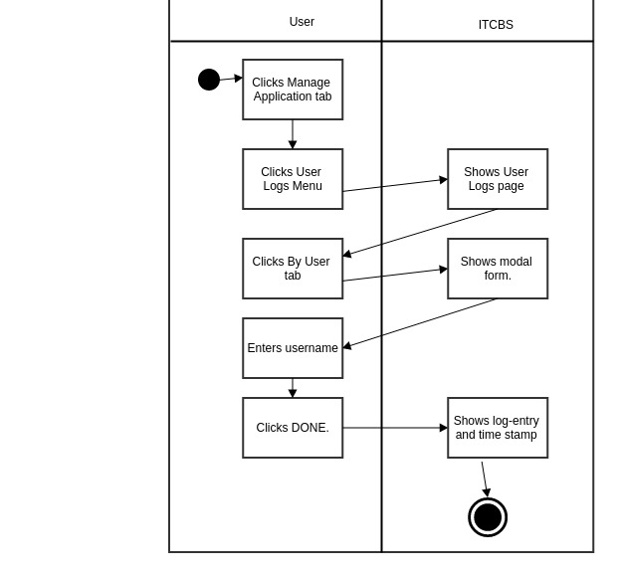

**3.1.1.4.2 Manage Accounts**

**3.1.1.4.2.1 View by User Type**

**3.1.1.4.2.1.A Use Case Specification**

|  |  |
| --- | --- |
| Description | The User (Technician, Administrator or Super Administrator) views accounts by user type. |
| Goal Goal | To view accounts according to their user type. |
| Preconditions | The User should be logged-in. |
| Assumptions | You are connected to a network.  You are already on the Manage Application Tab. |
| Frequency | Every time there is a need to view accounts according to their user type. |
| Flow of Events | Main Flow:  1. The User clicks the Manage Application Tab.  2. The User clicks the Manage Accounts.  3. The User clicks the “user type” (SuperAdmin, Admin, Technician, Client) |
| Post-conditions | The User views user accounts according to its type. |
| Actors | Technician, Administrator or Super Administrator |
| Included Use Cases | None |
| Extended Use Cases | None |
| Notes |  |

**3.1.1.4.2.1.B Activity Diagram**

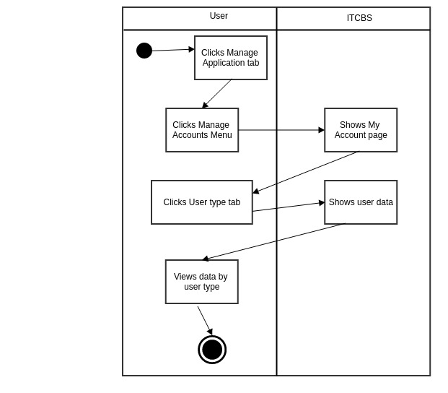

**3.1.1.4.2.1.1 Deactivate/Activate Account**

**3.1.1.4.2.1.1.A Use Case Specification**

|  |  |
| --- | --- |
| Description | The User (Technician, Administrator or Super Administrator) deactivates/activates user account. |
| Goal Goal | To deactivate/activate user account. |
| Preconditions | The User should be logged-in. |
| Assumptions | You are connected to a network.  You are already on the Manage Application Tab. |
| Frequency | Every time there is a need to deactivate/activate user account. |
| Flow of Events | Main Flow:  1. The User clicks the Manage Application Tab.  2. The User clicks the Manage Accounts.  3. The User clicks the Deactivate/ Activate Button. |
| Post-conditions | The User changes “Active” status in the database. |
| Actors | Technician, Administrator or Super Administrator |
| Included Use Cases | None |
| Extended Use Cases | None |
| Notes |  |

**3.1.1.4.2.1.1.B Activity Diagram**

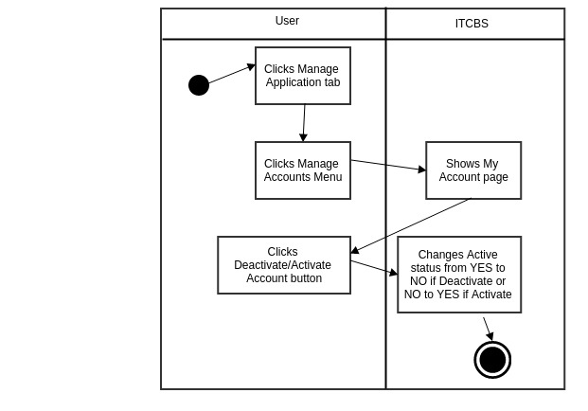

**3.1.1.4.2.1.2 Reset User Password**

**3.1.1.4.2.1.2.A Use Case Specification**

|  |  |
| --- | --- |
| Description | The User (Technician, Administrator or Super Administrator) resets user password. |
| Goal Goal | To reset user password. |
| Preconditions | The User should be logged-in. |
| Assumptions | You are connected to a network.  You are already on the Manage Application Tab. |
| Frequency | Every time there is a need to reset user password. |
| Flow of Events | Main Flow:  1. The User clicks the Manage Application Tab.  2. The User clicks the Manage Accounts.  3. The User clicks the Reset Password button.  4. The User clicks YES button.  5. The User clicks OK button. |
| Post-conditions | The User resets the user password in the database. |
| Actors | Technician, Administrator or Super Administrator |
| Included Use Cases | None |
| Extended Use Cases | None |
| Notes |  |

**3.1.1.4.2.1.2.B Activity Diagram**

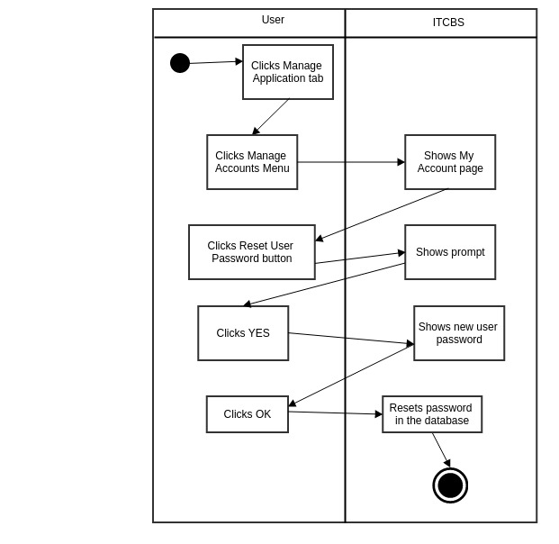

**3.1.1.4.2.2 Create Account**

**3.1.1.4.2.2.A Use Case Specification**

|  |  |
| --- | --- |
| Description | The User (Technician, Administrator or Super Administrator) creates new user account. |
| GoalGoal Goal | To create new user account. |
| Preconditions | The User should be logged-in. |
| Assumptions | You are connected to a network.  You are already on the Manage Application Tab. |
| Frequency | Every time there is a need to create a new account. |
| Flow of Events | Main Flow:  1. The User clicks the Manage Application Tab.  2. The User clicks the Manage Accounts.  3. The User clicks the Create Account.  4. The User inputs required and necessary information.  5. The User clicks Create Account button. |
| Post-conditions | The User adds new user account to the database and updates the number and list of users in the user accounts. |
| Actors | Technician, Administrator or Super Administrator |
| Included Use Cases | None |
| Extended Use Cases | None |
| Notes |  |

**3.1.1.4.2.2.B Activity Diagram**

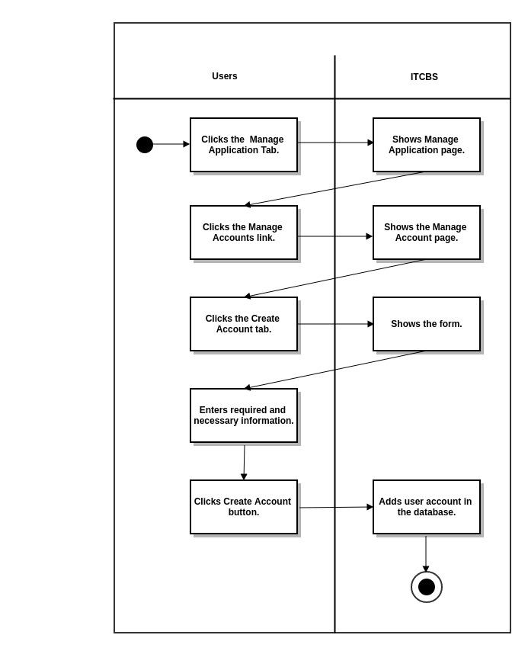

**3.1.1.4.3 Manage Work**

**3.1.1.4.3.1 Manage Selectable Work**

**3.1.1.4.3.1.1 Edit Selectable Work Details**

**3.1.1.4.3.1.1.A Use Case Specification**

|  |  |
| --- | --- |
| Description | The User (Technician, Administrator or Super Administrator) edits the selectable work details. |
| Goal | To edit the Selectable Work Details. |
| Preconditions | The User should be logged-in. |
| Assumptions | You are connected to a network.  You are already on the Manage Applications Tab. |
| Frequency | Every time the user wants to edit the selectable work details. |
| Flow of Events | Main Flow:  1. The User clicks the Manage Application Tab.  2. The User clicks the Manage Work Menu.  3. The User clicks the Edit Selectable Work Details button.  4. The User edits details.  5. The User clicks the Edit button.  6. The User clicks OK button. |
| Post-conditions | The User sees the edited selectable work details and is updated in the database. |
| Actors | Technician, Administrator or Super Administrator |
| Included Use Cases | None |
| Extended Use Cases | None |
| Notes |  |

**3.1.1.4.3.1.1.B Activity Diagram**

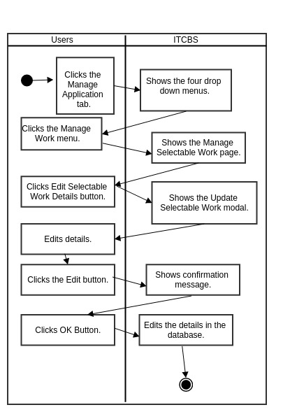

**3.1.1.4.3.1.2.a Make Selectable Work Hidden**

**3.1.1.4.3.1.2.a.A Use Case Specification**

|  |  |
| --- | --- |
| Description | The User (Technician, Administrator or Super Administrator) makes selectable work hidden. |
| Goal | To make the Selectable Work hidden. |
| Preconditions | The User should be logged-in. |
| Assumptions | You are connected to a network.  You are already on the Manage Applications Tab. |
| Frequency | Every time the user wants to make the selectable work hidden. |
| Flow of Events | Main Flow:  1. The User clicks the Manage Application Tab.  2. The User clicks the Manage Work Menu.  3. The User clicks the Make Selectable Work Hidden button. |
| Post-conditions | The selectable work is hidden. |
| Actors | Technician, Administrator or Super Administrator |
| Included Use Cases | None |
| Extended Use Cases | None |
| Notes |  |

**3.1.1.4.3.1.2.a.B Activity Diagram**

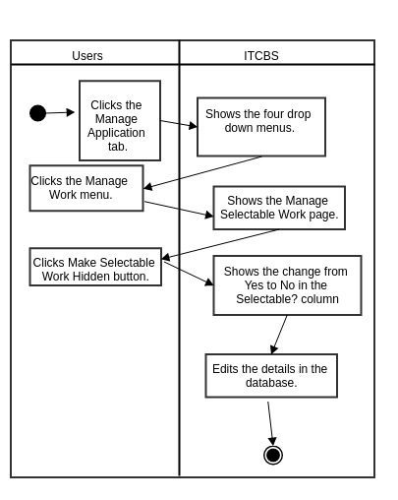

**3.1.1.4.3.1.2.b Make Selectable Work Visible**

**3.1.1.4.3.1.2.b.A Use Case Specification**

|  |  |
| --- | --- |
| Description | The User (Technician, Administrator or Super Administrator) makes selectable work visible. |
| Goal | To make the Selectable Work visible. |
| Preconditions | The User should be logged-in. |
| Assumptions | You are connected to a network.  You are already on the Manage Applications Tab. |
| Frequency | Every time the user wants to make the selectable work visible. |
| Flow of Events | Main Flow:  1. The User clicks the Manage Application Tab.  2. The User clicks the Manage Work Menu.  3. The User clicks the Make Selectable Work Visible button. |
| Post-conditions | The selectable work is visible. |
| Actors | Technician, Administrator or Super Administrator |
| Included Use Cases | None |
| Extended Use Cases | None |
| Notes |  |

**3.1.1.4.3.1.2.b.B Activity Diagram**

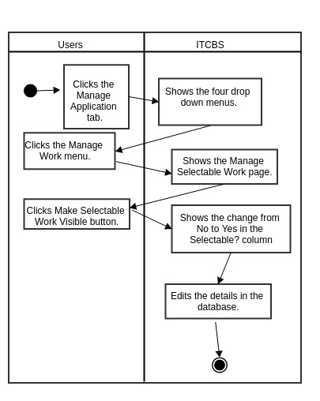

**3.1.1.4.3.2 Add New Work**

**3.1.1.4.3.2.A Use Case Specification**

|  |  |
| --- | --- |
| Description | The User (Technician, Administrator or Super Administrator) adds new work. |
| Goal | To add new work. |
| Preconditions | The User should be logged-in. |
| Assumptions | You are connected to a network.  You are already on the Manage Application Tab. |
| Frequency | Every time the user wants to add new work. |
| Flow of Events | Main Flow:  1. The User clicks the Manage Application Tab.  2. The User clicks the Manage Work Menu.  3. The User clicks the Add New Work.  4. The User adds new work details.  5. The User clicks Add New Work button.  6. The User clicks OK. |
| Post-conditions | The User adds new work in the database |
| Actors | Technician, Administrator or Super Administrator |
| Included Use Cases | None |
| Extended Use Cases | None |
| Notes |  |

**3.1.1.4.3.2.B Activity Diagram**

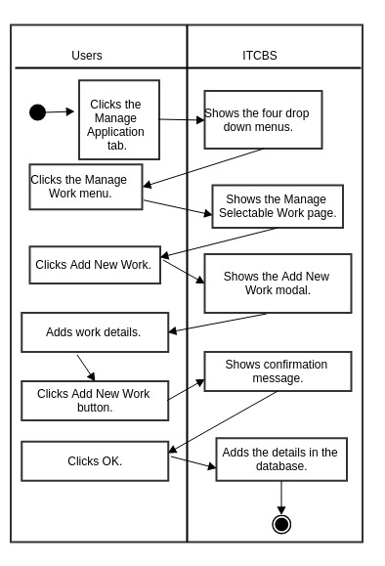

**3.1.1.4.4 Manage Materials**

**3.1.1.4.4.1 Manage Selectable Materials**

**3.1.1.4.4.1.1 Edit Selectable Materials Details**

**3.1.1.4.4.1.1.A Use Case Specification**

|  |  |
| --- | --- |
| Description | The User (Technician, Administrator or Super Administrator) edits the selectable material details. |
| Goal | To edit the Selectable Material Details. |
| Preconditions | The User should be logged-in. |
| Assumptions | You are connected to a network.  You are already on the Manage Applications Tab. |
| Frequency | Every time the user wants to edit the selectable material details. |
| Flow of Events | Main Flow:  1. The User clicks the Manage Application Tab.  2. The User clicks the Manage Material Menu.  3. The User clicks the Edit Selectable Material Details button.  4. The User edits details.  5. The User clicks the Edit button.  6. The User clicks OK button. |
| Post-conditions | The User sees the edited selectable material details and is updated in the database. |
| Actors | Technician, Administrator or Super Administrator |
| Included Use Cases | None |
| Extended Use Cases | None |
| Notes |  |

**3.1.1.4.4.1.1.B Activity Diagram**

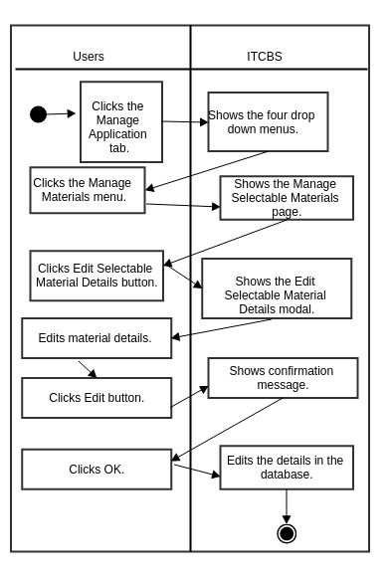

**3.1.1.4.4.1.2.a Make Selectable Materials Hidden**

**3.1.1.4.4.1.2.a.A Use Case Specification**

|  |  |
| --- | --- |
| Description | The User (Technician, Administrator or Super Administrator) makes selectable materials hidden. |
| Goal | To make the Selectable Materials hidden. |
| Preconditions | The User should be logged-in. |
| Assumptions | You are connected to a network.  You are already on the Manage Applications Tab. |
| Frequency | Every time the user wants to make the selectable material hidden. |
| Flow of Events | Main Flow:  1. The User clicks the Manage Application Tab.  2. The User clicks the Manage Material Menu.  3. The User clicks the Make Selectable Material Hidden button. |
| Post-conditions | The selectable material is hidden. |
| Actors | Technician, Administrator or Super Administrator |
| Included Use Cases | None |
| Extended Use Cases | None |
| Notes |  |

**3.1.1.4.4.1.2.a.B Activity Diagram**

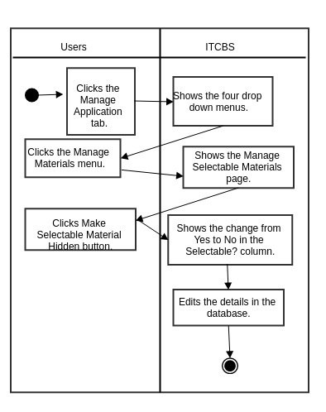

**3.1.1.4.4.1.2.b Make Selectable Materials Visible**

**3.1.1.4.4.1.2.b.A Use Case Specification**

|  |  |
| --- | --- |
| Description | The User (Technician, Administrator or Super Administrator) makes selectable materials visible |
| Goal | To make the Selectable Materials visible |
| Preconditions | The User should be logged-in. |
| Assumptions | You are connected to a network.  You are already on the Manage Applications Tab. |
| Frequency | Every time the user wants to make the selectable materials visible |
| Flow of Events | Main Flow:  1. The User clicks the Manage Application Tab.  2. The User clicks the Manage Material Menu.  3. The User clicks the Make Selectable Material Visible button. |
| Post-conditions | The selectable material is visible. |
| Actors | Technician, Administrator or Super Administrator |
| Included Use Cases | None |
| Extended Use Cases | None |
| Notes |  |

**3.1.1.4.4.1.2.b.B Activity Diagram**

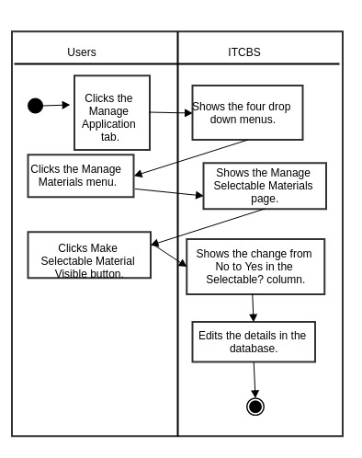

**3.1.1.4.4.2 Add New Materials**

**3.1.1.4.4.2.A Use Case Specification**

|  |  |
| --- | --- |
| Description | The User (Technician, Administrator or Super Administrator) adds new materials. |
| Goal | To add new materials. |
| Preconditions | The User should be logged-in. |
| Assumptions | You are connected to a network.  You are already on the Manage Application Tab. |
| Frequency | Every time the user wants to add new materials. |
| Flow of Events | Main Flow:  1. The User clicks the Manage Application Tab.  2. The User clicks the Manage Materials Menu.  3. The User clicks the Add New Materials.  4. The User adds new materials details.  5. The User clicks Add New Materials button.  6. The User clicks OK. |
| Post-conditions | The User adds new materials in the database |
| Actors | Technician, Administrator or Super Administrator |
| Included Use Cases | None |
| Extended Use Cases | None |
| Notes |  |

**3.1.1.4.4.2.B Activity Diagram**

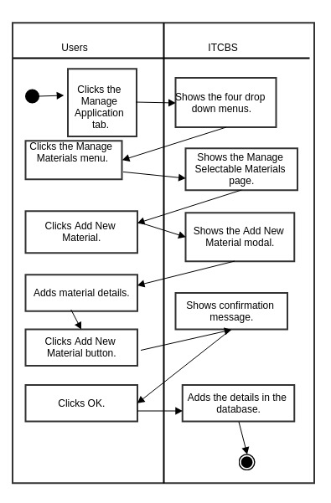

**3.1.1.5 My Account**

**3.1.1.5.1 Update Profile**

**3.1.1.5.1.A Use Case Specification**

|  |  |
| --- | --- |
| Description | The User (Client, Technician, Administrator or Super Administrator) updates account’s profile. |
| Goal | To update the account’s profile. |
| Preconditions | The User should be logged-in. |
| Assumptions | You are connected to a network.  You are already on the My Account Tab. |
| Frequency | Every time the User wants to update his/her profile |
| Flow of Events | Main Flow:  1. The User clicks the My Account Tab.  2. The User enters the new Given Name and Last Name in their respective text area.  3. The User clicks the Update Profile button. |
| Post-conditions | The User updates Given Name and Last Name in the database . |
| Actors | Client, Technician, Administrator or Super Administrator |
| Included Use Cases | None |
| Extended Use Cases | None |
| Notes |  |

**3.1.1.5.1.B Activity Diagram**



**3.1.1.5.2 Change Password**

**3.1.1.6.2.A Use Case Specification**

|  |  |
| --- | --- |
| Description | The User (Client, Technician, Administrator or Super Administrator) changes his/her password. |
| Goal | To change user account’s password. |
| Preconditions | The User should be logged-in. |
| Assumptions | You are connected to a network.  You are already on the My Account Tab. |
| Frequency | Every time the User wants to change his/her password. |
| Flow of Events | Main Flow:  1. The User clicks the My Account Tab.  2. The User clicks the Change Password button.  3. The User enters the old and new password.  4. The User clicks the Change Password button. |
| Post-conditions | The User updates password in the database. |
| Actors | Client, Technician, Administrator or Super Administrator |
| Included Use Cases | None |
| Extended Use Cases | None |
| Notes |  |

**3.1.1.5.2.B Activity Diagram**

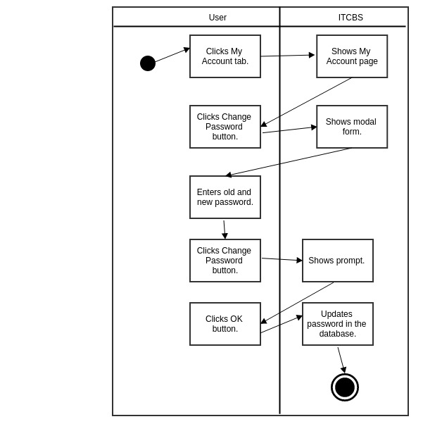

**3.1.1.6 Log Out**

**3.1.1.6.A Use Case Specification**

|  |  |
| --- | --- |
| Description | The User (Client, Technician, Administrator or Super Administrator) logs out. |
| Goal | To log out of the system. |
| Preconditions | The User should be logged-in. |
| Assumptions | You are connected to a network. |
| Frequency | Every time the user wants to log out. |
| Flow of Events | Main Flow:  1. The User clicks the Log Out tab. |
| Post-conditions | The User is logged out and redirects to log in page. |
| Actors | Client, Technician, Administrator or Super Administrator |
| Included Use Cases | None |
| Extended Use Cases | None |
| Notes |  |

**3.1.1.6.B Activity Diagram**

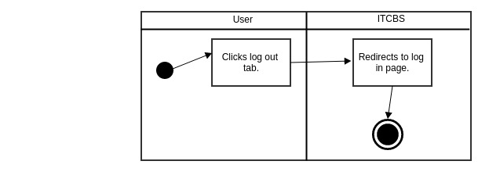

**3.2 Database Schema**

