Information Technology Center


ITC Billing System (ITCBS)

Software Requirements Specification

Version: 6.0 Date: 07/04/2016
Document History and Distribution

1. Revision History

2. Distribution

Recipient Name Recipient Organization Distribution Method

TABLE OF CONTENTS

1. INTRODUCTION
1.1 Purpose -----------------------------------------------------------------------------1
1.2 Scope ------------------------------------------------------------------------------- 1
1.3 Definitions, Acronyms and Abbreviations ------------------------------------ 1
1.4 References ------------------------------------------------------------------------- 3
1.4.1 Applicable Documents -------------------------------------------------------- 3
1.5 Product Overview ----------------------------------------------------------------- 3

2. SPECIFIC REQUIREMENTS
2.1 External Interface Requirements
2.1.1 User Interfaces ------------------------------------------------------- 3
2.1.2 Hardware Interfaces ------------------------------------------------- 3
2.1.3 Software Interfaces -------------------------------------------------- 4
2.1.4 Operation -------------------------------------------------------------- 4
2.1.5 Product Function ----------------------------------------------------- 4
2.1.6 Assumptions and Dependencies ----------------------------------- 4
2.2 Software Product Features -------------------------------------------------------- 4
2.3 Software System Attributes
2.3.1 Reliability -----------------------------------------------------------------5
2.3.2 Availability -------------------------------------------------------------5
2.3.3 Security --------------------------------------------------------------------5
2.3.4 Maintainability -----------------------------------------------------------5
2.3.5 Portability -----------------------------------------------------------------5
2.3.6 Performance -------------------------------------------------------------- 5
2.4 Database Requirements -------------------------------------------------------------5

3. FUNCTIONAL REQUIREMENTS
3.1 Use Cases --------------------------------------------------------------------------6
3.1.1. Log In ------------------------------------------------------------------6
3.1.1.1 Home
3.1.1.1.1 as SuperAdmin, Admin, Technician---------------------------- 8
3.1.1.1.2 as Client ----------------------------------------------------------- 9
3.1.1.2 Announcements
3.1.1.2.1 as SuperAdmin, Admin, Technician
3.1.1.2.1.1 Add Announcements
3.1.1.2.1.1.1 Add Announcement ----------------------------------------- 10
3.1.1.2.1.1.2 Reset ---------------------------------------------------------- 11
3.1.1.2.1.2 View Announcement ------------------------------------------12
3.1.1.2.1.2.1 Delete Announcement -------------------------------------- 13
3.1.1.2.2 as Client -----------------------------------------------------------15

3.1.1.3 Job Requests
3.1.1.3.1 View List of Job Requests
3.1.1.3.1.1 View (According To Status) ----------------------------------16
3.1.1.3.1.2 Search Jobs ----------------------------------------------------17
3.1.1.3.1.3 View Job Requests
3.1.1.3.1.3.1 Work(s) Done ------------------------------------------------19
3.1.1.3.1.3.2 Materials Used ----------------------------------------------19
3.1.1.3.1.3.3 Change Priority ---------------------------------------------19
3.1.1.3.1.3.4 Mark as Done -----------------------------------------------19
3.1.1.3.1.4 Edit Job Description ----------------------------------------- 20
3.1.1.3.1.5 Cancel Job Request------------------------------------------ 22
3.1.1.3.2. File A Job Request -------------------------------------------- 23
3.1.1.4 View Schedule
3.1.1.4.1 View Job Requests
3.1.1.4.1.1 Work(s) Done --------------------------------------------------25
3.1.1.4.1.2 Materials Used ------------------------------------------------27
3.1.1.4.1.3 Change Priority ---------------------------------------------- 29
3.1.1.4.1.4 Mark as Done ------------------------------------------------ 31
3.1.1.5 Generate Bill
3.1.1.5.1 Generate Bill ---------------------------------------------------33
3.1.1.5.2 Generate Job Request Form ---------------------------------- 35
3.1.1.6 Manage Application
3.1.1.6.1 User Logs
3.1.1.6.1.1 View By Log In/Log Out/Job Actions ---------------------37
3.1.1.6.1.2 View by User -------------------------------------------------39
3.1.1.6.2 Manage Accounts
3.1.1.6.2.1 View by User Type --------------------------------------------41
3.1.1.6.2.1.1 Deactivate/Activate Account ------------------------------43
3.1.1.6.2.1.2 Reset User Password --------------------------------------45
3.1.1.6.2.2 Create Account -------------------------------------------------47
3.1.1.6.3 Manage Work
3.1.1.6.3.1 Manage Selectable Work
3.1.1.6.3.1.1 Edit Selectable Work Details -------------------------------49
3.1.1.6.3.1.2.a Make Selectable Work Hidden ---------------------------51
3.1.1.6.3.1.2.b Make Selectable Work Visible----------------------------53
3.1.1.6.3.2 Add New Work --------------------------------------------------55
3.1.1.6.4 Manage Materials
3.1.1.6.4.1 Manage Selectable Materials
3.1.1.6.4.1.1 Edit Selectable Materials Details ---------------------------57
3.1.1.6.4.1.2.a Make Selectable Materials Hidden -----------------------59
3.1.1.6.4.1.2.b Make Selectable Materials Visible ------------------------61
3.1.1.6.4.2 Add New Materials ----------------------------------------------63
3.1.1.7 My Account
3.1.1.7.1 Update Profile ------------------------------------------------------65
3.1.1.7.2 Change Password --------------------------------------------------67
3.1.1.8 Log Out ---------------------------------------------------------------69

1. Introduction
1.1 Purpose

This software requirement specification serves as an overview and provides a complete description of all the functions and specifications of the ITC Billing System of the Information Technology Center, University of the Philippines, Los Baños.
This document will serve as the baseline for the developers on the implementation of the design and development of the software. This allows users to know what to expect in the software. This also serves as he guide for the testers on the evaluation of the software’s features and specifications.

1.2 Scope

The project aims to create a unified and online billing system for UPLB ITC. This includes the filing of job requests by the users, viewing the job requests filed and scheduling the job requests. The project can also track the job request and it can also generate bills and reports regarding the job request done.

1.3 Definitions, Acronyms and Abbreviations

Acronym | Meaning
ITC | Information Technology Center
UPLB | University of the Philippines Los Baños
ITCBS | Information Technology Center Billing System
SRS | Software Requirements Specification
Table 1. Acronyms used and its respective definition

1

Term/Phrase | MeaningSomeone who avails the services of  UPLB ITC.
Client | Someone who avails the services of  UPLB ITC.
Technician | User that has the ability to update(set the priority level of a certain job and mark job request as done), edit and cancel job requests, add materials and generate bill.
Administrator | User that has the ability to view job requests(set the priority level of a certain job), edit and cancel job request, add materials and generate bill.
Super Administrator | User that has the ability to file, view, update(set the priority level of a certain job and mark job request as done), edit and cancel job requests, add recommended materials, generate bill, generate report and create account.
Job Request | A form that includes the details of the service that the client has availed.
Bill | A form that includes the total amount and job requests  a client has to pay.
User | Client, Technician, Administrator, Super Administrator
Table 2. Terms and Phrases used and its respective definitions

2
  - References
1.4.1Applicable Documents

- 2015 ITC Billing System (ITCBS) Software Requirements Specification Version 5.0

1.5 Product Overview

The ITC Billing System (ITCBS) integrates the billing system for UPLB ITC’s System Administration, Network Administration and Technical Support sections. It caters to the need of the ITC team of a common system in managing job requests.

2. Specific Requirements

2.1 External Interface Requirements
2.1.1 User Interfaces

User interface is defined to make an ease for the user to use the system. User needs to log in to the system first to be able to access the system. Upon logging in, the user will first be directed to the home page which shows the updates and announcements. Based on the type of account the user logs in, whether as a Client, Technician, Administrator or Super Administrator, the user can access the site with specific limitations per user type. The Client can only file job request and view his job requests. The Technician can set the priority level of a certain job, edit and cancel job requests, add materials and generate bill. Administrator is the user who can view job requests, set the priority level of a certain job, edit and cancel job request, add materials, generate bill and report. The Super Administrator has the ability to file, view, update (set the priority level of a certain job and mark job request as done), edit and cancel job requests, add recommended materials, generate bill, generate report and create account.

2.1.2 Hardware Interfaces

ITC billing system is a web-based system that needs a server to handle the web application and its database. Any computer owned by the ITC team which has an access to the Internet will be able to use the system. The system will use printers for producing a hard copy of the job request forms and statement of account. There is no specific kind of printer required to use in the system and the printer driver must be installed depending on the kind of printer used. The USB port will also be used to connect the printer into the computer.

3

2.1.3 Software Interfaces

The system uses the standard web development tools to be able to create the system. No necessary external tools will be needed.
1. Code Igniter framework will be used for the development of the system.
2. MariaDB Version 10.0.25 will be utilized by the system to manage the database. The tables to be used will be well defined for the system to access the database easily and quickly.

2.1.4 Operation

The users (Technician, Administrator, Super Administrator) can entertain request from client within office hours from 8am to 5pm, Mondays-Fridays. They can update the job request and generate the bill for printing. Since the system to be developed is to be deployed locally, the site can only be accessed within the offices. Requests may only be encoded and processed within office hours.

2.1.5 Product Function

The system will keep record of all the services requested from the ITC. The system will generate a printed version of the job requests and bills for each service done.

2.1.6 Assumptions and Dependencies

The system assumes that there will only be four types of users of the system, the Super Administrator, Administrator, Technician and the Client. Each user type has its own access levels.
Users from each type have a predefined interface for their convenience. Each user must also use the latest version of the browser that they are using. The users (Super Administrator, Administrator, Technician) must update the job request forms and bills frequently so that the system will be able to update the database.

2.2 Software Product Features
The software product must be able to do the following
1. The user can see the recent job requests and be able to view the details of each job request.
2. The user can add, edit and cancel job request whenever they have to. This includes the updating of the job request whether it is already done or still on-going.
3. The system can generate job request forms and a viewable record of accepted jobs.

4

2.3 Software System Attributes

2.3.1 Reliability

The system must be able to recover from a serious error. It will also post warning messages if there will be errors encountered or during maintenance.

2.3.2 Availability

The system will be available online and in the ITC office.

2.3.3 Security

In order to use the system, the user must log-in first using his account. The password entered by the user when his account was encrypted using SHA1 so that the user will be the only one who knows his password.

2.3.4 Maintainability

The system will comply with the w3c web standards. The coding convention should be well-documented.

2.3.5 Portability

ITC billing system will be able to run on any operating system as long as it has a web browser on its latest version.

2.3.6 Performance

The system must be able to handle requests and usage of the user swiftly and at ease. Considering some possible constraints like Internet connection speed, server and computer hardware, web browser and etc., the ITCBS’s services should still cater the needs of the user.

2.4 Database Requirements

The system will use MariaDB Version 10.0.25 as its database. The system will have its own database which will be used for storing and tracking Job Requests and current funds.

5
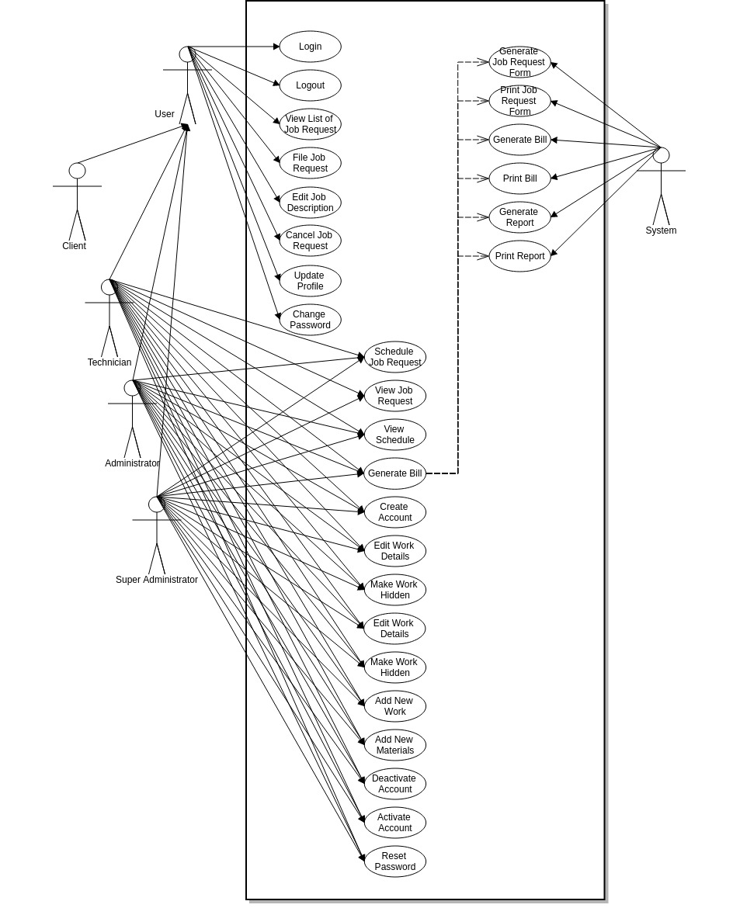
3. Functional Requirements
3.1 Use Cases

6
3.1.1 Login
3.1.1.A Use Case Specification
Description | The Users enters his/her username and password.
Goal | To allow only valid administrators and users to use the system.
Preconditions | The system is online.
Assumptions | You are connected to a network.
Frequency | Every time the user needs to use the system.
Flow of Events | Main Flow:  1. The Users enter his/her username and password  2. The Users click the Log In button.
2. System Authentication.
A) Alternate Flow: Authentication fails.
A1) Prompt “Invalid Credentials”.
A2) Return to step 1 of the Main Flow.
Post conditions | The Users can now access and use the system.
Actors | Users (Super Administrator, Technician, Administrator, Client)
Included Use Cases | None
Extended Use Cases | None
Notes

3.1.1.B Activity Diagram
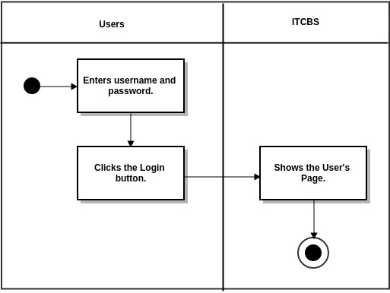
7
3.1.1.1 Home
3.1.1.1.1 as SuperAdmin, Admin, Technician
3.1.1.1.1. A. Use Case Specification

Description | The User views Home page.
Goal | To view the Home page.
Preconditions | The system is online.
Assumptions | You are connected to a network.
Frequency | Every time the user logs in.
Flow of Events | 1. The User clicks the Home tab.
Post conditions | The User can view the Home page and see scheduled jobs for today.
Actors | Users (Super Administrator, Technician, Administrator)
Included Use Cases | None
Extended Use Cases | None
Notes

3.1.1.1.1.B Activity Diagram

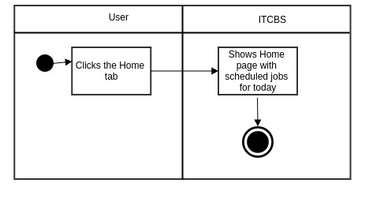

8

3.1.1.1.2 as Client
3.1.1.1.2.A Use Case Specification

Description | The User views Home page.
Goal | To view the Home page.
Preconditions | The system is online.
Assumptions | You are connected to a network.
Frequency | Every time the user logs in.
Flow of Events | 1. The User clicks the Home tab.
Post conditions | The User can view the Home page and see work rate and latest job requests.
Actors | Users (Client)
Included Use Cases | None
Extended Use Cases | None
Notes

3.1.1.1.2.B Activity Diagram

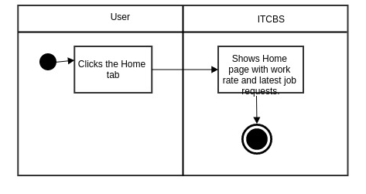

9
3.1.1.2 Announcements
3.1.1.2.1 as SuperAdmin, Admin, Technician
3.1.1.2.1.1 Add Announcements
3.1.1.2.1.1.1 Add Announcement
3.1.1.2.1.1.1.A Use Case Specification
Description | The User adds announcement.
Goal | To add announcement in the Announcements page.
Preconditions | The system is online.
Assumptions | You are connected to a network.
Frequency | Every time the user wants to add announcement.
Flow of Events | 1. The User clicks the Announcements tab.  2. The User enters announcements data in the Add Announcements form.  3. The User clicks Add Announcements button.
Post conditions | The User adds the new Announcement in the Announcements page.
Actors | Users (SuperAdmin, Admin, Technician)
Included Use Cases | None
Extended Use Cases | None
Notes
3.1.1.2.1.1.1.B Activity Diagram
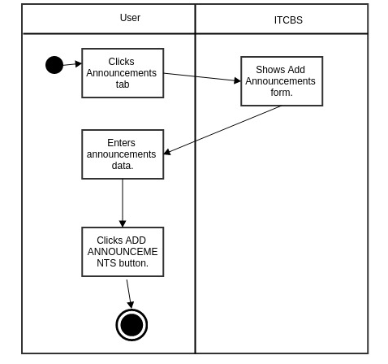

10
3.1.1.2.1.1.2 Reset
3.1.1.2.1.1.2.A Use Case Specification
Description | The User resets the announcement in the Add Announcements form.
Goal | To reset the announcement in the Add Announcements form
Preconditions | The system is online.
Assumptions | You are connected to a network.
Frequency | Every time the user wants to reset the data entered in the Add Announcements form.
Flow of Events | 1. The User clicks the Announcements tab.  2. The User enters announcements data in the Add Announcements form.  3. The User clicks Reset button.
Post conditions | The User resets the Add Announcements form.
Actors | Users (SuperAdmin, Admin, Technician)
Included Use Cases | None
Extended Use Cases | None
Notes
3.1.1.2.1.1.2.B Activity Diagram
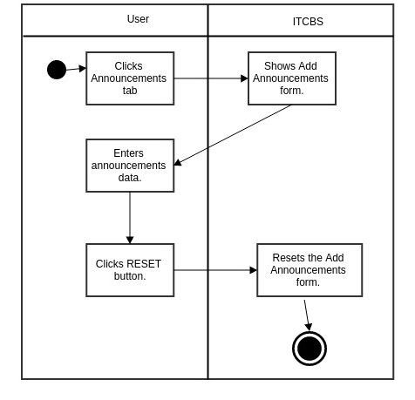

11
3.1.1.2.1.2 View Announcement
3.1.1.2.1.2.A Use Case Specification

Description | The User views the list of Announcements.
Goal | To view the Announcements’ title and content.
Preconditions | The system is online.
Assumptions | You are connected to a network.
Frequency | Every time the user wants to view the list of Announcements.
Flow of Events | 1. The User clicks the Announcements tab.  2. The User clicks View Announcements tab.  3. The User clicks the Announcement’s title.
Post conditions | The User views the Announcements’ title and content.
Actors | Users (SuperAdmin, Admin, Technician)
Included Use Cases | None
Extended Use Cases | None
Notes
3.1.1.2.1.2.B Activity Diagram
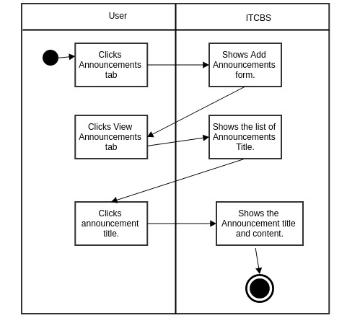

12
3.1.1.2.1.2.1 Delete Announcement
3.1.1.2.1.2.1.A Use Case Specification

Description | The User deletes the Announcement.
Goal | To delete the Announcements’ title and content.
Preconditions | The system is online.
Assumptions | You are connected to a network.
Frequency | Every time the user wants to delete the Announcement.
Flow of Events | 1. The User clicks the Announcements tab.  2. The User clicks View Announcements tab.  3. The User clicks the Announcement’s title.  4. The User clicks the DELETE ANNOUNCEMENT button.
Post conditions | The announcement was deleted.
Actors | Users (SuperAdmin, Admin, Technician)
Included Use Cases | None
Extended Use Cases | None
Notes

13

3.1.1.2.1.2.1.B Activity Diagram

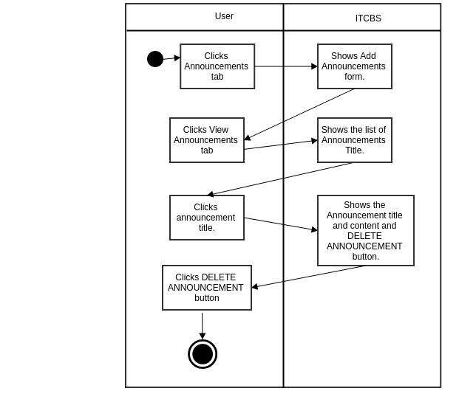

14
3.1.1.2.2 as Client
3.1.1.2.2.A Use Case Specification

Description | The User views the list of Announcements.
Goal | To view the Announcements’ title and content.
Preconditions | The system is online.
Assumptions | You are connected to a network.
Frequency | Every time the user wants to view the list of Announcements.
Flow of Events | 1. The User clicks the Announcements tab.  2. The User clicks the Announcement’s title.
Post conditions | The User views the Announcements’ title and content.
Actors | Users (Client)
Included Use Cases | None
Extended Use Cases | None
Notes

3.1.1.2.2.B Activity Diagram
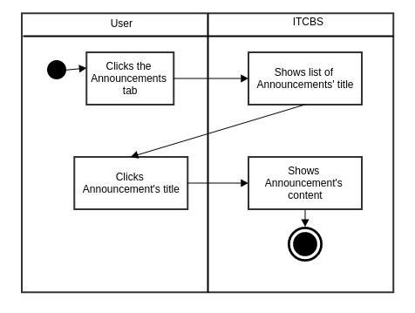

15

3.1.1.3 Job Requests
3.1.1.3.1 View List of Job Requests
3.1.1.3.1.1 View (According To Status)
3.1.1.3.1.1.A Use Case Specification

Description | The User views job requests according to its status
Goal | To view job requests according to its status
Preconditions | The system is online.
Assumptions | You are connected to a network.
Frequency | Every time the user needs to use the system.
Flow of Events | 1. The User clicks the Job Request tab.  2. The User clicks the Job Request status (PENDING, CANCELLED, PROCESSING, PROCESSED)
Post conditions | The User can view the job request according to its status.
Actors | Users (Super Administrator, Technician, Administrator)
Included Use Cases | None
Extended Use Cases | None
Notes
3.1.1.3.1.1.B Activity Diagram
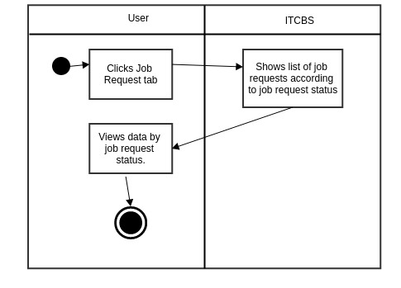

16

3.1.1.3.1.2 Search Jobs
3.1.1.3.1.2.A Use Case Specification

Description | The User searches job requests by search terms.
Goal | To search job requests by search terms.
Preconditions | The system is online.
Assumptions | You are connected to a network.
Frequency | Every time the user wants to search job requests.
Flow of Events | 1. The User clicks the Job Request tab.  2. The User clicks the View List of Job Requests.  3. The user clicks the Search Jobs button.  4. The User inputs search terms separated by spaces.  5. The User clicks the Search button.
Post conditions | The User can view the list of job requests containing searched terms.
Actors | Users (Super Administrator, Technician, Administrator)
Included Use Cases | None
Extended Use Cases | None
Notes

17

3.1.1.3.1.2.B Activity Diagram
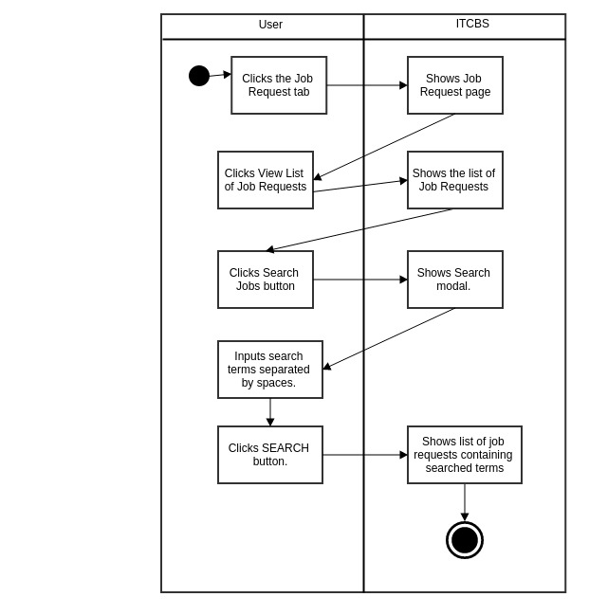

18

3.1.1.3.1.3 View Job Requests
3.1.1.3.1.3.1 Work(s) Done
3.1.1.3.1.3.1.A Use Case Specification
(Refer to Section 3.1.1.4.1.1.A Use Case Specification)
3.1.1.3.1.3.1.B Activity Diagram
(Refer to Section 3.1.1.4.1.1.B Activity Diagram)
3.1.1.3.1.3.2 Materials Used
3.1.1.3.1.3.2.A Use Case Specification
(Refer to Section 3.1.1.4.1.2.A Use Case Specification)
3.1.1.3.1.3.2.B Activity Diagram
(Refer to Section 3.1.1.4.1.2.B Activity Diagram)
3.1.1.3.1.3.3 Change Priority
3.1.1.3.1.3.3.A Use Case Specification
(Refer to Section 3.1.1.4.1.3.A Use Case Specification)
3.1.1.3.1.3.3.B Activity Diagram
(Refer to Section 3.1.1.4.1.3.B Activity Diagram)
3.1.1.3.1.3.4 Mark as Done
3.1.1.3.1.3.4.A Use Case Specification
(Refer to Section 3.1.1.4.1.4.A Use Case Specification)
3.1.1.3.1.3.4.B Activity Diagram
(Refer to Section 3.1.1.4.1.4.B Activity Diagram)

19

3.1.1.3.1.4 Edit Job Description
3.1.1.3.1.4.A Use Case Specification

Description Description | The User edits the job description.
Goal | To edit the job description.
Preconditions | The User should be logged-in.
Assumptions | You are connected to a network.  You are already on the Job Request Tab.
Frequency | Every time the user wants to edit the job description.
Flow of Events | Main Flow:  1. The User clicks the Job Request tab.  2. The User clicks View List of Job Requests..  3. The User clicks Edit Job Description  4. The User enters the new job description in the text area.  5. The User clicks the Edit button.
Post-conditions | The job description will be updated with the edited version in the database.
Actors | Client, Technician, Administrator or Super Administrator
Included Use Cases | None
Extended Use Cases | None
Notes

20

3.1.1.3.1.4.B Activity Diagram

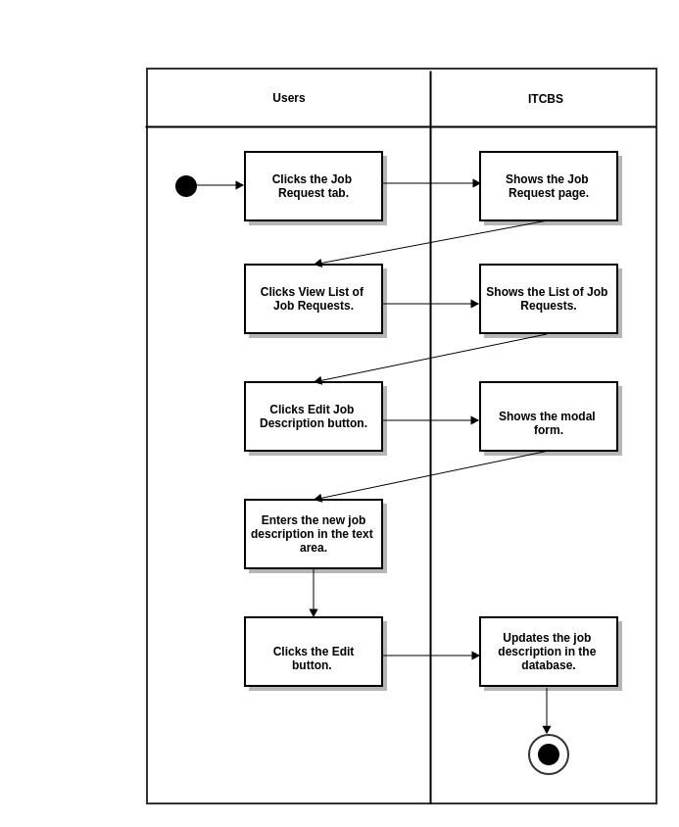

21
3.1.1.3.1.5 Cancel Job Request
3.1.1.3.1.5.A Use Case Specification

Description | The User cancels the job request.
Goal | To cancel the job request.
Preconditions | The User should be logged-in.
Assumptions | You are connected to a network.  You are already on the Job Request Tab.
Frequency | Every time the user wants to cancel his/her job request.
Flow of Events | Main Flow:  1. The User clicks the Job Request tab.  2. The User clicks View List of Job Requests..  3. The User clicks Cancel Job Request  4. The User clicks the YES button.
Post-conditions | The job request will be cancelled.
Actors | Client Technician, Administrator or Super Administrator
Included Use Cases | None
Extended Use Cases | None
Notes
3.1.1.3.1.5.B Activity Diagram
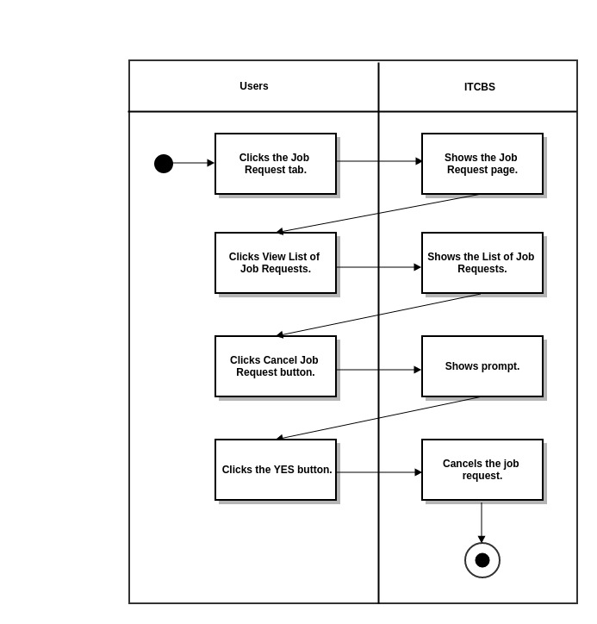
22
3.1.1.3.2. File A Job Request
3.1.1.3.2.A Use Case Specification

Description | The User creates a new job request.
Goal | Insert some information about a job request to the database.
Preconditions | The User should be logged-in.
Assumptions | You are connected to a network.  You are already on the Job Request Tab.
Frequency | Every time the user wants to file a job request.
Flow of Events | Main Flow:  1. The User clicks the Job Request tab.  2. The User clicks File A Job Request.  3. The User inputs required and necessary information.  4. The User clicks the Submit button.
Post-conditions | The User adds new job request to the database and updates the number and list of job requests in the Job Requests tab.
Actors | Client, Technician, Administrator or Super Administrator
Included Use Cases | None
Extended Use Cases | None
Notes

23

3.1.1.3.2.B Activity Diagram
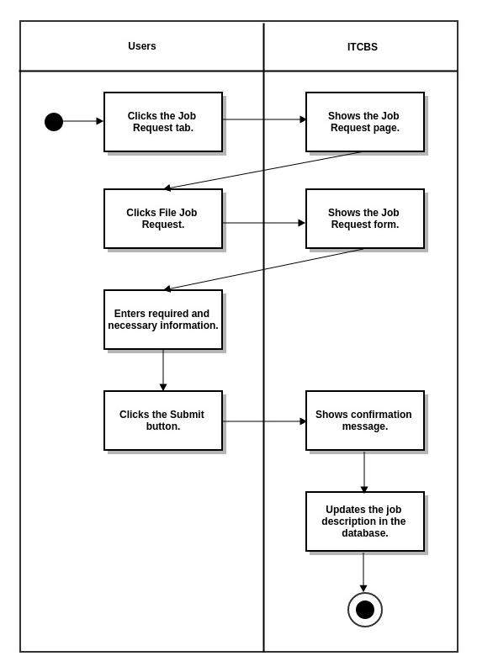

24
3.1.1.4 View Schedule
3.1.1.4.1 View Job Requests
3.1.1.4.1.1 Work(s) Done
3.1.1.4.1.1.A Use Case Specification

Description | The User (Technician, Administrator or Super Administrator) inputs the works done for the problem to be solved.
Goal | To insert what are the works done for the problem.
Preconditions | The Users should be logged-in.
Assumptions | You are connected to a network.  You are already on the View Schedule Tab.
Frequency | Every time the user wants to add what are the works done for the job request.
Flow of Events | Main Flow:  1. The User clicks the View Schedule tab.  2. The User clicks View Job Requests button.  3. The User clicks the Work(s) Done button.  4. The User enters what are the works done for the problem.
Post-conditions | The User adds what are the works done for the job request to the database.
Actors | Technician, Administrator or Super Administrator
Included Use Cases | None
Extended Use Cases | None
Notes

25

3.1.1.4.1.1 B Activity Diagram

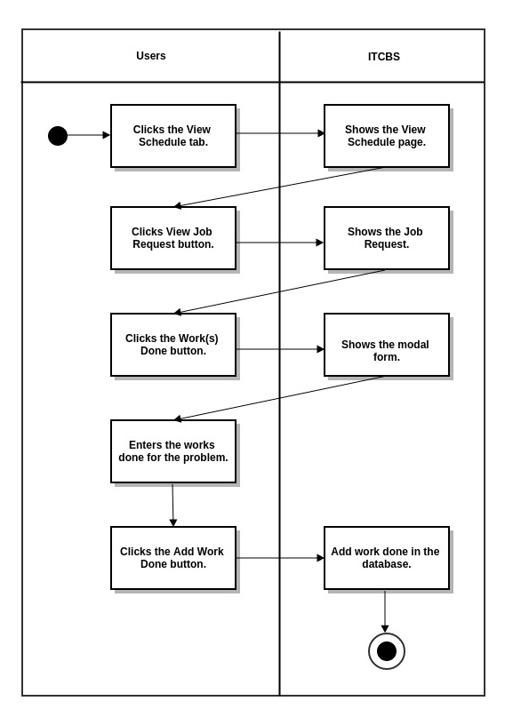

26

3.1.1.4.1.2 Materials Used
3.1.1.4.1.2.A Use Case Specification

Description | The User (Technician, Administrator or Super Administrator) inputs the materials used for the job request.
Goal | To add the materials used.
Preconditions | The User should be logged-in.
Assumptions | You are connected to a network.  You are already on the View ScheduleTab.
Frequency | Every time the user wants to add the materials used for the job request.
Flow of Events | Main Flow:  1. The User clicks the View Schedule tab.  2. The User clicks View Job Request button.  3. The User clicks Add Materials Used button.  4. The User selects material and input total number of units .  5. The User clicks the Add Material button.
Post-conditions | The User adds materials used in the database.
Actors | Technician, Administrator or Super Administrator
Included Use Cases | None
Extended Use Cases | None
Notes

27

3.1.1.4.1.2.B Activity Diagram
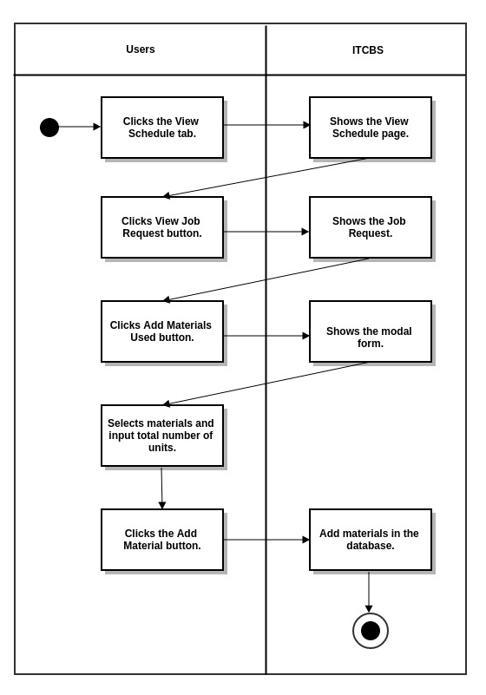

28

3.1.1.4.1.3 Change Priority
3.1.1.4.1.3.A Use Case Specification

Description | The User changes the priority of the job.
Goal | To change the priority of the job.
Preconditions | The User should be logged-in.
Assumptions | You are connected to a network.  You are already on the View Schedule Tab.
Frequency | Every time the User wants to change the job request’s priority.
Flow of Events | Main Flow:  1. The User clicks the View Schedule tab.  2. The User clicks View Job Request button.  3. The User clicks Change Priority button.  4. The User selects priority (Normal, Urgent or Very Urgent) .  5. The User clicks the Update Priority button.
Post-conditions | The user changes the job’s priority and views it in the View Schedule tab.
Actors | Technician, Administrator or Super Administrator
Included Use Cases | None
Extended Use Cases | None
Notes

29
3.1.1.4.1.3.B Activity Diagram
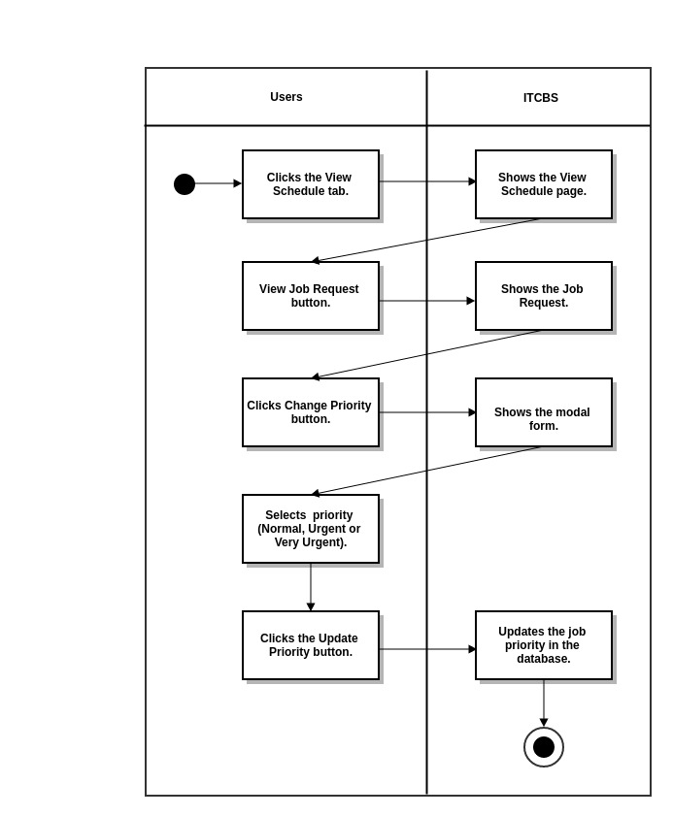

30
3.1.1.4.1.4 Mark as Done
3.1.1.4.1.4.A Use Case Specification

Description | The User (Technician or Super Administrator )marks the job as done.)
Goal | To mark the job as done.
Preconditions | The User should be logged-in.
Assumptions | You are connected to a network.  You are already on the View ScheduleTab.
Frequency | Every time the Technician finishes the job.
Flow of Events | Main Flow:  1. The User clicks the View Schedule tab.  2. The User clicks the View Job Request button.  3. The User clicks the Mark as Done button.
Post-conditions | The User marks the job as done and removes it in the view schedule tab.
Actors | Technician or Super Administrator
Included Use Cases | None
Extended Use Cases | None
Notes

31

3.1.1.4.1.4.B Activity Diagram
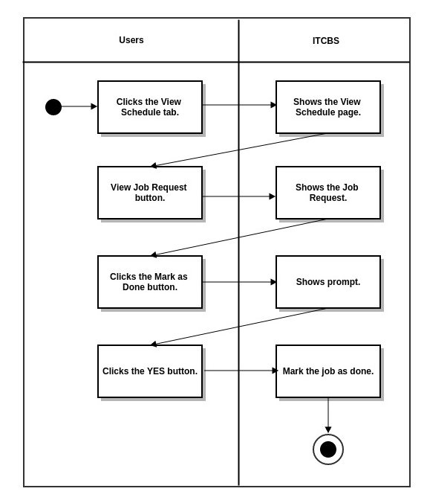

32

3.1.1.5 Generate Bill
3.1.1.5.1 Generate Bill
3.1.1.5.1.A Use Case Specification

Description | The User (Technician, Administrator or Super Administrator) generates the bill for the works done for job request.
Goal | To generate the bill for the works done for the job request.
Preconditions | The Users should be logged-in.
Assumptions | You are connected to a network.  You are already on the Generate Bill Tab.
Frequency | Every time the User wants to generate the finished job’s bill.
Flow of Events | Main Flow:  1. The User clicks the Generate Bill Tab.  2. The User clicks the Generate button.
Post-conditions | The User sees the Bill or amount to be paid.
Actors | Technician, Administrator or Super Administrator
Included Use Cases | None
Extended Use Cases | None
Notes

33

3.1.1.5.1.B Activity Diagram
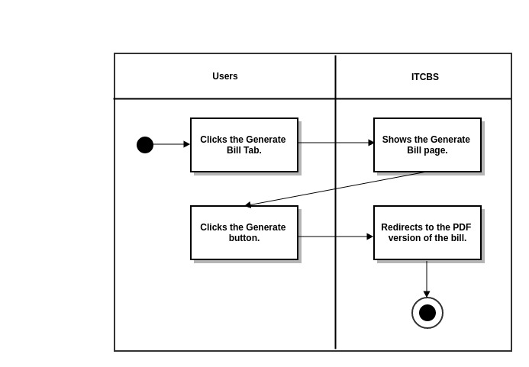

34

3.1.1.5.2 Generate Job Request Form
3.1.1.5.2.A Use Case Specification

Description | The User (Technician, Administrator or Super Administrator) generates the job request form for the finished job request.
Goal | To generate the job request for the works done for the job request.
Preconditions | The Users should be logged-in.
Assumptions | You are connected to a network.  You are already on the Generate Bill Tab.
Frequency | Every time the User wants to generate the job request form for the finished job request
Flow of Events | Main Flow:  1. The User clicks the Generate Bill Tab.  2. The User clicks the Job Request Form button.
Post-conditions | The User sees the Job Request Form
Actors | Technician, Administrator or Super Administrator
Included Use Cases | None
Extended Use Cases | None
Notes

35

3.1.1.5.2.B Activity Diagram

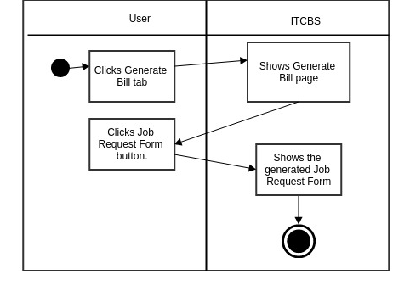

36
3.1.1.6 Manage Application
3.1.1.6.1 User Logs
3.1.1.6.1.1 View By Log In/Log Out/Job Actions
3.1.1.6.1.1.A Use Case Specification

Description | The User (Super Administrator) views the User Logs by Log In, Log Out and Job Actions Logs
Goal | To view the User Logs by Log In, Log Out and Job Actions Logs
Preconditions | The Users should be logged-in.
Assumptions | You are connected to a network.  You are already on the Manage Application Tab.
Frequency | Every time the User wants to view the User Logs
Flow of Events | Main Flow:  1. The User clicks the Manage Aplication Tab.  2. The User choose the User Logs Menu.
Post-conditions | The User sees the User Logs by Log In, Log Out and Job Actions Logs
Actors | Super Administrator
Included Use Cases | None
Extended Use Cases | None
Notes

37

3.1.1.6.1.1.B Activity Diagram

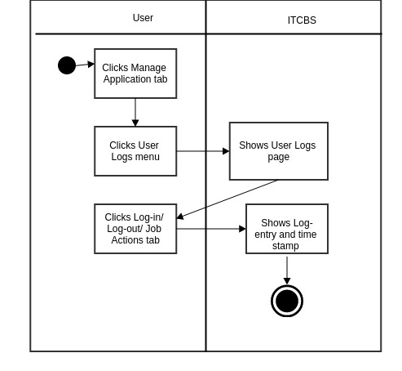

38

3.1.1.6.1.2 View by User
3.1.1.6.1.2.1 Use Case Specification

Description | The User (Technician, Administrator or Super Administrator) views accounts by user type.
Goal Goal | To view accounts according to their user type.
Preconditions | The User should be logged-in.
Assumptions | You are connected to a network.  You are already on the Manage Application Tab.
Frequency | Every time there is a need to view accounts according to their user type.
Flow of Events | Main Flow:  1. The User clicks the Manage Application Tab.  2. The User clicks the Manage Accounts.  3. The User clicks the “user type” (SuperAdmin, Admin, Technician, Client)
Post-conditions | The User views user accounts according to its type.
Actors | Technician, Administrator or Super Administrator
Included Use Cases | None
Extended Use Cases | None
Notes

39

3.1.1.6.1.2.2 Activity Diagram
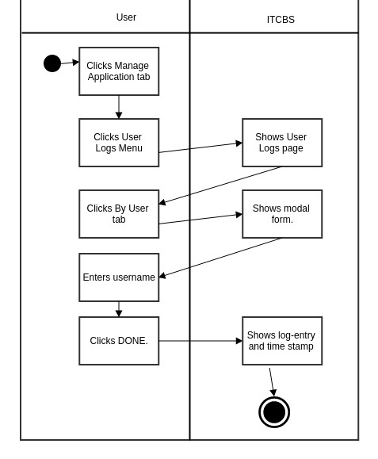

40
3.1.1.6.2 Manage Accounts
3.1.1.6.2.1 View by User Type
3.1.1.6.2.1.A Use Case Specification

Description | The User (Technician, Administrator or Super Administrator) views accounts by user type.
Goal Goal | To view accounts according to their user type.
Preconditions | The User should be logged-in.
Assumptions | You are connected to a network.  You are already on the Manage Application Tab.
Frequency | Every time there is a need to view accounts according to their user type.
Flow of Events | Main Flow:  1. The User clicks the Manage Application Tab.  2. The User clicks the Manage Accounts.  3. The User clicks the “user type” (SuperAdmin, Admin, Technician, Client)
Post-conditions | The User views user accounts according to its type.
Actors | Technician, Administrator or Super Administrator
Included Use Cases | None
Extended Use Cases | None
Notes

41
3.1.1.6.2.1.B Activity Diagram

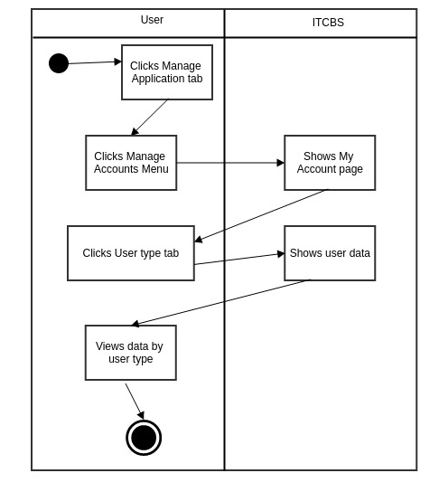

42

3.1.1.6.2.1.1 Deactivate/Activate Account
3.1.1.6.2.1.1.A Use Case Specification

Description | The User (Technician, Administrator or Super Administrator) deactivates/activates user account.
Goal Goal | To deactivate/activate user account.
Preconditions | The User should be logged-in.
Assumptions | You are connected to a network.  You are already on the Manage Application Tab.
Frequency | Every time there is a need to deactivate/activate user account.
Flow of Events | Main Flow:  1. The User clicks the Manage Application Tab.  2. The User clicks the Manage Accounts.  3. The User clicks the Deactivate/ Activate Button.
Post-conditions | The User changes “Active” status in the database.
Actors | Technician, Administrator or Super Administrator
Included Use Cases | None
Extended Use Cases | None
Notes

43
3.1.1.6.2.1.1.B Activity Diagram

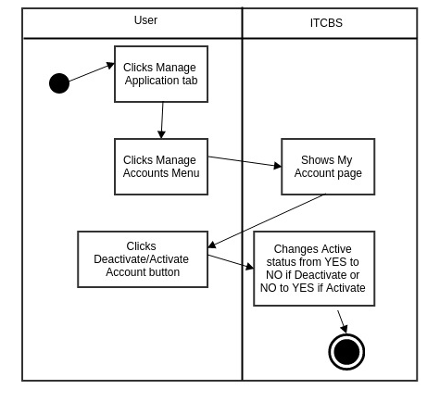

44

3.1.1.6.2.1.2 Reset User Password
3.1.1.6.2.1.2.A Use Case Specification

Description | The User (Technician, Administrator or Super Administrator) resets user password.
Goal Goal | To reset user password.
Preconditions | The User should be logged-in.
Assumptions | You are connected to a network.  You are already on the Manage Application Tab.
Frequency | Every time there is a need to reset user password.
Flow of Events | Main Flow:  1. The User clicks the Manage Application Tab.  2. The User clicks the Manage Accounts.  3. The User clicks the Reset Password button.  4. The User clicks YES button.  5. The User clicks OK button.
Post-conditions | The User resets the user password in the database.
Actors | Technician, Administrator or Super Administrator
Included Use Cases | None
Extended Use Cases | None
Notes

45
3.1.1.6.2.1.2.B Activity Diagram

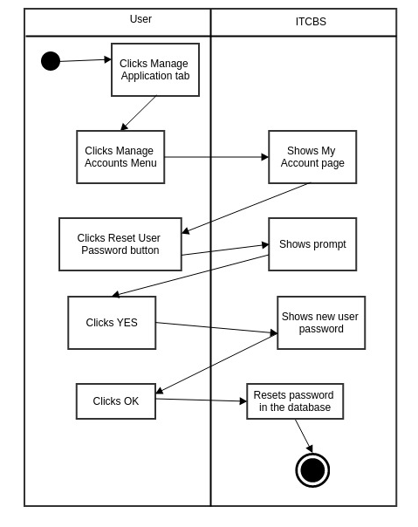

46

3.1.1.6.2.2 Create Account
3.1.1.6.2.2.A Use Case Specification

Description | The User (Technician, Administrator or Super Administrator) creates new user account.
GoalGoal Goal | To create new user account.
Preconditions | The User should be logged-in.
Assumptions | You are connected to a network.  You are already on the Manage Application Tab.
Frequency | Every time there is a need to create a new account.
Flow of Events | Main Flow:  1. The User clicks the Manage Application Tab.  2. The User clicks the Manage Accounts.  3. The User clicks the Create Account.  4. The User inputs required and necessary information.  5. The User clicks Create Account button.
Post-conditions | The User adds new user account to the database and updates the number and list of users in the user accounts.
Actors | Technician, Administrator or Super Administrator
Included Use Cases | None
Extended Use Cases | None
Notes

47
3.1.1.6.2.2.B Activity Diagram

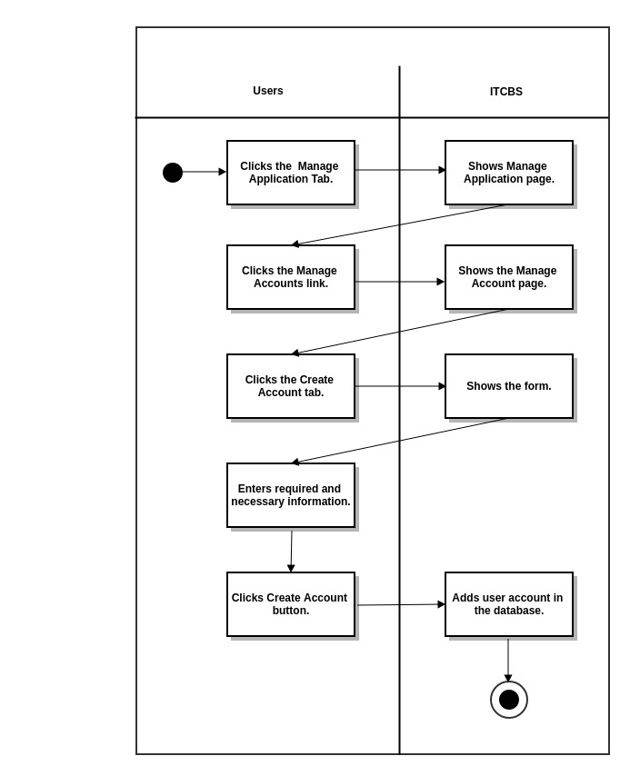

48
3.1.1.6.3 Manage Work
3.1.1.6.3.1 Manage Selectable Work
3.1.1.6.3.1.1 Edit Selectable Work Details
3.1.1.6.3.1.1.A Use Case Specification

Description | The User (Technician, Administrator or Super Administrator) edits the selectable work details.
Goal | To edit the Selectable Work Details.
Preconditions | The User should be logged-in.
Assumptions | You are connected to a network.  You are already on the Manage Applications Tab.
Frequency | Every time the user wants to edit the selectable work details.
Flow of Events | Main Flow:  1. The User clicks the Manage Application Tab.  2. The User clicks the Manage Work Menu.  3. The User clicks the Edit Selectable Work Details button.  4. The User edits details.  5. The User clicks the Edit button.  6. The User clicks OK button.
Post-conditions | The User sees the edited selectable work details and is updated in the database.
Actors | Technician, Administrator or Super Administrator
Included Use Cases | None
Extended Use Cases | None
Notes

49

3.1.1.6.3.1.1.B Activity Diagram

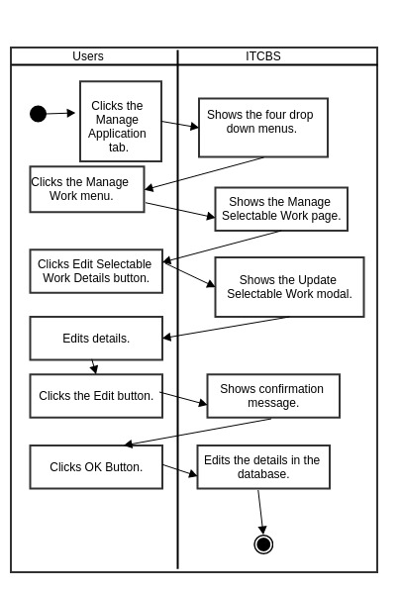

50

3.1.1.6.3.1.2.a Make Selectable Work Hidden
3.1.1.6.3.1.2.a.A Use Case Specification

Description | The User (Technician, Administrator or Super Administrator) makes selectable work hidden.
Goal | To make the Selectable Work hidden.
Preconditions | The User should be logged-in.
Assumptions | You are connected to a network.  You are already on the Manage Applications Tab.
Frequency | Every time the user wants to make the selectable work hidden.
Flow of Events | Main Flow:  1. The User clicks the Manage Application Tab.  2. The User clicks the Manage Work Menu.  3. The User clicks the Make Selectable Work Hidden button.
Post-conditions | The selectable work is hidden.
Actors | Technician, Administrator or Super Administrator
Included Use Cases | None
Extended Use Cases | None
Notes

51
3.1.1.6.3.1.2.a.B Activity Diagram

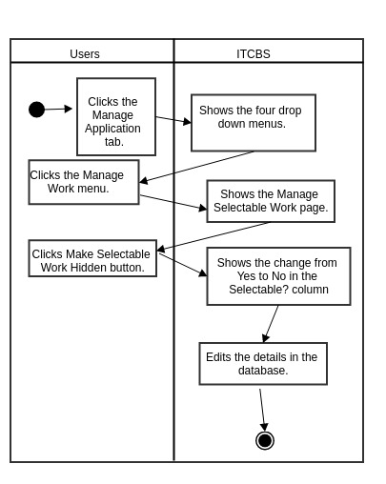

52
3.1.1.6.3.1.2.b Make Selectable Work Visible
3.1.1.6.3.1.2.b.A Use Case Specification

Description | The User (Technician, Administrator or Super Administrator) makes selectable work visible.
Goal | To make the Selectable Work visible.
Preconditions | The User should be logged-in.
Assumptions | You are connected to a network.  You are already on the Manage Applications Tab.
Frequency | Every time the user wants to make the selectable work visible.
Flow of Events | Main Flow:  1. The User clicks the Manage Application Tab.  2. The User clicks the Manage Work Menu.  3. The User clicks the Make Selectable Work Visible button.
Post-conditions | The selectable work is visible.
Actors | Technician, Administrator or Super Administrator
Included Use Cases | None
Extended Use Cases | None
Notes

53

3.1.1.6.3.1.2.b.B Activity Diagram

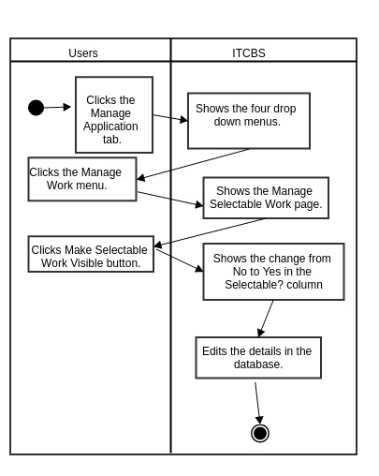

54
3.1.1.6.3.2 Add New Work
3.1.1.6.3.2.A Use Case Specification

Description | The User (Technician, Administrator or Super Administrator) adds new work.
Goal | To add new work.
Preconditions | The User should be logged-in.
Assumptions | You are connected to a network.  You are already on the Manage Application Tab.
Frequency | Every time the user wants to add new work.
Flow of Events | Main Flow:  1. The User clicks the Manage Application Tab.  2. The User clicks the Manage Work Menu.  3. The User clicks the Add New Work.  4. The User adds new work details.  5. The User clicks Add New Work button.  6. The User clicks OK.
Post-conditions | The User adds new work in the database
Actors | Technician, Administrator or Super Administrator
Included Use Cases | None
Extended Use Cases | None
Notes

55

3.1.1.6.3.2.B Activity Diagram
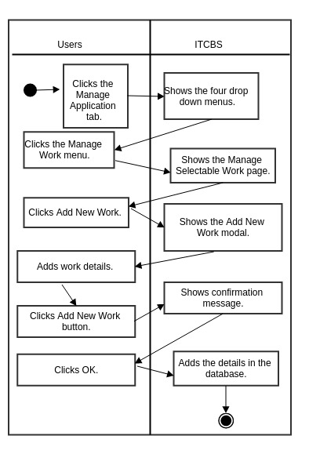

56
3.1.1.6.4 Manage Materials
3.1.1.6.4.1 Manage Selectable Materials
3.1.1.6.4.1.1 Edit Selectable Materials Details
3.1.1.6.4.1.1.A Use Case Specification

Description | The User (Technician, Administrator or Super Administrator) edits the selectable material details.
Goal | To edit the Selectable Material Details.
Preconditions | The User should be logged-in.
Assumptions | You are connected to a network.  You are already on the Manage Applications Tab.
Frequency | Every time the user wants to edit the selectable material details.
Flow of Events | Main Flow:  1. The User clicks the Manage Application Tab.  2. The User clicks the Manage Material Menu.  3. The User clicks the Edit Selectable Material Details button.  4. The User edits details.  5. The User clicks the Edit button.  6. The User clicks OK button.
Post-conditions | The User sees the edited selectable material details and is updated in the database.
Actors | Technician, Administrator or Super Administrator
Included Use Cases | None
Extended Use Cases | None
Notes

57

3.1.1.6.4.1.1.B Activity Diagram

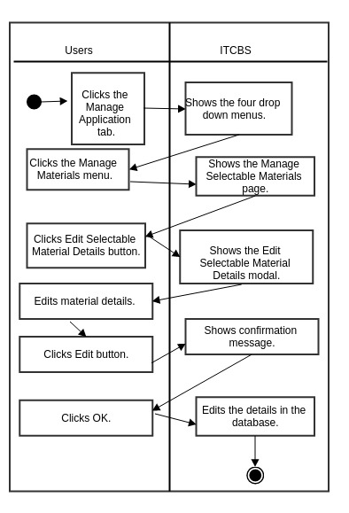

58

3.1.1.6.4.1.2.a Make Selectable Materials Hidden
3.1.1.6.4.1.2.a.A Use Case Specification

Description | The User (Technician, Administrator or Super Administrator) makes selectable materials hidden.
Goal | To make the Selectable Materials hidden.
Preconditions | The User should be logged-in.
Assumptions | You are connected to a network.  You are already on the Manage Applications Tab.
Frequency | Every time the user wants to make the selectable material hidden.
Flow of Events | Main Flow:  1. The User clicks the Manage Application Tab.  2. The User clicks the Manage Material Menu.  3. The User clicks the Make Selectable Material Hidden button.
Post-conditions | The selectable material is hidden.
Actors | Technician, Administrator or Super Administrator
Included Use Cases | None
Extended Use Cases | None
Notes

59

3.1.1.6.4.1.2.a.B Activity Diagram

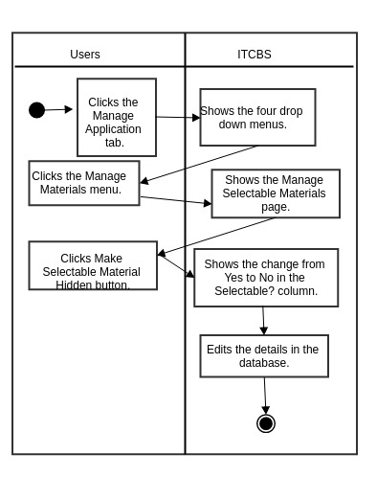

60
3.1.1.6.4.1.2.b Make Selectable Materials Visible
3.1.1.6.4.1.2.b.A Use Case Specification

Description | The User (Technician, Administrator or Super Administrator) makes selectable materials visible
Goal | To make the Selectable Materials visible
Preconditions | The User should be logged-in.
Assumptions | You are connected to a network.  You are already on the Manage Applications Tab.
Frequency | Every time the user wants to make the selectable materials visible
Flow of Events | Main Flow:  1. The User clicks the Manage Application Tab.  2. The User clicks the Manage Material Menu.  3. The User clicks the Make Selectable Material Visible button.
Post-conditions | The selectable material is visible.
Actors | Technician, Administrator or Super Administrator
Included Use Cases | None
Extended Use Cases | None
Notes

61

3.1.1.6.4.1.2.b.B Activity Diagram

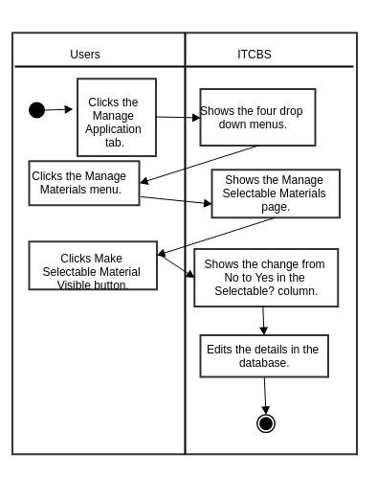

62

3.1.1.6.4.2 Add New Materials
3.1.1.6.4.2.A Use Case Specification

Description | The User (Technician, Administrator or Super Administrator) adds new materials.
Goal | To add new materials.
Preconditions | The User should be logged-in.
Assumptions | You are connected to a network.  You are already on the Manage Application Tab.
Frequency | Every time the user wants to add new materials.
Flow of Events | Main Flow:  1. The User clicks the Manage Application Tab.  2. The User clicks the Manage Materials Menu.  3. The User clicks the Add New Materials.  4. The User adds new materials details.  5. The User clicks Add New Materials button.  6. The User clicks OK.
Post-conditions | The User adds new materials in the database
Actors | Technician, Administrator or Super Administrator
Included Use Cases | None
Extended Use Cases | None
Notes

63
3.1.1.6.4.2.B Activity Diagram

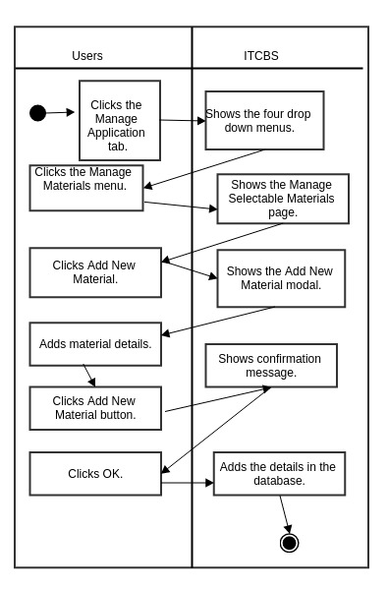

64
3.1.1.7 My Account
3.1.1.7.1 Update Profile
3.1.1.7.1.A Use Case Specification

Description | The User (Client, Technician, Administrator or Super Administrator) updates account’s profile.
Goal | To update the account’s profile.
Preconditions | The User should be logged-in.
Assumptions | You are connected to a network.  You are already on the My Account Tab.
Frequency | Every time the User wants to update his/her profile
Flow of Events | Main Flow:  1. The User clicks the My Account Tab.  2. The User enters the new Given Name and Last Name in their respective text area.  3. The User clicks the Update Profile button.
Post-conditions | The User updates Given Name and Last Name in the database .
Actors | Client, Technician, Administrator or Super Administrator
Included Use Cases | None
Extended Use Cases | None
Notes

65
3.1.1.7.1.B Activity Diagram

66

3.1.1.7.2 Change Password
3.1.1.7.2.A Use Case Specification

Description | The User (Client, Technician, Administrator or Super Administrator) changes his/her password.
Goal | To change user account’s password.
Preconditions | The User should be logged-in.
Assumptions | You are connected to a network.  You are already on the My Account Tab.
Frequency | Every time the User wants to change his/her password.
Flow of Events | Main Flow:  1. The User clicks the My Account Tab.  2. The User clicks the Change Password button.  3. The User enters the old and new password.  4. The User clicks the Change Password button.
Post-conditions | The User updates password in the database.
Actors | Client, Technician, Administrator or Super Administrator
Included Use Cases | None
Extended Use Cases | None
Notes

67

3.1.1.7.2.B Activity Diagram

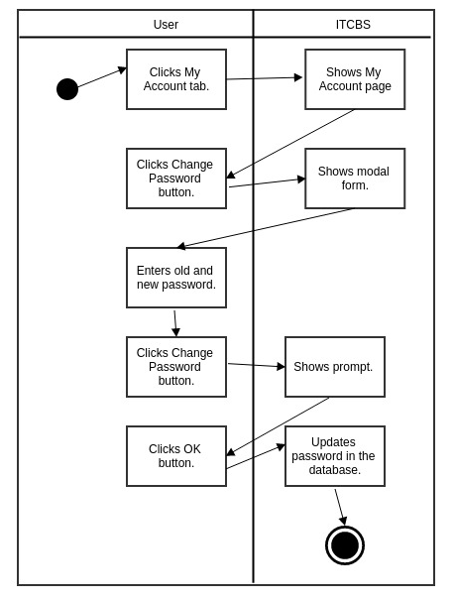

68
3.1.1.8 Log Out
3.1.1.8.A Use Case Specification
Description | The User (Client, Technician, Administrator or Super Administrator) logs out.
Goal | To log out of the system.
Preconditions | The User should be logged-in.
Assumptions | You are connected to a network.
Frequency | Every time the user wants to log out.
Flow of Events | Main Flow:  1. The User clicks the Log Out tab.
Post-conditions | The User is logged out and redirects to log in page.
Actors | Client, Technician, Administrator or Super Administrator
Included Use Cases | None
Extended Use Cases | None
Notes
3.1.1.8.B Activity Diagram

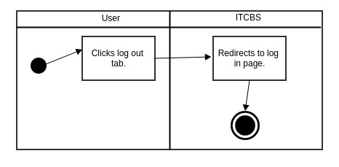

69

