ITC Billing System – User’s Manual

Information Technology Center



ITC Billing System (ITCBS)
User’s Manual

Version:1.0 Date: 03/13/2015
TABLE OF CONTENTS

1. GENERAL INFORMATION
1.1 System Overview -----------------------------------------------------------------------------
1.2 Organization of the Manual ---------------------------------------------------------------

2. SYSTEM SUMMARY
2.1 System Configuration --------------------------------------------------------
2.2 User Access Levels --------------------------------------------------------
2.3 Contingencies --------------------------------------------------------

3. GETTING STARTED
3.1 Installation & Logging In --------------------------------------------------------
3.2 Client Menu --------------------------------------------------------
3.2.1 Job Request Tab --------------------------------------------------------
3.2.2 My Account Tab --------------------------------------------------------
3.3 Technician Menu --------------------------------------------------------
3.3.1 Job Request Tab --------------------------------------------------------
3.3.2 View Schedule Tab --------------------------------------------------------
3.3.3 General Bill Tab --------------------------------------------------------
3.3.4 Manage Application Tab --------------------------------------------------------
3.3.5 My Account Tab --------------------------------------------------------
3.4 Administrator Menu --------------------------------------------------------
3.4.1 Job Request Tab --------------------------------------------------------
3.4.2 View Schedule Tab --------------------------------------------------------
3.4.3 General Bill Tab --------------------------------------------------------
3.4.4 Manage Application Tab --------------------------------------------------------
3.4.5 My Account Tab --------------------------------------------------------
3.5 Super Administrator Menu --------------------------------------------------------
3.5.1 Job Request Tab --------------------------------------------------------
3.5.2 View Schedule Tab --------------------------------------------------------
3.5.3 General Bill Tab --------------------------------------------------------
3.5.4 General Report Tab --------------------------------------------------------
3.5.5 Manage Application Tab --------------------------------------------------------
3.5.6 My Account Tab --------------------------------------------------------
3.5 Exit System --------------------------------------------------------
4. USING THE SYSTEM
4.1 Job Request Functionality --------------------------------------------------------
4.1.1 File a Job Request --------------------------------------------------------
4.1.2 View List of job Request --------------------------------------------------------
4.1.2.a Edit job Description --------------------------------------------------------
4.1.2.b Cancel Job Request --------------------------------------------------------
4.1.2.c Schedule Job Request --------------------------------------------------------
4.1 2.d View Job Request --------------------------------------------------------
4.1 2.d Search Job Request --------------------------------------------------------
4.2 View Schedule Functionality--------------------------------------------------------
4.3 Generate Bill Functionality--------------------------------------------------------
3.2.1 Generate Bill --------------------------------------------------------
3.2.2 Generate Job Request Form --------------------------------------------------------
4.4 Generate Bill Functionality--------------------------------------------------------
4.4.1 User Logs --------------------------------------------------------
4.4.2 Manage Accounts --------------------------------------------------------
4.4.3 Manage Work --------------------------------------------------------
4.4.4 Manage Material --------------------------------------------------------
4.4.5 Generate Report --------------------------------------------------------
4.5 My Account Functionality--------------------------------------------------------
4.5.1 Update Profile --------------------------------------------------------
4.5.2 Change Passowrd --------------------------------------------------------

GENERAL INFORMATION

1.1 System Overview

The ITC Billing System (ITCBS) integrates the billing system for UPLB ITC’s System Administration, Network Administration and Technical Support sections. It caters to the need of the ITC team of a common system in managing job requests. The system uses CodeIgniter framework and MariaDB for faster job transactions and record management. The system provides an online version of the job request form and saves the input data to a database that can be manipulated using the system. The main functionalities are already operational and ready for deployment but the system is still under further development. The ITCBS is accessible via the internet and is hosted via a local server.

1.2 Organization of the Manual

The user’s manual consists of four sections: General Information, System Summary, Getting Started and Using the System.
General Information section explains in general terms the system and the purpose for which it is intended.
System Summary section provides a general overview of the system. The summary outlines the uses of the system’s hardware and software requirements, system’s configuration, user access levels and system’s behavior in case of any contingencies.
Getting Started section explains how to get ITCBS and install it on the device. The section presents briefly the system menu.
Using the System section provides a detailed description of system functionalities.

SYSTEM SUMMARY

2.1 System Configuration

ITCBS operates on any computer that is connected to the internet. The system is hosted using the local server used by the ITC and is best viewed using Mozilla Firefox or Google Chrome browsers. Data entered by the user are saved in a database when the device used is connected to the Internet. After proper setup of the system on the local server, the system can be accessed anytime by the user.

2.2 User Access Levels
The ITCBS is specifically developed for exclusive use of the ITC, thus only ITC employees will have a full access of the system using their specified accounts. However, their registered clients can also use the system using their own accounts but with limited access. There are four types of users: the Super Administrator, the Administrator, the Technician and the Client. The system functionalities are limited according the type of user logged in. Creation of specific user accounts is taken into consideration in the design of the ITCBS.
The Client can only file and view his job requests. He can also edit the descriptiom of his job request and cancel his job requests. The Technician can file job requests in behalf of the clients, view all job requests and schedule job requests. He can also view the scheduled job requests, view each job request in details, edit the job request description and cancel job requests. Technicians can also add another Technician account and Client Account. The Administrator can file job requests in behalf of the clients, view all job requests and schedule job requests. He can also view the scheduled job requests, edit the job request description and cancel job requests. Administrators can also add another Administrator account, Technician account and Client Account. The Super Administrator has the fullest access among the User Types. The Super Administrator can file job requests in behalf of the clients and view all job requests. He can also view the scheduled job requests, view each job request in details, edit the job request description and cancel job requests. Super Administrators can also add another Super Administrator account, Administrator account, Technician account and Client Account. He is also the only User who can generate reports of the job requests.

2.3 Contingencies

GETTING STARTED

3.1 Installation and Logging In
A copy of the system may be pulled from: https://github.com/adtcruz/CMSC198. Upon proper setup on the local server, the system may be accessed anytime as long as the device is connected to the Internet or the local server. When logging in, the username and password will be asked from the User (Figure 1).
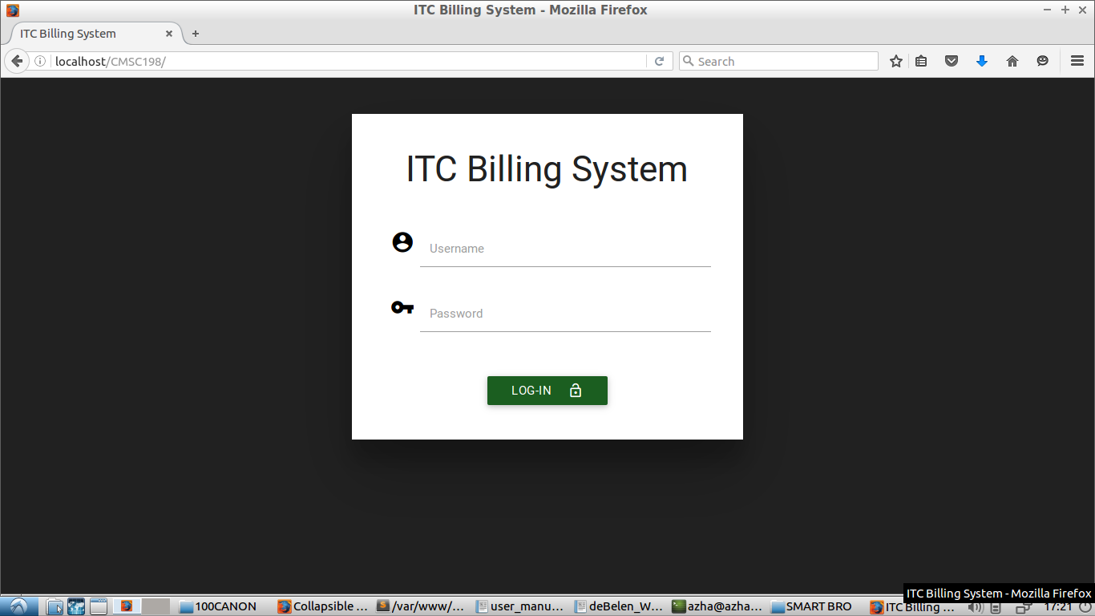
Figure 1. Login Page

3.2 Client Menu
Upon logging in as the Client, the menu for the client will show. The menu consists of four tabs: the Home tab, the Announcement Tab, the My Job Request tab, the Generate Bill Tab, the My Account tab and the Logout tab (Figure 2).
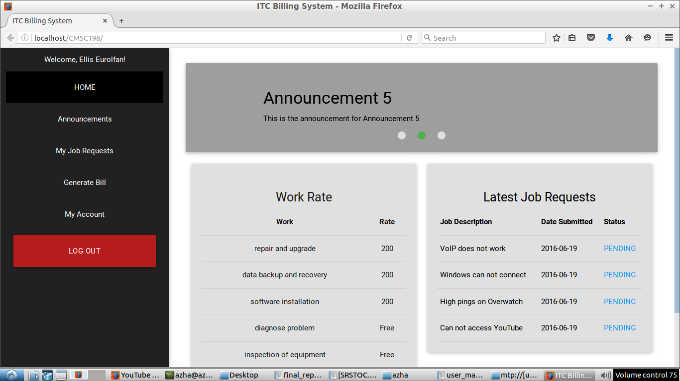
Figure 2. Client’s Home Page

3.2.1 Home Tab

3.2.2 Announcement Tab

3.2.3 Job Requests Tab
There are two tabs in the Job Request page: the File Job Request and View Job Request. The File Job Request tab shows the online version of the Job Request form. The View Job Request tab shows the list of the job requests that the Client filed, the details of the job requests and the actions that the Client can perform (Edit Job Description and Cancel Job Request). Each entry shows the job description, the Client who filed the job request, the start and finish date, the job status, the date the job request was filed, the person who filed the job request (if the Client was not the one who filed the job request) and the actions the client can perform. The user can also view his Job Requests according to its status. He can also search the Job Requests.

3.2.1 Generate Bill Tab

3.2.5 My Account Tab
The My Account page shows the User’s Information (Username, Account Type, and Full Name). The User can also update his Full Name and change his Password in this page.

3.3. Technician Menu
Upon logging in as the Technician, the menu for the technician will show. The menu consists of seven tabs: the Home tab, Job Request tab, the View Schedule tab, the Generate Bill tab, the Manage Application tab, the My Account tab and the Logout tab.

3.3.1 Job Requests Tab
There are two tabs in the Job Request page: the File Job Request and View Job Request. The File Job Request tab shows the online version of the Job Request form but it is different from the File Job Request tab of the Client. The Technicians’s File Job Request tab includes the list of offices and the client/s under the specified office.
The View Job Request tab shows the list of the job requests that were filed, the details of the job requests and the actions that the Technician can perform depending on the Job status (View job Request, Schedule Job, Edit Description, Cancel Job Request). Each entry shows the job description, the Client who requested the job, the start and finish date, the job status, the date the job request was filed, the person who filed the job request and the actions the Technician can perform. The user can also view the Job Requests according to their status. He can also search the Job Requests.

View Schedule Tab
All the scheduled jobs will be shown in the View Schedule page. It includes details like the Priority, the Scheduled Date, the Client Name, the Location and the Action that the technician can perform (View Job Request).

Generate Bill Tab
This is where the Technician can generate the bill and the Job Request Form. It shows the finished job and its details (Job ID and Client).

Manage Application Tab
The Manage Application Tab shows a dropdown menu: Manage Accounts, Manage Work, Manage Materials. The Manage Accounts Menu redirects to another page where all the User Accounts can be seen. The User Accounts can also be sorted by Client, Technician, Administrator and Super Administrator. The User can also add another account in this page. The Manage Work Menu redirects to another page where all the Selectable Work can be seen. The User can also add another work in this page. The Manage Materials Menu redirects to another page where all the Selectable Materials can be seen. The User can also add another material in this page.

My Account Tab
The My Account page shows the User’s Information (Username, Account Type, and Full Name). The User can also update his Full Name and change his Password in this page.

3.4 Administrator Menu
Upon logging in as the Administrator, the menu for the Administrator will show. The menu consists of seven tabs: the Home tab, Job Request tab, the View Schedule tab, the Generate Bill tab, the Manage Application tab, the My Account tab and the Logout tab.

3.4.1 Job Requests Tab
There are two tabs in the Job Request page: the File Job Request and View Job Request. The File Job Request tab shows the online version of the Job Request form but it is different from the File Job Request tab of the Client. The Administrator’s File Job Request tab includes the list of offices and the client/s under the specified office.
The View Job Request tab shows the list of the job requests that were filed, the details of the job requests and the actions that the Technician can perform depending on the Job status (Schedule Job, Edit Description, Cancel Job Request). Each entry shows the job description, the Client who requested the job, the start and finish date, the job status, the date the job request was filed, the person who filed the job request and the actions the Administrator can perform. The user can also view the Job Requests according to their status. He can also search the Job Requests.

3.4.2 View Schedule Tab
All the scheduled jobs will be shown in the View Schedule tab. It includes details like the Priority, the Scheduled Date, the Client Name and the Location.

3.4.3 Generate Bill Tab
This is where the Administrator can generate the bill and the Job Request Form. It shows the finished job and its details (Job ID and Client).

3.4.4 Manage Application Tab
The Manage Application Tab shows a dropdown menu: Manage Accounts, Manage Work, Manage Materials. The Manage Accounts Menu redirects to another page where all the User Accounts can be seen. The User Accounts can also be sorted by Client, Technician, Administrator and Super Administrator. The User can also add another account in this page. The Manage Work Menu redirects to another page where all the Selectable Work can be seen. The User can also add another work in this page. The Manage Materials Menu redirects to another page where all the Selectable Materials can be seen. The User can also add another material in this page.

3.4.5 My Account Tab
The My Account page shows the User’s Information (Username, Account Type, and Full Name). The User can also update his Full Name and change his Password in this page.

3.5 Super Administrator Menu
Upon logging in as the Technician, the menu for the technician will show (Figure 3). The menu consists of seven tabs: the Home tab, Job Request tab, the View Schedule tab, the Generate Bill tab, the Manage Application tab, the My Account tab and the Logout tab.

3.5.1 Job Requests Tab
There are two tabs in the Job Request page: the File Job Request and View Job Request. The File Job Request tab shows the online version of the Job Request form but it is different from the File Job Request tab of the Client. The Super Administrator’s File Job Request tab includes the list of offices and the client/s under the specified office.
The View Job Request tab shows the list of the job requests that were filed, the details of the job requests and the actions that the Technician can perform depending on the Job status (View job Request, Schedule Job, Edit Description, Cancel Job Request). Each entry shows the job description, the Client who requested the job, the start and finish date, the job status, the date the job request was filed, the person who filed the job request and the actions the Super administrator can perform. The user can also view the Job Requests according to their status. He can also search the Job Requests.

3.5.2 View Schedule Tab
All the scheduled jobs will be shown in the View Schedule tab. It includes details like the Priority, the Scheduled Date, the Client Name, the Location and the Action that the Super Administrator can perform (View Job Request).

3.5.3 Generate Bill Tab
This is where the Super Administrator can generate the bill and the Job Request Form. It shows the finished job and its details (Job ID and Client).

3.5.4 Generate Report Tab
Tohis is where the Super Administrator can generate the report.

3.5.5 Manage Application Tab
The Manage Application Tab shows a dropdown menu: User Logs, Manage Accounts, Manage Work, Manage Materials and Generate Report. The User Logs Menu redirects to another page where all Users Logs can be seen. The logs can also be sorted by Login, Logout, Job Actions and By User logs. The Manage Accounts Menu redirects to another page where all the User Accounts can be seen. The User Accounts can also be sorted by Client, Technician, Administrator and Super Administrator. The User can also add another account in this page. The Manage Work Menu redirects to another page where all the Selectable Work can be seen. The User can also add another work in this page. The Manage Materials Menu redirects to another page where all the Selectable Materials can be seen. The User can also add another material in this page. The Generate Report Menu redirects to another page where the User can generate reports.

3.5.6 My Account Tab
The My Account page shows the User’s Information (Username, Account Type, and Full Name). The User can also update his Full Name and change his Password in this page.

3.6 Exit System
Simply click on the logout button in the menu to exit the system.

Using the System

Job Request Functionalities

4.1.1 File a Job Request

Click the Job Request Tab in the Side Bar.
It will redirect you to the Job Request Page. Click the File Job Request tab to file a job request.

Enter the problems encountered.

If the user is not a client, choose the client’s office and the name of the client.

Click the Submit Button to file the job request.

4.1.2 View List of Job Request

1. Click the Job Request Tab in the Side Bar.
It will redirect you to the Job Request Page. Click the Job Requests tab to view the list of job requests and the actions the user can do in each job request.
a. Edit Job Description
1. Click the Edit Job Description Button
A modal form will show.
The user can edit the Job Request description depending on his user type. If the user is a a Client, he can only edit his Job request’s description. However, he cannot edit the description of the job requests filed under his name by either the Technician, Administrator or Super Adminstrator. If the user is a Technician or an Administrator, he can only edit the job description he filed in behalf of the Client. If the user is a Super Administrator, he can edit the descriptions of all the filed Job Request.
2. Enter the new Job Description in the text area.
3. Click the Edit button.
b. Cancel Job Request
1. Click Cancel Job Request Button
A prompt will show to confirm the action.
The user can cancel the job request depending on his user type. If the user is a a Client, he can only cancel his Job request. If the user is a Technician or an Administrator, he can only cancel the job request he filed in behalf of the Client. If the user is a Super Administrator, he can cancel all the filed Job Request.
2. Click the YES button to cancel the job request. Otherwise, click the NO button.
c. Schedule Job Request
1. Click Schedule Job Request Button
A modal form will show.
The user can schedule the job request depending on his user type. Only the Technician, Administrator and Super Administrator can schedule the Job Request. The scheduled Job will then be seen in the View Schedule Page.
2. Select a date in the calendar field.
3. Select the priority of the job request.
The priority levels are Normal, Urgent and Very Urgent.
4. Click the DONE button to schedule the job request. Otherwise, click the CANCEL button.
d. View Job Request
1. Click the View Job Request Button.
It will redirect you to the View Job Request Page.
The user can view the job request depending on his user type. Only the Technician and Super Administrator can view each Job Request. They can also view the Job Request in the View Schedule Page. In the View Job Request Page, the user can see the Job Request in full details. He can add the Work Done and the Materials Recommended for the Job request. He can also change the priority (Normal, Urgent, Very Urgent) of the job request and mark it done.
2. Click the ADD WORK DONE button to add work done.
A modal form will show.
a. Select the work done and the duration of work.
b. Click the ADD WORK DONE button to add the work done. Otherwise, click CLOSE button.
4. Click the ADD MATERIALS USED button to add the materials.
A modal form will show.
a. Select the materials and the number of units used.
b. Click the ADD MATERIAL button to add the work done. Otherwise, click CLOSE button.
5. Click the CHANGE PRIORITY button to change the priority of the Job Request.
The priority levels are Normal, Urgent and Very Urgent.
6. Click the MARK AS DONE button to mark the job as done.
A prompt will show to confirm the action.
7. Click GO BACK button to go back in the List of Job Requests.
e. Search Job Request
1. Click the SEARCH JOBS tab.
A modal form will show.
The user can search a Job Request depending on his user type. If the user is a a Client, he can only search his Job Requests and the Job requests filed under his name. If the user is a Technician or an Administrator, he can only search the Job Requests he filed in behalf of the Client. If the user is a Super Administrator, he can search all the filed Job Request.
2. Choose a search type. (By Job Description, etc.)
3. Enter input data.
4. Click the SEARCH button.

4.2 View Schedule Functionalities

1. Click the View Schedule Tab in the Side Bar.
Only the Technician, Administrator and Super Administrator can view the the list of scheduled jobs. However, the Administrator cannot view each Job request.
2. Click the View Job Request Button.
Refer to 4.1.2 (Part d) for the View Job Request functionality.

4.3 Generate Bill Functionalities
4.3.1 Generate Bill
1. Click the Generate Bill Tab in the Side Bar.
Only the Technician, Administrator and Super Administrator can can use this functionality. All the finished Job were shown in the Generate Bill page.
2. Click the GENERATE bill button to generate the client’s bill.
The user will be redirected to a PDF copy of the bill.
4.3.2 Generate Job Request Form
1. Click the Generate Bill Tab in the Side Bar.
Only the Technician, Administrator and Super Administrator can use this functionality. All the finished Job were shown in the Generate Bill page.
2. Click the GENERATE JRF button to generate the client’s job request form.
The user will be redirected to a PDF copy of the job request form.

4.4 Manage Application Functionalities
4.4.1 User Logs
1. Click the Manage Application Tab in the Side Bar.
Only the Super Administrator can use this functionality.
2. Click the USER LOGS menu.
The User will be redirected to the User Logs page.
3. Click on the tabs to view the logs by types.
The User logs are sorted depending on the types of logs: Login, Logout, Job Actions and By User logs.
4.4.2 Manage Accounts
1. Click the Manage Application Tab in the Side Bar.
Only the Technician, Administrator and Super Administrator can use this functionality.
2. Click the MANAGE ACCOUNTS menu.
The User will be redirected to the Manage Accounts page.
3. Click on the tabs to view the accounts by types.
The User Accounts are sorted depending on the types of users: Clients, Technicians, Administrator and Super Administrators.
4. Click the Create Account tab to create a new account.
The User will be redirected to a form. It has 4 tabs for the different user types.
1. Click on the tabs to show the forms of each account types.
2. Enter the required information.
3. Click the CREATE ACCOUNT button to create a new account.
The users have some limitation when adding new accounts depending on their user types. If the user is a Technician, he can only add new clients. If the user is and Administarors, he can add new Technicians and new Clients. The Super Adminitrator can add all ypes of user accounts.
4.4.3 Manage Work
1. Click the Manage Application Tab in the Side Bar.
Only the Technician, Administrator and Super Administrator can use this functionality.
2. Click the MANAGE WORK menu.
The User will be redirected to the Manage Selectable Work page.
3. Click on the EDIT WORK DETAILS button.
A modal form will show.
1. Edit the work details.
2. Click the EDIT button to make the changes. Otherwise, click the CANCEL button.
4. Click on the MAKE WORK HIDDEN/MAKE WORK VISIBLE button to hide/show the selectable work, respectively.
5. Click the ADD NEW WORK tab to add a new work.
The User will be redirected to a form.
1. Enter the required information.
2. Click the ADD NEW WORK button to add a new work.
4.4.4 Manage Materials
1. Click the Manage Application Tab in the Side Bar.
Only the Technician, Administrator and Super Administrator can use this functionality.
2. Click the MANAGE MATERIALS menu.
The User will be redirected to the Manage Selectable Materials page.
3. Click on the EDIT MATERIAL DETAILS button.
A modal form will show.
1. Edit the material details.
2. Click the EDIT button to make the changes. Otherwise, click the CANCEL button.
4. Click on the MAKE MATERIAL HIDDEN/MAKE MATERIAL VISIBLE button to hide/show the selectable work, respectively.
5. Click the ADD NEW MATERIALS tab to add a new material.
The User will be redirected to a form.
1. Enter the required information.
2. Click the ADD NEW MATERIAL button to add a new material.

4.4.5 Generate Report Functionalities
1. Click the Manage Application Tab in the Side Bar.
Only the Super Administrator can use this functionality.
2. Click the GENERATE REPORT menu.
The User will be redirected to the Generate Report page.
3. Enter the duration of the report (From Date 1 to Date 2)
4. Click the GENERATE report button to generate the report.
The user will be redirected to a PDF copy of the report.

4.5 My Account Functionalities
4.5.1 Update Profile
1. Click the My Account Tab in the Side Bar.
All users have this functionality. They can view their details (Account Type, Username, Given Name and Last Name) in the My Account Page.
2. Enter the New Given Name or Last Name in their respective text field.
3. Click the UPDATE PROFILE button to make the changes.
4.5.2 Change Password
1. Click the My Account Tab in the Side Bar.
All users have this functionality. They can view their details (Account Type, Username, Given Name and Last Name) in the My Account Page.
2. Click the CHANGE PASSWORD button.
A modal form will show.
3. Enter the old and new password.
4. Click the CHANGE PASSWORD button to change the password. Otherwise, Click the CANCEL button.

