**Information Technology Center**



**ITC Billing System (ITCBS)**

**Software Requirements Specification**

**Version: 6.0 Date: 07/04/2016**

**Document History and Distribution**

**1. Revision** **History**

**2. Distribution**

**Recipient Name Recipient Organization Distribution Method**

**TABLE OF CONTENTS**

**1. INTRODUCTION**

1.1 Purpose ----------------------------------------------------------------------------------------------------

1.2 Scope -------------------------------------------------------------------------------------------------------

1.3 Definitions, Acronyms and Abbreviations ------------------------------------------------------------

1.4 References -------------------------------------------------------------------------------------------------

1.4.1 Applicable Documents --------------------------------------------------------------------------------

1.5 Product Overview -----------------------------------------------------------------------------------------

**2. SPECIFIC REQUIREMENTS**

2.1 External Interface Requirements

2.1.1 User Interfaces ------------------------------------------------------------------------------

2.1.2 Hardware Interfaces ------------------------------------------------------------------------

2.1.3 Software Interfaces --------------------------------------------------------------------------

2.1.4 Operation --------------------------------------------------------------------------------------

2.1.5 Product Function -----------------------------------------------------------------------------

2.1.6 Assumptions and Dependencies -----------------------------------------------------------

2.2 Software Product Features ---------------------------------------------------------------------------------

2.3 Software System Attributes

2.3.1 Reliability ---------------------------------------------------------------------------------------

2.3.2 Availability ----------------------------------------------------------------------------------

2.3.3 Security ------------------------------------------------------------------------------------------

2.3.4 Maintainability ---------------------------------------------------------------------------------

2.3.5 Portability ---------------------------------------------------------------------------------------

2.3.6 Performance ------------------------------------------------------------------------------------

2.4 Database Requirements ----------------------------------------------**--------------------------**

**3. FUNCTIONAL REQUIREMENTS**

3.1 Use Cases ------------------------------------------------------------------------------------------------

**3.1.1. Log In ---------------------------------------------------------------**------------------------

**3.1.1.1 HOME**

3.1.1.1.1 as SuperAdmin, Admin, Technician--------------------------------------------------

3.1.1.1.2 as Client ----------------------------------------------------------------------------------

**3.1.1.2 ANNOUNCEMENTS**

3.1.1.2.1 as SuperAdmin, Admin, Technician

3.1.1.2.1.1 Add Announcements

3.1.1.2.1.1.1 Add Announcement ---------------------------------------------------------------

3.1.1.2.1.1.2 Reset --------------------------------------------------------------------------------

3.1.1.2.1.2 View Announcement ---------------------------------------------------------------

3.1.1.2.1.2.1 Delete Announcement -----------------------------------------------------------

3.1.1.2.2 as Client -------------------------------------------------------------------------------

3.1.1.3 **NOTIFICATIONS**

3.1.1.3.1 New Notifications(Mark As Read) ------------------------------------------------

3.1.1.3.2 Notifications Read -------------------------------------------------------------------

**3.1.1.4 JOB REQUESTS**

3.1.1.4.1 View List of Job Requests

3.1.1.4.1.1 View (According To Status) ------------------------------------------------------

3.1.1.4.1.1.a View Job Requests

3.1.1.4.1.1.a.1 Work(s) Done ------------------------------------------------------------------

3.1.1.4.1.1.a.1.1 Change Work Duration ------------------------------------------------------

3.1.1.4.1.1.a.1.2 Delete Work Done ----------------------------------------------------------

3.1.1.4.1.1.a.2 Materials Used -----------------------------------------------------------------

3.1.1.4.1.1.a.2.1 Change Material Quantity/Unit --------------------------------------------

3.1.1.4.1.1.a.2.2 Delete Material Used --------------------------------------------------------

3.1.1.4.1.1.a.3 Generate Form -----------------------------------------------------------------

3.1.1.4.1.1.a.4 Change Priority ----------------------------------------------------------------

3.1.1.4.1.1.a.5 Mark as Done ------------------------------------------------------------------

3.1.1.4.1.1.2 Edit Job Description -----------------------------------------------------------

3.1.1.4.1.1.3 Cancel Job Request-------------------------------------------------------------

3.1.1.4.1.2 Search Jobs -------------------------------------------------------------------------

3.1.1.4.2. File A Job Request ------------------------------------------------------------------

**3.1.1.5 VIEW SCHEDULE**

3.1.1.5.1 View Job Requests

3.1.1.5.1.1 Work(s) Done ----------------------------------------------------------------------

3.1.1.5.1.2 Materials Used ---------------------------------------------------------------------

3.1.1.5.1.3 Generate Form ---------------------------------------------------------------------

3.1.1.5.1.4 Change Priority --------------------------------------------------------------------

3.1.1.5.1.5 Mark as Done ----------------------------------------------------------------------

**3.1.1.6 MANAGE APPLICATION**

**3.1.1.6.1 User Logs**

3.1.1.6.1.1 View By Log In/Log Out/Job Actions -------------------------------------------

3.1.1.6.1.2 View by User ------------------------------------------------------------------------

**3.1.1.6.2 Manage Accounts**

3.1.1.6.2.1 View by User Type -----------------------------------------------------------------

3.1.1.6.2.1.1 Deactivate/Activate Account ---------------------------------------------------

3.1.1.6.2.1.2 Reset User Password ------------------------------------------------------------

3.1.1.6.2.2 Create Account --------------------------------------------------------------------

**3.1.1.6.3 Manage Work**

3.1.1.6.3.1 Manage Selectable Work

3.1.1.6.3.1.1 Edit Selectable Work Details --------------------------------------------------

3.1.1.6.3.1.2 Make Selectable Work Hidden/Visible---------------------------------------

3.1.1.6.3.2 Add New Work --------------------------------------------------------------------

**3.1.1.6.4 MANAGE MATERIALS**

3.1.1.6.4.1 Manage Selectable Materials

3.1.1.6.4.1.1 Edit Selectable Materials Details --------------------------------------------

3.1.1.6.4.1.2 Make Selectable Materials Hidden/Visible

3.1.1.6.4.2 Add New Materials -------------------------------------------------------------

**3.1.1.6.5 GENERATE REPORT**

3.1.1.6.5.1 Generate Report ----------------------------------------------------------------

3.1.1.6.5.2 Reset -----------------------------------------------------------------------------

**3.1.1.7 GENERATE BILL ----------------------------------------------------------------**

**3.1.2 MY ACCOUNT ----------------------------------------------------------------------**

3.1.2.1 Update Profile -----------------------------------------------------------------------

3.1.2.2 Change Password -------------------------------------------------------------------

**3.1.3 LOG OUT ------------------------------------------------------------------------------**

**1. INTRODUCTION**

**1.1 Purpose**

This software requirement specification serves as an overview and provides a complete description of all the functions and specifications of the ITC Billing System of the Information Technology Center, University of the Philippines, Los Baños.

This document will serve as the baseline for the developers on the implementation of the design and development of the software. This allows users to know what to expect in the software. This also serves as he guide for the testers on the evaluation of the software’s features and specifications.

**1.2 Scope**

The project aims to create a unified and online billing system for UPLB ITC. This includes the filing of job requests by the users, viewing the job requests filed and scheduling the job requests. The project can also track the job request and it can also generate bills and reports regarding the job request done.

## 1.3 Definitions, Acronyms and Abbreviations

|  |  |
| --- | --- |
| **Acronym** | **Meaning** |
| ITC | Information Technology Center |
| UPLB | University of the Philippines Los Baños |
| ITCBS | Information Technology Center Billing System |
| SRS | Software Requirements Specification |
|  |  |
|  |  |

*Table 1. Acronyms used and its respective definition*

|  |  |
| --- | --- |
| **Term/Phrase** | **MeaningSomeone who avails the services of**  **UPLB ITC.** |
| Client | Someone who avails the services of  UPLB ITC. |
| Technician | User that has the ability to update(set the priority level of a certain job and mark job request as done), edit and cancel job requests, add materials and generate bill. |
| Administrator | User that has the ability to view job requests(set the priority level of a certain job), edit and cancel job request, add materials and generate bill. |
| Super Administrator | User that has the ability to file, view, update(set the priority level of a certain job and mark job request as done), edit and cancel job requests, add recommended materials, generate bill, generate report and create account. |
| Job Request | A form that includes the details of the service that the client has availed. |
| Bill | A form that includes the total amount and job requests  a client has to pay. |
| User | Client, Technician, Administrator, Super Administrator |

*Table 2. Terms and Phrases used and its respective definitions*

* 1. **References**

**1.4.1Applicable Documents**

1. **2015 ITC Billing System** (ITCBS) Software Requirements Specification *Version 5.0*

## 1.5 Product Overview

The ITC Billing System (ITCBS) integrates the billing system for UPLB ITC’s System Administration, Network Administration and Technical Support sections. It caters to the need of the ITC team of a common system in managing job requests.

# 2. SPECIFIC REQUIREMENTS

## 2.1 External Interface Requirements

**2.1.1 User Interfaces**

User interface is defined to make an ease for the user to use the system. User needs to log in to the system first to be able to access the system. Upon logging in, the user will first be directed to the home page which shows the updates and announcements. Based on the type of account the user logs in, whether as a Client, Technician, Administrator or Super Administrator, the user can access the site with specific limitations per user type. The Client can only file job request and view his job requests. The Technician can set the priority level of a certain job, edit and cancel job requests, add materials and generate bill. Administrator is the user who can view job requests, set the priority level of a certain job, edit and cancel job request, add materials, generate bill and report. The Super Administrator has the ability to file, view, update (set the priority level of a certain job and mark job request as done), edit and cancel job requests, add recommended materials, generate bill, generate report and create account.

**2.1.2 Hardware Interfaces**

ITC billing system is a web-based system that needs a server to handle the web application and its database. Any computer owned by the ITC team which has an access to the Internet will be able to use the system. The system will use printers for producing a hard copy of the job request forms and statement of account. There is no specific kind of printer required to use in the system and the printer driver must be installed depending on the kind of printer used. The USB port will also be used to connect the printer into the computer.

**2.1.3 Software Interfaces**

The system uses the standard web development tools to be able to create the system. No necessary external tools will be needed.

1. **Code Igniter** framework will be used for the development of the system.

2. **MariaDB** *Version 10.0.25 wi*ll be utilized by the system to manage the database.

The tables to be used will be well defined for the system to access the database easily and quickly.

**2.1.4 Operation**

The users (Technician, Administrator, Super Administrator) can entertain request from client within office hours from 8am to 5pm, Mondays-Fridays. They can update the job request and generate the bill for printing. Since the system to be developed is to be deployed locally, the site can only be accessed within the offices. Requests may only be encoded and processed within office hours.

**2.1.5 Product Function**

The system will keep record of all the services requested from the ITC. The system will generate a printed version of the job requests and bills for each service done.

**2.1.6 Assumptions and Dependencies**

The system assumes that there will only be four types of users of the system, the Super Administrator, Administrator, Technician and the Client. Each user type has its own access levels.

Users from each type have a predefined interface for their convenience. Each user must also use the latest version of the browser that they are using. The users (Super Administrator, Administrator, Technician) must update the job request forms and bills frequently so that the system will be able to update the database.

**2.2 Software Product Features**

The software product must be able to do the following:

1. The user can see the recent job requests and be able to view the details of each job request.

2. The user can add, edit and cancel job request whenever they have to. This includes the updating of the job request whether it is already done or still on-going.

3. The system can generate job request forms and a viewable record of accepted jobs.

**2.3 Software System Attributes**

**2.3.1 Reliability**

The system must be able to recover from a serious error. It will also post warning messages if there will be errors encountered or during maintenance.

**2.3.2 Availability**

The system will be available online and in the ITC office.

**2.3.3 Security**

In order to use the system, the user must log-in first using his account. The password entered by the user when his account was encrypted using SHA1 so that the user will be the only one who knows his password.

**2.3.4 Maintainability**

The system will comply with the w3c web standards. The coding convention should be well-documented.

**2.3.5 Portability**

ITC billing system will be able to run on any operating system as long as it has a web browser on its latest version.

**2.3.6 Performance**

The system must be able to handle requests and usage of the user swiftly and at ease. Considering some possible constraints like Internet connection speed, server and computer hardware, web browser and etc., the ITCBS’s services should still cater the needs of the user.

**2.4 Database Requirements**

The system will use MariaDB Version 10.0.25 as its database. The system will have its own database which will be used for storing and tracking Job Requests and current funds.

**3. Functional Requirements**

**3.1 Use Cases**

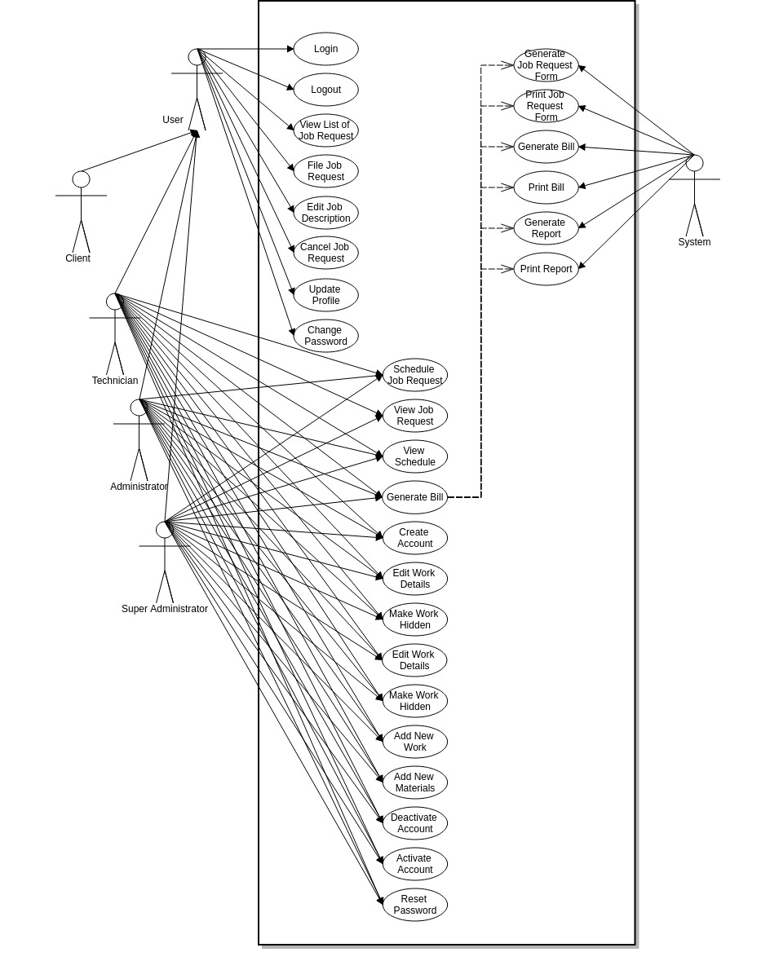

**3.1.1 Login**

**A. Use Case Specification**

|  |  |
| --- | --- |
| Description | The Users enters his/her username and password. |
| Goal | To allow only valid administrators and users to use the system. |
| Preconditions | The system is online. |
| Assumptions | You are connected to a network. |
| Frequency | Every time the user needs to use the system. |
| Flow of Events | Main Flow:  1. The User enters his/her username and password  2. The User clicks the Log In button. |
|  | 2. System Authentication.  **A) Alternate Flow: Authentication fails.**  A1) Prompt “Invalid Credentials”.  A2) Return to step 1 of the Main Flow. |
| Post conditions | The User can now access and use the system. |
| Actors | Users (Super Administrator, Technician, Administrator, Client) |
| Included Use Cases | None |
| Extended Use Cases | None |
| Notes |  |

#### B. Activity Diagram

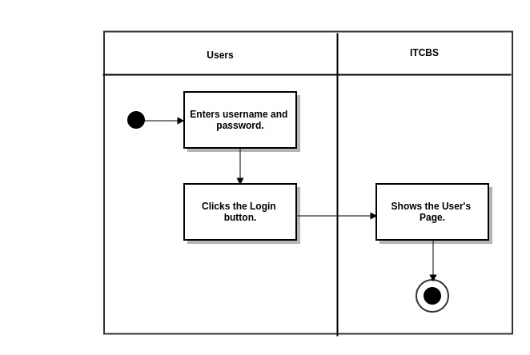

**3.1.1.1 HOME**

**3.1.1.1.1 as SuperAdmin, Admin, Technician**

**A. Use Case Specification**

|  |  |
| --- | --- |
| Description | The User views Home page. |
| Goal | To view the Home page. |
| Preconditions | The system is online. |
| Assumptions | You are connected to a network. |
| Frequency | Every time the user logs in. |
| Flow of Events | 1. The User clicks the List Icon.  2. The User clicks the Home tab. |
| Post conditions | The User can view the Home page containing job status and total work graph. |
| Actors | Users (Super Administrator, Technician, Administrator) |
| Included Use Cases | None |
| Extended Use Cases | None |
| Notes |  |

**B. Activity Diagram**

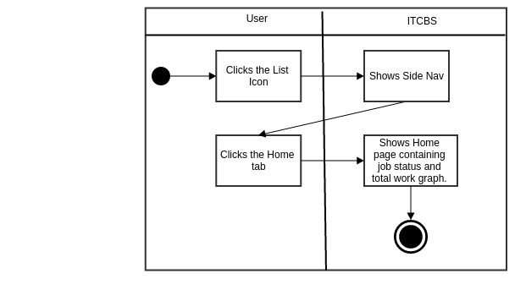

**3.1.1.1.2 as Client**

**A. Use Case Specification**

|  |  |
| --- | --- |
| Description | The User views Home page. |
| Goal | To view the Home page. |
| Preconditions | The system is online. |
| Assumptions | You are connected to a network. |
| Frequency | Every time the user logs in. |
| Flow of Events | 1. The User clicks the List Icon.  2. The User clicks the Home tab. |
| Post conditions | The User can view the Home page containing work rate and latest job requests. |
| Actors | Users (Client) |
| Included Use Cases | None |
| Extended Use Cases | None |
| Notes |  |

**B. Activity Diagram**

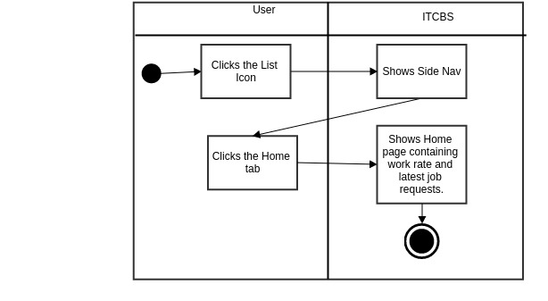

**3.1.1.2 ANNOUNCEMENTS**

**3.1.1.2.1 as SuperAdmin, Admin, Technician**

**3.1.1.2.1.1 Add Announcements**

**3.1.1.2.1.1.1 Add Announcement**

**A. Use Case Specification**

|  |  |
| --- | --- |
| Description | The User adds announcement. |
| Goal | To add announcement in the Announcements page. |
| Preconditions | The system is online. |
| Assumptions | You are connected to a network.  You are already in the Announcements tab. |
| Frequency | Every time the user wants to add announcement. |
| Flow of Events | 1. The User clicks the List Icon  2. The User clicks the Announcements tab.  3. The User enters announcements data in the Add Announcements form.  4. The User clicks Add Announcements button. |
| Post conditions | The User adds the new Announcement in the View Announcements page. |
| Actors | Users (Super Administrator, Technician, Administrator) |
| Included Use Cases | None |
| Extended Use Cases | None |
| Notes |  |

**B. Activity Diagram**

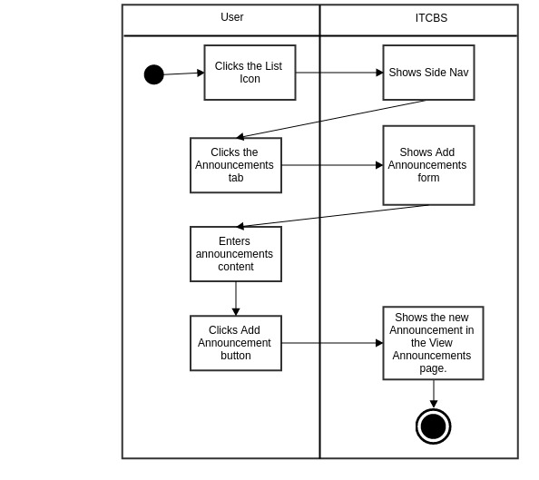

**3.1.1.2.1.1.2 Reset**

**A. Use Case Specification**

|  |  |
| --- | --- |
| Description | The User resets the announcement in the Add Announcements form. |
| Goal | To reset the announcement in the Add Announcements form |
| Preconditions | The system is online.  You are already in the Announcements tab. |
| Assumptions | You are connected to a network. |
| Frequency | Every time the user wants to reset the data entered in the Add Announcements form. |
| Flow of Events | 1. The User clicks the List Icon.  2. The User clicks the Announcements tab.  3. The User enters announcements data in the Add Announcements form.  4. The User clicks Reset button. |
| Post conditions | The User resets the Add Announcements form. |
| Actors | Users (Super Administrator, Technician, Administrator) |
| Included Use Cases | None |
| Extended Use Cases | None |
| Notes |  |

**B. Activity Diagram**

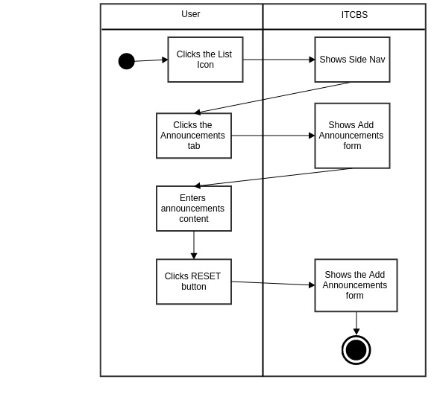

**3.1.1.2.1.2 View Announcement**

**A. Use Case Specification**

|  |  |
| --- | --- |
| Description | The User views the list of Announcements. |
| Goal | To view the Announcements’ title and content. |
| Preconditions | The system is online. |
| Assumptions | You are connected to a network.  You are already in the Announcements tab. |
| Frequency | Every time the user wants to view the list of Announcements. |
| Flow of Events | 1. The User clicks the List Icon.  2. The User clicks the Announcements tab.  3. The User clicks View Announcements tab.  4. The User clicks the Announcement’s title. |
| Post conditions | The User views the Announcements’ title and content. |
| Actors | Users (Super Administrator, Technician, Administrator) |
| Included Use Cases | None |
| Extended Use Cases | None |
| Notes |  |

**B. Activity Diagram**

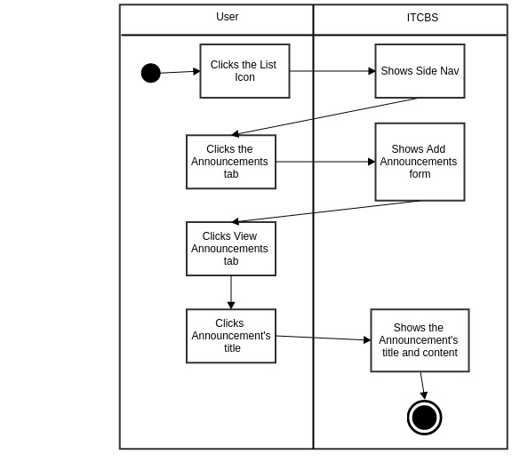

**3.1.1.2.1.2.1 Delete Announcement**

**A. Use Case Specification**

|  |  |
| --- | --- |
| Description | The User deletes the Announcement. |
| Goal | To delete the Announcements’ title and content. |
| Preconditions | The system is online.  You are already in the Announcements tab. |
| Assumptions | You are connected to a network. |
| Frequency | Every time the user wants to delete the Announcement. |
| Flow of Events | 1. The User clicks the List Icon.  2. The User clicks the Announcements tab.  3. The User clicks View Announcements tab.  4. The User clicks the Announcement’s title.  5. The User clicks the DELETE ANNOUNCEMENT button. |
| Post conditions | The announcement was deleted. |
| Actors | Users (Super Administrator, Technician, Administrator) |
| Included Use Cases | None |
| Extended Use Cases | None |
| Notes |  |

**B. Activity Diagram**

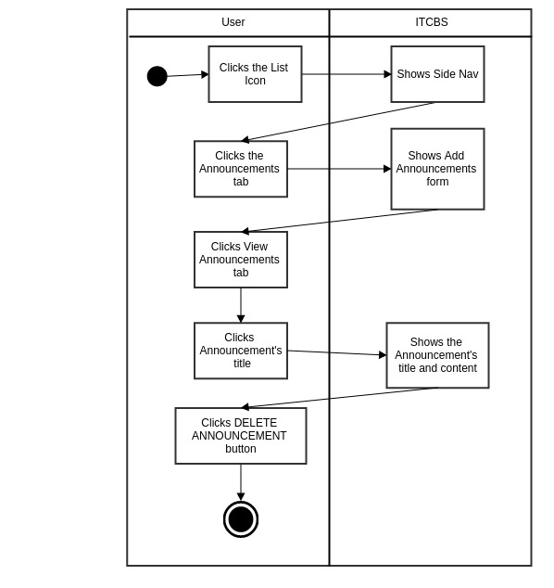

**3.1.1.2.2 as Client**

**A. Use Case Specification**

|  |  |
| --- | --- |
| Description | The User views the list of Announcements. |
| Goal | To view the Announcements’ title and content. |
| Preconditions | The system is online.  You are already in the Announcements tab. |
| Assumptions | You are connected to a network. |
| Frequency | Every time the user wants to view the list of Announcements. |
| Flow of Events | 1. The User clicks List Icon.  2. The User clicks the Announcements tab.  3. The User clicks the Announcement’s title. |
| Post conditions | The User views the Announcements’ title and content. |
| Actors | Users (Client) |
| Included Use Cases | None |
| Extended Use Cases | None |
| Notes |  |

**B. Activity Diagram**

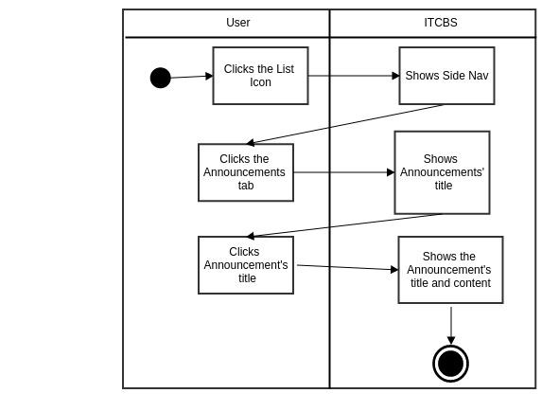

**3.1.1.3 NOTIFICATIONS**

**3.1.1.3.1 New Notifications (Mark as Read)**

**A. Use Case Specification**

|  |  |
| --- | --- |
| Description | The User views new notifications and marks as read. |
| Goal | To view new notifications and mark as read. |
| Preconditions | The system is online. |
| Assumptions | You are connected to a network.  You are already in the Notifications tab. |
| Frequency | Every time the user wants to view new notifications and mark as read. |
| Flow of Events | 1. The User clicks the List Icon.  2. The User clicks the Notifications tab.  3. The User clicks the Mark as Read button. |
| Post conditions | The User can view the Notifications in the Notifications Read filter tab. |
| Actors | Users (Super Administrator, Technician, Administrator, Client) |
| Included Use Cases | None |
| Extended Use Cases | None |
| Notes |  |

**B. Activity Diagram**

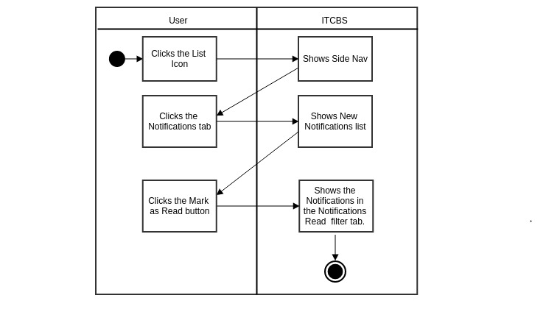

**3.1.1.3.2 Notifications Read**

**A. Use Case Specification**

|  |  |
| --- | --- |
| Description | The User views notifications read. |
| Goal | To view notifications read. |
| Preconditions | The system is online. |
| Assumptions | You are connected to a network.  You are in the Notifications tab. |
| Frequency | Every time the user wants to view notifications read. |
| Flow of Events | 1. The User clicks the List Icon.  2. The User clicks the Notifications tab.  3. The User clicks the Notifications Read filter tab. |
| Post conditions | The User can view the Notifications in the Notifications Read filter tab. |
| Actors | Users (Super Administrator, Technician, Administrator, Client) |
| Included Use Cases | None |
| Extended Use Cases | None |
| Notes |  |

**B. Activity Diagram**

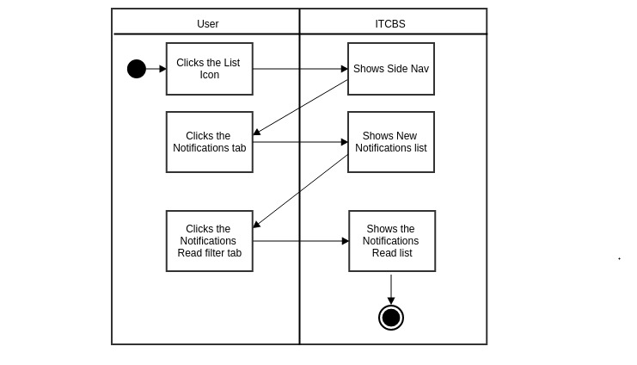

**3.1.1.4 JOB REQUESTS**

**3.1.1.4.1 View List of Job Requests**

**3.1.1.4.1.1 View (According To Status)**

**A. Use Case Specification**

|  |  |
| --- | --- |
| Description | The User views job requests according to its status |
| Goal | To view job requests according to its status |
| Preconditions | The system is online. |
| Assumptions | You are connected to a network.  You are already in the Announcements tab. |
| Frequency | Every time the user wants to view the job requests. |
| Flow of Events | 1. The User clicks the List Icon.  2. The User clicks the Job Request tab.  3. The User clicks the Job Request status button (PENDING, CANCELLED, PROCESSING, PROCESSED) |
| Post conditions | The User can view the job request according to its status. |
| Actors | Users (Super Administrator, Technician, Administrator, Client) |
| Included Use Cases | None |
| Extended Use Cases | None |
| Notes |  |

**3.1.1.3.1.1.B Activity Diagram**

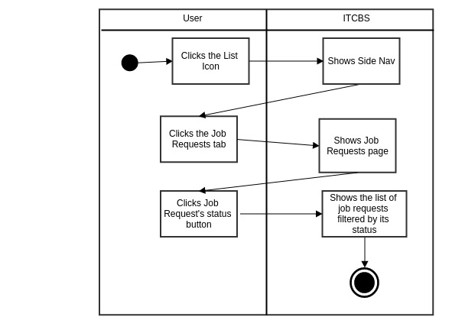

**3.1.1.4.1.1.a View Job Requests (Job Request status: PROCESSING)**

**3.1.1.4.1.1.a.1 Work(s) Done**

**A. Use Case Specification**

|  |  |
| --- | --- |
| Description | The User (Super Administrator, Technician) inputs the works done for the problem to be solved. |
| Goal | To insert what are the works done for the problem. |
| Preconditions | The Users should be logged-in. |
| Assumptions | You are connected to a network.  You are already on the Job Requests Tab |
| Frequency | Every time the user wants to add what are the works done for the job request. |
| Flow of Events | Main Flow:  1. The User clicks List Icon.  2. The User clicks the View Schedule tab.  3. The User clicks View Job Requests button.  4. The User clicks the Add Work Done button.  5. The User selects work and duration of work.  6. The User clicks the ADD WORK DONE button. |
| Post-conditions | The User can see the works done in the Job Request page. |
| Actors | Super Administrator, Technician |
| Included Use Cases | None |
| Extended Use Cases | None |
| Notes |  |

**B. Activity Diagram**

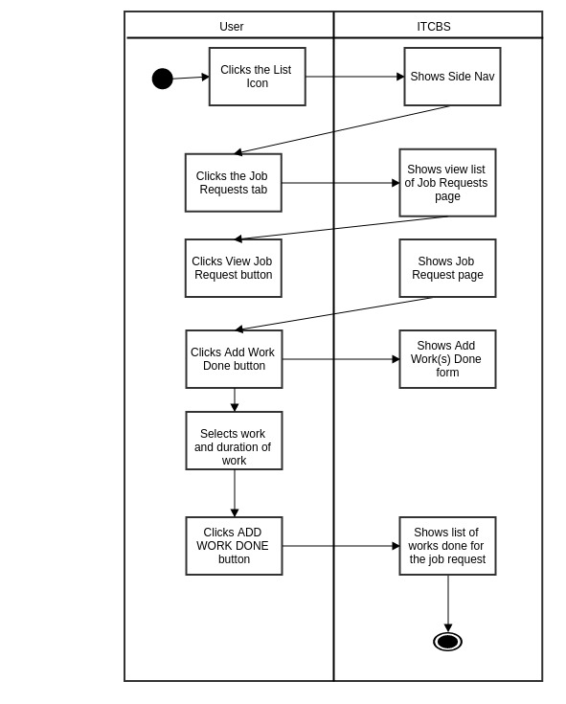

**3.1.1.4.1.1.a.1.1 Change Work Duration**

**A. Use Case Specification**

|  |  |
| --- | --- |
| Description | The User (Technician, Administrator or Super Administrator) inputs the works done for the problem to be solved. |
| Goal | To change the work duration |
| Preconditions | The Users should be logged-in. |
| Assumptions | You are connected to a network.  You are already on the Job Requests Tab. |
| Frequency | Every time the user wants to change the work duration |
| Flow of Events | Main Flow:  1. The User clicks List Icon.  2. The User clicks the Job Request tab.  3. The User clicks View Job Requests button.  4. The User clicks Change Work Duration button.  5. The User enters work duration (in hours).  6. The User clicks UPDATE WORK DURATION. |
| Post-conditions | The User can see the updated work duration by work’s total cost in the Job Request page |
| Actors | Super Administrator, Technician |
| Included Use Cases | None |
| Extended Use Cases | None |
| Notes |  |

**B. Activity Diagram**

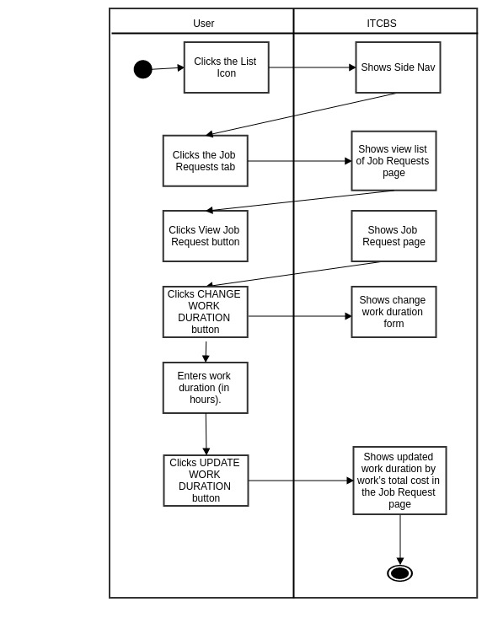

**3.1.1.4.1.1.a.1.2 Delete Work Done**

**A. Use Case Specification**

|  |  |
| --- | --- |
| Description | The User (Super Administrator, Technician) deletes the works done for the problem to be solved. |
| Goal | To delete the work done for the problem |
| Preconditions | The Users should be logged-in. |
| Assumptions | You are connected to a network.  You are already on the Job Requests Tab. |
| Frequency | Every time the user wants to delete the work done for the job request |
| Flow of Events | Main Flow:  1. The User clicks List Icon.  2. The User clicks the Job Request tab.  3. The User clicks View Job Requests button.  4. The User clicks DELETE WORK DONE. |
| Post-conditions | The work done is removed from the list of works done. |
| Actors | Super Administrator, Technician |
| Included Use Cases | None |
| Extended Use Cases | None |
| Notes |  |

**B. Activity Diagram**

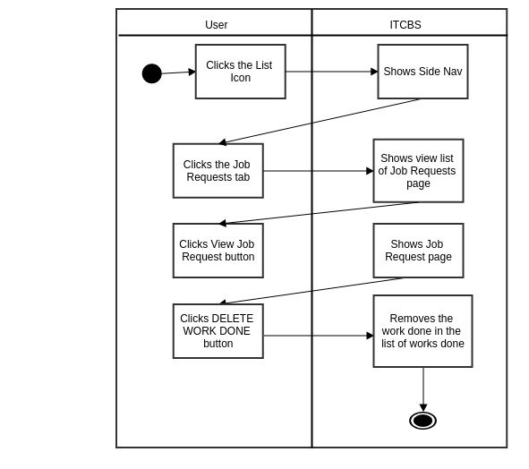

**3.1.1.4.1.1.a.2 Materials Used**

**A. Use Case Specification**

|  |  |
| --- | --- |
| Description | The User (Super Administrator, Technician) inputs the materials used for the job request. |
| Goal | To add the materials used. |
| Preconditions | The User should be logged-in. |
| Assumptions | You are connected to a network.  You are already on the Job Requests Tab. |
| Frequency | Every time the user wants to add the materials used for the job request. |
| Flow of Events | Main Flow:  1. The User clicks the List Icon.  2. The User clicks the Job Request tab.  3. The User clicks View Job Request button.  4. The User clicks Add Materials Used button.  5. The User selects material and inputs total number of units .  6. The User clicks the Add Material button. |
| Post-conditions | The User can see the materials used in the Job Request page |
| Actors | Super Administrator, Technician |
| Included Use Cases | None |
| Extended Use Cases | None |
| Notes |  |

**B. Activity Diagram**

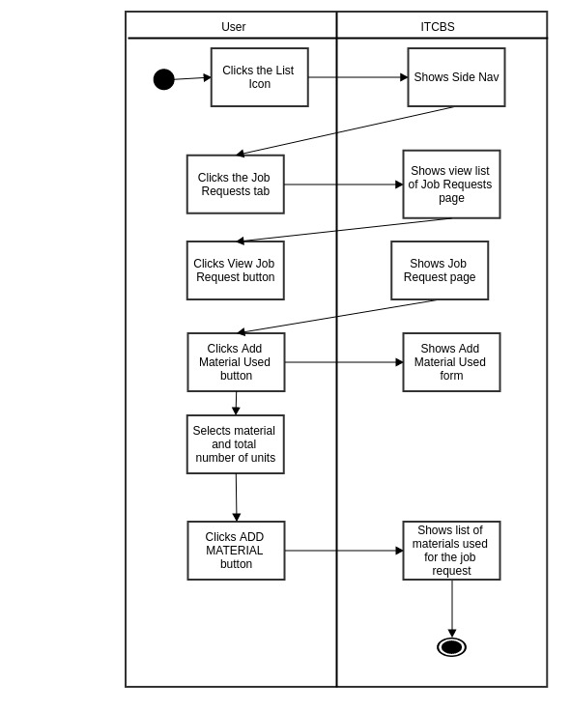

**3.1.1.4.1.1.a.2.1 Change Material Quantity/Unit**

**A. Use Case Specification**

|  |  |
| --- | --- |
| Description | The User (Super Administrator, Technician) changes material quantity/unit. |
| Goal | To change the material quantity/unit |
| Preconditions | The Users should be logged-in. |
| Assumptions | You are connected to a network.  You are already on the Job Requests Tab. |
| Frequency | Every time the user wants to change the material quantity/unit |
| Flow of Events | Main Flow:  1. The User clicks List Icon.  2. The User clicks the Job Requests tab.  3. The User clicks View Job Requests button.  4. The User clicks CHANGE MATERIAL QUANTITY/UNIT button.  5. The User enters Quantity/Unit.  6. The User clicks CHANGE QUANTITY/UNIT button. |
| Post-conditions | The User can see the updated quantity/unit by material’s total cost in the Job Request page |
| Actors | Super Administrator, Technician |
| Included Use Cases | None |
| Extended Use Cases | None |
| Notes |  |

**B. Activity Diagram**

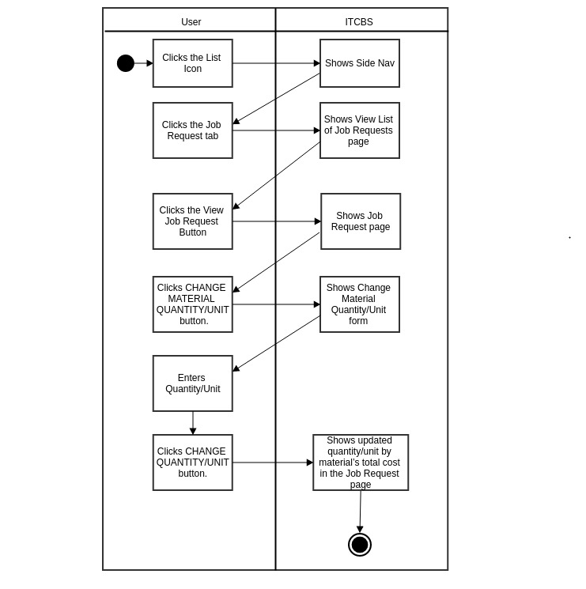

**3.1.1.4.1.1.a.2.2 Delete Material Used**

**A. Use Case Specification**

|  |  |
| --- | --- |
| Description | The User (Super Administrator, Technician ) deletes the material used for the problem. |
| Goal | To delete the materials used for the problem |
| Preconditions | The Users should be logged-in. |
| Assumptions | You are connected to a network.  You are already on the Job Request Tab. |
| Frequency | Every time the user wants to delete the materials used for the job request |
| Flow of Events | Main Flow:  1. The User clicks List Icon.  2. The User clicks the Job Request tab.  3. The User clicks View Job Requests button.  4. The User clicks DELETE MATERIALS USED button. |
| Post-conditions | The material used is removed from the list of materials used. |
| Actors | Super Administrator, Technician |
| Included Use Cases | None |
| Extended Use Cases | None |
| Notes |  |

**B. Activity Diagram**

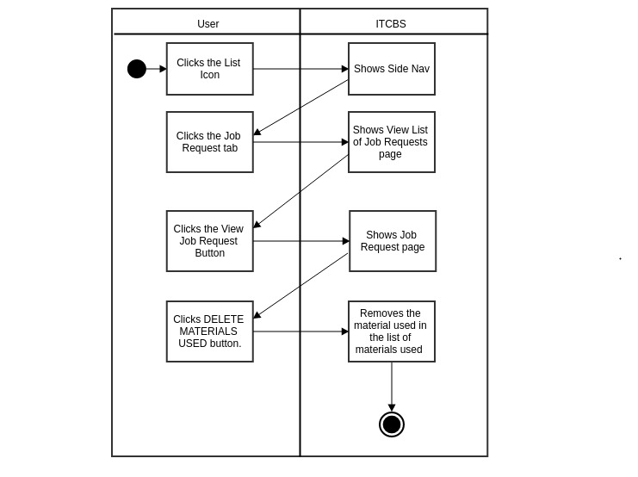

**3.1.1.4.1.1.a.3 Generate Form**

**A. Use Case Specification**

|  |  |
| --- | --- |
| Description | The User (Super Administrator, Technician) inputs the materials used for the job request. |
| Goal | To generate job request form. |
| Preconditions | The User should be logged-in. |
| Assumptions | You are connected to a network.  You are already on the Job Requests Tab |
| Frequency | Every time the user wants to generate job request form. |
| Flow of Events | Main Flow:  1. The User clicks the List Icon.  2. The User clicks the Job Request tab.  3. The User clicks View Job Request button.  4. The User clicks the GENERATE FORM button. |
| Post-conditions | The User can see the materials used in the Job Request page |
| Actors | Super Administrator, Technician |
| Included Use Cases | None |
| Extended Use Cases | None |
| Notes |  |

**B. Activity Diagram**

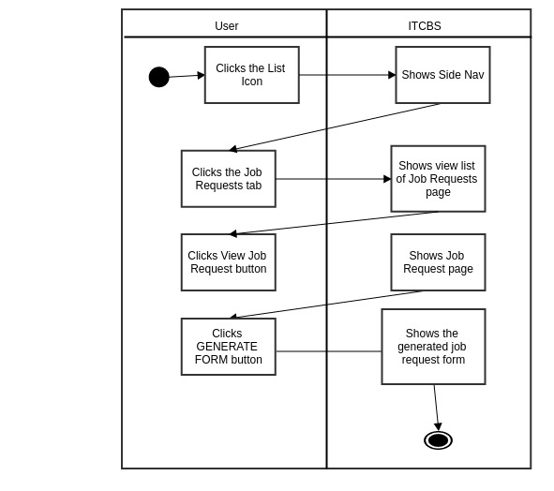

**3.1.1.4.1.1.a.4 Change Priority**

**A. Use Case Specification**

|  |  |
| --- | --- |
| Description | The User changes the priority of the job. |
| Goal | To change the priority of the job. |
| Preconditions | The User should be logged-in. |
| Assumptions | You are connected to a network.  You are already on the Job Requests Tab. |
| Frequency | Every time the User wants to change the job request’s priority. |
| Flow of Events | Main Flow:  1. The User clicks the List Icon.  2. The User clicks the Job Request tab.  3. The User clicks View Job Request button.  4. The User clicks Change Priority button.  5. The User selects priority (Normal, Urgent or Very Urgent) .  6. The User clicks the Update Priority button.  7. The User clicks the YES button.  8. The User clicks the OK button. |
| Post-conditions | The user changes the job’s priority and views it in the Schedule page. |
| Actors | Super Administrator, Technician |
| Included Use Cases | None |
| Extended Use Cases | None |
| Notes |  |

**B. Activity Diagram**

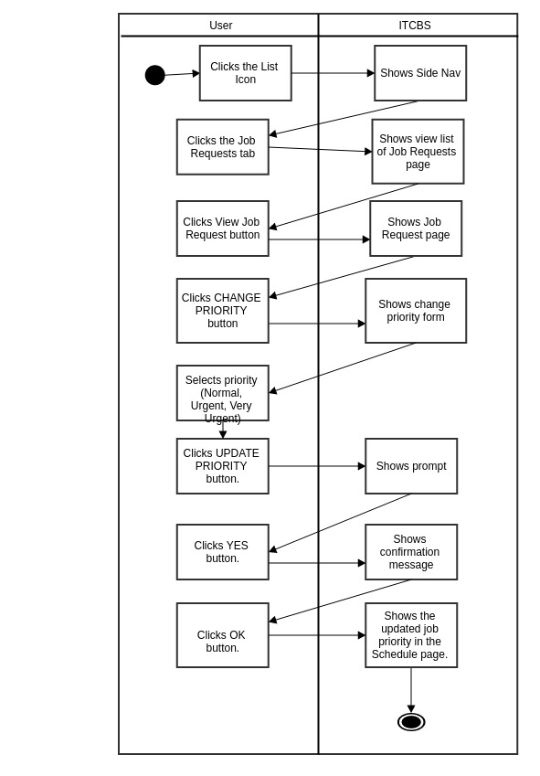

**3.1.1.4.1.1.a.5 Mark as Done**

**A. Use Case Specification**

|  |  |
| --- | --- |
| Description | The User (Super Administrator, Technician )marks the job as done. |
| Goal | To mark the job as done. |
| Preconditions | The User should be logged-in. |
| Assumptions | You are connected to a network.  You are already on the Job Requests tab. |
| Frequency | Every time the Technician finishes the job. |
| Flow of Events | Main Flow:  1. The User clicks the View Schedule tab.  2. The User clicks the View Job Request button.  3. The User clicks the Mark as Done button. |
| Post-conditions | The User marks the job as done and removes it in the view schedule tab. |
| Actors | Super Administrator, Technician |
| Included Use Cases | None |
| Extended Use Cases | None |
| Notes |  |

**B. Activity Diagram**

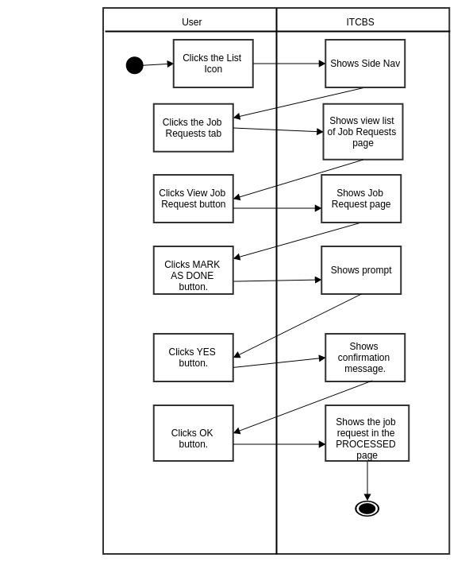

**3.1.1.4.1.1.b Schedule Job (Job Request status: PENDING)**

**A. Use Case Specification**

|  |  |
| --- | --- |
| Description Description | The User schedules the job request. |
| Goal | To schedule the job request. |
| Preconditions | The User should be logged-in. |
| Assumptions | You are connected to a network.  You are already on the Job Request Tab. |
| Frequency | Every time the user wants to schedule the job request. |
| Flow of Events | Main Flow:  1. The User clicks the List Icon.  2. The User clicks the Schedule Job button.  3. The User selects date and priority in the schedule job form.  4. The User clicks DONE button.  5. The User clicks OK button. |
| Post-conditions | The User can view the scheduled job request in the job request page. |
| Actors | Super Administrator, Technician, Administrator |
| Included Use Cases | None |
| Extended Use Cases | None |
| Notes |  |

**B. Activity Diagram**

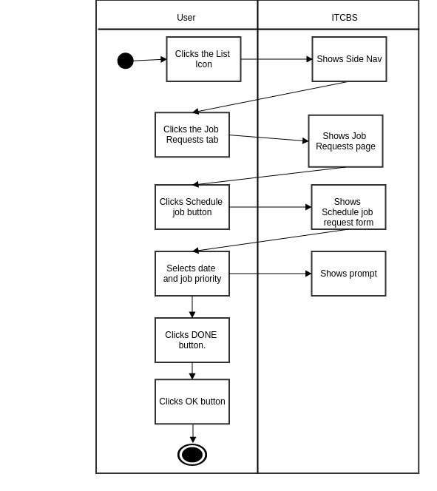

**3.1.1.4.1.1.2 Edit Job Description**

**A. Use Case Specification**

|  |  |
| --- | --- |
| Description Description | The User edits the job description. |
| Goal | To edit the job description. |
| Preconditions | The User should be logged-in. |
| Assumptions | You are connected to a network.  You are already on the Job Request Tab. |
| Frequency | Every time the user wants to edit the job description. |
| Flow of Events | Main Flow:  1. The User clicks the List Icon.  2. The User clicks the Job Request tab.  3.The User clicks Edit Job Description button.  4. The User edits the job description  5. The User clicks the EDIT button.  6. The User clicks the YES button.  7. The User clicks the OK button. |
| Post-conditions | The User can view the edited job description in the job request page. |
| Actors | Super Administrator, Technician, Administrator, Client |
| Included Use Cases | None |
| Extended Use Cases | None |
| Notes |  |

**B. Activity Diagram**

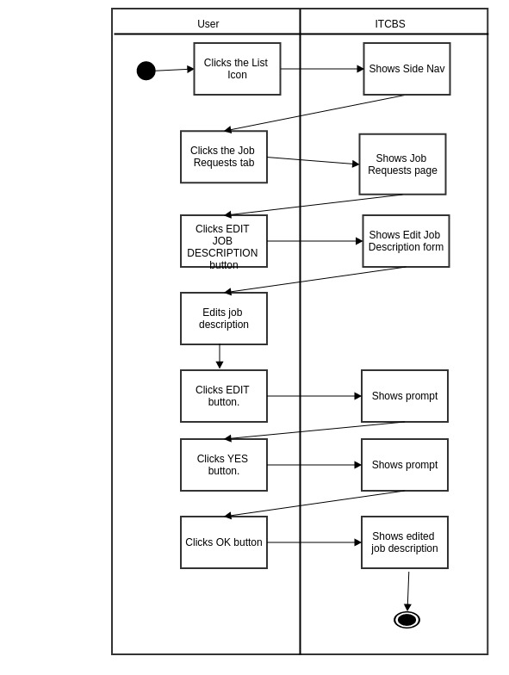

**3.1.1.4.1.1.3 Cancel Job Request**

**A. Use Case Specification**

|  |  |
| --- | --- |
| Description | The User cancels the job request. |
| Goal | To cancel the job request. |
| Preconditions | The User should be logged-in. |
| Assumptions | You are connected to a network.  You are already on the Job Request Tab. |
| Frequency | Every time the user wants to cancel his/her job request. |
| Flow of Events | Main Flow:  1. The User clicks the List Icon.  2. The User clicks the Job Request tab.  3. The User clicks Cancel Job Request  4. The User clicks the YES button.  5. The User clicks the OK button. |
| Post-conditions | The job request will be cancelled. |
| Actors | Super Administrator, Technician, Administrator, Client |
| Included Use Cases | None |
| Extended Use Cases | None |
| Notes |  |

**B. Activity Diagram**

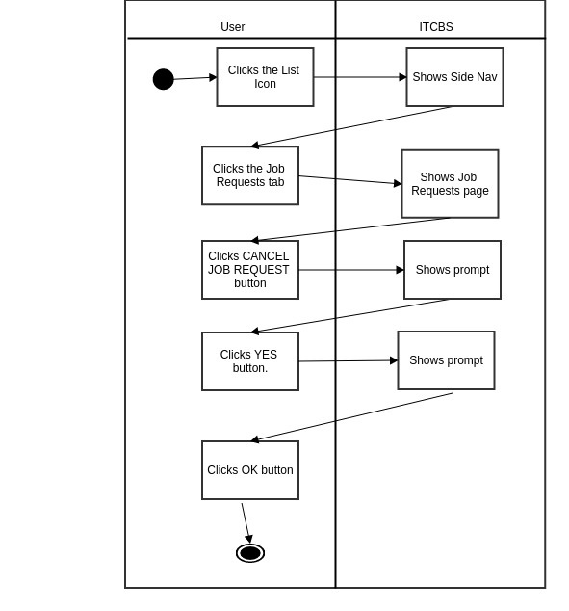

**3.1.1.4.1.2 Search Jobs**

**A. Use Case Specification**

|  |  |
| --- | --- |
| Description | The User searches job requests by search terms. |
| Goal | To search job requests by search terms. |
| Preconditions | The system is online. |
| Assumptions | You are connected to a network.  You are already on the Job Requests Tab. |
| Frequency | Every time the user wants to search job requests. |
| Flow of Events | 1. The User clicks the List Icon.  2. The User clicks the Job Request tab.  3. The User clicks the Search Jobs button.  5. The User inputs search terms separated by spaces.  6. The User clicks the Search button. |
| Post conditions | The User can view the list of job requests containing searched terms. |
| Actors | Users (Super Administrator, Technician, Administrator, Client) |
| Included Use Cases | None |
| Extended Use Cases | None |
| Notes |  |

**B. Activity Diagram**

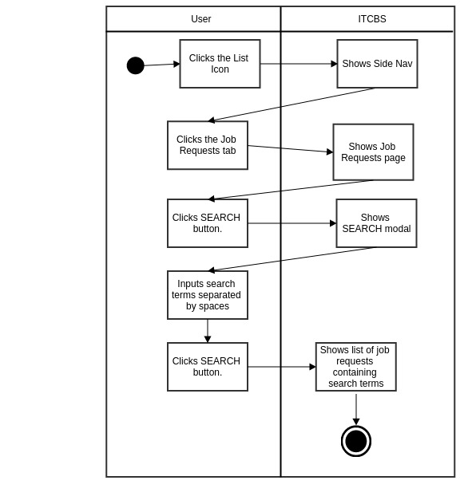

**3.1.1.4.2 File A Job Request**

**A. Use Case Specification**

|  |  |
| --- | --- |
| Description | The User creates a new job request. |
| Goal | Insert some information about a job request to the database. |
| Preconditions | The User should be logged-in. |
| Assumptions | You are connected to a network.  You are already on the Job Request Tab. |
| Frequency | Every time the user wants to file a job request. |
| Flow of Events | Main Flow:  1. The User clicks the List Icon.  2. The User clicks the Job Request tab.  3. The User clicks File A Job Request.  4. The User inputs required and necessary information in the File Job Request form.  5. The User clicks the Submit button. |
| Post-conditions | The User adds new job request to the database and updates the number and list of job requests in the Job Requests tab. |
| Actors | Super Administrator, Technician, Administrator, Client |
| Included Use Cases | None |
| Extended Use Cases | None |
| Notes |  |

**3.1.1.3.2.B Activity Diagram**

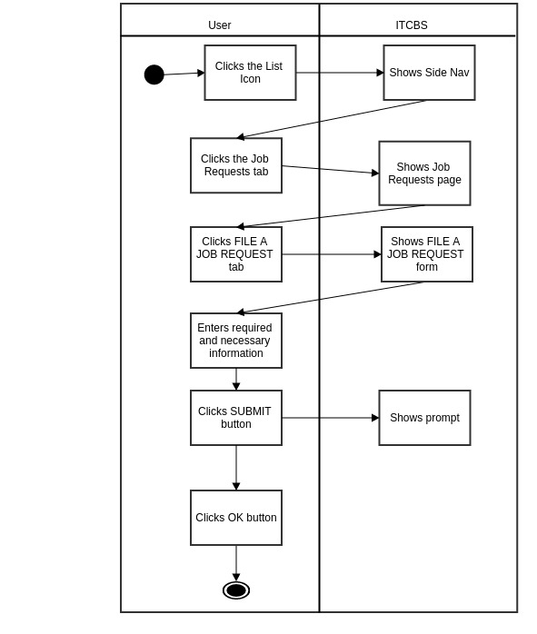

**3.1.1.5 View Schedule**

**3.1.1.5.1 View Job Request**

*Assumption: You are already in the View Schedule tab*

**3.1.1.5.1.1 Work(s) Done**

**A. Use Case Specification (***Refer to Section* ***3.1.1.4.1.a.1*** *Use Case Specification)*

**B. Activity Diagram** (*Refer to Section*  ***3.1.1.4.1.a.1*** *Activity Diagram)*

**3.1.1.5.1.2 Materials Used**

**A. Use Case Specification (***Refer to Section* ***3.1.1.4.1.a.2*** *Use Case Specification)*

**B. Activity Diagram** (*Refer to Section* ***3.1.1.4.1.a.2*** *Activity Diagram)*

**3.1.1.5.1.3 Generate Form**

**A. Use Case Specification (***Refer to Section* ***3.1.1.4.1.a.3*** *Use Case Specification)*

**B. Activity Diagram *(****Refer to Section* ***3.1.1.4.1.a.3*** *Activity Diagram)*

**3.1.1.5.1.4 Change Priority**

**A. Use Case Specification (***Refer to Section* ***3.1.1.4.1.a.4*** *Use Case Specification)*

**B. Activity Diagram *(****Refer to Section* ***3.1.1.4.1.a.4*** *Activity Diagram)*

**3.1.1.5.1.5 Mark as Done**

**A. Use Case Specification** (*Refer to Section* ***3.1.1.4.1.a.5*** *Use Case Specification)*

**B. Activity Diagram (***Refer to Section* ***3.1.1.4.1.a.5*** *Activity Diagram)*

**3.1.1.6 MANAGE APPLICATION**

**3.1.1.6.1 User Logs**

**3.1.1.6.1.1 View By Log In/Log Out/Job Actions**

**A. Use Case Specification**

|  |  |
| --- | --- |
| Description | The User (Super Administrator) views the User Logs by Log In, Log Out and Job Actions Logs |
| Goal | To view the User Logs by Log In, Log Out and Job Actions Logs |
| Preconditions | The Users should be logged-in. |
| Assumptions | You are connected to a network.  You are already on the Manage Application Tab. |
| Frequency | Every time the User wants to view the User Logs |
| Flow of Events | Main Flow:  1. The User clicks the List Icon.  2. The User clicks the Manage Application tab.  3. The User clicks the User Logs tab.  4. The User clicks the Log In/ Log Out/ Job Actions filter tab. |
| Post-conditions | The User sees the User Logs by Log In, Log Out and Job Actions Logs |
| Actors | Super Administrator |
| Included Use Cases | None |
| Extended Use Cases | None |
| Notes |  |

**B. Activity Diagram**

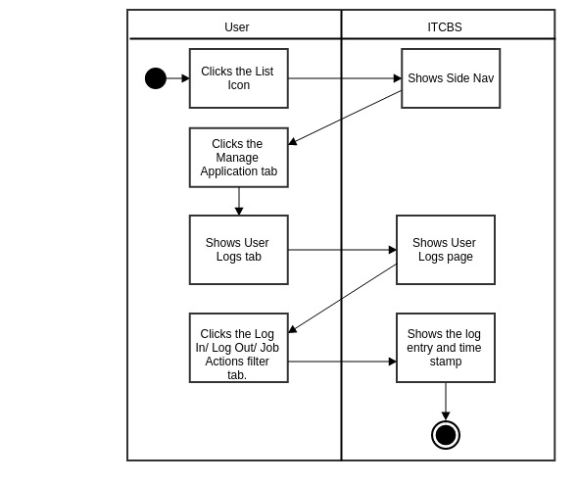

**3.1.1.6.1.2 View by User**

**A. Use Case Specification**

|  |  |
| --- | --- |
| Description | The User (Super Administrator) views user logs filtered by username. |
| Goal Goal | To view user logs filtered by username |
| Preconditions | The User should be logged-in. |
| Assumptions | You are connected to a network.  You are already on the Manage Application Tab. |
| Frequency | Every time there is a need to view user logs |
| Flow of Events | Main Flow:  1. The User clicks the List Icon.  2. The User clicks the Manage Application Tab.  3. The User clicks the Manage Accounts.  4. The User clicks the By User filter tab (SuperAdmin, Admin, Technician, Client)  5. The User enters the Username.  6. The User clicks the DONE button. |
| Post-conditions | The User views user logs filtered by username |
| Actors | Super Administrator |
| Included Use Cases | None |
| Extended Use Cases | None |
| Notes |  |

**B. Activity Diagram**

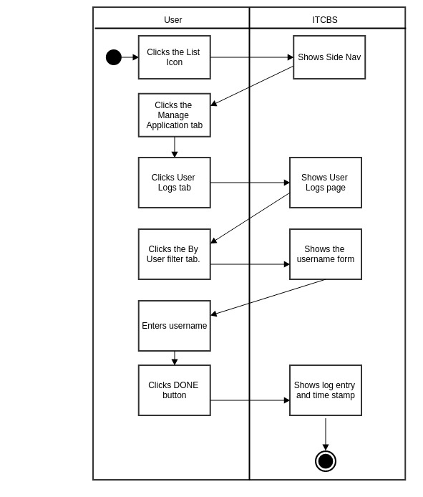

**3.1.1.6.2 Manage Accounts**

**3.1.1.6.2.1 View by User Type**

**A. Use Case Specification**

|  |  |
| --- | --- |
| Description | The User (Super Administrator, Technician, Administrator) views accounts filtered by user type. |
| Goal Goal | To view accounts filtered by user type. |
| Preconditions | The User should be logged-in. |
| Assumptions | You are connected to a network.  You are already on the Manage Application Tab. |
| Frequency | Every time there is a need to view accounts according to their user type. |
| Flow of Events | Main Flow:  1. The User clicks the List Icon.  2. The User clicks the Manage Application Tab.  3. The User clicks the Manage Accounts t.ab  4. The User clicks the User Type filter tab (SuperAdmin, Admin, Technician, Client) |
| Post-conditions | The User views user accounts filtered by user type. |
| Actors | Super Administrator, Technician, Administrator |
| Included Use Cases | None |
| Extended Use Cases | None |
| Notes |  |

**B. Activity Diagram**

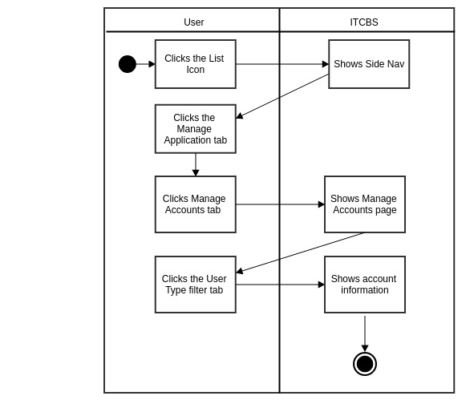

**3.1.1.6.2.1.1 Deactivate/Activate Account**

**A. Use Case Specification**

|  |  |
| --- | --- |
| Description | The User (Super Administrator, Technician, Administrator) deactivates/activates user account. |
| Goal Goal | To deactivate/activate user account. |
| Preconditions | The User should be logged-in. |
| Assumptions | You are connected to a network.  You are already on the Manage Application Tab. |
| Frequency | Every time there is a need to deactivate/activate user account. |
| Flow of Events | Main Flow:  1.The User clicks the List Icon.  2. The User clicks the Manage Application Tab.  3. The User clicks the Manage Accounts.  4. The User clicks the Deactivate/ Activate Button. |
| Post-conditions | The User changes the Active status in the Manage Accounts page. |
| Actors | Super Administrator, Technician, Administrator |
| Included Use Cases | None |
| Extended Use Cases | None |
| Notes |  |

**B. Activity Diagram**

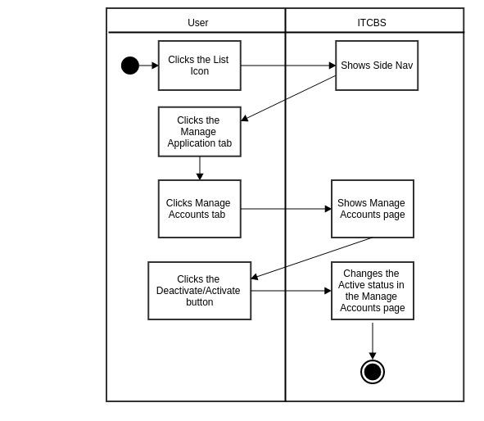

**3.1.1.6.2.1.2 Reset User Password**

**A. Use Case Specification**

|  |  |
| --- | --- |
| Description | The User (Super Administrator, Technician, Administrator) resets user password. |
| Goal Goal | To reset user password. |
| Preconditions | The User should be logged-in. |
| Assumptions | You are connected to a network.  You are already on the Manage Application Tab. |
| Frequency | Every time there is a need to reset user password. |
| Flow of Events | Main Flow:  1. The User clicks the List Icon.  2. The User clicks the Manage Application Tab.  3. The User clicks the Manage Accounts.  4. The User clicks the Reset Password button.  5. The User clicks YES button.  6. The User clicks OK button. |
| Post-conditions | The User resets the user password in the database. |
| Actors | Super Administrator, Technician, Administrator |
| Included Use Cases | None |
| Extended Use Cases | None |
| Notes |  |

**B. Activity Diagram**

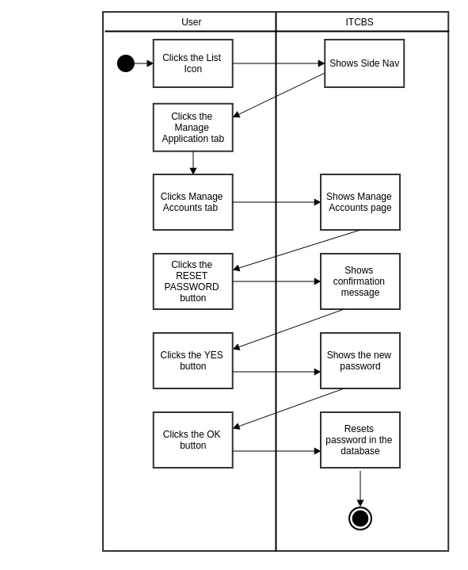

**3.1.1.6.2.2 Create Account**

**A. Use Case Specification**

|  |  |
| --- | --- |
| Description | The User (Super Administrator) creates new user account. |
| GoalGoal Goal | To create new user account. |
| Preconditions | The User should be logged-in. |
| Assumptions | You are connected to a network.  You are already on the Manage Application Tab. |
| Frequency | Every time there is a need to create a new account. |
| Flow of Events | Main Flow:  1. The User clicks the List Icon.  2. The User clicks the Manage Application Tab.  3. The User clicks the Manage Accounts.  4. The User clicks the Create Account.  5. The User clicks the User type filter tab.  6. The User inputs required and necessary information.  7. The User clicks Create Account button. |
| Post-conditions | The User adds new user account to the database and updates the number and list of users in the user accounts. |
| Actors | Super Administrator |
| Included Use Cases | None |
| Extended Use Cases | None |
| Notes |  |

**B. Activity Diagram**

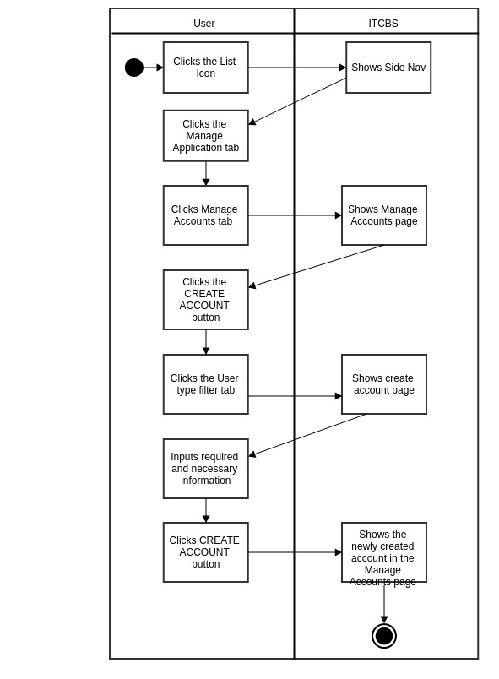

**3.1.1.6.3 Manage Work**

**3.1.1.6.3.1 Manage Selectable Work**

**3.1.1.6.3.1.1 Edit Selectable Work Details**

**A. Use Case Specification**

|  |  |
| --- | --- |
| Description | The User (Super Administrator, Technician, Administrator) edits the selectable work details. |
| Goal | To edit the Selectable Work Details. |
| Preconditions | The User should be logged-in. |
| Assumptions | You are connected to a network.  You are already on the Manage Applications Tab. |
| Frequency | Every time the user wants to edit the selectable work details. |
| Flow of Events | Main Flow:  1. The User clicks List Icon.  2. The User clicks the Manage Application Tab.  3. The User clicks the Manage Work Menu.  4. The User clicks the Edit Selectable Work Details button.  5. The User edits details.  6. The User clicks the Edit button.  7. The User clicks OK button. |
| Post-conditions | The User sees the edited selectable work details and is updated in the database. |
| Actors | Super Administrator, Technician, Administrator |
| Included Use Cases | None |
| Extended Use Cases | None |
| Notes |  |

**B. Activity Diagram**

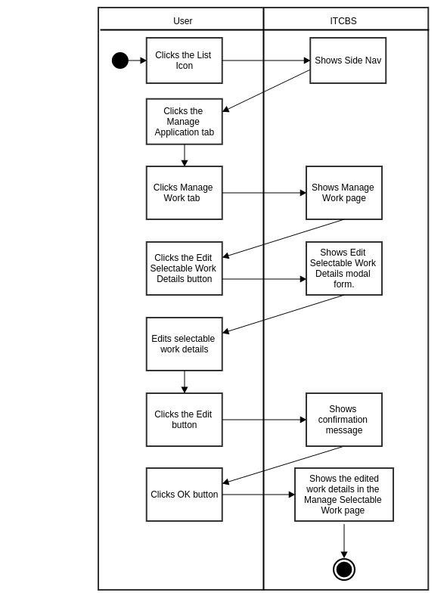

**3.1.1.6.3.1.2 Make Selectable Work Hidden/Visible**

**A. Use Case Specification**

|  |  |
| --- | --- |
| Description | The User (Super Administrator, Technician, Administrator) makes selectable work hidden/visible. |
| Goal | To make the Selectable Work hidden/visible. |
| Preconditions | The User should be logged-in. |
| Assumptions | You are connected to a network.  You are already on the Manage Applications Tab. |
| Frequency | Every time the user wants to make the selectable work hidden/visible. |
| Flow of Events | Main Flow:  1. The User clicks the List Icon.  2. The User clicks the Manage Application Tab.  3. The User clicks the Manage Work Menu.  4. The User clicks the Make Selectable Work Hidden/Visible button. |
| Post-conditions | The User changes the selectable work status in the Manage Selectable Materials page |
| Actors | Super Administrator, Technician, Administrator |
| Included Use Cases | None |
| Extended Use Cases | None |
| Notes |  |

**B. Activity Diagram**

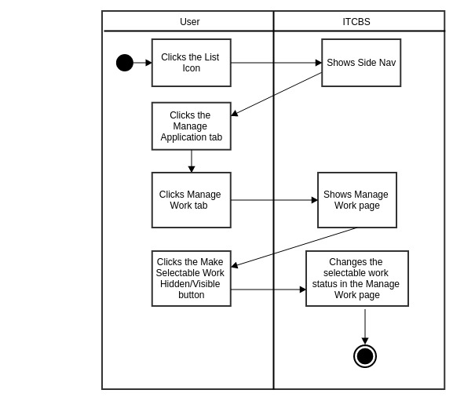

**3.1.1.6.3.2 Add New Work**

**A. Use Case Specification**

|  |  |
| --- | --- |
| Description | The User (Super Administrator, Technician, Administrator) adds new work. |
| Goal | To add new work. |
| Preconditions | The User should be logged-in. |
| Assumptions | You are connected to a network.  You are already on the Manage Application Tab. |
| Frequency | Every time the user wants to add new work. |
| Flow of Events | Main Flow:  1. The User clicks the List Icon.  2. The User clicks the Manage Application Tab.  3. The User clicks the Manage Work Menu.  4. The User clicks the Add New Work.  5. The User adds new work details.  6. The User clicks Add New Work button.  7. The User clicks OK. |
| Post-conditions | The User adds new work in the database |
| Actors | Super Administrator, Technician, Administrator |
| Included Use Cases | None |
| Extended Use Cases | None |
| Notes |  |

**B. Activity Diagram**

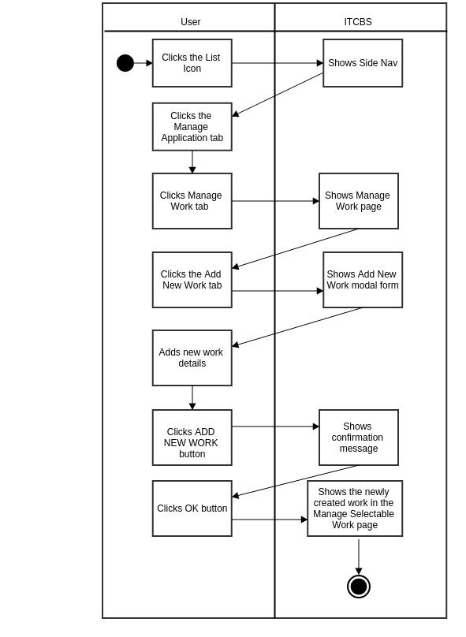

**3.1.1.6.4 Manage Materials**

**3.1.1.6.4.1 Manage Selectable Materials**

**3.1.1.6.4.1.1 Edit Selectable Materials Details**

**A. Use Case Specification**

|  |  |
| --- | --- |
| Description | The User (Super Administrator, Technician, Administrator) edits the selectable material details. |
| Goal | To edit the Selectable Material Details. |
| Preconditions | The User should be logged-in. |
| Assumptions | You are connected to a network.  You are already on the Manage Applications Tab. |
| Frequency | Every time the user wants to edit the selectable material details. |
| Flow of Events | Main Flow:  1. The User clicks the List Icon.  2. The User clicks the Manage Application Tab.  3. The User clicks the Manage Material Menu.  4. The User clicks the Edit Selectable Material Details button.  5. The User edits details.  6. The User clicks the Edit button.  7. The User clicks OK button. |
| Post-conditions | The User sees the edited selectable material details and is updated in the database. |
| Actors | Super Administrator, Technician, Administrator |
| Included Use Cases | None |
| Extended Use Cases | None |
| Notes |  |

**B. Activity Diagram**

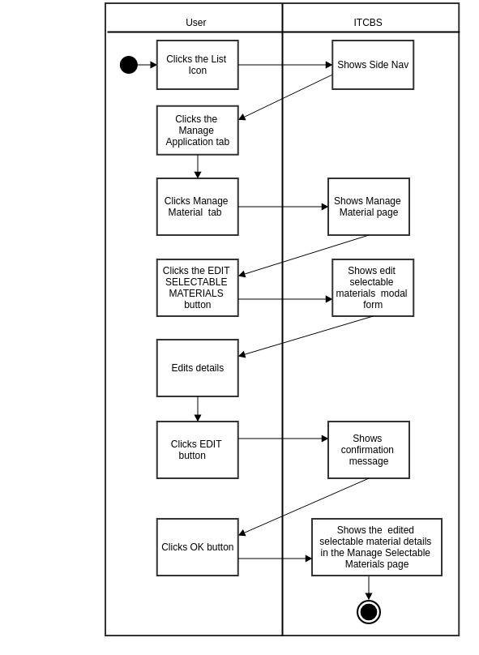

**3.1.1.6.4.1.2.a Make Selectable Materials Hidden/Visible**

**A. Use Case Specification**

|  |  |
| --- | --- |
| Description | The User (Super Administrator, Technician, Administrator) makes selectable materials hidden/visible. |
| Goal | To make the Selectable Materials hidden/visible. |
| Preconditions | The User should be logged-in. |
| Assumptions | You are connected to a network.  You are already on the Manage Applications Tab. |
| Frequency | Every time the user wants to make the selectable material hidden/visible. |
| Flow of Events | Main Flow:  1. The User clicks the List Icon.  2. The User clicks the Manage Application Tab.  3. The User clicks the Manage Material Menu.  4. The User clicks the Make Selectable Material Hidden/Visible button. |
| Post-conditions | The User changes the selectable material status in the Manage Selectable Materials page. |
| Actors | Super Administrator, Technician, Administrator |
| Included Use Cases | None |
| Extended Use Cases | None |
| Notes |  |

**B. Activity Diagram**

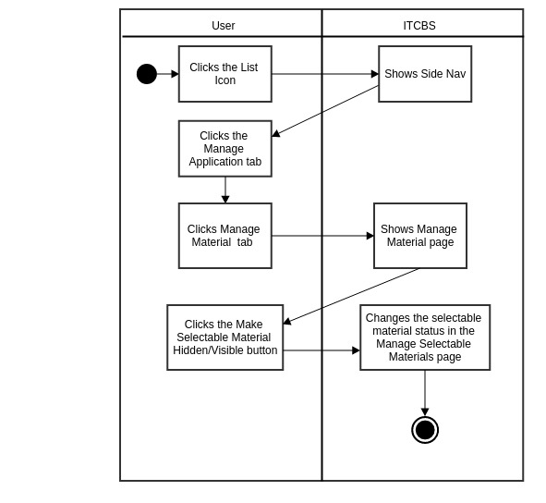

**31.1.6.4.2 Add New Materials**

**A. Use Case Specification**

|  |  |
| --- | --- |
| Description | The User (Super Administrator, Technician, Administrator) adds new materials. |
| Goal | To add new materials. |
| Preconditions | The User should be logged-in. |
| Assumptions | You are connected to a network.  You are already on the Manage Application Tab. |
| Frequency | Every time the user wants to add new materials. |
| Flow of Events | Main Flow:  1. The User clicks the Manage Application Tab.  2. The User clicks the Manage Materials Menu.  3. The User clicks the Add New Materials.  4. The User adds new materials details.  5. The User clicks Add New Materials button.  6. The User clicks OK. |
| Post-conditions | The User adds new materials in the database |
| Actors | Super Administrator, Technician, Administrator |
| Included Use Cases | None |
| Extended Use Cases | None |
| Notes |  |

**B. Activity Diagram**

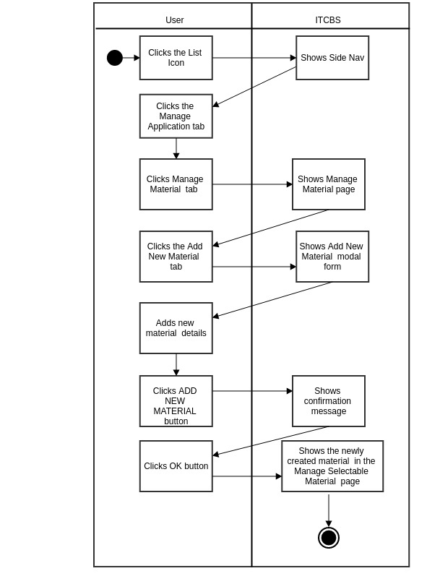

**3.1.1.6.5 Generate Report**

**3.1.1.6.5.1 Generate Report**

**A. Use Case Specification**

|  |  |
| --- | --- |
| Description | The User (Super Administrator) generates the report for the works done within a given period. |
| Goal | To generate the report for the works done within a given period. |
| Preconditions | The Users should be logged-in. |
| Assumptions | You are connected to a network.  You are already on the Manage Application tab. |
| Frequency | Every time the User wants to generate report for the works done within a given period. |
| Flow of Events | Main Flow:  1. The User clicks the List Icon.  2. The User clicks the Generate Report Tab.  3. The User clicks the Generate Report button.  4. The User selects start and end date. |
| Post-conditions | The User sees the Generated report on a new tab. |
| Actors | Super Administrator |
| Included Use Cases | None |
| Extended Use Cases | None |
| Notes |  |

**B. Activiy Diagram**

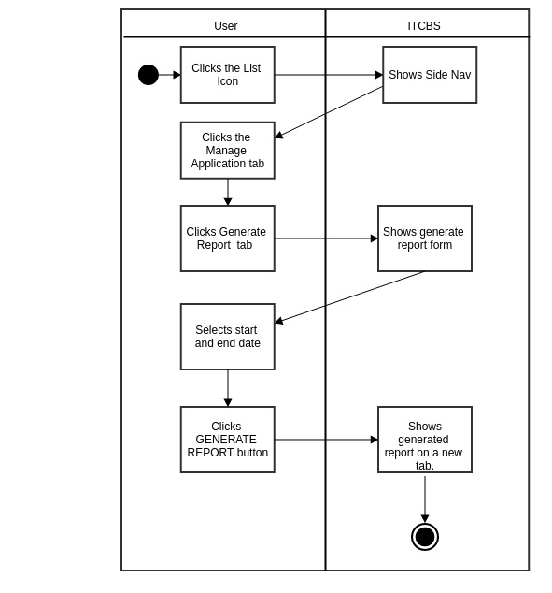

**3.1.1.6.5.2 Reset Generate Report**

**A. Use Case Specification**

|  |  |
| --- | --- |
| Description | The User (Super Administrator) resets the selected start and end date for the generate report function. |
| Goal | To reset the selected start and end date for the generate report function. |
| Preconditions | The Users should be logged-in. |
| Assumptions | You are connected to a network.  You are already on the Manage Application tab. |
| Frequency | Every time the User wants to generate report for the works done within a given period. |
| Flow of Events | Main Flow:  1. The User clicks the List Icon.  2. The User clicks the Generate Report Tab.  3. The User clicks the Generate Report button.  4. The User selects start and end date.  5. The User clicks RESET button. |
| Post-conditions | The User sees the Generated report on a new tab. |
| Actors | Super Administrator |
| Included Use Cases | None |
| Extended Use Cases | None |
| Notes |  |

**B. Activity Diagram**

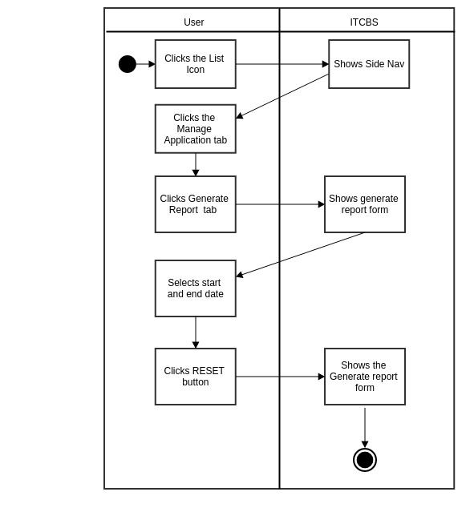

**3.1.1.7 Generate Bill**

**A. Use Case Specification**

|  |  |
| --- | --- |
| Description | The User (Client) generates the bill for the works done for job request. |
| Goal | To generate the bill for the works done for the job request. |
| Preconditions | The Users should be logged-in. |
| Assumptions | You are connected to a network.  You are already on the Generate Bill Tab. |
| Frequency | Every time the User wants to generate the finished job’s bill. |
| Flow of Events | Main Flow:  1. The User clicks the List Icon.  2. The User clicks the Generate Bill Tab.  3. The User clicks the GENERATE BILL button. |
| Post-conditions | The User sees the Bill or amount to be paid on a new tab. |
| Actors | Client |
| Included Use Cases | None |
| Extended Use Cases | None |
| Notes |  |

**B. Activity Diagram**

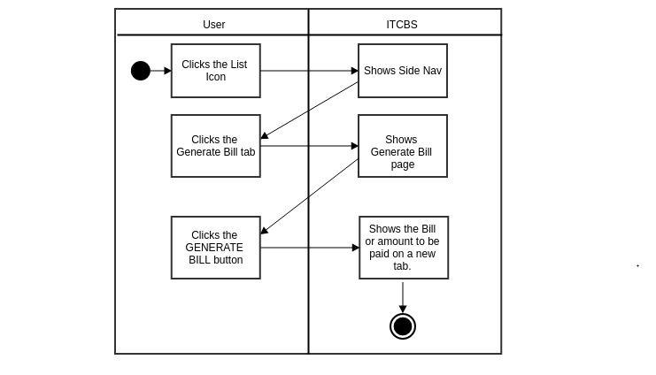

**3.1.2.My Account**

**3.1.2.1. Update Profile**

**A. Use Case Specification**

|  |  |
| --- | --- |
| Description | The User (Super Administrator, Technician, Administrator, Client) updates account’s profile. |
| Goal | To update the account’s profile. |
| Preconditions | The User should be logged-in. |
| Assumptions | You are connected to a network.  You are already on the User Menu. |
| Frequency | Every time the User wants to update his/her profile |
| Flow of Events | Main Flow:  1. The User clicks the User Menu.  2. The User clicks the My Account Tab.  3. The User enters the new Given Name and Last Name in their respective text area.  4. The User clicks the Update Profile button. |
| Post-conditions | The User updates Given Name and Last Name in the database. |
| Actors | Super Administrator, Technician, Administrator, Client |
| Included Use Cases | None |
| Extended Use Cases | None |
| Notes |  |

**B. Activity Diagram**

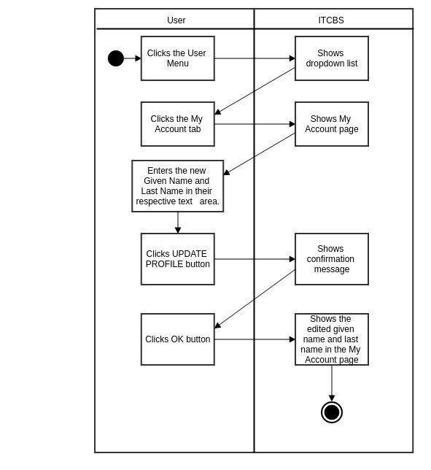

**3.1.2.2 Change Password**

**A. Use Case Specification**

|  |  |
| --- | --- |
| Description | The User (Super Administrator, Technician, Administrator, Client) changes his/her password. |
| Goal | To change user account’s password. |
| Preconditions | The User should be logged-in. |
| Assumptions | You are connected to a network.  You are already on the User Menu. |
| Frequency | Every time the User wants to change his/her password. |
| Flow of Events | Main Flow:  1. The User clicks the User Menu  2. The User clicks the My Account Tab.  3. The User clicks the Change Password button.  4. The User enters the old and new password.  5. The User clicks the Change Password button.  6. The User clicks the OK button. |
| Post-conditions | The User updates password in the database. |
| Actors | Super Administrator, Technician, Administrator, Client |
| Included Use Cases | None |
| Extended Use Cases | None |
| Notes |  |

**B. Activity Diagram**

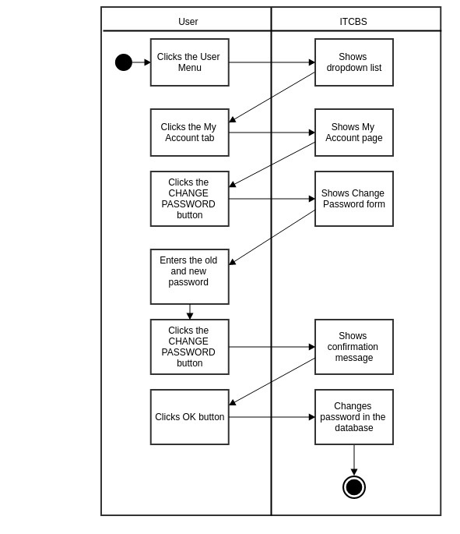

**3.1.3 Log Out**

**A. Use Case Specification**

|  |  |
| --- | --- |
| Description | The User (Super Administrator, Technician, Administrator, Client) logs out. |
| Goal | To log out of the system. |
| Preconditions | The User should be logged-in. |
| Assumptions | You are connected to a network.  You are already in the User Menu. |
| Frequency | Every time the user wants to log out. |
| Flow of Events | Main Flow:  1. The User clicks the User Menu.  2. The User clicks the Log Out tab. |
| Post-conditions | The User is logged out and redirected to log in page. |
| Actors | Super Administrator, Technician, Administrator, Client |
| Included Use Cases | None |
| Extended Use Cases | None |
| Notes |  |

**B. Activity Diagram**

