**360.243 Numerical Simulation and Scientific Computing II (VU 3,0) 2022S**

Group Members: Armin Tezer 01000274

Simon König 11702826

Jan Dudasko 01425878

**Exercise 2 - Task 4**

1. **Plot Energy conservation**

Plot 1: Total system energy

**Discussion:**

1. **Plot Evolution of the kinetic temperature**

Plot 2: Kinetic temperature

**Discussion:**

1. **Specific heat of the system**

Formula for the computation:

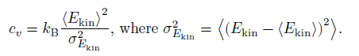

**Calculated Value:**