**360.243 Numerical Simulation and Scientific Computing II (VU 3,0) 2022S**

Group Members: Armin Tezer 01000274

Simon König 11702826

Jan Dudasko 01425878

**Exercise 2 - Task 4**

1. **Plot Energy conservation**

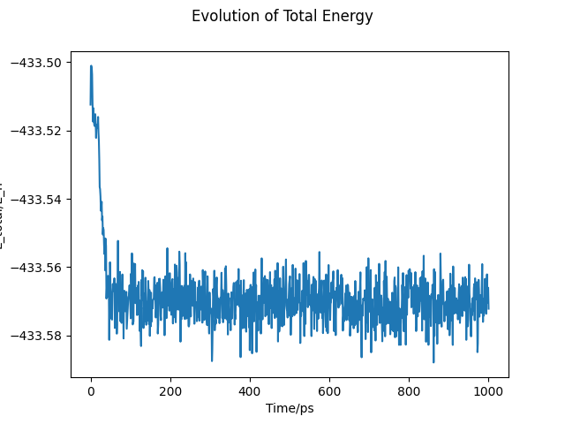

Plot 1: Total system energy

**Discussion:**

As expected the system conserves the total energy. The value oscillates (although only very slightly) due to model imprecisions (Newton`s equations of motion) and also due to the fact that only every 1000st step of the trajectory calculation was saved and subsequently used for plotting. The drop in the beginning could be explained by the initial setting. The Unit of energy used is Eh (see Task1).

1. **Plot Evolution of the kinetic temperature and potential energy**

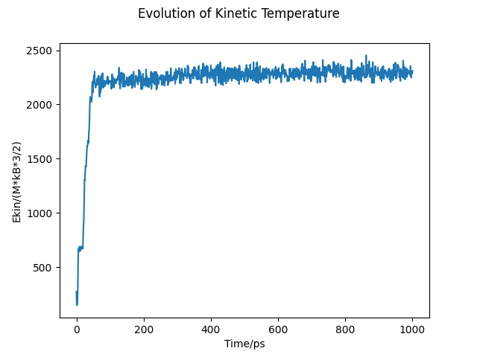

Plot 2: Kinetic temperature

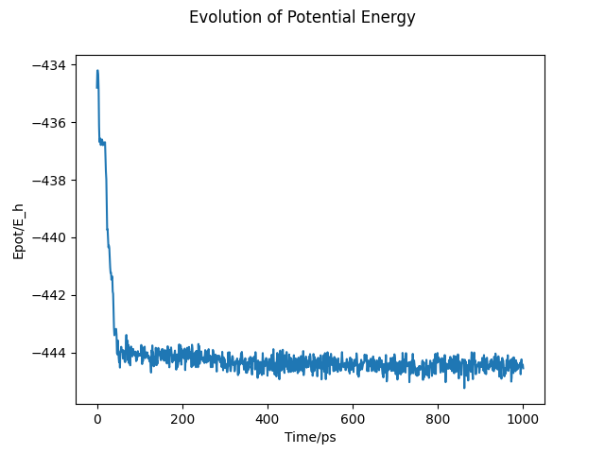

Plot 3: Potential energy

**Discussion:**

Corresponding to the conservation of the whole system energy, the kinetic and potential energy is also conserved.

1. **Specific heat of the system**

Formula for the computation:

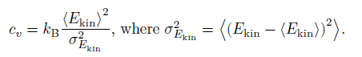

**Calculated Value:**

$$6.071680671051434e-17 E_{Hartree}/Kelvin$$