**360.243 Numerical Simulation and Scientific Computing II (VU 3,0) 2022S**

Group Members: Armin Tezer 01000274

Simon König 11702826

Jan Dudasko 01425878

**Exercise 1 (a+b)**

**Theory**

The aim of this exercise is to solve a 1d Diffusion problem stated in the following:

Where C denotes the concentration and the diffusion constant is D= 1e-6 Diffusion dominated transport equation can is distinguishable by a Peclet number << 1. To solve this equation, we are using an explicit scheme. The discretization in space is given as

$$\frac{C_{i-1}^{n}-2C_{i}^{n}+C_{i+1}^{n}}{{(∆x)}^{2}}$$

And the discretization in time as

$$\frac{C_{i}^{n+1}-C_{i}^{n}}{∆t}$$

This can be reformulated to

$$C_{i}^{n+1}=C_{i}^{n}+{d (C}_{i-1}^{n}-2C_{i}^{n}+C_{i+1}^{n})$$

With d as

$$d= \frac{∆t D}{{(∆x)}^{2}}$$

The constant determines the stability of our equation. Our solution is stable with d > 0.5 and unstable with d <= 0.5. The length of the domain is h, which can be arbitrarily chosen. We set h = 1.

**EX1 a**

The Diffusion equation is solved explicitly with Dirichlet/Von Neumann Boundary Conditions:

**EX1 b**

The Diffusion equation is solved explicitly with Dirichlet/Dirichlet Boundary Conditions:

**EX1 a & b**

A comparison between the results of a) and b) with differing boundary conditions can be found in the following plot. For a time -> inf and Neumann BC on one end we would expect the concentration to saturate, since there is no Flux through the boundary. Whereas with Dirichlet/Dirichlet BC flux is allowed on one boundary.

**Exercise 2**

**Theory**

The aim of this exercise is to solve the following 1D advection problem with the so called “Upwind scheme” with U = 1 and Δx = 0.01:

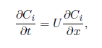

Advection dominated transport equation can is distinguishable by a Peclet number >>1. The Upwind approximation reads as follows, with i being a step in space-discretization and n a step in time-discretization:

$$\frac{C_{i}^{n+1}-C_{i}^{n}}{∆t}+U\frac{C_{i}^{n}-C_{i-1}^{n}}{∆x}=0$$

This can be reformulated to:

$$C_{i}^{n+1}=C_{i}^{n}\left(1-Co\right)+Co∙C_{i-1}^{n}$$

with the Courant number:

$$Co=\frac{U∙∆t}{∆x}$$

The Courant number is the characteristic value in terms of stability and accuracy as we will show with our computation. In order to be stable, the value must be Co ≤ 1. The error disappears for Co = 1, as this corresponds to the exact solution. The exact analytical solution is given by:

$$C\left(x,0\right)=C_{0}(x)$$

$$C\left(x,t\right)=C_{0}(x-Ut)$$

where C0 denotes the initial condition function.

**Computation and discussion**

1. **Initial condition: *C* = 1 for 0*.*1 *< x <* 0*.*3, C = 0 elsewhere**

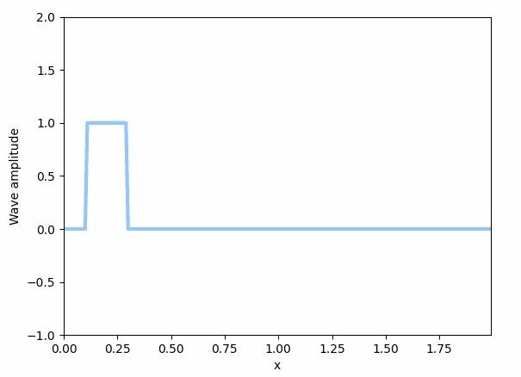

Plot 1: Initial square impulse

The following plot shows the analytic solution, followed by the “upwind” solution with Co = 1. These two solutions match exactly, as expected.

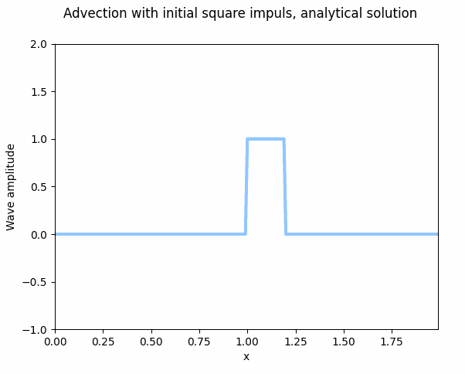

Plot 2: Analytical solution, square impulse

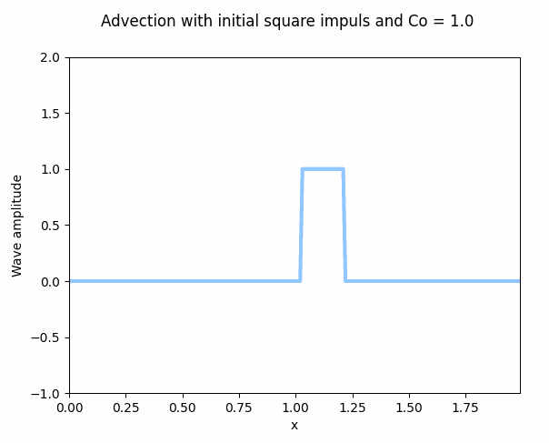

Plot 3: Upwind solution, square impulse, Co = 1

As expected, with Co > 1, the solution is unstable and explodes quickly even for Co only slightly bigger than 1.

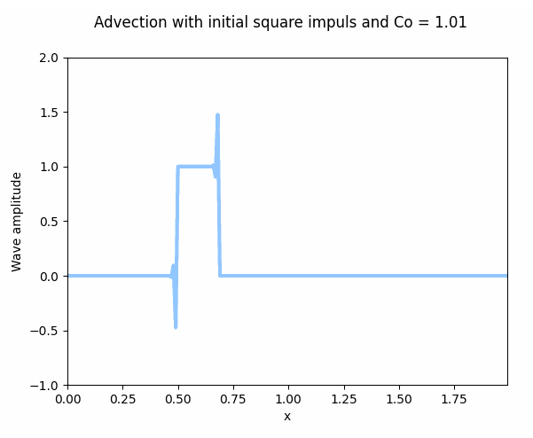

Plot 4: Upwind solution, square impulse, Co = 1.01

For Co smaller than 1, the solution remains stable, but we introduce an error, e.g. the solution does not correlate to pure advection. The error is scaled with (1 – Co). The following plot shows the solution with Co = 0.7. One can clearly see the dissipation.

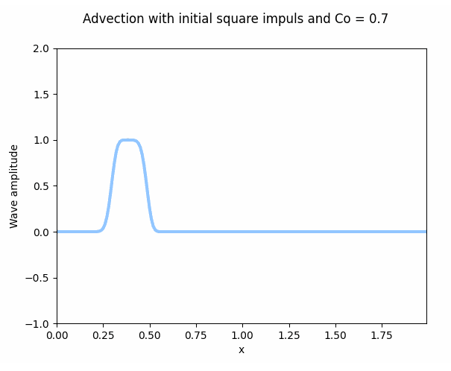

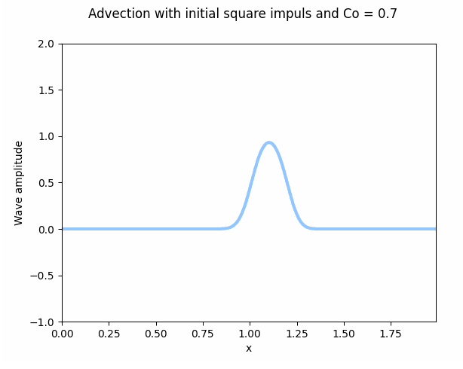

Plot 5: Upwind solution, square impulse, Co = 0.7

1. **Initial condition: *C* = exp(−10(4*x* − 1)^2))**

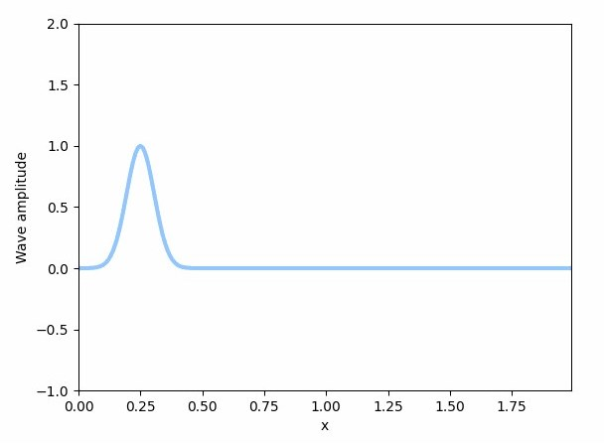

Plot 6: Initial Gaussian impulse

The following plot shows the analytic solution, followed by the “upwind” solution with Co = 1. These two solutions match exactly, as expected.

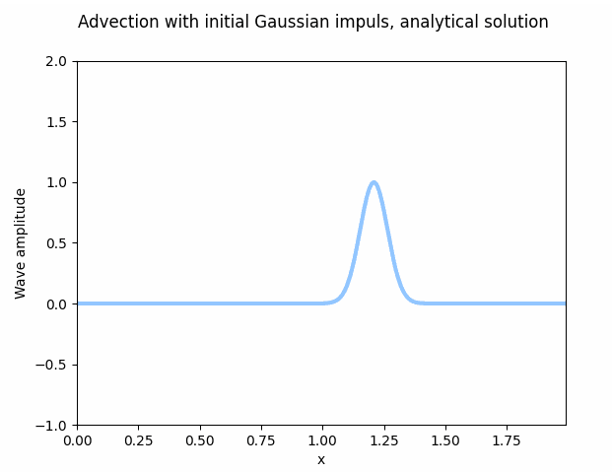

Plot 7: Analytical solution, Gaussian impulse

For Co ≠ 1, one observes exactly the same behavior as with the square impulse, with the following observations:

* the “explosion” of the unstable solution happens later and is better visible with slightly higher Co = 1.05
* the dissipation for Co = 0.7 is not that obvious, as the shape of the wave remains roughly the same (amplitude sinks and the “base” widens)

Co = 1.05:

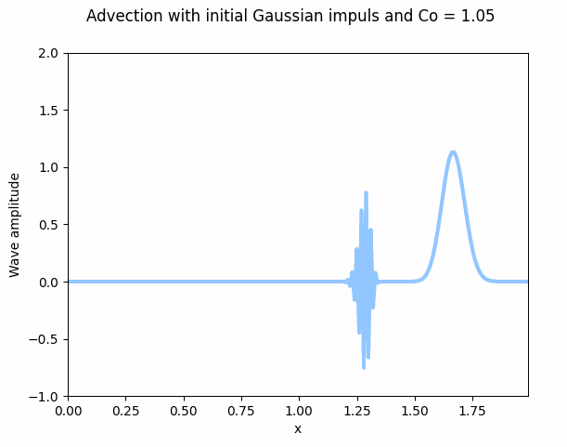

Plot 8: Upwind solution, Gaussian impulse, Co = 1.05

Co = 0.7:

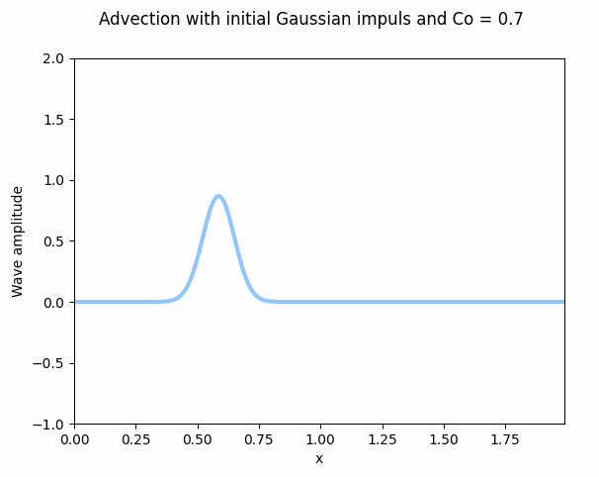

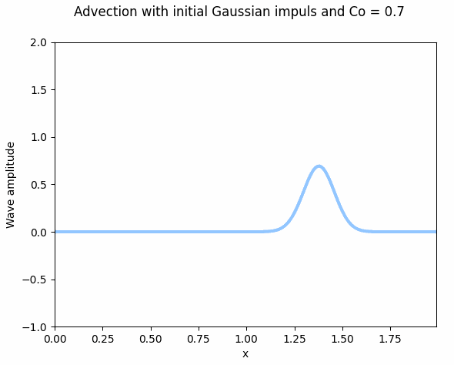

Plot 9: Upwind solution, Gaussian impulse, Co = 0.7

**Summary**

We were able to reproduce the behavior presented in the lecture. The moving plots (gif) are to be found within the same folder as this report and are denoted with their respective Courant number and initial condition.