|  |
| --- |
| **MES** International School  PATTAMBI 679303, PALAKKAD (DIST), KERALA  Affliated with CBSE, Delhi Code No. 930072 CBSE School N0. 75052 |
| **IDMS**  **Iris-based Driver Alertness Monitoring System**  A Project Report for ALL INDIA SENIOR SCHOOL CERTIFICATE EXAMINATION  Conducted by CBSE During the Year  2023- 2024 |
| **DEPARTMENT OF COMPUTER SCIENCE** |



|  |
| --- |
| **MES** International School  PATTAMBI 679303, PALAKKAD (DIST), KERALA  Affliated with CBSE, Delhi Code No. 930072 CBSE School N0. 75052 |
|  |
| **DEPARTMENT OF COMPUTER SCIENCE** |



is a bonafide record of their labour

**"Classic Games In Python"**

This is to certify that this student worked hard

under my guidance with dissertation entitled

NAME OF THE STUDENT :

REGISTER NUMBER :

PROJECT GUIDES : SOBITHA A RAHMAN

SUBEENA YASIR

SCHOOL SEAL : SIGNATURE OF PRINCIPAL :

SIGNATURE OF EXAMINER 1 : SIGNATURE OF EXAMINER 2 :

# INDEX

|  |  |  |
| --- | --- | --- |
| Sl. No. | Description | Page No. |
| 1 | Acknowledgement | 2 |
| 2 | Introduction | 3 |
| 3 | Objectives | 3 |
| 4 | Working | 4 |
| 5 | Algorithm   1. Iris Detection System |  |
|  | 5 |
| 6 | Source Code | 8 |
| 7 | Output | 21 |
| 8 | Bibliography | 43 |

**CONTENTS**

|  |  |  |
| --- | --- | --- |
| **S.NO** | **DESCRIPTION** | **PAGE NO:** |
| 01 | ACKNOWLEDGEMENT | 4 |
| 02 | INTRODUCTION | 5 |
| 03 | OBJECTIVE OF THE PROJECT | 5 |

**ACKNOWLEDGEMENT**

Apart from my effort, the success of my project depends largely on the encouragement and guidelines of many others. I take this opportunity to express my gratitude to the people who have been supportive in the successful completion of this project.

I express a deep sense of gratitude to the almighty God for giving me strength for the successful completion of the project.

I express my heartfelt gratitude to my parent for constant encouragement throughout this project.

I gratefully acknowledge the contribution of the individuals who have contributed in the making of this project.

I express my deep sense of gratitude to the luminary, the Principal, Mrs. Asha Byju, who has been a continuous source of motivation throughout this project.

I am, overwhelmed to express my thanks to the administration officer for providing me an infrastructure and moral support while carrying this project in the school

My sincere thanks to Mrs. Subeena and Mrs. Sobitha, the teachers in-charge, my guides, my mentors and above all friends, who critically reviewed my project and helped in solving each and every problem, that had occurred during the implementation of the project.

The guidance and support received from all the members who contribute and who are contributing to this project, was vital for the success of the project. I am grateful for their constant support and help.

**PROJECT ON :**

**INTRODUCTION**

IDAMS is a non-intrusive system that uses infrared cameras to monitor the driver's eyes. The system tracks the pupil's movement, blinking rate, and overall eye behavior to assess the driver's alertness. If the system detects that the driver is drowsy, it will issue a warning to the driver.

**OBJECTIVES**

Driver fatigue is a major cause of road accidents.The objective of this project is to reduce the number of deaths and injuries caused by driver fatigue in each year

* **Enhance driver safety:** IDAMS aims to significantly reduce the incidence of drowsy driving accidents by providing real-time monitoring of driver alertness.
* **Improve driver awareness:** IDAMS provides drivers with feedback on their alertness levels, promoting self-awareness and encouraging them to take breaks when necessary.
* **Reduce fatigue-related errors:** IDAMS can detect subtle signs of fatigue before they escalate into drowsiness, helping drivers maintain focus and avoid errors.
* **Promote responsible driving habits:** IDAMS encourages responsible driving practices by alerting drivers to potential drowsiness and prompting them to take appropriate countermeasures.
* **Contribute to the development of advanced driver assistance systems (ADAS):** IDAMS serves as a valuable component of ADAS, paving the way for more comprehensive and intelligent driving assistance technologies

**ALGORITHM:-**

1. Initialize the necessary libraries and variables:

* Import the required libraries: OpenCV, NumPy, and Dlib.
* Initialize the camera capture object.
* Initialize the face detector and landmark detector.
* Initialize variables for tracking drowsiness and alertness levels.
* Initialize variables for tracking eye blinks.

1. Capture a frame from the camera:

* Capture a frame from the camera using cv2.VideoCapture.read().

1. Convert the frame to grayscale:

* Convert the captured frame to grayscale using cv2.cvtColor().
* Detect faces in the grayscale frame:
* Detect faces in the grayscale frame using the face detector.

1. For each detected face:

* Extract the facial landmarks using the landmark detector.
* Calculate the eye blink ratio for each eye.
* Determine the current state (sleeping, drowsy, or active) based on eye blink ratios.
* Update the drowsiness and alertness levels based on the current state.
* Draw a rectangle around the detected face.
* Draw circles around the facial landmarks.
* Display the current state on the frame.

1. Display the frame and the result of the detector:

* Display the original frame using cv2.imshow().
* Display the frame with the detected face and landmarks using cv2.imshow().

1. Check for user input:

* Check if the user has pressed the Esc key (27).

1. Break the loop if the user has pressed Esc:

* If the Esc key is pressed, break the loop to terminate the program.

1. Continue capturing frames and processing them:

* Repeat steps 2 to 8 until the Esc key is pressed.

**SOURCE CODE:-**

###TIC, TAC TOE, ROCK PAPER SCISSORS, GUESS MY NUMBER####

**TIC TAC TOE**

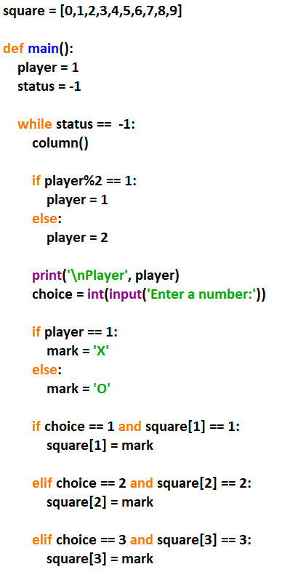

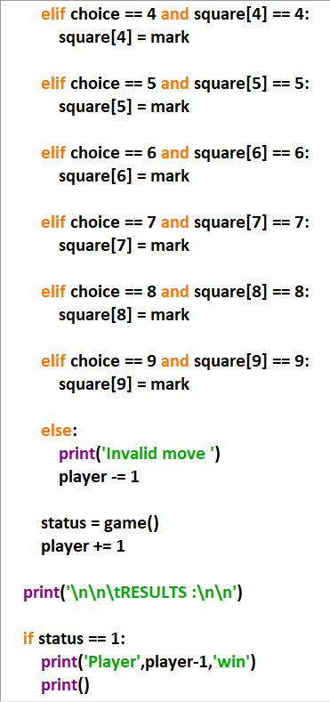

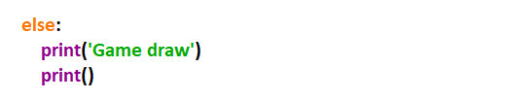

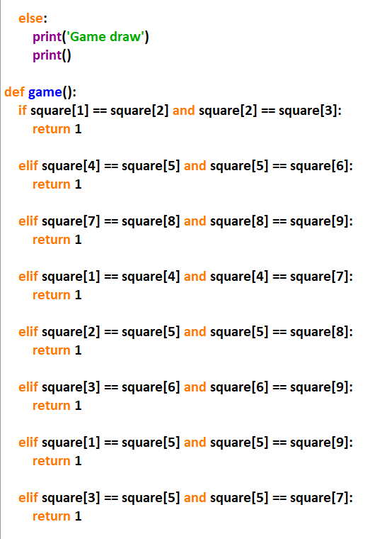

**OUTPUT**





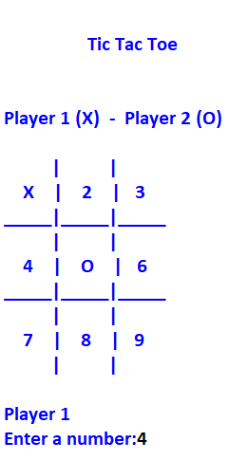

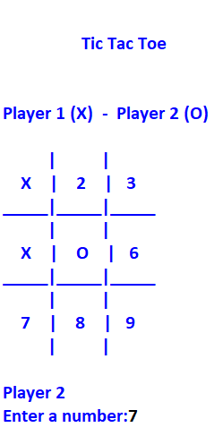

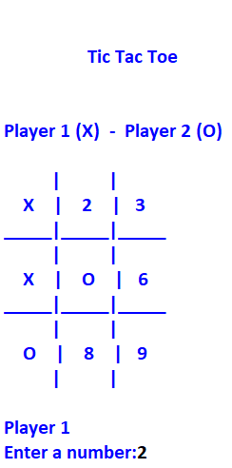

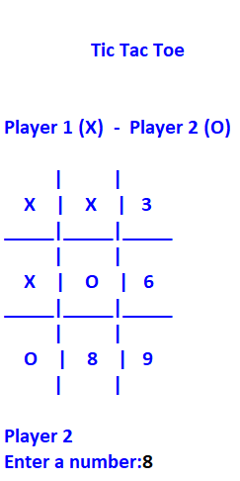

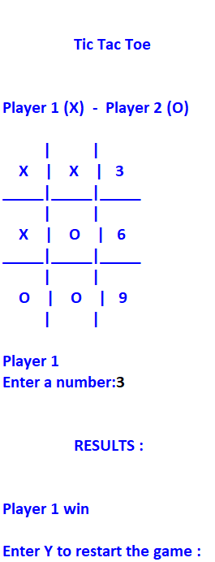



**ROCK PAPER SCISSORS**

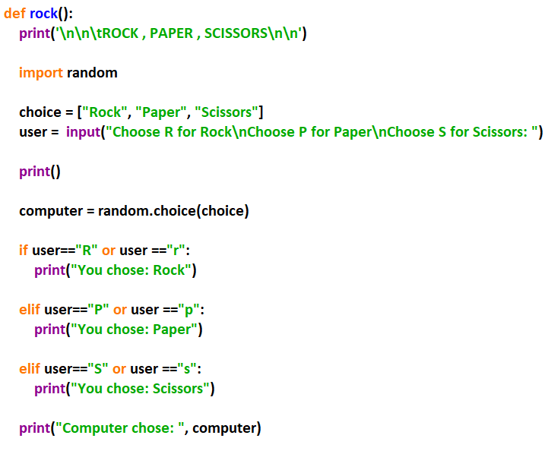

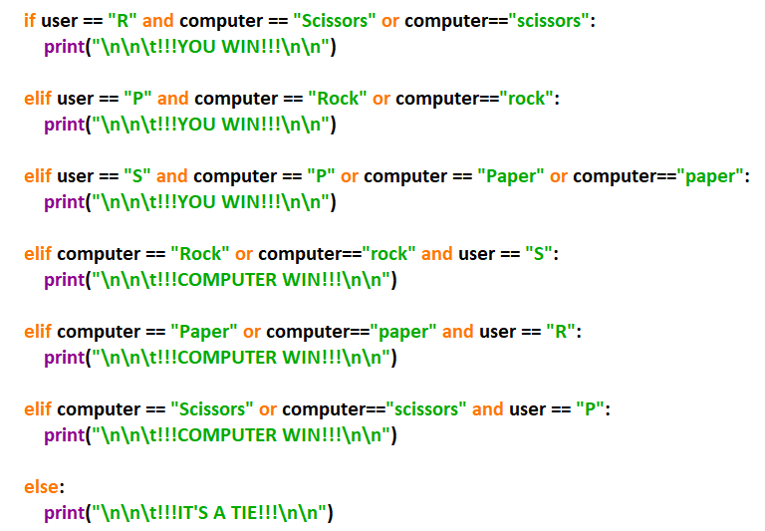

**OUTPUT**



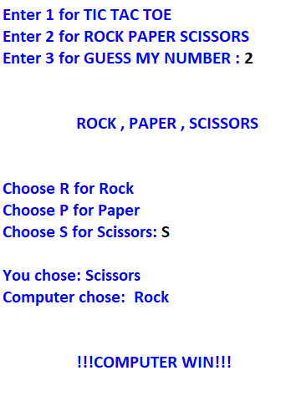

**GUESS MY NUMBER**

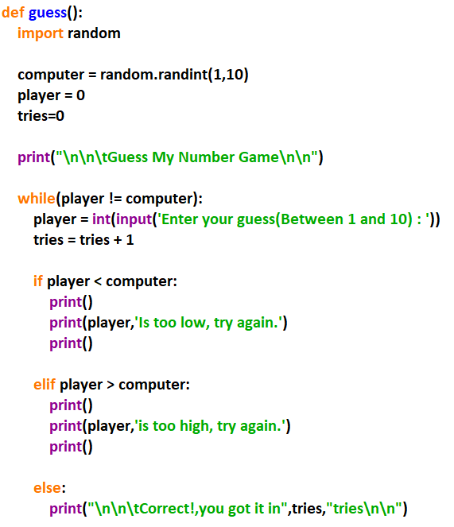

**OUTPUT**

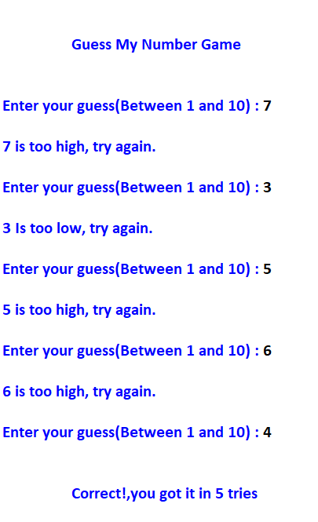

**MAIN PROGRAM**

