AI Prototype Demonstration
and Deployment Planning
Real-Time Network Intrusion Detection Using Machine Learning-Based Multi-Class Classification
Group 19 | FUSE AI-201 - AI Model Development and Implementation
Team: Adugna Necho Mulatu; Aminadab Tewhibo Mihret; Hussen Yasin Mohammed; Abdulfetah Hayerdin Mohammed; Nebiyu Mesfin Fikade.
Public resource | Link
GitHub source and model artifacts | https://github.com/adugnaNecho/Group19-network-intrusion-detection
Hosted Streamlit prototype | https://group19-network-intrusion-detection.streamlit.app/
Latest FPR chart hotfix commit | 8941226

1. Executive summary
Group 19 developed and deployed a five-class network-connection classifier using the public NSL-KDD benchmark. The prototype accepts a CSV of 41 connection features and returns a predicted class (Normal, DoS, Probe, U2R or R2L), the maximum class probability, a threat-severity label and probabilities for all five classes. A separate Analytics Dashboard summarizes benchmark evaluation evidence and predictions for the current upload.
The solution demonstrates the progression from the Module 4 problem proposal and Module 5 model implementation to a hosted Module 6 prototype with testing evidence and a proposed monitoring/support/maintenance plan. It is not a live packet sensor, firewall, automatic blocking system or production-grade security monitoring service.

Prototype capabilities
- Public GitHub repository for source, notebook, tests, documentation and versioned model artifacts.
- Public Streamlit Community Cloud interface for CSV upload, five-class inference and downloadable results.
- Analytics Dashboard with grouped validation/test comparison, class-wise metrics, confusion matrix and FPR evidence when present in the evaluation artifact.
- Optional FastAPI API and Docker packaging included in the repository; these are not separately hosted production services.
- Final source package test run: 29 automated tests passed in the finalization environment.

Hosted prediction demonstration
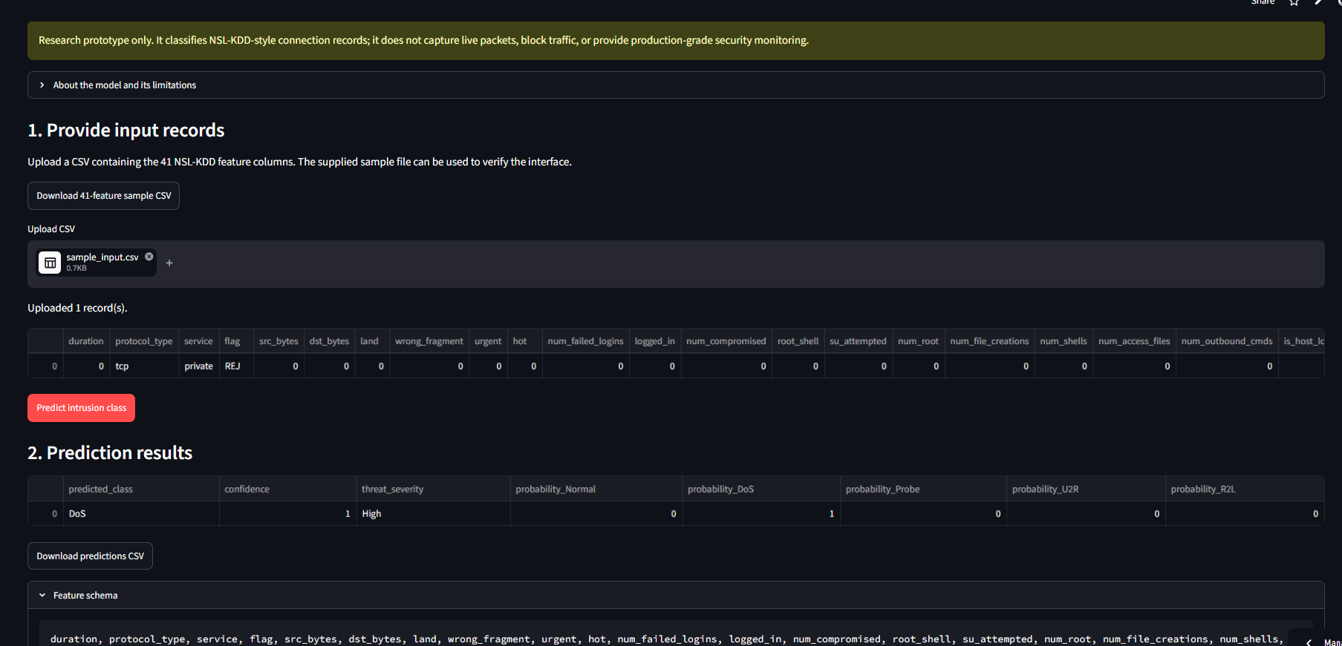
Figure 1. Group-provided screenshot of the deployed CSV prediction interface. The displayed one-row DoS output (maximum class probability 1.00; severity High) is an interface example, not proof of a correct or calibrated prediction.

2. Problem, dataset and model
Network intrusion detection requires distinguishing benign connection behavior from different attack categories. This project formulates the task as supervised five-class classification using NSL-KDD connection-level records. Raw labels are consolidated into Normal, Denial of Service (DoS), Probe, User-to-Root (U2R) and Remote-to-Local (R2L).
Dataset partition | Records | Role
KDDTrain+ | 125,973 | Training source
Training subset after split | 103,738 | Model fitting; SMOTENC applied within training pipeline
Validation subset | 22,235 | Stratified validation from KDDTrain+
KDDTest+ | 22,544 | Independent final test; not used for tuning

Model and preprocessing pipeline
- 41 NSL-KDD connection features are supplied to the model; label and difficulty metadata are excluded from predictors.
- Numerical features use median imputation and standard scaling.
- Categorical features (protocol_type, service and flag) use most-frequent imputation and one-hot encoding with unseen categories ignored.
- SMOTENC is integrated in the imbalanced-learn training pipeline and is used to synthesize minority examples during model fitting only.
- The selected Random Forest configuration reported by the training script uses 250 trees, max_depth=20 and min_samples_split=5.
- The preprocessing and estimator are saved as one joblib pipeline; a class mapping, evaluation JSON and SHA-256 sidecar are also exported.

3. Latest evaluation results
The following values are transcribed from the successful training run shared by the group on November 2-3, 2026. Validation and independent-test results are shown separately.
Metric | Validation | Independent KDDTest+
Accuracy | 99.89% | 74.62%
Macro precision | 97.17% | 79.35%
Macro recall | 99.46% | 48.71%
Macro F1 | 98.26% | 51.51%

Independent-test recall by class
Class | Recall | Support
Normal | 97.28% | 9,711
DoS | 76.57% | 7,460
Probe | 53.52% | 2,752
U2R | 8.96% | 67
R2L | 7.20% | 2,554

Interpretation: the validation-to-test gap is substantial. Low U2R and R2L recall indicates that the aggregate accuracy hides important weaknesses. The model is suitable for a benchmark prototype demonstration only; it must not be the sole basis for operational security decisions or automated blocking.

4. Public prototype and analytics dashboard
The public interface is hosted at https://group19-network-intrusion-detection.streamlit.app/ and uses the public GitHub repository https://github.com/adugnaNecho/Group19-network-intrusion-detection. The user workflow is: open the app, obtain or prepare a CSV with all 41 required model features, upload it, run Predict intrusion class, inspect class/score/severity outputs, and download the prediction CSV.

Benchmark analytics
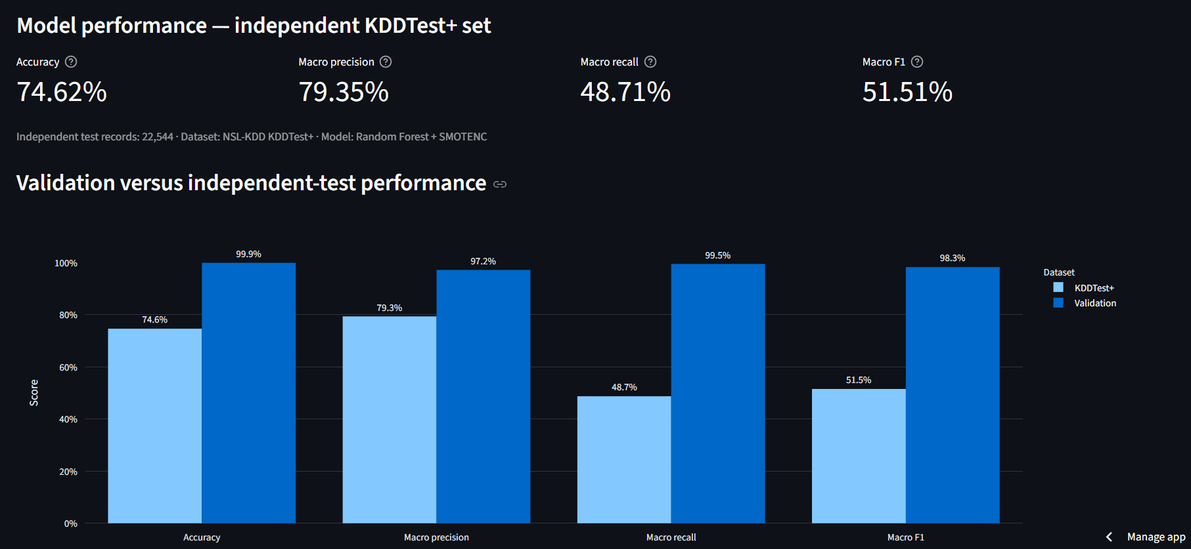
Figure 2. Supplied screenshot of grouped validation-versus-independent-test results. Separate bars use a 0-100% axis; the independent test provides the more conservative generalization estimate.

Class-wise performance and confusion matrix
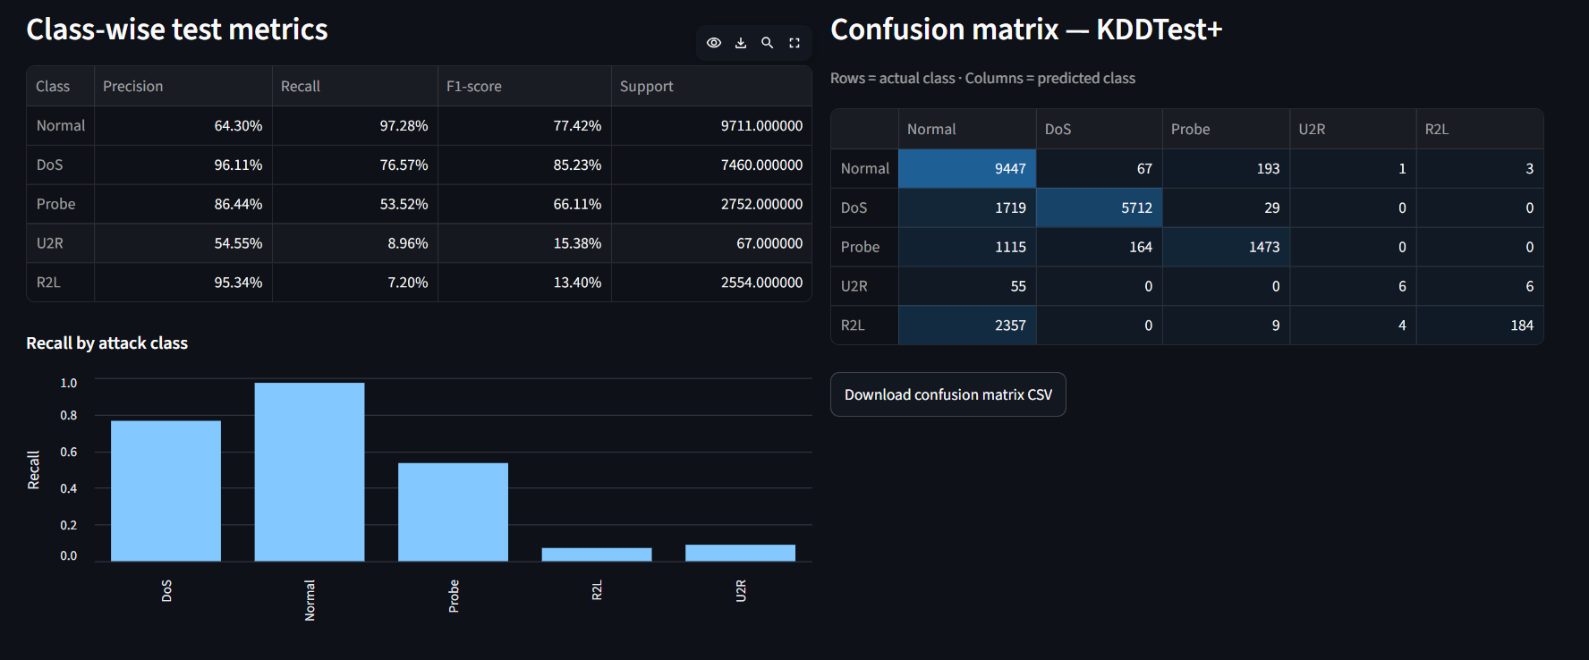
Figure 3. Supplied screenshot of class-wise test metrics and the measured 5 x 5 KDDTest+ confusion matrix. Rows are actual classes; columns are model predictions. This capture predates the final formatting refinement; the final source uses integer support counts and the same Normal, DoS, Probe, U2R, R2L order across class views.

5. FPR analysis and uploaded-record analytics
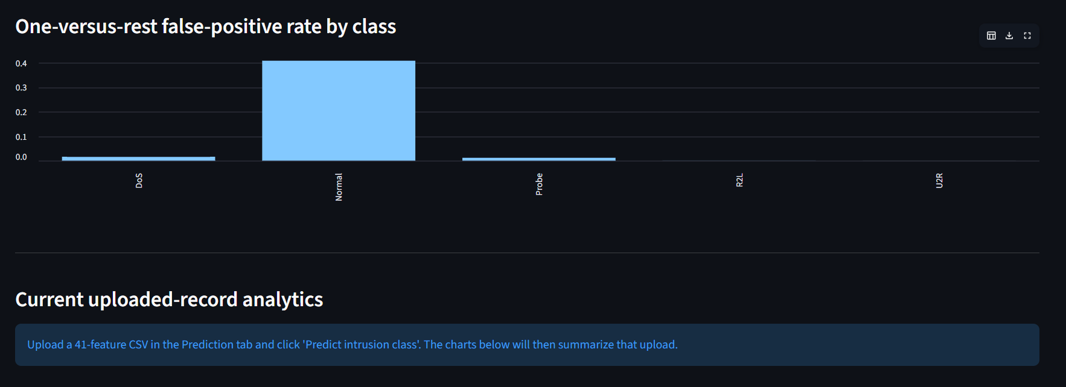
Figure 4. Supplied screenshot of one-versus-rest false-positive-rate visualization and the current-upload analytics section. The captured screen predates the final FPR chart hotfix.
The uploaded-record analytics summarize model predictions, not ground-truth labels. The feature plots use record order, not time, because the 41-feature NSL-KDD input schema contains no timestamps. Source/destination byte values may be log-transformed for display; this presentation transform does not modify model inputs.

6. Deployment and technical evidence
Component | Status in this project
GitHub repository | Public source/documentation repository; model artifacts reported under artifacts/.
Streamlit Community Cloud | Public hosted CSV prediction and Analytics Dashboard application.
FastAPI | Optional API source included; not claimed as a separate public hosted service.
Docker | Optional container packaging included; not claimed as a production deployment.
Automated tests | 29 tests passed in the finalization-environment source-package run; rerun locally before submission.

The FPR chart data-schema/fallback correction was committed to GitHub as `8941226`. The earlier Cloud screenshot showed a ValueError during Plotly FPR chart construction. The hotfix adds an explicit class column and a table fallback if chart rendering fails. The final post-hotfix Streamlit Cloud rebuild/smoke test should be confirmed in Manage app -> Logs before recording and submission.

7. Monitoring, support and maintenance plan
- Monitor request volume, latency, errors, resources, artifact version and prediction distribution in any future pilot.
- Use analyst-verified labels for rolling class-wise metrics; predicted labels alone are not ground truth.
- Screen feature drift and investigate sustained change; proposed PSI/KS thresholds are not validated production triggers.
- Retrain only with authorized reviewed labels; preserve an independent test set and record data, code, dependencies, metrics and checksums.
- Evaluate candidates offline and in shadow mode without enforcement; retain rollback and analyst review.
- Protect sensitive data, control retention/access, review dependencies and load only trusted model artifacts.
Status: these are proposals for a future pilot. Continuous monitoring, shadow deployment, automatic retraining, live packet capture, fallback IDS and production on-call are not implemented.

8. Data statement, limitations and future work
Data statement: public NSL-KDD benchmark records are used for training/evaluation; the sample CSV is constructed for interface demonstration. SMOTENC creates synthetic minority observations during training only; validation and KDDTest+ are not oversampled. Raw benchmark records are not redistributed in this ZIP.

Limitations
- Independent KDDTest+ Macro F1 is 51.51%, below validation Macro F1 of 98.26%.
- U2R recall is 8.96% and R2L recall is 7.20%; these classes are not reliably detected.
- NSL-KDD is historical benchmark data; modern/zero-day generalization is not established. The app classifies uploaded records only and does not capture live packets, block traffic or monitor production networks.
- The maximum class probability is not calibrated confidence without a separate calibration study.

Future improvements
- Analyze R2L/U2R false negatives and test class-sensitive learning with training-only cross-validation.
- Evaluate calibration, decision thresholds and newer authorized datasets with verified labels.
- Conduct a controlled pilot with human review, privacy/security safeguards and measured monitoring before operational use.

9. Group members and contribution record
The Module 5 notebook lists Adugna Necho Mulatu, Aminadab Tewhibo Mihret, Hussen Yasin Mohammed, Abdulfetah Hayerdin Mohammed and Nebiyu Mesfin Fikade. Individual roles are not specified in the notebook; members must complete `docs/team_contributions.md` with their actual work and evidence.

10. Canvas submission notes
Deliverable A is represented by this project portfolio and the public GitHub repository. Deliverable C is the separate one-page retrospective. Deliverable D is the separate data statement. Deliverable B requires the group to record an 8-9 minute capstone video (maximum 10 minutes and 250 MB); a recording script is included in the project package, but the actual video is not created here.
Confirm the Canvas deadline: the supplied page header stated November 11, 2026 at 9:59 a.m.; the embedded instructions stated November 6, 2026.

References
References: Tavallaee et al. (2009), “A Detailed Analysis of the KDD CUP 99 Data Set,” IEEE Symposium on Computational Intelligence for Security and Defense Applications. Dataset host: KaggleHub `hassan06/nslkdd`; public mirror: https://github.com/jmnwong/NSL-KDD-Dataset. Streamlit Community Cloud documentation: https://docs.streamlit.io/deploy/streamlit-community-cloud/.

