
The Great British Bake Off
SERIES TWO

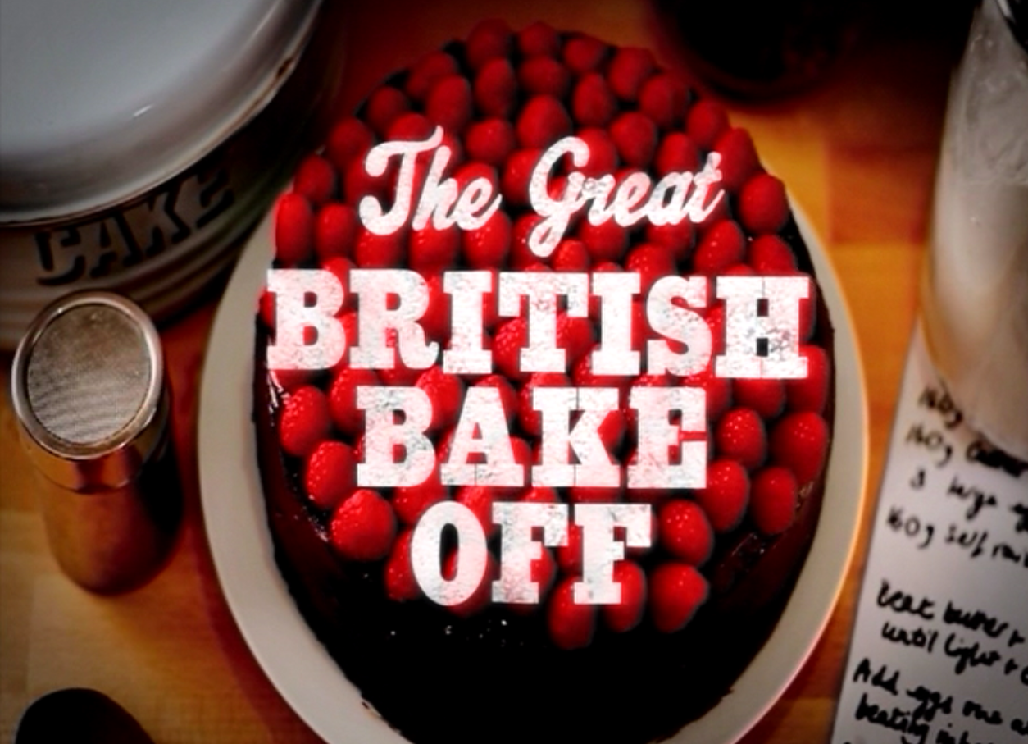
The BBC is looking to find Britain’s best amateur baker for the return of this exciting BBC2 series. If you would like to apply, please fill in the short form below. For eligibility criteria, please see application rules at the bottom of this form.

Please return to: BAKING@LOVEPRODUCTIONS.CO.UK or post to Love Productions, The Great British Bake Off Team, 43 Eagle Street, London, WC1R 4AT.

PLEASE ATTACH A RECENT PHOTO OF YOURSELF TO YOUR APPLICATION AND ANY PICTURES YOU MAY HAVE OF YOUR BAKING

BASIC DETAILS
Name
Age
Date of birth
Address
Contact numbers
Email address
Occupation
Nationality
BAKING INTERESTS
How long have you been baking for?

Who taught you how to bake?

Why do you enjoy it?
How often do you bake?

How wide is your baking repertoire?

What’s your experience level and how often do you bake each of these

- Biscuits

- Bread

- Pies

- Pasties

- Cakes

- Tarts

- Pastries

Please give an example of the most difficult thing you have baked in each discipline.

- Biscuits

- Bread

- Pies

- Pasties

- Cakes

- Tarts

- Pastries

Do you have a signature bake?

If so, why is it special? How did it become your signature bake? Any background / stories connected with it?

Do you have any family stories about baking? e.g. memories, family favourites, recipes handed down the generations, baking anecdotes
Have you ever had any baking disasters?!
Do you belong to any cookery related groups / clubs?
Have you ever studied any aspect of food / cookery / bakery at any level? If so, please give details and dates

Have you ever acquired any formal NVQ or other professional catering qualifications? If so, please give details and dates.
Have you ever worked in a food / cookery related field, past or present? If so, please give details (your exact role, was it full time or part time, please gives dates)
ABOUT YOURSELF
What is your living situation (married, co-habiting, living with parents, single, etc)
What other hobbies do you have?
What is your greatest ambition in life?

What do you think has been your greatest achievement in life so far?
Have you been on TV before? If so, please give details

Do you have any criminal convictions? If so, please give details

Anything else you would like to add?

THANK YOU

The Great British Bake Off Application Rules

- You must be aged 16 or above on 1st of April 2011.

- You must be resident of the UK (inc Isle of Man and Channel Islands).

- You must not have any catering NVQ or other catering qualifications unless acquired over 10 years ago.

- You cannot have ever worked full time as a baker, cook or chef.

- Your main source of income must not derive from commercial baking in a professional environment (restaurant, hotels, canteens, shops etc). The term ‘baking’ refers to the preparation and oven cooking of flour based goods such as bread, cakes, pastries, pies, tarts, and biscuits. It does not refer to other food forms that can be oven cooked, or other methods of cooking.

- You must be able to commit to all the filming days required which are currently expected to be during April, May and June 2011.

- You must not be or be closely related to a member of the BBC or Love Productions staff or anyone connected with the programme.

- You cannot have been convicted of any serious crime. Details of unspent convictions should be listed on the application form.

- If you are chosen to participate in the Programme, you agree to authorise Love Productions to conduct background checks in order to verify any of the information you have supplied and you agree to provide them with any assistance or further information necessary to do this.

- Submission of an application form and compliance with the above does not in any way constitute an offer to appear on the programmes.

- When selecting applicants for ‘The Great British Bake Off’ the following will be taken into account: skill, enthusiasm, drive, love of baking, lively characters who are comfortable being filmed. Initial selection will be based on the application forms and telephone interviews. In addition the Producers may (but may not) invite short listed applicants to attend an interview at their discretion. We will be looking for a mix of finalists to reflect the range in age, location, gender and diversity of amateur bakers in Britain.

- Love Productions have no obligation to produce the programme and even if the programme is made there will be no obligation on the BBC to broadcast or transmit or otherwise exploit the programme or include you or any filming in the programme.

- By submitting your application form you grant to Love Productions (and its licensees and assigns including the BBC) all necessary rights and consents for the full period of copyright (and afterwards so far as possible in perpetuity) to copy edit and/or use at their sole discretion the application form for any purposes connected with the programme, the promotion and advertising thereof and all other rights (including all allied and ancillary rights) by any means and in any and all media now known or hereafter invented throughout the world.

- If you are selected to take part in the programme you agree to sign a contributor consent form and grant all necessary rights.

- Application forms will be retained by Love Productions and by submitting your application you agree that they may share the information with the BBC. Love Productions and the BBC will use your personal details only for the purposes of considering your application for this series and for potential future series, for administration and for related services should you be successful. Your personal information will not be passed to anyone else except where we are obliged to do so. The information will be kept securely and in accordance with the Data Protection Act 1998 and other applicable legislation.

- The Production team's decisions regarding selection to the programmes are entirely at their discretion and are final.

