How to program in colorForth cf2023

Contents

Introduction 2

Step 1 Download and run colorForth 2

Step 2 Edit block 498 7

Step 3 Enter the program 9

Step 4 Save your work 12

Step 5 Load and run the program 14

Step 6 More features 15

Step 7 Save Your Work part 2 17

Appendix A Useful Commands 18

# Introduction

This is a tutorial on how to program in colorForth under Windows, using the [cf2023](https://www.inventio.co.uk/colorforth/) system that I distribute and support.

[colorForth](https://www.inventio.co.uk/colorforth/) is a dialect of the [Forth](https://en.wikipedia.org/wiki/Forth_(programming_language)) programming language, both of which languages were invented by Charles H. “Chuck” Moore ; - Forth around 1968, and colorForth in the late 1990’s.

The file [cf2023_colorForth.pdf](https://www.inventio.co.uk/colorforth/cf2023_colorForth.pdf) gives a more detailed explanation. colorForth is not like anything else.

When you press a key in colorForth something happens. Exactly what happens depends on the current state of the system, and this system state is displayed on the screen. In the abstract, this is true of every computer program – the difference with colorForth is that it is complete – there is nothing else going on.

[cf2023](https://www.inventio.co.uk/colorforth/) is and always will be work in progress. I hope to add version control, strings etc. etc. but without losing colorForth’s amazing simplicity.

My intention in supporting colorForth is to make it accessible to as many people as possible.

Feedback welcome howerd@inventio.co.uk [www.inventio.co.uk.](http://www.inventio.co.uk/)

Have fun!

Howerd Oakford

Step 1 Download and run colorForth

Download the file “cf2023_2023Apr04_roomed-zebra.7z” from : <http://www.inventio.co.uk/colorforth/>or by clickin[g](https://www.inventio.co.uk/cf2023/cf2023.7z) [here](https://www.inventio.co.uk/cf2023/cf2023_2023Apr04_roomed-zebra.7z):

<https://www.inventio.co.uk/cf2023/cf2023_2023Apr04_roomed-zebra.7z>

Unzip the file on a computer running Windows, for example into the folder cf2023.

Double click on **go.bat** .

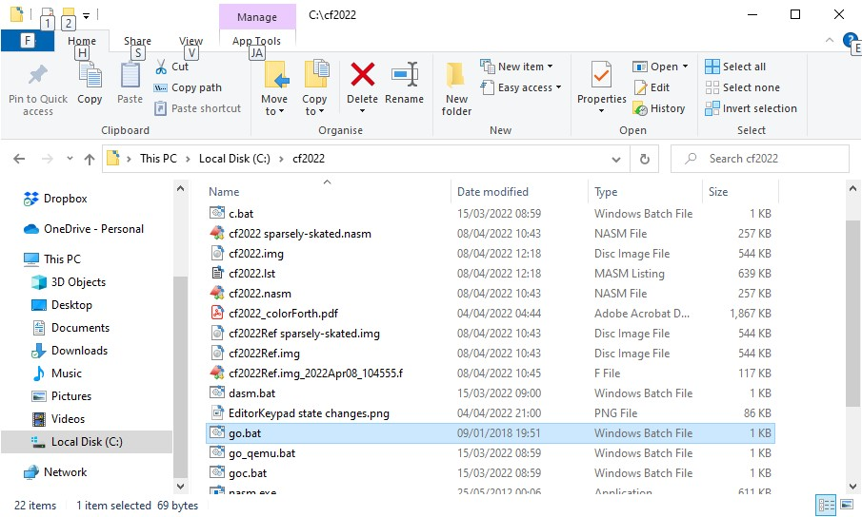

Press the Enter key on the keyboard or click on OK to allow Bochs to run in full screen mode :

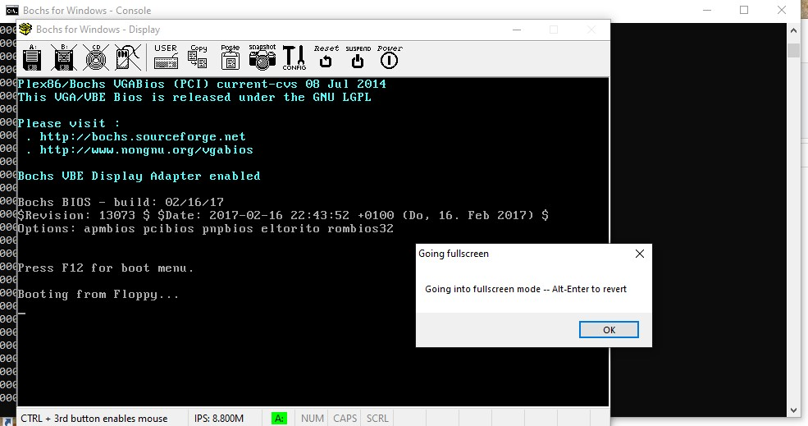

Note : you can press Alt-Enter on the keyboard to exit full screen mode, and from there you can click on the Power button to close Bochs.

The colorForth logo will flash briefly, then you should see block 64 in the colorForth editor :

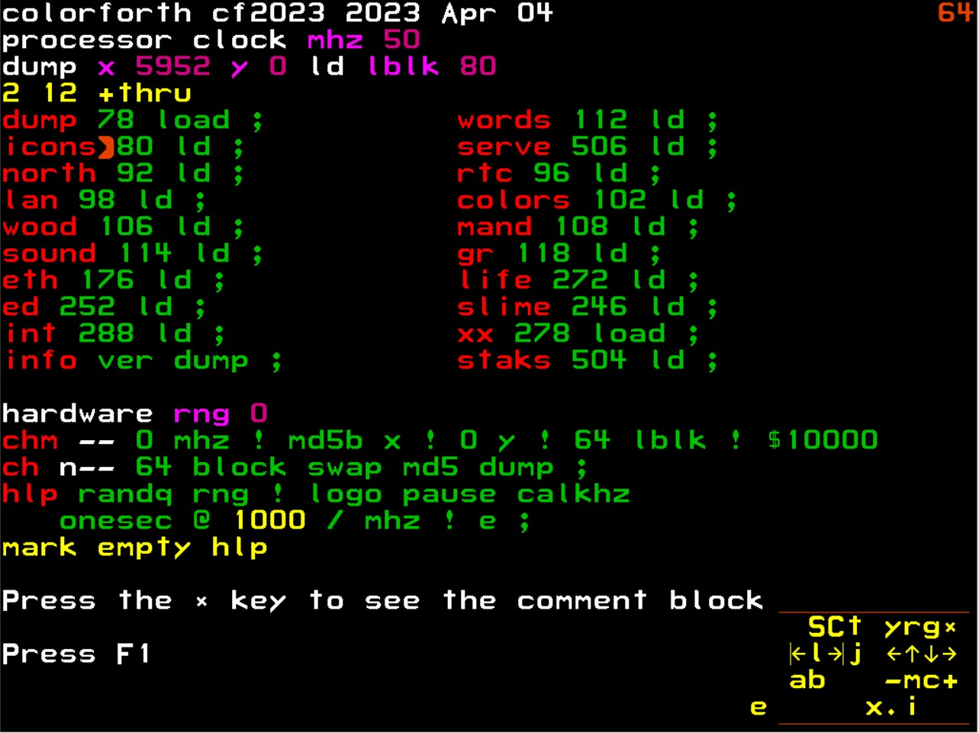

Press the F4 key on the keyboard to select colour-blind mode :

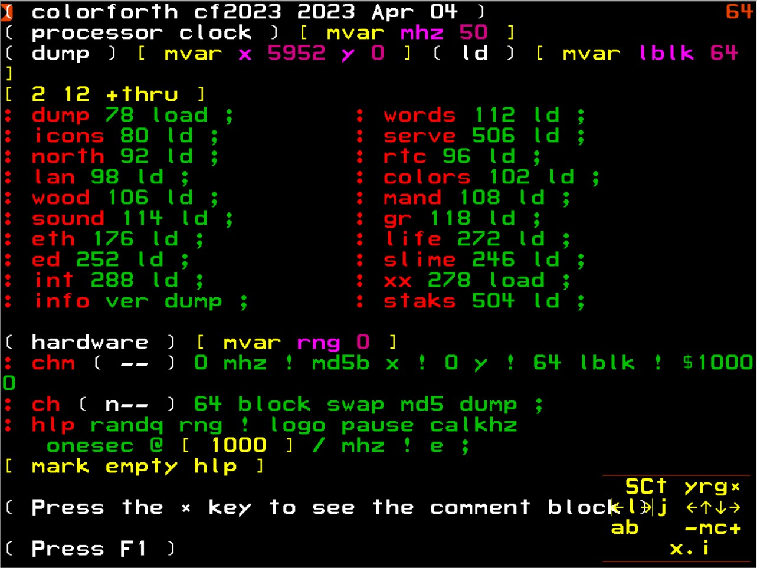

Colour-blind mode adds ‘:’ to red words, ‘(‘ and ‘)’ around comments and ‘[‘ and ‘]’ around immediate words.

This makes the code look more like conventional Forth, and makes it usable by colour-blind people.

Press the space bar on the keyboard to exit the colorForth Editor :

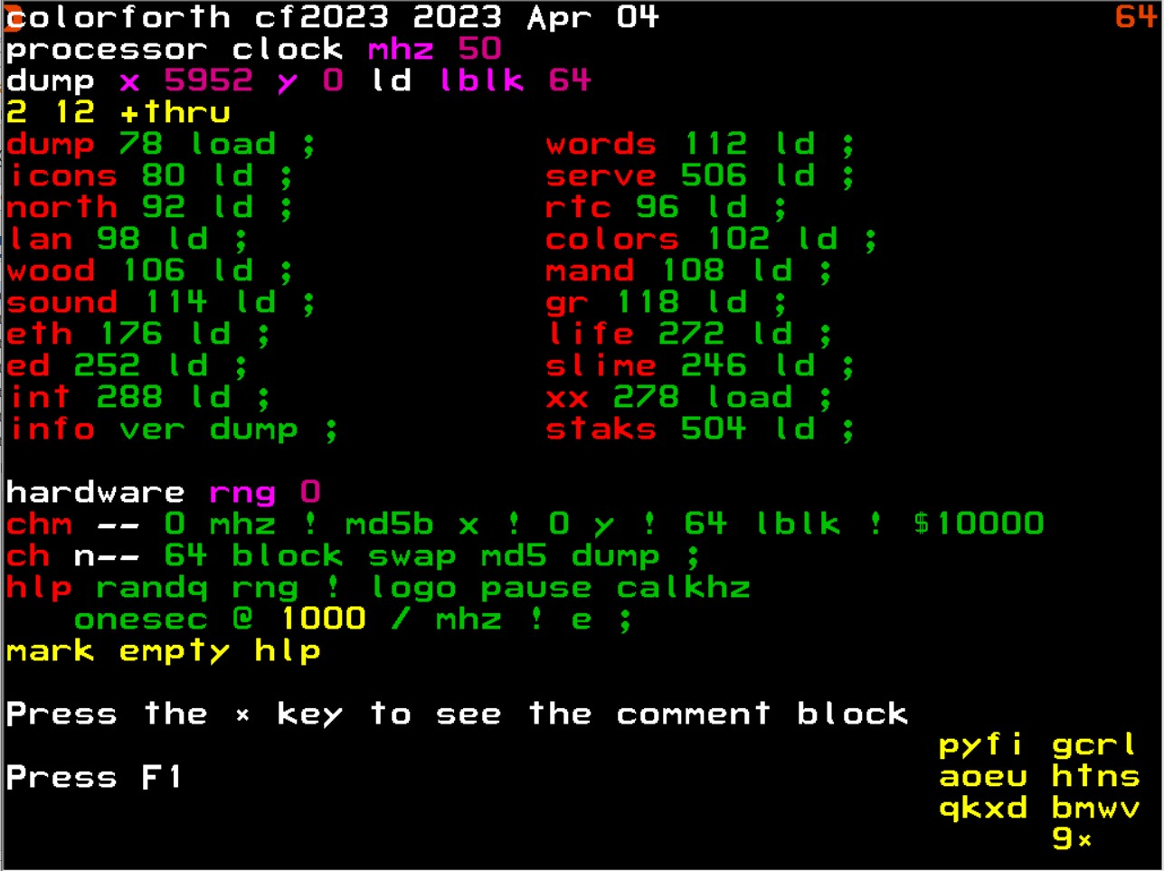

Notice the yellow keypad in the bottom right-hand corner showing “pyfi gcrl” etc. Yellow means “immediate” – whatever you type will be executed immediately when you press the space bar. Note that the two orange lines above and below the keypad (that indicate editor mode) are no longer there.

From now on, refer to the **keypad** to select which character to type, not the **keyboard**. You can read [cf2023_colorForth.pdf](https://www.inventio.co.uk/colorforth/cf2022_colorForth.pdf) for a more detailed explanation.

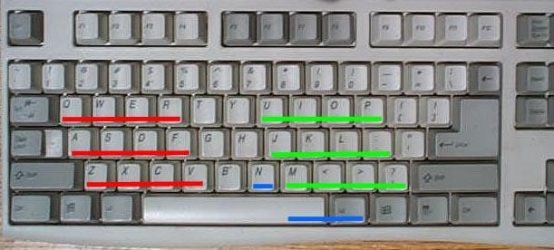

Figure 1 The **Keyboard**

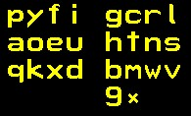

Figure 2 The **Keypad**

The “9*” on the bottom row of the keypad means that the Space bar will change to number mode (‘9’), and the small ‘x’ means that the AltGr key will change to alternate characters (such as *). The asterisk character ‘*’ looks like a small ‘x’, because it represents multiplication. The ‘N’ key on the keyboard is often used to exit a mode.

The actions for each of the 27 keys of the keyboard that are used is hinted at by the corresponding character on the keypad.

There is no underscore character ‘_’, so I will use it in the instructions below to mean “press the space bar”.

# Step 2 Edit block 498

Block 498 is where we will put our new program. Blocks 0 to 31 contain the primitive words of the colorForth system, blocks 32 to 63 contain the Forth words for the colorForth system, blocks 64 to 511 contain Apps.

_ \ press the space bar on the keyboard to enter number mode

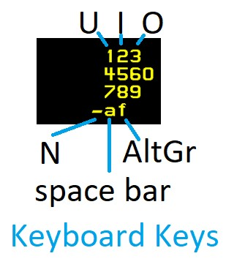

Figure 3 The keypad in number mode, showing keyboard keys

498 \ press the number keys to enter a number

This means, press the ‘I’ key, then the ‘K’ key on the keyboard, then whatever key is marked to the right of the ‘L’ key. On a German QWERTZ keyboard this is an ‘Ö’, on a QWERTY keyboard this is a ‘;’.

Press the space bar again to go back to text mode – this is hinted at by the ‘a’ on the keypad :

_ \ press the space bar on the keyboard to exit number mode

Now there is the number ‘498’ on the stack :

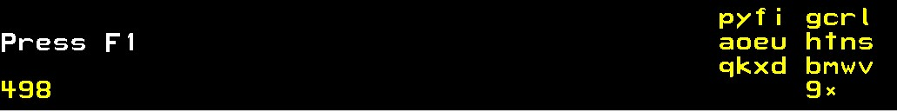

edit_ \ type “edit” to edit block 498 (the ‘_’ means the space bar)

To type “edit” you must press the keys DVRK on the keyboard, but it is best to try to forget about the keyboard and focus on the keypad. Note that the keypad is changing all the time.

The screen should now look like this :

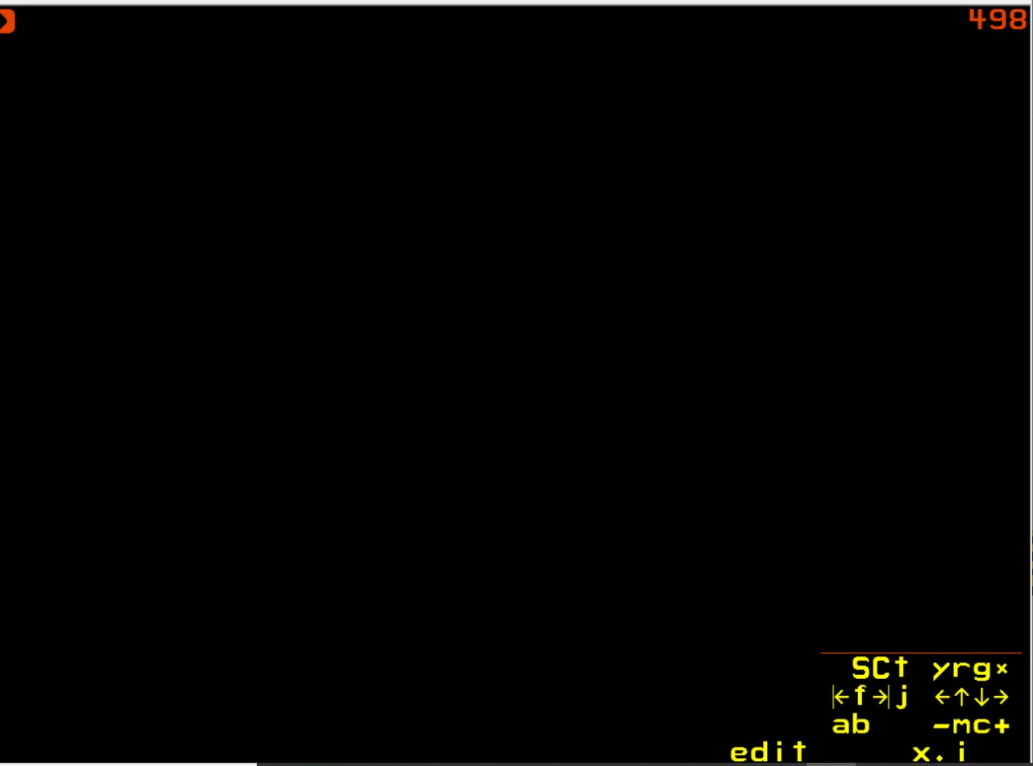

Top left is the orange cursor that shows where the next Forth word will be inserted.

Top right is the block number being edited, 498 in this case. This block is currently empty.

Bottom left shows the stack, which is also empty at the moment (it used to look like this).

The orange lines above and below the keypad show that we are in edit mode.

The word “edit” to the left of the keypad shows the last Forth word that was entered. As each character of a word is typed the character’s value is accumulated on the stack, and the text representation of this accumulated value is shown to the left of the keypad.

If you have exited the editor and want to get back, type “e” in yellow immediate mode, (then the space bar) to edit the last block that was edited.

We are now editing block 498, using the main editor keypad :

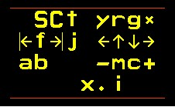

Figure 4 The main editor keypad

# Step 3 Enter the program

To define a new Forth word we need to enter a red name, so press ‘r’ on the main editor keypad (that is the ‘I’ key on the keyboard). There is no need to type a colon (‘:’ ) because in colour-blind mode one is automatically added.

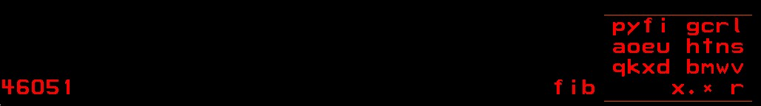

Figure 5 Creating the Forth word "fib", before pressing Space

Above shows the screen after having typed “fib”, but before pressing the space bar. The name “fib” is on top of the stack as a Huffman compressed value (46051), and is shown decompressed further to the right as “fib”.

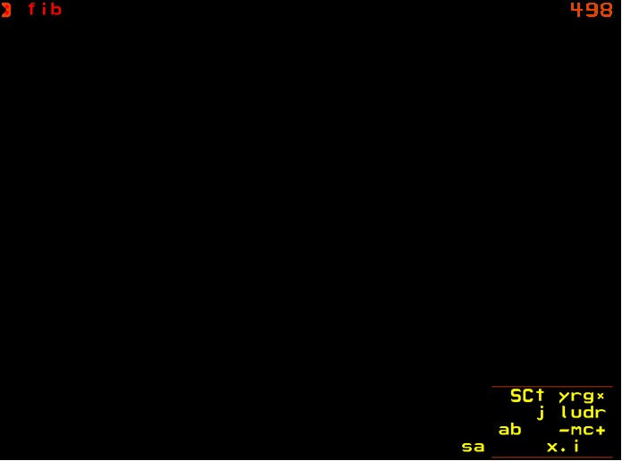

Figure 6 Creating the Forth word "fib", after pressing Space

After pressing the space bar, the value on the stack (45061) has been removed and copied to the cursor position in the block. The editor displays the value in the first 32 bits of the block as the red text (with a ‘:’) “fib”.

The editor keypad has now gone green, indicating compiling mode. Note the ‘g’ in the bottom right of the keypad, indicating green (it was previously a red ‘r’).

The cursor has now moved until after the “: fib” text. There is no space character in the colorForth Huffman compressed 32 bit values, but one will be added automatically by the editor when the next word is displayed.

Now we can enter the green (compiled) code for the new Forth word **: fib push 1 dup pop -2 +**

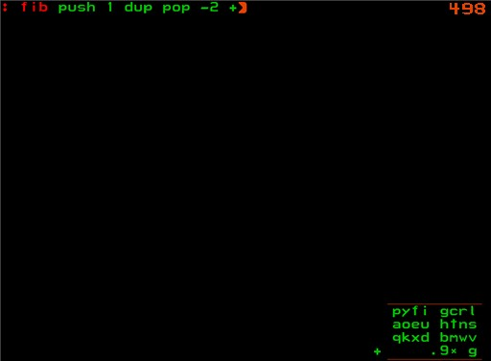

***It takes some practice to enter text and numbers using the keypad!***

To enter the number ‘1’ press the space bar without entering any other characters – this enters number mode.

Press the ‘1’ using the keypad (‘U’ on the keyboard) and then the space bar. To enter ‘-2’ press the ‘-’ on the keypad (‘N’ on the keyboard) then the number ‘2’ (‘I’ on the keyboard). Then press the space bar.

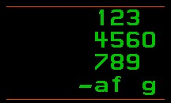

Figure 7 Number keypad

To type the ‘+’ character, press ‘*’ on the keypad (Alt-Gr on the keyboard) to enter alternate character mode :

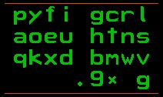 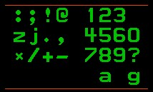

Figure 8 Alternate character keypad

Then press the ‘+’ key on the keypad (the ‘C’ key on the keyboard) and then the space bar.

# Step 4 Save your work

Having spent some time on entering part of the program, it is now a good time to save your work.

Exit the editor by pressing the ‘.’ key on the keypad (the ‘N’ key on the keyboard), then press the space bar until you get back to the yellow immediate keypad :

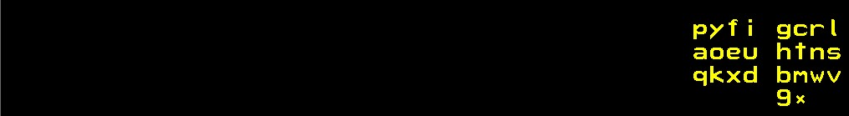

Type “sa” on the keypad, then the space bar. The cf2023 system will be saved to the file cf2023.img.

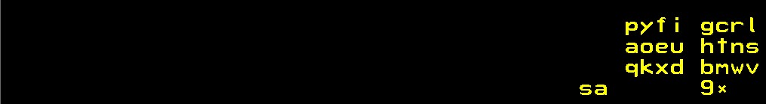

Typing “sa” returns to the editor so you can add more words.

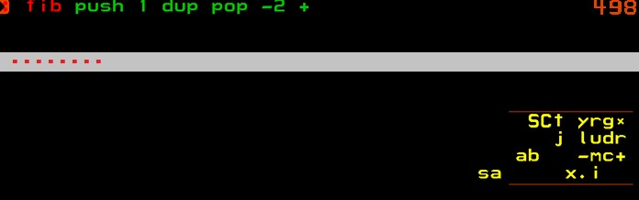

If you switch off Bochs and run **go.bat** again the cursor will have been reset to the start of the block. Use the “ludr” keys on the keypad, or the arrow keys on the keyboard, to move the cursor to after the ‘+”. The Home and End keys ( Pos1 and Ende on a German keyboard) also move the cursor to the beginning and end of the code.

The Enter key will execute a red token to the left of the cursor, or locate (display the source block) a green token.

For example, pressing the down arrow key 6 times from the start screen will highlight the red token “words”, pressing Enter will run “words” and display all colorForth words in the FORTH, MACRO and BLUE wordlists.

Then you can press ‘r’ on the keypad to enter a new red definition.

**: f -if drop nip ; then push swap over + pop -1 + f ;**

Note that the ‘-‘ in “-if” is an alternate character, not a number, you must enter it using the alternate character keypad.

But the ‘-‘ in “-2” is a number and must be entered using the number keypad (press the ‘-‘ key before the ‘2’).

**Save your work again!**

# Step 5 Load and run the program

Exit the editor again by pressing the space bar, then type “ll” to load the current block.

“ll” is one of many double-letter words – see Appendix A Useful Commands to see a list.

Press the space bar to view immediate number keypad, press ‘8’ on the keypad (for example), then the space bar, then type “fib” to calculate the 8th Fibonacci number.

|  |  |  |
| --- | --- | --- |
| 1,2,3,5,8,13,21, | 34 | ,55,89,144,233,377,610,987,1597,2584…. |

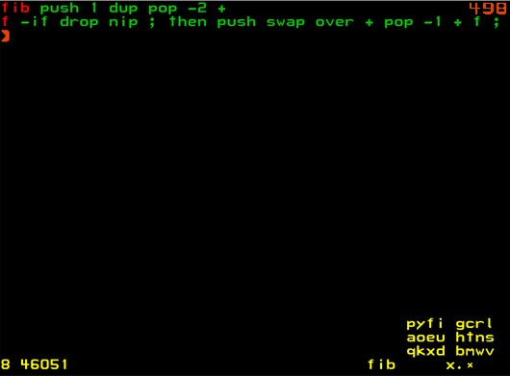

You can see the number 8 on the stack, then the Huffman compressed word “fib” (46051). Pressing the space bar gives the answer on the stack : **34**.

Note that I pressed F4 on the keyboard to leave colour-blind mode – the code fits better on one line.

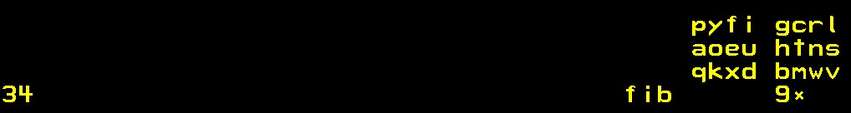

# Step 6 More features

You can add comments, stack comments and blue words (to format the text on the display) :

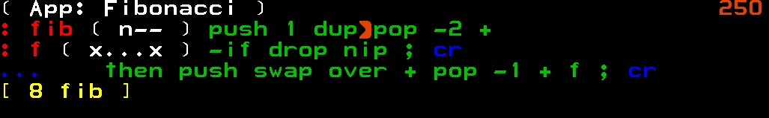

Press F3 to enable/disable the display of blue words. Press F4 to enable/disable colour-blind mode.

An alternative display looks like this :

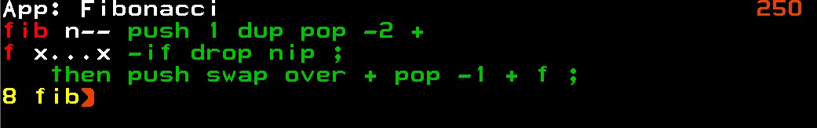

It is good practice to add a shadow block to explain what the App is doing :



Shadow blocks are in odd-numbered blocks, the Forth code is in even-numbered blocks, you can toggle between the two using the ‘*’ key in the main editor keypad.

The yellow immediate words [ 8 fib ] get executed when the block is loaded, so the answer 34 will get put on the stack. This saves some typing ;-)

The white comment on the top line “App: Fibonacci” marks this block as a cf2023 App.

Note that the first word must be exactly as written “App:” using the Capital ‘C’ mode in the main editor keypad. Running the colorForth explorer App by typing “xx” shows all the Apps in the system :

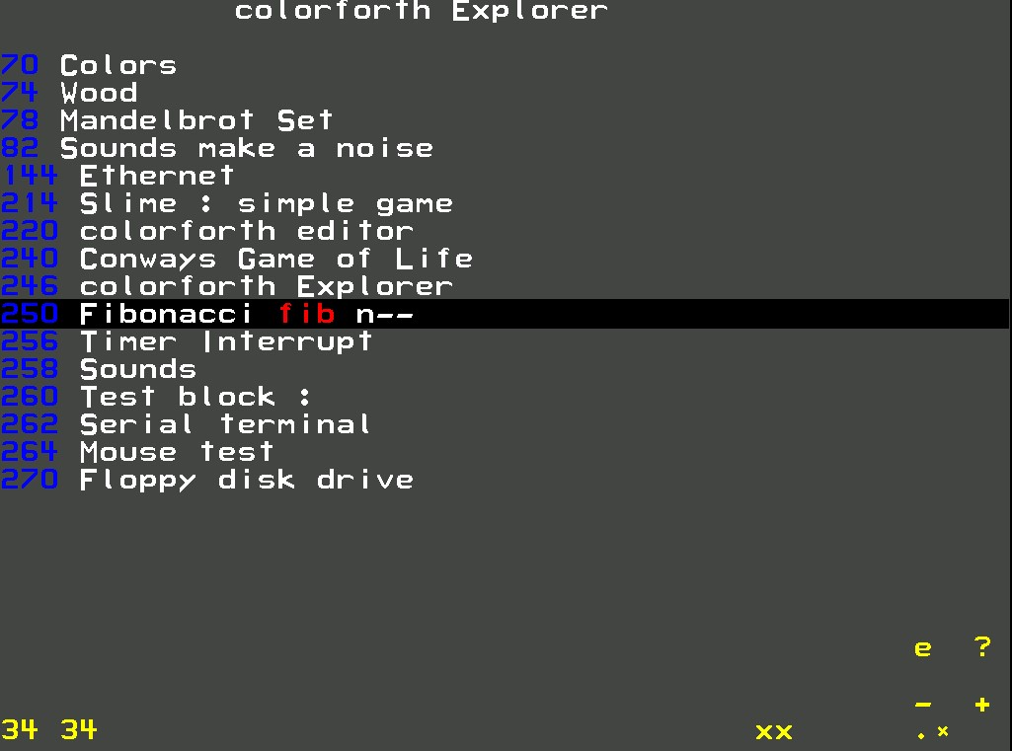

Use the ‘-‘ and ‘+’ keys on the keypad to highlight an App, then press the space bar to run it. You can see that I ran the Fibonacci App twice, leaving two answers on the stack.

# Step 7 Save Your Work part 2

***When you are happy with your program, you really must save it again in a different way.***

Typing “sa” or similar words such as “ss” and “save” copies the code that you have written (which is in RAM) to the file **cf2023.img** on disk.

You must make a copy of **cf2023.img** as a backup, because running the file **goc.bat** will overwrite it and **delete all of your work.**

**goc.bat** compiles the system and then runs it, but is uses the refence copy of the system **cf2023Ref.img** as the source to create a new **cf2023.img**. **goc** is short for **go**_**c**ompile. **go.bat** just runs cf2023.

I like to use Windows to copy the file **cf2023.img** to the file **cf2023_2023Apr04.img** for example – a crude form of version control.

There is also a batch file **new.bat** that copies cf2023.img to cf2023Ref.img :

copy /b .\cf2023.img .\cf2023Ref.img

Running **new.bat** will make your new program a part of the cf2023 system, so that running **goc.bat** will not delete it.

Note that running **goc.bat** restores the system to its “factory defaults” – you can use “xx” to find your App, or “498 edit” to view the code.

# Appendix A Useful Commands

|  |  |
| --- | --- |
| **Command** | **Action** |
| e | Run the Editor displaying the last block edited |
| 64 edit | Run the colorForth Editor displaying block 64 |
| xx | Run the colorForth Explorer |
| ll | Load the current block displayed by the Editor |
| vv | View the last block loaded by the command ld |
| uu | Undo all changes to the current block |
| ss | Save the current block to disk |
| save | Save the entire system to disk. You can change the USB stick to save a backup. |
| sa | Save and return to the Editor |
| logo | Show the colorForth logo screen |
| empty | Remove all compiled definitions since mark was called |
| mark | Mark the current system state for empty |
| $1000 dump | Dump the 16 32 bit cells starting at address $1000 |
| bye | Exit the system, discarding all edits since the last save, sa or ss |
| hlp | Update the hardware system info and display the start block. This is currently block 64, and displays a list of Apps. |
| life | Run the Conway’s Game of Life demo. Press the space bar to exit (marked by a ‘.’ In the keypad mnemonic), then type xx and press the space bar. Scroll to “Conways Game of Life” and press the e key to view the source code, then press the ‘*’ key in the Editor to view the documentation shadow block. |
| staks | Display the four task’s stacks. ‘U’ means Unused, ‘.’ means used. Checks that the stacks are not growing or shrinking… |
| chm | Check MD5 – shows the MD5 of the system blocks 64 to 127 |

You can also use the cursor control keys in the editor or the arrow, Home and End keys to move the cursor immediately after a red word (in either Editor or Interpret mode), then press the Enter Key (on the QWERTY or QWERTZ keyboard, not the keypad) to execute that word.

Pressing the Enter Key when the cursor is in front of a green token will locate and display the source block of the token

You can download colorForth cf2023, together with Bochs for running it under Windows here:

<https://www.inventio.co.uk/cf2023/cf2023_2023Apr04_roomed-zebra.7z>

More colorForth options here: <https://www.inventio.co.uk/colorforth/>

Enjoy!

Howerd Oakford 2023 Apr 04