WriteUp Hack@10 ( adump )
- Meowww ( forensics )
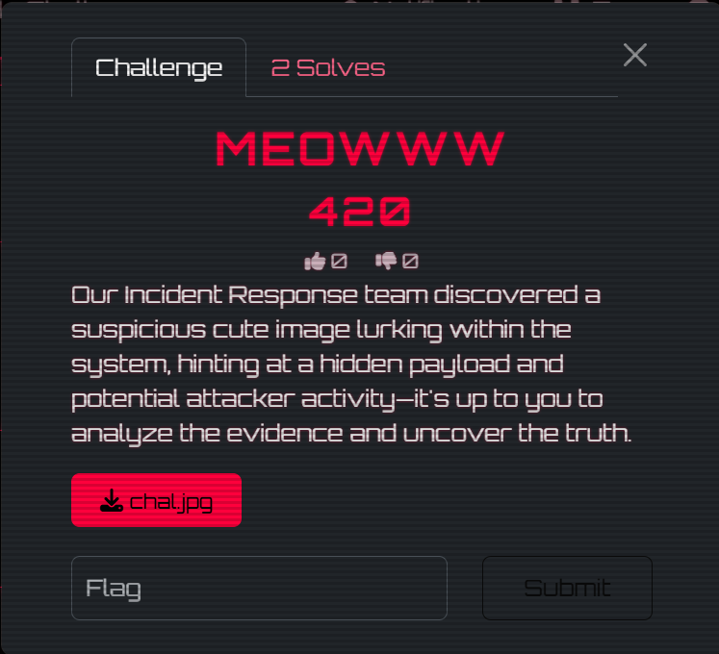

Chal.jpg
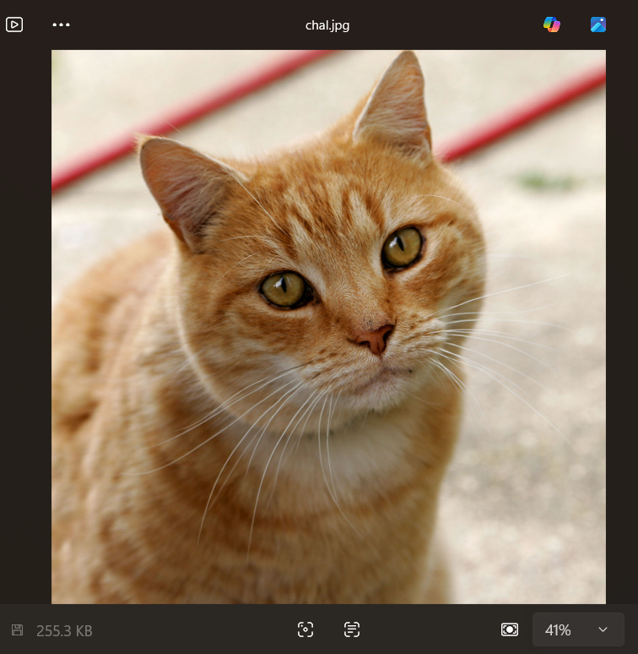

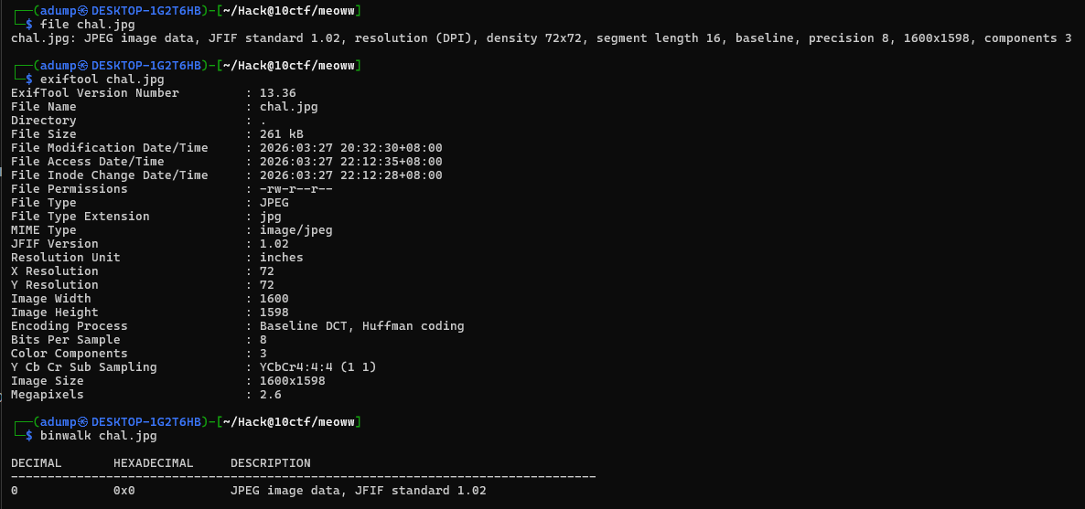
- Perform basic typical forensics image check

- Try extract embedded file using empty & common passpharase
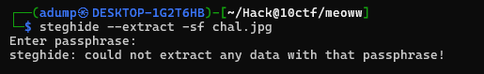
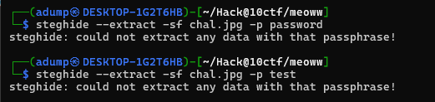

- Try bruteforcing using Rockyou.txt
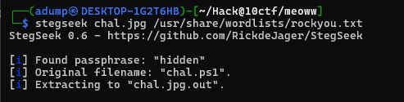
- Found the password and embedded files

- Checking the embedded fike content
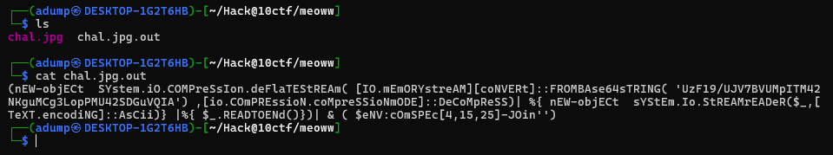

- Extracted the obfuscated flag
- Asking chatgpt for suggestions to deobfuscated the flag
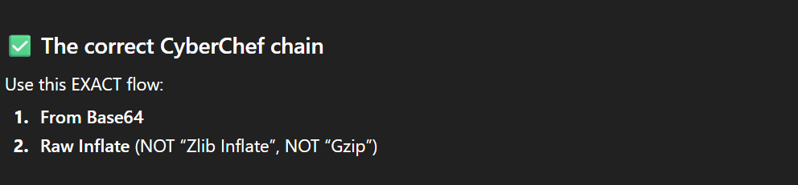
- Put on cyberchef
- Select the recipe
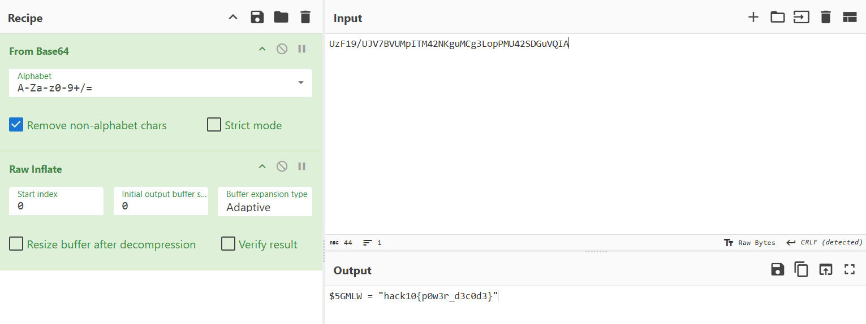
- Boom ! flag found
- Flag = hack10{p0w3r_d3c0d3}

- Detonator ( reveng )
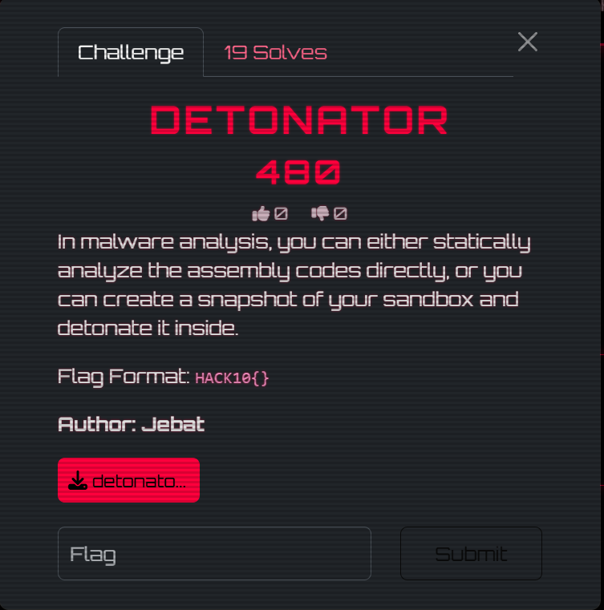
- Download the files

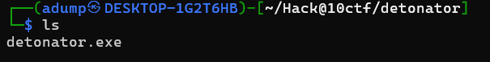
- Perform basic reverse engineering using Decompiler Explorer ( low size file )
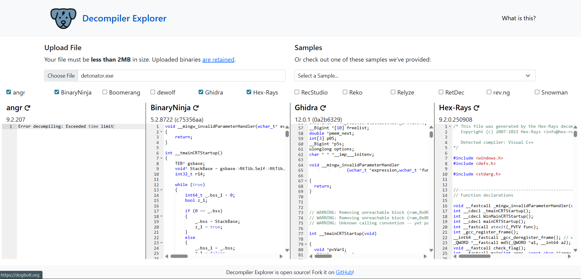

- Find the using seach function
- Found the fake flag

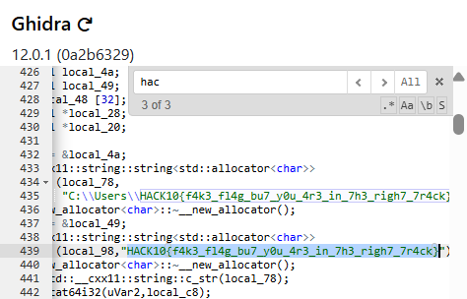
- Paste all the decompiler code to chatgpt for analysis
- The flag is static after analyzed ( by gpt )

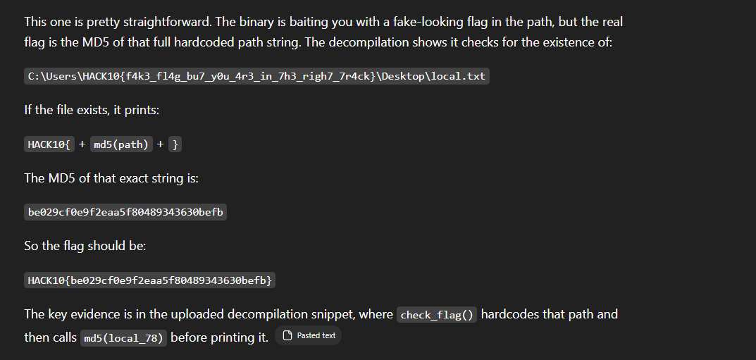
- Get the flag
- However we can highlighted a few useful function to understand the program core logic
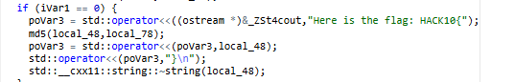
- As we can see here the flag here is HACK10 + md5 ( the path in local_78)
- After we extracted the strings inside local_78 functions we encrypt it using md5
- That explain what chatgpt response after we compare the encrypted strings and chatgpt given flag
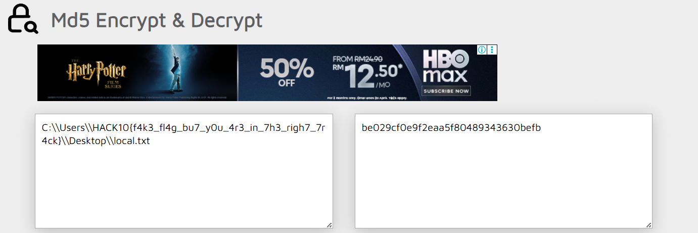

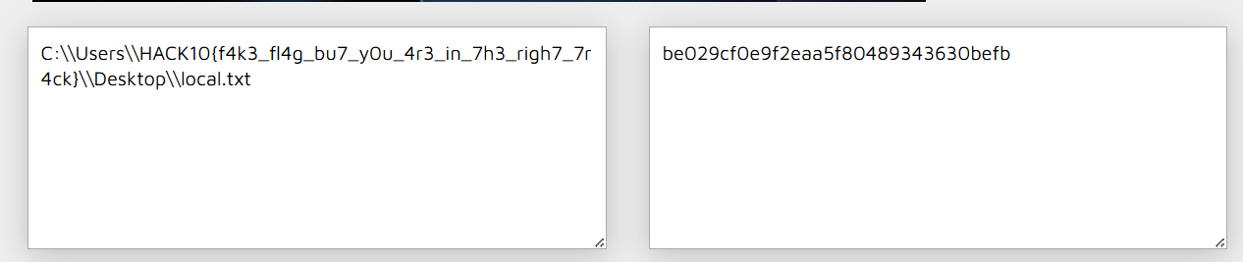

- DearHiringManager ( forensics )



- Download the chall files first
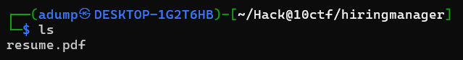

- Perform basic forensics check which is file type , metadata and embedded files
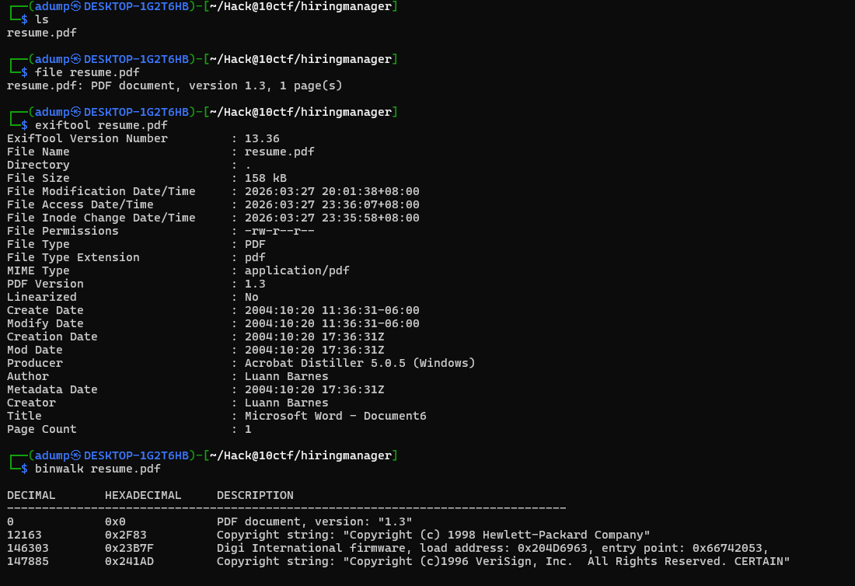

- Use pdf-parser to extract FULL pdf content
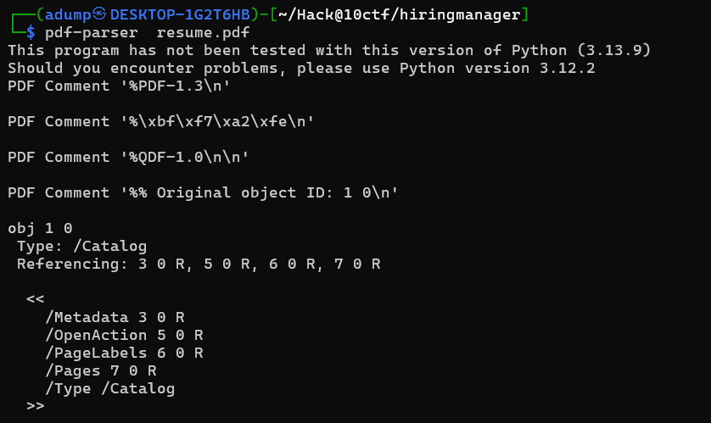

- Found flag after using grep
- The flag seems to be obfuscated and after a few while trying to deobfuscated that I decided to this as a fake flag first and look up another suspicious strings / functions
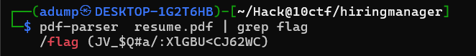
- Found another suspicious func that executed separated in var a and var b 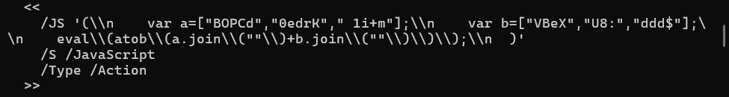
- Reason we choose this functions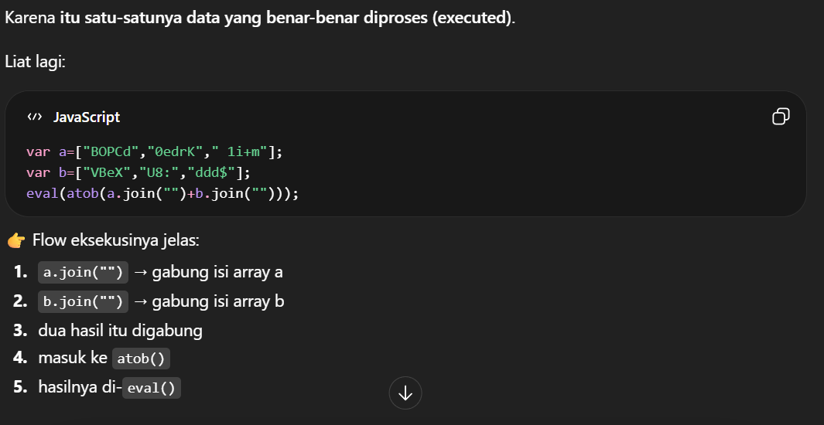
- Then I decided to combina strings from var a dan var b
- After combined it became this BOPCd0edrK 1i+mVBeXU8:ddd$
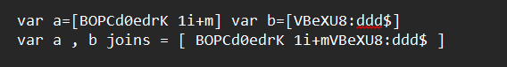
- Next we ask chatgpt to analyzed the strings and we can used dcode to identify matched cipher
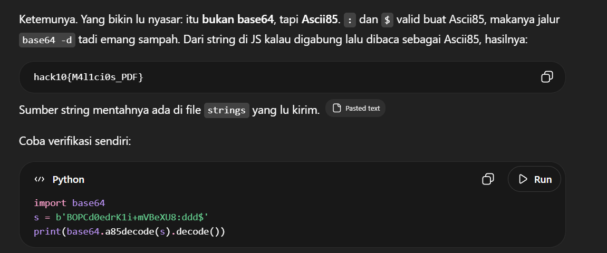

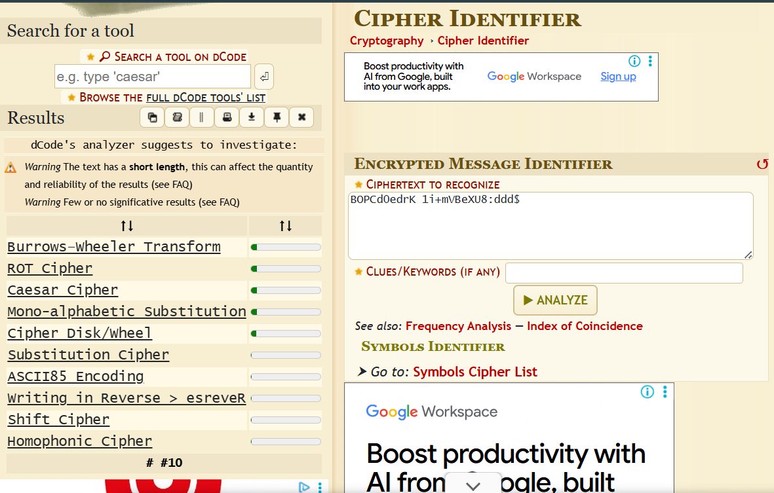

- We compared the suitable and found after analysis then decrypt it
- I use dcode and cyberchef
- 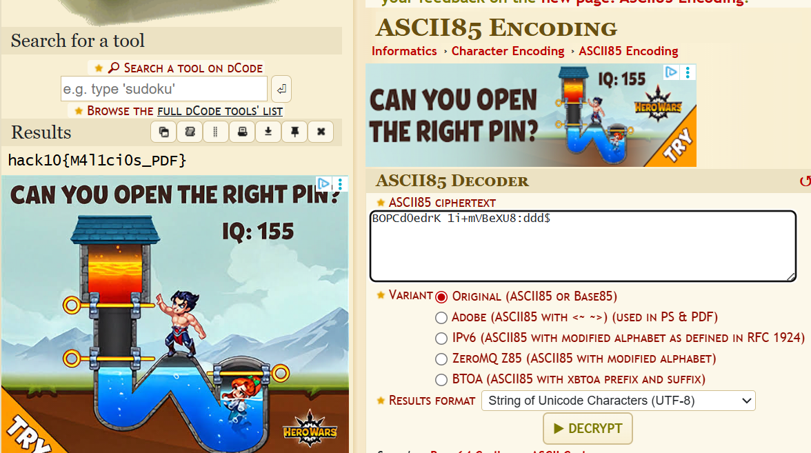
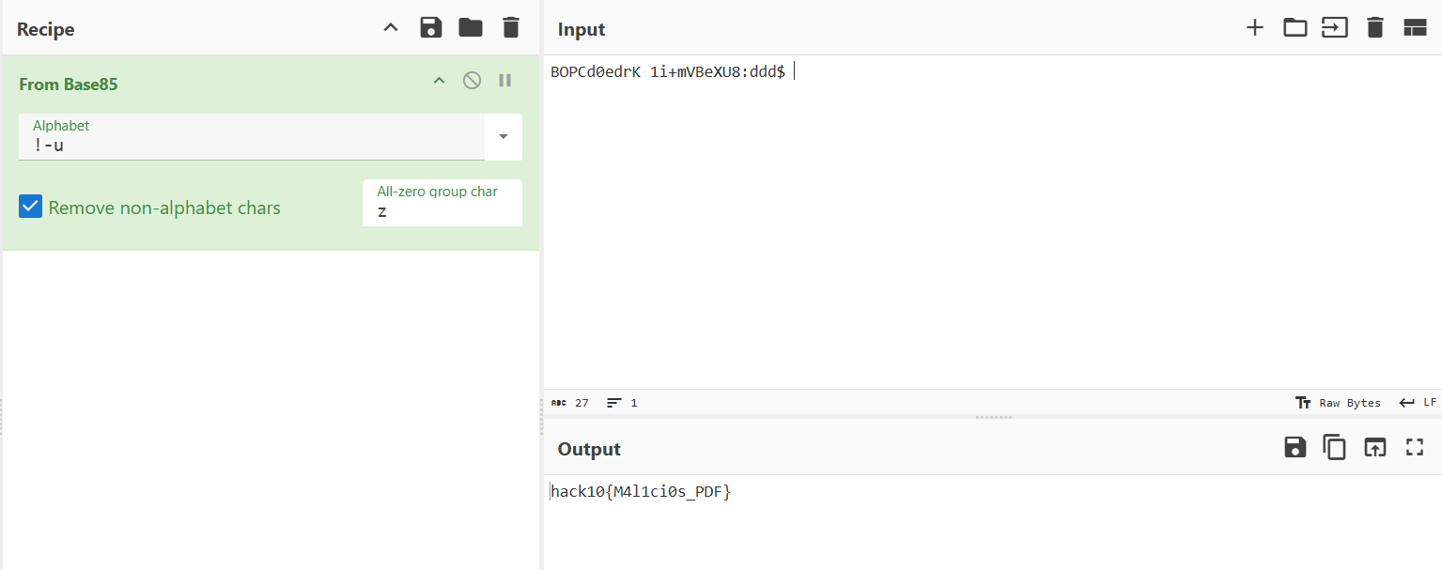

- Found the flag : hack10{M4l1ci0s_PDF}

- is it stacy, is it becky, is it kesha? ( reveng )

- Download the chall first

- Upload the chall file to decompile the program so that we can analyze the the program logic
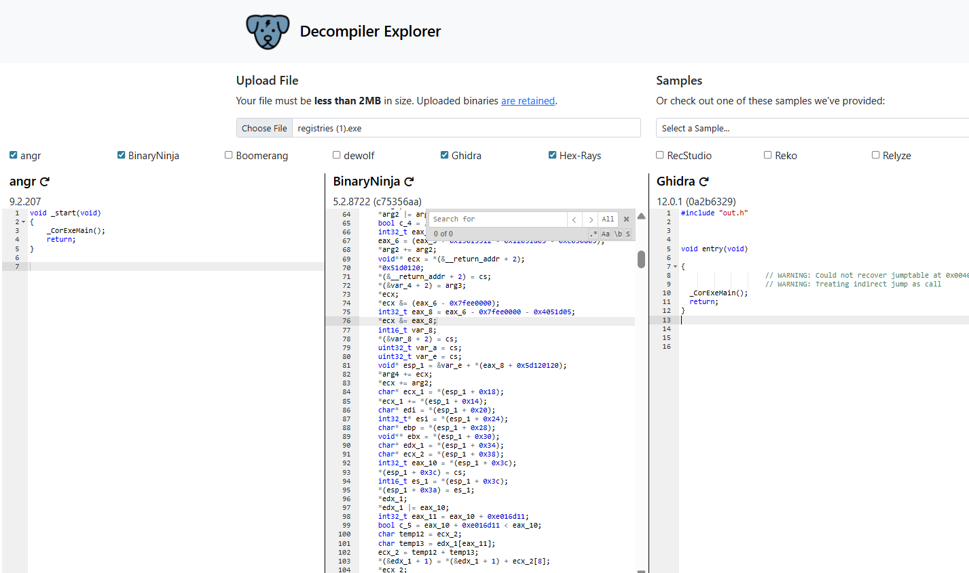

- I picked ghidra and paste to chatgpt to be analyzed
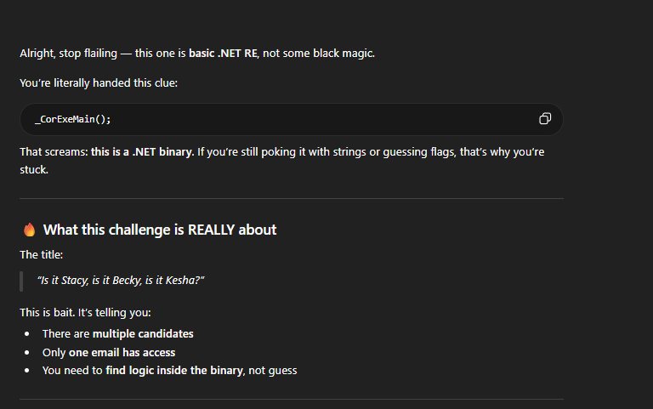
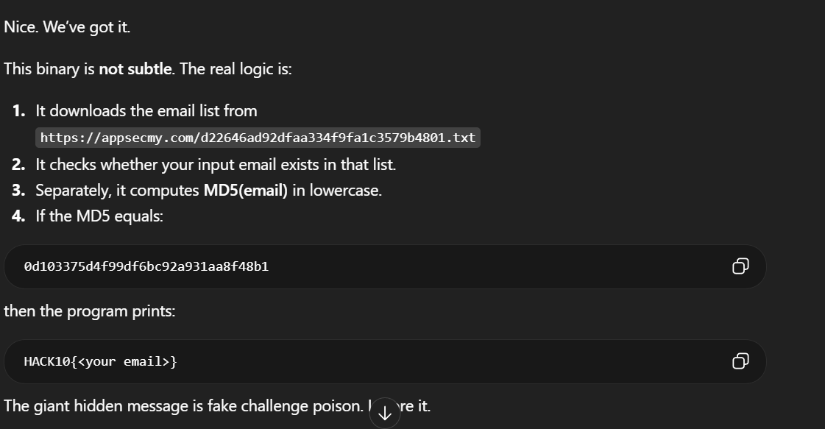
- This explain what this chall about which is we need to find suitable candidate as said in chall description that requires us to find who’s email has the access
- Its also compute the emails in md5 so we need to find match md5(email)
- So we need to find the emails ( dump or common emails ) first

- Then I try to find any information through strings and cat
- Found nothing on strings

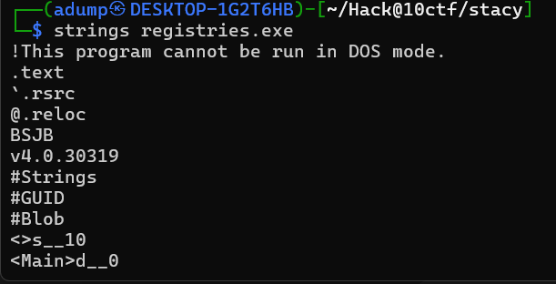
- Suddenly I found a link in cat
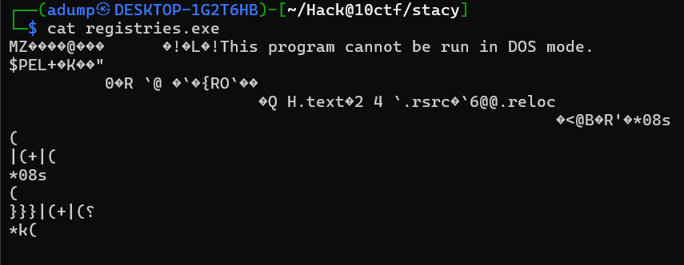

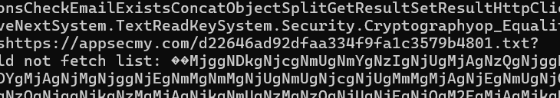
- https://appsecmy.com/d22646ad92dfaa334f9fa1c3579b4801.txt

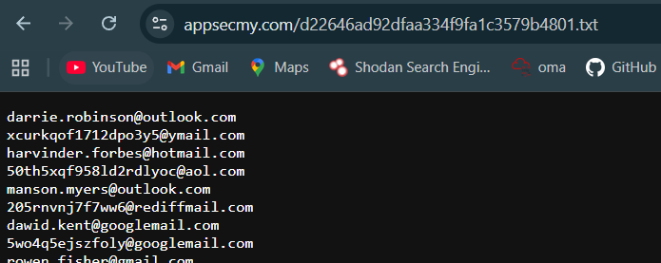
- found the emails dump
- I downloaded it using wget
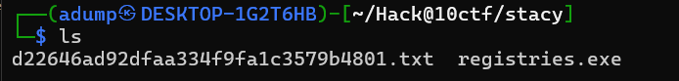
- Now that we has the emails dump and the program I asked gpt to create a program to find matched emails
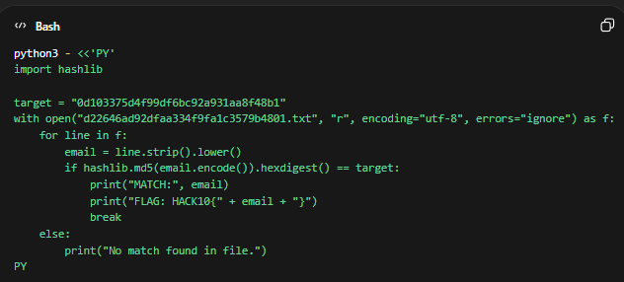
- Then we executed the python program to find matched md5(email)
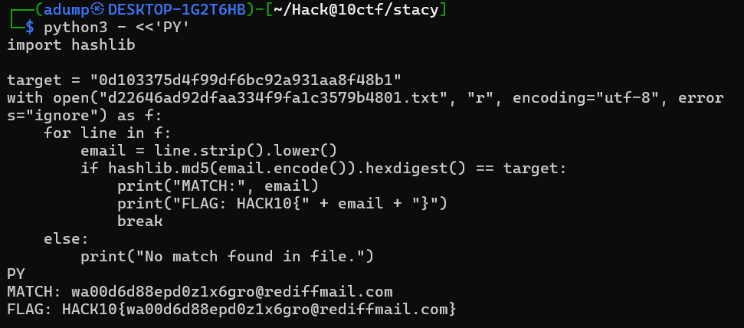
- Found the email then we compute it as final flag
- Flag : HACK10{wa00d6d88epd0z1x6gro@rediffmail.com}

- Hakari domain 2 ( Crypto )
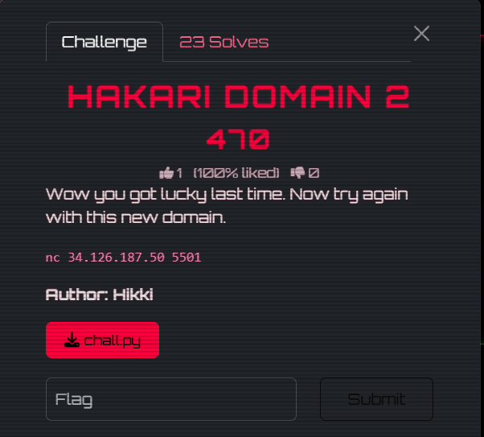
- We download the chall files first

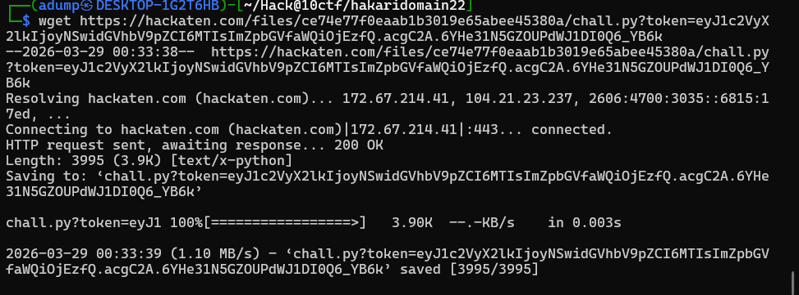

- We cat and analyzed the program

chall.py

import os
import random
import sys

from AES import AES

JACKPOT_STREAK = 3
MAX_ATTEMPTS = 250

def huh(*_args):
return None

def load_flag() -> bytes:
return os.getenv("FLAG", "hack10{REDACTED}").encode()

def read_guess(jackpot: bool) -> str:
if jackpot:
return input("Predict the next number or type 'exit': ").strip()
return input("Guess the next number: ").strip()

def bytes_to_int(block: bytes) -> int:
return int.from_bytes(block, "big")

def int_to_bytes(value: int) -> bytes:
return value.to_bytes(16, "big")

def main() -> None:
seed = os.urandom(8)
random.seed(seed)
flag = load_flag()
streak = 0
attempts = 0
jackpot = False

print("Welcome to Hakari Domain 2.")
print(f"Guess the next 32-bit number in [0, {2**32 - 1}].")
print(f"Reach {JACKPOT_STREAK} correct guesses in a row to hit jackpot.")
print(f"You have {MAX_ATTEMPTS} total attempts before the connection closes.")
print()

while attempts < MAX_ATTEMPTS:
try:
raw = read_guess(jackpot)
except EOFError:
print("\nBye.")
return

if jackpot and raw.lower() == "exit":
print("Leaving with your collected ciphertexts.")
return

try:
guess = int(raw)
except ValueError:
print("Numbers only.")
continue

if not 0 <= guess < 2**32:
print(f"Guess must be between 0 and {2**32 - 1}.")
continue

target = random.getrandbits(32)
attempts += 1

if guess != target:
streak = 0
print(f"Wrong. The number was {target}.")
print(f"Attempts used: {attempts}/{MAX_ATTEMPTS}")
continue

streak += 1
print(f"Correct. Current streak: {streak}")

if not jackpot and streak == JACKPOT_STREAK:
jackpot = True
print("Jackpot unlocked.")

key = os.urandom(16)
secret = os.urandom(16)
cipher = AES(key)
cipher._sub_bytes = huh
secret_enc = cipher.encrypt(secret)

print("Congratulations! You've hit the jackpot and unlocked the next phase.\n")
print("Keep predicting the next number to continue choosing actions.")
print("Encrypted Secret:", secret_enc.hex())
while True:
next_target = random.getrandbits(32)
prediction = int(input("Predict the next number or type -1 to exit: "))

if prediction == -1:
print("Leaving with your collected ciphertexts.")
return

if prediction != next_target:
print(f"Wrong. The number was {next_target}.")
return

option = int(input("[1] encrypt, [2] decrypt: "))

if option == 1:
plaintext = bytes.fromhex(input("Input plaintext to encrypt in hex: "))
assert len(plaintext) == 16

ciphertext = cipher.encrypt(plaintext)
print(f"enc(plaintext) = {bytes.hex(ciphertext)}")

if plaintext == secret:
print(flag)
exit()

elif option == 2:
ciphertext = bytes.fromhex(input("Input ciphertext to decrypt in hex: "))
assert len(ciphertext) == 16

if ciphertext == secret_enc:
print("No way!")
continue

plaintext = cipher.decrypt(ciphertext)
print(f"dec(ciphertext) = {bytes.hex(plaintext)}")

print(f"Attempts used: {attempts}/{MAX_ATTEMPTS}")

print(f"{MAX_ATTEMPTS} attempts used. Connection closed.")

if __name__ == "__main__":
try:
main()
except KeyboardInterrupt:
print("\nInterrupted.", file=sys.stderr)

- I uploaded the program to chatgpt to let it analyze the program
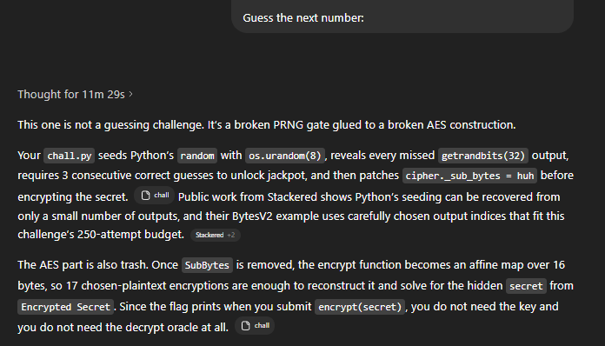
- So we need to create solver script , I named it as solve.py

Python solver script ( solve.py )
from pwn import *
import random

HOST = "34.126.187.50"
PORT = 5501
LEAKS = 234

def unshift_right(x, shift):
res = x
for _ in range(32):
res = x ^ (res >> shift)
return res

def unshift_left(x, shift, mask):
res = x
for _ in range(32):
res = x ^ ((res << shift) & mask)
return res

def untemper(v):
v = unshift_right(v, 18)
v = unshift_left(v, 15, 0xEFC60000)
v = unshift_left(v, 7, 0x9D2C5680)
v = unshift_right(v, 11)
return v

def invert_step(si, si227):
x = si ^ si227
mti1 = (x & 0x80000000) >> 31
if mti1:
x ^= 0x9908B0DF
x = (x << 1) & 0xFFFFFFFF
mti = x & 0x80000000
mti1 = (mti1 + (x & 0x7FFFFFFF)) & 0xFFFFFFFF
return mti, mti1

def init_genrand(seed):
mt = [0] * 624
mt[0] = seed & 0xFFFFFFFF
for i in range(1, 624):
mt[i] = ((0x6C078965 * (mt[i - 1] ^ (mt[i - 1] >> 30))) + i) & 0xFFFFFFFF
return mt

def recover_kj_from_ji(ji, ji1, i):
const = init_genrand(19650218)
key = ji - (const[i] ^ ((ji1 ^ (ji1 >> 30)) * 1664525))
return key & 0xFFFFFFFF

def recover_ji_from_ii(ii, ii1, i):
ji = (ii + i) ^ ((ii1 ^ (ii1 >> 30)) * 1566083941)
return ji & 0xFFFFFFFF

def recover_kj_from_ii(ii, ii1, ii2, i):
ji = recover_ji_from_ii(ii, ii1, i)
ji1 = recover_ji_from_ii(ii1, ii2, i - 1)
return recover_kj_from_ji(ji, ji1, i)

def recover_seed_candidates(outputs):
s = [untemper(x) for x in outputs]

i230_, i231 = invert_step(s[3], s[230])
i231_, i232 = invert_step(s[4], s[231])
i232_, i233 = invert_step(s[5], s[232])
i233_, i234 = invert_step(s[6], s[233])

i231 = (i231 + i231_) & 0xFFFFFFFF
i232 = (i232 + i232_) & 0xFFFFFFFF
i233 = (i233 + i233_) & 0xFFFFFFFF

seed_l = (recover_kj_from_ii(i233, i232, i231, 233) - 16) & 0xFFFFFFFF
seed_h1 = (recover_kj_from_ii(i234, i233, i232, 234) - 17) & 0xFFFFFFFF
seed_h2 = (recover_kj_from_ii((i234 + 0x80000000) & 0xFFFFFFFF, i233, i232, 234) - 17) & 0xFFFFFFFF

return [
((seed_h1 << 32) | seed_l).to_bytes(8, "big"),
((seed_h2 << 32) | seed_l).to_bytes(8, "big"),
]

def pick_seed(outputs):
for seed in recover_seed_candidates(outputs):
r = random.Random()
r.seed(seed)
if [r.getrandbits(32) for _ in range(len(outputs))] == outputs:
return seed
raise ValueError("seed recovery failed")

def gf_mul(a, b):
res = 0
for _ in range(8):
if b & 1:
res ^= a
hi = a & 0x80
a = (a << 1) & 0xFF
if hi:
a ^= 0x1B
b >>= 1
return res

def gf_pow(a, e):
res = 1
while e:
if e & 1:
res = gf_mul(res, a)
a = gf_mul(a, a)
e >>= 1
return res

def gf_inv(a):
if a == 0:
raise ZeroDivisionError
return gf_pow(a, 254)

def solve_gf256(mat, rhs):
n = len(mat)
aug = [mat[i][:] + [rhs[i]] for i in range(n)]

row = 0
for col in range(n):
pivot = None
for r in range(row, n):
if aug[r][col] != 0:
pivot = r
break
if pivot is None:
raise ValueError("singular matrix")

aug[row], aug[pivot] = aug[pivot], aug[row]

inv = gf_inv(aug[row][col])
aug[row] = [gf_mul(x, inv) for x in aug[row]]

for r in range(n):
if r != row and aug[r][col] != 0:
factor = aug[r][col]
aug[r] = [aug[r][c] ^ gf_mul(factor, aug[row][c]) for c in range(n + 1)]

row += 1

return bytes(aug[i][n] for i in range(n))

def recv_guess_result(io):
line = io.recvline()
if b"Wrong. The number was " in line:
return int(line.strip().split()[-1].rstrip(b"."))
if b"Correct. Current streak:" in line:
# if your dummy guess randomly hit, that output was 0
return 0
raise ValueError(f"unexpected line: {line!r}")

def oracle_encrypt(io, rng, pt):
nxt = rng.getrandbits(32)
io.recvuntil(b"Predict the next number or type -1 to exit: ")
io.sendline(str(nxt).encode())

io.recvuntil(b"[1] encrypt, [2] decrypt: ")
io.sendline(b"1")
io.recvuntil(b"Input plaintext to encrypt in hex: ")
io.sendline(pt.hex().encode())

io.recvuntil(b"enc(plaintext) = ")
return bytes.fromhex(io.recvline().strip().decode())

def main():
context.log_level = "error"
io = remote(HOST, PORT)

outputs = []
for _ in range(LEAKS):
io.recvuntil(b"Guess the next number: ")
io.sendline(b"0")
outputs.append(recv_guess_result(io))
io.recvuntil(b"Attempts used: ")
io.recvline()

seed = pick_seed(outputs)
print(f"[+] recovered seed: {seed.hex()}")

rng = random.Random()
rng.seed(seed)
for x in outputs:
assert rng.getrandbits(32) == x

for streak in range(1, 4):
io.recvuntil(b"Guess the next number: ")
io.sendline(str(rng.getrandbits(32)).encode())
io.recvuntil(f"Correct. Current streak: {streak}".encode())

io.recvuntil(b"Encrypted Secret: ")
secret_enc = bytes.fromhex(io.recvline().strip().decode())
print(f"[+] secret_enc = {secret_enc.hex()}")

base = oracle_encrypt(io, rng, b"\x00" * 16)

cols = []
for i in range(16):
pt = bytearray(16)
pt[i] = 1
ct = oracle_encrypt(io, rng, bytes(pt))
cols.append(bytes(c ^ d for c, d in zip(ct, base)))

mat = [[cols[c][r] for c in range(16)] for r in range(16)]
rhs = [c ^ d for c, d in zip(secret_enc, base)]
secret = solve_gf256(mat, rhs)
print(f"[+] recovered secret: {secret.hex()}")

nxt = rng.getrandbits(32)
io.recvuntil(b"Predict the next number or type -1 to exit: ")
io.sendline(str(nxt).encode())
io.recvuntil(b"[1] encrypt, [2] decrypt: ")
io.sendline(b"1")
io.recvuntil(b"Input plaintext to encrypt in hex: ")
io.sendline(secret.hex().encode())

print(io.recvall(timeout=2).decode(errors="ignore"))

if __name__ == "__main__":
main()

- We executed the solver script and get the flag
