**US e-Commerce Sales Analysis**

By: Olutola Adunoluwa Toby

**Gross Revenue**

﻿The total gross revenue generated in the fiscal year was $733.215.26. Revenue trended upward, resulting in a 90.65% increase between January 2020 and December 2020.﻿﻿ ﻿﻿ ﻿﻿This trend started in May 2020, rising by 89.40% ($39,568.21) in 7 months. The revenue also jumped from $44,261.11 to $83,829.32 during its steepest incline between May 2020 and December 2020.﻿﻿ ﻿ Revenue is forecasted to be $112,364.63 ($85490.73 – $139,238.53) in January 2021 and $125,290.36 ($96765.31 – $153815.41) in March with a confidence interval of 95%.

Figure : Gross revenue per month and forecast of revenue generation in the next quarter

**Profit**

The total profit (net revenue) generated was $93439.20. Profit trended upward, resulting in an 18.81% increase between January 2020 and December 2020.﻿﻿ ﻿﻿Profit started trending up in May 2020, rising by 33.75% ($2,140.76) in 7 months and jumped from $6,342.58 to $8,483.35 during its steepest incline between May 2020 and December 2020. The company is forecasted to maintain a profit of $7,155.99 (-$10.28– $14,322.26) between January and March 2021 with a confidence interval of 95%.

Figure : Profit generated per month

**High-Level Analysis**

Stored procedures using TSQL for automation

Figure : TSQL dynamic stored procedure query

**Product Category**

Technology had the highest revenue and profit; however, Office supplies accounted for most orders and customers, with technology having the least amount. Furniture was the least profitable product category.

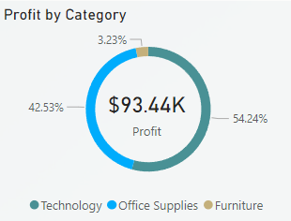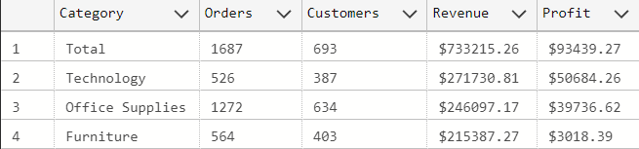

Figure : Left: Profit per product category. Right: High level analysis aggregating by product category

**Segment**

The consumer customer segment had the highest percentage of orders, customers, revenue, and profit. The corporate segment followed next, with the home office category having the least business.

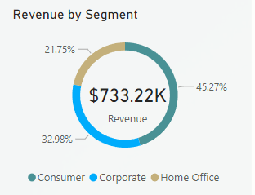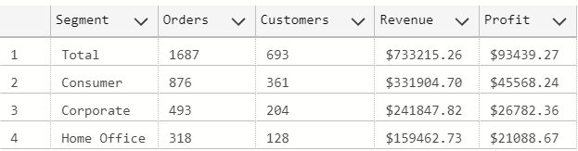

Figure : Revenue per Customer Segment

**Net Revenue (Profit) per State and City**

California generated the largest profit of $29,366.46 (gross revenue of $146.4k), with the city of Los Angeles alone generating about 30% of the state's profit ($10.06k) and 117 of its 291 customers. Most of California's profit was generated from the sales of office supplies and to the corporate customer segment. New York followed California with a profit of $24,357.07 and Washington with $17,256.78.

New York City generated the largest profit with $22,406.03, and 58% was from selling technological products, including phones and copiers, to consumers and home office customer segments. Seattle and Los Angeles were the runners-up in profit generated.

Figure : Profit (Net Revenue) per State

Figure : Profit generated per sub-category and top 5 products by profit generated

**Profit Forecast per Sub-category**

**Copiers**

The copiers sub-category generated a revenue of $62.9k and had the highest profit of $25.03k among all sub-categories, increasing by 122.67% between January and December 2020. The Canon Image Class 2200 Advanced Copier was the most profitable product making up about $15,680 - 62% - of its total profit. Copiers are forcasted to mainatain a profit of $2,810.71 (-$2,627.1 – $8,248.6) in January and $2,810.71 (-$5,991.22 – $11,612.65) in March 2021. Copiers had the least number of customers and the least quantity sold, 89% less than the next performing sub-category in quantity sold. Therefore, increasing the customer base and quantity sold will be the key to increasing the next quarterly profit.

Figure : Forecast of Profit for Copiers Sub-Category

**Accessories**

This sub-category generated the third highest revenue and profit of $59,946.2 and $15,672.4, respectively. The gross revenue had a steep incline between January and December 2020, rising by 134.68% to $4,989 in December; it is forecasted to rise to $8,511.4 in January and March 2021. The profit had a similar trend, rising by 189.7% in 2020. As a result, accessory sales are forecasted to generate a profit of $6,286.52 ($2,665.97– $9,887.1) in the first quarter of 2021.

The states of California and Washington had the highest market for accessories, with the Razer Tiamat Over Ear 7.1 Surround Sound PC Gaming Headset being the most profitable product.

Figure : Forecast of Profit for Accessories Sub-Category

**Phones**

Phone sales generated the highest gross revenue of $105,340.52 but a profit of $12,849.32 in 2020. Although phone sales had a slow trend upwards, increasing by 33.53% between January and December 2020, this sub-category is forecasted to generate a profit of $5,3373.36 ($1,219,5 - $9527.21) and gross revenue of $43,894.13 ($25,756.88 - $62,031.38) in the first quarter of 2021.

Phone sales had their highest market in New York and California, accounting for 40% of customers and 33.6% of all phone sales. Samsung Galaxy Mega 6.3 generated the highest profit in this sub-category.

Figure : Forecast of Profit for Phones Sub-Category

**Paper**

The paper sub-category generated a profit of $12,040.84 and had the highest customer patronage with 305 customers, 25% greater than the next sub-category, phones. Paper sales profit had a 293.74% increase in 2020 and is forecasted to be $5,046.8 ($1,386 - $8707.5) in the first quarter of 2021. California had the highest number of paper orders. It accounted for about 23% of customers in this sub-category, generating about 21% of paper's profits.

Xerox 1915, Xerox 1908, Easy-staple paper, Xerox 1888, and Xerox 1919 were the top profit-generating products in this sub-category.

Figure : Forecast of Profit for Paper Sub-Category

**Appliances**

Appliances generated a revenue of $42,926.93 and a profit of $7,865.27, accounting for only 8.42% of the company's profit. Profits are forecasted to be $2,132.37 ($155.67 - $4,109.1) in the first quarter of 2021 and a potential loss of up to $264.66 in January 2021. California generated about 43.5% of the profit in this sub-category, with only 37 customers and 148 appliances sold. More investments should be made in advertising to increase the customer base in this sub-category.

Figure : Forecast of Profit for Appliances Sub-Category

Figure : Number of customers and order quantity per sub-category

**Cohort Analysis**

**Helper Views**

1. **First Transaction Month:** This view includes the first transaction month for each customer and the difference in months between each record month and the customer's first transaction month.

Figure : First Transaction Month SQL View

1. **Customer Retention View**: Pivoted the first transaction month with the monthly difference as columns and unique customer IDs as values.

Figure : Customer Retention SQL View

The resulting table in Fig 15 (below) shows customer retention over months. For example, 67 customers made their first transaction in January 2020, the cohort month is January, and the cohort index is 0. On the right, 3 out of the 67 customers decided to make purchases after one month, and 8 out of 67 made purchases after two months.

Figure : SQL Result of Cohort Analysis

**Retention Rate**

Calculated the retention rate by dividing each monthly cohort, i.e., returning customers for each month difference index 1 to 11, by the number of customers with first transactions in each month – index 0. For example, in figure 15, 45 customers made their first order in November, out of which 11 customers returned to make purchases after one month (December); the retention rate for that cohort is = 24.44%. Figure 17 shows retention over the user and business lifetimes; it outlines the highest and lowest-performing cohorts that can be used to identify the factors driving the performance.

Figure : SQL Query for Retention Rate

Figure : Heat map of cohort retention rates using Python

**Retention Rate per Month Difference**

The total retention rate shows the average retention rate per monthly difference. This metric is used to determine customer behavior and engagement over time. The retention curve below shows the retention of these cohorts over the user's lifetime.

Figure : Monthly retention curve

**Monthly Retention Rate**

The monthly retention rate shows the percentage of returning customers divided by the number of existing/current customers (excluding new ones) each month. This metric can be used to determine how well the company is performing in advertisement monthly.

Figure : SQL query for monthly retention rate

Figure : SQL query result calculating the retention rate

Figure : Retention Rate per month using Python

**Dashboard**