Run Application with different application-xxx.propeties files

Run As > Run Configurations > Arguments > -Dspring.profiles.active=dev or -Dspring.profiles.active=qa

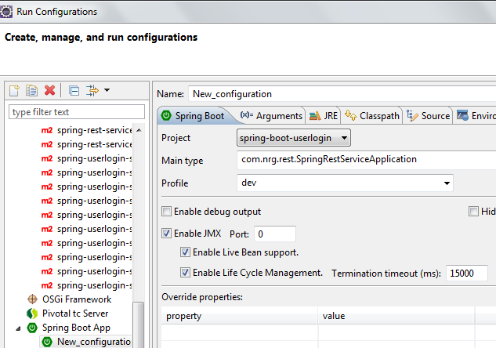

Run Test Cases with different application-xxx.propeties files

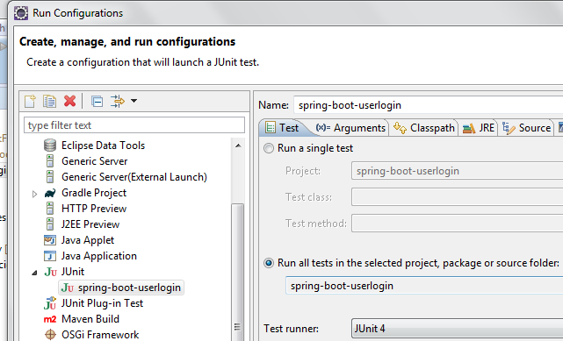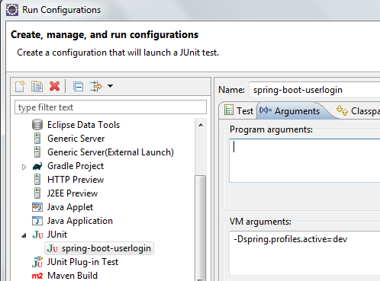

Maven Install to build jar with different application-xxx.propeties

Run As > Maven Build..

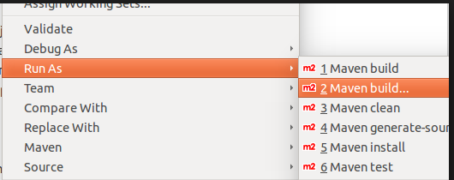

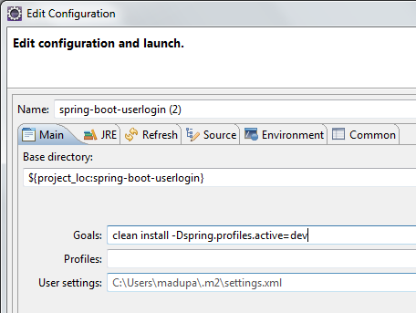

--------------------------------

POST http://localhost:8080/userlogin

{

"userName" : "admin",

"password" : "password"

}