CallForge — User Manual
  - A targeted-capture germline analysis pipeline (FASTQ → annotated joint callset → burden)
Bright Adu
Genomics & Bioinformatics Core
Noguchi Memorial Institute for Medical Research
University of Ghana, Legon, Ghana
2026-06-14
Contents

1. Introduction
CallForge is a disease- and organism-agnostic Nextflow DSL2 pipeline that turns demultiplexed paired-end FASTQs from a hybridization-capture panel into a high-quality, joint-genotyped, annotated callset spanning SNV/indel, CNV, STR and paralog-aware variants, and carries through to a rare-variant burden / association layer.
CallForge is the analysis counterpart to CaptureForge (the probe-design pipeline) and consumes CaptureForge’s handoff: the as-built target final_covered_targets.bed plus per-gene metadata (design class, CNV callability, paralog flags, STR loci, burden groups). That design-time knowledge drives and labels the matching analysis steps — the CaptureForge → CallForge interlock.
Its immediate use is a 59-gene human malaria-susceptibility panel on African-ancestry dried-blood-spot (DBS) samples, but it generalizes to any panel, cohort, and (where feasible) organism by changing inputs and configuration only — no code edits.
Who it is for. Bioinformaticians and genomics-core staff running targeted germline analysis who need a reproducible, QC-gated workflow with honest reporting. The pipeline emphasizes QC at every stage with captioned plots, fail-loud invariants (reference and annotation-database scope), and a flag-and-quarantine QC gate that never silently drops data.
Status note used throughout this manual. CallForge is implemented and verified end-to-end on a small synthetic test profile. Where a number is a property of that synthetic data (not of a real cohort), the text and figure captions say so explicitly — machinery-proven, not data quality. See §11 (Interpreting results) and §12 (Real-run checklist).

2. Concepts
Targeted-capture germline analysis. A hybridization-capture panel enriches sequencing for a defined set of target regions (here, CaptureForge’s final_covered_targets.bed). Reads are aligned to a reference, duplicates marked, and variants called jointly across the cohort so that genotypes — including homozygous-reference calls — are consistent and comparable across samples.
Joint genotyping. Per-sample gVCFs (GATK HaplotypeCaller) are combined (GenomicsDBImport or CombineGVCFs) and genotyped together (GenotypeGVCFs). Joint genotyping yields a square cohort matrix and well-calibrated genotypes, which matter for downstream cohort QC and burden testing.
The four variant classes (why each needs its own caller).
Class | Caller | Why a dedicated method
SNV / indel | GATK HaplotypeCaller (or DeepVariant) | local re-assembly of haplotypes
CNV | CNVkit (or GATK gCNV) | read-depth ratios vs a panel-of-normals, not per-base genotypes
STR | ExpansionHunter | repeat-aware genotyping from spanning/flanking reads
paralog-aware | paralog_flag.py confidence layer | multi-mapping ambiguity is a confidence problem, not a new caller
The CaptureForge → CallForge interlock. CaptureForge records, per gene, what it could and could not design well. CallForge consumes that:
- CNV callability — depth-callable genes (e.g. GYPC, HP) vs breakpoint-blind genes (e.g. CR1, CFH) label every CNV call’s confidence.
- STR catalog — STR-class targets seed the ExpansionHunter variant catalog.
- Paralog flags — paralog-ambiguous genes (e.g. CD209, CASP1, CR1, HP, CFH) drive the paralog confidence layer.
- Burden groups — collapse units for gene-set burden testing.
The reference invariant. CallForge aligns to the same no-alt GRCh38 primary assembly CaptureForge designed against, and asserts it fail-loud: no alt/decoy contigs, and the target BED’s build must match the reference (see §9, §13).
Rare-variant burden testing. Individually rare variants are aggregated per gene (and per gene-set) and tested for association with phenotype, adjusting for covariates and ancestry. CallForge filters to rare + functional variants, collapses by gene and CaptureForge burden group, and runs a gene-burden test (§7, §10).

3. Pipeline architecture
CallForge runs 16 stages (0–15). Each stage writes metrics (JSON/TSV), emits captioned plots (PNG+SVG), and feeds MultiQC plus a self-contained cohort QC dashboard. The diagram below is the authoritative map; external inputs (dashed = drives/labels downstream stages) feed in from the side.
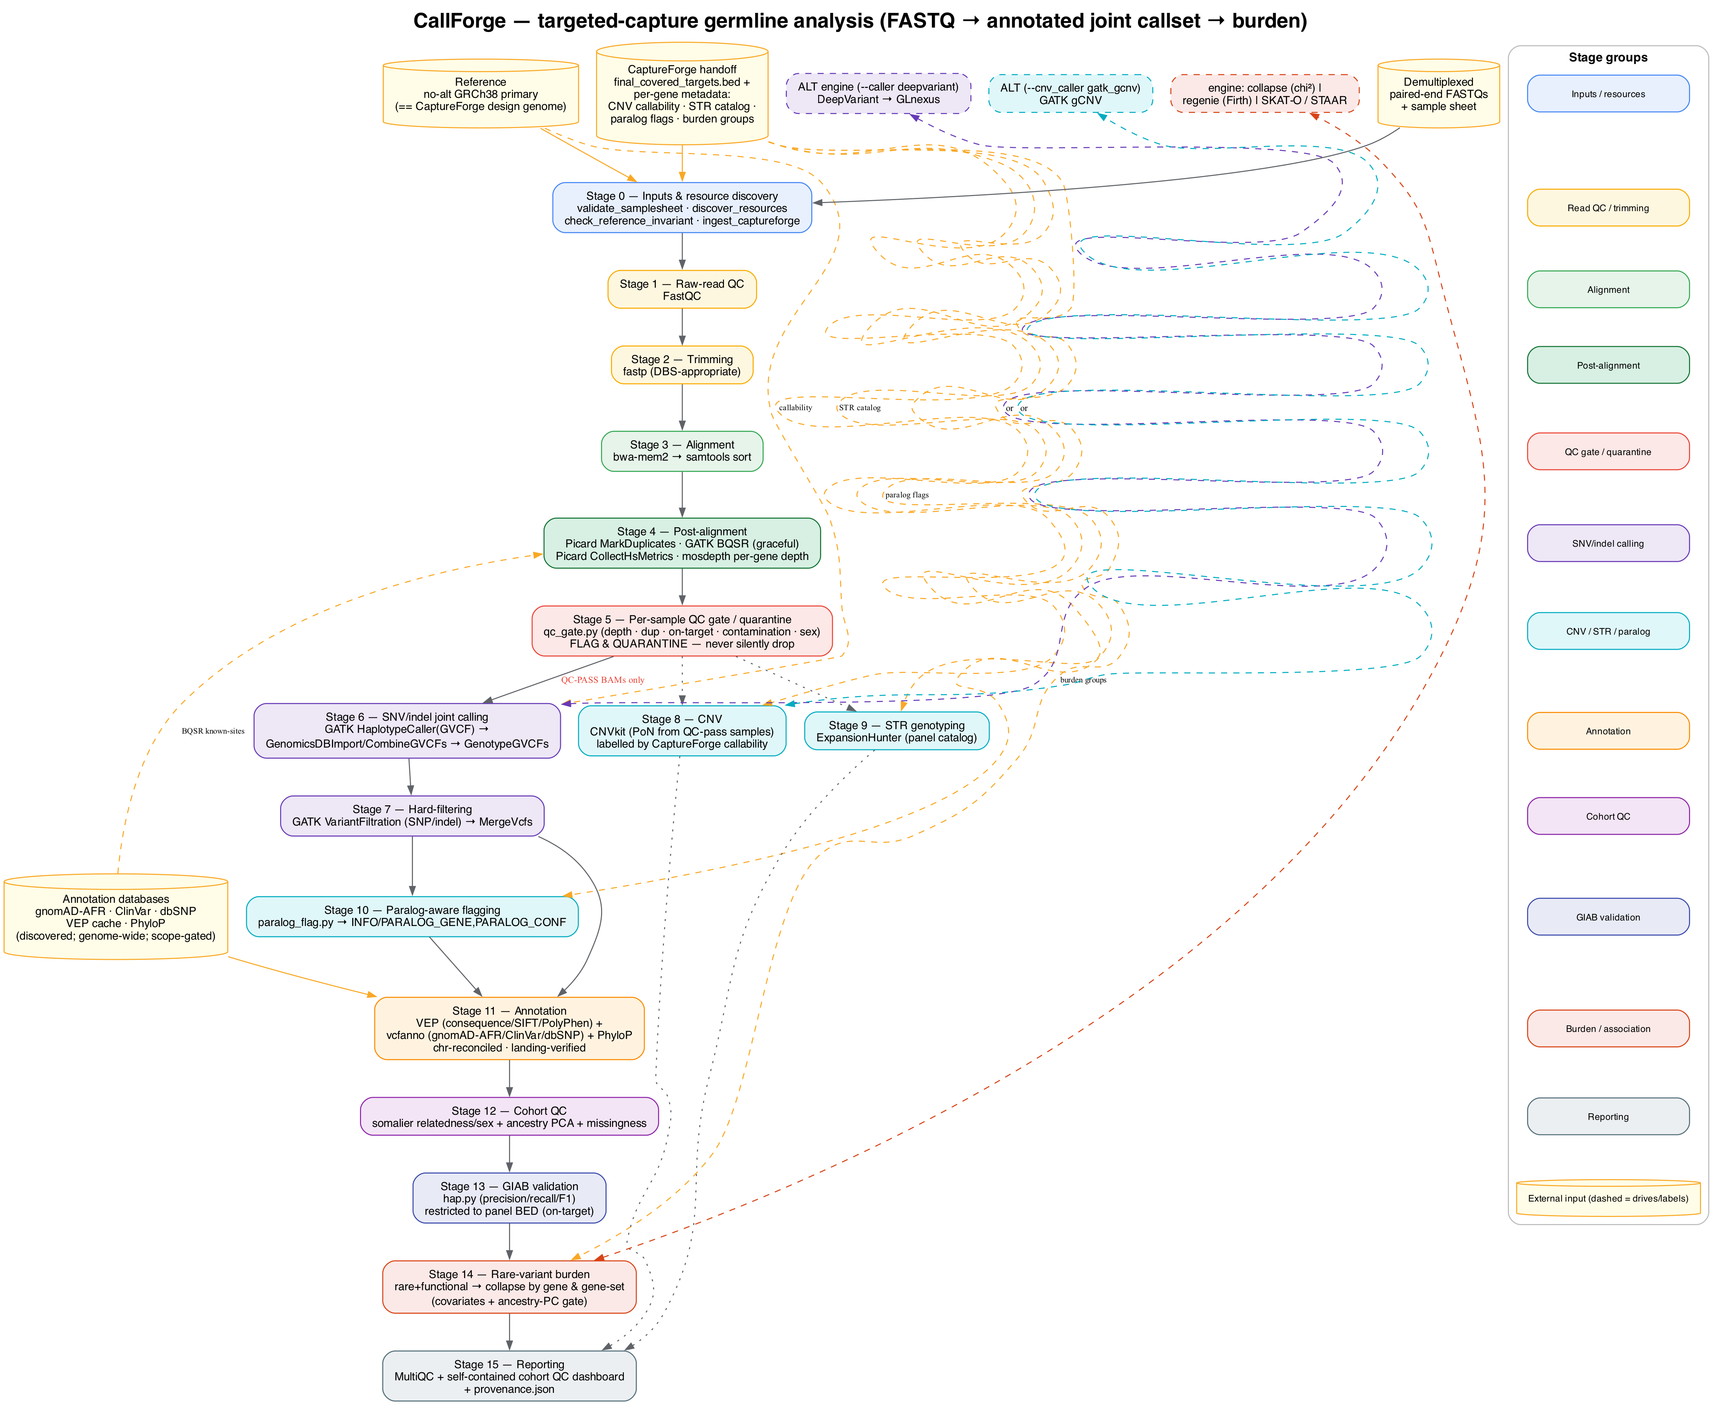
CallForge pipeline DAG — stages colour-coded by group; external inputs (reference, CaptureForge handoff, annotation databases, FASTQs) feed in; alternative engines (DeepVariant+GLnexus, gatk_gcnv, collapse/regenie/SKAT-O) shown as dashed branches.
Stage walkthrough (real inputs → outputs).
# | Stage | Key tool(s) | Main output(s) under results/
0 | Inputs & resource discovery | validate_samplesheet, discover_resources, check_reference_invariant, ingest_captureforge | stage0_inputs/ (manifest, invariant, gene_metadata.tsv)
1 | Raw-read QC | FastQC | stage1_rawqc/
2 | Trimming | fastp | stage2_trim/
3 | Alignment | bwa-mem2 → samtools sort | stage3_align/
4 | Post-alignment | Picard MarkDuplicates, GATK BQSR, CollectHsMetrics, mosdepth | stage4_postalign/
5 | Per-sample QC gate | qc_gate.py | stage5_qc_gate/ (qc_pass.txt, qc_quarantine.txt)
6 | SNV/indel joint calling | GATK HaplotypeCaller → GenomicsDBImport → GenotypeGVCFs | stage6_calling/joint.vcf.gz
7 | Hard-filtering | GATK VariantFiltration → MergeVcfs | stage7_filter/joint.filtered.vcf.gz
8 | CNV | CNVkit | stage8_cnv/ (cnv_calls.tsv, callability)
9 | STR | ExpansionHunter | stage9_str/
10 | Paralog-aware | paralog_flag.py | stage10_paralog/paralog.annotated.vcf.gz
11 | Annotation | VEP + vcfanno + PhyloP | stage11_annotation/annotated.vcf.gz, variants.flat.tsv
12 | Cohort QC | somalier | stage12_cohortqc/
13 | GIAB validation | hap.py | stage13_giab/
14 | Burden / association | collapse / regenie / SKAT-O | stage14_burden/burden_results.tsv
15 | Reporting | MultiQC + dashboard + provenance | stage15_report/
Nextflow / profile model. main.nf calls one subworkflow (subworkflows/callforge.nf) that wires modules in modules/. Behaviour is set by profiles composed on the command line: an execution profile (test, mac_local, hpc_slurm) plus an environment engine (conda, docker, apptainer). Each process declares its own pinned conda env (env/*.yml) or a pinned container (VEP, hap.py), so -profile ...,conda or ,apptainer builds exactly what each stage needs.
Engine options (see §7 for full defaults): SNV/indel --caller gatk|deepvariant; joint method --joint_method genomicsdb|combinegvcfs; CNV --cnv_caller cnvkit|gatk_gcnv; CNVkit segmentation --cnv_segment_method cbs|haar|hmm; burden --burden_engine regenie|skat|collapse.

4. Installation
CallForge needs Nextflow (>=23.10) and either conda/mamba or a container engine. Each stage runs in its own pinned environment (env/*.yml) or pinned container, so you do not install tools by hand — -profile conda (or ,apptainer) builds each environment on first use.

4.1 Local install (personal computer)
Common steps.
# 1. Nextflow (Java 17+ required)
curl -s https://get.nextflow.io | bash && sudo mv nextflow /usr/local/bin/
# or: mamba create -n nextflow -c bioconda 'nextflow>=23.10'
# 2. clone CallForge (it lives beside CaptureForge)
cd ~/Documents/Claude/Projects/callforge
# 3. core environment (others build on demand)
mamba env create -f env/callforge.yml
macOS (Apple Silicon). Some bioconda tools lack osx-arm64 builds. Two options:
# (a) Rosetta-emulated x86 env (documented path; the report flags emulated stages)
CONDA_SUBDIR=osx-64 mamba env create -f env/callforge.yml
# (b) native arm64 — works for most tools, but pin mosdepth >= 0.3.11
# (mosdepth 0.3.8 has no arm64 build; 0.3.8 + Rosetta is the alternative)
VEP and hap.py are run from their official containers (robust across platforms); ensure Docker is available and use -profile <exec>,docker.
Linux. Native; mamba env create -f env/*.yml resolves cleanly, or use the container route.
Container route. Build the core image once and run containerized:
docker build -t callforge:0.1.0 -f env/Dockerfile .
# Apptainer (HPC): apptainer build callforge.sif env/callforge.def

4.2 Shared HPC install (Ubuntu 24.04 SLURM cluster)
The production cohort run is intended for the cluster (native linux-64; no Rosetta). The hpc_slurm profile uses the SLURM executor (global, cluster-wide across the nodes) and Apptainer for the containerized tools.
# shared conda at /hpc/opt/conda
source /hpc/opt/conda/etc/profile.d/conda.sh
mamba env create -p /hpc/opt/conda/envs/callforge -f env/callforge.yml
mamba env create -p /hpc/opt/conda/envs/callforge-annotate -f env/annotate.yml
# ... and cohortqc / cnv / str / happy / burden / deepvariant as needed
# Apptainer image for the core tools (Docker is usually forbidden on clusters)
apptainer build callforge.sif env/callforge.def
export APPTAINER_BINDPATH=/data/refs,/data/annotation_db,$HOME/.vep # mount resources
# run
nextflow run main.nf -profile hpc_slurm,apptainer -params-file params.full.yaml \
--slurm_partition compute \
--slurm_account mylab \
--scratch_dir /scratch/$USER
An Lmod module + launcher wrapper is the recommended front door (set PATH to the shared Nextflow, source the shared conda, set APPTAINER_BINDPATH); see docs/hpc_deployment.md. conf/hpc_slurm.config sets a shared conda cache so each env builds once cluster-wide; --slurm_partition / --slurm_account / --scratch_dir are overridable. Heavy steps (index, align, large labels) get bigger slots.

5. Inputs

5.1 Sample sheet (CSV) — --input
Columns: sample_id, fastq_1, fastq_2, sex, phenotype, covariate_*, batch. Example:
sample_id,fastq_1,fastq_2,sex,phenotype,covariate_age,batch
S001,/data/fq/S001_R1.fastq.gz,/data/fq/S001_R2.fastq.gz,F,case,41,b1
S002,/data/fq/S002_R1.fastq.gz,/data/fq/S002_R2.fastq.gz,M,control,55,b1
HG002,/data/fq/HG002_R1.fastq.gz,/data/fq/HG002_R2.fastq.gz,M,control,30,b2
- sample_id unique; fastq_1/fastq_2 are the paired-end reads (validated to exist and differ). sex is M/F/U (free tokens normalized).
- phenotype is required only for the burden layer (case/control or quantitative). Without it, the pipeline runs through the annotated callset and skips burden with a message (burden_meta.json records status: skipped_no_phenotype).
- covariate_* columns (any number) become burden covariates; batch is carried for QC.
Validation (validate_samplesheet.py) writes samplesheet.valid.csv and samplesheet_summary.json (with burden_eligible).

5.2 CaptureForge handoff — --target_bed (+ metadata)
Point CallForge at CaptureForge’s as-built outputs:
target_bed: /path/captureforge/results/full_run/stage9_qc/final_covered_targets.bed
captureforge_dir: /path/captureforge/results/full_run # auto-finds metrics.json + baits.csv
paralog_genes: "CD209,CASP1,CR1,HP,CFH"
final_covered_targets.bed uses GENE|class names (e.g. ATP2B4|coding, GYPC|cnv). metrics.json supplies CNV callability; baits.csv an off-target signal. If CaptureForge outputs are absent, supply --gene_metadata (a per-gene TSV), --paralog_genes, and --str_catalog directly. ingest_captureforge.py produces gene_metadata.tsv with columns gene, classes, …, is_cnv_target, cnv_callable, cnv_callable_reason, is_str_target, str_loci, is_paralog, off_target_frac, low_coverage, burden_group.

5.3 Reference — --genome_fasta
The no-alt GRCh38 primary assembly the panel was designed against (Ensembl-named, e.g. 1,2,…,22,X,Y,MT). --genome_build GRCh38. CallForge builds .fai/.dict/bwa-mem2 index if absent and asserts the reference invariant (§9).

6. Annotation databases
Annotation is the most resource-sensitive stage and is treated carefully: CallForge discovers local resources, validates their genomic scope (fail-loud on region-limited databases), and reconciles contig naming so values are never silently missed. Nothing is downloaded unless a resource is missing and required and you opt in (--allow_download).

6.1 The databases
Database | Provides | Stage(s) | Param | Scope requirement
gnomAD (AFR) | population allele frequencies, incl. African-ancestry AF_afr | 11 (vcfanno), 14 (rare filter) | --gnomad_vcf, --gnomad_af_field AF_afr | genome-wide; scope-gated
ClinVar | clinical significance (CLNSIG, CLNDN, CLNREVSTAT, …) | 11 | --clinvar_vcf | genome-wide; scope-gated
dbSNP | rsIDs (ID column) | 11 (rsID), 4 (BQSR known-site) | --dbsnp_vcf, --known_sites | genome-wide; scope-gated
VEP cache | consequence, transcript, SIFT/PolyPhen, canonical/MANE | 11 | --vep_cache, --vep_release | species + assembly match
PhyloP | conservation score (bigWig) | 11 | --phylop_bw | genome-wide
Namespacing. gnomAD INFO fields are written back as gnomAD_* (e.g. gnomAD_AF_afr) so the cohort’s own AF/AC/AN are never overwritten — the classic annotation enrichment bug is designed out.

6.2 The genomic-scope gate (fail-loud)
A region-subset database (e.g. a single-locus gnomAD) silently returns “no AF / no ClinVar” outside its region — which a downstream filter would misread as rare-novel, corrupting burden testing. discover_resources.py therefore validates, per annotation VCF, that its data spans the target panel’s contigs (tabix-probed, chr/no-chr reconciled), checks the BGZF-EOF marker (rejects truncated downloads), and fails loud on a found-but-unfit database:
[discover_resources] UNFIT (found but region-limited): gnomad_vcf: data spans only
1/19 target contigs (frac=0.0526 < 0.9); region-subset DB — replace with genome-wide.
[discover_resources] FAIL: ... Refusing to under-annotate.
Tune with --scope_min (default 0.9); override only with --ignore_unfit_resources (not advised) or --allow_download.

6.3 Contig-naming / chr-reconciliation
The design reference / callset is Ensembl-numeric (1), gnomAD and PhyloP are usually chr-prefixed (chr1), and NCBI ClinVar is Ensembl-numeric. CallForge reconciles naming per resource: the query is renamed to a resource’s style only where it differs, then renamed back — and the annotation step then verifies the values actually landed (verify_annotation.py, fail-loud), so a contig-name mismatch can never silently drop an annotation.

6.4 Fetching databases — bin/fetch_annotation_dbs.sh
A resumable downloader for genome-wide gnomAD v4.1 + ClinVar (GRCh38):
# panel-slice mode (recommended for a targeted panel; a few hundred MB)
MODE=panel \
PANEL_BED=/path/final_covered_targets.bed \
OUTDIR=/path/annotation_db \
bash bin/fetch_annotation_dbs.sh
# full genome-wide mode (very large; use on HPC with a fast network)
MODE=full DATASETS="genomes" bash bin/fetch_annotation_dbs.sh
Panel mode merges nearby intervals to cut HTTP round-trips, slices each chromosome with per-chromosome retry, and is resumable (re-run to continue, not restart). dbSNP is not fetched by this script — supply a genome-wide dbSNP separately (it is also a BQSR known-site).

6.5 Resource auto-discovery
discover_resources.py scans --resource_dirs (default $HOME,/usr/local/share,/opt), validates each resource (build, index, scope, integrity), and writes stage0_inputs/resource_manifest.json. Missing human-only resources are reported and the dependent step skips gracefully. Explicit --vep_cache/--gnomad_vcf/--clinvar_vcf/… overrides take precedence and are still validated.

6.6 Bring-your-own / non-human databases
CallForge is organism-generic: VEP runs by --species (point at that species’ VEP cache), and vcfanno reads a bring-your-own-databases TOML (--vcfanno_toml). Human-only resources (gnomAD/ClinVar/BQSR known-sites) skip gracefully when absent. To register a new organism: set --species, --genome_fasta (that build), --vep_cache, and a --vcfanno_toml listing whatever frequency/clinical databases exist; leave the human DB params unset.

7. Configuration
Set parameters via -params-file params.yaml (see params.example.yaml) or --key value. Profiles set executor + resource ceilings: test (3–4 synthetic samples, minutes), mac_local (full, one machine), hpc_slurm (SLURM + Apptainer/shared-conda).
Key tunables (real defaults).
Param | Default | Meaning
--caller | gatk | SNV/indel engine: gatk or deepvariant
--joint_method | genomicsdb | genomicsdb or combinegvcfs
--ploidy | 2 | HaplotypeCaller ploidy
--cnv_caller | cnvkit | cnvkit or gatk_gcnv
--cnv_method | hybrid | CNVkit hybrid (capture) or amplicon
--cnv_segment_method | cbs | cbs (R/DNAcopy), haar (pure-python), hmm
--min_mean_target_depth | 30 | QC gate: min mean target depth (×)
--max_dup_rate | 0.40 | QC gate: max duplication fraction
--min_on_target | 0.40 | QC gate: min on-target fraction
--max_contamination | 0.03 | QC gate: max VerifyBamID2 FREEMIX
--enforce_sex_check | true | quarantine on sex mismatch (when assessable)
--snp_filter_expr | GATK WGS/WES default | SNP hard-filter JEXL
--indel_filter_expr | GATK WGS/WES default | indel hard-filter JEXL
--scope_min | 0.9 | min fraction of target contigs a DB must span
--known_sites | null | BQSR known-sites (dbSNP + Mills + 1000G)
--somalier_sites | null | somalier sites VCF (1000G for the build)
--str_catalog | null | ExpansionHunter catalog (else built from STR targets)
--burden_engine | regenie | regenie, skat, or collapse
--burden_af_max | 0.01 | rare threshold on gnomAD-AFR AF
--burden_csq | LoF + missense + splice + inframe set | qualifying consequences
--n_ancestry_pcs | 4 | ancestry PCs offered as covariates (PC-stability gate applies)
--vep_image | ensembl-vep 110 | VEP container (tag below)
--happy_image | hap.py 0.3.12 | hap.py container (tag below)
The container defaults are ensemblorg/ensembl-vep:release_110.0 (VEP) and jmcdani20/hap.py:v0.3.12 (hap.py).
Hard-filter thresholds are the GATK WGS/WES defaults. Revisit them on real targeted data (panel Ti/Tv, pass rates, and QUAL/DP distributions guide tuning).

8. Running — step-by-step scenarios
All multi-flag commands use backslash continuation (one flag per line). On a local machine use ,conda (and ,docker for the VEP/hap.py containers); on the cluster use ,apptainer.

8.1 Quickstart (test profile)
bash test/make_test_data.sh
nextflow run main.nf -profile test,docker
This builds a tiny self-contained fixture (mini-genome + synthetic reads) and runs all 16 stages in minutes. Use it to confirm your install.

8.2 Full human cohort (primary scenario)
# 1. write the sample sheet (§5.1) with phenotype if you want burden
# 2. confirm resources discover + pass the scope gate; fetch genome-wide
# gnomAD/ClinVar if missing (§6.4); supply a genome-wide dbSNP
# 3. run (authoring machine)
nextflow run main.nf \
-profile mac_local,conda \
-params-file params.full.yaml
# 3'. or the cluster
nextflow run main.nf \
-profile hpc_slurm,apptainer \
-params-file params.full.yaml
params.full.yaml wires the reference, the CaptureForge handoff, resource directories, and engine choices; set input: to your cohort sample sheet. Inspect results/stage5_qc_gate/qc_scorecard.tsv, then the annotated callset and the dashboard.

8.3 Callset-only (no phenotype)
Omit phenotype (or set --run_burden false). The pipeline runs through Stage 11 (annotated callset) + cohort QC + GIAB and skips burden; burden_meta.json records the skip. Everything else (annotated VCF, per-variant TSV, CNV/STR/paralog) is produced.

8.4 Burden / association run (with phenotype)
nextflow run main.nf \
-profile hpc_slurm,apptainer \
-params-file params.full.yaml \
--run_burden true \
--burden_engine regenie \
--burden_af_max 0.01 \
--n_ancestry_pcs 4 \
--covariates covariate_age,covariate_sex
Burden filters to rare+functional variants, collapses by gene and CaptureForge burden group, and tests with covariates + ancestry PCs. The ancestry-PC stability gate drops the PCs and runs unadjusted (recorded in provenance) if there are too few PCA sites for the cohort — read burden_results.tsv (its engine column states the engine) with the QQ / Manhattan plots and the validity caveats (§11).

8.5 A different panel
Swap the CaptureForge handoff — no code change:
nextflow run main.nf -profile mac_local,conda \
--input samplesheet.csv \
--genome_fasta /ref/GRCh38_noalt.fa \
--target_bed /panelB/final_covered_targets.bed \
--captureforge_dir /panelB/results/full_run

8.6 A different organism
nextflow run main.nf -profile mac_local,conda \
--input samplesheet.csv \
--genome_build <BUILD> \
--genome_fasta /ref/<species>_noalt.fa \
--target_bed /panel/final_covered_targets.bed \
--species <vep_species> \
--vep_cache /vep/<species> \
--vcfanno_toml /db/<species>.toml \
--run_burden false
Human-only resources (gnomAD/ClinVar/BQSR) skip gracefully. Minimum inputs: sample sheet, no-alt reference for that build, target BED, a VEP cache (or --vep_mode gtf with a --gtf), and a vcfanno TOML for any frequency/clinical databases you have.

8.7 HPC run
See §4.2. -profile hpc_slurm,apptainer; SLURM is global/cluster-wide; resources are copied to a shared path and bound into Apptainer.

8.8 Choosing engine alternatives
--caller deepvariant # DeepVariant + GLnexus (container) instead of GATK
--cnv_caller gatk_gcnv # GATK gCNV instead of CNVkit
--burden_engine skat # SKAT-O / STAAR (R) instead of regenie
--burden_engine collapse # chi-square collapsing (small-N / dependency-free)
Validate before production. DeepVariant+GLnexus, regenie, and SKAT-O/STAAR are wired but have not yet been executed end-to-end (the synthetic test cohort is too small). Exercise them on a real/realistic cohort before relying on them. The tested engines are GATK/GenomicsDB (calling) and collapse (burden).

8.9 GIAB validation run
Add a GIAB control to the sample sheet and supply truth:
nextflow run main.nf -profile mac_local,conda -params-file params.full.yaml \
--giab_control_id HG002 \
--giab_truth_vcf /giab/HG002_v4.2.1_benchmark.vcf.gz \
--giab_truth_bed /giab/HG002_v4.2.1_benchmark.bed
hap.py scores precision/recall/F1 restricted to the panel BED (on-target only), so off-target truth cannot distort the panel’s measured sensitivity.

9. Quality control
CallForge’s QC philosophy: a plot at every applicable stage (each with a one-line caption), gates that flag and quarantine rather than silently drop, and a single cohort QC dashboard plus MultiQC. The figures below are from the synthetic test run — they prove the machinery; real numbers come from a real cohort.

9.1 Read & alignment QC (Stages 1–4)
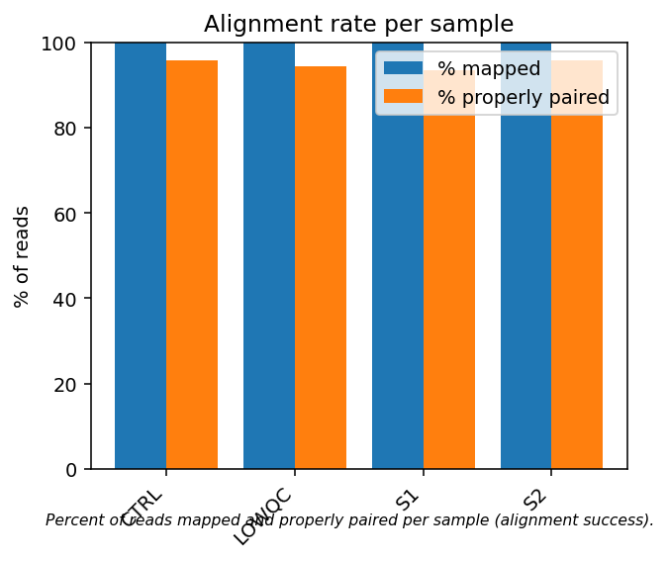
Percent of reads mapped and properly paired per sample (alignment success).
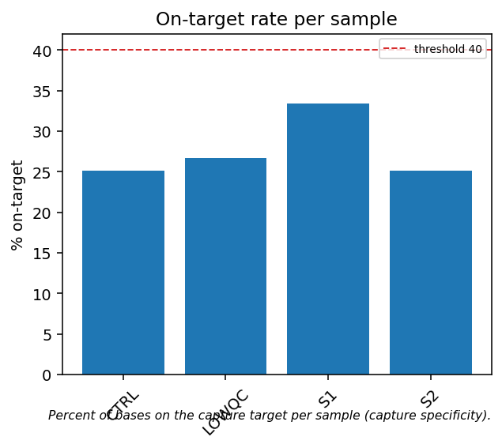
Percent of bases on the capture target per sample (capture specificity).
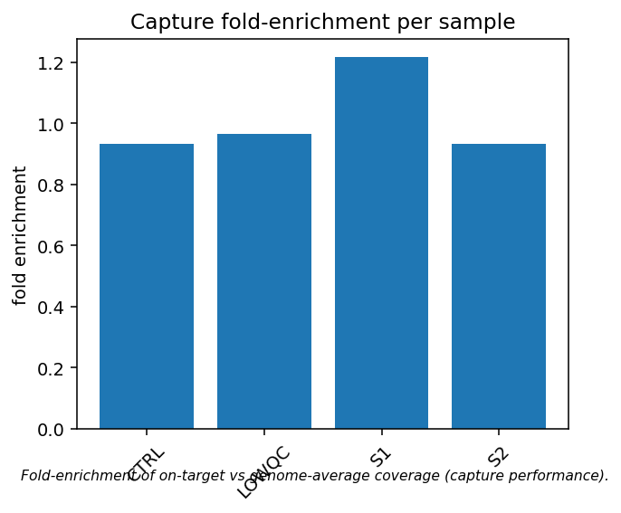
Fold-enrichment of on-target vs genome-average coverage (capture performance).
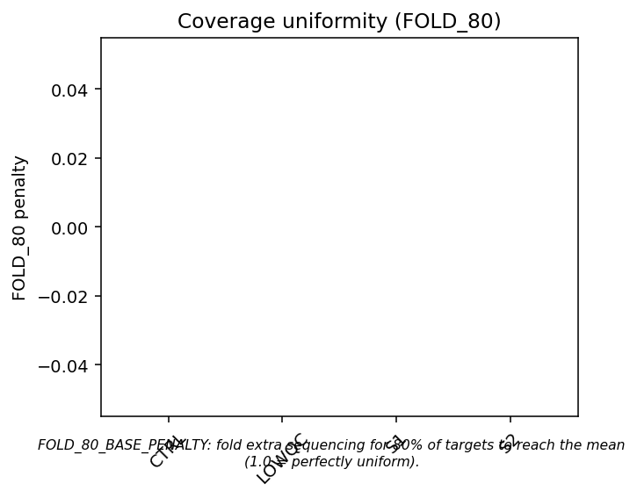
FOLD_80_BASE_PENALTY: fold extra sequencing for 80% of targets to reach the mean (1.0 = perfectly uniform).
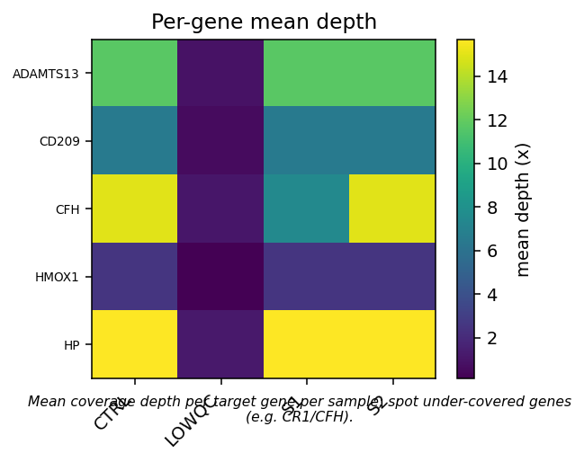
Mean coverage depth per target gene per sample; spot under-covered genes (e.g. CR1/CFH).
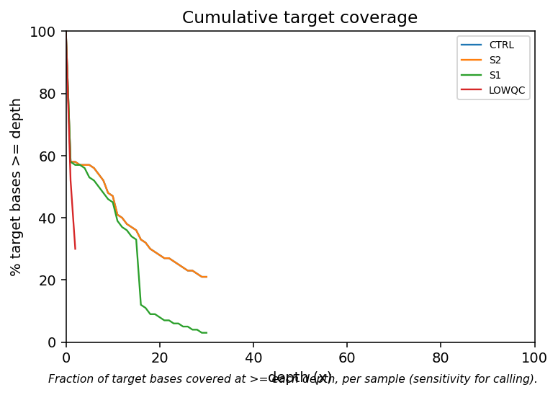
Fraction of target bases covered at >= each depth, per sample (sensitivity for calling).
CollectHsMetrics (vs the target BED) gives on-target %, fold-enrichment, % target ≥10/20/30×, and uniformity (FOLD_80); mosdepth gives per-target and per-gene depth in the CaptureForge track style. Duplicates are marked by coordinate (correct for capture). BQSR runs when known-sites are available and skips gracefully otherwise.

9.2 Per-sample QC gate & quarantine (Stage 5)
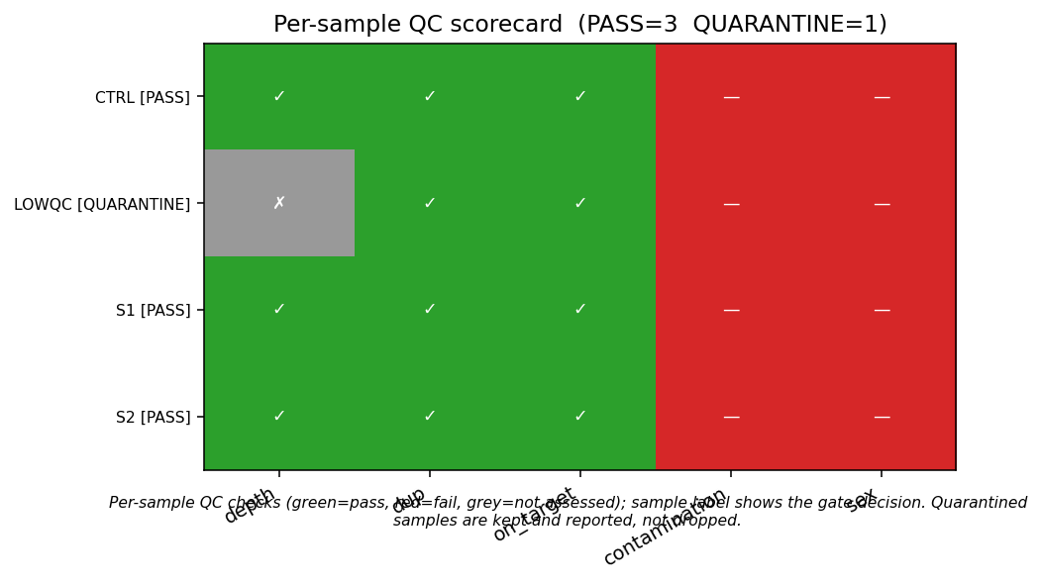
Per-sample QC checks (green=pass, red=fail, grey=not assessed); sample label shows the gate decision. Quarantined samples are kept and reported, not dropped.
qc_gate.py aggregates the per-sample metrics and applies thresholds (depth, dup, on-target, contamination, sex). Failing samples are flagged and QUARANTINED — written to qc_quarantine.txt with reasons, excluded from joint calling and from burden counts, but never silently dropped. Metrics that cannot be assessed (contamination without a VerifyBamID2 SVD panel; sex on an autosomal panel with no X/Y targets) are recorded NA, not failed.
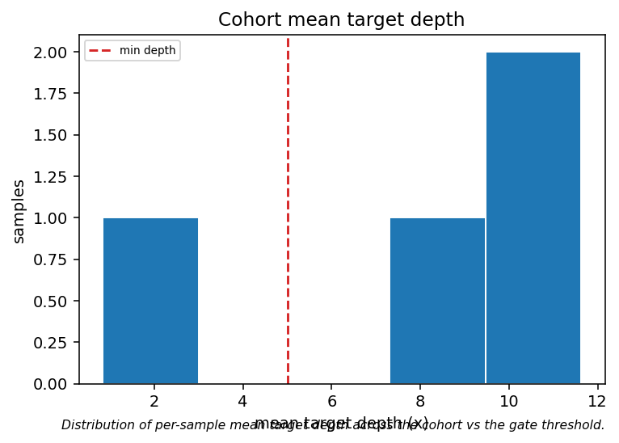
Distribution of per-sample mean target depth across the cohort vs the gate threshold.
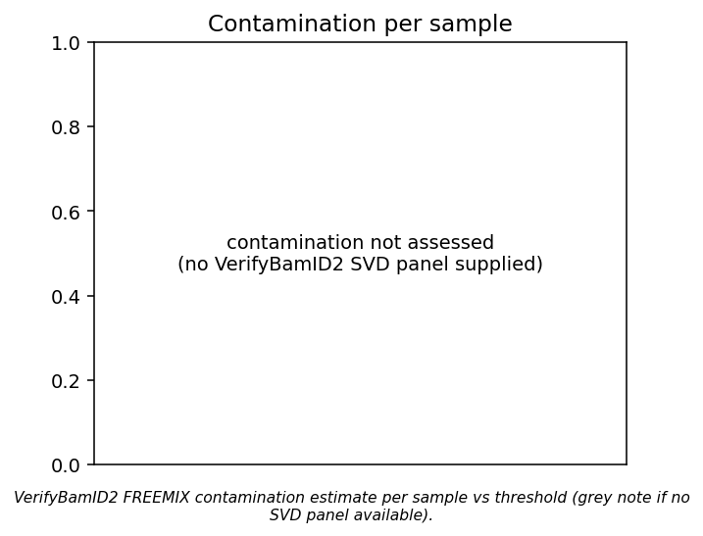
VerifyBamID2 FREEMIX contamination estimate per sample vs threshold (grey note if no SVD panel available).
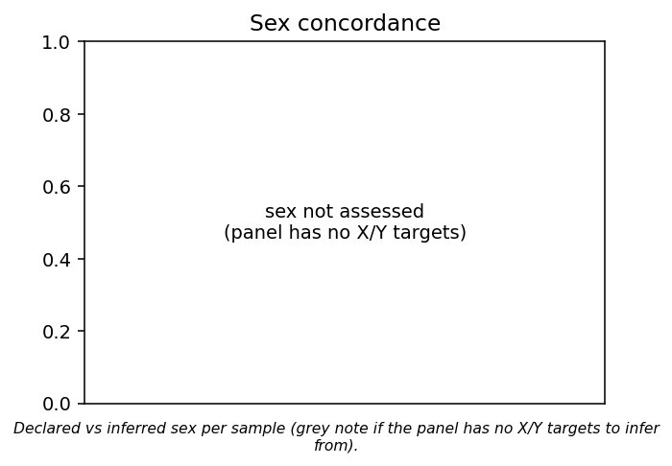
Declared vs inferred sex per sample (grey note if the panel has no X/Y targets to infer from).

9.3 Cohort QC dashboard & MultiQC (Stage 15)
make_dashboard.py builds stage15_report/cohort_qc_dashboard.html — a self-contained HTML embedding every captioned figure (base64) grouped by stage, plus the headline tables (resource manifest, QC scorecard, annotation landing, GIAB, burden). multiqc_report.html aggregates the per-tool outputs (FastQC, fastp, Picard, samtools, mosdepth).

10. Stage details & their plots

10.1 SNV/indel calling & filtering (Stages 6–7)
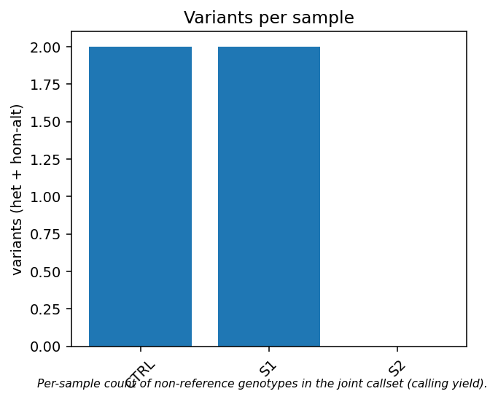
Per-sample count of non-reference genotypes in the joint callset (calling yield).
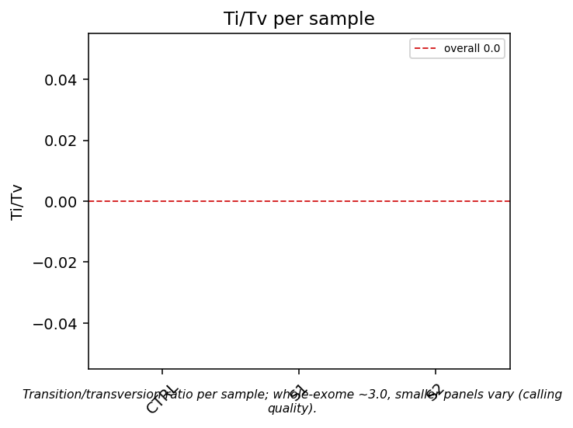
Transition/transversion ratio per sample; whole-exome ~3.0, smaller panels vary (calling quality).
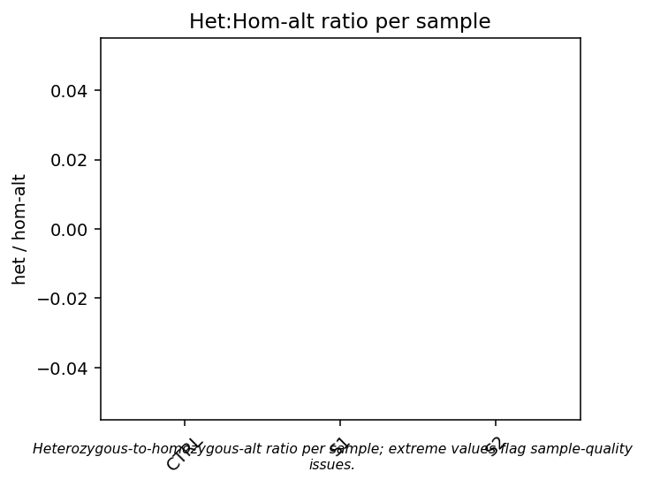
Heterozygous-to-homozygous-alt ratio per sample; extreme values flag sample-quality issues.
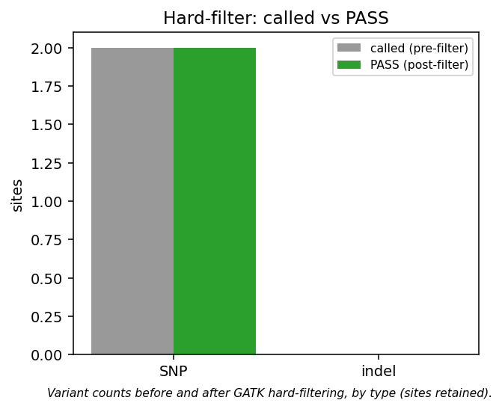
Variant counts before and after GATK hard-filtering, by type (sites retained).
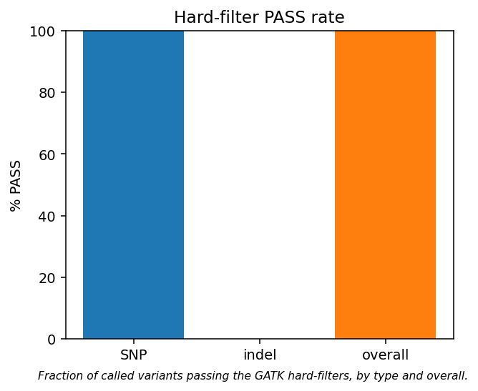
Fraction of called variants passing the GATK hard-filters, by type and overall.
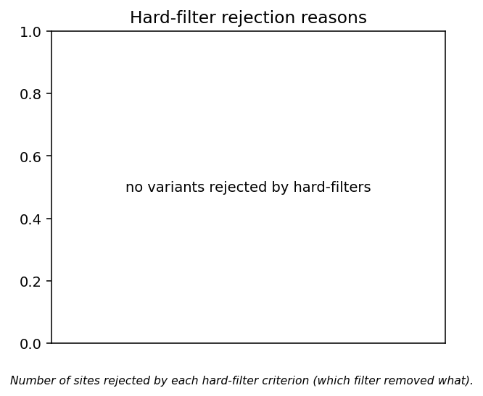
Number of sites rejected by each hard-filter criterion (which filter removed what).

10.2 CNV, STR, paralog (Stages 8–10)
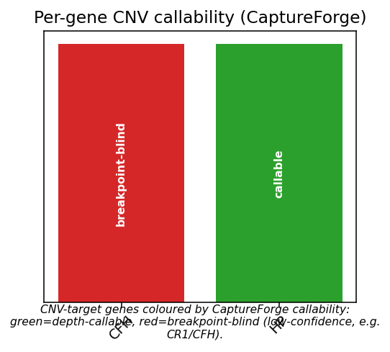
CNV-target genes coloured by CaptureForge callability: green=depth-callable, red=breakpoint-blind (low-confidence, e.g. CR1/CFH).
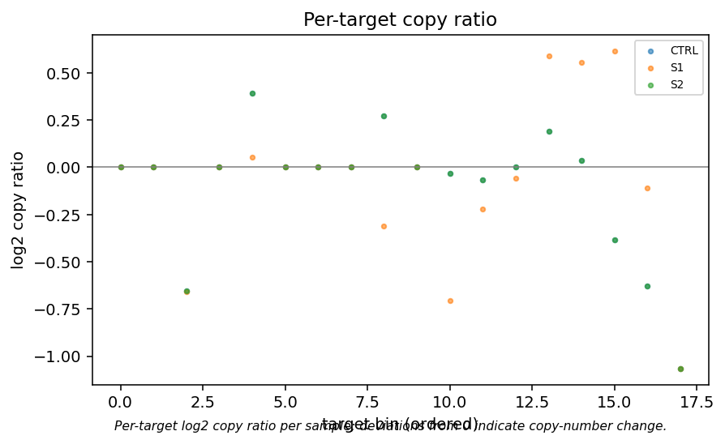
Per-target log2 copy ratio per sample; deviations from 0 indicate copy-number change.
CNV calls (cnv_calls.tsv) carry a cnv_callable and confidence column from CaptureForge metadata — a call at a breakpoint-blind gene (CR1/CFH) is labelled breakpoint_blind_low_confidence, not silently trusted.
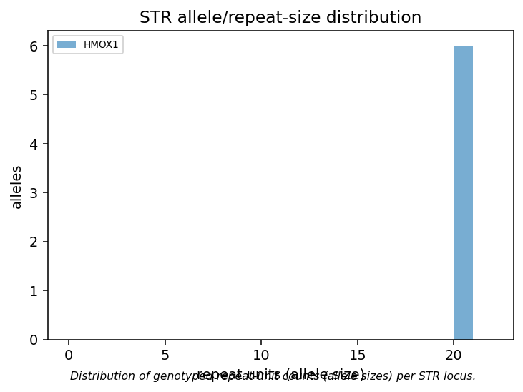
Distribution of genotyped repeat-unit counts (allele sizes) per STR locus.
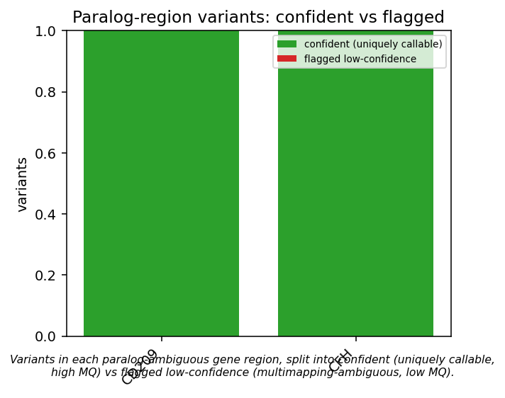
Variants in each paralog-ambiguous gene region, split into confident (uniquely callable, high MQ) vs flagged low-confidence (multimapping-ambiguous, low MQ).
Paralog-aware flagging writes INFO/PARALOG_GENE and INFO/PARALOG_CONF into paralog.annotated.vcf.gz so each variant in a paralog region carries its confidence.

10.3 Annotation (Stage 11)
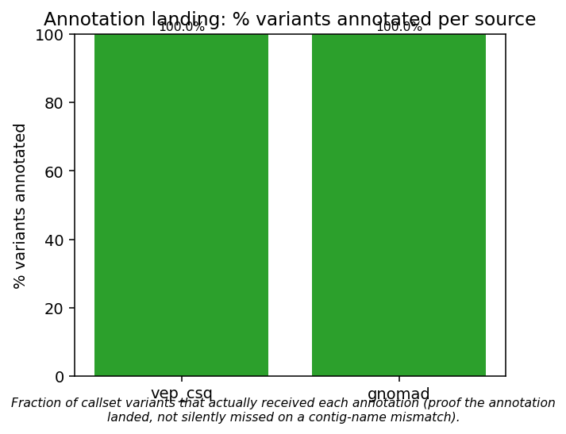
Fraction of callset variants that actually received each annotation (proof the annotation landed, not silently missed on a contig-name mismatch).
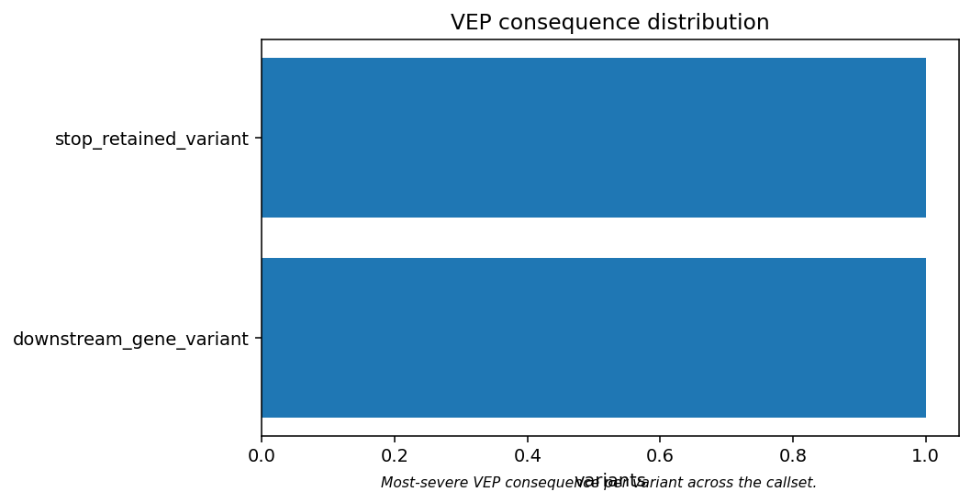
Most-severe VEP consequence per variant across the callset.
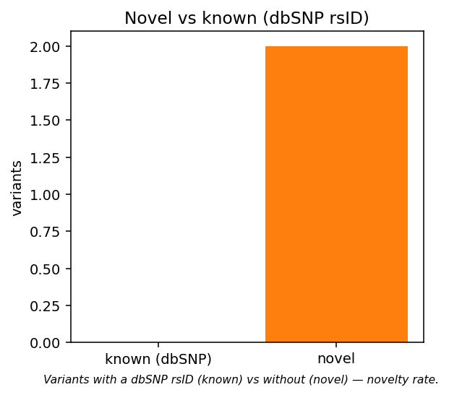
Variants with a dbSNP rsID (known) vs without (novel) — novelty rate.
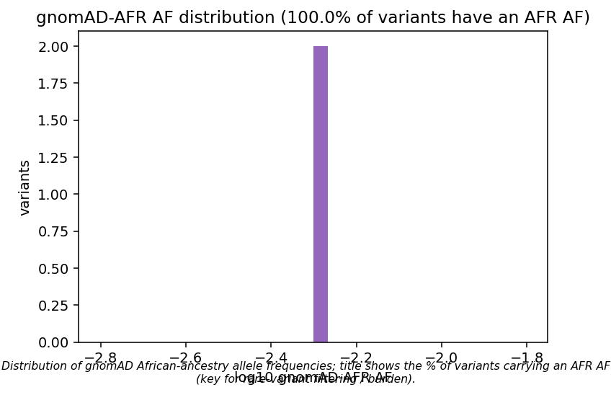
Distribution of gnomAD African-ancestry allele frequencies; title shows the % of variants carrying an AFR AF (key for rare-variant filtering / burden).
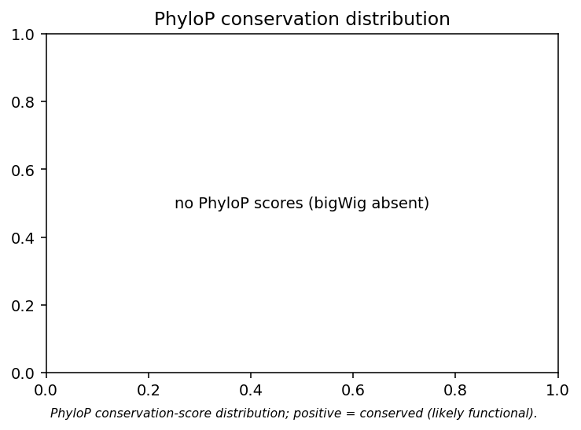
PhyloP conservation-score distribution; positive = conserved (likely functional).

10.4 Cohort QC (Stage 12)
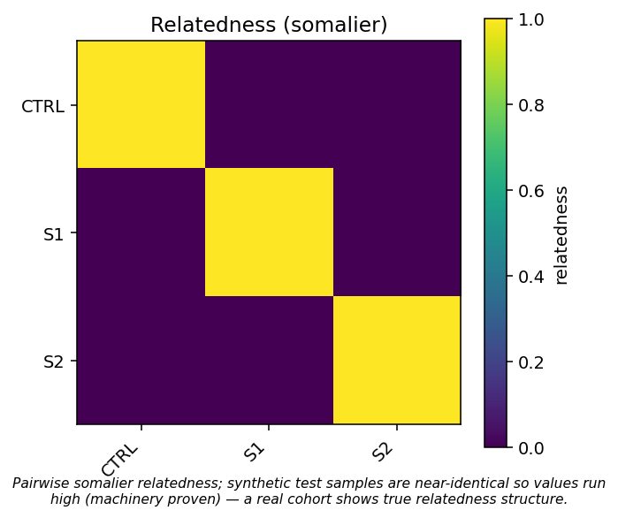
Pairwise somalier relatedness; synthetic test samples are near-identical so values run high (machinery proven) — a real cohort shows true relatedness structure.
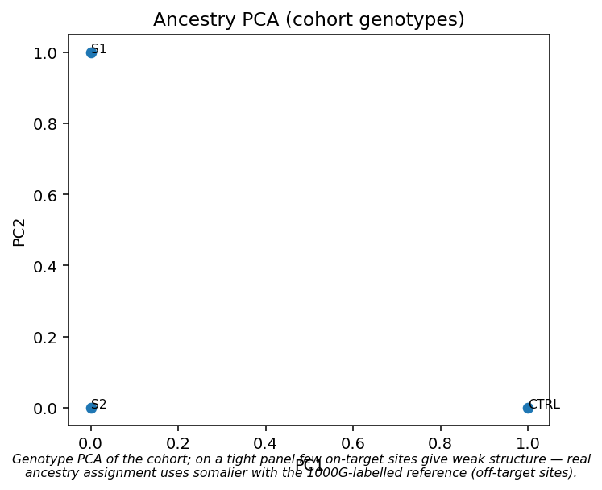
Genotype PCA of the cohort; on a tight panel few on-target sites give weak structure — real ancestry assignment uses somalier with the 1000G-labelled reference (off-target sites).
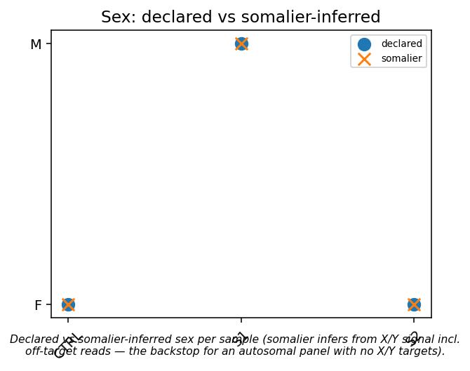
Declared vs somalier-inferred sex per sample (somalier infers from X/Y signal incl. off-target reads — the backstop for an autosomal panel with no X/Y targets).
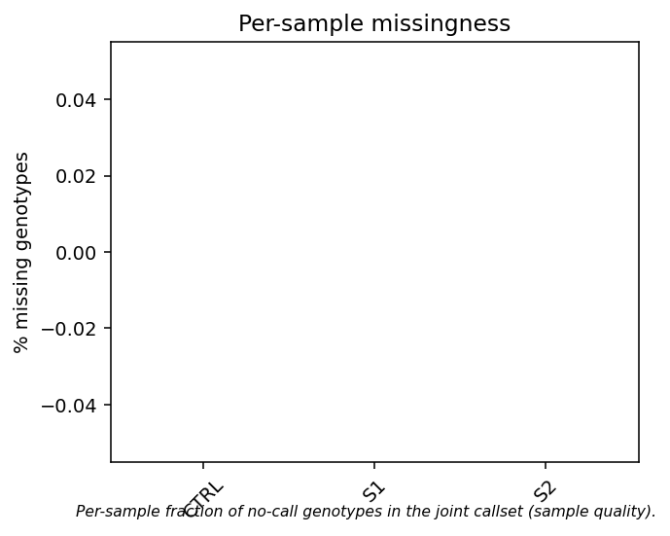
Per-sample fraction of no-call genotypes in the joint callset (sample quality).

10.5 GIAB validation (Stage 13)
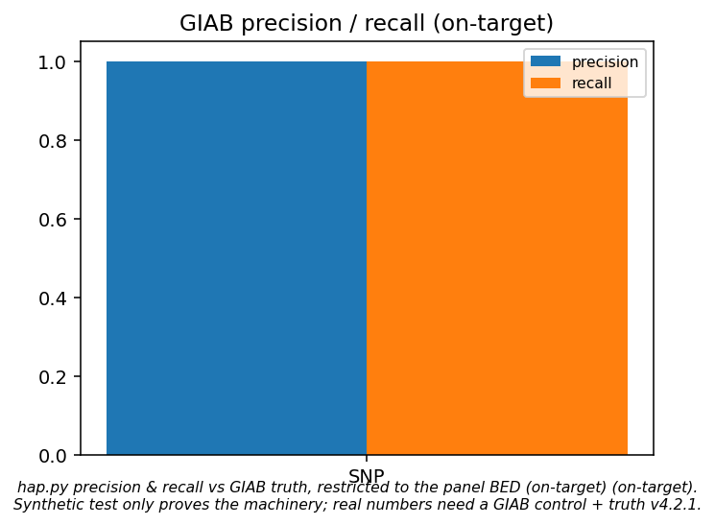
hap.py precision & recall vs GIAB truth, restricted to the panel BED (on-target). Synthetic test only proves the machinery; real numbers need a GIAB control + truth v4.2.1.
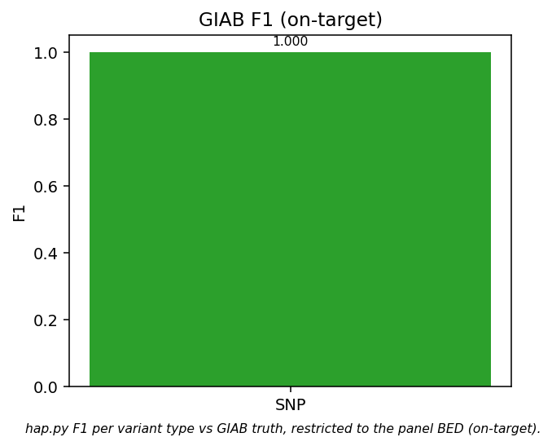
hap.py F1 per variant type vs GIAB truth, restricted to the panel BED (on-target).

10.6 Burden (Stage 14)
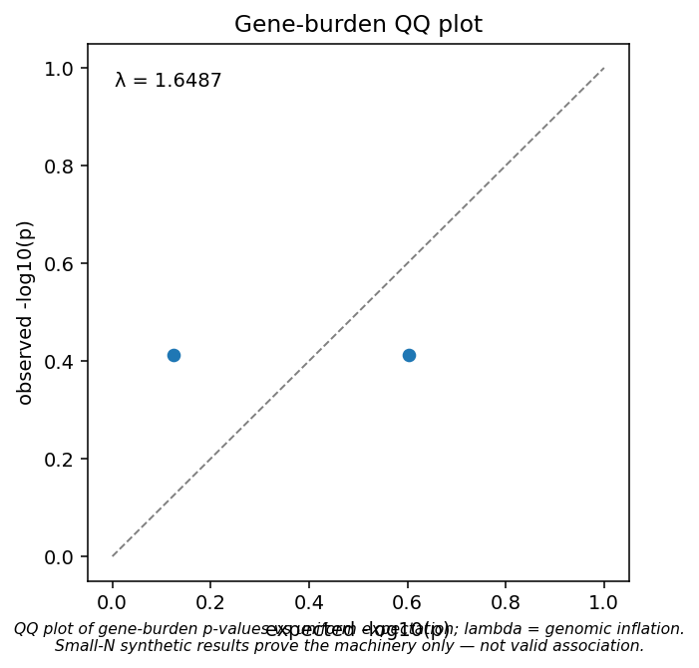
QQ plot of gene-burden p-values vs uniform expectation; lambda = genomic inflation. Small-N synthetic results prove the machinery only — not valid association.
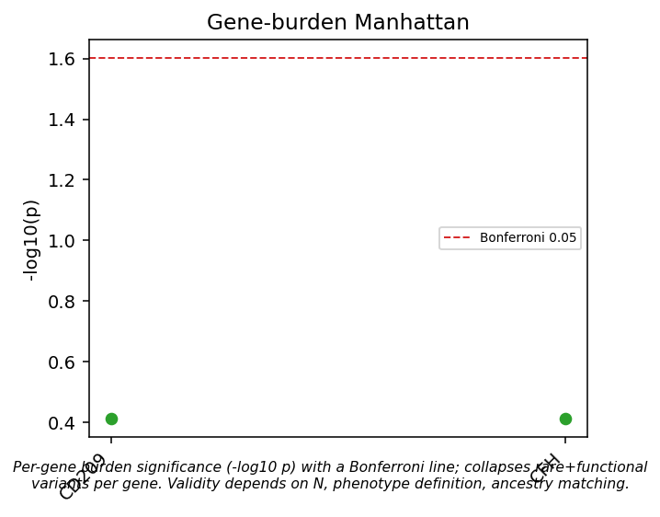
Per-gene burden significance (-log10 p) with a Bonferroni line; collapses rare+functional variants per gene. Validity depends on N, phenotype definition, ancestry matching.

11. Outputs explained
Output | Path | Notes
Annotated joint VCF | stage11_annotation/annotated.vcf.gz | VEP CSQ + gnomAD_* + ClinVar_* + PhyloP + paralog flags
Per-variant TSV | stage11_annotation/variants.flat.tsv | flattened; columns below
Filtered joint VCF | stage7_filter/joint.filtered.vcf.gz | FILTER = PASS / hard-filter name
CNV calls | stage8_cnv/cnv_calls.tsv | with cnv_callable + confidence
STR genotypes | stage9_str/str_calls.tsv | repeat units, read support, call rate
Paralog VCF | stage10_paralog/paralog.annotated.vcf.gz | INFO/PARALOG_GENE, PARALOG_CONF
Burden results | stage14_burden/burden_results.tsv | engine column stamps the method
Cohort QC | stage12_cohortqc/cohort_qc.json | relatedness, sex, missingness, PCA
GIAB metrics | stage13_giab/plots/giab_metrics.json | precision/recall/F1, on-target
Provenance | stage15_report/provenance.json | versions, resources, quarantine, PC gate
Dashboard | stage15_report/cohort_qc_dashboard.html | all figures + tables
Per-variant TSV columns (variants.flat.tsv): chrom, pos, ref, alt, rsID, filter, gene, consequence, gnomAD_AF, gnomAD_AF_afr, ClinVar_CLNSIG, PhyloP, paralog_gene, paralog_conf.
Burden results columns (burden_results.tsv): unit, kind, engine, n_carriers, case_carriers, control_carriers, chi2, p (the engine column means a collapse result can never be mistaken for a regenie association when the file is read on its own).

12. Interpreting results
Machinery-proven vs needs-real-cohort. On the synthetic test cohort the pipeline runs and the invariants fire, but the numbers are not data quality. Treat as machinery-proven (not real): on-target/enrichment/uniformity, Ti/Tv & het:hom, GIAB precision/recall, all burden association (small N), and relatedness/ancestry structure.
CaptureForge confidence labels. Read CNV calls through their callability label: depth-callable genes (e.g. GYPC, HP) are trustworthy; breakpoint-blind genes (CR1, CFH) are breakpoint_blind_low_confidence — treat their CNV calls cautiously. Paralog-region variants are split confident (uniquely callable, high MQ) vs flagged (multimapping ambiguity) — confirm flagged calls orthogonally.
Burden validity. Small cohorts show genomic inflation (high λ in the QQ plot) — not signal. The ancestry-PC gate drops unstable PCs and runs unadjusted (stated in provenance.json and the burden summary); an unadjusted run is a deliberate, declared choice, not a silent one. Burden validity depends on N, phenotype definition, and ancestry matching — CallForge does not imply publication-ready association on a small cohort.
GIAB. Precision = fraction of called variants that are true; recall = fraction of truth recovered; both on-target (panel-BED-restricted). Genome-wide scoring would distort a panel’s measured sensitivity.

13. Real-run checklist
Before the production cohort:
- Demultiplexed FASTQs + sample sheet (with phenotype for burden).
- Genome-wide gnomAD (AFR), ClinVar, dbSNP, PhyloP — each must pass the scope gate. dbSNP is needed in two places (annotation rsIDs + BQSR known-sites).
- BQSR known-sites via --known_sites (dbSNP + Mills + 1000G indels).
- 1000G GRCh38 somalier sites via --somalier_sites.
- GIAB control in the sheet + truth v4.2.1 (--giab_control_id, --giab_truth_vcf/bed).
- Confirm ancestry PCs are stable before using them as burden covariates (the gate enforces this; if unstable it runs unadjusted and says so).
- Validate-before-production engines: DeepVariant+GLnexus, regenie, SKAT-O/STAAR.
- Re-generate the genome-wide gnomAD panel slice on the HPC (fast network).
- Revisit GATK hard-filter thresholds for targeted data.

14. Troubleshooting
Symptom | Cause / fix
Scope-gate FAIL on a DB | region-subset DB — supply a genome-wide replacement (message names it)
Annotation values missing | chr-naming mismatch — handled by reconciliation; verify_annotation.py fails loud if not, check the manifest naming
VEP “CacheDir” error in gtf mode | do not pass --offline with --gtf (cache mode only)
mosdepth “exec format error” (arm64) | use mosdepth ≥0.3.11 or CONDA_SUBDIR=osx-64
grep -P errors in fetch script (macOS) | BSD grep lacks -P; the shipped script uses awk (keep it in sync)
No samples reach calling | all quarantined — read qc_quarantine.txt; relax thresholds only with justification
Unstable ancestry PCs | the gate drops them and runs unadjusted (recorded); do not force them
Truncated .bgz DB | BGZF-EOF check flags it truncated — re-fetch (resumable)
Hard-filter over-removes on a panel | tune --snp_filter_expr/--indel_filter_expr (defaults are WGS/WES)

15. Extending CallForge
- New annotation databases: add them to a vcfanno TOML (--vcfanno_toml); the scope gate + landing check apply.
- New organism: --species + VEP cache + vcfanno TOML; human DBs skip (§6.6).
- Engine choices: §8.8 — note the validate-before-production engines.
- Roadmap (not yet validated): end-to-end runs of DeepVariant+GLnexus, regenie, and SKAT-O on a real cohort; VQSR for large cohorts; manifest-driven BQSR known-sites.

16. Reproducibility & provenance
Every run writes stage15_report/provenance.json: pipeline version + git commit, the reference + invariant statement, the resource manifest (status/build/md5/AFR), QC thresholds + pass/quarantine lists with reasons, the burden status + ancestry-PC gate decision, and pointers to the pinned env/*.yml and the pinned VEP/hap.py containers. Pin Nextflow via manifest.nextflowVersion and tool versions via the env files; cite the exact reference and database releases recorded in the manifest.

17. Glossary & FAQ
gVCF — per-sample genomic VCF with reference-confidence blocks, the input to joint genotyping. PoN — panel-of-normals (CNVkit reference from QC-pass samples). FREEMIX — VerifyBamID2 contamination estimate. FOLD_80 — uniformity penalty (1.0 = uniform). λ (lambda) — genomic inflation factor. Burden test — gene/gene-set aggregation of rare variants vs phenotype.
FAQ.
- Do I need CaptureForge to run CallForge? No — you can supply --target_bed + --gene_metadata directly; but the per-gene labels (CNV callability, paralog, burden groups) come from CaptureForge metadata and enrich the analysis.
- What if I have no phenotype? The pipeline runs through the annotated callset and skips burden with a message.
- Why did a sample disappear from the callset? It was quarantined — see qc_quarantine.txt.

18. Citation & the CaptureForge ↔ CallForge pairing
Cite via CITATION.cff in the repository root. CallForge is the analysis counterpart to CaptureForge: CaptureForge designs the panel and records per-gene design knowledge; CallForge consumes that handoff and produces the analysed, annotated, QC’d callset and burden layer. Run them as a pair for a panel: design → sequence → CallForge.

