CaptureForge User Manual
  - A general-purpose hybridization-capture bait (probe) design pipeline — v0.1.0
13 June 2026
Table of Contents

1 Introduction
CaptureForge turns a gene list plus per-gene design intent into order-ready biotinylated-bait oligo sequences and a full QC/design report. It is a reusable, disease- and organism-agnostic method tool: point it at any gene list (any disease, any study) and, where feasible, any reference genome, by changing inputs and configuration only, with no code edits.
Everything upstream of physical oligo synthesis is in scope. Synthesis is outsourced, so the final deliverables are order-ready sequence files, a self-contained QC dashboard, and a clean final_covered_targets.bed handoff for a downstream variant-analysis pipeline (a separate tool).
CaptureForge designs baits. It does not order, synthesize, or contact any vendor, and it does not run downstream variant analysis.

1.1 When to use hybridization capture (vs amplicon vs WGS)
Approach | Best when | Trade-offs
Hybridization capture (CaptureForge) | Tens to thousands of targets; large or scattered regions (whole genes, promoters, CNV loci); flexible panel that you will revise | Higher up-front design effort; even coverage; tolerant of variation under the probe
Amplicon / multiplex PCR | Small, fixed sets of short, well-defined regions (hotspots); lowest cost per sample at small scale | Primer design is brittle near variants/repeats; hard to scale to whole genes
Whole-genome sequencing | You need the whole genome, or targets are unknown | Most sequencing per sample; most cost; most data to store/analyze
Use capture when you want gene-level coverage of a curated panel with room to grow, and you can tolerate masked/uncapturable sequence (repeats, segmental duplications) being intentionally left out.

1.2 Who this manual is for
Bioinformaticians and core-facility staff who will run CaptureForge to design a panel, interpret its QC, and prepare an order. It assumes comfort with the command line, Nextflow, and conda/containers, but explains the genomics concepts where they matter for decisions.

2 Concepts

2.1 What a capture bait (probe) is
A bait (or probe) is a short, single-stranded, biotinylated oligonucleotide — in CaptureForge, 120 nt by default — whose sequence is complementary to a region you want to sequence. A panel is the set of baits that together tile all your targets.

2.2 How hybridization capture works
- Library prep — fragment sample DNA and add sequencing adapters.
- Hybridization — denature the library and add the bait pool; baits anneal to their complementary fragments in solution.
- Streptavidin pulldown — magnetic streptavidin beads bind the biotin on the baits, pulling down the bait–fragment duplexes.
- Wash — wash away unbound (off-target) fragments.
- Enriched library — elute, amplify, and sequence — now strongly enriched for your targets.
CaptureForge designs step 2’s reagent: the bait pool. A bait tolerates some mismatch to its target (so it captures variants under the probe), which is also why specificity matters — a bait too similar to an off-target locus will pull that locus down too.

2.3 Per-region design classes
Not every target should be tiled the same way. CaptureForge tags each target interval with a design class that drives its tiling density, masking policy, GC policy, and boosting:
Class | What it targets | Tiling / policy
coding | canonical-transcript exons (incl. UTRs) ± splice flanks | 2× tiling, step = ½ bait; standard masking
promoter | strand-aware TSS window | 3× tiling, step = ⅓ bait; low-complexity relaxed; high-GC bound relaxed; boosted
regulatory | Regulatory-Build / cCRE features over the locus (if provided) | as promoter
cnv | the whole gene locus | 2× even tiling for read-depth CNV calling
str | the unique flanks of a short-tandem-repeat locus | the repeat core is removed at masking; tile flanks only
anchor | an rsID ± flank | ensure ≥2 baits span the variant; minimal masking
coding is always implied for every gene. The other classes are added per your input (see Preparing inputs). This is why a CNV gene and an STR gene that overlap the same locus produce visibly different bait layouts.

3 Pipeline architecture
CaptureForge is a Nextflow (DSL2) pipeline. main.nf calls one subworkflow (subworkflows/captureforge.nf) that chains 14 processes: a FASTA-index step, the ten design stages, and two visualization steps. Each stage is a module in modules/ that wraps a tool in bin/, writes its outputs under results/<outdir>/stageN_*/, and emits a stageN_summary.json of metrics.
Stage | Module / tool | Consumes | Emits
1 — Target definition | define_targets.py | gene list + GTF | targets.raw.bed (labelled gene\|class\|subtype)
2 — Masking | apply_masking.py (dustmasker + rmsk/simpleRepeat) | targets.raw.bed + genome | targets.masked.bed, targets.lost_to_mask.bed, *.str_core.bed
3 — Tiling | tile_candidates.py (bedtools) | masked targets + genome | candidates.bed, candidates.fasta
4 — Specificity | specificity_filter.py (blastn / bowtie2) | candidates + specificity index | candidates.specpass.bed, candidates.spec.tsv
5 — Composition | composition_filter.py (primer3) | spec-pass baits | composition.pass.bed/fasta, composition.tsv
6 — Re-tiling | gap_retile.py (reuses 4+5) | masked targets + passing baits | retiled.pass.bed/fasta, residual_gaps.bed
7 — Boost / dedup | boost_dedup.py | re-tiled baits | baits.dedup.bed/fasta/tsv
8 — Synthesis | scaffold_synthesis.py | dedup baits | synthesis.fasta, synthesis.tsv
9 — QC aggregation | aggregate_qc.py | all stage summaries + BEDs | final_covered_targets.bed, metrics.json, coverage_by_{gene,class}.tsv
10 — Export | export_package.py | dedup + synthesis + QC | baits.fasta, baits.csv, order_generic.tsv, MANIFEST, provenance.json
viz | make_figures.py, make_dashboard.py | QC + BEDs | figures/*.png/svg, qc_dashboard.html
The pipeline is driven by profiles (-profile test|local|hpc_slurm) that select the executor and resources, composed with a packaging profile (conda|docker|apptainer|singularity = how dependencies are provided). The comma composes them: an execution profile (local = this machine — any Linux/macOS, Windows via WSL2; hpc_slurm = a cluster) plus a packaging engine, e.g. -profile local,conda. An interactive DAG of the run is also written to results/<outdir>/pipeline_info/dag.html, alongside report.html, timeline.html, and trace.txt.
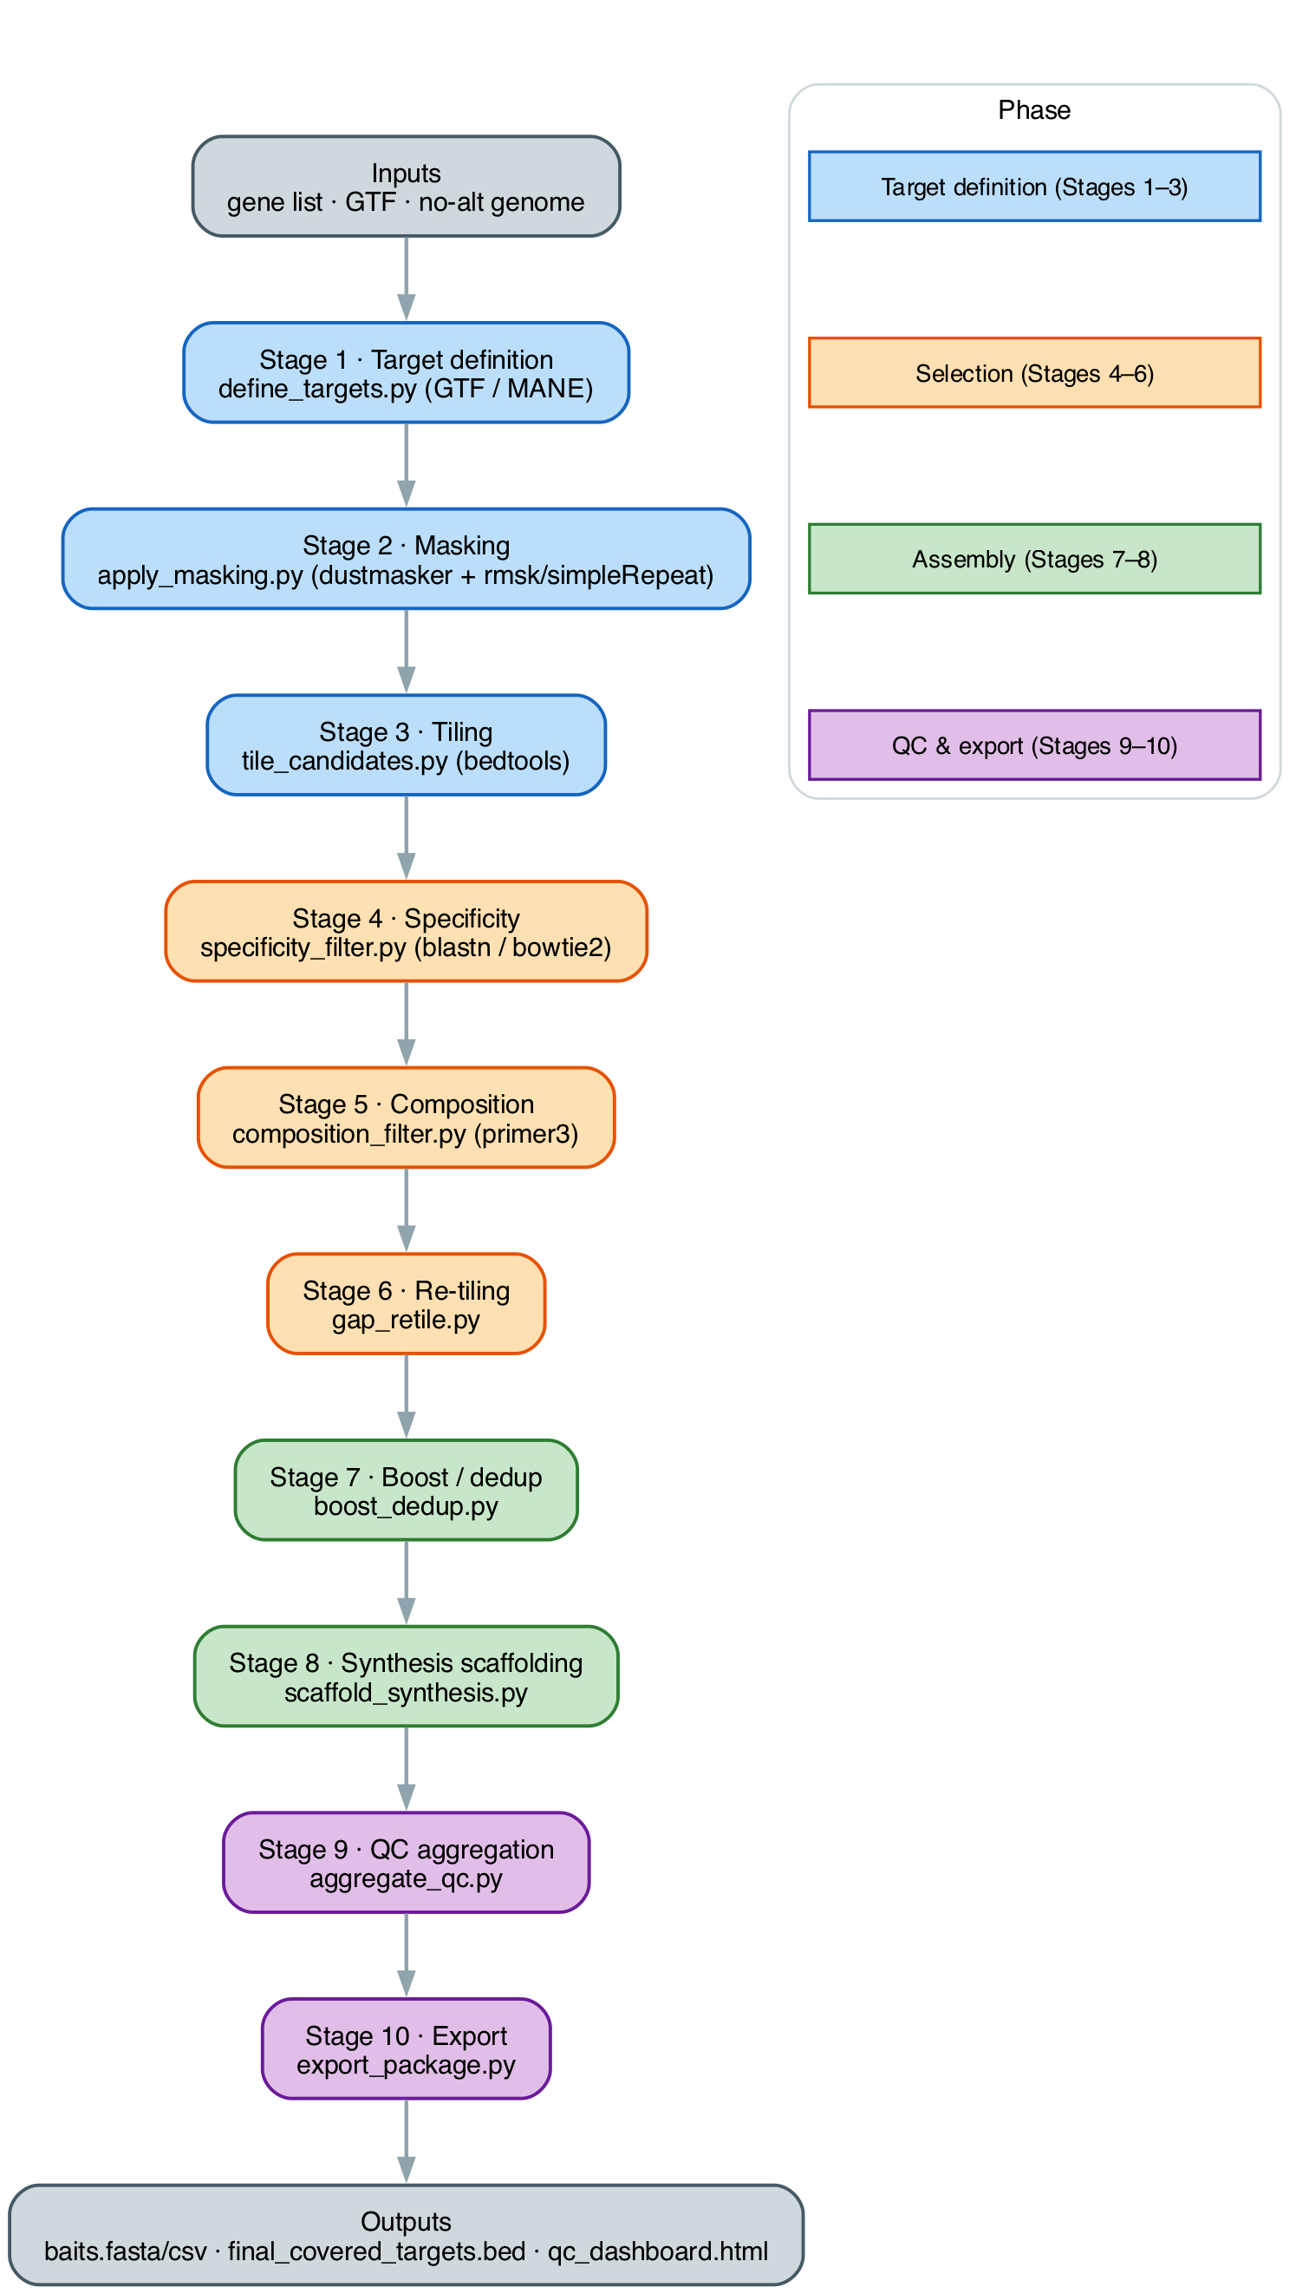
The 10-stage CaptureForge flow, color-coded by phase: target definition (blue) → selection (orange) → assembly (green) → QC & export (purple); grey nodes are inputs/outputs. Each node names the stage and its primary tool. Follow the arrows top-to-bottom; the same flow is what main.nf wires.

4 Installation

4.1 Prerequisites
- Nextflow ≥ 23.10 (needs Java 17+). The repo also bundles a launcher at ./.tools/nextflow.
- conda / mamba (for the pinned environment) or Docker / Apptainer (for the container).
- The captureforge command: pip install -e . from the repo root registers it on PATH (a thin front door — captureforge run/panel/index). The raw forms still work; captureforge is recommended.
CaptureForge supports two audiences: (1) local users on a personal laptop or workstation with no cluster, and (2) a shared HPC install used by many people. Both are covered below.

4.2 Local install (laptop or workstation — no HPC required)
You can install and run CaptureForge entirely on a personal computer. The test profile and small panels run comfortably on a laptop; a full whole-genome–specificity run is heavier but still completes on a workstation (it takes longer — see Running the pipeline). No cluster, scheduler, or admin rights are needed.

4.2.1 Option A — conda / mamba environment
The pinned environment in env/captureforge.yml provides the whole toolchain (bedtools, samtools, seqkit, bowtie2, bwa-mem2, genmap, BLAST/dustmasker, primer3, pysam, Biopython, pyfaidx, pandas, openpyxl, jinja2, matplotlib, ViennaRNA, …).
# Linux (native):
mamba env create -f env/captureforge.yml
# macOS Apple Silicon (arm64): build under Rosetta so all bioconda packages resolve
CONDA_SUBDIR=osx-64 mamba env create -f env/captureforge.yml
# activate the environment so `captureforge` installs into it, not your base environment
conda activate captureforge
# register the `captureforge` command (into the activated env)
pip install -e .
captureforge --version # success: prints e.g. "captureforge 0.1.0"
Apple-Silicon PATH note. The env builds as osx-64 under Rosetta. If you run -profile <x>,conda, Nextflow manages the environment for you. If instead you pre-activate the env and run without the conda engine, make sure the env’s bin is first on PATH, so /usr/bin/env python3 resolves to the env’s interpreter (not Homebrew’s):
conda activate captureforge && export PATH="$CONDA_PREFIX/bin:$PATH"

4.2.2 Option B — Docker (avoids the Apple-Silicon PATH issue entirely)
docker build -t captureforge:0.1.0 -f env/Dockerfile .
# then run with the docker engine profile, e.g.: captureforge run -profile test,docker
A laptop install is complete at this point: clone the repo, build the env (or image), and you can run the test profile and design real panels locally.

4.3 Shared HPC install
On a multi-user cluster, install once, centrally — environment, container image, and references on shared storage — so any user can run from any node with a single command. This section is the deployment spine; reference staging is covered under Reference data and the run command under Running the pipeline, both cross-referenced here. Paths under /hpc/... are examples — substitute your site’s layout (marked [site]). The deployment is validated end-to-end on a SingularityCE / SLURM / no-module cluster.

4.3.1 Cluster prerequisites
- OS / architecture: Linux x86-64.
- Container engine: SingularityCE or Apptainer — the same .sif runs under either (they differ only in the engine toggle). Docker is usually disallowed on shared clusters.
- Scheduler: SLURM (the hpc_slurm profile).
- Module system (optional): with Lmod, ship the modulefile stub; without it, the captureforge-run wrapper goes on a shared PATH and needs no module.
- Shared conda (optional): needed only if you build the host environment rather than running container-only. Source the cluster conda and create the env on shared storage so every node sees it. If the shared package cache is not group-writable, point it at a writable directory first — otherwise conda fails with “cannot set permissions” on the pkgs cache:
- source /hpc/opt/conda/etc/profile.d/conda.sh # [site] shared conda
export CONDA_PKGS_DIRS="$HOME/.conda/pkgs" # if the shared pkgs cache is read-only
mamba env create -f env/captureforge.yml # lands on shared storage; visible from any node
conda activate captureforge
- A container-only deployment skips the host env entirely — the tools come from the .sif.

4.3.2 Build the container image
One .sif serves the whole cluster, under either engine. sudo singularity build is the common path; an unprivileged build needs fakeroot configured (a /etc/subuid + /etc/subgid entry for your user):
sudo singularity build /hpc/opt/captureforge/captureforge.sif env/captureforge.def # [site] path
# unprivileged alternative (needs fakeroot):
# singularity build --fakeroot captureforge.sif env/captureforge.def
# Apptainer sites: apptainer build captureforge.sif env/captureforge.def
Build from the provided env/captureforge.def — it includes procps (ps) and base shell utilities that Nextflow needs to poll each task, so a stripped image makes tasks fail; do not trim it. Verify tools with a non-login shell (a login shell re-sources profiles and can reset PATH, hiding the image’s tools):
singularity exec /hpc/opt/captureforge/captureforge.sif bowtie2 --version
singularity exec /hpc/opt/captureforge/captureforge.sif python -c 'import matplotlib; print(matplotlib.__version__)'
singularity exec /hpc/opt/captureforge/captureforge.sif ps --version

4.3.3 Stage references
Fetch the no-alt primary assembly, clean its headers, faidx it, and build the specificity index from the cleaned FASTA — the genome and the index must be the same cleaned no-alt reference. The full procedure, including why header cleaning matters, is in Reference data. Place the references on shared storage and record their paths in the params file (below).

4.3.4 Configure: site env file and params template
Two files reduce a run to one line; fill in each once.
Site env file. Copy share/captureforge-env.sh.example, set the install root, image, references, engine, and container bind, and source it from each user’s ~/.bashrc:
cp share/captureforge-env.sh.example /hpc/opt/captureforge/captureforge-env.sh # [site]
echo 'source /hpc/opt/captureforge/captureforge-env.sh' >> ~/.bashrc
It sets PATH (so captureforge-run is found), CAPTUREFORGE_HOME/_SIF/_REFS/_ENGINE, and CAPTUREFORGE_BIND. On an Lmod site, module load captureforge/0.1.0 (after module use /hpc/opt/captureforge/share/modulefiles) sets the same variables instead.
Params file. Copy the annotated template and edit the reference paths, index, partition, and image:
cp conf/cluster.params.example.yaml site.params.yaml
It carries genome_fasta (the cleaned FASTA), gtf, specificity_db, specificity_aligner, bind_paths, container_image, and slurm_partition, so none of these are retyped per run.
The container bind. Singularity/Apptainer auto-mount only $HOME, /tmp, and the working directory. The specificity index is referenced in place, not staged into work dirs, so its root must be bound into task containers. Setting CAPTUREFORGE_BIND (e.g. /hpc) makes the wrapper export SINGULARITY_BIND / APPTAINER_BIND, which the engine profiles whitelist so they survive Nextflow’s per-task environment scrub; the wrapper also passes --bind_paths.
With the env sourced (or the module loaded) and the params file prepared, a run is a single command — see Running the pipeline → Full run (hpc_slurm):
captureforge-run -params-file site.params.yaml --input panel.txt --outdir results

4.3.5 Files this install relies on
- share/bin/captureforge-run — wrapper that forwards to nextflow run … -profile hpc_slurm,<engine> (default singularity; set CAPTUREFORGE_ENGINE=apptainer or CAPTUREFORGE_PROFILE to override) and passes the resolved CAPTUREFORGE_SIF as --container_image.
- share/captureforge-env.sh.example — the site env file (fill in once, source from ~/.bashrc).
- conf/cluster.params.example.yaml — the annotated params template.
- share/modulefiles/captureforge/0.1.0.lua — optional Lmod modulefile stub (edit install_root / refs_root); not needed on a no-module cluster.
docs/hpc_deployment.md walks the same deployment end-to-end.

5 Preparing inputs
CaptureForge auto-detects the input format and normalizes any one of three on-ramps into a single internal target table (stage1_targets/targets.tsv). The logic that turns genes into labelled regions is Stage 1 of the pipeline itself — no prior project file or script is ever required. The schema is documented in assets/gene_list_schema.md.

5.1 On-ramp 1 — Plain-text symbols (zero friction)
One gene symbol per line. Blank lines and # comments are ignored. Applies the default design classes (params.default_classes = coding,promoter).
# my_genes.txt
TP53
EGFR
PTEN

5.2 On-ramp 2 — CSV/TSV spec (the reusable format)
Header gene is required; all others optional. Boolean-ish columns accept 1/0, yes/no, true/false.
column | meaning
gene (required) | gene symbol (aliases in parentheses tolerated)
promoter | add the strand-aware promoter window
regulatory | intersect the Regulatory-Build / cCREs over the locus
cnv | add even-tiled CNV windows over the locus
str | tile unique flanks only (skip the repeat core)
extra_regions | extra intervals chr:start-end separated by ;
anchors | rsIDs / variant tokens separated by , or ;
gene,promoter,regulatory,cnv,str,extra_regions,anchors
TP53,1,0,0,0,,
EGFR,0,0,1,0,,
BRCA1,1,1,0,0,,rs1799966
PTEN,1,1,0,1,,

5.2.1 Scaffolding a spec from bare symbols
bin/init_gene_list.py turns a bare symbol list into an editable spec CSV pre-filled with the default classes, ready for you to add promoter/regulatory/cnv/str/anchor intent per gene:
captureforge panel my_genes.txt -o my_panel.spec.csv
# then edit my_panel.spec.csv and run with --input my_panel.spec.csv

5.3 On-ramp 3 — Rich curated workbook (.xlsx)
Reads the sheet named by --excel_sheet (default Candidate Panel (expanded)); the header row is detected automatically (the row containing a Gene cell). Recognized columns: Gene (required), Variant class, Key variants to capture, Locus, Burden group.

5.3.1 How Variant class text maps to design classes
The mapping is case-insensitive substring matching (coding is always added):
text contains | adds class
reg, promoter, enhancer, regulatory, haplotype | promoter (+ regulatory if enhancer/distal/regulatory)
cnv, copy number, structural, deletion, duplication | cnv
str, repeat, tandem, microsatellite, expansion | str
anything else (coding, LoF, burden, …) | coding

5.3.2 Aliases and anchors
Symbols written A (B) are resolved to whichever of A/B is a valid current symbol in the GTF (ERBB2 (HER2)→ERBB2, TP53 (p53)→TP53). Unresolvable symbols cause a loud failure with the offending list. rs\d+ tokens in Key variants to capture / anchors are extracted as anchor targets (resolved to coordinates via a dbSNP VCF or a --rsid_bed; see Reference data).

5.4 Worked tutorial — starting from a gene name (p53 → TP53)
Suppose all you have is a gene you care about: p53. This walkthrough takes you from that name to an order package, and shows where each on-ramp fits.

5.4.1 Step 1 — get the symbol right (the most common trap)
p53 is a protein nickname, not a gene symbol. CaptureForge resolves HGNC/Ensembl gene symbols against the GTF, so the symbol you feed it is TP53. If you pass p53, Stage 1 will not silently guess — it fails loudly and lists the unresolvable symbol. That loud failure is a feature: it stops you designing baits for the wrong (or no) locus.
Other nickname/alias traps that bite people:
You might type | Real symbol | Note
p53 | TP53 | protein name ≠ gene symbol
HER2 / Neu | ERBB2 | receptor nickname
PD-1 | PDCD1 | protein nickname
If you are unsure, look the gene up on genenames.org (HGNC) or Ensembl and use the approved symbol. Aliases written in parentheses (e.g. TP53 (p53)) are tolerated and resolved, but the bare approved symbol is cleanest.

5.4.2 Step 2 — choose an on-ramp
(a) Plain text — zero friction. A one-line file is a complete, valid input on its own:
echo TP53 > tp53.txt
With no other intent specified, TP53 gets the default design classes (params.default_classes = coding,promoter): the canonical-transcript coding exons (incl. UTRs, ±15 bp splice flank) plus a strand-aware promoter window (TSS−2000..+200). That is often all you want for a single gene.
(b) Scaffolded CSV spec — when you want to control intent. Generate an editable spec from the symbol list with bin/init_gene_list.py (it pre-fills the default classes; coding is always implied, and promoter is on by default):
captureforge panel tp53.txt -o tp53_panel.csv
That writes a CSV with the standard header and one row per gene, pre-filled:
gene,promoter,regulatory,cnv,str,extra_regions,anchors
TP53,1,0,0,0,,
Now edit it to add the intent you want — for TP53, say, turn on the regulatory class and add the common Pro72Arg polymorphism (rs1042522) as an anchor:
gene,promoter,regulatory,cnv,str,extra_regions,anchors
TP53,1,1,0,0,,rs1042522
Each column maps to a Stage 1 design class:
column | what it adds in Stage 1
(implicit) | coding — canonical exons ±15 bp splice flank (always)
promoter=1 | strand-aware promoter window (TSS−2000..+200)
regulatory=1 | intersect the Ensembl Regulatory Build / cCREs over the locus (needs --regulatory_gff)
cnv=1 | even-tiled windows across the whole locus (read-depth CNV)
str=1 | tile the unique flanks only (repeat core removed at masking)
anchors=rs1042522 | the rsID ±150 bp, guaranteed ≥2 baits (needs --rsid_bed or a dbSNP VCF)
(c) Rich Excel workbook — only when a curated panel already exists in spreadsheet form (the Variant class → design-class mapping above). For a single new gene you do not need this; use (a) or (b).

5.4.3 Step 3 — make sure references exist
You need a no-alt genome FASTA, a matching GTF, and a specificity index built from that genome (see Reference data). For human GRCh38, fetch the optional tracks once:
bin/fetch_references.sh --outdir refs gtf genome # genome writes *.clean.fa (+ .fai)
captureforge index \
--fasta refs/Homo_sapiens.GRCh38.dna.primary_assembly.clean.fa \
--aligner blast \
--out $PWD/refs/grch38_noalt

5.4.4 Step 4 — run
captureforge run -profile local \
--input tp53_panel.csv \
--genome_fasta refs/Homo_sapiens.GRCh38.dna.primary_assembly.clean.fa \
--gtf refs/Homo_sapiens.GRCh38.112.gtf.gz \
--specificity_db $PWD/refs/grch38_noalt \
--specificity_aligner blast \
--rsid_bed refs/anchors.rsid.bed \
--regulatory_gff refs/Homo_sapiens.GRCh38.regulatory_features.gff.gz \
--outdir results/tp53
The real parameter is --input (it auto-detects plain-text / CSV / Excel). --regulatory_gff and --rsid_bed are only needed because we turned on regulatory and added an anchor; drop them for the plain-text default run.

5.4.5 Step 5 — read the outputs
Under results/tp53/ you get the same deliverables as any run (see Outputs explained): order_package/baits.fasta and baits.csv (the order-ready baits + metadata), stage9_qc/final_covered_targets.bed (the as-built handoff), and qc_dashboard.html (open it to see the per-gene track for TP53 with its exon lane, the GC/Tm windows, and the bait-construct schematic).

5.4.6 Honest caveat — one small gene is not a pool
TP53 is ~25 kb with ~11 coding exons; on its own it yields only several hundred baits — far below oligo-pool synthesis minimums (the smallest tier in pool_tiers is 12,000). So “start from a gene name” is really how you add a gene to a larger panel: capture economics only work when tens to hundreds of genes share one pool. Build your CSV spec up to the full gene set, then run once — the pool cost is shared across every gene in the file.

6 Reference data
CaptureForge reference paths are parameters; you supply at minimum a genome FASTA and a GTF. Optional tracks (RepeatMasker, simpleRepeat, segmental dups, a regulatory build, dbSNP) improve masking and anchors but are not required.

6.1 Fetching human GRCh38 references
bin/fetch_references.sh downloads and checksums each reference and writes a provenance manifest. It is GRCh38/human-specific (Ensembl homo_sapiens + UCSC hg38). Heavy downloads never run automatically.
bin/fetch_references.sh --outdir refs gtf # only the Ensembl r112 GTF (~50 MB)
bin/fetch_references.sh --outdir refs rmsk simplerepeat # STR/repeat masks
bin/fetch_references.sh --outdir refs genome # genome + header-cleaned *.clean.fa (+ .fai)
bin/fetch_references.sh --outdir refs all # everything (heavy!)
The genome target downloads the no-alt dna.primary_assembly.fa.gz and writes a header-cleaned companion, Homo_sapiens.GRCh38.dna.primary_assembly.clean.fa (+ .fai) — headers truncated to the first whitespace token (1 2 … X Y MT + scaffolds). Use that cleaned FASTA both as --genome_fasta and as the input to the specificity index build (next section); it is why the genome and the index agree on contig names.
For non-human organisms, fetch the genome FASTA and GTF yourself (Ensembl / Ensembl Genomes / PlasmoDB) and pass them with --genome_fasta / --gtf (see Running on different organisms). Clean their headers the same way (awk '/^>/{print $1; next} {print}' in.fa > clean.fa && samtools faidx clean.fa).

6.2 The no-alt reference invariant (read this)
Specificity must run against the NO-ALT primary assembly, and the specificity index must be the SAME reference as the design genome.
If you index a toplevel / with-alt reference, genes in the MHC and other alt-haplotype regions will look non-specific against their own alternate-haplotype copies — for example, an MHC-region gene can appear 100% non-specific when its “off-targets” are its own copies on HSCHR6_MHC_* scaffolds. CaptureForge enforces the no-alt rule: Stage 4 (specificity_filter.py) fails loudly (exit 3) if the specificity reference contains alt/decoy/HLA contigs (HSCHR*, *_MHC_*, HLA-*, *_alt, *_decoy, hs38d1, EBV) and cross-checks that the db contigs are a subset of the design genome. On a clean primary assembly the check reports the contig count and passes (e.g. “reference invariant OK: no alt/decoy/HLA”).
The same-reference cross-check compares contig names on their first whitespace token on both sides — because index builders store the full FASTA header as the contig name while samtools faidx keeps only the first token (see Building the specificity index). So an index built from an un-cleaned FASTA still matches the genome; the alt/decoy invariant stays strict.

6.3 Building the specificity index
Build the index from the cleaned no-alt design genome — the *.clean.fa from fetch_references.sh genome (headers truncated to the first token). This matters: bowtie2-build / bwa index / makeblastdb store the full FASTA header as each contig name (1 dna:chromosome chromosome:GRCh38:1:…), whereas samtools faidx keeps only the first token (1). If the genome and the index disagree on names, Stage 4 sees two different references. Using the cleaned FASTA for both --genome_fasta and the index keeps them aligned (and the build_specificity_index.sh helper warns if it sees multi-token headers).
# BLAST (no index-build wait; convenient for local runs)
captureforge index \
--fasta refs/Homo_sapiens.GRCh38.dna.primary_assembly.clean.fa \
--aligner blast \
--out $PWD/refs/grch38_noalt
# bowtie2 (native, recommended on the HPC)
captureforge index \
--fasta refs/Homo_sapiens.GRCh38.dna.primary_assembly.clean.fa \
--aligner bowtie2 \
--out $PWD/refs/grch38_noalt_bt2
--specificity_db is referenced in place (not staged into work dirs), so it must be an absolute path to the index prefix. With bowtie2, Stage 4 reports hits with a cap (-k, not -a) tied to the off-target threshold, so it scales to the whole genome — a bait in a repeat element is rejected without enumerating its (potentially millions of) hits. Nothing to configure; it explains the fast specificity runtime.

7 Configuration

7.1 Profiles
Profile | Executor / use | Compose with
test | tiny mini-genome fixture; runs on a laptop in ~2 min | ,conda / ,docker
local | full pipeline on one machine (any Linux/macOS) | ,conda / ,docker
hpc_slurm | SLURM executor; big slots for the heavy specificity step | ,singularity / ,apptainer
Container-engine profiles conda, docker, apptainer, and singularity are composed, e.g. -profile hpc_slurm,singularity (SingularityCE clusters — no apptainer binary) or -profile hpc_slurm,apptainer. singularity and apptainer differ only in the engine toggle and run the same .sif image.

7.2 Parameter reference (real defaults from nextflow.config / conf/)
The single most useful question facing a long run command is “do I provide this, or is it already set up?” CaptureForge answers it with a three-layer model, so the validated run command is short — the values live in files you set up once:
- Env file (share/captureforge-env.sh, sourced once from ~/.bashrc) — install-time site wiring: CAPTUREFORGE_HOME/_SIF/_REFS/_BIND/_ENGINE. Feeds --container_image, --bind_paths, and the profile.
- Params file (-params-file site.params.yaml) — set once per cluster: genome, GTF, specificity index, binds, partition.
- Per-run flags — what changes every run: --input and --outdir (plus an optional --panel_name).
Every parameter below carries a provenance tag answering that question:
Tag | Who sets it / when
[install] | once, in the site env file (sourced from ~/.bashrc); not typed per run
[site] | once per cluster, in the params file; users inherit it via -params-file
[per-run] | you provide it every run (the minimal set)
[optional] | has a sane default; set only to override
[class-dependent] | only needed if the panel uses that design class (absent → feature skipped, no error)
captureforge run is a thin wrapper over nextflow run main.nf — only --pipeline and --print-cmd are argparse-owned; every parameter below is a Nextflow param forwarded verbatim (passthrough) and overridable with --<param> value or in the params file. Defaults shown are the actual declared defaults — spot-checked against the code, none invented.

7.2.1 Required & references
Parameter | What it is | Required? | Default | Provenance
input | gene list / CSV-TSV spec / .xlsx (auto-detected) | Yes (main.nf exits if unset) | null | [per-run]
genome_fasta | no-alt primary-assembly FASTA (cleaned headers) | Yes (exits if unset) | null | [site]
gtf | Ensembl GTF (gene models) | Yes (exits if unset) | null | [site]
specificity_db | aligner index / BLAST db prefix (absolute, no-alt) | In practice yes — Stage 4/6 fail without it; main.nf warns (does not exit) | null | [site]
specificity_aligner | bowtie2 | bwa | blast | No | bowtie2 | [site]
genome_build | reference-build label | No | GRCh38 | [optional]
ensembl_release | Ensembl release for provenance | No | 112 | [optional]
excel_sheet | sheet name (only when input is .xlsx) | No | Candidate Panel (expanded) | [optional]
mane_gff | MANE Select GFF3 (canonical pick) | No | null | [optional]
regulatory_gff | Ensembl Regulatory Build / cCREs | Only for regulatory class | null | [class-dependent]
rmsk_bed | UCSC RepeatMasker → Stage-2 masking | Only if repeat masking / str used | null | [class-dependent]
simplerepeat_bed | UCSC simpleRepeat → STR-core removal | Only for str class | null | [class-dependent]
segdups_bed | UCSC genomicSuperDups → cnv masking | Only for cnv class | null | [class-dependent]
dbsnp_vcf | dbSNP VCF for rsID anchors | Only for anchor class | null | [class-dependent]
rsid_bed | pre-resolved rsID BED (resolve_rsids.py) | Only for anchor class | null | [class-dependent]
refs_provenance | refs.provenance.json folded into outputs | No | null | [optional]
How required-ness was determined (from the code, not assumption): input, genome_fasta, gtf each have an explicit exit 1 guard in main.nf → hard-required. specificity_db only triggers a log.warn (Stages 4/6 then fail downstream) → required in practice, not enforced at launch. The optional refs (rsid_bed, rmsk_bed, simplerepeat_bed, segdups_bed, dbsnp_vcf, regulatory_gff) flow through the optfile() resolver in subworkflows/captureforge.nf: when absent they become a NO_<slot> sentinel, and the consuming module (masking.nf, target_definition.nf) drops the corresponding CLI flag — so the feature is silently skipped, never an error. They matter only when the panel actually uses that design class.

7.2.2 Container & HPC
Parameter | What it is | Required? | Default | Provenance
container_image | image every task runs inside (.sif path | docker tag) | Yes when a container engine is enabled (main.nf exits otherwise); not for native runs | '' | [site] (env-supplied)
bind_paths | host path(s) bound into containers for in-place refs | Needed when refs live outside $HOME//tmp/CWD | '' | [site] (env-supplied)
slurm_partition | SLURM queue | Yes under -profile hpc_slurm (main.nf exits if unset — no safe default) | null | [site]
slurm_queue_opts | extra sbatch/clusterOptions (e.g. --account=…) | No | '' | [optional]
scratch_dir | per-task scratch under SLURM | No | /tmp | [optional]
container_cache | shared engine image cache (hpc_slurm) | No | $HOME/.captureforge/container_cache | [install]
publish_mode | publishDir mode | No | copy | [optional]
max_cpus / max_memory / max_time | per-profile resource ceilings | No | profile-set (local 8/24 GB/48 h; hpc_slurm 32/128 GB/72 h; test 4/8 GB/2 h) | [optional]

7.2.3 Design thresholds (all [optional])
Parameter | What it is | Default
bait_len | bait length (nt) | 120
canonical_source | transcript pick: mane → ensembl_canonical → longest | mane
splice_flank | bp added around each exon | 15
promoter_upstream / promoter_downstream | TSS−2000 .. TSS+200 | 2000 / 200
anchor_flank | bp each side of an rsID anchor | 150
default_classes | classes applied to a bare symbol list | [coding, promoter]
tiling | per-class density / step_frac / even map | coding ½-step, promoter/reg ⅓, cnv even, str ⅓ flanks
offtarget_min_identity | secondary-hit identity threshold | 0.90
offtarget_min_lenfrac | secondary-hit length fraction | 0.50
offtarget_max_hits | tolerated off-target hits before reject | 1
gc_min / gc_max | GC window (fraction) | 0.25 / 0.70
gc_max_promoter | relaxed upper GC for promoter/regulatory | 0.80
homopolymer_max | max homopolymer run | 10
tm_min / tm_max | nearest-neighbour Tm window (°C) | 60.0 / 90.0
retile_max_passes | max gap re-tiling passes | 3
coverage_target | target fraction of masked target to cover | 0.95
bait_format | dna_pool | ivt_rna | ready_to_use | ivt_rna
synth_max_len | vendor synthesis length ceiling (nt) | 170
per_oligo_price | USD per oligo (placeholder estimate) | 0.00200
pool_tiers | oligo-pool size tiers | [12000, 92000, 244000]

7.2.4 Output
Parameter | What it is | Required? | Default | Provenance
panel_name | label written on outputs | No | captureforge_panel | [per-run] / [optional]
outdir | results directory | No (but you usually set it) | results | [per-run]
A few advanced params (genmap_*, dust_threshold, deltaG_min / use_vienna, t7_promoter, pcr_handle_5/3, bait_strand, tracks_per_page, covered_vs_raw_min) are declared in nextflow.config; some are present for documentation and not currently wired to a stage — see Troubleshooting → Known doc-vs-behaviour notes.

8 Running the pipeline
Recommended: captureforge run … (and captureforge panel / captureforge index) after pip install -e .. The developer raw form still works from a clone — the repo bundles a launcher, so ./.tools/nextflow run main.nf -profile local,conda … runs the pipeline directly (or system nextflow if installed). captureforge run prefers the bundled launcher and removes the boilerplate.

8.1 Quickstart — the test profile (10 genes, ~2 min)
The fixture (a generic TP53/EGFR/BRCA1/… mini-genome) ships pre-built in test/data/, so this runs straight from a clone — no build step, no local GRCh38 required:
conda activate captureforge # ensure the env is active (or run -profile test,conda)
captureforge run -profile test # or: -profile test,conda
bash test/check_outputs.sh # sanity-check; expects all 6 design classes
To rebuild/refresh the fixture (reproducibility, or after editing test/data/test_genes.csv), run test/data/make_test_reference.sh against your own local GRCh38 — it is not required for the quickstart above.

8.2 Full run — local
captureforge index \
--fasta refs/Homo_sapiens.GRCh38.dna.primary_assembly.clean.fa \
--aligner blast \
--out $PWD/refs/grch38_noalt
conda activate captureforge # captureforge run warns if the env is not active (native runs only)
captureforge run -profile local -params-file params.full.yaml

8.3 Full run — hpc_slurm (Singularity or Apptainer)
On a deployed cluster (see Shared HPC install), with the site env sourced and a params file prepared, a full run is a single command:
captureforge-run -params-file site.params.yaml --input panel.txt --outdir results
The wrapper resolves the install path, the container image, and the hpc_slurm,<engine> profile (default singularity) from the environment, exports the container bind, and forwards to nextflow run.
slurm_partition is required — there is no safe default, since clusters differ (global, compute, batch, normal, …). Set it in the params file or with --slurm_partition <queue>, and discover valid partitions with sinfo -s. If it is unset under hpc_slurm, the run fails loudly before any job is submitted rather than submitting to a non-existent partition. An account or QOS goes via slurm_queue_opts / clusterOptions in conf/hpc_slurm.config.

8.3.1 The short form and the expanded form are the same run
The validated deployment runs via a short command because the env file and params file already carry the site values. The long command below is that exact run with every inherited default written out explicitly — an override / debugging form, not what you type each run. The same job is simply:
captureforge-run -params-file site.params.yaml --input panel.txt --outdir results
Without the wrapper — or to see what it expands to — call captureforge run directly, composing hpc_slurm with your engine (hpc_slurm,singularity on SingularityCE clusters, hpc_slurm,apptainer on Apptainer) and pointing --pipeline at the installed main.nf. Each flag is annotated with who normally provides it, so you can see which lines are inherited (and therefore omittable) versus the genuine per-run inputs:
captureforge run \
--pipeline /hpc/opt/captureforge/main.nf \ # [install] env: CAPTUREFORGE_HOME
-profile hpc_slurm,singularity \ # [install] env: CAPTUREFORGE_ENGINE/_PROFILE
-params-file site.params.yaml \ # [site] the file carrying all of the below
--genome_fasta $CF_REFS/Homo_sapiens.GRCh38.dna.primary_assembly.clean.fa \ # [site] params file
--gtf $CF_REFS/GRCh38.112.gtf.gz \ # [site] params file
--specificity_db $CF_REFS/grch38_noalt_bt2 \ # [site] params file
--specificity_aligner bowtie2 \ # [site] params file (default bowtie2)
--rmsk_bed $CF_REFS/rmsk.GRCh38.txt.gz \ # [class-dependent] str/masking; params file
--simplerepeat_bed $CF_REFS/simpleRepeat.GRCh38.txt.gz \ # [class-dependent] str core; params file
--rsid_bed $CF_REFS/anchors.rsid.bed \ # [class-dependent] anchor class; params file
--slurm_partition <queue> \ # [site] params file (REQUIRED under hpc_slurm)
--scratch_dir $TMPDIR \ # [optional] default /tmp
--container_image /hpc/opt/captureforge/captureforge.sif \ # [site/install] env: CAPTUREFORGE_SIF
--bind_paths /hpc \ # [site/install] env: CAPTUREFORGE_BIND
--input panel.txt \ # [per-run] YOU provide this every run
--outdir results # [per-run] YOU provide this every run
Reading the annotations top-to-bottom: the [install] lines come from the sourced env file, the [site] and [class-dependent] lines from -params-file site.params.yaml, and only the two [per-run] lines (--input, --outdir) are genuinely yours each run — which is why the short form above is the norm.
A container engine requires --container_image. It sets process.container so every task runs inside the .sif (including the viz stages); enabling an engine without it makes Nextflow run tasks on the host with incomplete tools, and the pipeline fails loudly instead. Set it as container_image: in the params file, or let the wrapper supply it from CAPTUREFORGE_SIF. Bare -profile test (no engine) runs natively and needs no image.
Referenced-in-place references must be bound in. The --specificity_db index is read in place, not staged, and auto-mounts cover only $HOME//tmp/CWD — so its root needs a bind (CAPTUREFORGE_BIND, or bind_paths: / --bind_paths). See Shared HPC install → Configure for the mechanism.

9 Running on different organisms
CaptureForge is organism-agnostic: you change inputs and parameters, not code. The same Stage 1–10 pipeline runs for any species given a genome FASTA + GTF and a specificity index built from that genome. Below are real, runnable command shapes for three organisms plus a general checklist.
The two things that most often need per-organism attention are: (1) the canonical-transcript source (MANE exists only for human) and (2) the GC/Tm windows (an AT-rich genome will reject most baits at the human default GC window).

9.1 Human (GRCh38) — the baseline
The human baseline uses MANE Select canonical transcripts and the full set of human tracks.
captureforge run -profile local \
--input my_panel.spec.csv \
--genome_fasta refs/GRCh38.primary_assembly.fa \
--gtf refs/Homo_sapiens.GRCh38.112.gtf.gz \
--specificity_db $PWD/refs/grch38_noalt \
--specificity_aligner blast \
--rmsk_bed refs/rmsk.GRCh38.txt.gz \
--simplerepeat_bed refs/simpleRepeat.GRCh38.txt.gz \
--rsid_bed refs/anchors.rsid.bed \
--canonical_source mane

9.2 Mouse (GRCm39, Ensembl) — MANE-absent fallback
Mouse has no MANE. With --canonical_source mane, CaptureForge falls back automatically (MANE_Select → Ensembl_canonical → longest); the mouse Ensembl GTF carries Ensembl_canonical tags, so you can also set it explicitly. Mouse has an Ensembl Regulatory Build (pass it as a GFF) but you will supply your own variant BED for anchors.
# fetch GRCm39 primary assembly + GTF from Ensembl yourself, then:
captureforge index \
--fasta GRCm39.primary_assembly.fa \
--aligner bowtie2 \
--out $PWD/refs/grcm39_bt2
captureforge run -profile local \
--input mouse_panel.spec.csv \
--genome_fasta refs/GRCm39.primary_assembly.fa \
--gtf refs/Mus_musculus.GRCm39.112.gtf.gz \
--specificity_db $PWD/refs/grcm39_bt2 \
--specificity_aligner bowtie2 \
--canonical_source ensembl_canonical \
--regulatory_gff refs/Mus_musculus.GRCm39.regulatory_features.gff.gz \
--rsid_bed refs/mouse_anchors.bed # user-supplied (chrom start end id), optional
Caveats: fetch_references.sh is human-only — fetch mouse refs manually. UCSC rmsk/simpleRepeat use mm39 (not the hg38 paths in the script); if you don’t supply them, masking falls back to dustmasker (low-complexity) and STR-core removal is weaker (still functional). dbSNP anchors require a user BED.

9.3 Plasmodium falciparum — non-model, AT-rich genome
P. falciparum is ~81% AT (≈19% GC). Two things change materially:
- There is no MANE and usually no Ensembl_canonical tag in PlasmoDB/Ensembl-Protists GTFs → canonical selection falls back to the longest transcript. Set --canonical_source longest explicitly.
- The default GC window (0.25–0.70) rejects most baits, because most P. falciparum sequence has GC below 25%. You must widen and shift the GC window down, and lower the Tm floor (AT-rich baits melt lower). Without this, Stage 5 will reject the large majority of candidates.
# Gene models from PlasmoDB / Ensembl Protists; primary assembly (no alts):
captureforge index \
--fasta PlasmoDB-Pf3D7_Genome.fasta \
--aligner bowtie2 \
--out $PWD/refs/pf3d7_bt2
captureforge run -profile local \
--input pf_drug_resistance.spec.csv \
--genome_fasta refs/PlasmoDB-Pf3D7_Genome.fasta \
--gtf refs/PlasmoDB-Pf3D7.gtf \
--specificity_db $PWD/refs/pf3d7_bt2 \
--specificity_aligner bowtie2 \
--canonical_source longest \
--gc_min 0.15 --gc_max 0.55 \
--gc_max_promoter 0.60 \
--tm_min 50 --tm_max 85
A P. falciparum drug-resistance panel (e.g. pfcrt, pfmdr1, dhfr, dhps, kelch13) is designed exactly this way — coding classes for the resistance genes, the widened GC/Tm windows above, and a specificity index built from the Pf3D7 primary assembly.
Caveats: no regulatory build and no dbSNP — regulatory flags produce nothing (but promoter windows still work, since they come from the GTF TSS), and anchors require a user-supplied BED. No UCSC repeat tracks — masking is dustmasker-only (which is actually well-suited to the AT-rich, low-complexity-rich Pf genome). The no-alt invariant still applies: Pf has no alt haplotypes, so the check passes.

9.4 “Any organism” checklist
Before a new-organism run, confirm:
- Minimum inputs: a gene list; a no-alt primary-assembly genome FASTA; a matching GTF with gene_name attributes; a specificity index built from that FASTA (absolute path).
- Canonical source: mane only for human; use ensembl_canonical (most Ensembl species) or longest (non-model) otherwise.
- GC/Tm windows: check the genome’s GC content. AT-rich (Plasmodium, many bacteria) → lower gc_min, lower gc_max, lower tm_min. GC-rich → raise the window.
- Optional tracks: supply rmsk_bed/simplerepeat_bed (correct assembly!) and regulatory_gff if they exist; otherwise masking is dustmasker-only and regulatory classes are empty (promoter still works).
- Anchors: supply --rsid_bed (or a tabix dbSNP VCF via --dbsnp_vcf) only if you flagged anchors.
- Contig naming: the genome FASTA, GTF, and any tracks must use the same contig names; UCSC chr-prefixed tracks are normalized to Ensembl naming automatically, but mismatched assemblies are not.

10 Outputs explained
All outputs land under results/<outdir>/. The deliverables a user cares about:

10.1 order_package/
- baits.fasta — the final, order-ready bait constructs (for ivt_rna, each is handle5 + T7 + bait + handle3). FASTA header carries copies= and fmt=.
- baits.csv — one row per unique bait, full metadata. Columns:
column | meaning
bait_id | stable unique id (CF_NNNNNN\|gene\|class)
sequence | the final synthesis construct (handles + bait for ivt_rna)
copy_number | how many times this bait is represented in the pool (boosting; see Stage 7)
gene | source gene(s)
class | design class(es) the bait came from
source_region | the genomic region(s) it tiles
strand | + / -
GC | GC fraction of the bait core (the hybridizing 120-mer)
Tm | nearest-neighbour Tm (°C) of the core
off_target_flag | 1 if the bait retains a tolerated paralog/off-target hit, else 0
- order_generic.tsv — a vendor-neutral order table (Pool_Name, Probe_ID, Sequence, Replicates).
- MANIFEST — md5 checksums of the key outputs.
- provenance.json — tool versions, reference releases, git_commit, design_genome, and specificity_reference (so every output records exactly which reference produced it).

10.2 stage9_qc/
- final_covered_targets.bed — the handoff to a downstream analysis pipeline. This is the AS-BUILT coverage: the intersection of your raw targets with what the final baits actually cover, labelled gene|class. It is not the raw target set — measure downstream variant calls against this file, because it represents the regions you can actually expect reads in.
- metrics.json, coverage_by_gene.tsv, coverage_by_class.tsv — machine-readable QC.

10.3 qc_dashboard.html and figures/
A self-contained HTML dashboard (open in a browser) embeds every figure and the key metrics tables. All figures are also written as PNG + SVG under figures/. Per-stage intermediates live under stage1_targets/ … stage8_synthesis/; pipeline_info/ holds the Nextflow report/timeline/trace/dag.

11 Interpreting QC and coverage
This is the most important section for making good decisions.

11.1 Mappable vs raw coverage
CaptureForge reports coverage two ways:
- mappable coverage = covered ÷ masked (tileable) target — design efficiency over sequence you can actually bait.
- raw coverage = covered ÷ raw target — the honest end-to-end number over the nominal footprint.
A typical panel shows a high mappable number (often above 90%) and a lower raw number. In a repeat-heavy or AT-rich panel the gap can be dramatic — for illustration, mappable ≈ 90% against raw ≈ 67% (the bundled test panel’s gap is much smaller). This is by design. The gap is sequence intentionally removed by masking — repeats, segmental duplications, STR cores, Alu elements — which is genomically uncapturable by hybridization. A high mappable number with a lower raw number is the expected, honest result, not a failure.
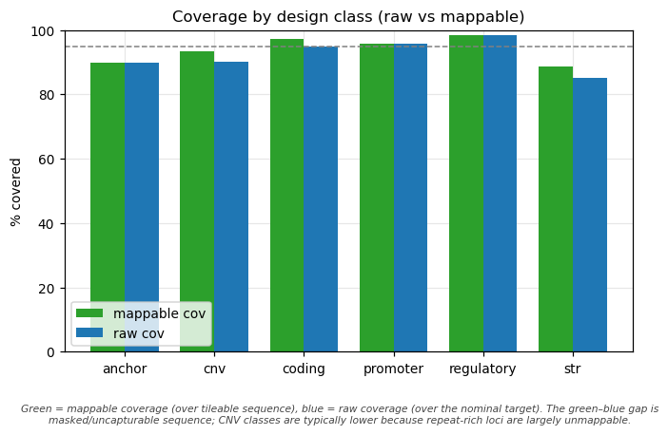
Coverage by design class. Green = mappable coverage (over tileable sequence), blue = raw coverage (over the nominal target). Read the green bars for design efficiency; the green–blue gap is masked/uncapturable sequence. coding/promoter/str classes are typically high mappable; cnv is usually lower because repeat-rich loci are partly masked and partly non-specific.
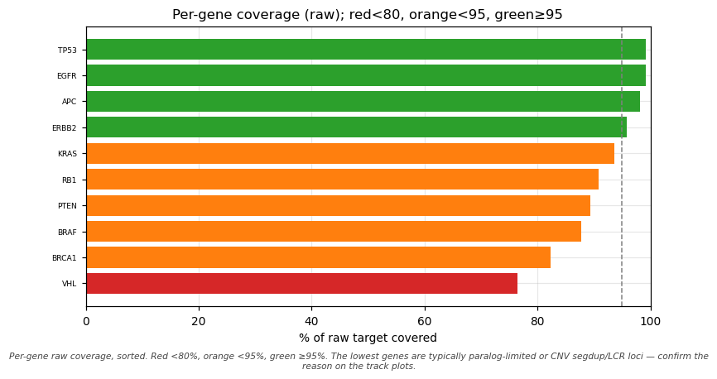
Per-gene raw coverage, sorted. Green ≥95%, orange <95%, red <80%. The red/orange genes are not “broken” — they are typically the paralog-limited and CNV/segdup loci discussed below. Use this to spot which genes need a second look, then confirm the reason on the track plots.
To see how each gene’s baits are composed by design class, the per-gene-by-class view stacks bait counts per gene (counts from baits.csv, multi-class baits attributed to their primary class so the bars sum to the unique-bait count). It makes the design intent obvious at a glance: a gene flagged str is dominated by its unique-flank baits, a cnv gene by whole-locus tiling, and a plain coding gene by coding+promoter. The full gene × class matrix is written to figures/baits_per_gene_by_class.tsv.

11.2 The three-tier per-gene honesty
Not all “incomplete” coverage means the same thing. Genes fall into three tiers:
- Cleanly covered — unique sequence, high mappable coverage (most of a panel).
- Paralog-limited coding — only the uniquely-baitable fraction is covered; the rest is too similar to a paralog to bait specifically (a gene in a multi-copy family, or with a near-identical paralog elsewhere in the genome). Baits that retain one tolerated paralog hit are tagged off_target_flag=1 in baits.csv.
- CNV breakpoint-blind — for CNV genes, depth bins are evenly spaced except across segmental-dup / LCR regions, which are exactly where the structural variation often occurs, leaving multi-kb gaps across those blocks.
A gene that is both paralog-limited and breakpoint-blind is the kind most likely to need an orthogonal assay (MLPA / long-read) if it is central to your study.

11.3 CNV read-depth callability is the decision metric — not raw CNV coverage
For a CNV gene, the question is not “what % of the locus is baited” but “are the baited bins evenly spaced enough to call copy number from read depth?” CaptureForge reports per-CNV-gene bin spacing (metrics.json → cnv_bin_spacing): number of bins, median and max inter-bin gap, and a depth_callable flag. A CNV gene in clean, unique sequence is depth-callable (small max gaps); one whose locus is broken up by LCRs is not (multi-kb blind spots). A gene can have hundreds of bins and still be breakpoint-blind.

11.4 Reading a per-gene track plot — real vs uncapturable gaps
Each per-gene panel has three lanes: target (raw, colored by class), tileable (after masking), and baits (final). Compare the lanes:
- A gap in baits where tileable is also empty → the sequence was masked away (repeat/segdup) → uncapturable, expected, not a coverage failure.
- A gap in baits where tileable is present → a real gap (a bait was rejected for specificity or composition) → worth investigating.
Each panel now has four lanes — target (raw, class-colored), exons (the coding exons ±15 bp splice flank, in green, right under the target so you can check no exon is missed), tileable (post-mask), and baits (final) — and the gene label includes the exon count alongside the chromosome location.
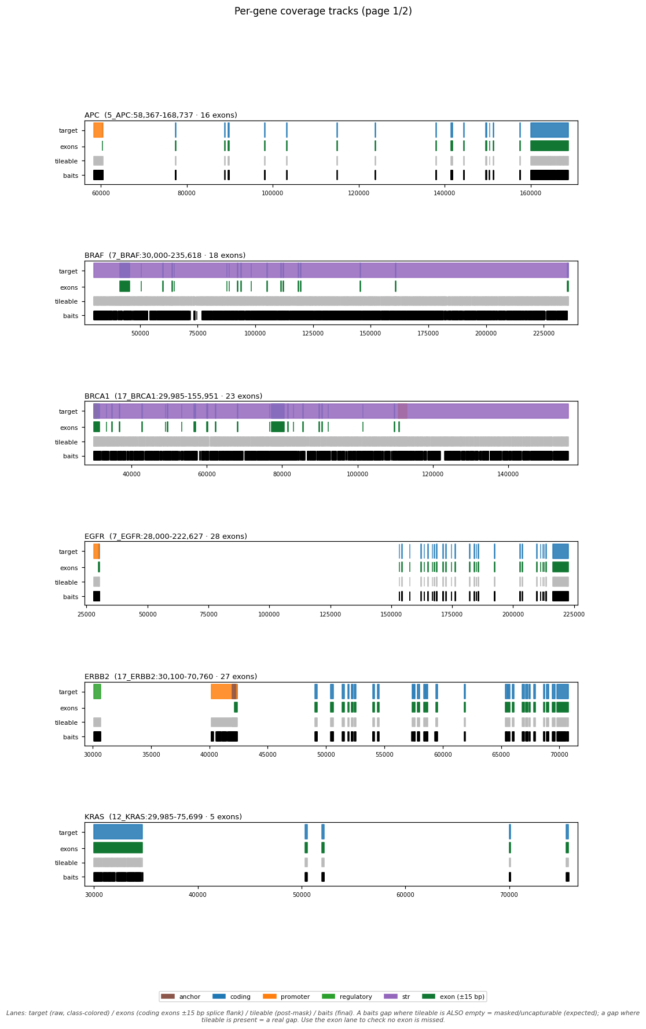
A clean page: the baits lane closely tracks the target, exons, and tileable lanes — every exon is well covered with only small, expected gaps. (Genes are laid out a few per page, spaced so coordinate ticks never collide with the next gene’s title; the label shows the exon count.)
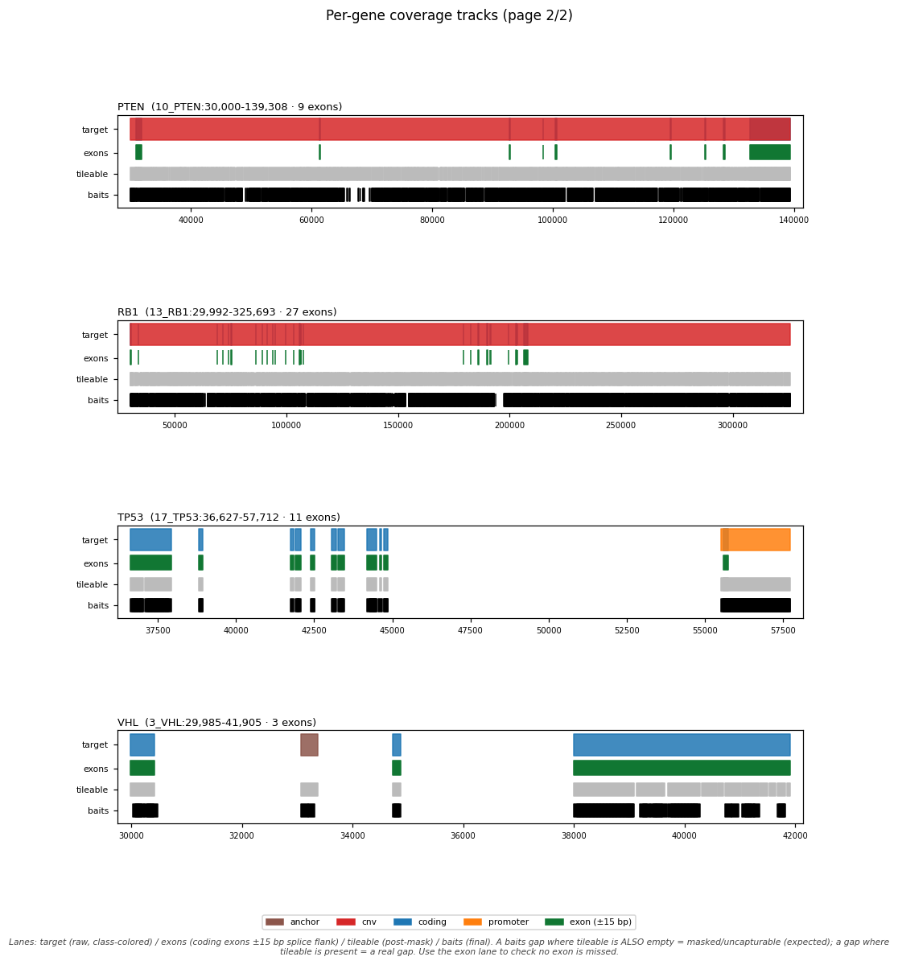
A second page of per-gene tracks. Where a gene carries a cnv or str class, the target lane spans the whole locus while the green exons lane shows where the coding exons sit; on a real run the baits lane thins out across any segmental-dup / LCR blocks that are unmappable. The exon lane lets you confirm which exons remain covered despite breakpoint-blind regions.

11.5 Composition QC — GC and Tm
Stage 5 rejects baits outside the GC window (default 25–70%, 80% upper for promoters), Tm window (60–90 °C), homopolymer (>10), or low entropy. The histograms show the passing population sitting inside those windows; the dashed lines are the thresholds. For an AT-rich organism these distributions shift left and you must move the windows (see Running on different organisms), or almost everything is rejected.
What these histograms count. They count spec-pass candidate baits — one row per tiled position (from composition.tsv); boosted copies are NOT multiplied in, so a boosted bait is counted once, not 2–4×. The tall spikes are therefore expected: dense tiling of a compositionally homogeneous region produces many near-identical baits at the same GC/Tm. What matters is that the bulk of the distribution sits inside the GC 25–70% / Tm 60–90 °C windows, not the spike heights.
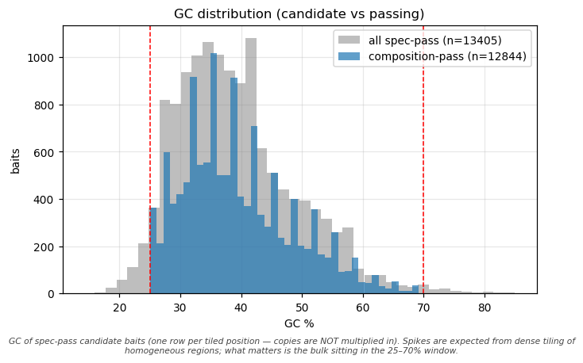
GC distribution (spec-pass candidate baits — positions, not copies). Grey = all specificity-passing candidates; blue = those that also pass composition. Dashed lines mark the 25–70% window. Spikes are expected; if the population sits outside the window (as for an AT-rich genome), widen/shift gc_min/gc_max.
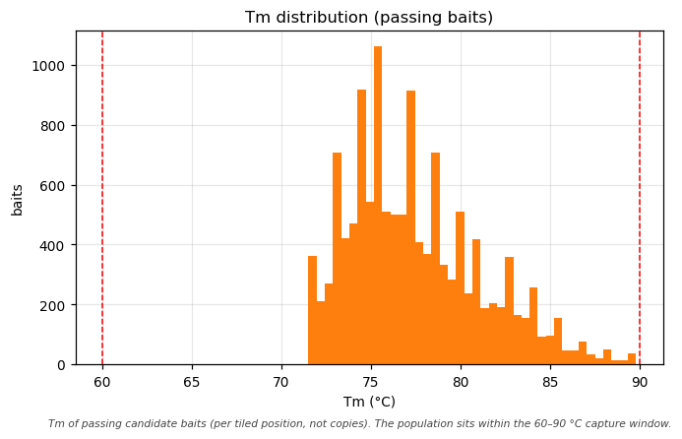
Tm distribution of passing candidate baits (positions, not copies), 60–90 °C window marked. AT-rich baits melt lower; if the population piles up below tm_min, lower it.

11.6 Specificity QC — the off-target distribution
Stage 4 counts, per bait, how many off-target loci it hits above the identity/length thresholds. A unique bait has 0; one tolerated hit (≤ offtarget_max_hits) still passes; more are rejected. The long tail (baits hitting hundreds or thousands of loci) are repeat-derived candidates, correctly discarded.
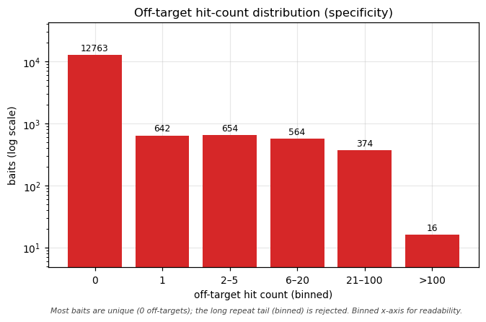
Off-target hit-count distribution, binned x-axis (0 / 1 / 2–5 / 6–20 / 21–100 / >100) with a log y-axis and counts above each bar. The bin at 0 are unique baits; the bin at 1 (tolerated, tagged off_target_flag=1) and 2–5 are paralog hits; the right-hand bins are repeat baits that are rejected. Binning keeps the 0-to-thousands range readable.

11.7 Boosting / dedup — copy number
Stage 7 collapses identical bait sequences (summing copies) and adds extra copies over boost-flagged classes (promoter/regulatory, anchors, high-GC promoters). Copies increase a probe’s molar representation in the pool; they do not add distinct oligos, so they do not change the pool size or tier.
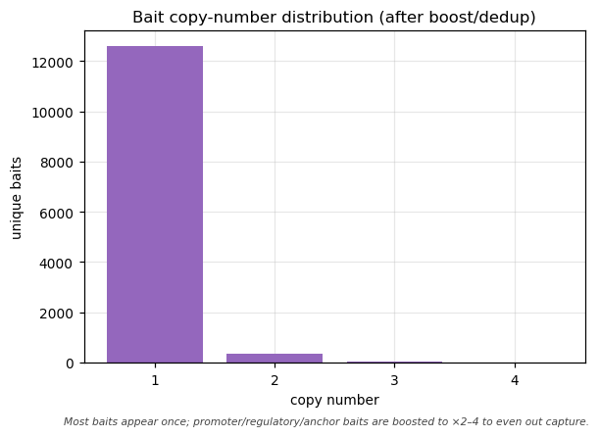
Bait copy-number distribution after boost/dedup. Most baits appear once (×1); promoter/regulatory and anchor baits are boosted to ×2–4 to even out capture efficiency.

11.8 Re-tiling convergence — when non-convergence is correct
Stage 6 iteratively tiles denser baits over gaps and re-checks them, up to retile_max_passes, aiming for coverage_target (0.95) of the masked target. A typical run climbs a few points across passes and then stops without reaching 0.95 — and that is the right outcome: the remaining gaps are non-specific / repeat sequence that denser baiting cannot fix. Non-convergence here is honest, not a bug — forcing baits into those regions only adds off-target probes.
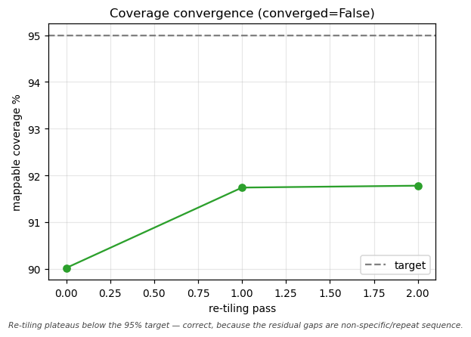
Coverage convergence across re-tiling passes. The curve plateaus below the target line because the residual gaps are genomically non-specific — the correct place to stop.

12 Cost and ordering

12.1 Pool cost and tiers
CaptureForge predicts an oligo-pool synthesis cost = unique baits × per_oligo_price, and the smallest oligo-pool tier the panel fits. As a worked example with the placeholder price, the bundled test panel of 12,963 unique baits at $0.00200/oligo costs $25.93. That count exceeds the smallest 12,000 tier, so it does not fit there — it crosses the 12,000 line and lands in the 92,000 tier, and a tripwire fires. The tripwire is the point: it prevents the pipeline from silently spilling into a larger, more expensive tier, so you decide whether to trim the panel or accept the bigger pool.
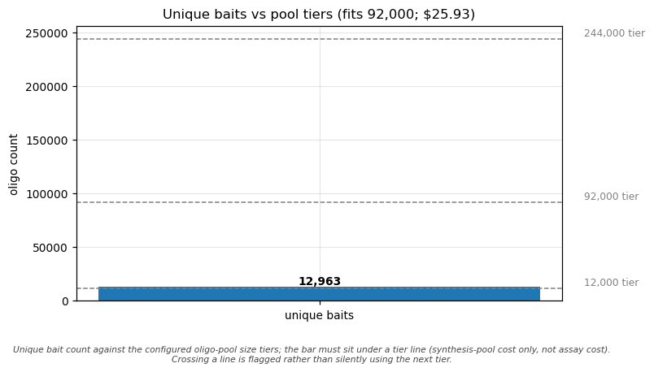
Unique bait count against the configured pool-size tiers. Here the bait-count bar crosses the smallest (12k) tier line and lands in the 92k tier, so the pipeline flags it (the tripwire) rather than silently using the next tier up. A count that stays under the smallest line would fit it with headroom.
What the pool cost is and is NOT. It is the synthesis cost of the oligo pool only. It does not include per-sample assay/capture reagents, biotinylation/IVT, sequencing, or vendor setup fees, and the $0.00200/oligo and the tier list are placeholders — replace them with real vendor quotes.

13 Troubleshooting

13.1 Reference, specificity, and coverage
Symptom | Cause | Fix
ERROR: specificity reference contains ALT/decoy/HLA contigs (exit 3) | You pointed --specificity_db at a toplevel/with-alt index | Rebuild from the no-alt primary assembly with bin/build_specificity_index.sh; see the reference-invariant section
ERROR: specificity_db not found … must be an ABSOLUTE path | Relative --specificity_db; it is referenced in place, not staged | Use an absolute path to the index prefix
ERROR: specificity db and --genome_fasta are DIFFERENT references | Index and genome contig names disagree (usually full-header vs first-token) | Build genome + index from the same cleaned FASTA (*.clean.fa from fetch_references.sh genome); Stage 4 also compares first-tokens
A gene at 0% coverage | Either a real paralog problem or a reference artifact | Check the off-target subjects: if they are alt-haplotype contigs (HSCHR…), it’s a reference artifact (the no-alt invariant) — fix the index; if they are a distinct paralog gene, it’s genuine paralog-limited coverage
Most baits rejected on a new organism | AT-rich (or GC-rich) genome vs the human GC/Tm window | Widen/shift gc_min/gc_max/tm_min (see Plasmodium example)
Re-tiling “did not converge” warning | Residual gaps are non-specific/repeat | Expected — see the convergence section; not an error

13.2 HPC and container
Symptom | Cause | Fix
In-container task: No such file or directory on the specificity index | Refs live outside $HOME//tmp/CWD and weren’t bound into the container | Set CAPTUREFORGE_BIND=<refs root> (wrapper) or bind_paths:/--bind_paths; auto-mounts don’t cover it
sbatch: error: invalid partition specified | slurm_partition points at a partition the cluster doesn’t have | Set it to a real partition (sinfo -s lists them); there is no safe default
Every task fails immediately; logs mention ps | Container image lacks procps (Nextflow polls tasks with ps) | Build from the provided env/captureforge.def (it includes procps); don’t strip the image
Tool reported missing although it’s in the image | A login shell (bash -lc) reset PATH | Verify with a non-login shell: singularity exec <img> <tool> --version
captureforge run warns “conda env not detected” under a container | Cosmetic; tools come from the image | Ignore (suppressed when an engine/--container_image is selected); no conda activate needed in-container
Specificity numbers differ local vs HPC | blastn (local) vs bowtie2 (HPC) detect off-targets slightly differently | Re-validate on the production engine before ordering; both are correct, the margins differ

13.3 Local (laptop)
Symptom | Cause | Fix
python3: command not found / ModuleNotFoundError on macOS | /usr/bin/env python3 resolved to Homebrew python, not the env | conda activate captureforge && export PATH="$CONDA_PREFIX/bin:$PATH", or run -profile <x>,conda/,docker
PDF build fails (no LaTeX) | No xelatex on the machine | Install TeX Live / TinyTeX, or fall back to the HTML→PDF route (see bin/build_manual.sh)

13.4 Known doc-vs-behaviour notes
A few parameters exist in nextflow.config for documentation but are not currently wired to a stage; the script defaults apply instead. Setting them has no effect:
- genmap_kmer, genmap_errors, genmap_min_mappability — GenMap is not invoked; specificity uses alignment (blast/bowtie2) only.
- mask_low_complexity, relax_lowcplx_promoter, str_skip_repeat_core — modules/masking.nf does not pass these; apply_masking.py defaults them on (which matches the config defaults).
- dust_threshold — the low-complexity cutoff actually used is composition_filter.py --min-entropy (default 1.2), not dust_threshold.
- tiling[*].density — informational; the tiler uses step_frac and even (boosting handles copies).

14 From design to order

14.1 Choosing a bait format (bait_format)
Format | What you order | Implication
ivt_rna (default) | DNA oligos = handle5 + T7 + bait + handle3 (170 nt) | Amplify by PCR, transcribe to biotinylated RNA baits in-house (T7). Lowest cost per capture; some wet-lab work
dna_pool | the bait cores only | Synthesized DNA oligo pool; simplest, but DNA baits and no amplification
ready_to_use | bait sequences + target BED | For a finished-bait vendor service (Arbor myBaits etc.)
The schematic below shows what the synthesized oligo looks like for each format (segments scaled by length in nt). For ivt_rna the 120 nt bait (probe) is flanked by a 5′ universal PCR handle, a T7 promoter, and a 3′ PCR handle (170 nt total): PCR-amplify the pool, then in-vitro-transcribe with T7 into biotinylated RNA baits. dna_pool and ready_to_use are the bait core only. The handle/T7 sequences are configurable (pcr_handle_5, t7_promoter, pcr_handle_3); the lengths shown come from the run’s stage-8 summary.
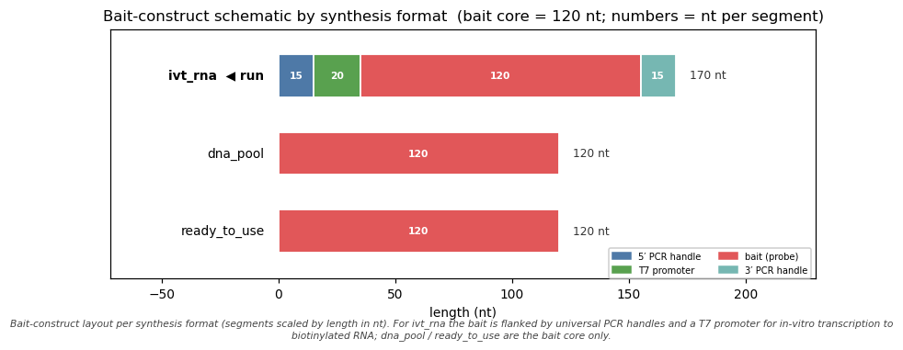
Bait-construct schematic for every synthesis format CaptureForge can produce; segments are scaled by length in nt and the format used for this run is marked ◀ run. ivt_rna = 5′ PCR handle (15) + T7 promoter (20) + bait (120) + 3′ PCR handle (15) = 170 nt; dna_pool / ready_to_use = the 120 nt bait core.

14.2 Mapping to a synthesizer template
CaptureForge emits a generic order package. Map baits.csv / order_generic.tsv to your vendor’s template before ordering (CaptureForge never contacts a vendor):
Vendor | Product | Note
Twist | oligo pool / custom panel | accepts FASTA + target BED
IDT | xGen Custom / Lockdown | 120 nt biotinylated probes
Agilent | SureSelect / custom baits | 120 nt RNA baits
Arbor Biosciences | myBaits | 80–120 nt, IVT RNA (ready_to_use)
GenScript / Twist | oligo pools | for ivt_rna (T7 + handles)
The baits.csv columns cover what every template needs; reshape/rename per the vendor. See assets/vendor_templates/.

14.3 Pre-order checklist
- Validate the production specificity engine — if you designed with blastn locally but will deploy bowtie2 on the HPC, re-run specificity on the production engine and diff.
- Decide orthogonal assays for breakpoint-blind / paralog-limited loci (the genes flagged in the QC).
- Replace placeholder costs (per_oligo_price, pool_tiers) with real vendor quotes.
- Confirm the Tm window matches your actual capture protocol (the default assumes capture, not PCR).
- Confirm accepted losses — e.g. an exon that falls entirely inside a high-copy SINE/Alu element is intentionally not baited (baiting it would pull down ~1M genomic Alu copies).

15 Extending CaptureForge
- Adjusting design classes / params — most behaviour is data-driven via nextflow.config params and the per-class tiling map; change tiling density, flanks, thresholds, or GC/Tm windows without touching code.
- Roadmap (NOT yet implemented):
  - Curated CNV-breakpoint targeting — replace whole-locus CNV tiling with targeted breakpoint baits (needs curated breakpoint coordinates).
  - Paralog-aware design — design baits at paralog-discriminating positions to recover more unique coverage for paralog-limited genes.
  - Pilot-capture coverage feedback loop — feed empirical pilot-capture depth back to re-balance bait copy numbers (boost under-covered, trim over-covered).

16 Reproducibility and provenance
Every run records what produced it:
- provenance.json — tool versions captured at runtime, reference releases, the git_commit, and the design_genome + specificity_reference paths (so the no-alt invariant is documented per run).
- refs.provenance.json (written by bin/fetch_references.sh) — source URL, release, and md5 of each reference.
- Pinned environments — env/captureforge.yml pins every tool version; the same file builds the Docker and Apptainer images.
- MANIFEST — md5 of each deliverable.
To cite the exact references, read the release + md5 fields from refs.provenance.json (for a human run, for example: Ensembl r112 GTF, UCSC hg38 rmsk/simpleRepeat, Ensembl Variation REST for rsIDs).

17 Glossary
- Bait / probe — biotinylated oligo complementary to a target region.
- Panel — the full set of baits.
- Design class — coding/promoter/regulatory/cnv/str/anchor; drives tiling and masking.
- Tiling — laying overlapping baits across a region; “2×” ≈ each base covered by ~2 baits.
- Masking — removing repeats/segdups/low-complexity/STR cores so you don’t bait non-unique sequence.
- Specificity — rejecting baits that also hybridize off-target.
- Mappable coverage — covered ÷ tileable target. Raw coverage — covered ÷ nominal target.
- AS-BUILT coverage — what the final baits actually cover (final_covered_targets.bed).
- No-alt primary assembly — reference without alternate haplotypes/decoys; required for specificity.
- Anchor — an rsID (± flank) you want ≥2 baits to span.

18 FAQ
- Do I need MANE? Only for human, and only to prefer the clinical canonical transcript. Other organisms fall back to Ensembl-canonical or the longest transcript.
- Why is my raw coverage “only” ~67%? (e.g. in a repeat-heavy panel where the gap is large.) Because a large share of that gap is sequence intentionally masked as uncapturable. Read the mappable number (covered ÷ tileable target) instead.
- Can I run without RepeatMasker/dbSNP/regulatory tracks? Yes — masking falls back to dustmasker, anchors need a user BED, and regulatory classes produce nothing (promoter windows still come from the GTF TSS).
- Why did a gene come out at 0%? Check whether the off-targets are alt-haplotype contigs (reference artifact — fix the index) or a real paralog (genuine, partial coverage).
- Does boosting increase my cost/tier? No — copies raise representation, not the number of distinct oligos.

19 Citation
Author: Bright Adu, Genomics and Bioinformatics Core Facility, Noguchi Memorial Institute for Medical Research, University of Ghana, Legon, Ghana.
See CITATION.cff in the repository root for the machine-readable citation. Cite CaptureForge by name and version, and cite the exact reference releases from refs.provenance.json.

20 Version / changelog
- 0.1.0 — initial release: 10-stage Nextflow pipeline, three profiles, three input on-ramps, no-alt reference invariant enforced, QC dashboard + figures, generic order package.

