FamilyForge — User Manual
  - A pedigree-aware clinical variant-interpretation tool (annotated VCF + pedigree + panel → ranked candidates + clinician / publication / clinical reports)
Bright Adu

Genomics & Bioinformatics Core
Noguchi Memorial Institute for Medical Research
University of Ghana, Legon, Ghana
2026-07-30
Contents

1. Introduction
FamilyForge is a pure-Python, disease-agnostic clinical variant-interpretation tool. It takes a single family’s annotated multi-sample VCF, a pedigree, and a curated gene panel, and produces segregation-checked candidate variants, a pragmatic ACMG-style A/B/C tiering, a copy-number (CNV) cross-check, genotype-based relatedness / sex QC, and a set of audience-specific reports (a concise clinician report, a full publication report, and a letterhead clinical-genomics report).
FamilyForge is the interpretation member of the forge family of sibling pipelines:
CaptureForge (probe design) → CallForge (sequence analysis) → FamilyForge (family interpretation).
CallForge turns demultiplexed FASTQs into a joint-genotyped, annotated callset; FamilyForge consumes that callset — specifically the annotated joint VCF.gz, and optionally CallForge’s cnv_calls.tsv and provenance.json — and answers the clinical question CallForge does not: given this family and this panel, which variants best explain the affected members’ disease, and how strong is the evidence?
What makes it “family-aware.” FamilyForge never scores a variant in isolation. Every candidate is tested against the affected / unaffected structure of the pedigree under explicit Mendelian models, cross-checked for monozygotic-twin concordance, and — where a parent was not sequenced — labelled honestly as inferred, not confirmed. Population frequency thresholds are applied differently for dominant versus recessive hypotheses, and the tiering rubric folds in ClinVar, predicted consequence, in-silico damage, conservation, and the gene’s known disease mechanism.
Who it is for. Clinical bioinformaticians, medical geneticists, and genomics-core staff who need a reproducible, honest first pass over a small family’s exome/genome data — one that ranks candidates, shows its evidence trail, and produces documents suitable for a multidisciplinary review or a case report.
Scope and status. FamilyForge is a research tool. Its outputs are candidates, not diagnoses: every Tier A/B finding is explicitly pending orthogonal confirmation (Sanger / MLPA / aCGH), functional validation, and formal ACMG classification by an accredited laboratory before any clinical action. It is implemented and verified end-to-end on a synthetic self-test (§12). The bundled gene-specific tiering rules and example configuration were developed around an inborn-error-of-immunity use case, but the tool is fully disease-agnostic: the panel and pedigree are inputs, never hardcoded, and all report wording (disease name, panel name, per-gene clinical notes) is supplied through configuration — nothing disease-specific is baked into the templates (§11).

2. Concepts
This section defines the ideas the tool is built on. It is worth reading once before the command reference, because the flags map directly onto these concepts.

2.1 The pedigree / phenotype model
FamilyForge represents a family as a set of members, each parsed from one line of a standard 6-column PED file:
Column | Meaning | Notes
1 | Family ID | free text (e.g. FAM01)
2 | Individual ID (iid) | must match the VCF sample name for a sequenced member
3 | Father ID | 0 if unknown/founder
4 | Mother ID | 0 if unknown/founder
5 | Sex | 1/M=male, 2/F=female, 0/U=unknown
6 | Phenotype | 2 = affected; anything else = unaffected
A crucial design choice: a member is marked sequenced if and only if its iid appears among the VCF sample names. Members present only to define relationships — most commonly an unsequenced father — are kept in the pedigree so the models can reason about obligate carriers and phase, but they contribute no genotypes. This is what lets FamilyForge state, for a de-novo-pattern variant, “de novo OR paternally inherited (unconfirmed)” rather than over-claiming.
Derived quantities the models use: affected (sequenced affected members), unaffected (sequenced unaffected members), and mothers_of_affected() (the set of mothers, present in the pedigree, of the affected members — the obligate-carrier check for recessive models).

2.2 Genotype quality gating
Before any inheritance model runs, each per-sample genotype is gated. A het, hom-alt, or hemizygous-alt call is demoted to “not usable” (ok = False, treated like a no-call by the models) when it fails the configured thresholds:
- genotype quality GQ < min_gq (default 20), or
- depth DP < min_dp (default 8), or
- for a heterozygous call, alt allele-balance AB < min_alt_ab (default 0.20).
Homozygous-alt allele balance is handled leniently (a small residual REF fraction does not by itself void a hom-alt call). Zygosity itself is computed allele-count-wise, with hemizygous recognised on chrX/chrY for male samples. This gate is the reason a noisy low-depth genotype cannot, on its own, manufacture a de-novo or compound-het call.

2.3 Inheritance models
FamilyForge evaluates four single-variant / gene-level Mendelian models. Each is checked against the affected/unaffected structure; a model only fires if the panel’s declared inheritance for the gene is compatible (or the panel leaves inheritance blank, in which case any model may fire).
- De novo / dominant (de_novo_or_dominant). All sequenced affected carry the allele (het), all sequenced unaffected are homozygous-reference, and the gene allows AD (or has no declared inheritance). If an unaffected relative also carries the allele, a separate reduced-penetrance dominant branch fires instead, at low confidence and flagged.
- Autosomal-recessive homozygous (ar_homozygous). All affected are homozygous-alt on an autosome, no unaffected sibling is homozygous, and (where sequenced) the mother is not homozygous-alt — an obligate-carrier mother is expected to be heterozygous. Confidence is high only when the twin genotypes are concordant and every sequenced mother is het.
- Autosomal-recessive compound heterozygous (ar_compound_het). Evaluated per gene: two different heterozygous variants, both het in all affected, on opposite parental haplotypes (in trans). Phase is inferred from the mother — one allele maternal (mother het), the other absent in the mother (mother hom-ref, therefore inferred paternal). No unaffected relative may carry both alleles. When the father is unsequenced, the paternal allele is labelled inferred.
- X-linked recessive (x_linked_recessive). On chrX, affected males are hemizygous for the allele, no sister is homozygous, the mother (where sequenced) is a heterozygous carrier, and the gene allows XLR/XL.
Each model emits a human-readable segregation string — e.g. MOTHER(unaff)=het; SIBLING(unaff)=ref; TWIN_1(aff)=hom; TWIN_2(aff)=hom — so a reviewer can see the family pattern at a glance.

2.4 Monozygotic-twin handling
If two or more samples are declared an MZ-twin group (via --mz-twins or config), they are treated as genetic replicates: for a candidate to reach high confidence, the twins must be genotype-concordant at that site. A discordant genotype across an MZ pair is almost always a technical artifact (a dropout or a miscall), so the candidate is flagged and its confidence capped — and in tiering, a low-confidence Tier A is demoted to Tier B. Independently, the genotype-QC step reports pairwise concordance across the whole panel, so you can verify that a declared MZ pair really behaves like one (≈1.0) and that first-degree relatives sit near 0.5–0.7.

2.5 ACMG-style tiering (A / B / C)
FamilyForge assigns each candidate a tier, a pragmatic triage signal — not a full, formal ACMG classification:
- Tier A — likely actionable. ClinVar pathogenic/likely-pathogenic (rare, segregating); or biallelic predicted-LoF in a LoF-mechanism gene under a recessive model; or a STAT3 dominant-negative hotspot missense/LoF under a de-novo/dominant pattern; or a rare damaging missense in a Tier-1/2 gene with strong in-silico consensus (AlphaMissense likely-pathogenic, REVEL ≥ 0.7, or CADD ≥ 25) under a matching-inheritance model.
- Tier B — strong VUS. Predicted-LoF in a panel gene, or a rare missense with supportive in-silico evidence, where mechanism or inheritance still needs confirmation. Tier A findings are capped to B when ClinVar is conflicting, or when genotype confidence is low / MZ-twin discordant.
- Tier C — weaker / downgraded. Rare in-panel variants with limited support, or variants downgraded because they are too common in gnomAD for their model, or ClinVar benign.
The evaluation is top-to-bottom, first-match-wins; §9 and the tiering diagram (Figure 2) document every branch. Alongside the tier, FamilyForge records an evidence trail — the list of criteria that fired (ClinVar status, consequence, AF, SIFT/PolyPhen/PhyloP, AlphaMissense/REVEL/CADD, segregation model) — which is printed verbatim in the reports.
A separate classify() step maps each row to a five-level colour convention for the reports — P (pathogenic), LP (likely pathogenic), VUS, LB (likely benign), B (benign) — from ClinVar, tier, and allele frequency.

2.6 CNV interpretation
SNV/indel calling is blind to large deletions, yet deletions are a classic disease mechanism for some genes (the bundled example is DOCK8 in AR-HIES). FamilyForge reads CallForge’s cnv_calls.tsv (tolerant of column-name variations), keeps deletions that overlap a panel gene, and tiers them: Tier A if the gene is a configured CNV-priority gene and the event is in an affected sample, otherwise Tier B. Low-confidence CNV labels and the SNV-blind mechanism are surfaced as flags, and every CNV candidate carries the standing recommendation to confirm by read-depth/IGV and an orthogonal assay (MLPA/aCGH).

2.7 Genotype-based relatedness & sex QC
Independently of any external sites file (no somalier required), FamilyForge cross-checks the samples from their own genotypes:
- Pairwise concordance over shared, quality autosomal sites — a relatedness / MZ / sample-swap check.
- Sex inference from chrX heterozygosity — a sample with a very low chrX het-rate (< 0.10) is inferred male, otherwise female — compared against the declared sex in the PED.
These land in every report’s QC section and in candidates.json.

3. Architecture
FamilyForge is a small, readable Python package. A single command (familyforge) orchestrates the whole run; a second entry point (familyforge-clinical-report) renders the letterhead clinical report from the machine-readable output. The figure below is the authoritative map: inputs (top) flow through ingest/parse, into the interpretation modules, into reporting, and out to the deliverables.
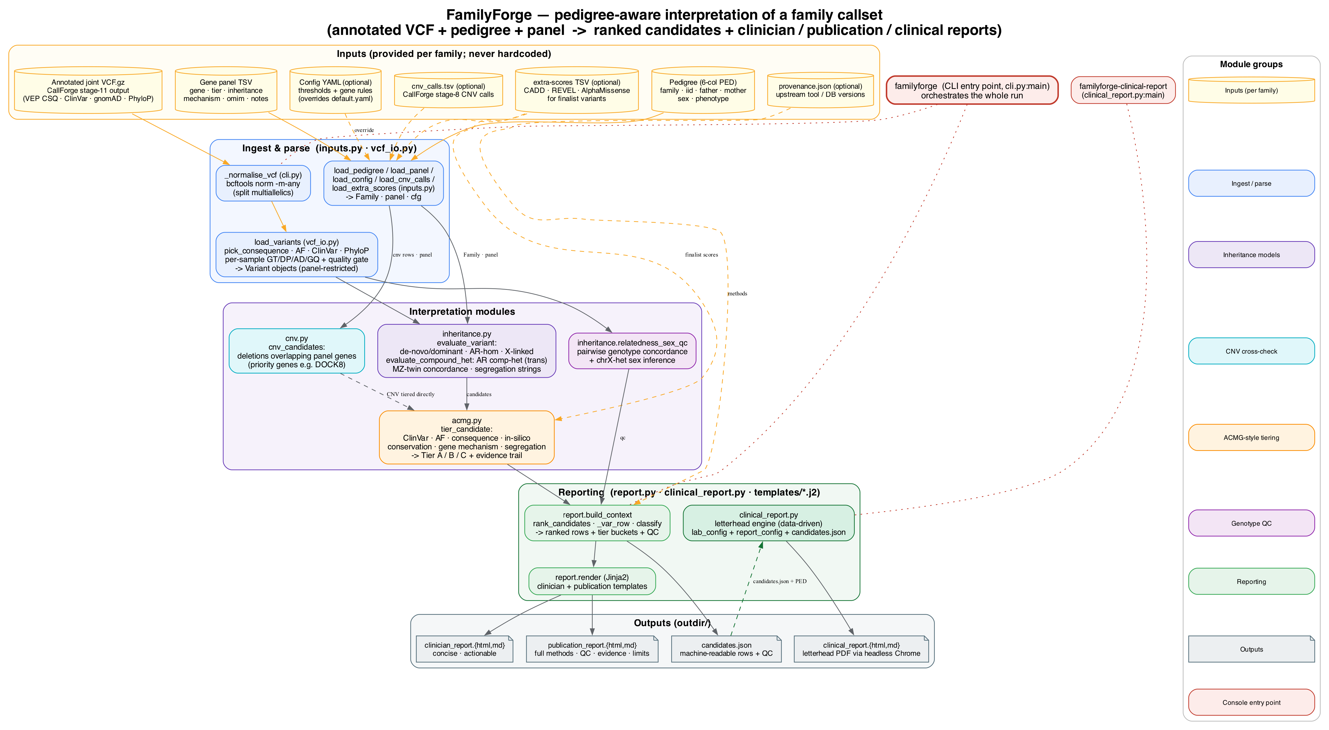
FamilyForge architecture — inputs (annotated VCF, pedigree, panel, optional config / CNV / extra-scores / provenance) are parsed by vcf_io.py and inputs.py, interpreted by inheritance.py, cnv.py, and acmg.py, then rendered by report.py and the clinical_report.py letterhead engine into clinician, publication, clinical, and JSON outputs.
Module map.
File | Responsibility
cli.py | Argument parsing, orchestration, VCF normalisation, JSON dump
inputs.py | Loaders: config (YAML), pedigree (PED), panel (TSV), CNV calls, extra scores
vcf_io.py | Parse the annotated VCF into Variant objects; pick consequence; quality-gate genotypes
model.py | Dataclasses: Member, Family, GeneAnno, Variant, Candidate
inheritance.py | Mendelian models, compound-het, MZ concordance, relatedness/sex QC
acmg.py | ACMG-style A/B/C tiering with an evidence trail
cnv.py | CNV deletion cross-check against panel genes
report.py | Build the report context; render clinician + publication (HTML + MD)
clinical_report.py | Standalone letterhead clinical-report engine (HTML + MD)
config/default.yaml | Default thresholds and gene-specific rules
templates/*.j2 | Jinja2 templates for all four report styles
tests/selftest.py | Synthetic end-to-end test with planted, known-answer variants
Data-flow spine (as in cli.main): normalise VCF → load panel → discover which pedigree members are in the VCF → load_variants (panel-restricted, quality-gated) → apply optional --extra-scores → run evaluate_variant + evaluate_compound_het + cnv_candidates → tier_candidate each SNV/indel candidate → relatedness_sex_qc → build_context → render (four report files) → write candidates.json.

4. Installation
FamilyForge is a standard Python package (build backend: setuptools). It needs Python ≥ 3.10 and five pure-Python/compiled dependencies: cyvcf2, pandas, numpy, jinja2, pyyaml. cyvcf2 provides fast VCF parsing (it ships binary wheels for common platforms). bcftools on PATH is recommended but optional — it is used to split multiallelic sites; without it, multiallelic records are skipped with a warning.

4.1 pip + virtualenv (recommended for a single user)
# 1. obtain FamilyForge and enter the repository
git clone https://github.com/aduton1000/familyforge.git
cd familyforge
# 2. create and activate an isolated environment
python3 -m venv .venv
source .venv/bin/activate # Windows: .venv\Scripts\activate
# 3. install (editable so local edits take effect immediately)
pip install -e .
# 4. confirm the console entry points are on PATH
familyforge --help
familyforge-clinical-report --help

4.2 conda / mamba (recommended when you also want bcftools)
mamba create -n familyforge -c conda-forge -c bioconda \
python=3.11 cyvcf2 pandas numpy jinja2 pyyaml bcftools
mamba activate familyforge
pip install -e . # register the familyforge console commands

4.3 Verify the installation
Run the bundled self-test (§12). It fabricates an annotated VCF with planted variants and confirms FamilyForge recovers the expected models, tiers, and reports:
python tests/selftest.py
# expect: Tier A genes: {'STAT3', 'DOCK8', 'PGM3'} ... SELFTEST PASS

5. Inputs
FamilyForge takes one required trio — VCF + PED + panel — plus four optional inputs. All are provided at run time; nothing is hardcoded.

5.1 The annotated VCF (--vcf, required)
A multi-sample, bgzipped VCF — normally CallForge’s stage-11 annotated.vcf.gz. FamilyForge reads:
- Per-sample FORMAT: GT, DP, AD, GQ (for zygosity + quality gating).
- VEP CSQ (INFO): Consequence, SYMBOL, HGVSc, HGVSp, SIFT, PolyPhen, CANONICAL, MANE_SELECT/MANE, and the population-AF fields listed in af_fields.
- INFO annotations: ClinVar_CLNSIG (or CLNSIG, or the CSQ CLIN_SIG field), PhyloP, and PARALOG_GENE/PARALOG_CONF if present.
For each variant, FamilyForge picks one transcript consequence — preferring a panel gene, then a MANE/canonical transcript, then the most-severe consequence — and, in its primary pass, keeps only variants whose picked gene is in the panel. The MANE Select RefSeq accession is retained so the reports can present clinical-standard HGVS.
Multiallelic handling: FamilyForge runs bcftools norm -m-any first (unless --skip-norm), so genotype interpretation is unambiguous. If a record is still multiallelic at parse time, it is skipped.

5.2 The pedigree (--ped, required)
A 6-column PED (§2.1). Sample IDs in column 2 must match the VCF sample names for sequenced members. Example (family.ped) — an unsequenced father, an unaffected mother, an unaffected sibling, and affected MZ twins:
FAM01 FATHER 0 0 1 0
FAM01 MOTHER 0 0 2 1
FAM01 SIBLING FATHER MOTHER 2 1
FAM01 TWIN_1 FATHER MOTHER 1 2
FAM01 TWIN_2 FATHER MOTHER 1 2
Here FATHER has no genotypes in the VCF, so FamilyForge marks him relationship-only; TWIN_1/TWIN_2 are the affected (phenotype 2) males.

5.3 The gene panel (--panel, required)
A tab-separated file, one gene per row, with a header line beginning gene. Columns after the gene are optional; missing columns default sensibly.
gene tier inheritance mechanism omim notes
STAT3 1 AD DN 147060 DBD/SH2 hotspot incl R382
DOCK8 1 AR LOF 243700 biallelic LOF, large deletions
PGM3 2 AR HYPO 615816 hypomorphic/LOF
IL2RG 1 XLR LOF 300400 X-linked SCID/IEI
- tier — the gene’s a-priori priority (1/2 = Tier-1/2 disease gene; used by the strong-missense Tier A branch). Defaults to 3.
- inheritance — a comma-separated set of AD, AR, XLR/XL; gates which models may fire. Leave blank to allow any model.
- mechanism — free set (e.g. LOF, DN, HYPO); informational, surfaced in reports.
- omim, notes — free text for the reports.

5.4 Configuration (--config, optional)
A YAML file that overrides keys in the packaged config/default.yaml (§8). Supply only the keys you want to change.

5.5 CNV calls (--cnv, optional)
A CallForge cnv_calls.tsv. The parser is tolerant of column-name variants: it recognises gene/genes/symbol/overlapping_genes, call/type/cnv/event/status, cn/copy_number/log2, sample/sample_id, chrom/chr, start, end, callability/confidence/label. A row counts as a deletion if its call text says del/loss/deletion, or copy number < 1.5, or log2-ratio < −0.4.

5.6 Finalist in-silico scores (--extra-scores, optional)
When genome-wide dbNSFP is unavailable, you can attach externally retrieved scores for a handful of finalist variants. A TSV keyed by chrom:pos:ref>alt:
key cadd_phred revel alphamissense_score alphamissense_class
chr17:42322000:G>A 29.4 0.86 0.978 likely_pathogenic
chr9:300000:C>T 34.0 . . .
Matching rows have their CADD/REVEL/AlphaMissense fields populated before tiering, which can lift a strong missense to Tier A.

5.7 Provenance (--provenance, optional)
A CallForge provenance.json. Its contents (tool/DB versions, git commit) are threaded into the publication report’s methods section for reproducibility.

6. The familyforge command
familyforge is the primary entry point. It runs the full interpretation in one call.
familyforge --vcf VCF --ped PED --panel PANEL --outdir DIR
[--cnv TSV] [--config YAML] [--study-name NAME]
[--mz-twins "ID1,ID2" ...] [--provenance JSON]
[--extra-scores TSV] [--skip-norm]
Flag reference.
Flag | Req. | Purpose
--vcf | Yes | Annotated joint VCF.gz (CallForge stage-11 output)
--ped | Yes | 6-column PED pedigree
--panel | Yes | Gene-panel TSV (gene,tier,inheritance,mechanism,omim,notes)
--outdir | Yes | Output directory (created if absent)
--cnv |  | CallForge cnv_calls.tsv for the CNV cross-check
--config |  | Override YAML (merged over config/default.yaml)
--study-name |  | Report title (default Family study)
--mz-twins |  | Comma-separated MZ-twin sample IDs; repeatable for multiple twin sets
--provenance |  | CallForge provenance.json for the methods section
--extra-scores |  | TSV of finalist CADD/REVEL/AlphaMissense scores
--skip-norm |  | Skip bcftools norm (use if the VCF is already biallelic-split)
Generic example.
familyforge \
--vcf /path/to/callforge/anno/annotated.vcf.gz \
--ped /path/to/config/family.ped \
--panel /path/to/config/gene_panel.tsv \
--cnv /path/to/callforge/cnv/cnv_calls.tsv \
--config /path/to/config/familyforge.yaml \
--extra-scores /path/to/config/finalist_scores.tsv \
--provenance /path/to/callforge/provenance.json \
--mz-twins TWIN_1,TWIN_2 \
--study-name "Family FAM01 exome" \
--outdir /path/to/results/reports
What it prints (to stderr): the number of panel variants loaded and samples seen, how many extra scores matched, and the tier counts (nA / nB / nC), followed by the list of files written.

7. The familyforge-clinical-report command
The second entry point renders a letterhead clinical-genomics report — the disease- agnostic, data-driven document intended for a clinical file. It consumes the machine- readable candidates.json produced by a familyforge run, plus the pedigree and two small YAML files, and emits an HTML report (render to PDF with headless Chrome) and a Markdown twin.
familyforge-clinical-report --lab-config LAB.yaml --report-config REPORT.yaml
--candidates candidates.json --ped PED --out OUT.html
Flag | Purpose
--lab-config | Reusable lab branding YAML (institute, logos, head-of-lab, confidentiality)
--report-config | Per-report YAML (accession, specimen, disease name, sample labels, QC rows, management)
--candidates | The candidates.json from a familyforge run
--ped | The same PED (for sex/relationship fallback)
--out | Output HTML path (a .md twin is written alongside)
The --lab-config supplies branding fields (lab_abbrev, institute, university, lab_name, logo_banner, logo_lab, head_name, head_title, confidentiality); the logos are read and embedded as base64 so the HTML is self-contained. The --report-config supplies the per-case content: accession, report_type, status, test, specimen, reference_genome, referral_reason, disease_name, panel_name, a samples map (labels/relationships/status), optional qc_rows, gene_management, and notes. All clinical content is data — nothing about the disease is baked into the engine.
Generic example (render to PDF at the end):
familyforge-clinical-report \
--lab-config /path/to/config/lab_branding.yaml \
--report-config /path/to/config/report_meta.yaml \
--candidates /path/to/results/reports/candidates.json \
--ped /path/to/config/family.ped \
--out /path/to/results/reports/clinical_report.html
# render the letterhead HTML to PDF (self-contained; repeating header per page)
chrome --headless=new --no-pdf-header-footer \
--print-to-pdf=/path/to/results/reports/clinical_report.pdf \
file:///path/to/results/reports/clinical_report.html
The letterhead template repeats the institutional banner at the top of every printed page (via a <thead> that Chrome repaints), applies the P→LP→VUS→LB→B colour scale to the primary finding, and appends a technical appendix (QC metrics, methods summary, limitations and disclaimer) with a signature/stamp block for the authorising laboratory head.

8. Configuration
All thresholds and gene rules live in familyforge/config/default.yaml. Override any subset with --config your.yaml; your keys are merged on top of the defaults.
Key | Default | Meaning
min_gq | 20 | Minimum genotype quality; below → genotype not usable
min_dp | 8 | Minimum depth at the genotype
min_alt_ab | 0.20 | Minimum ALT allele-balance to accept a het/hom-alt
max_ref_ab_for_hom | 0.10 | Max REF fraction tolerated for a hom-alt
af_dominant_max | 0.0001 | Max popmax AF for a plausible dominant causal allele
af_recessive_max | 0.01 | Max popmax AF for a plausible recessive causal allele
af_fields | (list) | CSQ/INFO AF fields to take the max over (incl. African-ancestry)
lof_consequences | (list) | Consequences counted as loss-of-function
missense_consequences | (list) | Consequences counted as missense/protein-altering
splice_region | (list) | Splice-region consequences
phylop_conserved | 2.0 | PhyloP above this = conserved position
revel_supportive | 0.5 | REVEL ≥ this = supportive
revel_strong | 0.7 | REVEL ≥ this = strong (PP3-strong-ish)
cadd_high | 25.0 | CADD PHRED ≥ this = high deleteriousness
mz_twin_groups | [] | MZ-twin sample-ID groups (also settable via --mz-twins)
mz_min_concordance | 0.97 | Expected genome-wide MZ concordance
stat3_dbd_range | [321,465] | STAT3 DNA-binding-domain residue range
stat3_sh2_range | [585,688] | STAT3 SH2-domain residue range
stat3_hotspot_residues | (list) | Individual STAT3 hotspot residues
lof_mechanism_genes | (list) | Genes whose LoF is the disease mechanism
cnv_priority_genes | [DOCK8] | Panel genes where deletions are especially important
disease_name | the suspected condition | Report wording — the disease under investigation
panel_name | custom | Report wording — the panel’s name
gene_clinical_notes | (map) | Gene → short clinical/counseling note emitted for the top candidate
The af_fields default deliberately includes African-ancestry fields (gnomADe_AFR_AF, gnomADg_AFR_AF, gnomAD_AF_afr) alongside the global ones, so frequency filtering is appropriate for African-ancestry families. The stat3_*, lof_mechanism_genes, and cnv_priority_genes keys are the gene-specific rules: they bias the tiering toward known disease mechanisms, and you extend them (or replace them for a different disease area) purely in configuration. The disease_name, panel_name, and gene_clinical_notes keys are the report-content settings that make the reports disease-agnostic (§11): they supply the disease/panel names and the per-gene counseling notes shown in the clinician and publication reports, with nothing disease-specific baked into the templates. The shipped gene_clinical_notes entries (DOCK8, STAT3) are illustrative examples of the format only.

9. Interpretation logic in detail
This section documents exactly how a candidate becomes a tier and an evidence trail. It mirrors acmg.tier_candidate and the inheritance models; Figure 2 is the decision map.
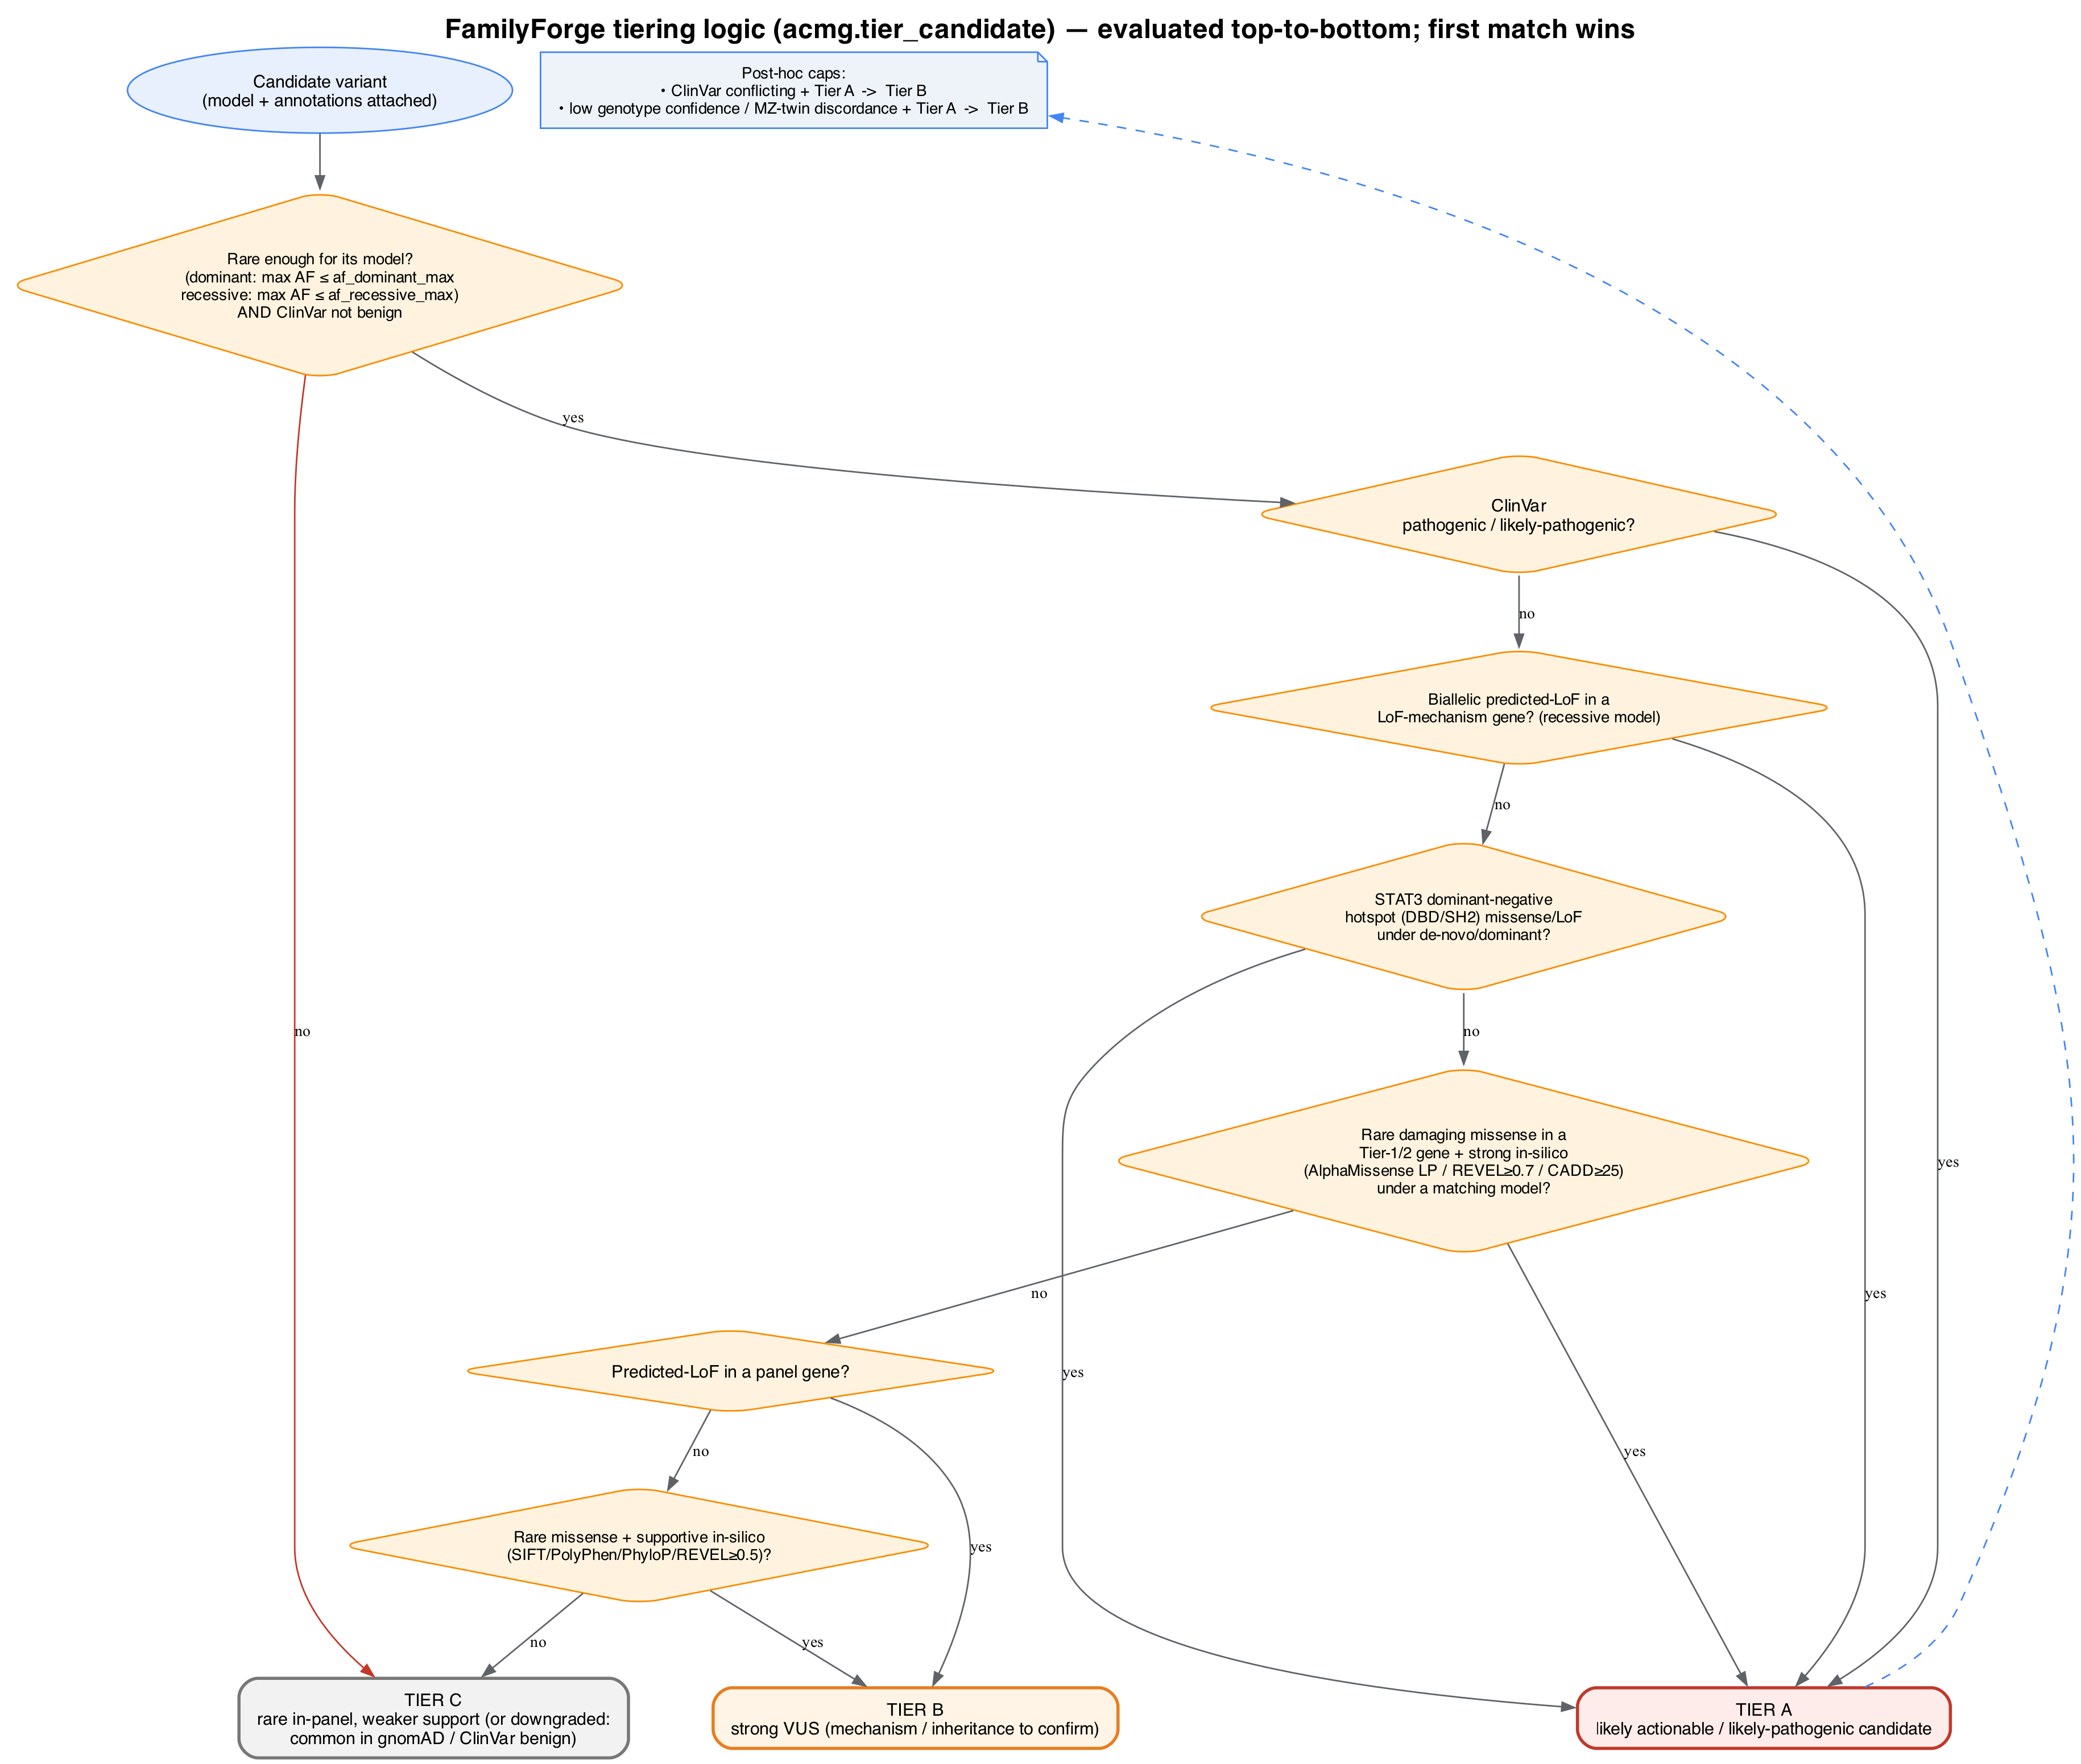
FamilyForge tiering decision flow (acmg.tier_candidate). Branches are evaluated top-to-bottom and the first match wins; two post-hoc caps demote a Tier A to Tier B under ClinVar-conflicting or low-confidence/MZ-discordant conditions.
Step 1 — establish the model. Every candidate arrives already carrying a model (de_novo_or_dominant, ar_homozygous, ar_compound_het, x_linked_recessive, or cnv_deletion) set by the inheritance/CNV step, together with a segregation string and a confidence (high/moderate/low).
Step 2 — gather evidence. For SNV/indel candidates, tier_candidate derives: ClinVar class (pathogenic / benign / conflicting / VUS / none), whether the consequence is LoF / missense / splice-region, whether the allele is rare enough for its model (using af_dominant_max for dominant models and af_recessive_max for recessive ones), whether the gene is a LoF-mechanism gene, whether it is a STAT3 hotspot, whether the position is conserved (PhyloP), and whether in-silico support is supportive or strong (SIFT deleterious, PolyPhen damaging, PhyloP conserved, AlphaMissense likely-pathogenic, REVEL ≥ 0.5/0.7, CADD ≥ 25). It records a human-readable evidence list used verbatim in the reports.
Step 3 — decide the tier (first match wins):
- Not rare, or ClinVar benign → Tier C (downgraded).
- ClinVar pathogenic/likely-pathogenic → Tier A (“rare, segregates”).
- Biallelic predicted-LoF in a LoF-mechanism gene, recessive model → Tier A.
- STAT3 dominant-negative hotspot missense/LoF, de-novo/dominant → Tier A.
- Rare damaging missense in a Tier-1/2 gene with strong in-silico consensus, under a matching-inheritance model → Tier A (likely-pathogenic candidate; pending functional + parental confirmation).
- Predicted-LoF in a panel gene → Tier B (mechanism/inheritance to confirm).
- Rare missense with supportive in-silico → Tier B.
- Otherwise → Tier C.
Step 4 — apply caps. A Tier A with conflicting ClinVar is demoted to Tier B; a Tier A with low genotype confidence (e.g. an MZ-twin discordance) is demoted to Tier B with the reason annotated.
How the reports read this. report.classify() translates (tier, ClinVar, AF) into the five-level P/LP/VUS/LB/B colour code; rank_candidates orders findings by tier, then confidence, then the gene’s panel tier, so the single most-defensible finding is always top. The clinician and publication templates print the model, zygosity, segregation string, evidence trail, and tier reason; the letterhead engine renders the top finding as the primary result with recommendations.

10. Outputs
A familyforge run writes, into --outdir:
File | Audience | Contents
clinician_report.html / .md | Clinician / MDT | Concise: summary, family table, priority (Tier A/B) findings with evidence, clinical implications, QC, caveats
publication_report.html / .md | Manuscript / case report | Full: methods, tiered candidate tables (A/B/C), per-candidate evidence, provisional ACMG-code table, QC tables, panel table, limitations
candidates.json | Downstream / letterhead engine | Machine-readable: context summary, ranked rows, and QC — the input to familyforge-clinical-report
Running familyforge-clinical-report then adds clinical_report.html (+ .md), which you render to clinical_report.pdf.
Reading a candidate row. Each row carries: gene, model, tier, confidence, zygosity, segregation string, inheritance note, tier reason, the flags/evidence list, and (for SNV/indels) locus, rsID, filter, consequence, clinical-HGVS (MANE-prefixed), ClinVar, gnomAD (global + AFR), PhyloP, SIFT, PolyPhen, and CADD/REVEL/AlphaMissense where supplied. Compound-het rows also carry the partner allele; CNV rows carry the deletion locus and copy-number.

11. Report templates & the clinical letterhead
FamilyForge ships three report styles, all as Jinja2 templates under familyforge/templates/:
- clinician.{html,md}.j2 and publication.{html,md}.j2 — rendered by report.py. These are the concise and full research reports.
- clinical_letterhead.{html,md}.j2 — rendered by clinical_report.py, the institutional letterhead document.
All three report styles are disease-agnostic and config-driven. No disease, panel, or gene name is hardcoded in any template. The wording is supplied through configuration and the report YAMLs:
- clinician / publication templates read disease_name, panel_name, and the gene_clinical_notes map from the run config (config/default.yaml, overridable with --config), threaded into the report context as meta.disease_name, meta.panel_name, and meta.gene_clinical_notes. Titles, the summary line, the panel-name heading, and the phenotype-correlation note all interpolate these values. Per-gene clinical/counseling text is data-driven: for the top candidate gene, the template emits the matching gene_clinical_notes entry if one exists, and nothing otherwise — so counseling notes are configured, never coded. Missing values degrade gracefully to neutral defaults (the suspected condition, custom).
- clinical_letterhead template (letterhead engine) takes its disease name, panel name, sample labels, methods wording, and management text from the report_config YAML, exactly as before.
To adapt the reports to your disease area, set disease_name, panel_name, and gene_clinical_notes in a --config YAML (and the corresponding fields in the letterhead report_config). The bundled defaults ship two illustrative gene_clinical_notes entries (DOCK8, STAT3) purely as examples of the format; replace them with notes appropriate to your panel. The methods/provenance paragraph retains generic tool-provenance wording (CallForge/FamilyForge/VEP/GATK) with no disease- or gene-specific phrasing.
The letterhead template is designed for print: A4 geometry, a repeating banner header, the P→LP→VUS→LB→B colour scale, a variant-detail table, interpretation and recommendations, a signature/stamp block, and a second-page technical appendix (QC metrics, methods, limitations & disclaimer). Because logos are embedded as base64, the HTML is a single self-contained file that headless Chrome prints faithfully to PDF.

12. Worked example — the self-test
The bundled tests/selftest.py is the fastest way to see FamilyForge end-to-end. It writes a synthetic annotated VCF for a four-member family (MOTHER, SIBLING, and the affected MZ twins TWIN_1/TWIN_2), with an unsequenced FATHER in the PED, and plants four known-answer variants plus a benign decoy:
- STAT3 de-novo hotspot missense (p.Arg382Trp) — het in both affected, ref in mother/sibling → expected Tier A, de-novo/dominant.
- DOCK8 homozygous stop-gained — hom in both affected, het in mother/sibling → expected Tier A, AR-homozygous.
- PGM3 compound-het (a maternal stop-gained + an inferred-paternal frameshift) → expected Tier A, AR-compound-het.
- A common, benign STAT3 missense → expected to be filtered out (downgraded).
python tests/selftest.py
Expected result:
=== SELFTEST RESULT ===
Tier A genes: {'STAT3', 'DOCK8', 'PGM3'}
summary: {'n_candidates': ..., 'tierA': 3, 'tierB': ..., 'tierC': ...}
...
SELFTEST PASS
The test also confirms the four report files are written and non-empty, and that the MZ pair TWIN_1~TWIN_2 shows high genotype concordance. Inspect the generated out/ directory to see real clinician, publication, and JSON outputs.

13. Troubleshooting
Symptom | Cause / fix
WARN: bcftools not on PATH — skipping normalisation | Install bcftools, or pass --skip-norm if the VCF is already biallelic-split. Without it, multiallelic sites are ignored.
loaded 0 panel variants | The picked-consequence gene never matched the panel. Check that SYMBOL in the VEP CSQ uses the same gene symbols as the panel, and that the VCF is actually annotated.
A sequenced member shows as not sequenced | Its PED iid (column 2) does not exactly match a VCF sample name. Names are case-sensitive.
No Tier A/B despite an obvious candidate | Check genotype quality (a low-GQ/DP/AB call is gated out), the panel’s inheritance (an incompatible model will not fire), and the AF thresholds (too-common alleles are downgraded).
Expected de-novo call is “unconfirmed” | This is by design when the father is not sequenced — add paternal DNA to confirm.
MZ pair flagged discordant / Tier A capped to B | A genotype differs across the twins at that site — usually a technical dropout; review depth/AB, and confirm the twins really are the declared pair via the QC concordance table.
CNV rows ignored | The row was not recognised as a deletion (call text / copy-number / log2 thresholds), or its gene did not overlap the panel. Check column names against §5.5.
Letterhead engine errors on a missing logo | logo_banner/logo_lab paths in the lab-config must point to readable image files (they are base64-embedded).

14. Reproducibility & provenance
Reproducibility rests on three things: the inputs (VCF, PED, panel, config), the configuration (all thresholds and rules are in config/default.yaml and echoed into the publication report’s methods), and the upstream provenance (--provenance threads CallForge’s tool/DB versions and git commit into the report). The candidates.json is a complete, machine-readable record of every ranked candidate and the QC, so a run can be re-examined without re-running the analysis. Pin the package version (familyforge.__version__, printed in every report) and the config file alongside your results.

15. Limitations
- Candidates, not diagnoses. Every Tier A/B finding is pending orthogonal confirmation (Sanger / MLPA / aCGH), functional validation, and formal ACMG classification by an accredited laboratory.
- Missing parents. With an unsequenced parent, de-novo status and compound-het phase are inferred, not confirmed.
- Annotation-bound. Interpretation quality is bounded by the upstream annotation: population-AF completeness (ancestry-specific fields especially), and in-silico coverage. When genome-wide dbNSFP is unavailable, supply finalist scores via --extra-scores.
- Panel-restricted. The primary pass keeps only variants in panel genes; variants outside the panel are not evaluated.
- Pragmatic tiering. The A/B/C rubric is a triage signal, not the full ACMG framework; it does not enumerate every ACMG criterion or compute a formal combined classification.
- Report content is configured, not inferred. All report styles are disease-agnostic (§11); the disease/panel names and per-gene counseling notes are supplied via config, so set disease_name, panel_name, and gene_clinical_notes for your disease area rather than relying on the neutral defaults.
- CNV depth. CNV cross-check surfaces deletions overlapping panel genes from an external caller’s output; it does not itself call CNVs and requires orthogonal confirmation.

16. Glossary
- ACMG — American College of Medical Genetics variant-classification framework; FamilyForge implements a pragmatic subset for triage.
- AF / popmax — population allele frequency; the maximum across the configured af_fields.
- Compound heterozygous (in trans) — two different heterozygous variants in the same gene on opposite parental haplotypes.
- De novo — a variant present in the child but neither parent; here often inferred when a parent is unsequenced.
- Hemizygous — a single-copy genotype (males on chrX/chrY).
- HGVS — standard nomenclature for cDNA (c.) and protein (p.) changes; reports prefer the MANE Select RefSeq transcript.
- LoF — loss-of-function (stop-gained, frameshift, canonical splice, etc.).
- MANE Select — the jointly agreed representative transcript per gene (NCBI/EMBL-EBI).
- MZ twins — monozygotic (identical) twins; treated as genetic replicates.
- Segregation — how a variant’s genotypes track the affected/unaffected pattern in the family.
- VUS — variant of uncertain significance.

17. References & citation
Cite FamilyForge using the repository CITATION.cff:
Adu, B. FamilyForge: pedigree-aware Mendelian and ACMG-style interpretation of a family callset. Genomics & Bioinformatics Core, Noguchi Memorial Institute for Medical Research, University of Ghana, Legon, Ghana. Version 0.1.0, 2026.
The forge family. CaptureForge (design) → CallForge (analysis) → FamilyForge (interpretation). FamilyForge consumes CallForge’s annotated joint VCF, cnv_calls.tsv, and provenance.json.
Underlying resources referenced by the interpretation logic and reports: Ensembl VEP (consequence, HGVS, MANE, SIFT, PolyPhen); gnomAD (population allele frequencies); ClinVar (clinical significance); PhyloP (conservation); and the finalist in-silico predictors CADD, REVEL, and AlphaMissense. The ACMG/AMP variant-interpretation guidelines (Richards et al., 2015) inform the pragmatic tiering rubric.

