HPV Whole-Genome Nanopore Analysis Pipeline
  - Pipeline Report & User Manual — shared cluster deployment
Bright Adu, PhD
2026-06-06
Table of Contents

Document control
Field | Value
Document | HPV Whole-Genome Nanopore Analysis Pipeline — Report & User Manual
Author | Bright Adu, PhD — Genomics and Bioinformatics Core, Noguchi Memorial Institute for Medical Research, University of Ghana, Legon, Ghana · ORCID 0000-0002-3622-2137
Manual version | v1.1 (final; deployed-shared-install reality)
Date | 2026-06-06
Scheme version | Primer scheme v5 (canonical accessions; 12 high-risk HPV types)
Shared install root | INSTALL_ROOT=/hpc/opt/hpv-bioinfo
Shared conda home | HPV_CONDA_HOME=/hpc/opt/conda (named hpv-* envs)
Deployed pipeline | HPV_PIPELINE=/hpc/opt/hpv-bioinfo/pipeline (run via hpv-run)
Validation (callers) | artic+clair3, Clair3 model r1041_e82_400bps_hac_g615
Validation (deployment) | verify_env.sh under a non-admin account: 53 passed, 0 failed
How this document was produced — read this first. Every fact here was pulled from the live system or actual run outputs, never from memory:
- Tool versions are the actual installed builds, read from a live conda list of all six shared envs (/hpc/opt/conda/envs/hpv-{qc,artic,asm,py,typing,smk}), captured on the production cluster and shipped beside this manual as hpv_env_versions.txt. Runtime --version banners (e.g. minimap2 2.31-r1302, nextflow 26.04.3) are quoted where they differ from the conda package string.
- Validation evidence (engine, model, %genome, seam N, co-infection, and the non-admin verify_env.sh result) is quoted from the actual run outputs.

1 Scope
This document is both a reference report (what the pipeline is, how it is built, and how it was validated) and a practical user manual (how any lab member runs it on real sequencing data). It covers the HPV whole-genome tiling-amplicon Nanopore analysis system for 12 high-risk HPV types — HPV 16, 18, 31, 33, 35, 39, 45, 52, 56, 58, 59, 66 — using a lineage-robust primer scheme (v5) designed for sub-Saharan African genomic diversity. Each type is amplified as a 6-amplicon, dual-pool tiling set spanning the full ~7.8–7.9 kb circular genome, including the origin-spanning junction amplicon. The platform is CPU-only and runs on the shared HPC cluster; basecalling and demultiplexing happen upstream on the instruments (GridION / PromethION P2 Solo). The pipeline takes demultiplexed fastq_pass/barcodeNN/ reads and produces per-type whole-genome consensus sequences, variant calls, coverage QC, and publication-quality figures.
Audience: all lab users on the cluster who run analyses, plus a methods-section reader who needs the provenance and validation record.

2 Executive summary
The system performs end-to-end HPV whole-genome reconstruction from Nanopore tiling-amplicon reads:
- Ingest demultiplexed fastq_pass/barcodeNN/ reads per sample.
- Read QC (length/quality stats; optional pycoQC run report from sequencing_summary).
- Amplicon-aware length filter (retains the short ~1.1 kb HPV52 L1 gap-fill amplicon while removing chimeras / short fragments).
- Type assignment (binning) by competitive minimap2 mapping against all 12 references — co-infection-aware (a sample can resolve to more than one type).
- Per-type consensus via the real ARTIC minion + Clair3 path, including the two-run origin-junction handling that recovers the seam.
- Coverage QC (per-amplicon depth, pool balance, completeness).
- Summary tables + publication figures.
Key properties:
- CPU-only. No GPU and no basecaller on the cluster — Clair3 and everything else run on CPU. Basecalling happens on the GridION and PromethION P2 Solo (both R10.4.1, 400 bps chemistry).
- Shared, all-users deployment. Named hpv-* conda envs live in the shared cluster conda (/hpc/opt/conda/envs); reference data, models, schemes and the pipeline code itself live on the shared pool (/hpc/opt/hpv-bioinfo; code at $HPV_PIPELINE, run via hpv-run). The login profile auto-loads variables and PATH silently, so a non-admin user needs no setup, no GitHub clone, and nothing in their home directory to run the pipeline. All run-time output goes to the user’s own working directory; nothing is written to the shared install.
- Validated two ways (see the Validation record). (1) End-to-end on the real ARTIC 1.10.1 + Clair3 2.0.1 path (engine artic+clair3, 100 % genome, 0 % N, seam N = 0, co-infection split). (2) The all-users deployment verified by verify_env.sh under a genuine non-admin account: 53 passed, 0 failed.
Software validation vs biological validation. Both proofs are software validations — they show the pipeline runs end to end and deploys correctly for all users. Biological validation on control material (characterised isolates / clinical positives) is the next, separate, wet-lab step.

3 System architecture

3.1 Shared-pool layout (all-users model)
Two shared locations, both on /hpc so every node sees them identically:
Component | Location | Notes
Named conda envs | /hpc/opt/conda/envs/hpv-{qc,artic,asm,py,typing,smk} | Created like the lab’s wgs_* envs; resolve cluster-wide by name
Shared data/tools | INSTALL_ROOT=/hpc/opt/hpv-bioinfo | Owned root:bioinfo, dirs 2775 setgid, files world-readable
Primer schemes | $SCHEME_DIR = …/primer-schemes/HPV*/V5/ | reference.fasta, primer.bed, insert/amplicon BEDs
References | $REF_DIR = …/references/hpv_all_types.fasta | + .fai, + .mmi minimap2 index
Clair3 models | $MODELS_DIR = …/clair3_models/ | r10.4.1 400 bps fast / hac / sup (read-only)
Binaries | …/bin | On PATH; holds nextflow and the hpv-run launcher
Pipeline code | $HPV_PIPELINE = …/pipeline | Deployed run_pipeline.py, hpvpipe.py, qc_report.py, qc_lib.py, simulate_test_data.py, Snakefile, main.nf, nextflow.config, testdata/ — the copy all users run
Manual / docs | …/docs | This manual (.md/.pdf/.docx) + figures
Profile | /etc/profile.d/hpv-bioinfo.sh | Auto-loads SCHEME_DIR, REF_DIR, MODELS_DIR, HPV_PIPELINE, HPV_ARTIC_RUN; provides hpv-activate, hpv-run
Logs / scheme summary | …/logs/ ; scheme_summary.tsv | Install logs + per-type scheme provenance
The all-users rule (HARD): the shared install is read/execute for everyone, write for admins only. No analysis step writes to /hpc/opt/hpv-bioinfo or the shared conda. All outputs, caches, work and temp go to the user’s CWD/HOME — the profile points NXF_HOME, APPTAINER_CACHEDIR and CONDA_PKGS_DIRS into $HOME, and Clair3 models are read-only (passed by path, never written back).

3.2 Stage-flow diagram
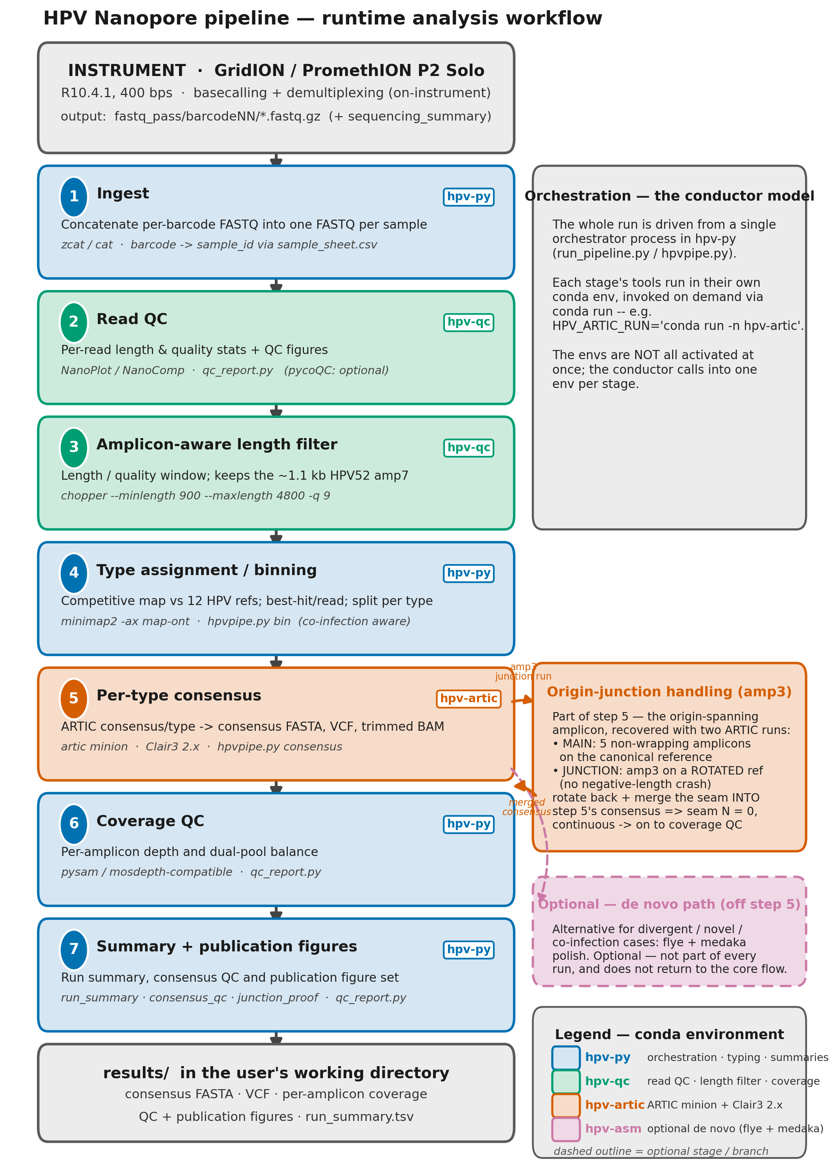
Runtime analysis workflow. End-to-end data flow from instrument output to results/, with the seven implemented stages (numbered), the one-line action, tool(s) and conda environment for each. The pipeline is orchestrated from a single process in hpv-py; each stage’s tools are invoked in their own conda environment via conda run (the conductor model — e.g. HPV_ARTIC_RUN='conda run -n hpv-artic'), never all activated at once. Stage 5 shows the two-run origin-junction handling (main run on the canonical reference + a rotated-reference run for the wrapping amplicon, merged back to an origin-continuous consensus). The optional de novo branch (hpv-asm) and optional pycoQC step are shown with dashed outlines. Colour encodes the conda environment (legend) and is colour-blind-safe / greyscale-legible.
The same graph is implemented three ways with identical stages: run_pipeline.py (single-driver, recommended), Snakefile (Snakemake), and main.nf (Nextflow). The core stage logic lives in pipeline/hpvpipe.py.

4 The six conda environments
All six are named envs in the shared cluster conda and activate cluster-wide:
conda activate hpv-qc # exactly like: conda activate wgs_prokka
# or, equivalently:
hpv-activate qc
Version tables carry the actual installed builds. Each shows the spec floor (>= pin from server-setup/envs/<env>.yml) and the installed (live) build read from conda list on the cluster (full capture in hpv_env_versions.txt). The Python interpreter version is in each heading. Re-confirm on the node with conda list -n hpv-<name> or conda run -n hpv-<name> <tool> --version.

4.1 hpv-qc — read QC, filtering, coverage (Python 3.13.13)
Purpose: read-level QC, length/quality filtering, coverage, generic utilities. Use it for: read QC and the length filter, plus ad-hoc seqkit/samtools/mosdepth inspection.
Tool | Floor | Installed (live)
python | 3.10 | 3.13.13
nanoplot | 1.42 | 1.46.2
nanocomp | 1.23 | 1.25.6
pycoqc | 2.5 | 2.5.0.3
multiqc | 1.21 | 1.35
fastqc | 0.12 | 0.12.1
seqkit | 2.6 | 2.13.0
csvtk | 0.30 | 0.37.0
mosdepth | 0.3.8 | 0.3.14
bedtools | 2.31 | 2.31.1
samtools | 1.19 | 1.23.1
chopper | 0.7 | 0.13.0
htslib · tabix · pigz | — | 1.23.1 · 1.11 · 2.8
hpv-activate qc
NanoPlot --fastq fastq_pass/barcode01/*.fastq.gz -o qc/barcode01 --N50
pycoQC -f sequencing_summary_*.txt -o qc/pycoQC.html # needs the seq summary
seqkit stats -a fastq_pass/barcode01/*.fastq.gz

4.2 hpv-artic — ARTIC consensus + Clair3, CPU (Python 3.11.15)
Purpose: the core variant-calling / consensus environment — ARTIC fieldbioinformatics with Clair3 2.x (PyTorch models), CPU-only. Use it for: per-type consensus. The pipeline shells into this env via HPV_ARTIC_RUN="conda run -n hpv-artic".
Tool | Floor | Installed (live)
python | 3.9 | 3.11.15
artic (fieldbioinformatics) | 1.6 | 1.10.1 (engine of record)
clair3 | 2.0.1 | 2.0.1
pytorch-cpu (Clair3 backend) | — | 2.10.0 (cpu_generic — confirms CPU-only)
align_trim | 1.1.0 | 1.1.0
primalbedtools | 1.0.0 | 1.0.0
minimap2 | 2.26 | 2.31 (runtime 2.31-r1302)
samtools | 1.19 | 1.23.1
bcftools | 1.19 | 1.23.1
htslib | 1.19 | 1.23.1
seqtk · biopython · pyfaidx · tabix | — | 1.5 · 1.87 · 0.9.0.4 · 1.11
Also present: whatshap 2.8, longphase 2.0.2 (phasing), bwa 0.7.19, mafft 7.526, pysam 0.24.0.
The ARTIC minion.log.txt from the validation run confirms the live tool chain: minimap2 -a -x map-ont; align_trim --normalise 100 … --primer-match-threshold 35 --min-mapq 20; and run_clair3.sh … --platform=ont --model_path=…/r1041_e82_400bps_hac_g615.
hpv-activate artic
artic --version
# ARTIC offline scheme loading uses the local files directly (no manifest fetch):
artic minion --threads 16 \
--bed "$SCHEME_DIR/HPV16/V5/HPV16.primer.bed" \
--ref "$SCHEME_DIR/HPV16/V5/HPV16.reference.fasta" \
--model-dir "$MODELS_DIR" \
SAMPLE_X.HPV16 # the pipeline orchestrates this — see Origin-junction handling

4.3 hpv-asm — optional de novo path (Python 3.12.13)
Purpose: optional de novo assembly / polishing for divergent, novel, or hard co-infection cases. medaka here is the standalone polisher only — NOT the ARTIC variant caller (variant calling is Clair3 in hpv-artic).
Tool | Floor | Installed (live)
python | 3.9 | 3.12.13
flye | 2.9.3 | 2.9.6
medaka | 1.11 | 2.2.2
racon | 1.5 | 1.5.0
minimap2 | 2.26 | 2.31 (runtime 2.31-r1302)
samtools | 1.19 | 1.23.1
bcftools | — | 1.23.1
any2fasta | — | 0.8.1
pytorch-cpu (medaka backend) | — | 2.9.1 (cpu_mkl)
hpv-activate asm
flye --nano-hq typing/SAMPLE_X.HPV16.fastq.gz \
--out-dir asm/SAMPLE_X.HPV16 --threads 16
medaka_consensus -i typing/SAMPLE_X.HPV16.fastq.gz \
-d draft.fasta -o medaka_out -t 16

4.4 hpv-py — typing/binning, summaries, figures (Python 3.13.13)
Purpose: the Python analysis environment — type assignment (binning), summary tables, and publication QC figures. Use it for: ingest, binning, coverage QC, figures, and to drive the whole pipeline (run_pipeline.py / qc_report.py).
Tool | Floor | Installed (live)
python | 3.10 | 3.13.13
pysam | 0.22 | 0.24.0
biopython | 1.83 | 1.87
pandas | 2.1 | 3.0.3
numpy | 1.26 | 2.4.6
scipy | 1.11 | 1.17.1
pyfaidx | 0.7 | 0.9.0.4
scikit-bio | 0.5.9 | 0.7.3
matplotlib | 3.8 | 3.10.9
seaborn | 0.13 | 0.13.2
plotly | 5.20 | 6.8.0
python-kaleido | 0.2.1 | 1.3.0
minimap2 | 2.26 | 2.31 (runtime 2.31-r1302)
samtools | 1.19 | 1.23.1
mosdepth | 0.3.8 | 0.3.14
bedtools | 2.31 | 2.31.1
fonttools | — | 4.63.0
Also present: statsmodels 0.14.6.
hpv-activate py
hpv-run --help # == python "$HPV_PIPELINE/run_pipeline.py" --help
# hpv-run runs the orchestrator in THIS env (hpv-py) and calls other
# envs per-stage via conda run — see "Running a real analysis".
# regenerate figures from an existing results/ dir:
PYTHONPATH="$HPV_PIPELINE" \
python "$HPV_PIPELINE/qc_report.py" \
--results results --scheme-dir "$SCHEME_DIR"
# prove the figure module on synthetic demo data:
PYTHONPATH="$HPV_PIPELINE" \
python "$HPV_PIPELINE/qc_report.py" --demo --outdir /tmp/demo/figures

4.5 hpv-typing — optional k-mer / competitive read typing (Python 3.14.5)
Purpose: optional k-mer / competitive-mapping read typing against a custom 12-type HPV database, plus BLAST / Entrez utilities for ad-hoc lookup. Use it for: an independent typing cross-check (the primary binning runs in hpv-py).
Tool | Floor | Installed (live)
python | 3.10 | 3.14.5
minimap2 | 2.26 | 2.31 (runtime 2.31-r1302)
samtools | 1.19 | 1.23.1
pysam | 0.22 | 0.24.0
kraken2 | 2.1.3 | 2.17.1
seqkit | 2.6 | 2.13.0
blast | — | 2.17.0
entrez-direct | — | 24.0
hpv-activate typing
minimap2 -x map-ont -a "$REF_DIR/hpv_all_types.fasta" reads.fastq.gz \
| samtools sort -o aln.bam
# kraken2 needs a custom 12-type HPV DB built separately by an admin

4.6 hpv-smk — Snakemake workflow manager (Python 3.13.13)
Purpose: the Snakemake workflow engine (alternative to the Nextflow binary on PATH).
Tool | Floor | Installed (live)
python | 3.10 | 3.13.13
snakemake-minimal | 8.10 | 9.22.0
pandas | 2.1 | 3.0.3
The installed Snakemake is the 9.x series (floor was 8.10). The example commands use options stable across 8/9.

5 The analysis pipeline in detail
Each stage lists what it does, the env/tool, inputs/outputs, and key parameters. Defaults are read from run_pipeline.py / hpvpipe.py.

5.1 Stage 1 — Ingest
- Env/tool: hpv-py (pure Python / gzip).
- In: fastq_pass/<barcode>/*.fastq{,.gz} per the sample sheet. Out: results/reads/<sample>.fastq.gz (one concatenated FASTQ per sample).
- Maps each barcodeNN to its sample_id from sample_sheet.csv.

5.2 Stage 2 — Read QC
- Env/tool: hpv-qc (NanoPlot/pycoQC); the driver also writes per-read length tables.
- In: per-sample reads (+ optional sequencing_summary_*.txt). Out: results/qc/read_stats.tsv, results/qc/lengths/<sample>.lengths.tsv, and a pycoQC run report only if the sequencing_summary was uploaded.

5.3 Stage 3 — Amplicon-aware length filter
- Env/tool: hpv-qc (chopper if present; else a built-in AWK/Python filter).
- In: per-sample reads. Out: results/filtered/<sample>.filt.fastq.gz.
- Key parameters: --min-len 900 (default), --max-len 4800 (default), quality -q 9.
Caveat — the length window must keep HPV52 amp7. The HPV52 L1 gap-fill amplicon (amp7, ~1117 bp) is shorter than the 2–4 kb tiling amplicons. The minimum length must stay ≥ ~900 bp or this amplicon is filtered out and HPV52 loses L1 coverage.

5.4 Stage 4 — Type assignment (binning)
- Env/tool: hpv-py — competitive minimap2 mapping (hpvpipe.py bin).
- In: filtered reads + references/hpv_all_types.fasta. Out: results/typing/<sample>.types.tsv, per-type results/typing/<sample>.<TYPE>.fastq.gz, and results/typing/type_counts.tsv.
- Key parameters: --min-reads 20 (default; a type must reach this read count to be “present”), --min-ident 0.80 (default minimum identity for read assignment), --threads.
- Co-infection handling: each read is assigned to its best-scoring type; a sample can yield multiple present types (e.g. the validated HPV16/HPV58 co-infection). Every present type is carried independently through consensus.

5.5 Stage 5 — Per-type consensus (ARTIC + Clair3, with junction handling)
- Env/tool: hpv-artic (ARTIC minion -> align_trim -> Clair3), orchestrated by hpvpipe.py consensus; the portable pysam pileup engine is an explicit opt-in fallback.
- In: per-type reads + per-type scheme (primer.bed, reference.fasta) + Clair3 models. Out: results/consensus/<sample>.<TYPE>.consensus.fasta, VCFs, per-amplicon depth tables, …consensus_qc.tsv, …junction_proof.tsv.
- Key parameters: --use-artic (real ARTIC+Clair3 path), --require-artic (strict: abort on any failure), --allow-fallback (opt in to the portable engine), --mindepth 3 (default; positions below become N), --model/--model-dir (Clair3 model — see Clair3 model selection). ARTIC internally runs align_trim --normalise 100 --primer-match-threshold 35 --min-mapq 20.
- The dual-pool design (Pool 1 / Pool 2 alternating amplicons) is honoured by ARTIC’s read-group handling; the origin-junction two-run mechanism is detailed in the next section.

5.6 Stages 6–7 — Coverage QC, summary & figures
- Env/tool: hpv-py (qc_report.py, mosdepth-style per-base/amplicon coverage).
- Out: results/coverage/*, results/run_summary.tsv, results/consensus/consensus_qc.tsv, and results/figures/ (every figure as SVG + PDF + 300-dpi PNG, colour-blind-safe, embedded fonts). See Interpreting outputs.

6 Origin-junction handling
This is the system’s most distinctive feature.

6.1 Why there is a seam
HPV genomes are circular, but reference FASTAs and ARTIC are linear. To tile the whole genome the scheme must place one amplicon that spans the origin (position 0) — this is amp3 in every type (scheme_summary.tsv: junction_amplicon = 3, junction_wraps_origin = YES for all 12 types). On a linear reference, that amplicon’s right primer coordinate is smaller than its left (it wraps past the end back to the start). For HPV16, rotation.json records amp3 as canonical LEFT = [6722, 6744], RIGHT = [874, 896] on a genome of length L = 7906 — i.e. it runs from ~6722 across the origin to ~896.
ARTIC’s align_trim computes each amplicon’s length as right_end − left_start. For a wrapping amplicon that is negative, and align_trim then attempts np.zeros(length) — historically this crashed with “ValueError: negative dimensions are not allowed.” The seam must therefore be handled explicitly, or amp3 (and the region across the origin) is lost.

6.2 Why a single rotated frame is not enough
The intuitive fix — rotate the reference so the origin moves to the middle and amp3 becomes contiguous — works for amp3, but it just moves the wrap to whichever amplicon now spans the new origin. A single rotated frame always leaves some amplicon wrapping. There is no single linear frame in which all six amplicons of a circular tiling scheme are simultaneously non-wrapping.

6.3 The implemented two-run solution
The pipeline runs ARTIC twice, each on a frame where every amplicon it sees is positive-length, then merges:
- Main run — canonical reference, amp3 removed. ARTIC is given a primer BED with the junction amplicon excluded (<sample>.<TYPE>.no_amp3.primer.bed), so align_trim only ever sees the 5 non-wrapping amplicons. These are mapped, primer-trimmed, and called by Clair3 normally. The origin seam is left as N in this consensus.
- Junction run — rotated reference, amp3 only. A per-type rotated reference is built (rotate-build): the origin is shifted by an offset (~L/2) so amp3 becomes one contiguous, positive-length amplicon. For HPV16, rotation.json shows amp3 rotated to LEFT = [2769, 2791], RIGHT = [4827, 4849] (offset 3953) — clearly positive. ARTIC + Clair3 call amp3 on this frame.
- Rotate back & merge. The amp3 consensus is mapped back to canonical coordinates (pos_canon = (pos_rot + offset) mod L) and used to fill only the seam positions still N in the main consensus. Length is unchanged; no double-counting.
Both runs go through the real align_trim + Clair3, and neither run ever passes a negative-length amplicon to align_trim. The validation-run logs show exactly this: the main run calls align_trim … <sample>.no_amp3.primer.bed, and the junction run (*.artic.rotj) calls align_trim … HPV16.rot.primer.bed on HPV16.rot.reference.fasta.

6.4 Evidence it recovers the seam (junction_proof.tsv)
The per-(sample×type) junction_proof.tsv records the merge. From the validation run:
metric | HPV16 (SAMPLE_COINF) | HPV58 (SAMPLE_COINF)
junction_amplicon | amp3 | amp3
junction_engine | artic+clair3 | artic+clair3
rotation_offset | 3953 | 3912
seam_region_bp | 2036 | 2208
canonical_only_seam_N | 448 | 588
merged_seam_N | 0 | 0
seam_bases_filled_from_rotated | 448 | 588
seam_identity_to_reference_pct | 100.0 | 100.0
continuous_across_origin | YES | YES
length_unchanged | YES | YES
The canonical-only consensus would have left 448 (HPV16) / 588 (HPV58) N bases across the origin; after the rotated amp3 run and merge, merged seam N = 0 at 100 % identity to reference, continuous across the origin, length unchanged.

7 Clair3 model selection

7.1 Installed models
$MODELS_DIR (= /hpc/opt/hpv-bioinfo/clair3_models/) holds the full R10.4.1 400 bps Clair3 2.x set — fast / hac / sup — because the lab runs both a GridION and a PromethION P2 Solo and the Dorado preset can differ per run. The hac build used in validation is r1041_e82_400bps_hac_g615; all three tiers are installed (the setup step fails loudly if any of fast/hac/sup is missing). List them on the node with ls "$MODELS_DIR".
Clair3 runs on CPU. In hpv-artic, Clair3 2.0.1 is backed by pytorch-cpu 2.10.0 (cpu_generic) — no CUDA/GPU build is installed. Inference uses the PyTorch (.pt) models under $MODELS_DIR.

7.2 Auto-selection and override
- Auto: the pipeline reads the FASTQ header basecall_model_version_id and selects the matching installed model by chemistry/speed/tier; it warns and uses the nearest installed model if an exact match is absent.
- Override: force a model explicitly with --model <name> --model-dir "$MODELS_DIR".
# inspect what model selection would pick for a given FASTQ:
python "$HPV_PIPELINE/hpvpipe.py" model-select \
--reads results/typing/SAMPLE_X.HPV16.fastq.gz \
--models-dir "$MODELS_DIR"
# GridION header …_400bps_hac@v5.2.0 -> selects r1041_e82_400bps_hac_*
# P2-Solo header …_400bps_sup@v5.0.0 -> selects r1041_e82_400bps_sup_*
# force a tier if needed (passed through to hpvpipe consensus):
# --model r1041_e82_400bps_sup_g615 --model-dir "$MODELS_DIR"

8 Running a real analysis
How hpv-run uses the six environments — it does not activate them all. hpv-run launches the orchestrator (run_pipeline.py) inside one environment, hpv-py, via conda run -n hpv-py. You never manually activate anything. The pipeline’s own logic (ingest, binning, coverage QC, figures) is Python and runs in hpv-py. A stage that needs a different environment is invoked as a subprocess via conda run -n <env> — it is never activated in your shell. Specifically, the consensus stage calls hpv-artic through HPV_ARTIC_RUN="conda run -n hpv-artic …" to run artic minion + Clair3. Think of hpv-py as the conductor: it calls another env per-stage for its specific tools and then exits it, so only hpv-py is ever active in the session. The six envs are deliberately isolated (their tool/dependency versions would conflict if merged), so per-stage conda run is the correct way to compose them — not simultaneous activation.
Which environment runs what (default run_pipeline.py path):
Stage(s) | Environment | How it is invoked
Orchestration, ingest, binning, coverage QC, figures (and the portable consensus engine when --use-artic is off) | hpv-py | the home env (conda run -n hpv-py) — what hpv-run starts
Consensus: artic minion + Clair3 (with --use-artic) | hpv-artic | subprocess via HPV_ARTIC_RUN="conda run -n hpv-artic …"
(The optional read-QC tools in hpv-qc and the optional de novo path in hpv-asm are called the same way — conda run -n <env> — when you use them, but they are not part of the default automated run_pipeline.py run.) The Explicit equivalent block below (conda activate hpv-py; python "$HPV_PIPELINE/run_pipeline.py" …) is what hpv-run does internally — hpv-py is the home env.

8.1 Running as any user (zero setup)
The pipeline is deployed on the shared pool and the login profile auto-loads the environment silently at login. So a brand-new non-admin user, on any node, just logs in and runs — no source, no GitHub clone, no server-setup, nothing in $HOME. After login, SCHEME_DIR, REF_DIR, MODELS_DIR, HPV_PIPELINE and HPV_ARTIC_RUN are already set and hpv-run is already on PATH.
# log in, then go to your own working directory (outputs land here, never in /hpc/opt):
cd ~/my_run_2026-06
# simplest: one command, real ARTIC + Clair3 path (strict)
hpv-run \
--fastq-pass fastq_pass \
--samplesheet sample_sheet.csv \
--scheme-dir "$SCHEME_DIR" \
--ref "$REF_DIR/hpv_all_types.fasta" \
--models-dir "$MODELS_DIR" \
--outdir results \
--use-artic --require-artic
hpv-run runs run_pipeline.py inside the hpv-py env via conda run (no manual activation), and sets HPV_ARTIC_RUN so --use-artic reaches hpv-artic (see the call-out at the top of this chapter on how the environments are composed). Explicit equivalent — this is exactly what hpv-run does internally:
conda activate hpv-py
python "$HPV_PIPELINE/run_pipeline.py" \
--fastq-pass fastq_pass \
--samplesheet sample_sheet.csv \
--scheme-dir "$SCHEME_DIR" \
--ref "$REF_DIR/hpv_all_types.fasta" \
--models-dir "$MODELS_DIR" \
--outdir results \
--threads 16 \
--use-artic --require-artic
Flag notes: --use-artic turns on the ARTIC minion + Clair3 path; --require-artic is strict (aborts non-zero on any failure — use it for any reportable result); replace it with --allow-fallback to permit the portable engine for quick triage; length/typing thresholds are tunable (--min-len 900 --max-len 4800 --min-reads 20).
Threading on the 72-core node: Clair3 is the bottleneck. Prefer moderate threads per job × several jobs in parallel over maxing one job. A good default is --threads 16 with multiple samples concurrent via Snakemake/Nextflow; keep total cores and RAM within budget.

8.2 Distribution model (source vs deployed)
- GitHub repo — source of truth / version control (developers only).
- /hpc/opt/hpv-bioinfo/pipeline ($HPV_PIPELINE) — the deployed copy everyone runs, via hpv-run or $HPV_PIPELINE/....
- Updating = an admin pulls new code and re-runs the deploy step of setup_hpv_nanopore_env.sh, which refreshes $HPV_PIPELINE in place. Ordinary users never touch server-setup or GitHub to run the pipeline, and have nothing to update on their side.

8.3 Before you start — copy these off the instrument
- The demultiplexed fastq_pass/ folder (barcodeNN/ subfolders of *.fastq.gz).
- sequencing_summary_*.txt — needed for the pycoQC run-health plots (channel activity, yield-over-time, pore occupancy). Without it those panels are skipped (read-derived QC still works).
- Keep both Pool 1 and Pool 2 reads — the pool-balance figure needs both.
Input layout the pipeline expects:
fastq_pass/
barcode01/*.fastq.gz
barcode02/*.fastq.gz
sequencing_summary_*.txt # optional, enables pycoQC
sample_sheet.csv

8.4 The sample sheet
sample_sheet.csv — header barcode,sample_id,expected_types,notes:
barcode,sample_id,expected_types,notes
barcode01,SAMPLE_001,,
barcode02,SAMPLE_002,HPV16;HPV58,suspected co-infection
barcode = the MinKNOW barcodeNN folder; expected_types is optional and ;-separated.

8.5 Equivalent: Snakemake
conda activate hpv-py
snakemake -s "$HPV_PIPELINE/Snakefile" -j4 \
--config scheme_dir="$SCHEME_DIR" \
ref="$REF_DIR/hpv_all_types.fasta" \
models_dir="$MODELS_DIR" \
fastq_pass=fastq_pass \
samplesheet=sample_sheet.csv \
use_artic=true threads=16

8.6 Equivalent: Nextflow
nextflow run "$HPV_PIPELINE/main.nf" \
--fastq_pass fastq_pass \
--samplesheet sample_sheet.csv \
--scheme_dir "$SCHEME_DIR" \
--ref "$REF_DIR/hpv_all_types.fasta" \
--models_dir "$MODELS_DIR" \
--outdir results --use_artic
# tune CPU/RAM per process in nextflow.config

8.7 SLURM / scheduler batch jobs
/etc/profile.d/hpv-bioinfo.sh auto-loads for interactive login shells, but batch / non-login jobs do not read /etc/profile.d. A job script must load the environment explicitly at the top:
#!/bin/bash
#SBATCH --job-name=hpv --cpus-per-task=16 --mem=32G
source /etc/profile.d/hpv-bioinfo.sh # or: source /hpc/opt/hpv-bioinfo/etc/hpv-bioinfo.env
cd "$SLURM_SUBMIT_DIR"
hpv-run \
--fastq-pass fastq_pass \
--samplesheet sample_sheet.csv \
--scheme-dir "$SCHEME_DIR" \
--ref "$REF_DIR/hpv_all_types.fasta" \
--models-dir "$MODELS_DIR" \
--outdir results \
--threads "$SLURM_CPUS_PER_TASK" \
--use-artic --require-artic

8.8 Where outputs land
Everything is written under your --outdir (default ./results) in your own working directory — never to /hpc/opt:
results/
reads/<sample>.fastq.gz # ingested per-sample reads
qc/read_stats.tsv, qc/lengths/ # read QC
filtered/<sample>.filt.fastq.gz # length-filtered reads
typing/<sample>.types.tsv # type calls (+ per-type FASTQ)
consensus/<sample>.<TYPE>.consensus.fasta # per-type whole-genome consensus
consensus/<sample>.<TYPE>.*.vcf(.gz) # Clair3 variant calls
consensus/<sample>.<TYPE>.consensus_qc.tsv # per-type QC row
consensus/<sample>.<TYPE>.junction_proof.tsv # seam recovery proof
consensus/consensus_qc.tsv # aggregated QC
coverage/ # per-amplicon / per-base depth
figures/ # SVG + PDF + 300-dpi PNG
run_summary.tsv # sample -> types present

9 Interpreting outputs

9.1 run_summary.tsv
One row per sample: sample_id and the ;-separated types_present. From the validation run:
sample_id types_present
SAMPLE_HPV16 HPV16
SAMPLE_HPV58 HPV58
SAMPLE_COINF HPV16;HPV58

9.2 consensus_qc.tsv
One row per (sample × type):
column | meaning
sample_id, type | the sample and HPV type
pct_genome | % of the reference reconstructed (non-N)
pct_N | % of the consensus that is N
engine | caller path used (artic+clair3 or portable)
model | Clair3 model (e.g. r1041_e82_400bps_hac_g615)
seam_N | N bases across the origin after the junction merge
junction_engine | engine used for the amp3 junction run
junction_bases_filled | seam bases recovered from the rotated amp3 run

9.3 Consensus FASTAs / VCFs
- …consensus.fasta — the per-type whole-genome consensus (origin-continuous after merge).
- …pass.vcf / …merged.vcf.gz — Clair3 variant calls (per ARTIC read-group, then merged).

9.4 The QC figures (results/figures/)
Each is emitted as SVG + PDF + 300-dpi PNG:
- 03_amplicon_heatmap_<TYPE> — per-amplicon coverage heatmap (sample × amplicon, log-depth); the single most useful view (dropout shows as a cold cell).
- 04_depth_<sample>_<TYPE> — per-base depth track (even tiling, seam continuity).
- 01_read_counts_yield — reads/yield per sample.
- 02_length_quality — length × quality (confirm the ~1.1 kb HPV52 amp survives).
- 06_type_assignment — binning per sample (co-infections show as multiple bars).
- 07_consensus_completeness — % genome / % N per sample×type.
- Pool-balance panel — Pool 1 vs Pool 2 representation (needs both pools).
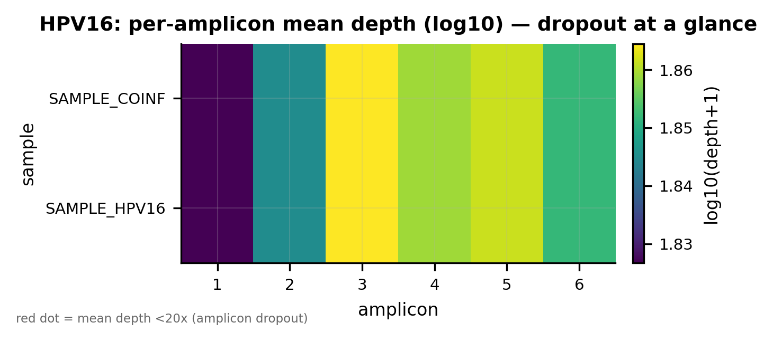
Per-amplicon coverage heatmap (HPV16) — log-depth per amplicon; cold cells = dropout.
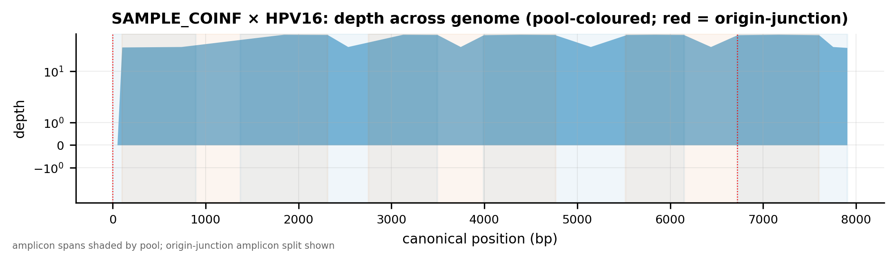
Per-base depth track, SAMPLE_COINF / HPV16 — even tiling and origin continuity.
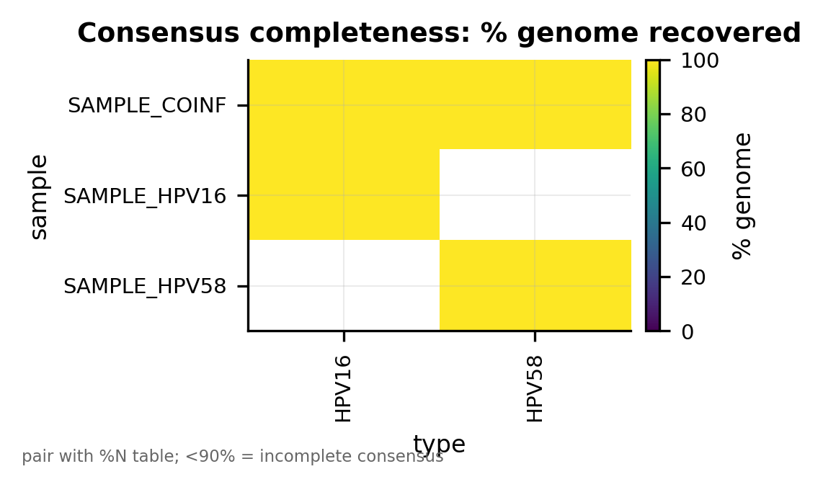
Consensus completeness — % genome reconstructed and % N per sample×type.
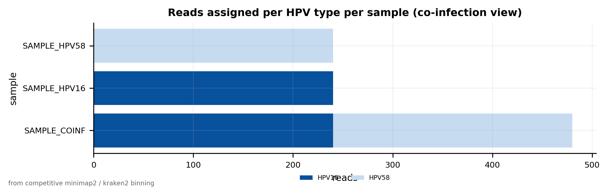
Type assignment — reads binned per HPV type; co-infection shows two types in one sample.

9.5 Design caveats analysts must expect
- HPV52 amp7 over-representation. The short ~1.1 kb L1 gap-fill amplicon over-amplifies in multiplex, so HPV52 depth is skewed toward amp7. Expected; the wet-lab mitigation is to reduce HPV52_7 primer concentration or post-PCR normalise.
- HPV35 amp4 lower depth on divergent isolates. HPV35 amp4 has a documented, African-justified inclusivity exception (panel inclusivity 75 % from USA/divergent isolates; African inclusivity 100 %). Expect lower amp4 depth on non-African divergent isolates — not a pipeline fault.

10 Validation record
Two independent software validations were performed. Both are software validations; biological validation on control material is the next, separate, wet-lab step.

10.1 (1) End-to-end on the real ARTIC + Clair3 path
A built-in synthetic dataset of three samples — SAMPLE_HPV16, SAMPLE_HPV58, and SAMPLE_COINF (a deliberate HPV16 + HPV58 co-infection) — was run end to end through the real ARTIC + Clair3 path (--use-artic --require-artic) on the cluster (16 threads). From the actual consensus_qc.tsv:
sample_id | type | pct_genome | pct_N | engine | model | seam_N | junction_engine | filled
SAMPLE_HPV16 | HPV16 | 100.0 | 0.0 | artic+clair3 | r1041_e82_400bps_hac_g615 | 0 | artic+clair3 | 448
SAMPLE_HPV58 | HPV58 | 100.0 | 0.0 | artic+clair3 | r1041_e82_400bps_hac_g615 | 0 | artic+clair3 | 588
SAMPLE_COINF | HPV16 | 100.0 | 0.0 | artic+clair3 | r1041_e82_400bps_hac_g615 | 0 | artic+clair3 | 448
SAMPLE_COINF | HPV58 | 100.0 | 0.0 | artic+clair3 | r1041_e82_400bps_hac_g615 | 0 | artic+clair3 | 588
Columns: pct_genome / pct_N = % genome reconstructed / % N; seam_N = origin N after merge; junction_engine = caller for the amp3 run; filled = junction_bases_filled.
Evidence this is the real caller path (not the portable fallback): the ARTIC minion.log.txt shows align_trim --normalise 100 … --primer-match-threshold 35 --min-mapq 20 on the no_amp3 BED (main run) and the rotated BED (junction run), and run_clair3.sh … --platform=ont --model_path=…/r1041_e82_400bps_hac_g615 producing the per-amplicon VCFs.
Conclusions: all four sample×type combinations reconstruct 100 % of the genome, 0 % N; the origin seam is fully recovered (merged_seam_N = 0 at 100 % identity, via the real ARTIC+Clair3 two-run mechanism — see Origin-junction handling); and the co-infection is correctly resolved (SAMPLE_COINF -> HPV16;HPV58, both reconstructed completely).

10.2 (2) All-users deployment verified under a non-admin account
verify_env.sh was run by a genuine non-admin user on a node: 53 passed, 0 failed. It confirmed:
- Named-env activation — all six hpv-* envs resolve and activate by name (conda activate hpv-<name>), with clean tool-version rows.
- Deployed pipeline end-to-end — simulate_test_data.py + run_pipeline.py from $HPV_PIPELINE ran to completion, producing run_summary.tsv, the co-infection split, figures, and a valid sorted+indexed BAM (samtools quickcheck on a real *.canonical.bam).
- No writes to the shared install — the non-admin user could not write /hpc/opt/hpv-bioinfo, the shared conda, or $HPV_PIPELINE; all outputs landed in the user’s own workdir/HOME.
- Silent profile auto-load — /etc/profile.d/hpv-bioinfo.sh sources with zero output, sets HPV_PIPELINE and puts hpv-run on PATH, runs no conda init, and does not duplicate PATH on re-source.
- Clair3 2.x models — fast/hac/sup present, readable, PyTorch (2.x) format.

11 Troubleshooting & FAQ
CommandNotFoundError: … hpv-artic / env not found. Run conda env list — you should see hpv-qc … hpv-smk next to wgs_*. If missing, the shared install isn’t on this node’s conda; contact an admin. Never create the envs yourself.
hpv-run: command not found. Normally hpv-run is on PATH automatically at login. If you are in a non-login/batch shell, source /etc/profile.d/hpv-bioinfo.sh first. Confirm with echo "$HPV_PIPELINE" (-> /hpc/opt/hpv-bioinfo/pipeline) and command -v hpv-run. You never need a home-directory copy; if $HPV_PIPELINE is missing entirely, the admin has not run the deploy step.
Clair3 “model not found”. ls "$MODELS_DIR" to see the installed r1041_e82_400bps_{fast,hac,sup}_* builds. Pass an explicit --model <name> --model-dir "$MODELS_DIR". Confirm the FASTQ basecall_model_version_id matches an installed tier.
align_trim: “negative dimensions are not allowed” (historical — fixed). This was the origin-junction amplicon (amp3) wrapping position 0 -> negative length. It is resolved by the two-run design (see Origin-junction handling). If you see it again, you are pointing ARTIC at a raw canonical BED that still contains amp3 — use the pipeline’s consensus stage, which builds the no_amp3 and rotated BEDs for you.
Low amplicon depth. Check the 03_amplicon_heatmap figure. Expected design hotspots: HPV52 amp7 (high) and HPV35 amp4 on divergent non-African isolates (low) — see Design caveats. Otherwise suspect input depth or a pool imbalance (confirm both pools were included).
Co-infection: only one type expected but two reported. The binner is co-infection-aware by design. Check typing/<sample>.types.tsv read counts; raise --min-reads if a low-count second type is index-hopping noise rather than a true co-infection.
A sample×type failed and the run aborted. That is --require-artic doing its job (strict, no silent fallback). Read results/consensus/<sample>.<TYPE>.artic.main/*.minion.log.txt. For quick triage you may re-run with --allow-fallback, but do not report fallback consensus as ARTIC+Clair3 results.
Where do logs/outputs go? Under your --outdir (default ./results); per-stage ARTIC logs in results/consensus/<sample>.<TYPE>.artic.{main,rotj}/. Nothing is written to /hpc/opt.
Who do I contact for admin changes? Anything touching /hpc/opt/hpv-bioinfo or the shared conda (new models, scheme updates, env rebuilds, pipeline updates) is admin-only — file a request with the bioinformatics core.

12 Appendix

12.1 Core runtime version strings
From each tool’s own --version banner on the cluster (complements the conda-package versions in the env tables): artic 1.10.1 · clair3 2.0.1 · minimap2 2.31-r1302 · samtools 1.23.1 · bcftools 1.23.1 · nextflow 26.04.3 · snakemake 9.22.0 · python 3.13.13.

12.2 Full conda list per env
The complete package list for all six envs (every dependency, version, build string, channel) is shipped beside this manual as hpv_env_versions.txt, captured live from the production cluster. Headline summary:
Env | Python | Headline installed versions
hpv-qc | 3.13.13 | nanoplot 1.46.2 · nanocomp 1.25.6 · pycoqc 2.5.0.3 · multiqc 1.35 · fastqc 0.12.1 · seqkit 2.13.0 · csvtk 0.37.0 · mosdepth 0.3.14 · bedtools 2.31.1 · samtools 1.23.1 · chopper 0.13.0
hpv-artic | 3.11.15 | artic 1.10.1 · clair3 2.0.1 · pytorch-cpu 2.10.0 · align_trim 1.1.0 · primalbedtools 1.0.0 · minimap2 2.31 · samtools/bcftools/htslib 1.23.1 · whatshap 2.8 · longphase 2.0.2
hpv-asm | 3.12.13 | flye 2.9.6 · medaka 2.2.2 · racon 1.5.0 · minimap2 2.31 · samtools 1.23.1 · pytorch-cpu 2.9.1 · any2fasta 0.8.1
hpv-py | 3.13.13 | pysam 0.24.0 · pandas 3.0.3 · numpy 2.4.6 · scipy 1.17.1 · scikit-bio 0.7.3 · matplotlib 3.10.9 · seaborn 0.13.2 · plotly 6.8.0 · kaleido 1.3.0 · minimap2 2.31 · mosdepth 0.3.14
hpv-typing | 3.14.5 | minimap2 2.31 · samtools 1.23.1 · kraken2 2.17.1 · seqkit 2.13.0 · blast 2.17.0 · entrez-direct 24.0
hpv-smk | 3.13.13 | snakemake-minimal 9.22.0 · pandas 3.0.3
bin/ | — | nextflow 26.04.3 (runtime) + the hpv-run launcher
Regenerate the capture on the node:
for e in hpv-qc hpv-artic hpv-asm hpv-py hpv-typing hpv-smk; do
echo "=== $e ==="; conda list -n "$e"
done > hpv_env_versions.txt
The exact resolved builds are also exported at install time to /hpc/opt/hpv-bioinfo/envs_locks/<env>.lock.yml (build strings in .fullbuild.lock.yml).

12.3 The all-users permissions model
- Shared install INSTALL_ROOT=/hpc/opt/hpv-bioinfo owned root:bioinfo, dirs 2775 (setgid), files world-readable — read/execute for all users on any node.
- Named hpv-* envs in /hpc/opt/conda/envs (created like the lab’s wgs_* envs).
- No analysis step writes to the shared install. Run-time output/cache/work/temp go to the user’s CWD/HOME (NXF_HOME, APPTAINER_CACHEDIR, CONDA_PKGS_DIRS -> $HOME). Clair3 models are read-only, passed by --model-dir.
- Only admins modify the shared install; setup_hpv_nanopore_env.sh is idempotent and name-scoped (only ever creates/rebuilds hpv-*, never base/wgs_*).

12.4 Design provenance
- Scheme version v5, 12 high-risk types, 6 amplicons each, dual-pool (Pool 1 / Pool 2), one origin-spanning junction amplicon (amp3) per type. Per-type clade, canonical accession, genome length, junction amplicon and degenerate-primer counts are in scheme_summary.tsv (e.g. HPV16/Alpha9/K02718/7906 bp; HPV58/Alpha9/D90400/7824 bp).
- Documented design exceptions: HPV35 amp4 African-justified inclusivity exception; HPV52 amp7 ~1.1 kb L1 gap-fill over-amplification (softsite_exceptions.md, wetlab_balancing_notes.md).
- Full design methods & phylogeny: see the project METHODS_REPORT / FINAL_REPORT_v1-v5.

12.5 How to report issues
Include: the exact command, the relevant results/consensus/<sample>.<TYPE>.artic.*/…minion.log.txt, the consensus_qc.tsv / junction_proof.tsv rows, and conda list -n hpv-artic. Send to the bioinformatics core. For shared-install changes (models, schemes, envs, pipeline updates), file an admin request — do not modify /hpc/opt yourself.
End of document. Manual v1.1 · 2026-06-06 · generated from the live conda list (hpv_env_versions.txt), the real ARTIC+Clair3 synthetic validation run, and the non-admin verify_env.sh result (53 passed, 0 failed).

