Title: Sentimental Analysis on President TRUMP.

First Name | Last Name | Online Students? (Y or N) | Monday or | Shared with ITMD 525? (Y or N)
 |  |  | Tuesday
Abhishek | Dutta | N | Tuesday | N

Table of Contents

1. Introduction and Motivations 3

2. Data Description 4

3. Research Problems and Solutions 5

4. KDD 6

4.1. Data Processing 6

4.2. Data Mining Tasks and Processes 7

5. Evaluations and Results 9

5.1. Evaluation Methods 9

5.2. Results and Findings 11

6. Conclusions and Future Work 11

6.1. Conclusions 14

6.2. Limitations 14

6.3. Potential Improvements or Future Work 14
1. Introduction and Motivations

Twitter is a beautiful and most used platform for spontaneous and raw emotional expression. Unlike the other social media platforms Twitter is a user friendly and simple platform which attracts many users (including celebrities) to post their opinions which may have a global impact as it has a wide audience and user-base. Therefore, pulling data from such a tremendous source is a good base for any analysis.

Therefore, we have taken up the task to perform a Sentimental Analysis on such a personality who happens to be the President of one of the most influential country, the United States of America. The main reason behind taking up this topic is that Mr. Trump being the president of America holds a very crucial position and after 2016 election, people around the world have started following news related to him very closely and started sharing their views on him frequently. People from various parts of the world have opinions and views on each decision that he makes or bill that his team proposes. Therefore, it gives us a fantastic opportunity to analyze what people think about him and about the decision that he makes. Based on the tweets, we are planning to extract the sentiments of the people related to president Trump.

Sentiment analysis is the detection of attitudes or emotions conveyed in a body of text. It is a subset of a larger field of study called Natural Language Processing (NLP). Examples: Movie reviews: Is this review positive or negative? How many stars?

Twitter sentimental analysis is the process to determine emotional tone behind a series of words used to gain understanding of attitudes, emotions and opinions.

Why Sentimental Analysis? Shifts in sentiments of the social media has shown correlation with the shift in trend of the stock market. Example: Obama administration team applied and used sentimental analysis to grasp the public opinion and accordingly made some policy announcements and campaign topics just ahead of the 2012 elections.
2. Data Description

We are planning to extract data from Twitter using #President Trump. For this we would have a data set of 5000 entries out of which 80 % would be falling under training and 20% test. We have download the tweets from twitter by setting up and API on http://apps.twitter.combased on few keys like Customer key, Customer Token, Access token and Secret Token key.
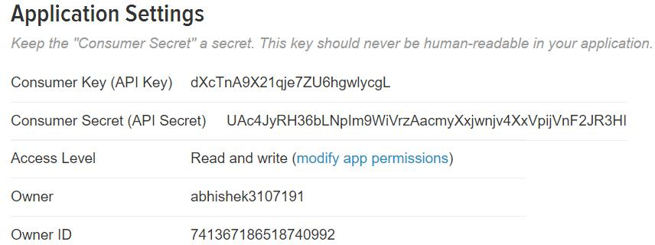

R commands to fetch data based on the unique keys generated.
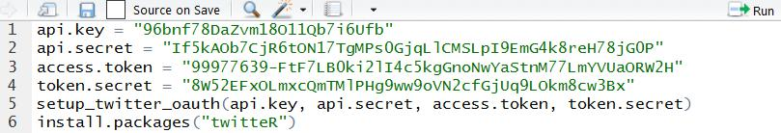
3. Research Problems and Solutions

With the data that we have extracted from twitter we will perform a sentimental analysis. After cleaning the data (tweets) i.e. by removing all the unwanted words and keeping list of positive and negative words present to calculate the sentiment score and based on that we will proceed with our analysis to determine that what are the sentiments of the people about Trump i.e. are there more positive or more negative things being said about him.

We will calculate the score and based on the score being positive, negative we will define labels to it as positive /negative/neutral. Neutral label is assigned when the sentiment score is either 0 or both positive and negative are equal.

Below mentioned are the steps they we have followed to achieve the solution that we are looking for.

Based on our analysis and sentiment score calculation we will find and analyze the following

things:

  - Top 5 Positive tweets abut TRUMP.

  - TOP 5 Negative tweets about TRUMP.

  - Mostly used words amongst the 5000 tweets dataset.

  - Has more number of people tweeted positive tweets or negative tweets for TRUMP over a span of time.

- Process Flow step by step:
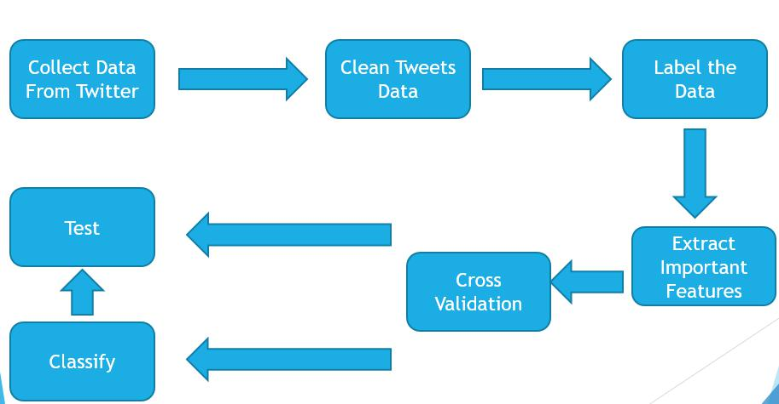
4. KDD

4.1. Data Processing

Data Cleaning

The 5000 tweets that we extracted from twitter had many words, characters and images that were not required for our sentimental analysis. For example, a link will not help us find a positive or negative sentiment or calculate a sentiment. Also, there are many words in a tweet that don’t have a positive or negative meaning and hence are of no use to us and therefore we remove them using Corpus function available in R BY STEMMING and stopping them.
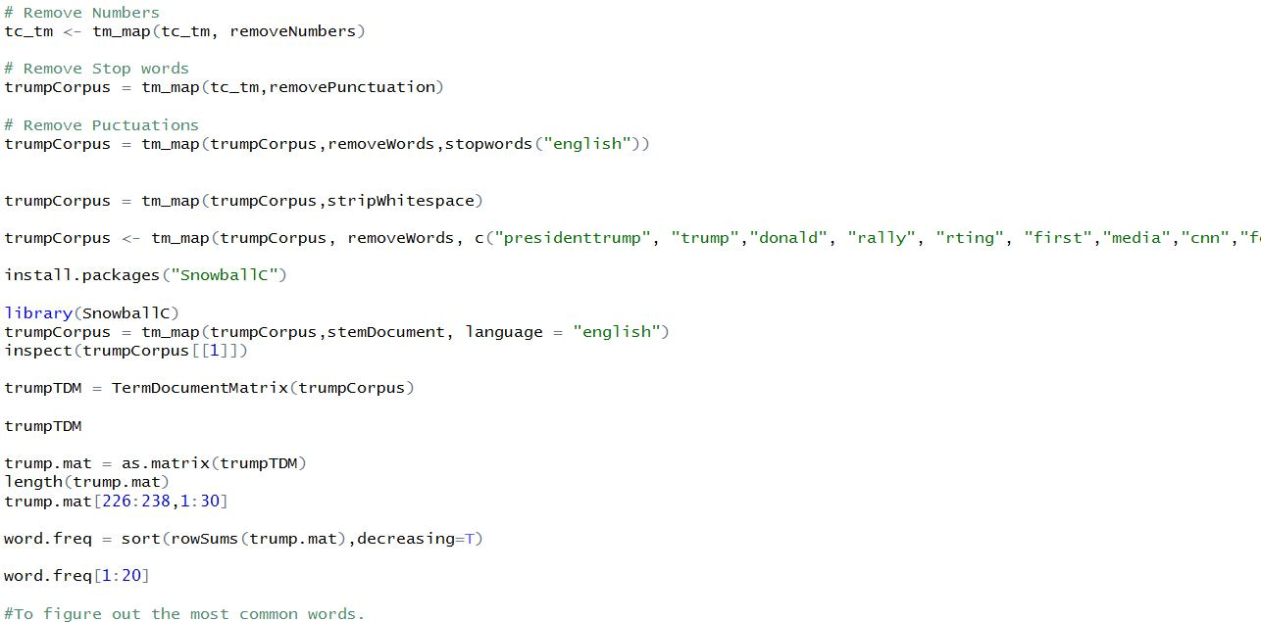

To remove links (http://, https://), emoticons, punctuations and non-other important words and expressions or numbers we have used GSUB function available in R.
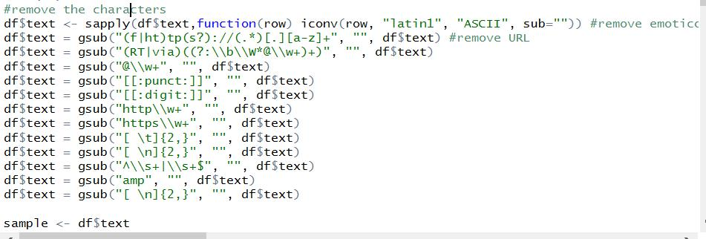

4.2. Data Mining Tasks and Processes

- Search through the words in the body of text and find POSITIVE (+1) and NEGATIVE (-1) words. Many/most of the words in the text will not receive a score or be scored as zero. The sentiment score could simply be the sum of the scored words.

- For Positive /Negative words calculation we have used the below mentioned link https://www.cs.uic.edu/~liub/FBS/sentiment-analysis.html#lexicon

- But we also understand that in social media there are many people who use urban-lingo i.e. words like gr8, Awsum, Kewl and even they fall under a specific positive or negative category and can influence our sentimental analysis therefore we have also considered and added a few such mostly used words in our R-code. But again, since words are endless therefore it totally depends what all to include and what basis.

Once we calculate the score therefore if the score of positive words is high then negative words then it would fall under POSITIVE LABEL. If the negative score is greater than Positive score then it would fall under NEGATIVE LABEL. If scores are 0 or both POSITIVE and NEGATIVE scores are equal then it would fall under the NEUTRAL LABEL.

Using function in R and the calculating the score we see that the Text gets the score i.e. positive /Negative corresponding to the Text
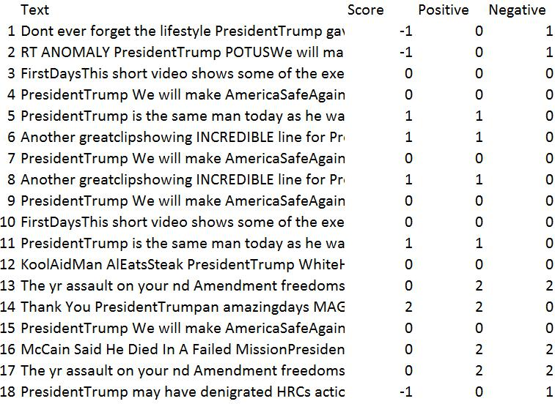

Data with the Labels Positive/Negative/Neutral based on the Score.Therefore, Labels are assigned to the tweets next to it. Here If the score it positive then positive label, if score is negative then negative label and if the score of positive and negative are equal or if the score =0 for both positive and negative then the score comes out to be Neutral.

As this is a classical classification problem we need to just determine whether we have the sentence as positive or negative in totality, we then need to use the Naïve BayesAlgorithm, Decision tree and Random Forest.Here the process will be: Classifier: Input: The Tweets which the user posts on twitter. Also, called as the “bag of words” are used as the features as we use the unique words as a feature. So, we would capture the frequency of thewords. Output: Prediction of the class/labels if the tweet is Positive/Negative/Neutral.
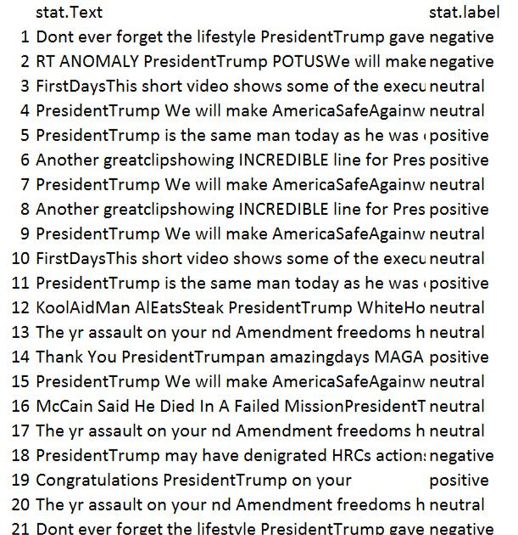
5. Evaluations and Results

5.1. Evaluation Methods

We have used Cross Validation as the Evaluation method for our model as our dataset is comparatively small and therefore we have proceeded with it and used classification techniques such as Naïve Bayes Classifier, J48 Decision Tree and Random Forest Classifier. Below are the attached screen-prints for the same.

- On using Naïve Bayes Classification, we find out that the Currently classified instances or the accuracy comes out to be 88.94% as seen in the figure.
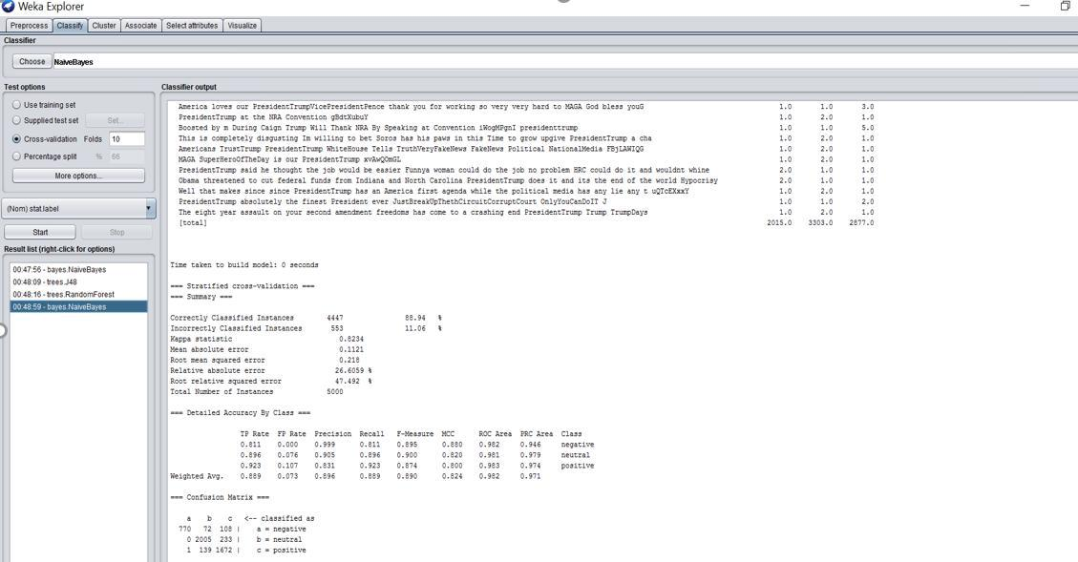
- J-48 Classifier Accuracy=89.7%
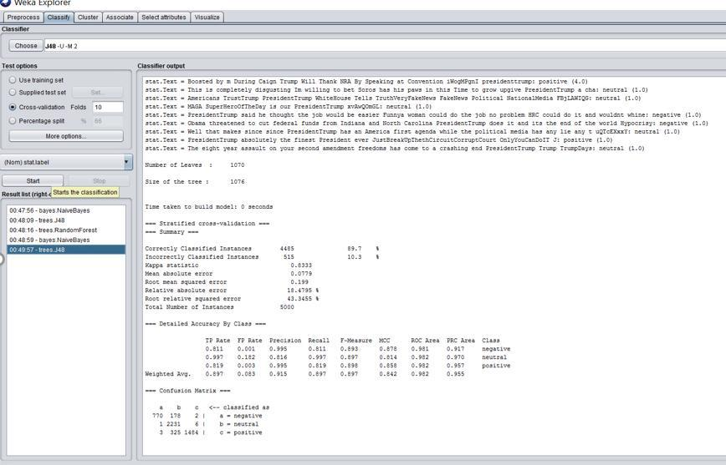

- Random Forest shows Accuracy=89.8%
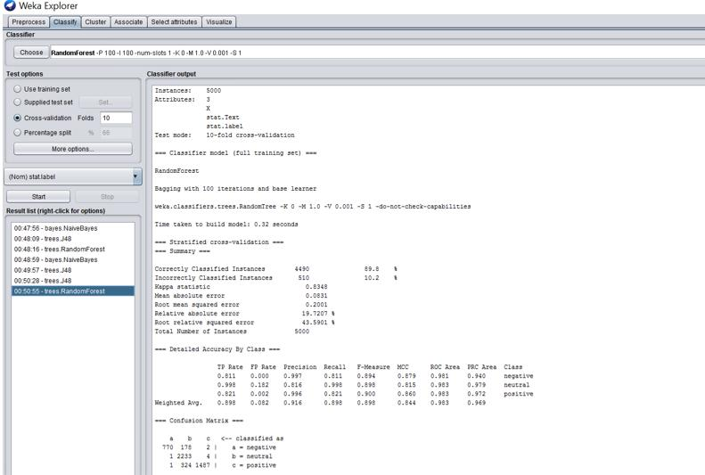
- Plot showing Accuracy of the classifiers.
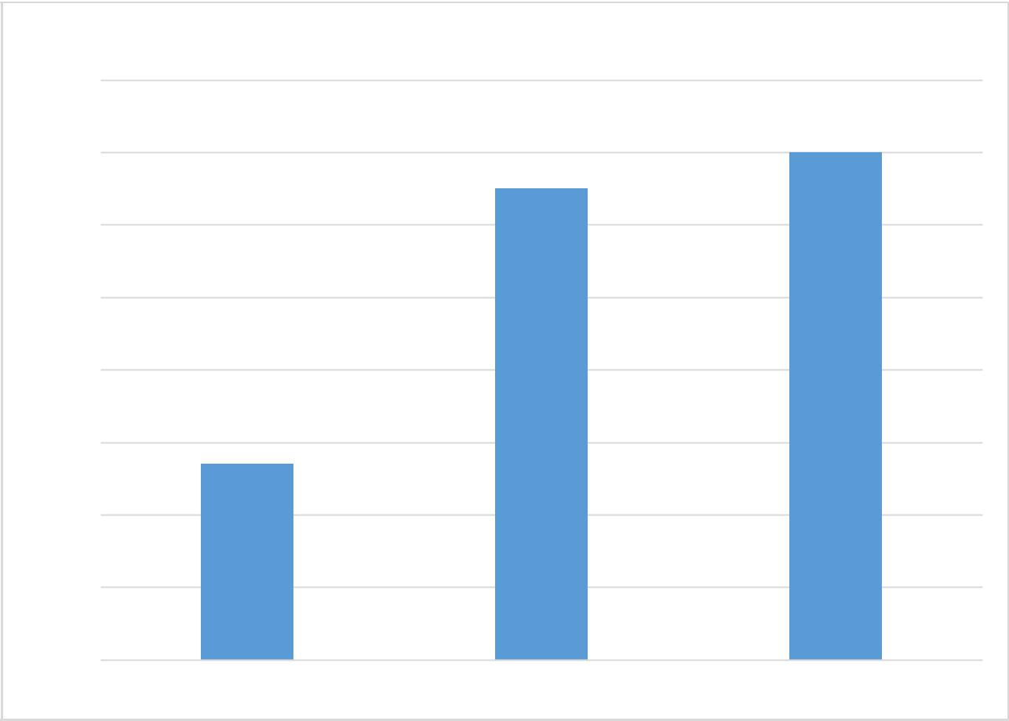

Classifier vs Accuracy Plot

90.00%

89.80%

89.60%

89.40%

89.20%

89.00%

88.80%

88.60%

88.40%

NAÏVE BAYES J-48 RANDOM FOREST

Therefore, as the plot suggests Random Forest showed us the highest Accuracy i.e. 89.8% in comparison to others which are J48 decision tree and Naïve Bayes

5.2. Results and Findings

This shows us the graph of the No. of tweets to the score of the tweets. From this graph we can interpret that there are a lot of number of neutral tweets as the value on 0 score is high and then come positive no. of tweets with score 1.
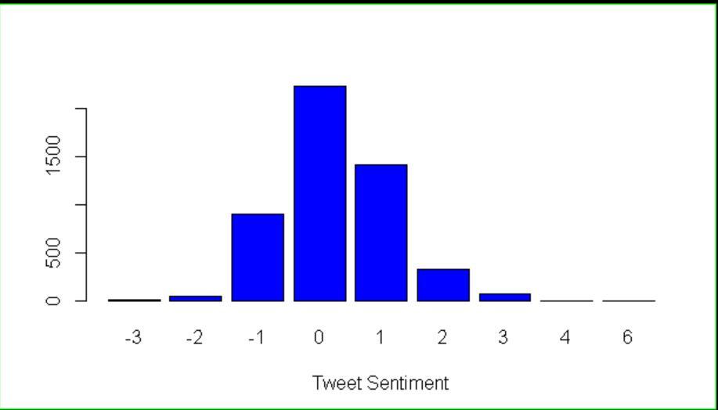

- This gives us the list of the best (most positive) among the tweets that are extracted from twitter.
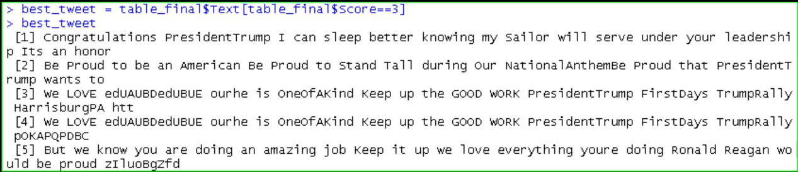

- This gives us the list of the worst tweets from the 5000 tweets extracted by us.
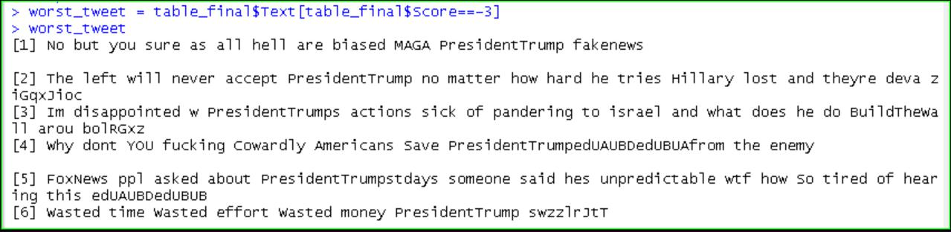
- This is visually showing us the Frequently used words in the tweets.
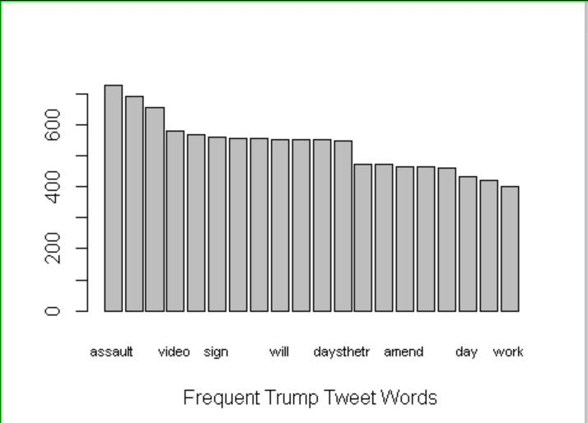

- This visually shows us the maximum no. of words used in form of WORD CLOUD.

- From here we can see that assault is the word used mostly in the tweets.
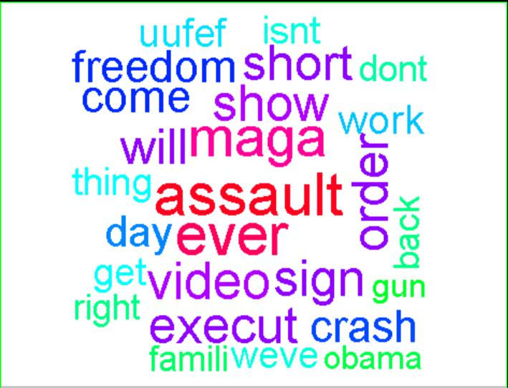
6. Conclusions and Future Work

6.1. Conclusions

After extracting and performing our analysis we have figured out various points which helped us analyze many things about the current thoughts and opinions people have about TRUMP.

It helped us get the information that there are recently many positive things being said about the president. This is also supposed to be practically possible as we must not forget the fact that he has been elected by the people of USA and therefore it shows that there is a good section of people that believes in him and his policy making and support him.

The second this we analyzed was that maximum no. of times the word assault was used during the extraction of the recent 5000tweets. This is practically possible as recently he has proposed a policy for making GUNS legal in USA and therefore the assault tweets were all related to it as many people shared their opinion over it.

6.2. Limitations

- Nowadays, most of the tweets have emoticons to express their emotions and therefore emoticons, GIF, Pictures can also be a valuable tool for sentimental analysis and in our case, we have considered only positive and negative words in calculating our sentimental analysis. Therefore, if we perform our sentimental analysis considering the above-mentioned expressions then analysis would become more effective and higher accuracy can be achieved.

2)The Positive and Negative bag of words that we have added to help us get the positive and negative score is though large but still does not contains all the words in the dictionary therefore this is a limitation. But still we have added few more words which are present in our positive or negative bag of words and considered few widely used urban-lingos as they are mostly tweeted these days, words like gr8, awwsum, aww, Sex C etc.

6.3. Potential Improvements or Future Work

- We can introduce the emoticons, GIFS and try to implement a function so that we can also consider it in our sentimental score analysis in future that would increase our scope for getting more accuracy and we must also not forget that today’s generation likes to keep things short and simple therefore use of GIFs, Urban-lingos and emoticons are too much.

- We can also work on the area of timely comparison and growth of TRUMPs popularity or his downfall. The results of the sentimental analysis would help us predict some solutions which would help him in his future campaigns and policy announcements ahead of future elections as sentimental analysis tells us about the recent mindset of the public about whom they tweet.

