Comparative genome-centric analysis reveals seasonal variation in the function of coral reef microbiomes

Intro :

Coral reef are frail ecosystem which are sensitive to changes in their environment (such as surface temperature , anthropogenic pression and acidification of oceans). It leads to a change of the microbiome affection the corals and the holobionte in general. As the coral die macro-algae take its place leading to more dissolved organic carbon in the environment which helps the development of pathogenic bacterioplanktos accelerating the death of coral.

There is an important need to increase the research on the symbiosis of corals with its microbiome. Thanks to the development of computer science in metagenomics field it is now possible.

Mat and met :

Australian Institute of Marine science collected 6 samples for metagenomics studies of marine sponge (Coscinoderma matthewsi), macroalgae (Sargassum spp.) and seawater in Geoffrey Bay, Magnetic Island (Great Barrier Reef, Queensland, Australia). The seawater was collected using collapside steril bags at 2 meter depth. The sample was pre-filtered with 50micrometer to remove larfe particles, a second step of filtering using Sterivex-filter (Milipore) at 0,2micrometer. The sponge sample was taken at 7m depth and macro algae at 3m. They were filtered (0,2micrometer) with sterilized seawater to remove attached microbes. The samples were then immediately frozen at - 80°C

They also collected 6 samples of seawater at 2 meters depth to collect information on pollution of the coral reef. They studied the salinity of the water and quantified :
- non purgzable organic carbon
- non purgeable inorganic carbon
- particulate organic carbon
- total suspended solids
- chlorophyll a
- disolved inorganic nutrients ( ammonium, nitrate, phosphate)
- particulate nitrogen
- total nitrogen
the sample were duplicated.

Prior to the DNA extraction a step of centrifuge was used to separate the proteins to DNA.

Sequencing :

The libraries were prepared using Nextera XT Library Preparation Kit (Illumina). They used illumina Hiseq sequencing making paired-ends reads with a length of 250 pb.

Assembling, binning and dereplication:

They removed illumina’s adaptator and trimmed the reads [1] then assembled them [2].

They mapped the assembled reads to know the coverage [3] then used them to generate metagenome-assembled-genomes (MAGs) [4] using binning tools[4,5] .

They assessed the quality of the binning ( completeness and contamination) [5] and only kept MAGs with quality >= 50 (where quality = completeness−3 × contamination)[6]

To calculate the abundance of MAGs from each habitat (sponge, macro-algae, seawater) they were de-replicated separately at 95% Average Nucleotide Identity (95% ANI) to avoid arbitrarily placement of reads close to 2+ MAGs [7]. A second step was to map the trimmed reads against the de-replicated MAGs (95%ANI )[8].

Taxonomy and annotation:

They assigned a taxonomy MAGs (95%ANI ) [9] and their functional annotation [10] using Kyoto Encyclopaedia of Genes and Genomes Orthology database. Then they assessed the completeness of the previous assignations [11] and only kept KEGG modules with >= 70% completeness. Finally they verified their results by comparing the MAGs ( 95% ANI) against the metagenomic community profiles found by the extraction of 16S rRNA using [12].
They added another step for seawater MAGs95%ANI belonging to the phylum Bacteroidota by screening the presence of Polysaccharide Utilisation Loci (PULs) [13] with Carbohydrate Active enzyme (CAZy) database and the Protein Family (Pfam) database.

Statistical analysis:

They used R for their analysis and its packages : vegan, Venndiagram , DESeq, phyloseq and ggplot2. ( + Adobe Illustrator ).

The annotation was evaluated of MAGs95%ANI with permutation Multivariate Analysis of Variance (PERMANOVA) and Non-metric multidimensional scaling (NMDS). They transformed the annotation in a matrix presence/absence of KEGG Modules using binary Bray Curtis Dissimilarity Index. The results were presented with a Venn diagrams. Similarity Percentage (SIMPER with 10,000 permutations) was then used to observe the dissimilarity between summer and winter of the functions found with KEGG. Log2 fold change of significant KEGG Modules was calculated to compare the proportional changes between groups using the gtools package v3.8.1. in R

On the environmental metadata they were z-score standardized ( centré – réduit) then compared by season ( summer vs winter) using a t-test.

The functional profiles of taxa across seasons was studied using the same methode as MAGs95%ANI.

Microbial taxa showing significant differences in abundance between the peak of summer ( February) and the peak of winter ( August) were evaluated using DESeq.

Finally, the impact of environmental metadata on the abundance of seawater MAGs95%ANI was analysed using Bray–Curtis distance-based redundancy analysis (dbRDA) and the best model was choosen using ordistep() function of the vegan package ( keeping only significant variable based on anova.cca() function, p < 0.05). The percentage of explanatory values of the significant environmental variables was assessed by co-linearity using Pearson correlation.

Résultats

125 MAGs95%ANI were recovered, 67 in seawater, 38 for sponge and 20 for algae, belonging to 15 bacterial an d 3 archaeal phyla.
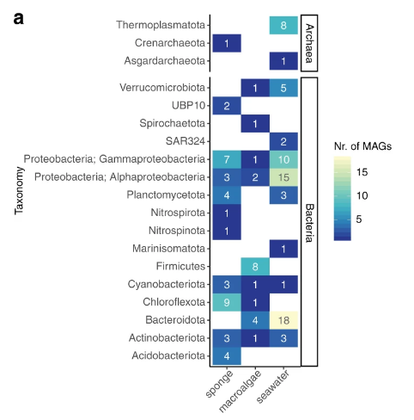

The seawater, sponge, and macroalgae had respectively 35.2, 63.5 and 27.7% of high quality MAGs. The comparison with 16 rRNA showed that the MAGs were representative of the most dominant taxa.

The functional profils varied greatly between habitats, PERMANOVA F(2/122) = 5.24, p = 9.99 × 10−5, 10,000 permutations
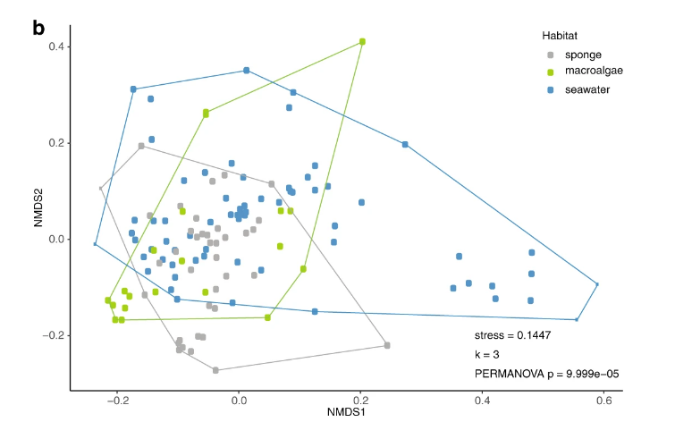

KEGG Modules involved in carbohydrate metabolism, energy metabolism and processing of environmental information represented on average more than half of all KEGG Modules annotated in sponge, macroalgae and seawater MAGs95%ANI while biosynthesis of secondary metabolites were only present in macoalgae
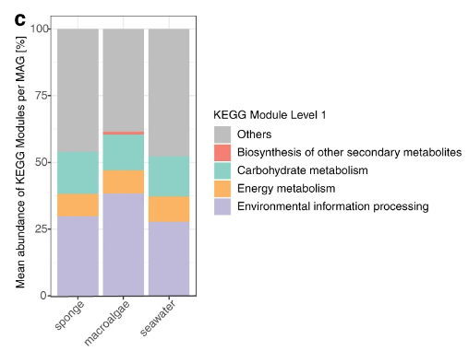
85% of functions linked to carbohydrate metabolism were shared between the 3 samples while only 41% and 35% were shared for energy metabolism and environmental processing function. The most conserved functions between the 3 habitats were ATP synthesis and carbon fixation. The algae was the habitat with the most unique KEGG modules and are principally related to antibiotic and environment sensor.
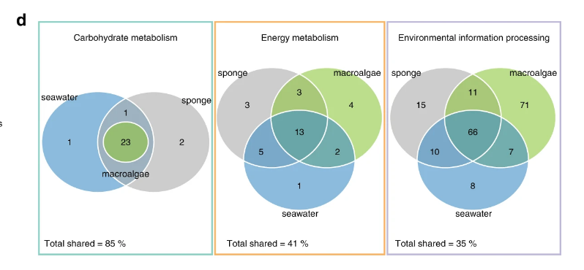

The temperature of seawater significantly changed between summer and winter p = 0.0039. Ammonium , nitrite and nitrate are positively correlated with the temperature of seawater while the total of suspended solid is inverse of temperature. Further more, algae thrive in warm water and is at its peak during summer.

The most stable habitat between seasons is the sponge with only 1/11 taxa changing while seawater and particularly algae have the abundance of their taxa which changes.
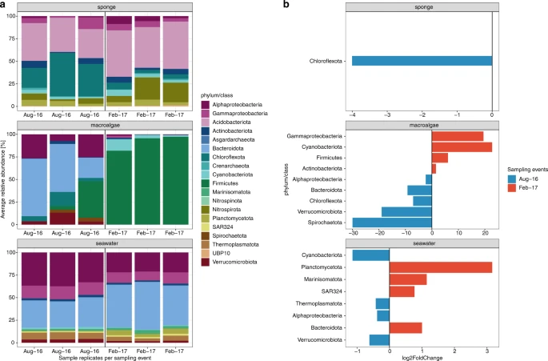

Further more the functions of the phylum which aren’t stable between season are also changing.

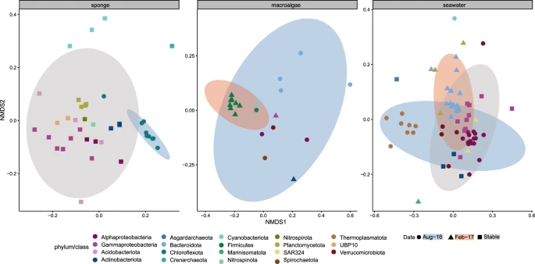

(Seawater)

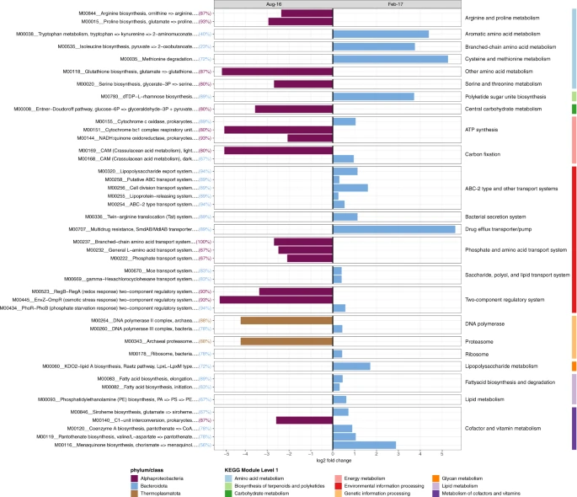

Discussion

DEF

Un holobionte, ou supraorganisme, est un ensemble composé par un organisme animal ou végétal et les micro-organismes qu'il héberge. Les micro-organismes habitant l'hôte constituent le microbiote.

In metagenomics, binning is the process of grouping reads or contigs and assigning them to individual genome. Binning methods can be based on either compositional features or alignment (similarity), or both.

Softwares:

[1] : SeqPurge (v2018_04)
[2] : metaSpades (v3.13.0)
[3] : BamM (v1.7.3)
[4] : uniteM (v0.0.15 )
- [4,5] MaxBin (v2.2.4), MetaBAT (v2.12.1) and GroopM (v0.3.4)
[5] : CheckM (v1.0.12)
[6] : SingleM v0.12.1
[7] : dRep v1.0.0
[8] : coverM v0.2.0
[9] : GTDBtk v0.2.1
[10, 11, 13] : enrichM v0.4.7 (11: classify function)
[12] : GraftM v0.12.0

