# Editing the Licence File

1. Make a copy locally of Docs\IRISExchequer.Licence which is the encrypted licence file.
2. In Delphi load and run the TestDLL.Dpr project in this folder:-

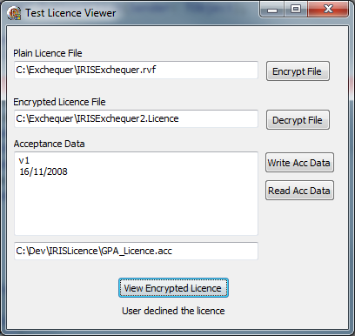

1. Set ‘Encrypted Licence File’ to point to your local copy of Docs\IRISExchequer.Licence
2. Set ‘Plain Licence File’ to a IRISExchequer.rvf in the same directory.
3. Click the Decrypt File button to create the .rvf file.
4. Run Editor\ActionTestUni.exe and open the .rvf file and make any changes required.
5. Change the ‘Encrypted Licence File’ to point to a new filename, e.g. IRISExchequer2.Licence.
6. Click the Encrypt File button, this will encrypt the edited .rvf file creating a new encrypted licence file.
7. Click the View Encrypted Licence button at the bottom and check your changes in the resulting window.

Repeat steps 6-9 until OK.

1. Replace Docs\IRISExchequer.Licence with the updated version and run the CD to test it.