How to use TmsClientSocket component

TmsClientSocket component can be used for creating client application. It is an ancestor of all high-level client components, such as TmsSMTPClient, TmsPOPClient, TmsHTTPClient, TmsNNTPClient etc.

We will write the client application, which works with the server program, written in the chapter How to Use TmsListenerSocket and TmsServerThread components.

Start up Delphi, and create new application. Then, on the Form1 drop TmsClientSocket component, also one TMemo, and one TButton components. Name the TMemo as RecvMemo, and TButton - as ConnectButton, also, change the caption of the button to Connect. Then, set the port property of TmsClientSocket component to 1090, this is the port where our server will listen, and set the Host property to localhost, or 127.0.0.1, which will indicate that we will be running the server on the same computer where we are running the client.

Our form should look like this:
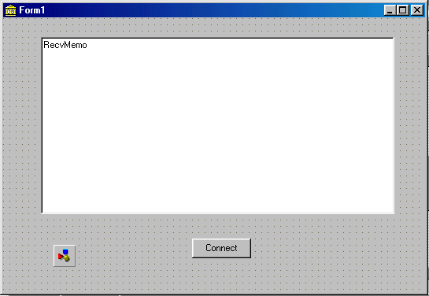

Then, double click the connect button and create the event handler which looks like the following:

procedure TForm1.ConnectButtonClick(Sender: TObject);
var
TempStream: TStream;
begin
TempStream:=TMemoryStream.Create;
try
msClientSocket1.Connect;
msClientSocket1.RecvStream(TempStream,-1);
TempStream.Position:=0;
RecvMemo.Lines.LoadFromStream(TempStream);
msClientSocket1.Disconnect;
finally
TempStream.Free;
end;
end;

In this procedure, we are creating a temporary stream, which will receive the data from the server. Since we know that the server will send the data and close the connection to indicate the end of the session, we are using RecvStream method of TmsClientSocket component. Since we don’t know in advance the size of the received data, we are passing minus one as a parameter. Then after the data was received, we are loading it into the Memo component on our form.

Start up the project ls1.dpr, then, recompile this application, run it, and click Connect button. You will see the received data, in memo component.

