How to use TmsFTPClient component

TmsFTPClient component implements File Transfer Protocol (FTP, RFC 959), and used to store and retrieve files to/from the FTP server.

Start up Delphi, and create new application. Drop on the main form TmsFTPClient component, also four TLabels, four TEdits, and one TButton components. Name Edit components as ServerEdit, UserNameEdit, PasswordEdit, and FileNameEdit, rename Button component to UploadButton, and set its caption as Upload.

Your form should look like this:

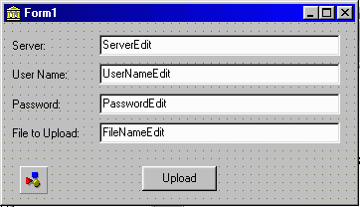

Then, double click UploadButton and create the event handler, which looks like this:

procedure TForm1.UploadButtonClick(Sender: TObject);
begin
msFTPClient1.Host:=ServerEdit.Text;
msFTPClient1.UserName:=UserNameEdit.Text;
msFTPClient1.Password:=PasswordEdit.Text;
msFTPClient1.Login; msFTPClient1.StoreFile(FileNameEdit.Text,
ExtractFileName(FileNameEdit.Text));
msFTPClient1.Logout;
end;

First three lines – we are setting Host, UserName and Password properties of TmsFTPClient component. Then, we are logging into the server, by calling Login method, and uploading the file, specified in the FileNameEdit edit box. Full path must be specified. Last line logs us out from the server and closes the connection. The program will store out file with the same name, in the current directory on the server.

This application is in the DOCS folder. Name of the project is ftp.drp. Also, take a look at the ftpdemo.drp, in the DEMOS folder. It is the fully functional FTP client.

