How to use TmsSMTPClient and TmsMessage components

TmsSMTPClient component implements Simple mail transfer protocol (SMTP), defined in RFC 821. It allows you to send Internet mail messages using SMTP server. TmsSMTPClient component should be used in conjunction with TmsMessage component, which is the implementation of RFC 622 compatible email message.

Start up Delphi, and create new application. Drop on the Form1 TmsSMTPClient and TmsMessage components. Then, click TmsSMTPClient component on the form, go to the Object Inspector, find MailMessage property and set it to msMessage1. It will tell to the msSMTPClient1 object what exactly we are going to send.

Now, drop three TLabel, three TEdit, one TMemo, and one TButton components on the form, so that it looks like this:
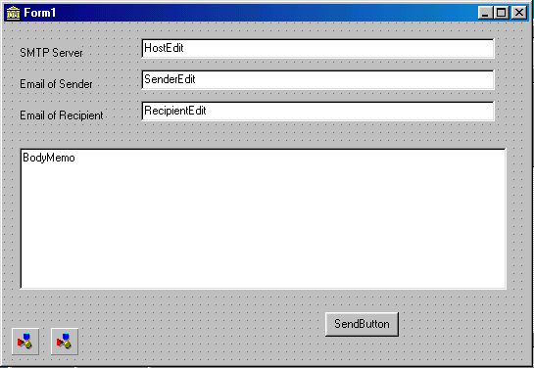

Then, double click SendButton and create the event handler, which looks like the following:

procedure TForm1.SendButtonClick(Sender: TObject);
begin
msSMTPClient1.Host:=ServerEdit.Text;
msMessage1.Clear;
msMessage1.Sender.Address:=SenderEdit.Text;
msMessage1.Recipients.AddAddress(RecipientEdit.Text,'');
msMessage1.Body:=BodyMemo.Lines;
msSMTP1.Send;
end;

Then, compile the application and run it. In the Server box you should enter the domain address of the SMTP server of your ISP, e.g. smtp.mydomain.com, in the Sender email box – your email address, and in the recipient box – the email address of recipient. In the memo field type the message you want to send, and click Send button. If you are connected to the Internet, the message will be sent.

The application described above is included in the package. Its name is smtp.dpr.

Please take a look at the application smtpdemo.dpr, which is also included in the package. It demonstrates how to use other capabilities of TmsSMTPClient and TmsMessage components, such as using event handlers, and sending attachments. Also, take a look at the help file, which contains detailed description of important properties and methods of these components.

