Exchequer Enterprise

Barclays Business Master Plug-in
for A Bilbrough

User Guide

Version 1.0

International Payment Plug-In for A. Bilbrough

Introduction
This Plug-In is designed to work with Exchequer Enterprise v5 to output a payment file in an international format suitable for importing into Barclays BusinessMaster.

Installation

Unzip the attached zip file (BBM.ZIP) into a temporary directory then, from that directory, run the install program BBM_INST.EXE. This will install the Plug-In into your Enterprise Folder. You can check that installation has been successful by running Enterprise and selecting Help/About from the main menu, then scrolling throught the text in the About box. If the Plug-In has installed successfully you should see the following:

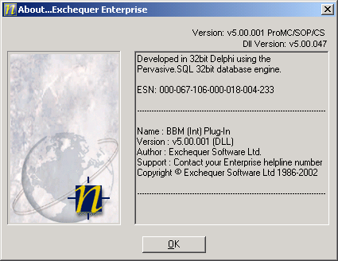

Setup

The file BBM.INI in your Enterprise folder is used to store the main settings for the Plug-In. Before running the Plug-In for the first time, you should ensure that the following details have been entered into the file.

In the [DataAccess] section 'DataBase' should be the filename and path of the MS Access database used to store the bank settings and 'Table' should be the name of the table used within that database. E.g.:

[DataAccess]
DataBase=D:\Bilbro\EE_International_Bank_Lookup.mdb
Table=EE_International_Lookup

In the [Banks] section you should ensure that there is an entry for each bank account that will be used, consisting of the GL Code which identifies that bank and the account number, in the format GL Code=Account Number. E.g.:

[Banks]
2010=12341234
2020=45678999

In the [Output] section 'Delimiter' specifies the character used to delimit non-numeric fields in the output lines. This will normally be a double quote character (“). Leave blank if no delimiter is required. ‘Folder’ specifies the folder where output files will be written. If this is blank then files will be written to the Enterprise directory.

Currencies

Within Enterprise, the currency rates must be set up so that the screen code for each currency in use is the ISO currency standard.

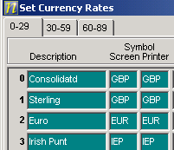

Generating a payment file

The payment files are generated via the batch payments routine contained within the main menu procedures option.

To generate a payment run:-

- Set the payment run type to BACS
- Specify the required bank account g/l code in the bank details (e.g. 20020).
- Finally specify the currency of the payment.

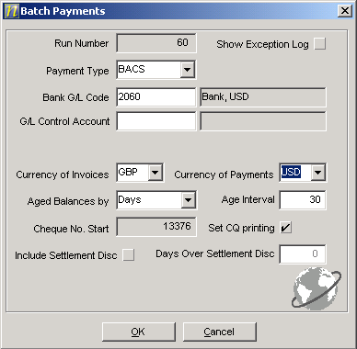

If you choose any currency other than GBP as the payment currency, then you will be given a warning that as standard the UK BACS format does not support foreign currencies. This warning can be ignored.

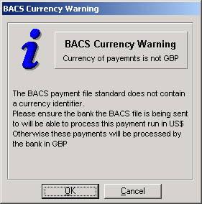

Once the payment run has finished you will be advised of the name and location of the file which has been created. The output file will be in SIF File Format for International Payments suitable for importing into Barclays BusinessMaster and will be called BBMPAY.TXT.

