Enterprise
ABN-AMRO Electronic Payment Hook

Created 22/02/2000

Introduction

Exchequer Software have developed a hook to allow electronic payments to be submitted using ABN AMRO’s OfficeNet program.
The hook supports domestic payments using the Dutch ClieOp03 format, and foreign payments using the ABN BTL91 format which connects to the SWIFT (Society for Worldwide Interbank Financial Telecommunication) system.

Initial Setup procedures

System Setup
The currency table in Enterprise must be set up so that the screen code for each currency in use is the ISO currency standard.
e.g. NLG - Dutch gliders, USD - US Dollars, GBP - Pounds Sterling

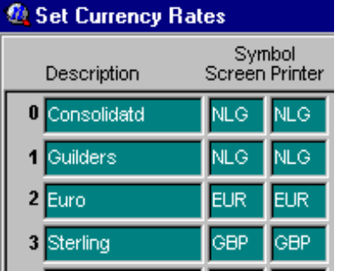

The company details in system setup must contain the UPS address town in line 2 of the company address.

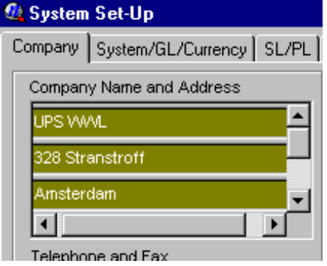

Setting up the G/L
Enterprise will need to have as many G/L codes setup necessary to represent each of the physical bank accounts payments will be made from. These must be setup as Balance Sheet (‘B’) type accounts.

e.g. 20010 ABN NLG/EUR Account.
20020 ABN USD Account..

Two creditor control accounts need to be set up for domestic payments, and foreign payments respectively. These must be set up as Control (‘C’) type accounts within the liabilities section of the balance sheet.

e.g. 31025 Domestic Creditors
31027 Foreign Creditors.
Setting up and maintaining the payment control file ENTABNHK.INI

An external initialisation (INI) file is used to help manage the payment hook, and allow you to maintain any changes to how you would like the system to work in the future.

The file looks like this

[CONTROL]
DOMESTIC_PAYMENT_GL = 31025
FOREIGN_PAYMENT_GL=31027

DOMESTIC_DIR=s:\temp\clieop\
FOREIGN_DIR=s:\temp\btl91\
PAYMENT_DESC=UPS WWL Payment

[BANK1]
ENT_GL_CODE=20010
SWIFT_CODE= ABNANL2A
BANK_NAME=ABN AMRO Domestic
BANK_TOWN=AMSTERDAM
BANK_ISO_COUNTRY=NL
BANK_ISO_CURRENCY=EUR
BANK_COUNTRY=HOLLAND
BANK_ACCOUNT_NO=619152869
BANK_EXCHANGE_CODE=ABNA

[BANK2]
ENT_GL_CODE=20020
SWIFT_CODE=ABNANL2A
BANK_NAME=ABN USD
BANK_TOWN=AMSTERDAM
BANK_ISO_COUNTRY=NL
BANK_ISO_CURRENCY=USD
BANK_COUNTRY=USA
BANK_ACCOUNT_NO=112345670
BANK_EXCHANGE_CODE=ABNA

The section marked [CONTROL] contains general information used to manage the payment process.

DOMESTIC_PAYMENT_GL=31025 : This is used to specify the domestic G/L control code set up within Enterprise.

FOREIGN_PAYMENT_GL=31027 : This is used to specify the foreign G/L control code set up within Enterprise.

DOMESTIC_DIR=s:\temp\clieop\ : This is used to specify the directory you would like the domestic payments file to be created in.

FOREIGN_DIR=s:\temp\btl91\ : This is used to specify the directory you would like the foreign payments file to be created in.

The foreign and domestic directories can be the same.

PAYMENT_DESC=UPS WWL Payment : Use this option to specify the text which will appear on your suppliers statement indicating where the payment has come from. There is a limit of 32 characters.

The section marked [BANKn] where n is a number between 1 & 100 is used to provide additional bank account details for the bank accounts you will be making payments from, and covers both domestic and foreign accounts.

You can add in as many bank accounts as you like, up to a limit of 100, simply by copying an existing bank section, and increasing the [BANK] number by 1. E.g. [BANK3]

ENT_GL_CODE=20010 : This is used to identify which G/L code in Enterprise corresponds to this bank account.

SWIFT_CODE= ABNANL2A : This is used to specify the SWIFT code of your bank account.

BANK_NAME=ABN AMRO Domestic : This is used to identify the name of the bank the account belongs to

BANK_TOWN=AMSTERDAM : This is used to specify the name of the town the bank containing the account is located in.

BANK_ISO_COUNTRY=NL : This is used to specify the two digit ISO country code of the country the bank containing the account is located in.

BANK_ISO_CURRENCY=EUR : This is used to specify the three digit ISO currency code of the currency the bank account is nominated in.

BANK_COUNTRY=HOLLAND : This is used to specify the name of the country the bank containing the account is located in.

BANK_ACCOUNT_NO=619152869 : This is used to specify the bank account number associated with this account.

BANK_EXCHANGE_CODE=ABNA : This is used to specify the first four letters of the SWIFT address of the exchange bank which receives orders for processing.

Setting up Suppliers

Suppliers need to be setup specifically depending on whether they are domestic creditors, i.e. paid electronically into a Dutch bank account (and they are Dutch resident), or whether they are foreign creditors, i.e. paid electronically into a foreign bank account.

Setting up a domestic creditor supplier

For a domestic supplier you must ensure the following fields are used as defined.

- The second line of address must contain the suppliers Town. I.e. Amsterdam.

- Ctrl GL Code must be set up with the Domestic Creditor Control G/L account i.e. 31025

- Pay Type must be set to BACS.

- The payment system will combine Sort code ,Bank A/C & Bank Ref (in that order) to form a complete bank account number. We suggest that for domestic payments, the Bank Ref field is used to store the domestic 10 digit bank account field.

Setting up a foreign creditor supplier

For a foreign supplier you must ensure the following fields are used as defined.

- The second line of address must contain the suppliers town. I.e. Amsterdam.

- Ctrl GL Code must be set up with the Foreign Creditor Control G/L account i.e. 31027

- Area must contain the two digit ISO country code for the suppliers address. i.e. NL

- Pay Type must be set to BACS.

- The payment system will combine Sort code ,Bank A/C & Bank Ref (in that order) to form a complete bank account number. We suggest that for foreign payments, under 18 digits long use the Bank Ref field on its own. For larger bank account numbers over 18 digits, start the account number in Bank A/C and finish it in Bank Ref.
- User defined field 1 must contain the SWIFT code of the suppliers bank.
- Trading Terms message field 1 must contain the name of the suppliers foreign bank. i.e Bank of America
- Trading Terms message field 2 must contain the town of the suppliers foreign bank. i.e. Washington

Generating a Domestic payment file

The payment files are generated via the batch payments routine contained within the main menu procedures option.

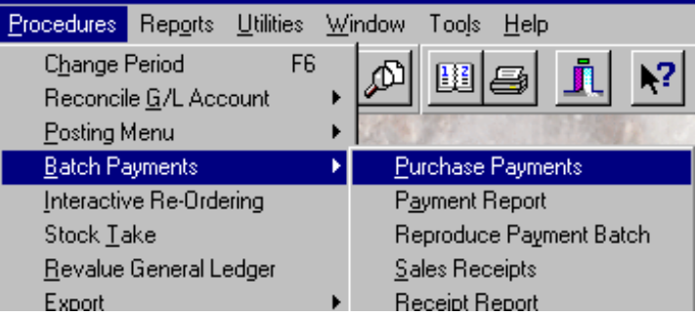

To generate a domestic payment run:-

- Set the payment run type to BACS
- Specify the domestic bank account g/l code in the bank details (e.g. 20010).
- Specify the domestic control g/l code within the G/L control details. (e.g. 31025)
- Finally specify the currency of the payment as either in NLG, or EUR.

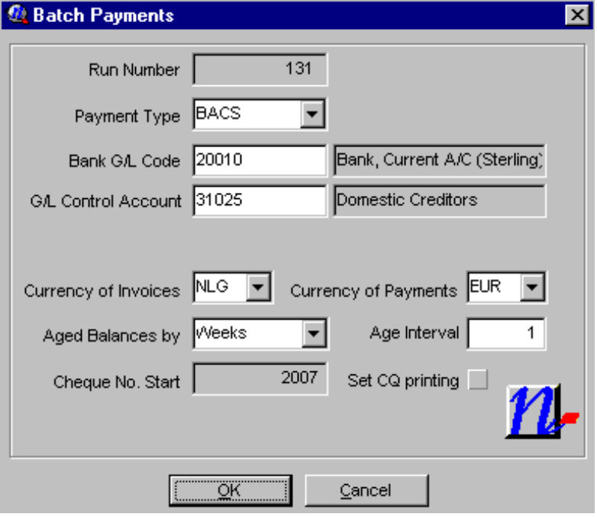

Note: It is very important that the correct combination of Bank Account, and G/L control code are used, as these two fields determine if the payment run is domestic or foreign.

Currency of invoices will determine which outstanding invoices are available for payment. Choosing the base currency will tell enterprise to include all outstanding invoices regardless of currency.
Currency of payment will determine in which currency the payment file is generated. For domestic payments this can be either NLG, or EUR.
If you choose Euro as the payment currency, then you will be given a warning that as standard the UK BACS format does not support foreign currencies. This warning can be ignored.

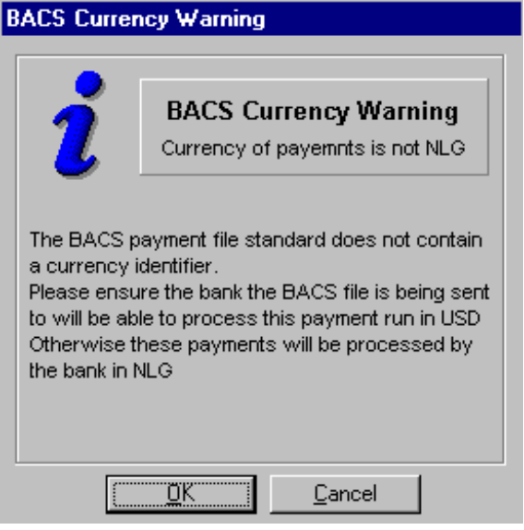

The batch payments system will then search for all outstanding transactions marked with that g/l control code, and display them within the batch payments screen.

Although you will be prompted for a batch payments processing date by Enterprise, OfficeNet will ignore this date, and replace it with the date specified during the import.

When you process the payments run, the payments hook will attempt to create a file called CLIEOP03.nnn in the domestic directory as specified within the ENTABNHK.INI file.
The files are numbered sequentially starting from 1. If CLIEOP03.001 already exists, the system will attempt to create CLIEOP03.002 and so on, until it reaches 99 which it will stop with an error. It is Therefore important that you delete these files once they have been successfully imported into OfficeNet.

As the payment run finishes you will be advised of the name of the file which has been created.

Generating a Foreign payment file

The payment files are generated via the batch payments routine contained within the main menu procedures option.

To generate a foreign payment run:-

- Set the payment run type to BACS
- Specify the foreign bank account g/l code in the bank details (e.g. 20020).
- Specify the foreign control g/l code within the G/L control details. (e.g. 31027)
- Finally specify the currency of the payment as whichever currency the bank account you have chosen operates in.

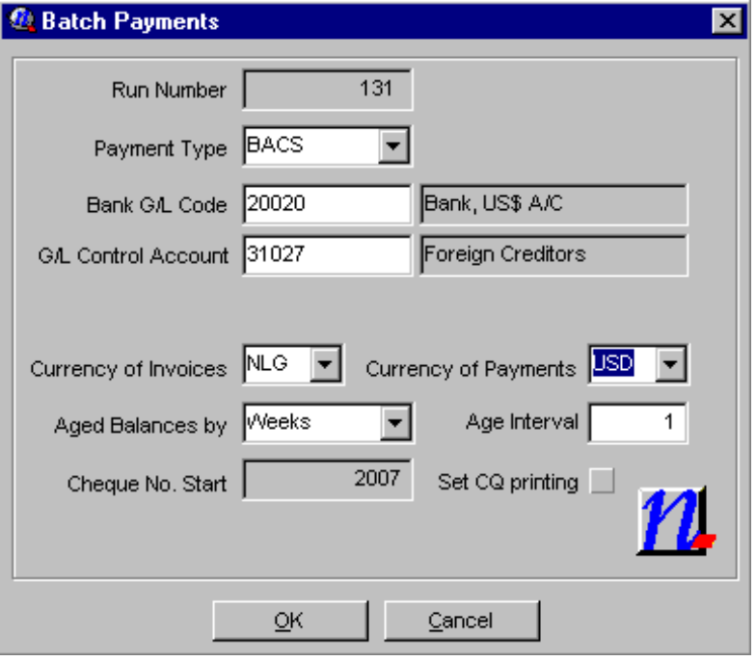

Note: It is very important that the correct combination of Bank Account, and G/L control code are used, as these two fields determine if the payment run is domestic or foreign.

Currency of invoices will determine which outstanding invoices are available for payment. Choosing the base currency will tell enterprise to include all outstanding invoices regardless of currency.
Currency of payment will determine in which currency the payment file is generated. For foreign payments this must be the currency of the bank account the payment will be made from. E.g. USD.

If you choose any currency other than NLG as the payment currency, then you will be given a warning that as standard the UK BACS format does not support foreign currencies. This warning can be ignored.

The batch payments system will then search for all outstanding transactions marked with that g/l control code, and display them within the batch payments screen.

Although you will be prompted for a batch payments processing date by Enterprise, OfficeNet will ignore this date, and replace it with the date specified during the import.

When you process the payments run, the payments hook will attempt to create a file called AnnBTL91.txt in the foreign directory as specified within the ENTABNHK.INI file.
The files are numbered sequentially starting from 1. If A01BTL91.TXT already exists, the system will attempt to create A02BTL91.TXT and so on, until it reaches 99 which it will stop with an error. It is Therefore important that you delete these files once they have been successfully imported into OfficeNet.

As the payment run finishes you will be advised of the name of the file which has been created.

The payment hook will set all foreign payments with domestic costs being paid for by you out of your domestic NLG/EUR account, and the correspondence costs being borne by the beneficiary of the payment.
The SWIFT priority is set to standard. Both the costs and priority can be overwritten once the payment details have been imported within OfficeNet.

Importing a Domestic payment file created by Enterprise into OfficeNet v2.0

Once a CLIEOP03.nnn file has been successfully created you need to import the file into OfficeNet. (These instructions assume OfficeNet has already been set up with all your ABN bank accounts).

To import into OfficeNet:-

- Load OfficeNet.
- Choose Start OfficeNet Extra
- Log in with your user name and password.
- Choose option 5 Import/Export
- Choose Import formats
- From the list of imports available, choose CLIEOP03

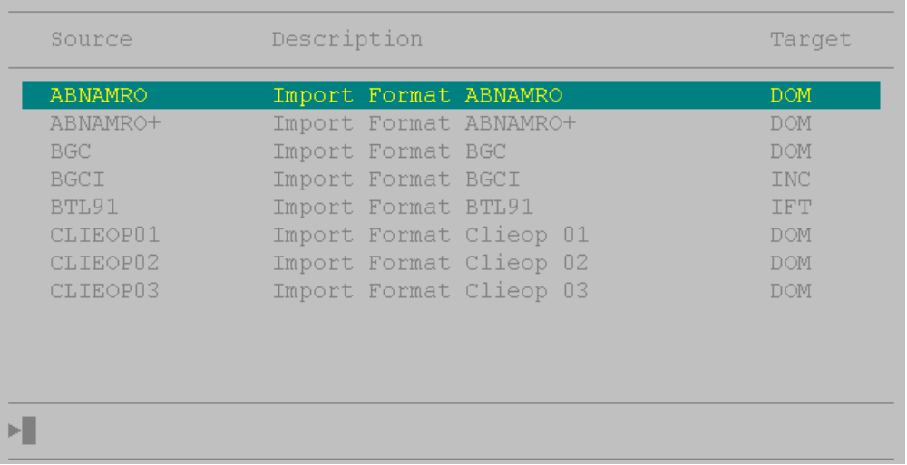

- The first time you go into this option you will need to create a new CLIEOP03 import file, using the New key F7.
- Name the format as DOM for Domestic payments.
- Set Form of payment as follows:-
- N for normal will separate each payment request on your bank statement as individual debits corresponding to each supplier paid.
- B for batch will result in a single entry on your bank statement representing the total value of the entire payment run as a single debit.
- Enterprise’s bank reconciliation can handle either method.

- The processing date will need to be set for each import run, and determines on which date you require the payment run to be processed by the bank.
- Leave the maximum amount as 0, or set it to a value appropriate to you.
- Specify the same directory as in ENTABNHK.INI for domestic payments.
- Enter the file name as “CLIEOP03.”.
- Store the format using the Cfm key F10

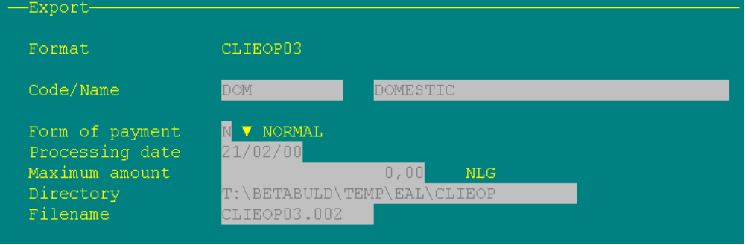
- To import using the format,
- Choose the DOM format.
- Edit it using the Edit key F9
- Change the processing date as required.
- Edit the file name to that of the file generated by Enterprise. I.e. CLIEOP03.001
- Store the format using the Cfm key F10
- Press Cfm (F10) again to import.

- Once the import is successful, you will be able to see the imported payments via the Main Menu Payments/Orders option, followed by Domestic Payments

Editing a payment instruction from inside OfficeNet

Should you need to edit a payment instruction once it is inside OfficeNet, for example to change the how the bank charges are paid you will need to follow this procedure for both domestic and foreign payments.

The payments are imported from Enterprise as SETS. Whilst a payment instruction has the status as SET, it cannot be edited from the payment screen.

To edit:-

- Choose option 2, Payments/Orders from the main OfficeNet menu.
- Choose option 4, Sets
- Find the set you wish to edit, and press space so that a marker appears next to it. (this selects the set for action. You can mark multiple sets at once)
- Press F2, Act.
- Choose 4, reopen.
- The set will disappear from the sets screen. This is normal

You may now edit the payment details via the Domestic or Foreign payment screen.
- Importing a Foreign payment file created by Enterprise into OfficeNet v2.0

Once an AnnBTL.txt file has been successfully created you need to import the file into OfficeNet. (These instructions assume OfficeNet has already been set up with all your foreign ABN bank accounts).

To import into OfficeNet:-

- Load OfficeNet.
- Choose Start OfficeNet Extra
- Log in with your user name and password.
- Choose option 5 Import/Export
- Choose Import formats
- From the list of imports available, choose BTL91

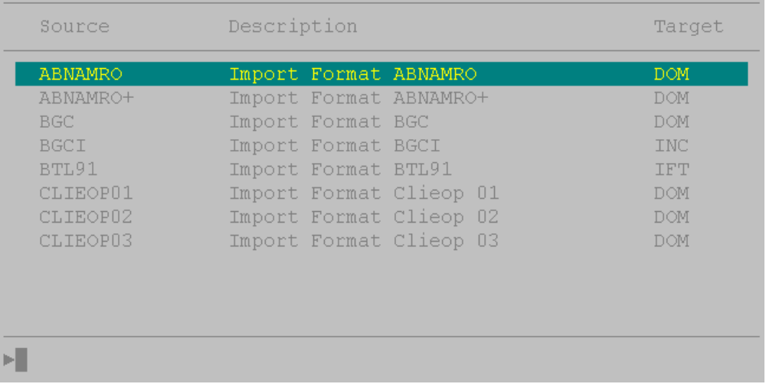

- The first time you go into this option you will need to create a new BTL91 import file, using the New key F7.
- Name the format as FOREIGN for Foreign payments.
- The processing date will need to be set for each import run.
- Leave the maximum amount as 0.
- Specify the same directory as per ENTABNHK.INI for foreign payments.
- Enter the file name as “A01BTL91.TXT.”.
- Store the format using the Cfm key F10

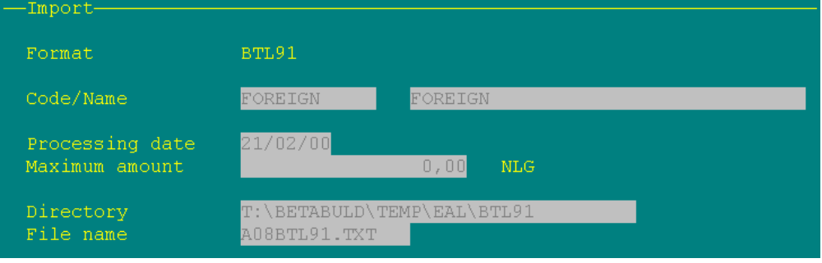

- To import using the format,
- Choose the FOREIGN format.
- Edit it using the Edit key F9
- Change the processing date as required.
- Edit the file name to that of the file generated by Enterprise. I.e. A01BTL91.TXT
- Store the format using the Cfm key F10
- Press Cfm (F10) again to import.

- Once the import is successful, you will be able to see the imported payments via the Main Menu Payments/Orders option, followed by Foreign payments.
Installing the Hook for the first time.

In order to install the hook for the first time, you will need the following files.

- ENTABNHK.INI (The control file)
- ENTCUSTM.INI (The Enterprise customisation file manager)
- ABNEPF.DLL (The ABN/UPS Electronic Payment Hook)
- ENTER1.EXE (The replacement v4.30c exe which has the modifed BACS hooks contained within it.)

- A Single CD manual Upgrade CD to v4.30c

- The first step is to upgrade the system to v4.30c. using the upgrade CD and license diskette.

- The four files specified above need to be copied into the main Enterprise directory after the v4.30c upgrade has been completed.

To check if the hook has installed correctly, run Enterprise after the above steps have been completed, choose Help/About from the main menu, and scroll to the bottom of the about box. Continue scrolling past the copyright messages, you should see the following text.

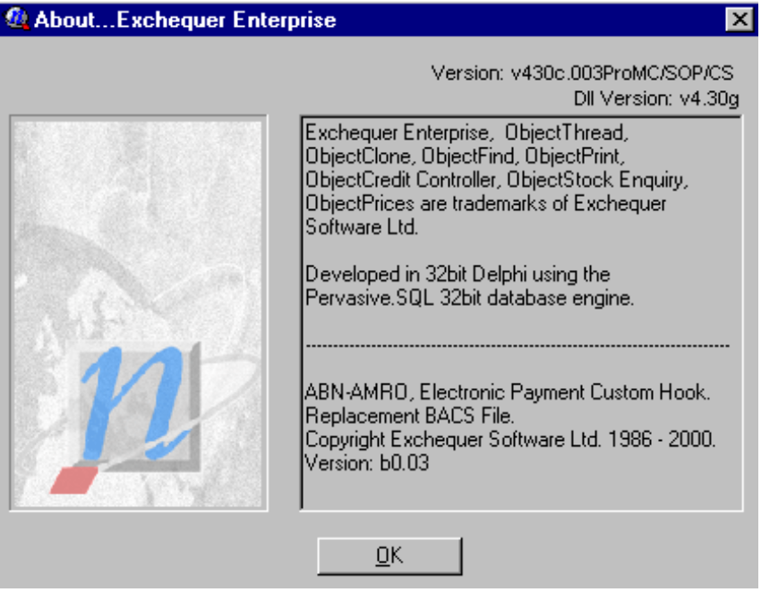

If you do not see this text, the hook has not installed correctly. Review the steps given above, and try again.

Please confirm both the version number of the main program is v4.30c.003 or greater, and that the hook version is b0.03 or greater.

