HSBC Hexagon format plugin

This plugin creates a batch transaction file in a format suitable for HSBC’s Hexagon system.

Setup

Hexagon will accept transactions in Sterling or Euros. (These cannot be mixed in one batch.) If transactions are in Euros then the currency table in Enterprise MUST be set up to that the Screen Symbol for Euros is either the standard Euro Symbol (€ - Ascii code 128) or ‘EUR’. The export process will treat anything other than these as Sterling.

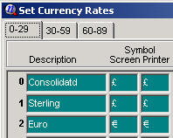

Output

As files are limited to 200 transactions the plugin will create as many files as are needed. Files will be placed into the Enterprise data directory and named HEX00001.DAT, HEX00002.DAT,HEX00003.DAT, …etc.

