Multi-Bacs plugin

The Multi-BACS plugin allows users to export batch payment or receipt runs in selected formats according to the bank and payment method being used.

Each separate format to be used for batch payments or receipts should be assigned a Bank GL Code. Bank details (eg the company’s sort code and acccount number for the appropriate account) for each GL Code are then stored in the file Mbacs.Ini (in the Enterprise data directory) in the following format:

[GL CODE 2010]
BANK_SORT=777777
BANK_ACC=88888888
BANK_REF=
BACS_TYPE=6
PAY_FILE=Multipay.txt
REC_FILE=Multideb.txt

[GL CODE 3010]
BANK_SORT=010101
BANK_ACC=90909090
BANK_REF=
BACS_TYPE=2
PAY_FILE=BacsPay.txt
REC_FILE=Bacsddeb.txt

BANK_REF can be left blank unless it is needed for a building society account. It is also used for the DBS IDEAL format.

The BACS_TYPE field refers to the number of the particular bank format that is being used for this GL code. Format numbers are shown below.

PAY_FILE and REC_FILE denote the filenames to be used for payment files and receipt files respectively. Please refer to your bank for any required naming conventions.

If you are using the ABN-Amro format then you do not need to enter the bank details in MBACS.INI. Simply enter BACS_TYPE as 13 for each GL Code used for ABN-Amro transactions. The bank details for each code are stored in the separate file ENTABNHK.INI.

The file Mbacs.ini should be placed into your Enterprise data directory.

Format Numbers

- Standard BACS with no date
- Allied Irish Bank
- Bank of Ireland
- Development Bank of Singapore IDEAL
- HSBC Hexagon
- Barclays Bacstel
- Natwest Autopay
- Standard BACS with no date and no contra record
- Lloyds TSB PcPay Comma Separated
- Lloyds TSB PcPay Fixed-length
- Coutts (Not yet available)
- Barclays BusinessMaster
- Natwest PayAway
- ABN-Amro
- Bank of Scotland HOBS

Example

Suppose you wish to make some payments using Bank of Ireland EFT and some using Allied Irish Banks EFT. You would proceed in the following way.

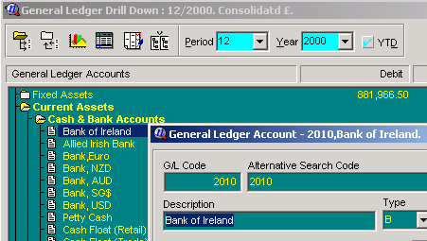

In the General Ledger, expand Cash & Bank Accounts and create a new entry for each format you wish to use. Here we have entered the BOI as GL Code 2010 and AIB as 2020.

Create a new text file in your Enterprise data directory and call it Mbacs.ini. Open the file and type in the following (replacing the numbers in the square brackets with the GL Codes of the entries you have created and entering the appropriate sort code and account number):

; Bank of Ireland
[GL CODE 2010]
BANK_SORT=777777
BANK_ACC=88888888
BANK_REF=
BACS_TYPE=2
PAY_FILE=BI_Pay.dat
REC_FILE=BI_Ddeb.dat

; Allied Irish Bank
[GL CODE 2015]
BANK_SORT=010101
BANK_ACC=90909090
BANK_REF=
BACS_TYPE=1
PAY_FILE=AIB_Pay.txt
REC_FILE=AIB_ddeb.txt

When you have finished typing in the details save and close the file.

When making a payment of receipt batch run, proceed as normal. When the Batch dialog appears type the appropriate GL code for the format required into the Bank GL field. This will ensure that the correct format is used.

