Multi-BACS Plug-in

The Multi-BACS Plug-in allows users to export batch payment or receipt runs in selected formats according to the bank and payment method being used.

Each separate format to be used for batch payments or receipts should be assigned a Bank GL Code. Bank details (e.g. the company’s sort code and account number for the appropriate account) for each GL Code are then stored in the file Mbacs.Ini (in the Enterprise data directory) in the following format:

[GL CODE 2010]
BANK_SORT=777777
BANK_ACC=88888888
BANK_REF=
BACS_TYPE=6
PAY_FILE=Multipay.txt
REC_FILE=Multideb.txt

[GL CODE 3010]
BANK_SORT=010101
BANK_ACC=90909090
BANK_REF=
BACS_TYPE=2
PAY_FILE=BacsPay.txt
REC_FILE=Bacsddeb.txt

BANK_REF can be left blank unless it is needed for a building society account. It is also used for the DBS IDEAL format.

The BACS_TYPE field refers to the number of the particular bank format that is being used for this GL code. Format numbers are shown below.

PAY_FILE and REC_FILE denote the filenames to be used for payment files and receipt files respectively. Please refer to your bank for any required naming conventions.

If you are using the ABN-Amro format then you do not need to enter the bank details in MBACS.INI. Simply enter BACS_TYPE as 13 for each GL Code used for ABN-Amro transactions. The bank details for each code are stored in the separate file ENTABNHK.INI.

The file Mbacs.ini should be placed into your Enterprise data directory.

Format Numbers

- Standard BACS with no date
- Allied Irish Bank
- Bank of Ireland
- Development Bank of Singapore IDEAL
- HSBC Hexagon
- Barclays Bacstel
- Natwest Autopay
- Standard BACS with no date and no contra record
- Lloyds TSB PcPay Comma Separated
- Lloyds TSB PcPay Fixed-length
- Coutts Crownline
- Barclays BusinessMaster
- Natwest PayAway
- ABN-Amro
- Bank of Scotland HOBS
- Not Used
- RBS Royline for Windows
- Not Used
- Coop Financial Director
- Yorkshire Bank Telebank Business
- RBS Cash Management
- Ulster Bank Anytime
- Den Danske Bank

Example

Suppose you wish to make some payments using Bank of Ireland EFT and some using Allied Irish Banks EFT. You would proceed in the following way.

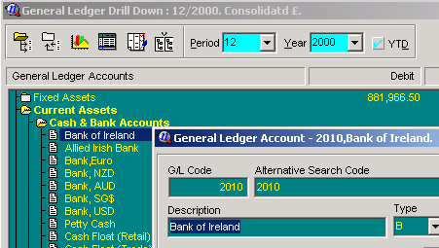
In the General Ledger, expand Cash & Bank Accounts and create a new entry for each format you wish to use. Here we have entered the BOI as GL Code 2010 and AIB as 2020.

Create a new text file in your Enterprise data directory and call it Mbacs.ini. Open the file and type in the following (replacing the numbers in the square brackets with the GL Codes of the entries you have created and entering the appropriate sort code and account number):

; Bank of Ireland
[GL CODE 2010]
BANK_SORT=777777
BANK_ACC=88888888
BANK_REF=
BACS_TYPE=2
PAY_FILE=BI_Pay.dat
REC_FILE=BI_Ddeb.dat

; Allied Irish Bank
[GL CODE 2015]
BANK_SORT=010101
BANK_ACC=90909090
BANK_REF=
BACS_TYPE=1
PAY_FILE=AIB_Pay.txt
REC_FILE=AIB_ddeb.txt

When you have finished typing in the details save and close the file.

When making a payment of receipt batch run, proceed as normal. When the Batch dialog appears type the appropriate GL code for the format required into the Bank GL field. This will ensure that the correct format is used.

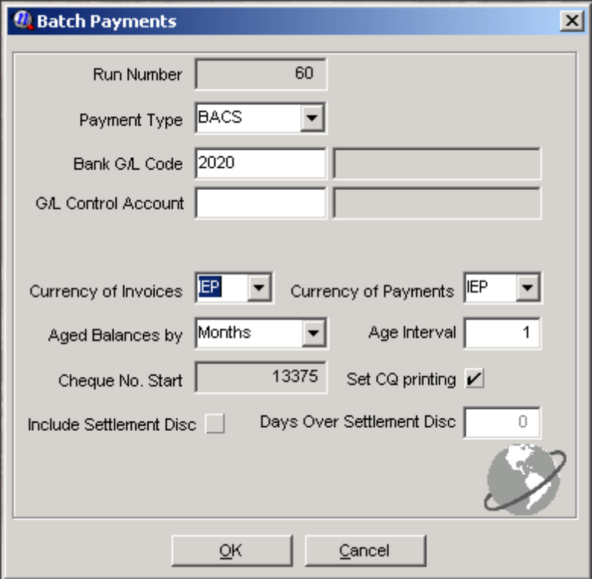

Allied Irish Bank EFT File format

This creates a batch transaction file in Allied Irish Bank EFT File Format.

Setup procedure

INI file

The process uses the file AIB_EFT.INI for settings. AIB_EFT.INI must be in the Enterprise data directory. The only setting in the INI file is the Authorised User ID for the bank’s EFT service. This should be entered in the INI file as below.

[EFT]
UserID=

Output

Output files will be saved to the Enterprise data directory under the following names:

AIBPAY.DAT for payment runs
AIBDDEB.DAT for receipt runs

Currency

The Allied Irish Bank format allows transactions to be in either Punts or Euros. If transactions are in Euros then the currency table in Enterprise MUST be set up to that the Screen Symbol for Euros is either the standard Euro Symbol (€ - ASCII code 128) or ‘EUR’. The export process will treat anything other than these as Punts.

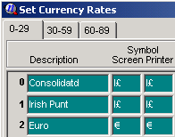

Troubleshooting

Error message: Check system bank details. Run aborted
Remedy: In Enterprise select Utilities\System Setup\General Settings from the main menu. On the company tab scroll to the right and ensure that the values in the A/C field and the Sort Code field are in the correct format: the A/C should be exactly 8 digits and the Sort Code should be exactly six digits. Do not include any characters other than digits in these fields.

Error message: Check bank details for:
Remedy: This error message will list the accounts to check. For each account, select the eComm tab and ensure that values in the Bank A/C field and the Sort Code field are formatted correctly i.e. 8 digits and 6 digits respectively with no other characters. Also ensure that the Pay Type is set to BACS.

Bank of Ireland EFT File format

This creates a batch transaction file in the Bank of Ireland EFT format.

Setup procedure

INI file

The process uses the file BI_EFT.INI for settings. BI_EFT.INI must be in the Enterprise data directory. The only setting in the INI file is the Authorised User ID for the bank’s EFT service. This should be entered in the INI file as below.

[EFT]
UserID=

Output

Output files will be saved to the Enterprise data directory under the following names:

BI_PAY.DAT for payment runs
BI_DDEB.DAT for receipt runs

Troubleshooting

Error message: Check system bank details. Run aborted
Remedy: In Enterprise select Utilities\System Setup\General Settings from the main menu. On the company tab scroll to the right and ensure that the values in the A/C field and the Sort Code field are in the correct format: the A/C should be exactly 8 digits and the Sort Code should be exactly six digits. Do not include any characters other than digits in these fields.

Error message: Check bank details for:
Remedy: This error message will list the accounts to check. For each account, select the eComm tab and ensure that values in the Bank A/C field and the Sort Code field are formatted correctly i.e. 8 digits and 6 digits respectively with no other characters. Also ensure that the Pay Type is set to BACS.

Barclays Bacstel format Plug-In

This creates a batch transaction file in a format suitable for Barclay’s Bacstel system.

Output

Output files will be saved to the Enterprise data directory under the following names:

BACS.IMP for payment runs
DDEB.IMP for receipt runs

Each file will be in fixed-length format and will contain the following fields (in order):

Destination Sort Code
Destination Account Number
Transaction Type
Amount
Reference
Destination Account Name

Troubleshooting

Error message: Check system bank details. Run aborted
Remedy: In Enterprise select Utilities\System Setup\General Settings from the main menu. On the company tab scroll to the right and ensure that the values in the A/C field and the Sort Code field are in the correct format: the A/C should be exactly 8 digits and the Sort Code should be exactly six digits. Do not include any characters other than digits in these fields.

Error message: Check bank details for:
Remedy: This error message will list the accounts to check. For each account, select the eComm tab and ensure that values in the Bank A/C field and the Sort Code field are formatted correctly i.e. 8 digits and 6 digits respectively with no other characters. Also ensure that the Pay Type is set to BACS.

Barclays BusinessMaster Plug-in

When you run a batch payment, the hook will produce a file called BAC1.TXT. This file is suitable for importing into Barclays BusinessMaster.

Ini file

The process uses the file ENTBMAST.INI for settings. ENTBMAST.INI must be in the Enterprise data directory. The only setting in the ini file is the Currency Number for Sterling from the Currency Table within Enterprise. This should be entered in the ini file as below.

[Currency]
Sterling=1

Troubleshooting

Error message: Check system bank details. Run aborted
Remedy: In Enterprise select Utilities\System Setup\General Settings from the main menu. On the company tab scroll to the right and ensure that the values in the A/C field and the Sort Code field are in the correct format: the A/C should be exactly 8 digits and the Sort Code should be exactly six digits. Do not include any characters other than digits in these fields.

Error message: Check bank details for:
Remedy: This error message will list the accounts to check. For each account, select the eComm tab and ensure that values in the Bank A/C field and the Sort Code field are formatted correctly i.e. 8 digits and 6 digits respectively with no other characters. Also ensure that the Pay Type is set to BACS.

DBS Ideal IBG Format Plug-In

This creates a batch transaction file in a format suitable for the Development Bank of Singapore’s Ideal Interbank giro system.

Setup

The Plug-In uses the file IDEAL.INI for settings. IDEAL.INI must be in the Enterprise data directory. The only setting in the INI file is the user's Company ID, which is the ID under which the user logs into IDEAL. This should be entered in the INI file as below.

[Ideal]
UserID=

Bank details

Bank account no can be up to 11 digits
Bank no can be 4 digits
Branch can be 3 digits

These must be stored as follows

Bank Account and Bank No must be stored in the Bank Reference field separated by a hyphen or dash (-). E.g. where the bank account is 1111111111 and the bank no is 7171, the reference field should be 1111111111-7171

The Branch number should be stored in the Sort Code field.

Output

Output files will be saved to the Enterprise data directory under the following names:

IDEAL.DAT for payment runs
IDEALDD.DAT for receipt runs

Troubleshooting

Error message: Check system bank details. Run aborted
Remedy: In Enterprise select Utilities\System Setup\General Settings from the main menu. On the company tab scroll to the right and ensure that the values in the A/C field and the Sort Code field are in the correct format: the A/C should be exactly 8 digits and the Sort Code should be exactly six digits. Do not include any characters other than digits in these fields.

Error message: Check bank details for:
Remedy: This error message will list the accounts to check. For each account, select the eComm tab and ensure that values in the Bank A/C field and the Sort Code field are formatted correctly i.e. 8 digits and 6 digits respectively with no other characters. Also ensure that the Pay Type is set to BACS.

HSBC Hexagon format Plug-In

This creates a batch transaction file in a format suitable for HSBC’s Hexagon system.

Setup

Hexagon will accept transactions in Sterling or Euros. (These cannot be mixed in one batch.) If transactions are in Euros then the currency table in Enterprise MUST be set up to that the Screen Symbol for Euros is either the standard Euro Symbol (€ - ASCII code 128) or ‘EUR’. The export process will treat anything other than these as Sterling.

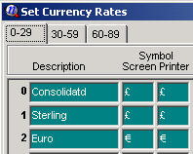

Output

As files are limited to 200 transactions the Plug-In will create as many files as are needed. Files will be placed into the Enterprise data directory and named HEX00001.DAT, HEX00002.DAT,HEX00003.DAT, …etc.

Troubleshooting

Error message: Check system bank details. Run aborted
Remedy: In Enterprise select Utilities\System Setup\General Settings from the main menu. On the company tab scroll to the right and ensure that the values in the A/C field and the Sort Code field are in the correct format: the A/C should be exactly 8 digits and the Sort Code should be exactly six digits. Do not include any characters other than digits in these fields.

Error message: Check bank details for:
Remedy: This error message will list the accounts to check. For each account, select the eComm tab and ensure that values in the Bank A/C field and the Sort Code field are formatted correctly i.e. 8 digits and 6 digits respectively with no other characters. Also ensure that the Pay Type is set to BACS.

Lloyds TSB PC Pay ASCII Format Plug-In

This creates a batch transaction file in a format suitable for Lloyd TSB’s PC Pay system.

Output

The Plug-In will create a file called PCPAY.TXT in the Enterprise data directory. The file will be in fixed-length format.

Troubleshooting

Error message: Check system bank details. Run aborted
Remedy: In Enterprise select Utilities\System Setup\General Settings from the main menu. On the company tab scroll to the right and ensure that the values in the A/C field and the Sort Code field are in the correct format: the A/C should be exactly 8 digits and the Sort Code should be exactly six digits. Do not include any characters other than digits in these fields.

Error message: Check bank details for:
Remedy: This error message will list the accounts to check. For each account, select the eComm tab and ensure that values in the Bank A/C field and the Sort Code field are formatted correctly i.e. 8 digits and 6 digits respectively with no other characters. Also ensure that the Pay Type is set to BACS.

Lloyds TSB PC Pay CSV Format Plug-In

This Plug-In creates a batch transaction file in a format suitable for Lloyd TSB’s PC Pay system.

Output

The Plug-In will create a file called PCPAY.CSV in the Enterprise data directory. The file will be in comma-separated format.

Troubleshooting

Error message: Check system bank details. Run aborted
Remedy: In Enterprise select Utilities\System Setup\General Settings from the main menu. On the company tab scroll to the right and ensure that the values in the A/C field and the Sort Code field are in the correct format: the A/C should be exactly 8 digits and the Sort Code should be exactly six digits. Do not include any characters other than digits in these fields.

Error message: Check bank details for:
Remedy: This error message will list the accounts to check. For each account, select the eComm tab and ensure that values in the Bank A/C field and the Sort Code field are formatted correctly i.e. 8 digits and 6 digits respectively with no other characters. Also ensure that the Pay Type is set to BACS.

NatWest Autopay Plug-In

This Plug-In creates a batch transaction file in a format suitable for NatWest’s Autopay system.

Setup

The AutoPay format requires a four-digit Bank Reference number as shown on the mandate for each account and also needs to know whether the account requires a remittance advice. This information should be stored in one of the User Defined fields on the Supplier record in the format xxxx/a where ‘xxxx’ is the four-digit Bank Reference number and ‘a’ is either Y or N to specify whether a remittance advice is required or not. The default is N.

The same User-Defined field should be used for each supplier and to let the Plug-In know which field the information is stored in it should be entered into the file NATWEST.INI in the Enterprise data directory. This file should be created and the appropriate value entered before trying to use the Plug-In. The number of the UD Field used should be entered as follows (assuming you are using UDField 1):

[AUTOPAY]
BANKREF=1

Output

The output file will be saved to the Enterprise data directory under the name AUTOIMP.TXT

Troubleshooting

Error message: Check system bank details. Run aborted
Remedy: In Enterprise select Utilities\System Setup\General Settings from the main menu. On the company tab scroll to the right and ensure that the values in the A/C field and the Sort Code field are in the correct format: the A/C should be exactly 8 digits and the Sort Code should be exactly six digits. Do not include any characters other than digits in these fields.

Error message: Check bank details for:
Remedy: This error message will list the accounts to check. For each account, select the eComm tab and ensure that values in the Bank A/C field and the Sort Code field are formatted correctly i.e. 8 digits and 6 digits respectively with no other characters
NatWest PayAway Plug-In

This Plug-In creates a batch transaction file in a format suitable for NatWest’s PayAway system.

Output

Output files will be saved to the Enterprise data directory under the following names:

PWPAY.TXT for payment runs
PWDDEB.TXT for receipt runs

Each file created is in fixed-length format and contains the following fields (in order):

Bank Sort Code
Bank Account Number
Bank Account Name
Amount
Reference

Troubleshooting

Error message: Check system bank details. Run aborted
Remedy: In Enterprise select Utilities\System Setup\General Settings from the main menu. On the company tab scroll to the right and ensure that the values in the A/C field and the Sort Code field are in the correct format: the A/C should be exactly 8 digits and the Sort Code should be exactly six digits. Do not include any characters other than digits in these fields.

Error message: Check bank details for:
Remedy: This error message will list the accounts to check. For each account, select the eComm tab and ensure that values in the Bank A/C field and the Sort Code field are formatted correctly i.e. 8 digits and 6 digits respectively with no other characters. Also ensure that the Pay Type is set to BACS.

ABN-AMRO Electronic Payment Hook

Introduction

Exchequer Software have developed a hook to allow electronic payments to be submitted using ABN AMRO’s OfficeNet program.
The hook supports domestic payments using the Dutch ClieOp03 format, and foreign payments using the ABN BTL91 format which connects to the SWIFT (Society for Worldwide Interbank Financial Telecommunication) system.

Initial Setup procedures

System Setup
The currency table in Enterprise must be set up so that the screen code for each currency in use is the ISO currency standard.
e.g. NLG - Dutch gliders, USD - US Dollars, GBP - Pounds Sterling

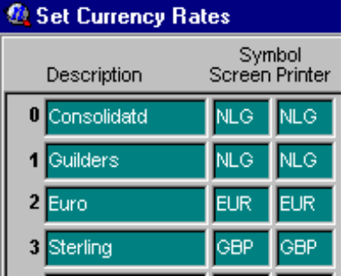

The company details in system setup must contain the UPS address town in line 2 of the company address.

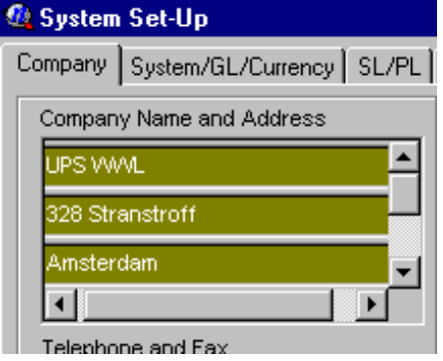

Setting up the G/L
Enterprise will need to have as many G/L codes setup necessary to represent each of the physical bank accounts payments will be made from. These must be setup as Balance Sheet (‘B’) type accounts.

e.g. 20010 ABN NLG/EUR Account.
20020 ABN USD Account..

Two creditor control accounts need to be set up for domestic payments, and foreign payments respectively. These must be set up as Control (‘C’) type accounts within the liabilities section of the balance sheet.

e.g. 31025 Domestic Creditors
31027 Foreign Creditors.

Setting up and maintaining the payment control file ENTABNHK.INI

An external initialisation (INI) file is used to help manage the payment hook, and allow you to maintain any changes to how you would like the system to work in the future.

The file looks like this

[CONTROL]
DOMESTIC_PAYMENT_GL = 31025
FOREIGN_PAYMENT_GL=31027

DOMESTIC_DIR=s:\temp\clieop\
FOREIGN_DIR=s:\temp\btl91\
PAYMENT_DESC=UPS WWL Payment

[BANK1]
ENT_GL_CODE=20010
SWIFT_CODE= ABNANL2A
BANK_NAME=ABN AMRO Domestic
BANK_TOWN=AMSTERDAM
BANK_ISO_COUNTRY=NL
BANK_ISO_CURRENCY=EUR
BANK_COUNTRY=HOLLAND
BANK_ACCOUNT_NO=619152869
BANK_EXCHANGE_CODE=ABNA

[BANK2]
ENT_GL_CODE=20020
SWIFT_CODE=ABNANL2A
BANK_NAME=ABN USD
BANK_TOWN=AMSTERDAM
BANK_ISO_COUNTRY=NL
BANK_ISO_CURRENCY=USD
BANK_COUNTRY=USA
BANK_ACCOUNT_NO=112345670
BANK_EXCHANGE_CODE=ABNA

The section marked [CONTROL] contains general information used to manage the payment process.

DOMESTIC_PAYMENT_GL=31025 : This is used to specify the domestic G/L control code set up within Enterprise.

FOREIGN_PAYMENT_GL=31027 : This is used to specify the foreign G/L control code set up within Enterprise.

DOMESTIC_DIR=s:\temp\clieop\ : This is used to specify the directory you would like the domestic payments file to be created in.

FOREIGN_DIR=s:\temp\btl91\ : This is used to specify the directory you would like the foreign payments file to be created in.

The foreign and domestic directories can be the same.

PAYMENT_DESC=UPS WWL Payment : Use this option to specify the text which will appear on your suppliers statement indicating where the payment has come from. There is a limit of 32 characters.

The section marked [BANKn] where n is a number between 1 & 100 is used to provide additional bank account details for the bank accounts you will be making payments from, and covers both domestic and foreign accounts.

You can add in as many bank accounts as you like, up to a limit of 100, simply by copying an existing bank section, and increasing the [BANK] number by 1. E.g. [BANK3]

ENT_GL_CODE=20010 : This is used to identify which G/L code in Enterprise corresponds to this bank account.

SWIFT_CODE= ABNANL2A : This is used to specify the SWIFT code of your bank account.

BANK_NAME=ABN AMRO Domestic : This is used to identify the name of the bank the account belongs to

BANK_TOWN=AMSTERDAM : This is used to specify the name of the town the bank containing the account is located in.

BANK_ISO_COUNTRY=NL : This is used to specify the two digit ISO country code of the country the bank containing the account is located in.

BANK_ISO_CURRENCY=EUR : This is used to specify the three digit ISO currency code of the currency the bank account is nominated in.

BANK_COUNTRY=HOLLAND : This is used to specify the name of the country the bank containing the account is located in.

BANK_ACCOUNT_NO=619152869 : This is used to specify the bank account number associated with this account.

BANK_EXCHANGE_CODE=ABNA : This is used to specify the first four letters of the SWIFT address of the exchange bank which receives orders for processing.

Setting up Suppliers

Suppliers need to be setup specifically depending on whether they are domestic creditors, i.e. paid electronically into a Dutch bank account (and they are Dutch resident), or whether they are foreign creditors, i.e. paid electronically into a foreign bank account.

Setting up a domestic creditor supplier

For a domestic supplier you must ensure the following fields are used as defined.

- The second line of address must contain the suppliers Town. I.e. Amsterdam.

- Ctrl GL Code must be set up with the Domestic Creditor Control G/L account i.e. 31025

- Pay Type must be set to BACS.

- The payment system will combine Sort code ,Bank A/C & Bank Ref (in that order) to form a complete bank account number. We suggest that for domestic payments, the Bank Ref field is used to store the domestic 10 digit bank account field.

Setting up a foreign creditor supplier

For a foreign supplier you must ensure the following fields are used as defined.

- The second line of address must contain the suppliers town. I.e. Amsterdam.

- Ctrl GL Code must be set up with the Foreign Creditor Control G/L account i.e. 31027

- Area must contain the two digit ISO country code for the suppliers address. i.e. NL

- Pay Type must be set to BACS.

- The payment system will combine Sort code ,Bank A/C & Bank Ref (in that order) to form a complete bank account number. We suggest that for foreign payments, under 18 digits long use the Bank Ref field on its own. For larger bank account numbers over 18 digits, start the account number in Bank A/C and finish it in Bank Ref.
- User defined field 1 must contain the SWIFT code of the suppliers bank.
- Trading Terms message field 1 must contain the name of the suppliers foreign bank. i.e. Bank of America
- Trading Terms message field 2 must contain the town of the suppliers foreign bank. i.e. Washington

Generating a Domestic payment file

The payment files are generated via the batch payments routine contained within the main menu procedures option.

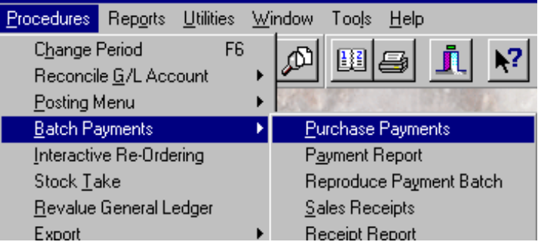

To generate a domestic payment run:-

- Set the payment run type to BACS
- Specify the domestic bank account g/l code in the bank details (e.g. 20010).
- Specify the domestic control g/l code within the G/L control details. (e.g. 31025)
- Finally specify the currency of the payment as either in NLG, or EUR.

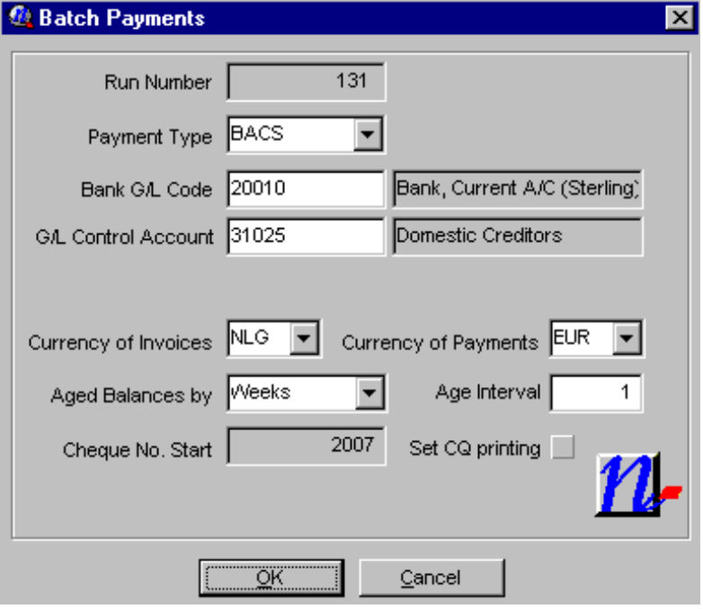

Note: It is very important that the correct combination of Bank Account, and G/L control code are used, as these two fields determine if the payment run is domestic or foreign.

Currency of invoices will determine which outstanding invoices are available for payment. Choosing the base currency will tell enterprise to include all outstanding invoices regardless of currency.
Currency of payment will determine in which currency the payment file is generated. For domestic payments this can be either NLG, or EUR.
If you choose Euro as the payment currency, then you will be given a warning that as standard the UK BACS format does not support foreign currencies. This warning can be ignored.

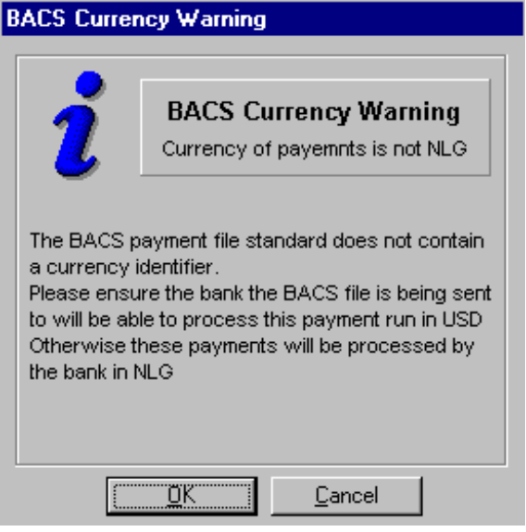

The batch payments system will then search for all outstanding transactions marked with that g/l control code, and display them within the batch payments screen.

Although you will be prompted for a batch payments processing date by Enterprise, OfficeNet will ignore this date, and replace it with the date specified during the import.

When you process the payments run, the payments hook will attempt to create a file called CLIEOP03.nnn in the domestic directory as specified within the ENTABNHK.INI file.
The files are numbered sequentially starting from 1. If CLIEOP03.001 already exists, the system will attempt to create CLIEOP03.002 and so on, until it reaches 99 which it will stop with an error. It is therefore important that you delete these files once they have been successfully imported into OfficeNet.

As the payment run finishes you will be advised of the name of the file which has been created.

Generating a Foreign payment file

The payment files are generated via the batch payments routine contained within the main menu procedures option.

To generate a foreign payment run:-

- Set the payment run type to BACS
- Specify the foreign bank account g/l code in the bank details (e.g. 20020).
- Specify the foreign control g/l code within the G/L control details. (e.g. 31027)
- Finally specify the currency of the payment as whichever currency the bank account you have chosen operates in.

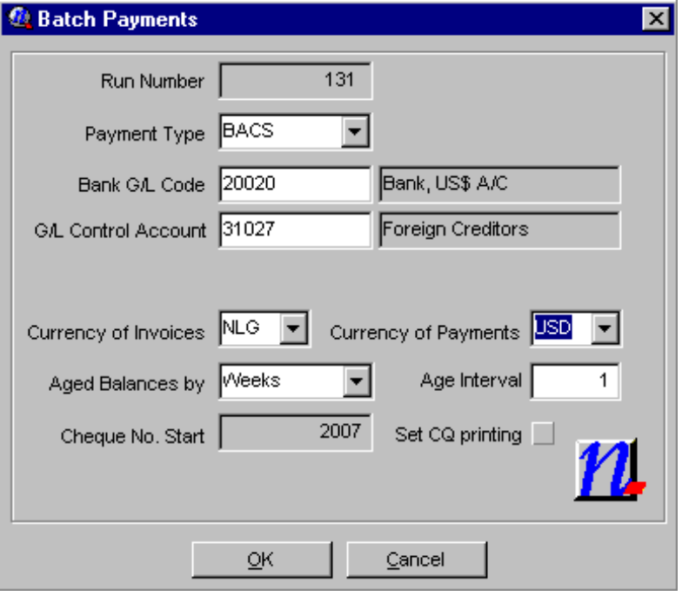

Note: It is very important that the correct combination of Bank Account, and G/L control code are used, as these two fields determine if the payment run is domestic or foreign.

Currency of invoices will determine which outstanding invoices are available for payment. Choosing the base currency will tell enterprise to include all outstanding invoices regardless of currency.
Currency of payment will determine in which currency the payment file is generated. For foreign payments this must be the currency of the bank account the payment will be made from. E.g. USD.
If you choose any currency other than NLG as the payment currency, then you will be given a warning that as standard the UK BACS format does not support foreign currencies. This warning can be ignored.

The batch payments system will then search for all outstanding transactions marked with that g/l control code, and display them within the batch payments screen.

Although you will be prompted for a batch payments processing date by Enterprise, OfficeNet will ignore this date, and replace it with the date specified during the import.

When you process the payments run, the payments hook will attempt to create a file called AnnBTL91.txt in the foreign directory as specified within the ENTABNHK.INI file.
The files are numbered sequentially starting from 1. If A01BTL91.TXT already exists, the system will attempt to create A02BTL91.TXT and so on, until it reaches 99 which it will stop with an error. It is therefore important that you delete these files once they have been successfully imported into OfficeNet.

As the payment run finishes you will be advised of the name of the file which has been created.

The payment hook will set all foreign payments with domestic costs being paid for by you out of your domestic NLG/EUR account, and the correspondence costs being borne by the beneficiary of the payment.
The SWIFT priority is set to standard. Both the costs and priority can be overwritten once the payment details have been imported within OfficeNet.

Importing a Domestic payment file created by Enterprise into OfficeNet v2.0

Once a CLIEOP03.nnn file has been successfully created you need to import the file into OfficeNet. (These instructions assume OfficeNet has already been set up with all your ABN bank accounts).

To import into OfficeNet:-

- Load OfficeNet.
- Choose Start OfficeNet Extra
- Log in with your user name and password.
- Choose option 5 Import/Export
- Choose Import formats
- From the list of imports available, choose CLIEOP03

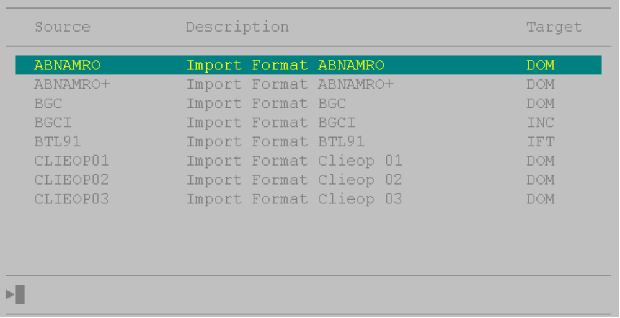

- The first time you go into this option you will need to create a new CLIEOP03 import file, using the New key F7.
- Name the format as DOM for Domestic payments.
- Set Form of payment as follows:-
- N for normal will separate each payment request on your bank statement as individual debits corresponding to each supplier paid.
- B for batch will result in a single entry on your bank statement representing the total value of the entire payment run as a single debit.
- Enterprise’s bank reconciliation can handle either method.

- The processing date will need to be set for each import run, and determines on which date you require the payment run to be processed by the bank.
- Leave the maximum amount as 0, or set it to a value appropriate to you.
- Specify the same directory as in ENTABNHK.INI for domestic payments.
- Enter the file name as “CLIEOP03.”.
- Store the format using the Cfm key F10

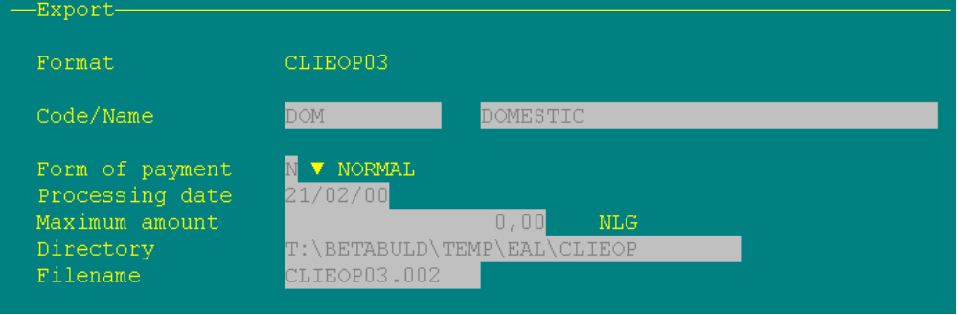
- To import using the format,
- Choose the DOM format.
- Edit it using the Edit key F9
- Change the processing date as required.
- Edit the file name to that of the file generated by Enterprise. I.e. CLIEOP03.001
- Store the format using the Cfm key F10
- Press Cfm (F10) again to import.

- Once the import is successful, you will be able to see the imported payments via the Main Menu Payments/Orders option, followed by Domestic Payments

Editing a payment instruction from inside OfficeNet

Should you need to edit a payment instruction once it is inside OfficeNet, for example to change the how the bank charges are paid you will need to follow this procedure for both domestic and foreign payments.

The payments are imported from Enterprise as SETS. Whilst a payment instruction has the status as SET, it cannot be edited from the payment screen.

To edit:-

- Choose option 2, Payments/Orders from the main OfficeNet menu.
- Choose option 4, Sets
- Find the set you wish to edit, and press space so that a marker appears next to it. (this selects the set for action. You can mark multiple sets at once)
- Press F2, Act.
- Choose 4, reopen.
- The set will disappear from the sets screen. This is normal

You may now edit the payment details via the Domestic or Foreign payment screen.
- Importing a Foreign payment file created by Enterprise into OfficeNet v2.0

Once an AnnBTL.txt file has been successfully created you need to import the file into OfficeNet. (These instructions assume OfficeNet has already been set up with all your foreign ABN bank accounts).

To import into OfficeNet:-

- Load OfficeNet.
- Choose Start OfficeNet Extra
- Log in with your user name and password.
- Choose option 5 Import/Export
- Choose Import formats
- From the list of imports available, choose BTL91

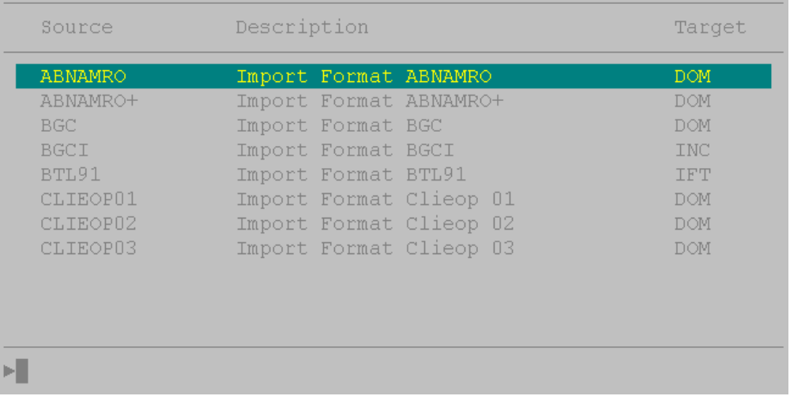

- The first time you go into this option you will need to create a new BTL91 import file, using the New key F7.
- Name the format as FOREIGN for Foreign payments.
- The processing date will need to be set for each import run.
- Leave the maximum amount as 0.
- Specify the same directory as per ENTABNHK.INI for foreign payments.
- Enter the file name as “A01BTL91.TXT.”.
- Store the format using the Cfm key F10

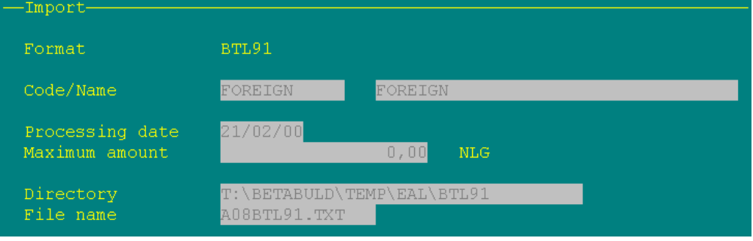

- To import using the format,
- Choose the FOREIGN format.
- Edit it using the Edit key F9
- Change the processing date as required.
- Edit the file name to that of the file generated by Enterprise. I.e. A01BTL91.TXT
- Store the format using the Cfm key F10
- Press Cfm (F10) again to import.

- Once the import is successful, you will be able to see the imported payments via the Main Menu Payments/Orders option, followed by foreign payments.
Bank of Scotland HOBS Plug-In

This Plug-In creates a batch transaction file in a format suitable for the Bank of Scotland’s HOBS system.

Output

The output file will be saved to the Enterprise data directory under the name EXCHHOBS.IMP

Troubleshooting

Error message: Check system bank details. Run aborted
Remedy: In Enterprise select Utilities\System Setup\General Settings from the main menu. On the company tab scroll to the right and ensure that the values in the A/C field and the Sort Code field are in the correct format: the A/C should be exactly 8 digits and the Sort Code should be exactly six digits. Do not include any characters other than digits in these fields.

Error message: Check bank details for:
Remedy: This error message will list the accounts to check. For each account, select the eComm tab and ensure that values in the Bank A/C field and the Sort Code field are formatted correctly i.e. 8 digits and 6 digits respectively with no other characters. Also ensure that the Pay Type is set to BACS.

Coutts Crownline Format Plug-in

This plug-in creates a batch transaction file in a format suitable for Coutts’ Crownline system.

The Coutts format allows you to specify if the header record is included or not in the BACS file created. To let the plug-in know whether this is required create a file called ENTCOUTT.INI in the Enterprise data directory and add the following entry. Setting ExcludeHeader = 1 will remove the header record, setting to 0 will include the header record:

[Settings]
ExcludeHeader=0

Output

The plug-in will create a file called BAC00001.DAT in the Enterprise data directory. The file will be in Coutts format.

Troubleshooting

Error message: Check system bank details. Run aborted
Remedy: In Enterprise select Utilities\System Setup\General Settings from the main menu. On the company tab scroll to the right and ensure that the values in the A/C field and the Sort Code field are in the correct format: the A/C should be exactly 8 digits and the Sort Code should be exactly six digits. Do not include any characters other than digits in these fields.

Error message: Check bank details for:
Remedy: This error message will list the accounts to check. For each account, select the eComm tab and ensure that values in the Bank A/C field and the Sort Code field are formatted correctly i.e. 8 digits and 6 digits respectively with no other characters. Also ensure that the Pay Type is set to BACS.

Royal Bank of Scotland RoyLine for Windows BACS Plug-In

This Plug-In will replace the standard format BACS file created from a payment run with a file in the Royal Bank of Scotland’s RoyLine for Windows Transfer (Domestic) format.

Output

The plug-in will create a file called RoyLBacs.txt in the Enterprise data directory. This file will be in the Standard (Domestic) format suitable for use with RoyLine for Windows.

Troubleshooting

Error message: Check system bank details. Run aborted
Remedy: In Enterprise select Utilities\System Setup\General Settings from the main menu. On the company tab scroll to the right and ensure that the values in the A/C field and the Sort Code field are in the correct format: the A/C should be exactly 8 digits and the Sort Code should be exactly six digits. Do not include any characters other than digits in these fields.

Error message: Check bank details for:
Remedy: This error message will list the accounts to check. For each account, select the eComm tab and ensure that values in the Bank A/C field and the Sort Code field are formatted correctly i.e. 8 digits and 6 digits respectively with no other characters. Also ensure that the Pay Type is set to BACS.

Royal Bank of Scotland Royline Cash Management Plug-In

This Plug-In will replace the standard format BACS file created from a payment run with a file in the Royal Bank of Scotland’s Royline Cash Management format.

Output

The plug-in will create a file called Roy_Bacs.txt in the Enterprise data directory. This file will be in the format suitable for use with Royline Cash Management.

Troubleshooting

Error message: Check system bank details. Run aborted
Remedy: In Enterprise select Utilities\System Setup\General Settings from the main menu. On the company tab scroll to the right and ensure that the values in the A/C field and the Sort Code field are in the correct format: the A/C should be exactly 8 digits and the Sort Code should be exactly six digits. Do not include any characters other than digits in these fields.

Error message: Check bank details for:
Remedy: This error message will list the accounts to check. For each account, select the eComm tab and ensure that values in the Bank A/C field and the Sort Code field are formatted correctly i.e. 8 digits and 6 digits respectively with no other characters. Also ensure that the Pay Type is set to BACS.

Co-op Financial Director Format plug-in

This plug-in creates a batch transaction file in a format suitable for Co-op’s Financial Director system.

Output

The plug-in will create a file called COOPBACS.TXT in the Enterprise data directory. The file will be in comma-separated format.

Troubleshooting

Error message: Check system bank details. Run aborted
Remedy: In Enterprise select Utilities\System Setup\General Settings from the main menu. On the company tab scroll to the right and ensure that the values in the A/C field and the Sort Code field are in the correct format: the A/C should be exactly 8 digits and the Sort Code should be exactly six digits. Do not include any characters other than digits in these fields.

Error message: Check bank details for:
Remedy: This error message will list the accounts to check. For each account, select the eComm tab and ensure that values in the Bank A/C field and the Sort Code field are formatted correctly i.e. 8 digits and 6 digits respectively with no other characters. Also ensure that the Pay Type is set to BACS.

Yorkshire Bank BACS Plug-in

This plug-in creates a batch transaction file in a format suitable for importing into Yorkshire Bank’s Telebank® Business.

Output

Output files will be saved to the Enterprise data directory under the following name: YORKBACS.TXT

Troubleshooting

Error message: Check system bank details. Run aborted
Remedy: In Enterprise select Utilities\System Setup\General Settings from the main menu. On the company tab scroll to the right and ensure that the values in the A/C field and the Sort Code field are in the correct format: the A/C should be exactly 8 digits and the Sort Code should be exactly six digits. Do not include any characters other than digits in these fields.

Error message: Check bank details for:
Remedy: This error message will list the accounts to check. For each account, select the eComm tab and ensure that values in the Bank A/C field and the Sort Code field are formatted correctly i.e. 8 digits and 6 digits respectively with no other characters. Also ensure that the Pay Type is set to BACS.

Ulster Bank Anytime Plug-In

This plug-in creates a batch transaction file in a format suitable for Ulster Bank’s Anytime system.

Setup procedure

Ini file

The process uses the file ULSTRBNK.INI for settings. ULSTRBNK.INI must be in the Enterprise data directory. The only setting in the ini file is the Authorised User ID for the bank’s EFT service. This should be entered in the ini file as below.

[EFT]
UserID=

Output

Output files will be saved to the Enterprise data directory under the following name:

BANKFL.EMT for payment runs

Troubleshooting

Error message: Check system bank details. Run aborted
Remedy: In Enterprise select Utilities\System Setup\General Settings from the main menu. On the company tab scroll to the right and ensure that the values in the A/C field and the Sort Code field are in the correct format: the A/C should be exactly 8 digits and the Sort Code should be exactly six digits. Do not include any characters other than digits in these fields.

Error message: Check bank details for:
Remedy: This error message will list the accounts to check. For each account, select the eComm tab and ensure that values in the Bank A/C field and the Sort Code field are formatted correctly i.e. 8 digits and 6 digits respectively with no other characters. Also ensure that the Pay Type is set to BACS.

Den Danske Bank Plug-In

This plug-in creates a batch transaction file in a format suitable for the Den Danske Bank System.

Output

The output file will be saved to the Enterprise data directory under the name DANSKE.TXT

Troubleshooting

Error message: Check system bank details. Run aborted
Remedy: In Enterprise select Utilities\System Setup\General Settings from the main menu. On the company tab scroll to the right and ensure that the values in the A/C field and the Sort Code field are in the correct format: the A/C should be exactly 8 digits and the Sort Code should be exactly six digits. Do not include any characters other than digits in these fields.

Error message: Check bank details for:
Remedy: This error message will list the accounts to check. For each account, select the eComm tab and ensure that values in the Bank A/C field and the Sort Code field are formatted correctly i.e. 8 digits and 6 digits respectively with no other characters. Also ensure that the Pay Type is set to BACS.

