Enterprise COM Toolkit

Distribution Plans

Shipping the COM Toolkit with Enterprise
The major difference to the Toolkit DLL is that we will supply the COM Toolkit library as part of the Exchequer Enterprise system starting with v4.32.

One of the problems with the Toolkit DLL is that developers test their program with whatever Toolkit is shipping at the time, and then stick with that version missing all the bug fixes and data conversions along the way.

In several cases we have found developers using old v4.30 Toolkit DLL’s with Enterprise v4.31, and in one case a v4.22 Toolkit! A lot of developers with stick with a Toolkit DLL until it no longer works.

By shipping the COM Toolkit in Enterprise it will be automatically upgraded whenever the Enterprise system is, so that it is no longer possible to miss data conversions.

And as the COM Toolkit uses the Toolkit DLL Release Code we will not be giving anything away, the documentation will still only be available to people with a developer licence.

Enterprise Setup Program
This will obviously have to be modified to install the COM Toolkit in the Enterprise directory, and to perform some basic configuration routines:- Currency Settings, Exchequer Path, etc…

Enterprise Workstation Setup
The Workstation Setup should be modified to detect the COM Toolkit in the Enterprise directory and to automatically register it.

Enterprise Splash Screen
The splash screen can be modified to check that the COM Toolkit is properly registered in the same way it already checks for the Enterprise OLE Server and the VCFI Graph OCX control.

Rather than display the error and force the users to ‘Fix’ it, it might be better to just create an error log file and fix it automatically in the background without any user intervention.

Enterprise Registry Configuration Utility (EntReg)
This has already been modified to detect and optionally register the COM Toolkit if present in the Enterprise directory:-

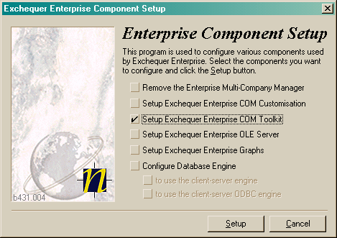

Toolkit Configuration and Test Utility
A new utility should be written which provides a friendly interface into ExchDll.Ini and allows some basic testing to be done. This will perform the same test role as the Test32.Exe program does with the Toolkit DLL.

It would be nice if this utility also allowed ExchDll.Ini to be edited, preferably with validation if the COM Toolkit is up and running.

Upgrading the COM Toolkit

Exchequer Enterprise COM Toolkit Upgrade Program
This program can be used to upgrade an existing COM Toolkit on a workstation, it looks up the COM Toolkit in the Windows Registry to find the path, just leaving the user to click the ‘Upgrade’ button:-

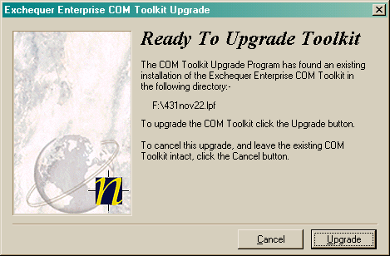

If no COM Toolkit is registered on the workstation it will report an error, and recommends that a workstation setup is performed on the machine.

This program should be made available as a public download from www.exchequer.com, if it is available only to dealers then this will cause problems for customers with a developer licence, and third-party software houses linking to Enterprise.

We could optionally extend the program to allow it to install the COM Toolkit into an Enterprise v4.31, but this would mean that extra files have to be included in the setup program increasing its size.

The current size of the program is already 1.15Mb with only the necessary files being included.

