PowerBuilder and the Exchequer COM Toolkit

These few pages should give you the basic knowledge of integrating some Exchequer functionality into your PowerBuilder application.

CODE EXAMPLES:

Create an MDI FRAME WINDOW for your application.

IN THE “OPEN” EVENT OF THE MDI FRAME WINDOW
( First and foremost you must create the OLEOBJECT in PowerBuilder, so you can access the Exchequer COM Object.
In these examples the OLEOBJECT will be called lole_connection )

long li_rc1, li_rc2

lole_connection = CREATE oleobject

li_rc1 = lole_connection.ConnectToNewObject("Enterprise01.toolkit")

IF li_rc1 <> 0 THEN
MessageBox("ERROR !!","Error in processing Exchequer OLE Object. Please contact your administrator" , STOPSIGN!, OK!)
DESTROY lole_connection
Else
li_rc2 = lole_connection.opentoolkit

IF li_rc2 <> 0 THEN
MessageBox("ERROR !!","Error while initialisation of Exchequer COM Toolkit" , STOPSIGN!, OK!)
DESTROY lole_connection
END IF
End If

IN THE “CLOSE” EVENT OF MAIN MDI WINDOW

//Close COM toolkit
ret1 = lole_connection.CloseToolkit

if ret1 <> 0 then
MessageBox("ERROR !!","Error in closing Exchequer COM Toolkit" , STOPSIGN!, OK!)
end if

GLOBAL VARIABLE
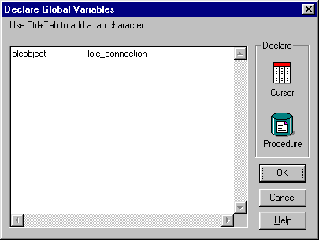
When you’ve initially created the OLEOBJECT you create a global variable of lole_connection, which will be referenced in the application to access the COM Object.

CREATE DATAWINDOW

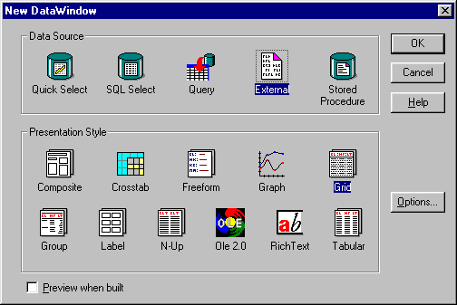
Create your DataWindow with DataSource of
External and whatever Presentation Style you
want. In my example I used Grid Style.

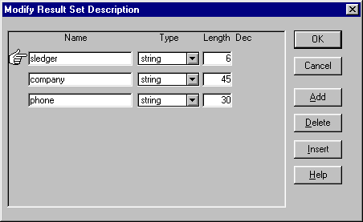
Then type in the Result Set Description of the
fields you want to display.

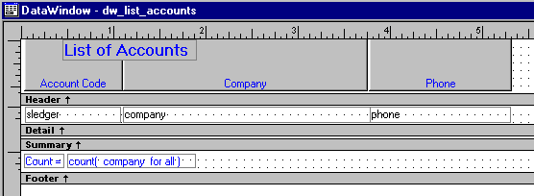
Then set-up the Datawindow design you want.

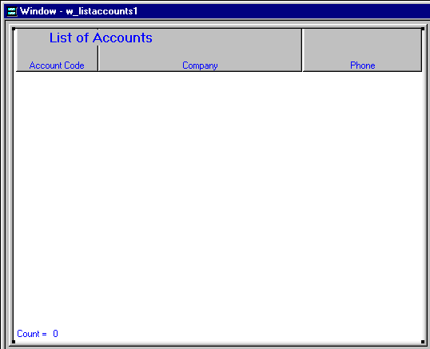
Create your window with a datawindow
and design it the way you want.

“OPEN” EVENT OF THE LIST ACCOUNT WINDOW

string errmsg
long ret
int i

lole_connection.customer.index = 0
ret = lole_connection.customer.getfirst

if ret = 0 then

DO WHILE ret=0

i = dw_accounts.insertrow(0)

if i < 1 then
Messagebox("Error","Error while inserting rows.",StopSign!)
else
dw_accounts.object.sledger[i] = lole_connection.customer.accode

dw_accounts.object.company[i] = lole_connection.customer.accompany

dw_accounts.object.phone[i] = lole_connection.customer.acphone
end if

ret = lole_connection.customer.getnext

LOOP
Else
errmsg = lole_connection.lasterrorstring
messagebox("Error",errmsg)
end if

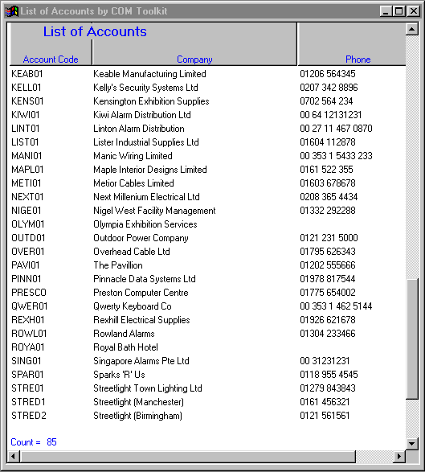
RESULTS

