New Functionality for the Tools Menu in v5.61

Version 1.1

The following functionality is required to be added to the Tools menu for v5.61 of Enterprise
- The user will be allowed to put their options anywhere in the enterprise menu structure
- The user will be able to add submenus as well as options, to create a menu structure of their own.
- Each option will be available to specific users, or all enterprise users.
- Btrieve files will be used to store the setup of the tools menu (not an ini file, as it currently is).
- There will be a conversion routine (which is run the first time you run the new version) which will convert the old ini file to the new Btrieve file structure.
- There will be optional password security on the administration module for the tools menu.

User Interface

The user interface will obviously need to be upgraded to encompass all this new functionality. The main part of this will be displaying the whole of the Enterprise menu structure, and allowing the user to insert their options where they want them. The suggested user interface is to use a tree structure as shown below :

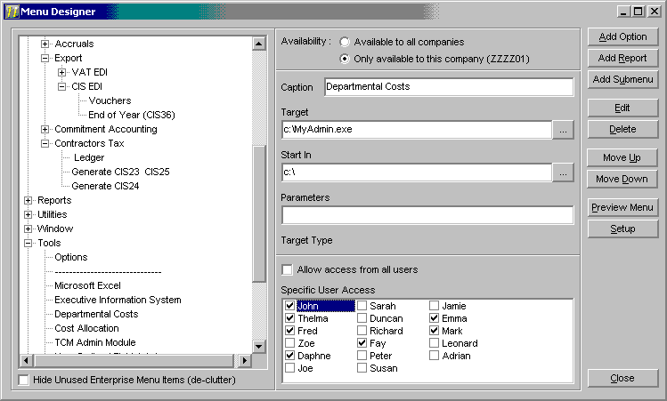
Add Option : This button will allow you to add a new option into the currently highlighted position in the menu tree.
Add Report : This button will allow you to add a new report into the currently highlighted position in the menu tree. Note that the fields Target, Target Type, Start In and Parameters will not be available for reports. A new field “Report Code” (a string of 255 length) will be available, which you will be able to browse for. The browse dialog will allow you to pick the report from the new report writer’s tree structure. Note that this option will only be available if the new report writer is available, and is licensed.
Add Submenu : This button will allow you to add a new submenu into the currently highlighted position in the menu tree. Note that the fields Target, Target Type, Start In and Parameters will not be available for sub menus.
Edit : This button will allow you to edit the currently selected item in the menu tree. Note that Enterprise options will be non-editable.
Delete : This button will allow you to delete the currently selected item in the menu tree. Note that Enterprise options will not be available for deletion.
Move Up : This button will move the selected option up above the previous option.
Move Down : This button will move the selected option down below the next option.
Preview Menu : This button will show you a preview of the current menu, so you can test the menu that you have created.
Setup : This will take you to the setup section of the plug-in, where you can configure the password security.
Hide Unused Enterprise Menu Items (de-clutter) : This option will hide all the enterprise options in the list and all unneeded submenus. This will then show only the user-defined items (and the submenus necessary to show these items) making it much easier to find these items. Note that the 3 add functions will not be available when this box it ticked.
Notes :
- Icons will be used against the menu items, so that user defined items stand out.
- When Items are added, a component name is fabricated and stored for use when adding the menu item. Also, the component name of the parent of the item is also stored.
- The All users option is available, so that when you add a user to your system, you do not have to go through all your user-defined options, and add the new user to each item.
- The user will also be able to drag and drop the user-defined options (not the standard enterprise ones) around the menu tree in order to place them, where they want them.

Availability
The availability of options / sub-menus can be defined to be either for all companies, or for the current company. If you specify an option to be available only for the current company, you can specify the option to be available for all users or specific users. If you specify an option to be for all companies, you can specify the option to be visible for all companies or specific companies, as shown below :
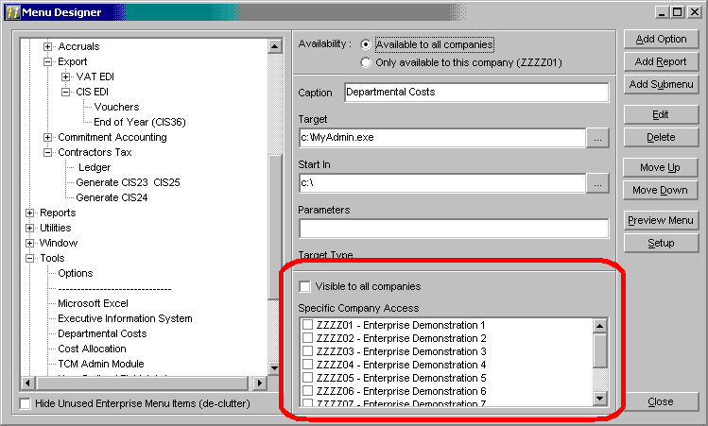

Data Storage

Item naming and positioning
Storing the position of the user-defined menu options in the database is a bit tricky, as it will need to cope with the possibility of the standard enterprise menu changing in the future. It will also need to deal with different versions of enterprise that have different menu structures, and different users that may be shown different menus.
Each user-defined menu item (or submenu) will be stored in the database with 3 fields that identify itself, and its position.
There will firstly be a “component name” which will be the component name used when adding the item to the enterprise menu structure. This name is to be determined by taking the caption of the item, removing all invalid characters, and prefixing it with “UO_” for a User option, or “UM_” for a user submenu. If a component of that name has already been defined, then a number (starting with 1) will be appended onto the name until a unique name is found (i.e. if there is already a UM_Utilities1 and not a UM_Utilities2, then the new unique component name will be UM_Utilities2).
Secondly there will be a “component parent name” which will store the component name of the menu item that contains the user item (or menu). Using this field we can build up the tree-like structure we need to represent the Enterprise Menu Structure.
Thirdly, there will be a “position” field. The position will be a number defining the position within the menu that the item is going to appear. This could cause minor inconveniences when new items are added into the main enterprise menu structure, but there is no good way of dealing with this that I can think of. if one of the user’s items ends up a few items up or down the list, all that they would have to do is to move their item back to where they want it.

Reading the tree structure
When reading the options out of the database there will have to be a bit of intelligence built into the routine. The main issue is that you may be trying to add a user option into a user menu that has not yet been added.
Note that if an option to be added to the menu has a parent component that is not in existence (either in the enterprise menu or in the user menus) then a warning message will be displayed.

Database Tables
For storing the information for the menu options we will be using 1 file with a variant structure, which will be stored in the main company’s directory. The three types of record used in the table will be :
- Menu Items : We will need this record to store all the menu items, and their details.
- Users Cross Reference : We will need this record to store the cross reference of the user’s that are allowed to have access to the menu items.
- System Setup : This record will currently be storing the Password to access the admin module for this plug-in.

Miscellaneous

Debug Options
There are several option in the menu structure of enterprise that should never be shown to the user. These options need to be identified and not shown to the user. We don’t want to “hard code” which options to remove, as EL may want to add some more in, in the future. My suggestion is to use a prefix of ‘XXX’ in the caption or name of all options that we do not wish to show to the user. This way any new debug option that EL adds in can also be removed without modifying the tools plug-in to specifically do so.

Plug-In CD
When a Plug-In is installed, often there is an option to add the admin module for it into the tools menu. To maintain this functionality we will need to update the EntSetup DLL to add a new entry into the Btrieve file. The new option will default to all companies, and will be added at the end of the “tools” menu. The user can then move it or modify it, as they wish.

