Exchequer Enterprise
Customisation Notes

Examples of Modifying the
Delphi Customisation Classes

05 January 2000

Introduction
This document provides examples of how the Delphi Customisation Classes within Exchequer Enterprise can be modified whilst still providing backward compatibility for existing Hook DLL’s.

The diagram below shows how the Delphi Customisation system is designed to work:-

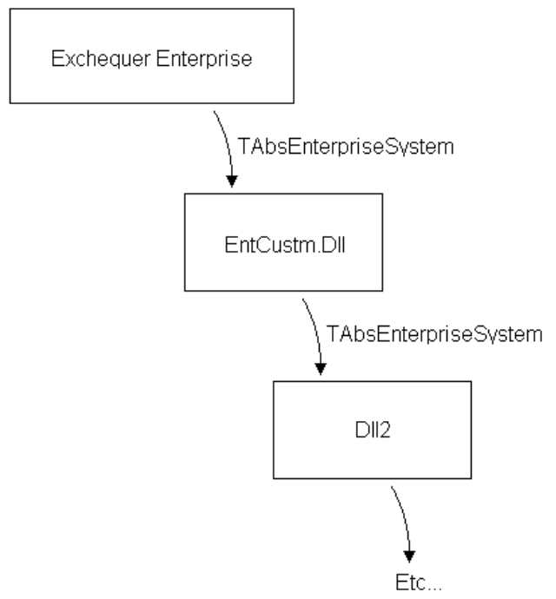
Enterprise internally implements a descendant of the abstract TAbsEnterpriseSystem class, with all the abstract methods implemented.

An instance of this descendant class is passed out to the Customisation DLL’s as a TAbsEnterpriseSystem.

The DLL’s can receive this class as either a TAbsEnterpriseSystem, or as one of its descendants with increased functionality.

If treated as a TAbsEnterpriseSystem then only the base functionality will be available.

If treated as a descendant then all the functionality up to that descendant will be available, functionality added in future descendants will not be available until the DLL is modified to use that descendant.

If an old version of Enterprise is used with a new Customisation DLL using a descendant implemented after that version of Enterprise, then the Customisation DLL will crash.

Base Classes

Abstract

// Base Abstract Class
TAbsCustomer = Class(TObject)
Protected
Function GetField1 : cuStr4; Virtual; Abstract;
Procedure SetField1 (Value : cuStr4); Virtual; Abstract;
Public
Property Field1 : cuStr4 Read GetField1 Write SetField1;
End; { TAbsCustomer }

// Base Abstract Class
TAbsEnterpriseSystem = Class(TObject)
Protected
Function GetCustomer : TAbsCustomer; Virtual; Abstract;
Public
Property Customer : TAbsCustomer Read GetCustomer; { Customer Details }
End; { TAbsEnterpriseSystem }

Implementation

// Implementation of Abstract TAbsCustomer
TCustomer = Class(TAbsCustomer)
Private
F1 : cuStr4;
Protected
Function GetField1 : cuStr4; Override;
Procedure SetField1 (Value : cuStr4); Override;
Public
Constructor Create;
End; { TCustomer }

// Implementation of Abstract TAbsEnterpriseSystem
TEnterpriseSystem = Class(TAbsEnterpriseSystem)
Private
FCustomer : TCustomer;
Protected
Function GetCustomer : TAbsCustomer; Override;
Public
Constructor Create;
Destructor Destroy; Override;
End; { TEnterpriseSystem }

Modifying Subclasses
A descendant of TAbsCustomer is created as TAbsCustomer01 to contain a new property, Field2.

A descendant of TAbsEnterpriseSystem is also create to re-publish the Customer property as a TAbsCustomer01.

Abstract

// Descendant Customer Object
TAbsCustomer01 = Class(TAbsCustomer)
Protected
Function GetField2 : cuStr4; Virtual; Abstract;
Procedure SetField2 (Value : cuStr4); Virtual; Abstract;
Public
Property Field2 : cuStr4 Read GetField2 Write SetField2;
End; { TAbsCustomer01 }

// Descendant Object
TAbsEnterpriseSystem01 = Class(TAbsEnterpriseSystem)
Protected
Function GetCustomer01 : TAbsCustomer01; Virtual; Abstract;
Public
Property Customer : TAbsCustomer01 Read GetCustomer01; { Customer Details }
End; { TAbsEnterpriseSystem01 }

Implementation

// Implementation of Abstract TAbsCustomer
TCustomer = Class(TAbsCustomer01)
Private
F1 : cuStr4;
F2 : cuStr4;
Protected
Function GetField1 : cuStr4; Override;
Procedure SetField1 (Value : cuStr4); Override;

Function GetField2 : cuStr4; Override;
Procedure SetField2 (Value : cuStr4); Override;
Public
Constructor Create;
End; { TCustomer }

// Implementation of Abstract TAbsEnterpriseSystem
TEnterpriseSystem = Class(TAbsEnterpriseSystem01)
Private
FCustomer : TCustomer;
Protected
Function GetCustomer : TAbsCustomer; Override;
Function GetCustomer01 : TAbsCustomer01; Override;
Public
Constructor Create;
Destructor Destroy; Override;
End; { TEnterpriseSystem }

Adding A New Subclass
A new class property, SubClass : TAbsCustomerSub, has been added into a new descendant Customer class, TAbsCustomer02.

TAbsEnterpriseSystem02, a new descendant of TAbsEnterpriseSystem01, has been created to publish the modified customer class.

Abstract

// Base Abstract Class
TAbsCustomerSub = Class(TObject)
Protected
Function GetField1 : cuStr4; Virtual; Abstract;
Public
Property Field1 : cuStr4 Read GetField1;
End; { TAbsCustomerSub }

// Descendant Object
TAbsCustomer02 = Class(TAbsCustomer01)
Protected
Function GetSubClass : TAbsCustomerSub; Virtual; Abstract;
Public
Property SubClass : TAbsCustomerSub Read GetSubClass;
End; { TAbsCustomer02 }

// Descendant Object
TAbsEnterpriseSystem02 = Class(TAbsEnterpriseSystem01)
Protected
Function GetCustomer02 : TAbsCustomer02; Virtual; Abstract;
Public
Property Customer : TAbsCustomer02 Read GetCustomer02; { Customer Details }
End; { TAbsEnterpriseSystem02 }

Implementation

// Implementation of Abstract TAbsCustomerSub
TCustomerSub = Class(TAbsCustomerSub)
Private
F1 : cuStr4;
Protected
Function GetField1 : cuStr4; Override;
Public
Constructor Create;
End; { TCustomerSub }

// Implementation of Abstract TAbsCustomer
TCustomer = Class(TAbsCustomer02)
Private
F1 : cuStr4;
F2 : cuStr4;
FSubClass : TCustomerSub;
Protected
…
Function GetSubClass : TAbsCustomerSub; Override;
Public
Constructor Create;
Destructor Destroy; Override;
End; { TCustomer }

// Implementation of Abstract TAbsEnterpriseSystem
TEnterpriseSystem = Class(TAbsEnterpriseSystem02)
Private
FCustomer : TCustomer;
Protected
Function GetCustomer : TAbsCustomer; Override;
Function GetCustomer01 : TAbsCustomer01; Override;
Function GetCustomer02 : TAbsCustomer02; Override;
Public
Constructor Create;
Destructor Destroy; Override;
End; { TEnterpriseSystem }

Modifying the New SubClass
A new descendant, TAbsCustomerSub01, has been created from TAbsCustomerSub to allow the addition of a new field.

A new descant of TAbsCustomer is created to publish the new descendant of TAbsCustomerSub.

A new descendant of TAbsEnterpriseSystem is created to publish the new descendant of TAbsCustomer.

Abstract
// Descendant Object
TAbsCustomerSub01 = Class(TAbsCustomerSub)
Protected
Function GetField2 : cuStr4; Virtual; Abstract;
Public
Property Field2 : cuStr4 Read GetField2;
End; { TAbsCustomerSub01 }

// Descendant Object
TAbsCustomer03 = Class(TAbsCustomer02)
Protected
Function GetSubClass01 : TAbsCustomerSub01; Virtual; Abstract;
Public
Property SubClass : TAbsCustomerSub01 Read GetSubClass01;
End; { TAbsCustomer03 }

// Descendant Object
TAbsEnterpriseSystem03 = Class(TAbsEnterpriseSystem02)
Protected
Function GetCustomer03 : TAbsCustomer03; Virtual; Abstract;
Public
Property Customer : TAbsCustomer03 Read GetCustomer03; { Customer Details }
End; { TAbsEnterpriseSystem03 }

Implementation

// Implementation of Abstract TAbsCustomerSub
TCustomerSub = Class(TAbsCustomerSub01)
Private
F1 : cuStr4;
F2 : cuStr4;
Protected
Function GetField1 : cuStr4; Override;
Function GetField2 : cuStr4; Override;
Public
Constructor Create;
End; { TCustomerSub }

// Implementation of Abstract TAbsCustomer
TCustomer = Class(TAbsCustomer03)
Private
F1 : cuStr4;
F2 : cuStr4;

FSubClass : TCustomerSub;
Protected
…
Function GetSubClass01 : TAbsCustomerSub01; Override;
Public
Constructor Create;
Destructor Destroy; Override;
End; { TCustomer }

// Implementation of Abstract TAbsEnterpriseSystem
TEnterpriseSystem = Class(TAbsEnterpriseSystem03)
Private
FCustomer : TCustomer;
Protected
…
Function GetCustomer03 : TAbsCustomer03; Override;
Public
Constructor Create;
Destructor Destroy; Override;
End; { TEnterpriseSystem }

