Exchequer Enterprise v4.31

eComms Module

Internal Use Only

Overview
Enterprise has been extended to allow the Email and Faxing of printed documents and reports, this is known as the eComms Module.

The Email/Faxing of Documents is expected to allow our Customers to considerably reduce costs associated with sending monthly statements, remittance advices, copy invoices, etc… by replacing paper based statements with Email or Faxing. This will eliminate the cost of the printing, paper, envelope, stamp and envelope stuffer for the cost of the phone call.

The Email/Faxing of Reports is expected mainly to be used internally within companies and for Technical Support.

During the development of this we were concerned with the security of the information being emailed to the customers as well as the size of the attachment. If a statement was emailed to a customer in a format where it could be easily changed then it was liable to be hacked by unscrupulous companies. For this reason, text and graphics based formats such as word documents and bitmap images were rejected.

In the end we decided to support the Adobe Acrobat standard and our own internal format based on that used by our printer engine.

Adobe Acrobat is an industry standard document format that is independent of any particular operating system or product, research at the recent shows showed that people thought that using Adobe Acrobat was a very good idea. Acrobat files are also quite secure as you would need to purchase the correct Adobe utilities in order to edit them. The downside with Adobe Acrobat is that the licencing would cost approximately £150 per user.

We included our own internal format to circumvent this licencing issue. Our internal format is an extension of the format used by the printer engine in Enterprise and is actually more secure than the Adobe Acrobat Format as there are no programs in existence that can read and change the contents of the file. The downside is that the files are bigger than their Acrobat equivalent, particularly if the forms have graphics on them. However, it does give a higher quality output when the email recipient prints it.

The emails themselves can be sent in either using MAPI, a Microsoft standard, or through the normal SMTP Server method.

Faxes can be sent using MAPI or the Enterprise Fax System.

System Setup
Various new fields have been added to the Fax/Email tab within the Enterprise System Set-Up dialog.
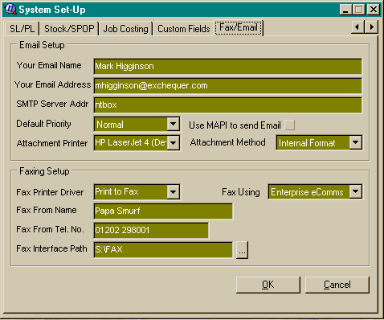

Email Setup
This section contains the existing fields for the EDI VAT shipped last year as well as new fields purely for the Email.

Attachment Printer | This tells the printing routines which printer should be used to create the attachment, this obviously depends on the Attachment Method detailed below. For the Enterprise Internal Format it should be set to a normal printer whose settings for page size, etc… will be used to create the document. For the Adobe Acrobat PDF format it must be set the Adobe Acrobat PDF Writer printer.
Attachment Method | This tells the printing routines what format the documents are going to be attached to emails in:-  Internal Format – This is the format used internally by the printing routines within Enterprise. The system will attach a .EDF file, Enterprise Document File, to the email and the recipient will need the Exchequer EDF Reader to view it. The EDF Reader will be provided as a single file install program of approx. 540k.  Adobe Acrobat PDF – This format uses the Adobe PDF Writer to create industry standard PDF files, the email recipient will need the Adobe Acrobat Reader to view it. The Acrobat Reader can be freely distributed and is available from Adobe’s web-site, WWW.Adobe.Com, and can also be found on many magazine cover disks, the single file install is approx. 3.9Mb in size.

Faxing Setup
This is a new section and contains the following fields:-

Fax Printer Driver | This tells the printing routines which printer to use for faxing, for the Enterprise eComms faxing it should be set to the ‘Print To Fax’ printer installed by the eComms module. For MAPI it should be set to whichever printer you want to use for page sizes, etc…
Fax Using | This tells the printing routines which fax method is going to be used:-  Enterprise eComms – This uses an Enterprise fax driver to print to the Enterprise Fax System.  MAPI – This uses Simple MAPI to send faxes.  NOTE: Enterprise will be extended in the future to support other fax systems like WinFax and FaxNow.
Fax From Name | Default From Name
Fax From Tel. No. | Default From Fax Number.
Fax Interface Path | This is the path to the Enterprise Fax System, currently S:\FAX, and is disabled for MAPI faxing which doesn’t use it.

Enterprise Print Setup Dialog
Enterprise’s Print Setup dialog has been modified slightly and now consists of 3 tabs:- Printer, Fax and Email. You will notice that the dialog now automatically changes size as yoou change tabs.

To print something you fill out the Printer tab and click the OK button on the Printer Tab, for faxing fill out the Fax tab and click the OK button on the Fax tab, to Email fill out the Email tab and click the OK button on the Email tab.

You will notice a slight delay when you first move from the Printer Tab to the Fax or Email Tabs if you have MAPI Email or Faxing enabled. This is caused by Enterprise checking to see if MAPI is available.

If you are using the Enterprise Fax System and don’t have the Fax Client running the Fax Tab will be hidden automatically. This is checked each time the Print dialog is created.

Printer Tab
The printer tab basically represents the original printing functionality within Enterprise. It has been slightly modified in appearance, but basically unchanged.
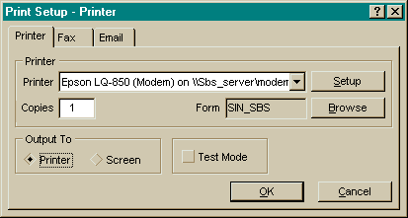

Fax Tab
The Fax Tab handles all the information required to fax a form or report.
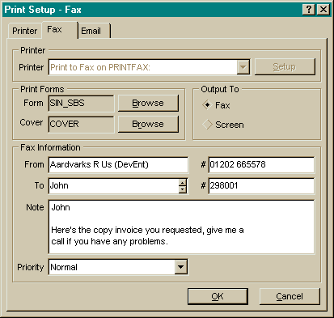
The To Name and Number will be intelligently defaulted by Enterprise depending on what type of document you are printing.

Printer | This is only available when faxing via MAPI, otherwise it must be left as defined in System Setup.
Cover | This is the Fax Cover Page that must be of the same form type, EFD or PCC, as the main form.
Note | This is a free format memo field that can be accessed from within the Form Designer. It is intended for use on the Fax Cover Page.
Priority | This is used by the Enterprise Fax System to determine whether it is an Urgent, Normal or Off-Peak job.

Email Tab
The Email tab allows the entry of any information required to send a document or report via email.
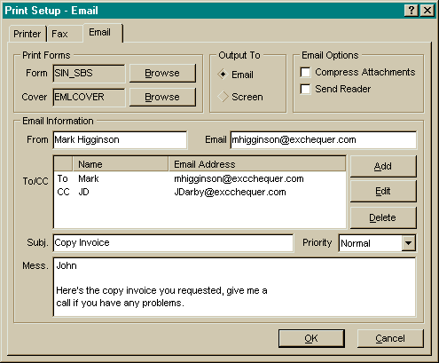

Various fields will be added into the Customer/Supplier Records during the next conversion to allow these fields to be defaulted.

Cover | This is an optional cover page for the email.
Compress Attachments | This compresses the EDF/PDF file into a PK-ZIP v2.04g compatible .ZIP file.
Send Reader | This is intended to allow the EDF or PDF readers to be sent to the recipient with minimum hassle. It basically attaches the contents of the READER subdirectory to the email.
To/CC | This is a list of recipients which will receive the email.
Subj. | Email Subject
Priority | The email priority.
Mess. | This is a free format memo field that is placed in the email as the message, and which can also be accessed from within the Form Designer for an optional Email Cover Page.

General Changes
To make the system easier to use, two ‘Most Recently Used’ style lists have been built into the dialog. This first operates on the main forms and the second on the cover pages, these lists are accessible through popup menus on the edit boxes and remember the last 10 forms selected through the Browse buttons. These lists are NOT stored when Enterprise shuts down.

The popup menu on the Cover Page forms also has a clear option to allow something to be generated without the cover page.

Miscellaneous
Cover Pages cannot be used with reports because of technical limitations.

Form Designer
Other than the ability to print to fax and email very little has changed in the Form Designer.

System Setup Form Definition Sets
The System Setup Form Definition Sets have been extended to include default Fax and Email Cover Pages.

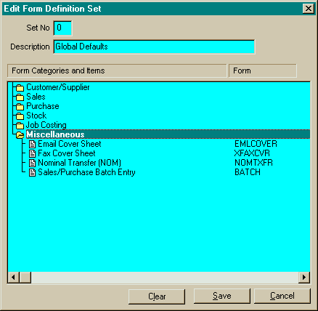
Data Dictionary
The Data Dictionary has been extended to give access to the new fields on the Fax and Email tabs of the Print Dialog. This allows the information to be shown on a cover page. The Fax tab is represented by FAX… fields and the Email tab by EML… fields.

NOTE: These fields will always be available within the forms even when not sending a fax or email, this allows them to be used as user definable fields if required.

PCC Forms
For printing PCC Forms to Fax and Email it has been necessary add in two more setup statements:-

@FXFNT Courier New
@FXSIZ 8

These are used to define the font which the system creates the Fax/Email in. If not specified the system defaults to Courier New 9 point.

Exchequer EDF Reader
This is a new utility required for Faxing via MAPI and for reading EDF files attached to Emails.

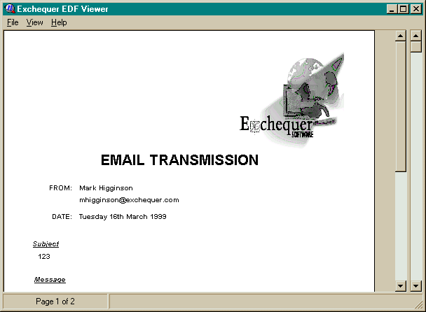

When it is installed you will find any EDF files attached to Emails will be shown with the Enterprise icon and double-clicking on them will run the view.

Enterprise Fax System
The Enterprise Fax System will be a simple networked fax system that can be run from Windows based PC’s over a Netware or NT network.

The Development and Sales Departments have been testing a prototype of the system for the last couple of months and together we have identified various bugs and improvements to be made to the developed product.

The system will consist of three components:-

- The Client Interface

This will be run on the user’s workstations and will interface their computer with the Server Engine. If the user prints to the Enterprise Fax Driver from applications other than Enterprise this will display a dialog asking for the fax details.

- The Server Engine

This will be left running on an NT Server or a Windows Workstation and is responsible for sending the faxes.

- The Administration Utility

This is the users interface onto the Server Engine for administrative purposes.

NOTE: This product is not intended to be a rival for the big faxing systems.

