Exchequer Enterprise v4.40

Security & Setup Modifications

January 2001

Dictnary.Dat
Dictnary.Dat should only be installed in the main programs directory and in local programs directories, the copy in each sub-company should be removed.

Exchequer, the DOS Report Writer, the Windows Report Writer and the Form Designer DLL should all be modified to pick up the dictionary from the .exe directory.

It may also be used in checks to determine whether a directory contains a valid enterprise system and a valid set of company data.

The replication of DICTNARY.DAT to sub-companies should be removed.

Company Id Number (CID)
One of the problems with applying security to Enterprise is enforcing it, without a complex enforcement system it is usually possible to find a simple workaround.

As an example, if we simply moved the running user count from ExchqSS.Dat to the common Company.Dat it would be global across all companies. However, making a copy of the Enterprise directory would give you two Company.Dat’s, instantly doubling the number of users you can get into Enterprise.

The Company Id Number (CID) is designed to help enforce any global level security we decide to implement by allowing us to easily identify a set of company data, and to control access to that data.

Implementation

Setting the CID
The CID will be a random long integer that will give in the region of 2.1 billion possible values, which are fairly good odds for uniqueness. Alternatively we could use a GUID, which Microsoft guarantee are unique per machine, and probably unique world-wide. A GUID would give us roughly 5.4 trillion-trillion-trillion possible values and Windows API routines are available to generate GUID’s for us.

The CID’s on existing data will be set automatically by the Enterprise v4.40 Conversion/Upgrade program, and will be set automatically as part of the Add Company wizard.

When a set of company data is added into the Multi-Company Manager it will check the CID and set it if not already set.

The Data Copy Wizard will have to be modified NOT to copy the CID around.

Multi-Company Manager
Should the Multi-Company Manager have a company record without a Company Id it will display it in the list as invalid, and prevent the users running with that set of data. The simplest solution will be for the users to delete the company and re-add it again.

When adding an existing company into the Multi-Company Manager it will check the CID is set and copy the CID into the Company Record. If the CID is not set then the MCM will set it.

Add, Edit and Delete Company will also be modified so that they require Exclusive Access to the data, this is needed to eliminate possible security loopholes.

Log files should be written every time a company is added, edited (path changed) or deleted.

Technical Support Backdoor
No technical support backdoor’s should be required, as the CID doesn’t itself prevent the users from doing anything.

Data from Customers will be able to be added into our own systems in the same way that happens with v4.31.

If a backup is restored after the CID has changed, then the security will prevent the data being used. This can be fixed by deleting the existing company record entry in the MCM with the wrong CID and adding the company in again.

Company Licence Count
A licence on the number of companies allowed within the Multi-Company Manager has been requested, as some sites are running hundreds of companies with no additional licencing requirements.

This is a tricky issue as the licence didn’t explicitly limit the number of companies that a user can have, so this would have to be carefully designed and sympathetically handled.

Additionally in Peer-To-Peer environments you may need two or more references to each company, as the machine holding the data will be C:, and the others D:. Including these in the licence count would not be fair.

Capabilities and Limitations
The following design will stop more than the designated number of company data sets being added into a single Multi-Company Manager.

However, this can be hacked my making a complete copy of the Enterprise directory and running them as two separate systems, each with X companies.

Implementation
The following diagram attempts to illustrate the contents of a v4.40 Multi-Company Manager.

COMP01 represents a normal set of company data on a common drive, COMP02 represents a set of company data stored on a local hard disk, and COMP03 a reference to the same data, which has been shared out on a peer-to-peer basis to other computers.
Company.Dat
(Max Companies: 4)

COMP01
(CID-96)
COMP02 (C:)
(CID 836613)
COMP03 (D:)
(CID 836613)

Storing the Company Security Codes
The Security Code, Release Code and Expiry Date for the Company Count security could either be stored in a new record within Company.Dat, or just within the Enterprise Licence File, Entrprse.Dat.

Storing them in Entrprse.Dat would be the best place, but there may not be enough free space to justify allocating it to this.

Storing it in Company.Dat should not be a problem as it is a variant file, but a recovery plan should be generated to cover a situation where Company.Dat has been deleted and no backups are available.

How Many Companies are in Company.Dat
The simplest way to know how many companies are already in Company.Dat is to count the instances of different Company Id Numbers.

The Company Id will be common across multiple Peer-To-Peer entries so it is a fair representation of how many sets of company data are in the MCM.

Upgrading from Pre-4.40
The Upgrade Program should be able to detect the current status of the system and to perform the appropriate actions to bring it up to spec.

Global User Count Across Companies
Currently the security allows an 8-User licence to be used as 8-Users per company, when it actually means 8-Users in total across all companies. This means that some users are using this feature to get additional users for free.

Capability and Limitations
This following design will prevent a set of company data from being used simultaneously in multiple Multi-Company Managers, This is because the User Count checks between the Company Record in Company.Dat and ExchqSS.Dat will fail as soon as someone tries to access the company from a second MCM.

It will also limit the total number of users who can access the companies in any one MCM to the specified number.

This system cannot prevent the user running two completely separate Enterprise systems with the full number of users available in each.

Implementation
The following diagram attempts to illustrate the links between the Multi-Company Manager and the individual sets of company data.

COMP01 represents a normal set of company data on a common drive, COMP02 and COMP03 represent a set of company data stored on a local hard disk, and shared out on a peer-to-peer basis.

Company.Dat
(Global User Count: x)

COMP01
(CID-96)
(User Count: x)
COMP02 (C:)
(CID 836613)
(User Count: x)
COMP03 (D:)
(CID 836613)
(User Count: x)

COMP01
(CID-96)
(User Count: x)

COMP02
(CID-836613)
(User Count: x)

User Count Storage
The master User Count will be stored in Company.Dat together with a master count for the total number of logged in users across all companies.

There MUST be a separate Logged In User Count stored in Company.Dat. If the current Logged In User Count was stored on each Company Record, and the total count derived from the sum of those records, the user count could be bypassed by deleting company entries after the users have logged into the system!

Each Company Record in the MCM will also store the total number of users logged into that company, and ExchqSS.Dat will store a duplicate count for the company.

If these two counts disagree then that suggests that the Company Data may be in more than one Multi-Company Manager, which is breaking the licence agreement. The count on the Company Record would contain the number of users who entered through that instance of the MCM, whereas the count in ExchqSS.Dat would contain the total users who have logged into that set of company data.

Although to be fair, it could be that an update operation failed, or that a historical backup was restored, although Backup’s and Restore’s should always be done when everyone is logged out of the system, and the counts should therefore be zero in both ExchqSS.Dat and on the Company record.

Multi-Company Manager
Another column can be added into the Multi-Company Manager to show the number of users logged into each company.

Release Codes
The Multi-Company Manager would need to be modified to allow the Global User Count to be stored, and provide a dialog to allow it to be set manually.

The Setup Program would need to be modified to set and maintain it.

Running Enterprise
When Enterprise is run it will try to get Exclusive access to the Company Data to determine if anyone else is using the system.

If Exclusive access is achieved then the User Counts in both the Company Record (for all CID instances) and ExchqSS.Dat will be reset to zero, and the global count reduced by the lower of the two counts. We may want to write a log file when this happens. Once that has been done the login dialog will be displayed.

If the Global User Count was reduced by the count held in ExchqSS.Dat, it opens a loophole in the security.

If you have duplicated your Enterprise system and have two companies referenced by both systems, you could get 3 people to log into company A through the main MCM. You then get 3 people to log into company B through the duplicate MCM, but to crash out rather than log out.

This would leave the User Count in ExchqSS.Dat set to 3, and if it was just a demo company you wouldn’t worry about corrupting the data.

You then get someone to log into company B through the main MCM, where no users are currently logged into company B. The Exclusive check during startup would pass and it would see that 3 people were logged in and crashed out, and then it would reduce the Global User Count in Company.Dat by 3.

This means that as far as the Global User Count in the main MCM was concerned no one is logged in!

You could also achieve a similar result by restoring a Company.Dat that has user counts already set.

If the attempt to open the data Exclusively failed, the CID User Counts in the Company Record and in ExchqSS.Dat will be compared. If they match then the Login dialog will be displayed, otherwise a message will be displayed telling the user to run the Reset User Count function, and Enterprise will shutdown.

The Login dialog will display the total number of users logged into all companies, which will be retrieved by a call to EntComp.Dll.

After the user successfully logs in Enterprise will check for a free user slot as it currently does, and if OK the three User Counts held in ExchqSS.Dat and Company.Dat will be updated.

NOTE: It would be friendlier to stop them at the Login dialog.

Reset User Count Function
This function will be available in the Multi-Company Manager to correct the user counts should a mismatch occur.

For each company in the MCM it will attempt to open ExchqSS.Dat Exclusively, if it succeeds it will reset the User Counts to zero, if it fails it will copy the user count from ExchqSS.Dat back into the company Record.

Once all Company Records have been processed the master count of logged in users would be set based on the reset counts.

Log Files will be added for all companies modified during this process.

Toolkit User Count

Original Email

One of the things I would like to introduce fairly soon, is a user count check on the toolkit.

The way we should work it is to implement a 30 day and a full user count. The next release could set a 30 day user count equal to that of the main system and warn them they need to register the full user count with us within 30 days.

Capabilities and Limitations
The following proposal will allow the storage of a global Toolkit User Count to control access into the Toolkit DLL.

One of the Limitations is that a proper workstation setup needs to be done one every workstation using the Toolkit, previously they only needed the Btrieve settings. If the workstation is not adequately configured the Ex_InitDll function will fail.

Another limitation is that if a workstation is setup for a duplicate copy of Enterprise it will happily use the licencing in that copy.

Implementation

Release Code Storage
The Release Codes will be stored in either Entrprse.Dat or Company.Dat depending on availability of space in Entrprse.Dat.

Company.Dat will also be used to store the current user count for the Toolkit, this will be a global count, and not company specific.

The following fields will be required for the User Counts and Expiry Dates:-

30DayUserRelCode : String[10];
30DayUserSecCode : String[10];
30DayUserExpiry : Real;
FullUserRelCode : String[10];
FullUserSecCode : String[10];
TkUsrLogCount : Longint;

The 30-day user count will override the full user count if set,

Ex_InitDLL – Checking Release Codes
The Toolkit DLL will firstly need to be modified so that it knows the location of the main Enterprise directory containing Company.Dat and Entrprse.Dat.

The safest way of identifying the correct directory is to extract the path of the OLE Server from the registry, in the same way the Enterprise Splash Screen does. As this method is completely transparent to the users and programmers it is not easily hackable, and it doesn’t require any changes to either programs or configuration files.

Using the OLE Server path does mean that a proper workstation installation needs to be done on every workstation using the Toolkit DLL.

Several other solutions were identified and considered before being rejected:-

1) | A new entry in ExchDll.Ini containing the path.
 | This has the benefit of not requiring any program changes to programs using the Toolkit, but would be a POP to workaround. Making a second copy of the Enterprise directory would hack this one.
2) | Either a new function or an extension of an existing function, e.g. Ex_InitDLL2.
 | This has the penalty of requiring program changes to programs using the Toolkit, and it would be a POP to workaround. Making a second copy of the Enterprise directory would hack this one.

It is anticipated that the COM Toolkit will be shipped as a component of Enterprise, so it will know that Company.Dat and Entrprse.Dat will be in its own directory, or diverted via EntWRepl.Lst.

Once the directory has been identified, the Toolkit can load the security info and perform the checks as required. Two separate statii should be returned:-

21 Unable to load Security Information (Try doing a workstation setup to fix)
22 Toolkit User Count Exceeded

If the Security Check passes then the Global User Count should be incremented and an internal flag set to indicate that a slot has been allocated.

NOTE: When the backdoor code is specified the user count checking should not be done.

Ex_CloseDLL/Ex_CloseData
These functions will have to check the internal flag set by Ex_InitDLL and reduce the global Toolkit User Count if set.

CD Licence
This will need additional fields to store the 30-Day and Full User Counts for the Toolkit:-

licTKUserCntFull : SmallInt;
licTKUserCnt30 : SmallInt;

CD Licence Generator
This will need to be extended to allow the User Counts to be set. I would move all the Toolkit details into a sub-screen off the module selection dialog, with just a link to it on the module selection dialog itself.

Setup Program
SCD_SetupLicence in EntComp.DLL will have to be modified to set the release codes, and the Replication Function will have to be modified to copy the Toolkit Release Codes around to all companies.

Multi-Company Manager
This will need new options to manually specify the Toolkit User Count.

Reset User Count Function
This function will need to be extended to cover the Toolkit User count as well.

If all companies have been opened exclusively then the Toolkit User Count can be safely reset, if any of the Companies failed to open exclusively then the Toolkit may be in use and the User Count should not be reset.

Hook Licencing and Installation

Original Email
The other thing I would like you to think about is a mechanism to control the hooks. We will start selling them in earnest this year and I would like a system of installing them, we could have all available hooks on a separate CD with the lic file controlling their release and installation, i.e. automatically updating/installing entcustm.ini.

At some stage I would also like a release code mechanism, which I think should perhaps live in the hooks themselves to control Ireland primarily, as once their dealers get hold of the bacs hook, I am sure it will get liberally propagated...

Design
A lot of the following informations will be vague, as the design does depend to a degree on the final user interface design, which has yet to be determined.

Aims
The aim of this project is to allow a CD to be provided to dealers and trainers containing all the hooks we supply. Longer term it may include a selection from dealers and third-party developers, Enterprise Modules, and miscellaneous tools, and it may even be given to end-users.

The CD should provide a friendly interface that clearly describes the functionality of the hook, and details any limitations that the hook has. (RTF, HTML?)

If the user wants to they should be able to install 30-day Trial Versions without requiring a licence, or a

full versions with a licence. The licence could be either a file, ala SCD, or possibly an over the phone release code.

The User should be able to be upgrade any hooks they already have to the latest version, without any additional licencing requirement.

Basic Design
The plan is for us to provide a program on the CD which auto-run’s and gives the user a list of available items.

The exact UI design has not been done at this point, we just have a basic idea of a tree on the left with categories and sub-items, and a browser area on the right containing the detail of the currently selected sub-item. Buttons will be available along the bottom for various functions like installing a trial version, etc…

The TurboPower Component CD’s look good and are easy to use, screenshots of the introduction and detail are shown below:-
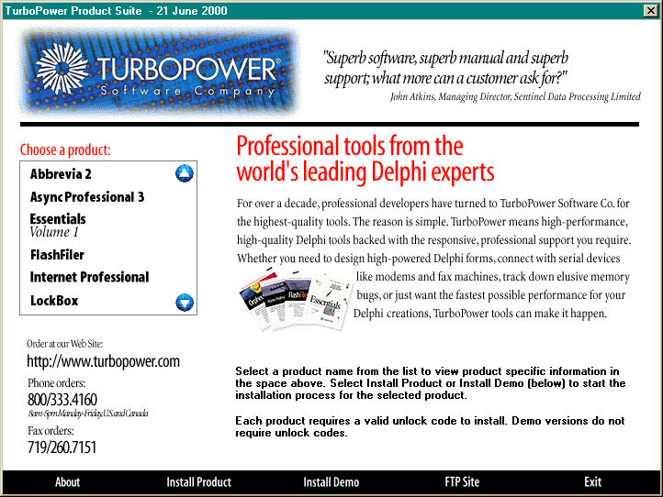
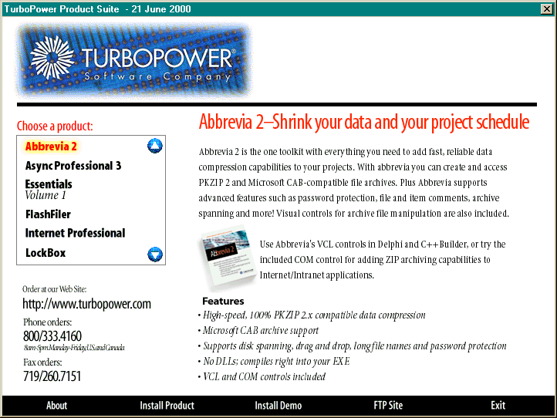

The program will read ALL details in from external data files on the CD, allowing changes to be done to the contents and information without any changes to the program itself.

This will also allow Exchequer Australia, Exchequer EIRE, Exchequer New Zealand and LanPro to easily customise it to local requirements.

CD Structure
The root of the CD will contain the autorun.inf file and the main program, off the root will be
subdirectories containing the components on offer.

Each subdirectory will contain a data file that contains all the information the main program needs to link in its details. This will include details on how to install it, whether trial versions are available, etc…

The details on each component could be provided as a bitmap, like the TurboPower CD shown above, or as HTML and JPG’s or as Rich-Text Format files.

There will also be a setup program that can be used to install the components, parameters could be passed in to indicate 30-day trial or full.

Licencing
The Hook Licence details will be stored in a separate file in the Enterprise directory, with sufficient capacity to handle 300 hook licences.

For each hook a Security Code, Release Code and Expiry Date will be stored, allowing the Hook to be disabled, fully released or released for a 30 day trial period.

To prevent the Hook Licence File being deleted and hooks re-installed for additional trial periods a setting in Entrprse.Dat will record that the Hook Licence File is in existence.

If the file goes missing with this flag set then something nasty should happen if they try to install any more hooks.

Hook Configuration
A standalone configuration program should be provided by the hook vendor, that will be installed with the hook into the Enterprise directory.

The Hook Installation program should automatically allow the hook to be configured at the end of the install.

Release Code Checking
A standard function will be provided to allow a Hook release code to be checked, this may be in EntComp.Dll, or in a brand new DLL. A new DLL has the advantage in that it will be small, allowing it to be statically linked to from the hooks, and then it can dynamically load EntComp.Dll as needed.

The function is not being provided as part of the customisation interface, because this system may also be used by non-hook systems.

Miscellaneous Setup Changes

Demo Installations
Collette and Martin have requested that Demo Installations do not display the Security Code dialog, as it is unnecessary and confuses users.

This looks fairly straightforward to do, the following section of code in ModRels.Pas needs to be extended as shown to check the licence type is not either a Demo CD or Demo Licence:-

If (DLLStatus = 0) And (Not (EntLicR.licLicType In [1, 2])) Then Begin
{ Display Security Warning }
If (UpperCase(Trim(W_InstType)) = 'A') Then
DLLStatus := SCD_SecWarnWizard (W_MainDir, W_MainDir, 1, EntLicR, DoneRelCode)
Else
DLLStatus := SCD_SecWarnWizard (W_MainDir, W_MainDir, 2, EntLicR, DoneRelCode);

{ 1 is also a valid return valid }
If (DLLStatus = 1) Then DLLStatus := 0;
End; { If }

This will cause the Security Warning dialog to be skipped entirely, we may want some sort of warning message to replace it?

Security Warning Dialog
When it sends an email or fax for an expired system the expiry date is shown as DD/MM/YYYY, it should be modified to say ‘Expired’ and also set emails as high priority.

CSV Import Module
The CSV Import Module needs to be added into the setup program as part of the Import Module.

XSL Stylesheets
Extend the Data Copy wizard to allow users to copy the XSL Style Sheets into the new company.

Add Blank Company
When adding a blank company the option of installing blank GL and Stock files should be offered, currently people have to install a blank company and then delete these items before they can setup their own structures.

