Exchequer Enterprise v4.31

Customisation Briefing

With the v4.31 release of Exchequer Enterprise we have decided to follow a 2-way strategy for the customisation:-

1. Delphi 5 Objects
This is a development of the existing Delphi 2 Customisation which has been available in Enterprise for the last two years. It will be updated for changes made in v4.31, but should remain compatible with any existing customisation DLL’s. It provides Enterprise v4.31 with a proven customisation interface and provides a large degree of backward compatibility.

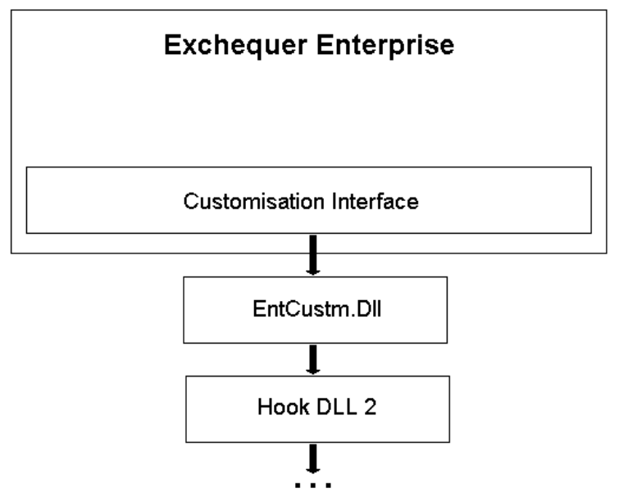

Further details of how the Delphi Customisation works can be found in the Customisation Help File supplied on Dealer CD’s.

2. COM Customisation
This is a new COM based customisation designed to provide language independence and future proofing.

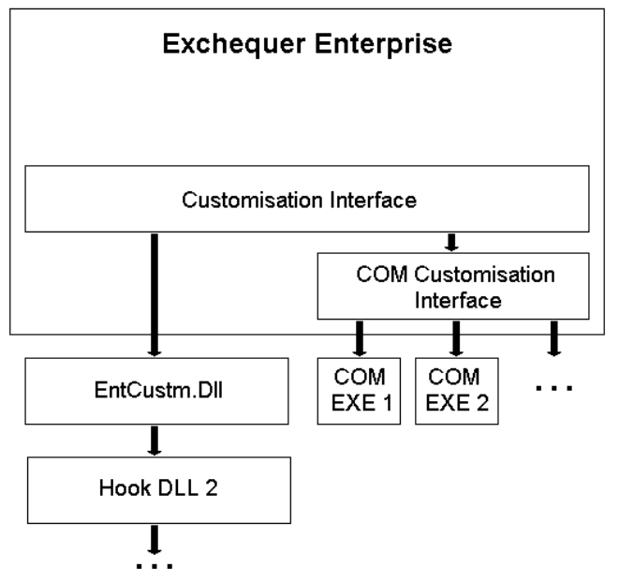

By being COM based, language independance is assured, because all of the major development tools, e.g. Visual Basic, C and Delphi, support the use of COM and many other tools will support it as well.

The customisation is done through an out-of-process COM Client (aka .EXE) which is registered with the Enterprise Customisation routines, and is run automatically when Enterprise initialises its customisation subsystems.

The COM Client will create an instance of the Enterprise Customisation Object, which is available within the main Enterprise .EXE which is now a COM Server. As Enterprise is a COM Server this will also allow closer and more sophisticated links to be developed in the future.

The Customisation Object will be similar to TAbsEnterpriseSystem from the Delphi 5 Customisation model, it provides access to a class heirachy which describes the state of Enterprise at the point a hook event occurs. It also provides various functions to make writing the customisation easier.

When a hook event occurs inside Enterprise an Event will be triggered inside the Customisation Object allowing the COM Client to respond as appropriate.

Delphi 5 Customisation vs COM Customisation
The Delphi 5 Customisation is a proven system which has been shipping and commercially used for 2+ years, the COM Customisation is completely new.

The Delphi 5 Customisation supports Hooks, Menu Customisation and Label Customisation, whereas the COM Customisation will initially support only Hooks. Menu Customisation and Label Customisation may be provided at a later date for COM customisers.

The Delphi 5 Customisation will execute faster than the COM Customisation as the COM routines will require the OS to perform Marshalling to allow the .EXE to .EXE communication required. Marshalling is a system to allow COM communication between processes in 32-bit Windows.

The COM Customisation is language independent, whereas the Delphi 5 Customisation must be written in Delphi 5.

The COM Customisation will require less code to be written as the chaining concept used by the Delphi 5 Customisation isn’t used.

