Exchequer Enterprise v4.31

Oyez Straker

Sales Order Contact Plug-In

Overview
Oyez Straker require a plug-in to execute when a Sales Order is stored to allow the contact details to be stored on the Sales Order. As they also want to be able to search on the contact, the Alt Ref field on the Transaction has been selected for this purpose.

An Administration Module is needed to setup the contact details which will be stored in a Btrieve File.

Additionally a CSV Import routine will be needed to allow the customer to load an existing contacts database of approximately 120,000 records into the plug-in. This will be a once off import to be performed by Exchequer Software using CSV Data supplied by the customer.

Data Dictionary files can also be provided for the Contacts Database to allow the contacts to be accessed externally from ODBC compliant applications such as Microsoft Word and Seagate Crystal Reports.

Limitations
This plug-in will only effect Sales Orders added through Enterprise in the normal manner. If Sales Orders are added in any other way, e.g. through Exchequer (DOS), the Toolkit DLL or the Import Module, the plug-in will not effect them.

Plug-in Design
When a Sales Order (SOR) is stored the plug-in will check the Alt-Ref field to see if it is blank.

If blank, the following popup window will be displayed showing a list of all contacts, in Code order, for the order’s customer:-
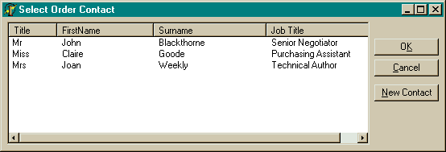

Selecting a contact and clicking the OK button will put that contacts ‘Contact Code’ into the Alt-Ref field on the Order. Clicking the Cancel button will cause the dialog to close without a contact being selected.

Additionally, new contacts for the customer can be added using the New Contact button.

Administration Module
The Contacts will be maintained from a button added into the Customers List in Enterprise, this will integrate the system into Enterprise and allow easy maintenance.
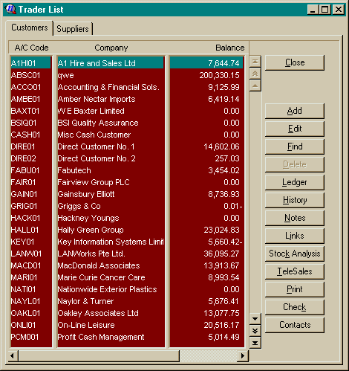
Button displays Contacts List for selected customer

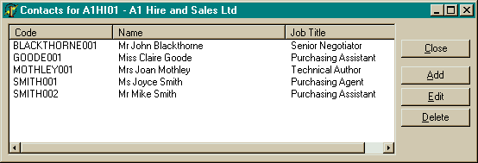
Clicking the ‘Contacts’ button will take the user into the Contacts List for the currently selected customer, this allows the list of contacts to be maintained.

The following fields will be available for each contact:-

Contact Code | This is a unique 20 digit alphanumeric field based on the contacts surname which will uniquely identify each contact within the Enterprise company. To ensure uniqueness a 3 digit number will be appended after the surname, this will allow multiple ‘JONES’ contacts to be added as ‘JONES’, ‘JONES002’, ‘JONES003’, …  NOTE: Once defined the Contact Code cannot be changed as it will not be feasible to update transactions linked to the contact.
Title | Contacts Title, e.g. Mr, Mrs, Miss, Ms, …
FirstName | Contacts first/christian name
Surname | Contacts Surname
Position | Contacts Job Title
Salutation | Method of address, e.g. Jon, Mr Frewer, …
Telephone No | Contacts Telephone Number
Fax Number | Contacts Fax Number
Email Address | Contacts Email Address
DateAdded | Date the Contact was added into database

Data Dictionary Files
Data Dictionary Files (DDF) can be provided as an option to allow the customer to access the contacts database from other programs, e.g. Microsoft Word, Crystal Report Writer, etc…

CSV Import Routine
A routine will be written to allow Contacts to be imported into the database from the customers existing Contacts database.

The existing database will be provided to Exchequer Software as a CSV file. The CSV file will contain the fields held in the contacts database, which is detailed below in the ‘Database Design’ section.

Database Design
The Contacts will be stored in a Btrieve file which will be kept in the main Enterprise programs directory, having all the sub-companies consolidated into one Btrieve file will simplify the hook.

Each Contact Record will store the following details:-

ContactRecType = Record
coCompany : String[6]; // Enterprise Company Code
coAccount : String[10]; // Enterprise Parent Account Code

coCode : String[20]; // Unique Contact Code
coTitle : String[10]; // Title – ‘Mr’, ‘Mrs’, ‘Miss’, ‘Ms’,etc…
coFirstName : String[30]; // Christian Name – ‘Mark’, ‘Kevin’, etc…
coSurname : String[30];
coPosition : String[30]; // Job Title
coSalutation : String[20]; // Method Of Address – ‘Jon’, ‘Mr Frewer’
coContactNo : String[30]; // Telephone Number
coDate : String[8]; // Added Date in YYYYMMDD format
coFaxNumber : String[30]; // Fax Number
coEmailAddr : String[100]; // Email Address

coSpare : Array [1..120] Of Char;
End; { ContactRecType }

The record will be padded out using the coSpare field to provide a small amount of space for future requirements.

Index 0 – coCompany + coAccount + coCode
This Index will be used to load the contacts into both the Popup Selection Window and the Administration Module in Surname order.

Index 1 – coCompany + coCode
This index will be used to calculate the unique Contact Codes, it will allow the uniqueness of a code within a company to be easily checked.

