Exchequer Enterprise

Trade Counter Sales System

Design Specification v1.2

Overview
The Trade Counter Sales System is a simple front-end application using the Toolkit DLL which is intended for Trade Counter operations. It will be a straightforward application which is intended for use with keyboard only, with an optional Barcode scanner.

Here is a simple diagram showing the program flow between different areas of the system:-

LOGIN

Cancel
Sale

SALES ENTRY

Back

TENDER

PRINT SIN/SRI

Additionally, after entering the Sales Entry window the user can opt to find an existing transaction, searching by either the Transaction Reference Number, the Alternate Reference or by Account Code. This will allow sales staff to reference the transaction for returns or warranty, or for making additional payments against it, if it wasn’t paid in full initially.

A major emphasis has been placed on the ability to drive the operation of the pos entirely via the keyboard.
A minimum screen resolution of 800x600 is assumed.
Windows System

Login
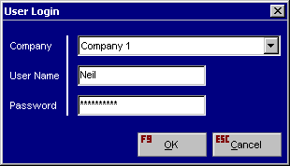
The Login dialog will allow the user to log into the sales system using a valid Enterprise User Id and Password, a company must also be picked on multi-company systems. It is intended that the system should optionally be able to be left in this window between sales as a security measure.

Transaction Entry
After logging in the user will be taken to the Sales Entry window to build the transaction:-

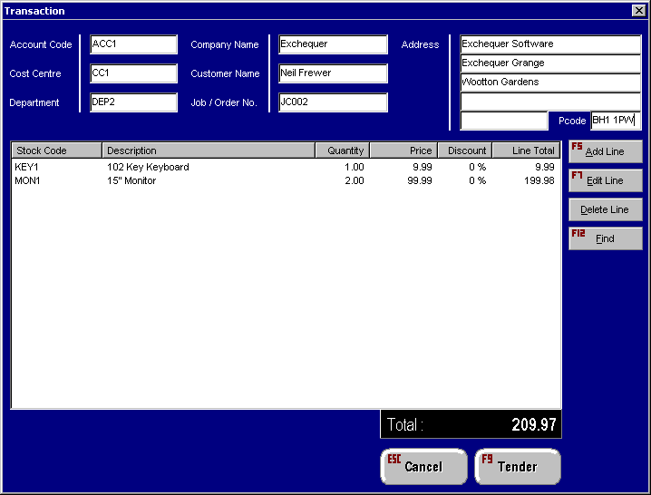

First the user should set the Account Code, for cash sales this would be a general code. It is important that the Account Code is set initially, as Account Customers may have special prices setup. When the Account Code is changed it should recalculate the price for any existing lines, to take into account any discounts. The Cost Centre, Department, company name, customer name, Job / Order No. and Address can also optionally be entered in this screen.

Adding Transaction Lines

A series of lines can be added into the transaction using F5 to bring up the line dialog, or potentially a barcode scanner can be used to select the stock item.

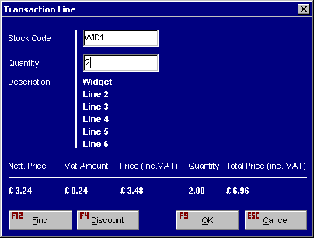

Finding a Stock Item

You will be able to find a stock item by one of the following fields :
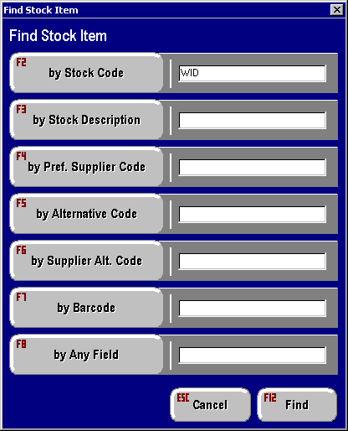

Clicking on find will bring up a list of Stock items to pick from, or if there is only one match it will Pick that Stock Item.
Discounts

Prices can only be changed using discount structure and will need a supervisor password to do so, if the use doesn’t have supervisor rights then a supervisor can authorise the change at that point.

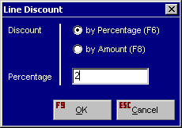
Note : In the Btrieve file there will be a setting which determines whether a new add line dialog pops-up after you have added a line etc. There will also be a setting which defines whether a line is completed by a bar code scan. I.e. it automatically puts in 1 as the quantity and you have to go back and edit it if you want > 1.

When the ‘F9 Tender; button is selected any required Serial Numbers will be requested.

Finding a Transaction

The ‘F12 Find’ button can be used to lookup an existing transaction using the Various fields shown :

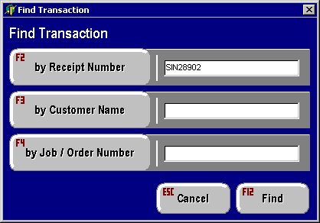
Clicking on find will bring up a list of Transactions to pick from, or if there is only one match it will show you that transaction.

Existing Transactions cannot be changed, but additional payments can be made against them in the Tender window.

Note : This screen will only allow you to find EPOS transactions.

Tendering
The Tender window will be used for paying off the transaction, payment types will be defined in an .INI file with GL Codes.

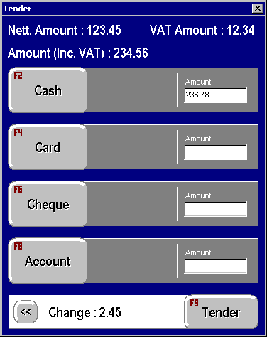

Customers can choose to either leave the transaction outstanding as a Sales Invoice (SIN), or to make a deposit (SIN + SRC), partially pay it off (SIN + SRC) or fully pay it off (SRI).

For Cash Customers, it will also take the tendered amount, and calculate the change. The name of the customer can optionally be placed into the Short Your Ref field on the transaction to make later lookups easier. EL: Short ref may not be big enough so we may need to use Long YourRef.

When the Tender screen is completed the system will print either a Sales Invoice, or Sales Receipt depending on the transaction. To cover potential printer problems, the system will pause here so reprints can be done if necessary.

Credit Card Details

For Credit Card customers the Card Number, Name, Expiry Date and any transaction Authorisation Code will be placed into the User Defined fields on the Receipt Line in the SRC or SRI.

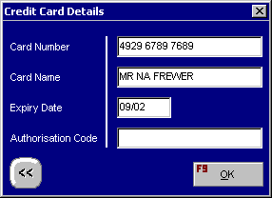

Additional Notes

Barcoding
Barcode support will be built into the Stock Code field by using a prefix character, ‘<’, to indicate that a bar code has been entered instead of a Stock Code.

Cost Centres and Departments
If enabled, the default Cost Centre and Departments will be taken from optional defaults in an .INI file for the Computer Name. These can optionally be overridden when the Operator logs in with defaults for the Operator.
A set-up option will allow the cost centres to be derived from the stock records or account codes as per Enterprise instead.

Each POS will uniquely identify its own transactions by populating UD1 of each transaction with its POS number to facilitate a break down of sales by POS.

Deposits
The system is also intended to allow deposits to be made in situations where something is being ordered, and the full payment is made on delivery. The Tender Screen allows partial payments to be made, and when the item is collected the original transaction can be looked up and the outstanding balance paid off.

Passwords and Security
The system will use the standard Enterprise security, with two additional options being added into the password lists for ‘user can use POS System’ and ‘User is POS Supervisor’.

Printing
The SIN/SRI will be printed through the Toolkit Printing Functions to a designated printer (default printer?). The form can be in either PCC or EFD format, and the form name will be defined within the Trade Counter System. We may need different forms for CASH and Account sales.
It should be possible to print to a receipt printer or full sized printer based on the form designer.

Euro
No provision for the euro or other currencies has been made on this initial version, although the printed forms would be able to give a euro equivalent on all the prices.

Cash Drawer
We intend providing support for the operation of a cash drawer. An option will be given to state under what conditions the cash drawer is opened.

Reconciliation Report
It is anticipated that an end of day report will be produced from each, or by one POS detailing a breakdown in summary or full of all sales taken, versus payments taken, by POS, and by operator.
An initial float value will be provided so that cash in draw can be taken into account.
Any discrepancies between ales and takings (unders and overs) will be accounted for within Enterprise.

Multi location stock
Where multi location stock is in operation, a default location will be assigned to each POS, and all stock will be assumed to have originated from this single location, no provision for location override is anticipated.
Misc Emails on Subject

From Darran regarding Barcode Scanners
You are correct in that the barcode scanners that we use essentially decode the barcode and stuff its character equivalent into the keyboard buffer.

There is no problem in having the scanner stuff in a '<' in the case of Enterprise or a '?' in the case of Exchequer before each barcode - the only draw back that we have found is that once you program a prefix the scanner puts in that prefix every time you scan a barcode. It is also our experience that it is not feasible to have users changing the prefix so a scanner needs to be initially setup up to be for use with Enterprise or Exchequer.

We buy the scanners complete with stand and all cables to cater for both AT and PS/2 keyboards for approx IR£150.00. They plug in between the keyboard and the PC, no additional power supply or anything is required.

With regard to programming the prefix's read the following:

The model Scanner that we use, a Metrologic MS951 supports a max of 2 User Programmable Prefix ID characters and 2 suffix ID characters - the user programmable ID's are setup by scanning the relevant barcodes from the Programming Guide supplied with the scanner.

In summary the guide contains a barcode for all of the system operations and a barcode for each decimal value 0 to 9. Each character in the ASCII Reference Table is denoted by a 3 digit decimal value. So to set prefix ID 1 to '<' you would scan the following barcodes from the manual:

From Kevin Horlock
Thanks for the spec, on the whole it sounds as if what is in the spec will suit the saw centre well. Their requirement where the Futura QPOS option collapsed was live stock and pricing etc.

The one element I think would still be missing would be the end of day reconcillation element of the actual till draw. My workaround to date, would have been to have a bank account set up specifically for a the "till", the opening of the till draw goes in tandem with this element. Is there any specific till/hardware you have in mind that overcomes this problem, or should I stick with CB systems (or whoever in the future for other POS sites) making use of a hook point.

It may also be that these people may be willing to be a test centre for us?. If you think its worth proposing to them let me know.

Eduardo’s Reply
I would like to pursue this one ourselves as it would be a good test bed. I had hoped to use the payment part of the G/L as a means of reconciliation, but we have not thought this through. Perhaps when you are next in we could go through it to discuss your own thoughts. We have no specific hardware in mind yet other than a PC with a cash draw connected to it some how. I believe you can use the fact you are printing to a receipt printer act as a trigger to open the draw.

We could do with getting Richard involved in this discussion.

Richards Investigation
Having done some research it appears that the manufacturers of peripherals use epson ESC/POS command set for controlling add-ons.The normal configuration is p/c to printer(serial) then to run the drawer and display from there.The drawer is opened using a drawer kick command from the softwear.It is important that the printer has pass through ports in case of failure.The majority of peripherals have there own power supply.Epson supply technical information and drivers for both win.3.1,95 & nt and dos on the web site at

WWW.POS.EPSON.CO.UK/SUPPORT/UTILITIES.HTM

I have also found a site where you can download almost any manufactures technical documents,its WWW.SCANSOURCE.COM.I have downloaded a file and its in s:\rh\520i.pdf to see if it made any sense to anyone. However there is no hard and fast rules cash drawers can be purchased powered or not dependent on the rs232 port in the p/c as well as remote displays,it would mean thatyou will tend to use up the available com ports quicker using this method.

From Eduardo
A few issues we need to incorporated in the design of the Trade Counter module

We need to operate a cash drawer, this will be done via a com port. Each Till needs to be identified and any resulting transactions will need to be stamped (User defined field perhaps) with the originating Till.

We may need to support a customer display, again via a com port.

We will need to produce a report for reconciliation purposes which shows sales for the day against cash taken. A float for the start of day may need to be input as a negative SRI. A cash reconciliation sheet form to be available for manual entry via FD.

Darran’s Feedback
I have read through the specification and have to say that I'm already looking forward to the demo !

Comments:
When Tendering for Cash Customers the name of the customer can be entered into the Short Your Ref field - could this be into the Long Your Ref field as the Short at only 10 characters is very short.

Would it be possible to also have a mask to enter a company name and address - perhaps store in the TH usd's ? In a lot of cases even though you might want to treat a customer as a cash customer ie. not open an a/c they may well want to use the receipt/invoice to claim vat - when this is the case most customers will insist on a docket that shows their company or trading name as well as their address. We currently have the SRI def setup to print out the delivery address fields from the sri and the operator types in the company name and address here if necessary.

The Stock Code field will have support for the '<' prefix indicating a barcode - will this be the only search prefix supported ? If so I would recommend that the Alt Code prefix be added - a lot of Trade Counters will be working from a manufacturer's catalogue and in most cases this will be their alt ref for the stock item in question.

Re printing - I would agree that separate layouts for Cash and Account Sales will be necessary. In our POS mock-up at the moment we use SRI's for cash sales and SIN's for normal account sales. The SIN layout is setup to print onto pre printed full size tractor feed paper and an Invoice Printer is defined to print to LPT1. For SRI's the layout is setup to print off on a till receipt printer and a printer is defined to print to LPT2. This has a notable shortcoming in that we rely on the operator to select the correct printer from the Print To menu provided by Exchequer. We also use a Cash Drawer that the Receipt Printer kicks open during the printing of the SRI. This is achieved by passing a CTRL Code to the Receipt Printer, see below

@ES [#27,#112,#0] {Open Cash Drawer}
@ES [#27,#105] {Cut Off Receipt}

I've been meaning to test the PCC format layouts in Enterprise for a while now but never got around to it ! I'm sure you can tell me off hand in any case whether the PCC format supports the @ES function used above or not ? HM: Coded, but not personally tested.

To take this a step further if you are allowing different forms for different transactions can you also allow a different printer per form ? HM: Already supported within Enterprise Forms, not PCC Forms.

