The Exchequer Trade Counter Module

Installing the Trade Counter Module.

The installation for the Trade Counter Module varies from most other Enterprise modules, due to the fact that you must install the Trade Counter on every machine that you wish to run it on. When you install Enterprise on your network, a Trade directory will be created – This is the directory that you use to install the TCM (Trade Counter Module) from. Do not try to run the Trade Counter Module from this directory, as it will not work. You will be allowed to run the Administration Module from here, but will only be granted access to the reports, so that you can run the reports from any machine on the network.

When you have installed the TCM on all machines that you require, you should have a setup something like this:

Server
X:\Excheqr\Entrprse\Trade

Till #1

Till #2

Till #3

C:\Excheqr\Trade
C:\Excheqr\Trade
C:\Excheqr\Trade

Installation Procedure :

- Run TCMSetup.exe from the Trade directory off of your Enterprise directory.
- Click on the Next button on the Welcome dialog – Btrieve will now be configured on your workstation.
- You will now be asked for the installation directory. Enter the local directory that you wish to install the trade counter module to. Click on Next to continue.
- A dialog will now appear asking for the name of your till. This name will be stored against your transactions, and is used in the reports of the Trade Counter Module. Enter a description, then click on Next to continue.
- You can now define which Program group to add the icons to, then click on Next.
- You will now be informed that the Setup program is ready to install the files onto your system. You must click on the checkbox that states that no one is currently running this copy of Enterprise, before beginning the installation. Click on Install to start copying the files.
- When all the files have been copied, it will inform you. Click on Finish to complete the installation. The Trade Counter Administration module will now be run for you.

Setting up your Trade Counter Module.

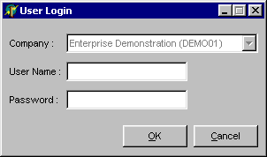
- Run the newly created icon ‘Trade Counter Administrator’ to configure the options in your Trade Counter System.
- You will now be asked to login :

Pick a company (if you have more than one), Type in your Enterprise username and password, and then click on OK to continue.

- To enter the system setup for your till, run the System Setup option under the Utilities menu.
- You will now be presented with a tabbed dialog, which allows you to change all the options for the Trade Counter Module.
- When you have made the changes that you require, click on the Save button to save your changes.
General Tab

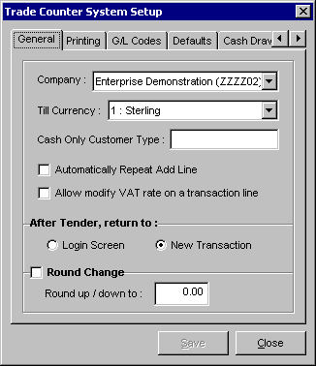
Company : This option allows you to pick a default company for this Till. When you run the Trade Counter Module, you will be using this company, and will not be able to change it. When you run the Administration module, it will default to this company, but you will be able to change it.

Till Currency : This option allows you to pick a currency for the Till, all posted transactions will be posted in this currency.

Cash Only Customer Type : This allows you to pick a customer type (Account Type on the customer record in Enterprise) for which they will only be allowed to pay by cash in the Trade Counter Module.

Automatically Repeat Add Line : When you have this option checked, it will continually bring up the Add Line dialog, until you click on Cancel.

Allow modify VAT rate on a transaction line : If you have this option checked, it will allow you to change the VAT rate of any item that you add in the Trade Counter Module. This option is also protected by an Enterprise password.

After Tender Return To : This option sets whether or not, you are brought out to the Login prompt, every time a transaction is completed. If you set it to Login Screen, you will be taken back to the login, if you set it to New Transaction, you will be taken to the main Transaction screen ready to add another new transaction.

Round Change : If you have this option checked then all of your change will be rounded to the nearest amount input in the box below. The remaining amount will be written off. (e.g. if you have it set to 0.05, and the change is 12.56, the actual change given would be 12.55, if the change were 12.58 then the actual change would be 12.60 etc.)

Printing Tab

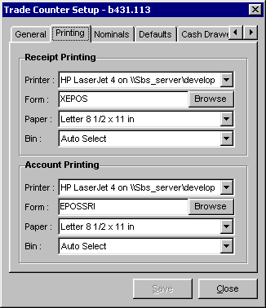

There are 4 different settings for each of the 2 printer types. The only difference between the settings is that they are either for the Receipt or the Account Printer. You can choose which of these 2 printers to print to, on the Tender screen before you print the transaction.

Printer : This is the Windows Printer driver that you are going to use to print to this printer.

Form : This is the Enterprise form (EFD, or EDF) used to print the transaction

Paper : Allows to select the paper size that you are printing to

Bin : Allows you to pick the Printer Bin, or location, that you wish to print to on your printer.
Nominals Tab

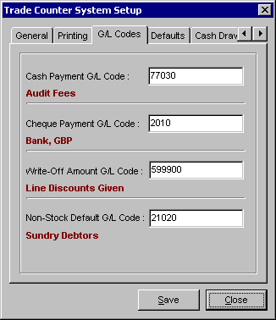

Cash Payment Nominal Code : This defines the nominal code to which cash payments are allocated to, when transactions are posted into Enterprise.

Cheque Payment Nominal Code : This defines the nominal code to which cheque payments are allocated to, when transactions are posted into Enterprise.

Write-Off Amount Nominal Code : This defines the nominal code to which written-off amounts are allocated to, when transactions are posted into Enterprise.

Non-Stock Default Nominal Code : This defines the nominal code to which sales of Non-Stock items are allocated to, when transactions are posted into Enterprise.

Defaults Tab

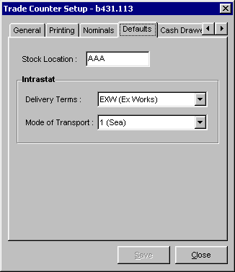

Stock Location : This defines the stock location which any stock is said to have come from when you sell it through the trade counter module (Note : This is only enabled when multi-location stock is switched on).

Delivery Terms : This is the default delivery terms which is used for all sold items in the trade counter module (Note : This is only enabled when SSD/Intrastat fields are enabled in Enterprise).

Mode of Transport : This is the Mode of Transport which is used for all sold items in the trade counter module (Note : This is only enabled when SSD/Intrastat fields are enabled in Enterprise).

Cash Drawer Tab

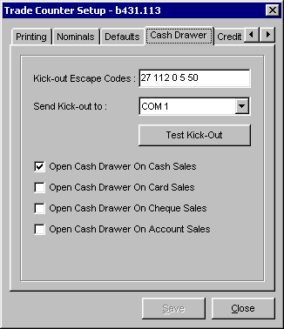

Kick-out Escape Codes : This is the list of escape codes that need to be sent out, to open the cash drawer. It will be a list of numbers separated by a single space between each one.

Send Kick-out to : This defines the Com-Port that the above escape codes will be sent to, to open the cash drawer.

Test Kick-Out : Clicking on this button will send the defined escape codes down the defined port - hopefully opening the cash drawer.

Open Cash Drawer On Cash Sales : When ticked, the cash drawer will open, when you do a Tender which involves a Cash amount.

Open Cash Drawer On Card Sales : When ticked, the cash drawer will open, when you do a Tender which involves an amount put on a Card.

Open Cash Drawer On Cheque Sales : When ticked, the cash drawer will open, when you do a Tender which involves an amount paid for by cheque.

Open Cash Drawer On Account Sales : When ticked, the cash drawer will open, when you do a Tender, leaving an amount on the Account.

Credit Cards Tab

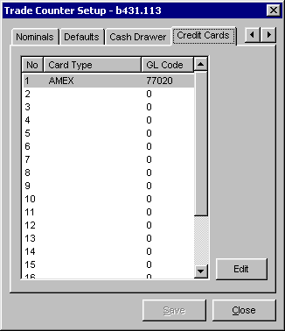

On this tab is a list of 20 different credit cards and their GL / Nominal Codes. You can setup the description of a card and set a nominal code for payments of this card to go to. When you do a Tender to a card, you will be asked for the type of card. The payment will then be allocated to the GL Code that you have setup for that card type.

Adding a Basic Transaction in the Trade Counter Module.

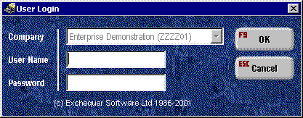
- First you must pick a company, and login to the Trade Counter Module using your Enterprise username and password :

- Press F9 to continue, this will then take you to the main transaction screen :
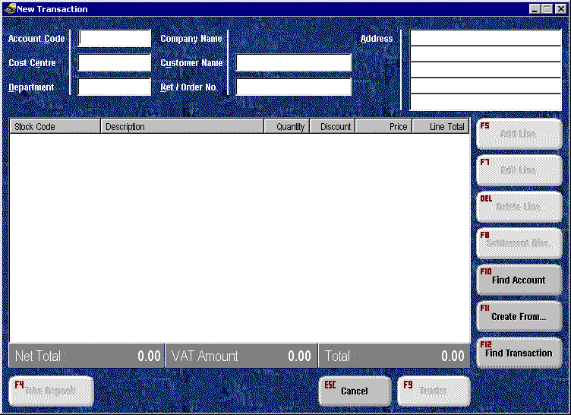

- Pick an account code by one of the following methods

- Pressing return to get a list of accounts by account code.
- Typing in all or part of the Account Code followed by return. A list will pop-up if there is more than 1 match to your search.
- Enter the “/” character followed by all or part of the Account Name and press return to search.
- Enter the “?” character followed by all or part of the alternative code for that account and press return to search.
- Enter “**” followed by the text that you want to find in any field, followed by return.
- Press F10 to use the Fins Account function (we will cover this in more detail later).

- If you have Cost Centres and Departments enabled in Enterprise then these will be the next 2 fields that you need to fill in. For these fields partially or fully type in the code of the cost centre / department, or just press return, to pick from a list.
- The customer name will come from the account details, but you can override this for each transaction (i.e. it will not change the name that is stored against the customer itself).
- You can now enter in a Job / Order number if necessary.
- The address is brought in from the account, but can be modified if necessary for each transaction. This will be stored in the delivery address of the transaction.
- To add an item using a barcode scanner, just scan the barcode when in the main screen, or press F5 and then scan, if you wish to define a higher quantity than one.
- If you are manually adding a line, press F5 and the following dialog will appear :
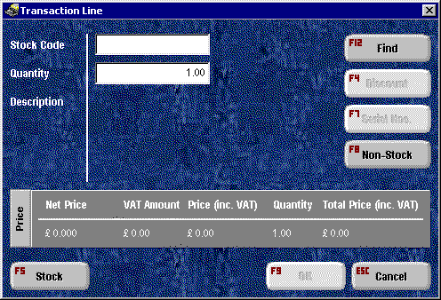
- To find a stock item you can use one of the following methods :
- Pressing return to get a list of Stock Items by code.
- Typing in all or part of the Stock Code followed by return. A list will pop-up if there is more than 1 match to your search.
- Enter the “/” character followed by all or part of the Description of the stock item, then press return to search.
- Enter the “?” character followed by all or part of the alternative code for the stock item, then press return to search.
- Enter “**” followed by the text that you want to find in any field, followed by return.
- Press F12 to use the Find Stock Item Function (we will cover this in more detail later).
- Now enter the quantity of the item that you are selling
- Press F9 to add this stock item to the list.
- Repeat steps 9 – 12 for each item that you want to add, or just scan the barcodes of all the items that you want to add to this transaction.
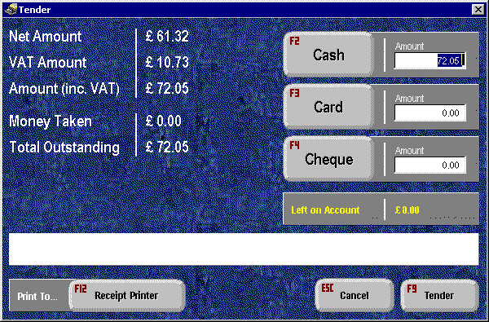
- Press F9 to go to the Tender screen :

The tender screen allows you to split the payment between different pay types (Cash, Card, Cheque). Any money left over will be either left on account, or written-off.
- Enter the amount of cash, card and cheque that you are taking for this transaction. If you press the F2, F3 or F4 keys, the amount that it currently left on account will be added to the corresponding Tender Type.
- To select the printer that you want the receipt to appear on, press F12, this will toggle between the account and the receipt printer. When you have entered all the figures and are ready, press F9 to complete the transaction.
- If you entered an amount that is more than the Total Outstanding then, the change for this will be shown in the white box on the screen. If you did not specify enough to cover the whole transaction then the following message will appear :
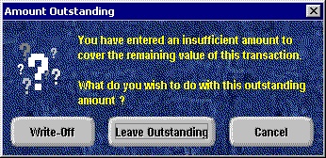
If you choose to Write-Off the amount, it is taken as a discount payment on the transaction, and the transaction created in Enterprise will be an SRI. If you choose to leave the amount out standing then an SIN and an SRC will be created, with the remaining balance being left on the account. This will also mean that you can come back to this transaction at a later date, and pay off the remaining amount.
- If you chose to pay by credit card, a details window will appear asking you for the card details :
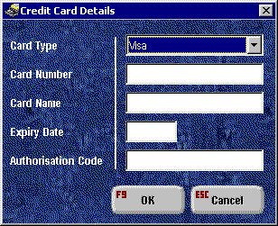
Pick the card type from the list (you can set this list up in the Configuration Program), and fill in the rest of the details, pressing F9 when you have finished.
- A Receipt should now be produced on the printer that you specified in the Tender screen. If a printout is not produced, you may want to check your printer settings in the Configuration Program.
- You have now added a simple transaction using the Trade Counter Module.

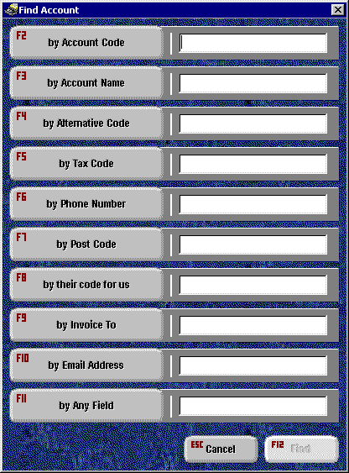
Finding an Account

- To find an account using the Find Account function, you need to press the F10 key, from the main transaction screen. This will bring up the following dialog :

- Press the Function Key which corresponds with the field that you want to find by – e.g. F7 to Find by postcode.
- The cursor will now go to the correct input field. Input the text that you want to find by and then press F12 to execute the Find.
- If there is more than one account record that matches your input, then a list is shown for you to pick from. You can then use the cursor keys to pick the required account.
- If there is one matching record then you will be taken back to the main transaction screen with the account details filled in.
- If no account is found then a message will pop-up informing you of this.

Adding Non-Stock Items

If you wish to add an Item to your transaction that does not currently exist in your Stock Database, you can do this by adding a “Non-Stock” item.

- From the main transaction screen press F5 to add a new stock item to the list
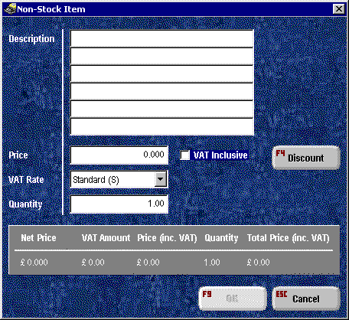
- Now press F8, to make the new item a “Non-Stock” item. A screen like this should now appear :

- You can now enter in all the details necessary to sell this Item. You can enter in up to 6 lines of description, the selling price, the VAT Rate and the quantity.
- Press F9 to add this item to the Transaction

Please Note : This will not add a stock item into Enterprise, only a line into the transaction that you are creating.
Adding a Line Discount

The Discounts from within Enterprise are, by default, already taken into account when you add them to a transaction in the Trade Counter Module. You can however add an additional discount on top of this structure. To add a line discount :

- From the details window of the Stock or Non- Stock Item, press F4 to bring up the discount window :
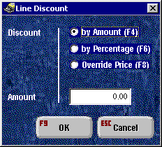
- You can now select how you want to discount this item :

- By specifying an amount to take off of the current price (F4).
- By specifying a percentage to remove from the current price (F6).
- By specifying a new price to override the old one with (F8).

- Now enter the value that you want to use for you discount, and Press F9 to apply the discount.

Stock Interrogation

You can examine the stock levels for a stock item, in the stock item details screen. To toggle the stock view on and off, you can use the F5 key

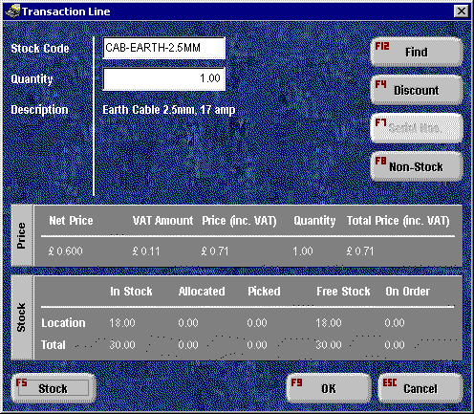
Settlement discounts

The Settlement Discount information for a transaction is brought in from the Account that the transaction is pertaining to. You can, though, change the discount percentage and days per transaction, if you do not want to use the default from the account. To change the settlement discount information for a transaction :

- From the main transaction screen press F8 to bring up the following window :
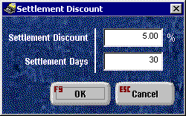
- You can now set the Settlement discount percentage and days for this transaction. Press F9 to store your new settings.

When you are Tendering a transaction which has a settlement discount defined for it you will get an extra option on the Tender screen, shown below :

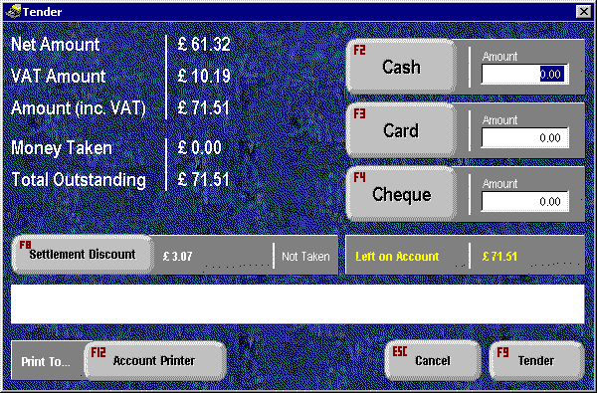
Use the F8 key to toggle between taking, and not taking the settlement discount. You will see that the Total Outstanding amount will change accordingly.

Finding a Stock Item

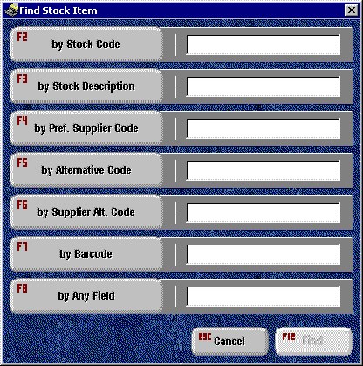
- To find a Stock Item using the Find Stock function, you need to press the F12 key, from the Add Line screen. This will bring up the following dialog :

- Press the Function Key which corresponds with the field that you want to find by – e.g. F3 to Find by Description
- The cursor will now go to the correct input field. Input the text that you want to find by and then press F12 to execute the Find.
- If there are more than one stock records that match your input, then a list is shown for you to pick from. You can then use the cursor keys to pick the required item.
- If there is one matching record then you will be taken back to the line details screen with the stock details filled in.
- If no items are found then a message will pop-up informing you of this.

Taking a Deposit

It is possible to take a specified amount as a deposit on a transaction, instead of paying off the full amount. To do this, follow this procedure :

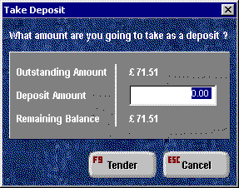
- From the main transaction screen press F4, you should then be presented with the following screen :

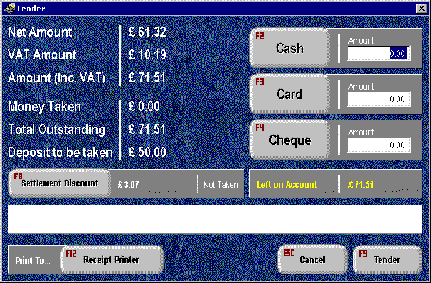
- Entered the required amount, then press F9 to go to the Tender screen :

- You will notice that there is now a ‘Deposit to be taken’ shown on the screen, and the Tendering process is now based around the deposit amount, not the Total Outstanding.

Reprinting a Transaction

After you have printed the receipt for a transaction, or if you are viewing a completed transaction, you will be presented with the tender screen in a different state :

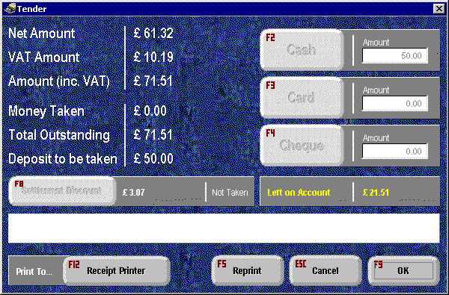
In this state you can press F9 or ESC to exit the screen, or press F5 to reprint the transaction to the selected printer. You can toggle between the Receipt and Account printers by using F12, and can reprint as many times as you like.

Finding an Existing Transaction

You may want to find an existing transaction for different reasons :

- You may just want to view a transaction.
- You may want to pay off an additional amount from a transaction that is not yet completely paid off.
- You may want to print another receipt from a completed transaction.

You can only find transactions that have been created in the Trade Counter system. To find an existing transaction :

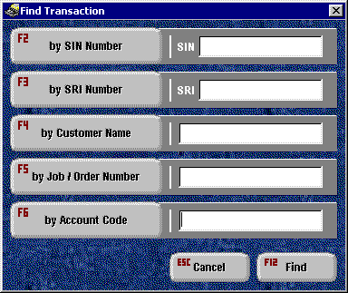
- From the main transaction screen, press F12 to bring up this dialog :

- Press the Function Key which corresponds with the field that you want to find by – e.g. F4 to Find by Customer Name.
- The cursor will now go to the correct input field. Input the text that you want to find by and then press F12 to execute the Find (note : if you press F12 without inputting anything, you will get a full list of all Trade Counter transactions).
- If there is more than one transaction that matches your input, then a list is shown for you to pick from. You can then use the cursor keys to pick the required item.
- If there is only one matching transaction then this transaction will be loaded into the main transaction screen.
- If no transactions are found then a message will pop-up informing you of this.
- You can now pay-off / view / reprint the transaction as appropriate.
Editing a line

To edit a stock line that already exists in the list, you need to do the following :

- In the main transaction screen, highlight the stock item in the list using the Cursor keys.
- Press F7 to open up the edit line dialog.
- You can now edit all the details of the selected stock item.

Deleting a line

To delete a stock line from the current transaction, you need to do the following :

- In the main transaction screen, highlight the stock item in the list using the Cursor keys.
- Press the Delete key on the keyboard.
- You will now be asked if you are sure you want to delete the stock item from the list.
- Press ‘Y’ for Yes on the keyboard and the item will be deleted.

Creating a new Transaction based on an existing one

You may want to base a new transaction on an existing one, or duplicate one that already exists. To do this you press F11 from the main transaction screen. This will take you through the exact same procedure as Find Transaction (detailed elsewhere in this document), but will create a new transaction instead. You can edit and delete the existing lines in the transaction, as well as adding new ones. When you have finished modifying the transaction, you then tender the transaction as you would normally.

Configuring Your Barcode Scanner

To use a bar code scanner with the Trade Counter system, you must setup it up to transmit an STX (start transaction) before the barcode, and to transmit an ETX (end transaction) after the barcode. So that the transmission will be something like this :

[STX]5018503084781[ETX]

You will need to refer to the manual supplied with your bar-code scanner to find out how you can do this with your specific model.

The End of Day report

The end of day report is run from within the Trade Counter Administrator module. It will show you the sales and tendered amounts within a selected date range. The report is broken down by till, and within that, by operator. To run the End of Day report :

- From the menu heading Reports select the End of Day Report option. You will then be presented with the following dialog :
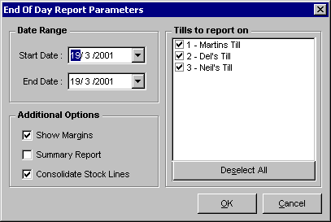
- As you can see, you can select a date range for the report, and select which tills you want to report on. The other options work as follows :

Show Margins : When this is selected the columns Cost, Margin and GP% are shown.
Summary Report : When this is selected the report will not detail each item sold for each operator - it will only show the totals for each operator.
Consolidate Stock Lines : When this is selected, all sales of each particular item are consolidated into one line, to save on space.

- When you have selected your report criteria, click on the OK button to run the report.

