Bespoke SQL Administrator
Overview
The general idea behind this program is to ease the setup/installation and development of the MS-SQL part of our bespoke programs. It is for use with our bespoke applications/Plug-Ins that use MS-SQL databases to store their data.
The key functions performed by this utility are :
- Creation of SQL Logins needed to access MS-SQL.
- Creation of SQL Databases for our bespoke.
- Creation of SQL Users needed to access our bespoke Database(s).
- Creation of SQL Tables for our bespoke.
- Setup of the Accompanying XML File, that stores the settings for our Plug-Ins.
- Storing the Login/User names and passwords, so that any program / plug-in written can read the correct Login/user/password to use.
The utility is named BespokeSQLAdmin.exe, which will normally reside in the main Exchequer directory (i.e. where ENTER1.EXE is), alongside this, BespokeFuncs.dll is also required to be located in the same dir. This dll contains functions needed to develop your plug-ins/utilities using info setup by the Bespoke SQL Administrator.

Pervasive / MS-SQL
The utility has been written to work in 2 environments :
- In a Pervasive Environment, where the Exchequer data is not stored in an MS-SQL database, but
the data for the bespoke will be stored in MS-SQL (Express or Server)
- In an MS-SQL Environment where the Exchequer Data is stored in an MS-SQL database, and the data for the bespoke plug-in/utility is also stored in an MS-SQL database. Note: In this environment, the bespoke database must stored be in the same MS-SQL server instance, as the Exchequer database.
The main difference between the 2 environments is that you have to set the MS-SQL server name in the XML to run under a Pervasive version of Exchequer. If you run the administrator without an MS-SQL server name in the XML file, then a dialog will appear asking you to input one, which will populate this value in the XML file.

Logins / Users
It has been decided that there will be 2 Logins / Users, used for accessing the MS-SQL databases for our bespoke Plug-Ins / Utilities.
- The Read Only Login/User : ExchBespokeUser_RO
- The Read Only Login/User’s Password : ExchBespoke_RO
- The Name and Password are stored in the accompanying XML file (see below). Both are encrypted using Blowfish.
- The Read Only Username and password are set, and cannot be changed. The password is visible in the Bespoke SQL Administrator, as this is available for anyone to use for reporting etc.
- If you are running against an MS-SQL version of Exchequer, this Login/User will also have read access to the Exchequer MS-SQL database.
- The Read/Write Login/User : ExchBespokeUser_RW
- The Read/Write Login/User’s Password is randomly generated, at the time
- The Name and Password are stored in the accompanying XML file (see below). Both are encrypted using Blowfish.
- The Read/Write Username and password are set (on initial startup), and cannot be changed. The password is not visible in the Bespoke SQL Administrator, (other than by using a special password) as this is not to be know, or available to the user.
- If you are running against an MS-SQL version of Exchequer, this Login/User will also have read access to the Exchequer MS-SQL database.

Database Codes
This whole system is based on the Plug-In codes that we use for our security system. There is only ever going to be one database per Plug-In, so we can safely use the Plug-In code to identify the Database. This means every plug-in that uses this system must have a code (even if you are not using the security system - which you should be using !).
The code is a 16 character code which is structured as follows :
EXCHXXXXXX000123
EXCH : This is always EXCH, and never changes.
XXXXXX : This is a six char code used to described the Plug-In/utility
000123 : This is a sequential (and incremental) number which must be unique.
These codes are stored in Plug-In Codes.xlsx which is on the bespoke sharepoint site : http://datsps1/sites/absdev/Exch_Bespoke/Shared%20Documents/Plug-In%20Codes.xls
It is very important that this repository is used to add and lookup these codes. When you add a code, check out the Excel file, add a new code on the end, and then check it back it.
This code is then used to uniquely identify the Plug-In, in the Bespoke SQL Administrator, as well as for the security for the plug-in.

ExchBespoke.xml
The details for the MS-SQL Server Name (pervasive only), Users/Logins, Database, Tables, SQL Scripts etc. are all stored in a file called ExchBespoke.xml.
Notes:
- Logins & passwords, are blowfish encrypted.
- The file needs to reside in the same directory as BespokeSQLAdmin.exe.
- It’s all pretty self explanatory once you have seen the scope of the utility

Example XML File :
<?xml version="1.0"?>
<Bespoke>
<Pervasive>
<ServerName>P004433\IRISEXCHEQUER</ServerName>
</Pervasive>
<SQL>
<Users>
<ReadOnly>
<ID>FrFLYm+-jetiR0v96egIBYRCHuvqWbRB</ID>
<Password>FrFLYm+-jeu8BY6Sv5INOU</Password>
</ReadOnly>
<ReadWrite>
<ID>FrFLYm+-jetiR0v96egIBbpVvIi+xL0-</ID>
<Password>Gz4Li+t8VmyZ0+6J11IecR59C9dlTW0B</Password>
</ReadWrite>
</Users>
</SQL>
<PlugIns>
<PlugIn>
<Code>EXCHGALREB000218</Code>
<Description>Galaxy Purchase Rebate Plug-In</Description>
<SQLDatabase>
<Name>ExchBespoke_EXCHGALREB000218</Name>
<Scripts>
<Script Order="1" CreateDatabase="1">
<Name>Create Database (ExchBespoke_EXCHGALREB000218)</Name>
<Line>Create Database &quot;ExchBespoke_EXCHGALREB000218&quot;</Line>
<Line> Collate SQL_Latin1_General_CP1_CI_AS</Line>
<Line></Line>
</Script>
<Script Order="2" CreateDatabase="0">
<Name>Add Stored Procedure isp_AddSupplierReturnID</Name>
<Line>CREATE PROCEDURE isp_AddSupplierReturnID (@1 varchar(6),</Line>
<Line> @2 varchar(6))</Line>
<Line> AS</Line>
<Line> INSERT INTO Supplier (suCompanyCode, suSupplierCode)</Line>
<Line> VALUES (@1, @2)</Line>
<Line> SELECT SCOPE_IDENTITY()</Line>
<Line> RETURN</Line>
</Script>
<Script Order="3" CreateDatabase="0">
<Name>Add Stored Procedure isp_AddStockRebateReturnID</Name>
<Line>CREATE PROCEDURE isp_AddStockRebateReturnID (@1 int,</Line>
<Line> @2 varchar(16), @3 decimal(5,2))</Line>
<Line> AS</Line>
<Line> INSERT INTO StockRebate (srSupplierFolioNo, </Line>
<Line>srStockCode, srRebatePercent)</Line>
<Line> VALUES (@1, @2, @3)</Line>
<Line> SELECT SCOPE_IDENTITY()</Line>
<Line> RETURN</Line>
</Script>
</Scripts>
<Tables>
<Table>
<Name>Supplier</Name>
<Scripts>
<Script Order="1" CreateDatabase="0">
<Name>Create Supplier Table</Name>
<Line>CREATE TABLE [dbo].[Supplier](</Line>
<Line> [suFolioNo] [int] IDENTITY(1,1) NOT NULL,</Line>
<Line> [suCompanyCode] [varchar](6) NOT NULL,</Line>
<Line> [suSupplierCode] [varchar](6) NOT NULL,</Line>
<Line> CONSTRAINT [PK_suFolioNo] PRIMARY KEY CLUSTERED</Line>
<Line> (</Line>
<Line> [suFolioNo] ASC</Line>
<Line> )WITH (PAD_INDEX = OFF, STATISTICS_NORECOMPUTE = OFF</Line>
<Line> , IGNORE_DUP_KEY = OFF, ALLOW_ROW_LOCKS = ON</Line>
<Line> , ALLOW_PAGE_LOCKS = ON) ON [PRIMARY]</Line>
<Line> ) ON [PRIMARY]</Line>
</Script>
<Script Order="2" CreateDatabase="0">
<Name>Create Index Idx_suCompCodeSuppCode</Name>
<Line>CREATE UNIQUE NONCLUSTERED INDEX </Line>
<Line>[Idx_suCompCodeSuppCode] ON [dbo].[Supplier]</Line>
<Line> (</Line>
<Line> [suCompanyCode] ASC,</Line>
<Line> [suSupplierCode] ASC</Line>
<Line> )WITH (PAD_INDEX = OFF, STATISTICS_NORECOMPUTE = OFF</Line>
<Line> , SORT_IN_TEMPDB = OFF, IGNORE_DUP_KEY = OFF</Line>
<Line> , DROP_EXISTING = OFF, ONLINE = OFF</Line>
<Line> , ALLOW_ROW_LOCKS = ON, ALLOW_PAGE_LOCKS = ON) </Line>
<Line> ON [PRIMARY]</Line>
</Script>
</Scripts>
</Table>
<Table>
<Name>StockRebate</Name>
<Scripts>
<Script Order="1" CreateDatabase="0">
<Name>Create StockRebate Table</Name>
<Line>CREATE TABLE [dbo].[StockRebate](</Line>
<Line> [srFolioNo] [int] IDENTITY(1,1) NOT NULL,</Line>
<Line> [srSupplierFolioNo] [int] NOT NULL,</Line>
<Line> [srStockCode] [varchar](16) NOT NULL,</Line>
<Line> [srRebatePercent] [decimal](5, 2) NOT NULL,</Line>
<Line> CONSTRAINT [PK_srFolioNo] PRIMARY KEY CLUSTERED</Line>
<Line> (</Line>
<Line> [srFolioNo] ASC</Line>
<Line> )WITH (PAD_INDEX = OFF, STATISTICS_NORECOMPUTE = OFF</Line>
<Line> , IGNORE_DUP_KEY = OFF, ALLOW_ROW_LOCKS = ON</Line>
<Line> , ALLOW_PAGE_LOCKS = ON) ON [PRIMARY]) </Line>
<Line> ON [PRIMARY]</Line>
</Script>
<Script Order="2" CreateDatabase="0">
<Name>Create Index Idx_srSuppFolioStockCode</Name>
<Line>CREATE UNIQUE NONCLUSTERED INDEX </Line>
<Line> [Idx_srSuppFolioStockCode] ON [dbo].[StockRebate]</Line>
<Line> (</Line>
<Line> [srSupplierFolioNo] ASC,</Line>
<Line> [srStockCode] ASC</Line>
<Line> )WITH (PAD_INDEX = OFF, STATISTICS_NORECOMPUTE = OFF</Line>
<Line> , SORT_IN_TEMPDB = OFF, IGNORE_DUP_KEY = OFF</Line>
<Line> , DROP_EXISTING = OFF, ONLINE = OFF</Line>
<Line> , ALLOW_ROW_LOCKS = ON, ALLOW_PAGE_LOCKS = ON)</Line>
<Line> ON [PRIMARY]</Line>
</Script>
</Scripts>
</Table>
</Tables>
</SQLDatabase>
</PlugIn>
</PlugIns>
</Bespoke>

Using the Utility to add a new project (for developers).
When adding a new project to a system that has no existing MS-SQL Plug-Ins (that use this administrator) you will need to start with a blank XML file as follows :
<?xml version="1.0"?>
<Bespoke>
<Pervasive>
<ServerName>P004433\IRISEXCHEQUER</ServerName>
</Pervasive>
<SQL>
<Users>
<ReadOnly>
<ID></ID>
<Password></Password>
</ReadOnly>
<ReadWrite>
<ID></ID>
<Password></Password>
</ReadWrite>
</Users>
</SQL>
<PlugIns>
</PlugIns>
</Bespoke>

When you then start the Bespoke SQL Administrator, the logins and users will then be setup on your system, as detailed in the Startup section below. You can then add the details you need in the section Adding details, or viewing/editing existing details, below.
Note: If you are adding a new project to a system that already has an existing ExchBespoke.xml file, all you have to do is open up the administrator and add the new details.

Startup
When you first run up the Bespoke SQL Administrator, if it needs to create all the necessary stuff in MS-SQL, it will ask you to login :
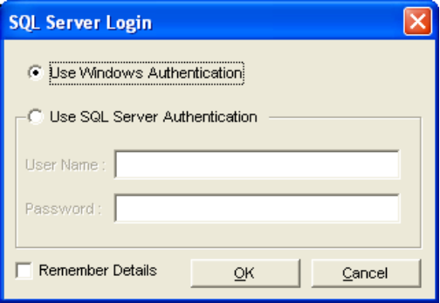
It will then automatically create all of the Logins, Databases, Users and Tables that have been configured in the XML file - if they don’t already exist.
The following Dialog will then be shown, which lists the functions that have been run :
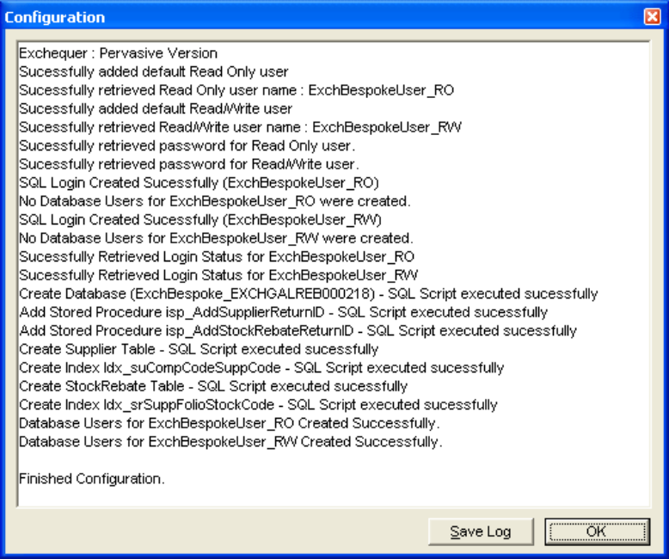
Any failed operations will be shown in red text.
You can save this log to a file (RTF – Rich Text File) by clicking on the Save Log button.
Adding details, or viewing/editing existing details.
The utility by default is read only. If you need to add edit or delete items then you must first “login”. This is done from the menu option “File – Login”. The password for this is available to us by running a special exe file – LoginPassword.EXE. When run on the same machine as the Administrator utility, it will automatically paste the “special password” into the clipboard of the machine. You can then paste this password into the Login dialog in the administrator. You will then be able to use the add, edit and delete functions.
Note: Never leave this file (LoginPassword.EXE) on a customer’s machine – it is for internal use only.
IRIS Exchequer Tab – This shows the version of Exchequer that you are running against (pervasive or MS-SQL), and (if it is an MS-SQL version) the database name and server name for the Exchequer database.
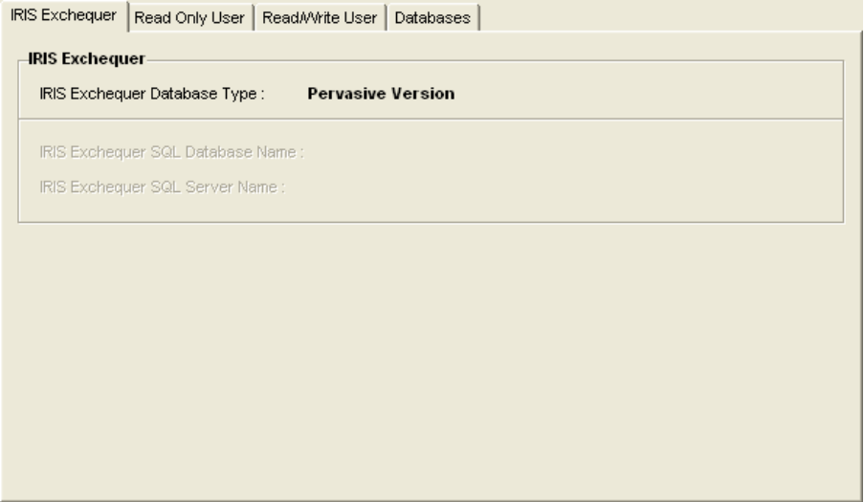

Read Only User Tab – This shows the details of the Read Only User/Login.
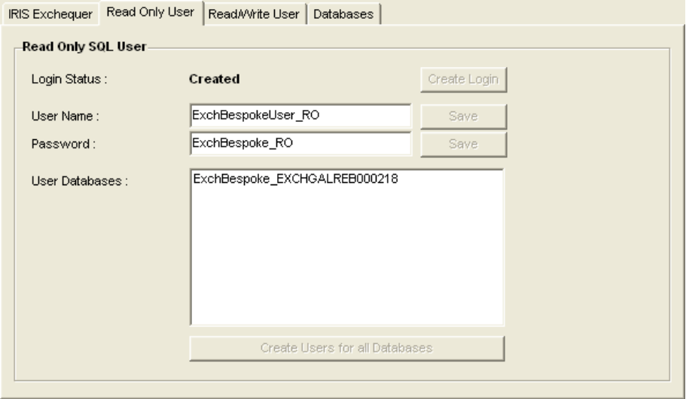

Read/Write User Tab – This shows the details of the Read/Write User/Login.
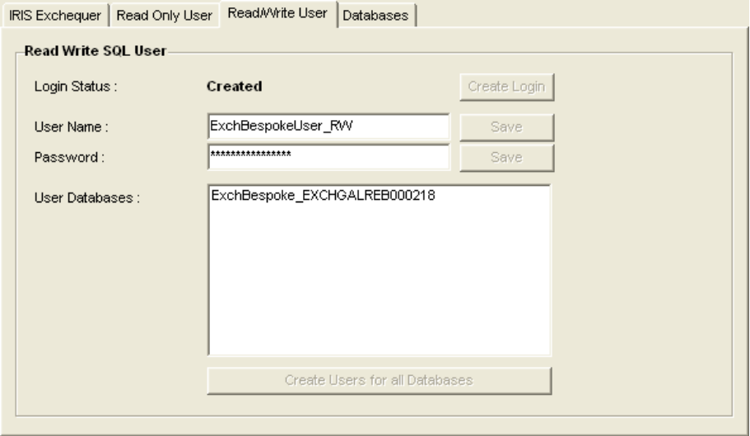

Database Tab – This shows the bespoke databases setup, and allows you to (if available) add, edit, delete bespoke database details. It also allows you to setup the tables for a database, and get an example connection string for connecting to the database :
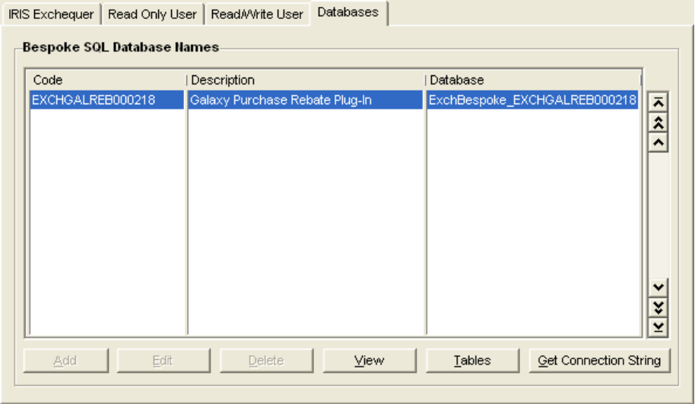

Database Details – This shows the details for a bespoke SQL database. You can also run the scripts for creating the database. See the section above on Database Codes on how to create a Plug-In Code.
This is available from the Add, Edit & View buttons above.
Note: By default the Database name is the Database Code prefixed by “ExchBespoke_”
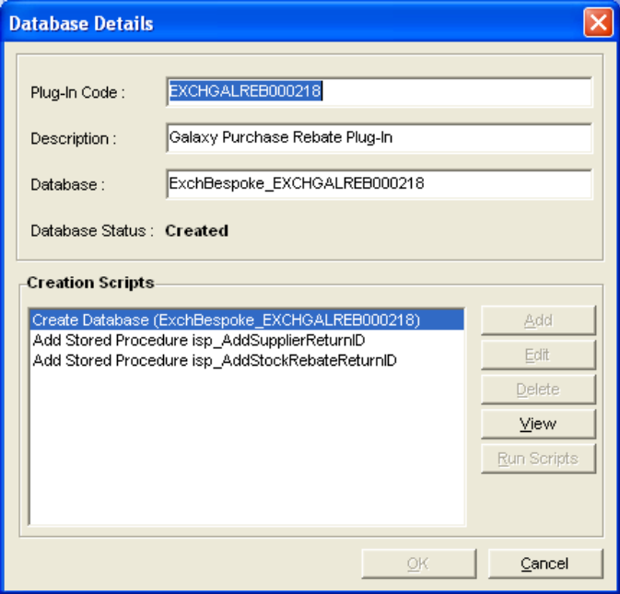

Tables – This shows a list of tables for the database – available from the “Tables” button on the Database tab of the main screen.
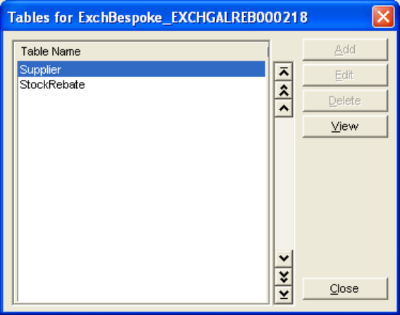

Table Details – Shows the details for a table. Also allows you to run the scripts to create the table. Available from the Add, Edit, View buttons above.
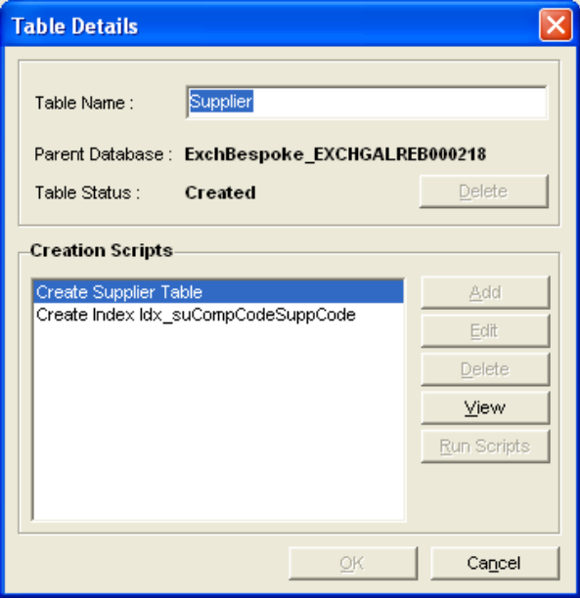

Script Details – This shows the details of an SQL script. You can also run the SQL script. Available from wherever you can add, edit and view SQL scripts.
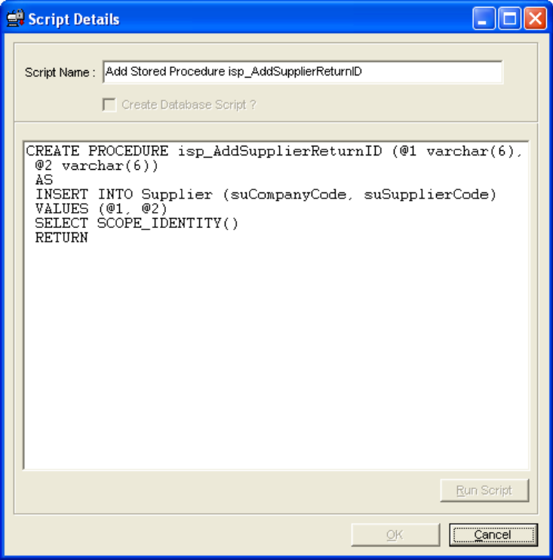
Note: any items shown in red indicate a possible problem with the setup of the item.

Installation
When you first install a plug-in on a system which doesn’t already have an ExchBespoke.xml file, you will need configure the XML file in the following way :
- Blank all the IDs and Passwords in the <Users> section. These will then be auto populated when you first run up the administrator.
Note: The developer should supply the XML file to QA, already in this state.
- Pervasive Only - Fill in the <ServerName> key with the MS-SQL server name that you wish to install and use the bespoke database on. (e.g. COMPUTERNAME\IRISEXCHEQUER). If you do not fill this out, it will ask you for a server name, when you first start up the SQL Administrator.
Note: For MS-SQL versions the bespoke database will always be installed onto the same MS-SQL server that the Exchequer Database resides on. This is why you do not have to define the server name for MS-SQL sites.
- You must then run up the SQL administrator, which will then setup these details and creates everything that is necessary to run the Plug-In/utility.

If you are installing a plug-in onto a system that already has a plug-in installed that uses this Bespoke SQL utility, the on-site installation procedure will be different. :
- Firstly get a copy of the customer’s existing ExchBespoke.xml file.
Note: This is very important, as it contains the password for the read/write user. If you were to change this, it would no longer match the password on the site’s MS-SQL server, and it would all go horribly wrong.
- DO NOT Blank all the IDs and Passwords in the <Users> section.
- Add the new Database, Tables, Scripts etc. into the existing XML file using the Bespoke SQL Administrator, or copy it in manually to the XML file (easier).
- This XML file can then be delivered to the customer site alongside the bespoke plug-in. This will need to replace the existing XML file on site.
Note : Clearly it’s best to rename the existing XML file, rather than write over the top of it.
- You must then run up the SQL administrator on-site, which will then setup these details and create everything that is necessary to run the new Plug-In/utility.
Note : This may be something that we consider automating in the future, but bear in mind that this will only affect customers who have more than one bespoke that uses MS-SQL databases.

All of the SQL details needed, should now have been setup for you, and the associated plug-in/utility should now be ready for use.
Limitations
Currently you cannot move SQL scripts up and down, to change their order. If you really need to do this, you can manually edit the Order attribute against the scripts directly in the XML file.
Currently when you delete an SQL Script, it does not renumber the order of the subsequent scripts. Again, you can fix this my manually editing the Order attribute against the scripts directly in the XML file.
When updating / deleting some parts using the administrator you may find that blank keys will be left over in the XML file. This is due to the way that the XML component we use works. It doesn’t do any harm, but we may look at fixing this in the future.

File Locations
You can find the latest versions of the EXE files and DLLs in tortoise SVN, alongside some blank and example XML files :
svn://bmtdev1/bespoke/BespokeSQL/tags/v6.XX.XXX/release

BespokeFuncs.dll (for developers)
All of this is very nice, but you obviously need to use the details stored in the XML file to access the data in the bespoke MS-SQL database. So - how do you get at these details and use them ? The answer is : BespokeFuncs.dll
There are loads of functions available to you in BespokeFuncs.Dll - I have tried to keep these VB compatible by using what I hope are VB compatible data types.
pSpecialPassword : Some functions have a parameter called pSpecialPassword. This is a special password (!) that you must pass in, in order for the function to work. This is to stop these functions from being called by any old Joe. This is currently the only stumbling block with this utility, as we have not yet created a VB compatible routine, that can create this password (there is a Delphi one).
We will need to go get this sorted out pretty soon, so that you VB guys can use these routines.

SQLGetExchequerDatabaseProperties
function SQLGetExchequerDatabaseProperties (var pDatabaseName : pChar; var pServerName : pChar) : LongInt;
This function retrieves the database and server name for the registered version of Exchequer on the system (only use for MS-SQL versions of Exchequer).
pDatabaseName : This returns the Exchequer Database name for the registered version of Exchequer on the system.
pServerName : This returns the Server Name that holds the Exchequer Database for the registered version of Exchequer on the system.
Result : 0 = Success, Error codes are negative.

SQLGetUsername
This function gets the bespoke username (Read Only or Read/Write).
function SQLGetUsername (var pUserName: PChar; bReadOnly : WordBool; pSpecialPassword : PChar) : LongInt;
pUserName: Returns the username.
bReadOnly : Tells the function whether to retrieve the Read Only or Read/Write user name (TRUE = Read Only, FALSE = Read/Write).
pSpecialPassword : See above.
Result : 0 = Success, Error codes are negative.

SQLGetUserPassword
This function gets the password for the bespoke username (Read Only or Read/Write).
function SQLGetUserPassword (var pUserPassword : PChar; bReadOnly : WordBool; pSpecialPassword : PChar) : LongInt;
pUserPassword : Returns the password for the user.
bReadOnly : Tells the function whether to retrieve the Read Only or Read/Write password (TRUE = Read Only, FALSE = Read/Write).
pSpecialPassword : see above.
Result : 0 = Success, Error codes are negative.

SQLGetBespokeDatabaseNameForCode
function SQLGetBespokeDatabaseNameForCode (pCode : PChar; var pDatabase : PChar) : LongInt;
pCode : Plug-In Code (e.g. EXCHABCDEF123456)
pDatabase : Returns the database name for the code given.
Result : 0 = Success, Error codes are negative.

SQLBuildBespokeConnectionString
Builds an SQL connection string, to connect to a Bespoke Database.
function SQLBuildBespokeConnectionString (pPlugInCode : PChar; bReadOnly : wordbool; var pConnectionString : PChar; pSpecialPassword : PChar) : LongInt;
pPlugInCode : This is the Code for the Plug-In / Database (e.g. EXCHABCDEF123456)
bReadOnly : Tells the function whether you want to connect using the Read Only or Read/Write user (TRUE = Read Only, FALSE = Read/Write).
pConnectionString : Returns the connection string.
pSpecialPassword : see above.
Result : 0 = Success, Error codes are negative.

SQLBuildAdminConnectionString
Builds an SQL connection string, to connect to a specified Database.
function SQLBuildAdminConnectionString (bWindowsAuth : WordBool; pUserName, pPassword, pDatabaseName : PChar; var pConnectionString : PChar) : LongInt;
bWindowsAuth : Do you want to use Windows authentication to connect ?
pUserName : MS-SQL User name that you are using to connect to MS-SQL.
pPassword : MS-SQL Password for the user that you are using to connect to MS-SQL.
pDatabaseName : MS-SQL Database name that you want to connect to.
pConnectionString : Returns the connection string.
Result : 0 = Success, Error codes are negative.

SQLExecute
Executes an SQL query.
function SQLExecute (bWindowsAuth : WordBool; pSQLUserName, pSQLPassword, pDatabaseName, pSQL : PChar; bShowErrors : WordBool; pSpecialPassword : PChar) : LongInt;
bWindowsAuth : Do you want to use Windows authentication to connect ?
pSQLUserName : MS-SQL User name that you are using to connect to MS-SQL.
pSQLPassword : MS-SQL Password for the user that you are using to connect to MS-SQL.
pDatabaseName : MS-SQL Database name that you want to query.
pSQL : The query you want to execute.
bShowErrors : Do you want to display error messages ?
pSpecialPassword : see above.
Result : 0 = Success, Error codes are negative.

SQLGetServerNamePervasive
Gets the MS-SQL Server Name. Used only when running under a pervasive version of Exchequer.
procedure SQLGetServerNamePervasive (var pServerName : PChar);
pServerName : Returns the MS-SQL Server Nsme (stored in the XML file).

SQLExchVersionSQL
Returns whether the registered version of Exchequer is an SQL version.
function SQLExchVersionSQL: WordBool;
Result : TRUE = SQL Version, FALSE = Pervasive version.

Other functions
You probably won’t need these ones :
function SQLAddDatabaseUser (bWindowsAuth : WordBool; pSQLUserName, pSQLPassword, pUser, pDatabaseName : PChar; bReadOnly : WordBool; pSpecialPassword : PChar) : LongInt; stdCall;
function SQLAddDefaultUser (bReadOnly : WordBool; pSpecialPassword : PChar) : LongInt; stdCall;
function SQLAddDefaultUser (bReadOnly : WordBool; pSpecialPassword : PChar) : LongInt; stdCall;
function SQLDatabaseDelete (bWindowsAuth : WordBool; pUserName, pPassword, pDatabaseName : PChar; pSpecialPassword : PChar) : LongInt; stdCall;
function SQLDatabaseExists (pDatabaseName : PChar; var bExists : WordBool) : LongInt; stdCall;
function SQLTableExists (pPlugInCode, pTableName : PChar; var bExists : WordBool) : LongInt; stdCall;
function SQLLoginExists (pLogin : PChar; var bExists : WordBool) : LongInt; stdCall;
function SQLUserExistsForDatabase (pUser, pDatabaseName : PChar; var bExists : WordBool) : LongInt; stdCall;
function SQLLoginCreate (bWindowsAuth : WordBool; pUserName, pPassword, pLoginName, pLoginPassword, pSpecialPassword : PChar) : LongInt; stdCall;
function SQLBuildStandardConnectionString (bReadOnly : wordbool; var pConnectionString : PChar; pSpecialPassword : PChar) : LongInt; stdCall;
Writing a new project from scratch
The first thing to do is to create the databases, tables, stored procedures etc. that you need for the bespoke, in MS-SQL Management Studio.
The database name that you use must be based on the bespoke plug-in code (see section on “database codes” above). The name of the database must be “ExchBespoke_” with the plug-in code appended onto the end : e.g. “ExchBespoke_EXCHSDHAPF000227”. The table names are up to you.
Once you have created the required databases, tables etc, you need to produce the create scripts needed to create these tables, stored procedures etc. These scripts can then be used in the Bespoke SQL administrator.
If this is the first plug-in using this utility in the copy of exchequer, you will now need to copy the following files into you the directory that your plug-in resides in (normally the main exchequer directory) :
- A blank ExchBespoke.xml file
- BespokeFuncs.dll
- BespokeSQLAdmin.exe
Note: If the logins (ExchBespokeUser_RO & ExchBespokeUser_RW) already exist on your SQL Server, they will need to be manually deleted.
Now run up the Bespoke SQL administrator, and the required Logins in MS-SQL should be created for you. You can now login to the Bespoke SQL administrator (using LoginPassword.exe), and start adding in the scripts that you created earlier. Add in all the databases tables and all the creation scripts that they need.
Once this is complete you will need to delete your database in MS-SQL management server, and use the Bespoke SQL utility to re-create it. Assuming the scripts all run successfully, check that the database has then been created correctly.

Notes :
Any foreign Key definitions have to be made after all the tables have been created. For this reason we currently have to add these as creation scripts of the last table in the database, so that they run successfully.

