Daybook Posting

Contents

Overview 1
Details 3
PrePostInput (PostInpU.pas) 3
Prepare and display the filter dialog 3
Prepare the list of document types 3
Add to the thread queue 4
Prepare and display the Job Costing options dialog 4
Add the Job Costing task to the thread queue 4
TEntPost.Control_Posting (PostingU.pas) 5
Prepare a list of document types 5
Check any hook points 5
Process Auto transactions 5
Process batch transactions 5
Process transactions 5
Auto-Transactions 6
TEntPost.Post_ItAuto (PostingU.pas) 7
Prepare job-costing 7
Prepare notification hook 7
Adjust list of document types 7
Prepare print forms 7
Locate first Auto record 7
Check for on-hold or suspended 7
Save record position 8
Read and adjust currency rates 8
Determine period/year or date 8
Calculate the due date 8
Store operator name 8
Determine VAT date 8
Set document allocation status 9
Assign next document number 9
Assign next folio number 10
Generate transaction lines 10
Save transaction 10
Update balance 10
Print report 11
Call hook point 11
Update or delete auto transaction 11
Locate next auto record 11
Print reports 11
tdPostExLocal.LUpdateBal (ExBtTh1U.pas) 12
Locate the customer/supplier record 12
Prepare the credit/debit amounts 12
Update the balance history 12
Update ‘last edited’ flag 13
tdPostExLocal.LPost_To_Hist (ExBtTh1U.pas) 14
Locate history record 14
Calculate balances 14
Batch Transactions 15
TEntPost.Post_ItBatch (PostingU.pas) 16
Prepare job-costing 16
Locate first batch record 16
Increment PostingCount 16
Update LastFolio 16
Check transaction 16
Lock record 16
Post details 16
Save record 17
Update customer/supplier balance 17
Next record 17
TEntPost.Post_BatchDetails (PostingU.pas) 18
Locate batch transactions 18
Lock record 18
Determine VAT Date 18
Set document allocation status 18
Save record 18
Update customer/supplier balance 19
Update Job Costing 19
Find next record 19
TPostJob.LUpdate_JobAct (JobPostU.pas) 20
Locate record 20
Check transaction line 20
Assign/calculate values 20
Save record 20
TEntPost.Post_AdjDetails (PostingU.pas) 21
Check Stock Valuation flag 21
Create Nominal Transfer record 21
Locate transaction lines 21
Update history 21
Substitute stock parameters 21
Get nominal codes 21
Call hook point 21
Add stock valuation lines 22
Add Job Costing uplift 22
Finalise transaction line 22
Finalise transaction 22
Main Posting 23
TEntPost.Post_It (PostingU.pas) 25
TranOk2Run 25
Call InitProgress(ItemCount) 25
Call InitPostingSumm(PostSummary, False) 25
AutoRecover 25
SetCtrlCCDep - Hook Point 25
Find first Transaction 25
Call UpdateProgress() 25
Call Include_Transaction() 25
Lock record 26
Call SetControlCodes() 26
Prepare Run Number 26
Set VAT Date and Period 26
Store Company and Daily Exchange Rates 26
Call PostDetails() 26
Post VAT History 26
Post Reverse Change VAT 27
Post Totals 27
Update Balance 27
Post Rounding Differences 27
Update CIS Date 27
Create Auto-Reverse Nominal 27
Call Post_CtrlDetails() 28
PostDetails() 29
Locate first transaction line 29
Calculate totals 29
Save transaction line 29
Call LPost_To_Nominal() 29
Call LPost_To_CCNominal() 29
Additional control code lines 30
Call Stock_GenAVal() 30
Post Commitment Values 30
Call Process_PayIn() 30
Call PostJCUplift() 30
Finalise Post_Details 30
Sub-Routines 31
Include_Transaction() 31
SetControlCodes() 32
LPost_To_Nominal() 32
LPost_To_CCNominal() 33
Stock_PostCtrl() 34
Post_To_Stock() 34
Stock_GenAVal() 35
Post_To_RunCtrl 36
Ctrl_CuStkHist() 37
Post_CuStkHist 37
Process_Payin() 38
PostJCUplift() 38
Post_CtrlDetails() 38
Stock_PostAValue() 39
Update_LiveCommit() 39
Code sample 41
From PostingU.pas 41

Overview
Daybook Posting is launched via the Daybook Post button on the Daybook dialog.

This then displays a list of document types, to allow the user to include/exclude the document types for the posting run.

The Daybook Post task is added to the thread list, and the Process method of the TEntPost object (which handles the main posting) will be called by the thread controller.

The posting routine starts with Post_ItAuto, which adds transaction records for all the relevant Auto transactions.

It then calls Post_ItBatch, which locates all the relevant batch transactions, and creates transaction records for all the transactions in the batch. ???

The Post_It routine is then called, which actually posts the transactions, then adds a print task to the thread list, to print the Daybook Post report.

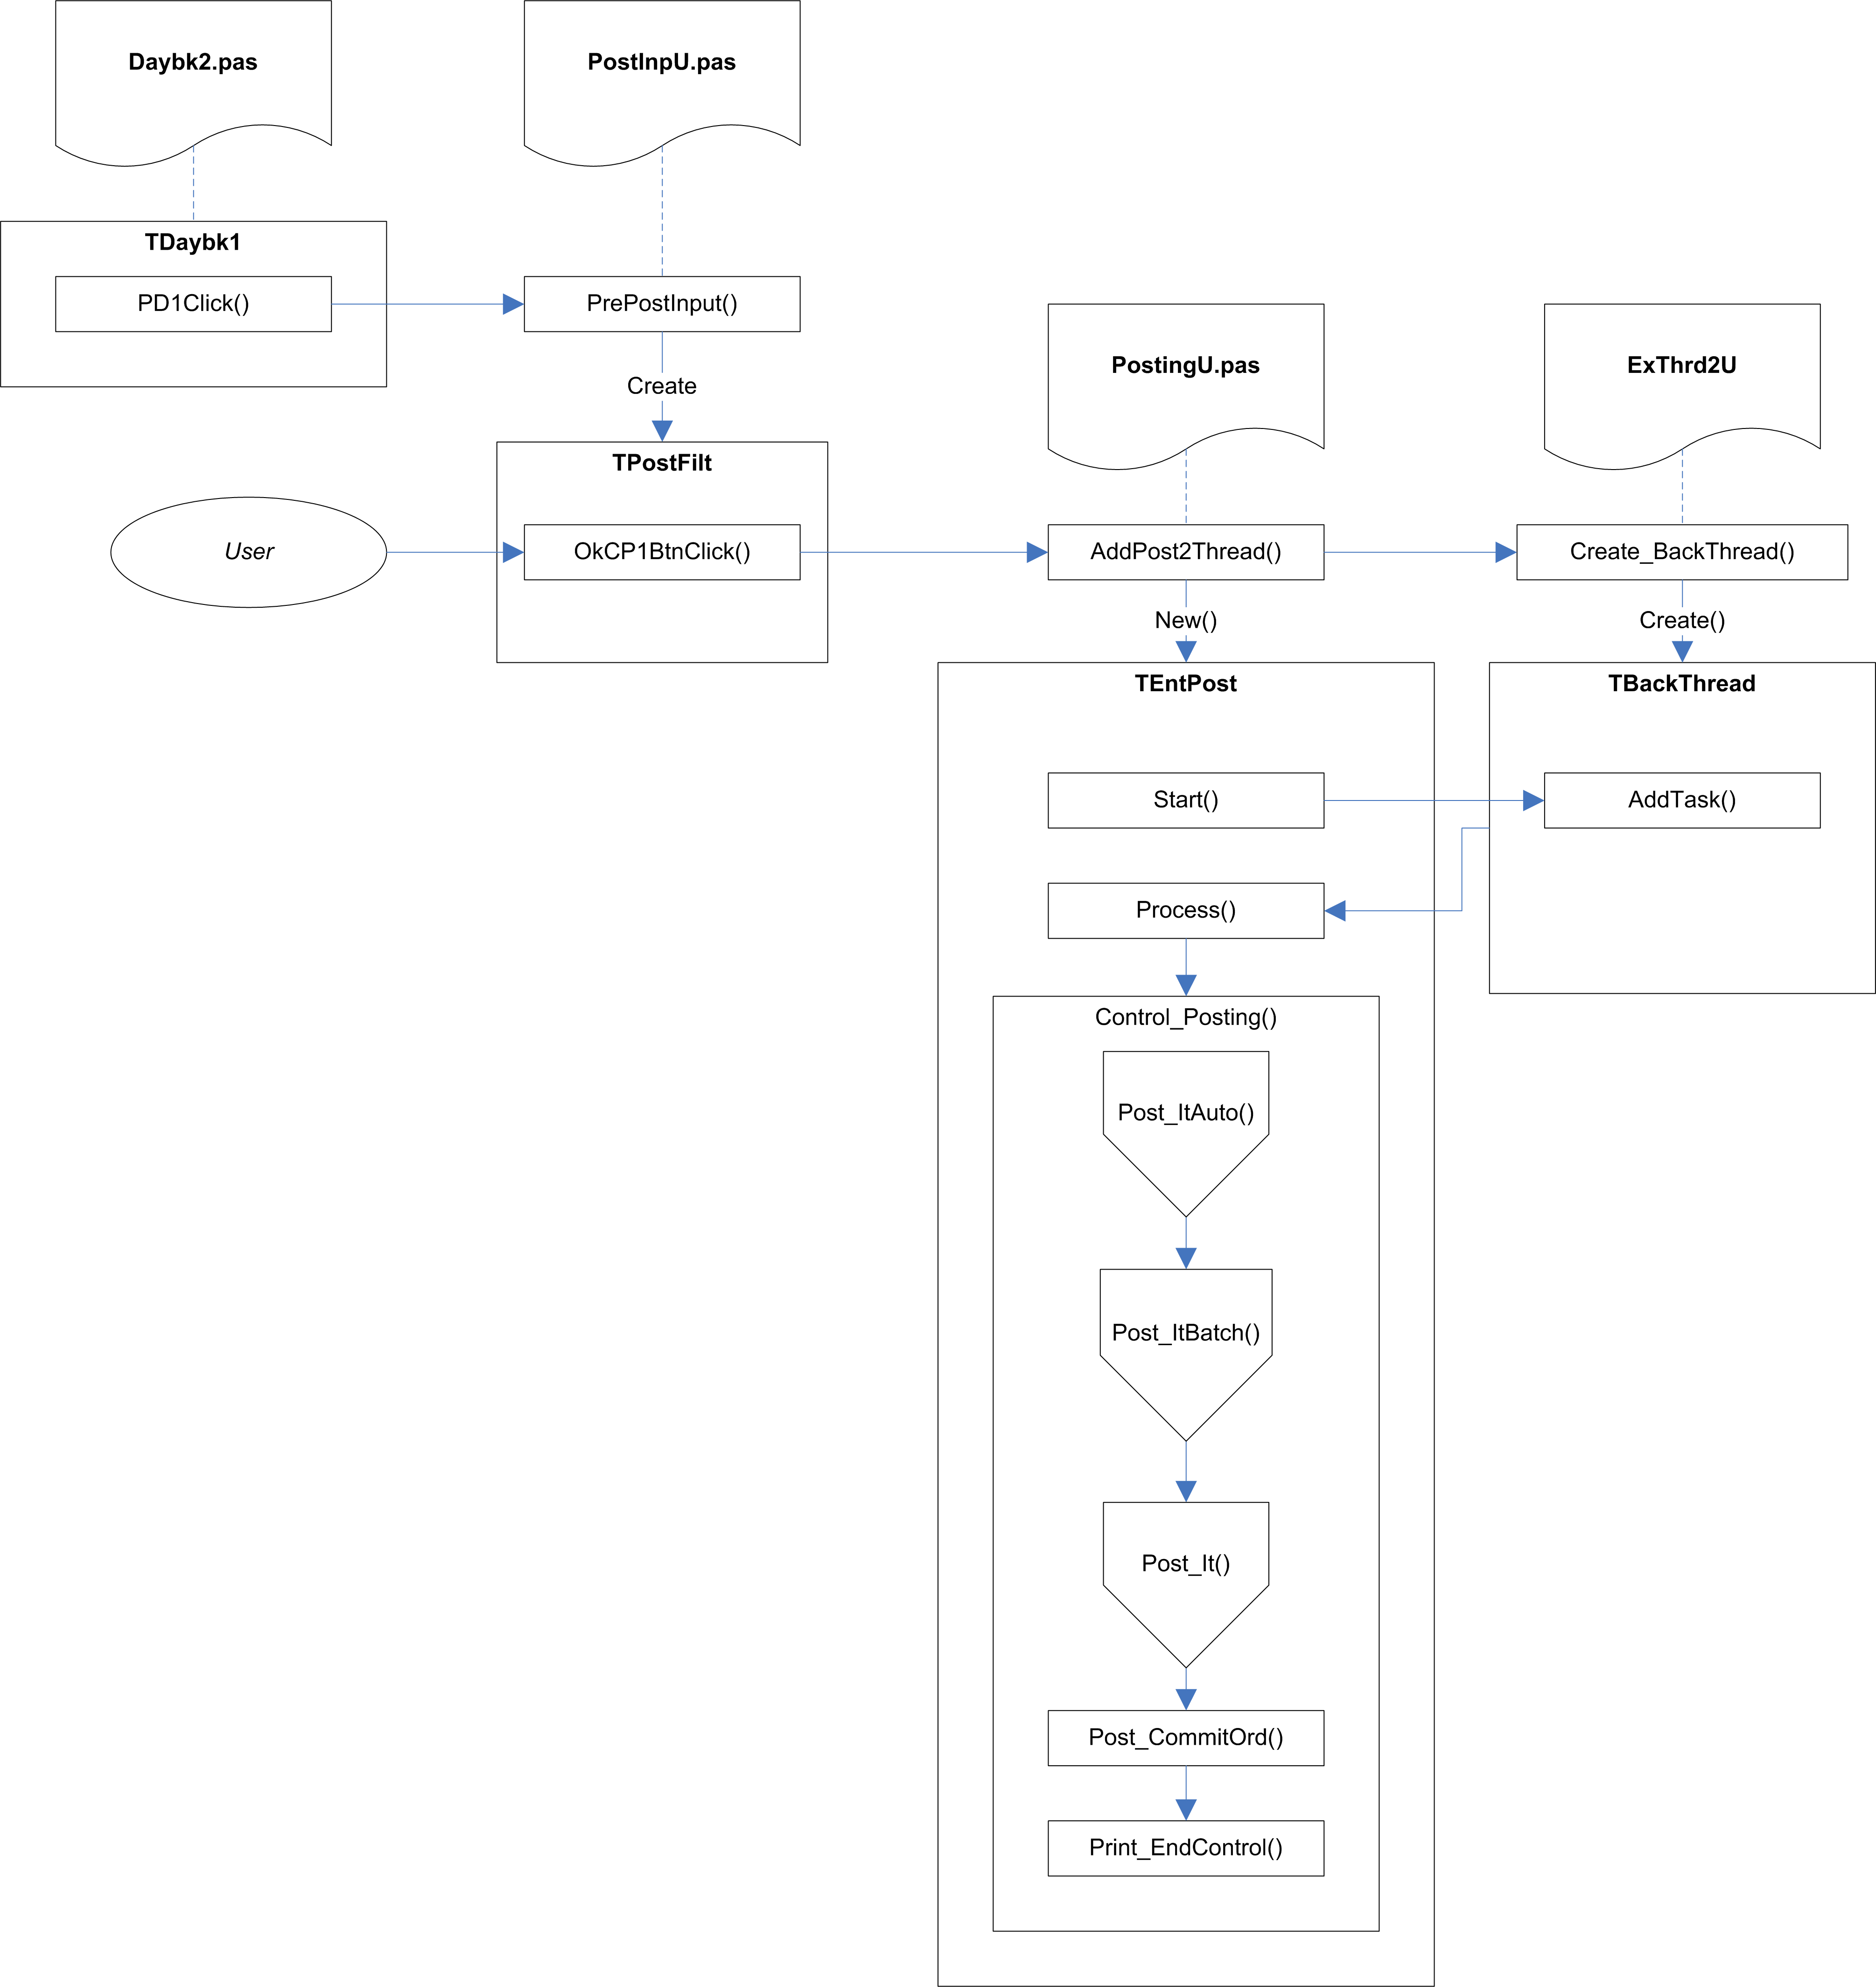

Fig.1 Overview

Details
The routine starts when the user clicks the Daybook Post button on the DayBook dialog. This calls the PrePostInput procedure in PostInpU.pas.

PrePostInput (PostInpU.pas)

Parameter | Comments
AOwner: TComponent | The Daybook dialog passes itself as this parameter. When called from the Post All Daybooks menu option of the main form, the main form is passed as this parameter.
PMode: Byte | This uses the SetPostMode function in PostingU.pas, which takes a document type, and determines the posting mode from it:  0=All Daybooks  1=Sales  2=Purchase  3=Nominal  4=Stock Adjustment.  If the Daybook dialog is currently displaying Auto Transactions, 20 is added to the mode, for Sales and Purchase Daybooks only.
PAsk: Boolean | This is always passed as True within Exchequer.
PParam: TPrintParamPtr | This is always passed as nil within Exchequer.

Prepare and display the filter dialog
The PMode value is copied to a file-wide variable, GPMode, so that it is available to the filter dialog (the filter dialog copies the value to its own PostMode property).

The filter dialog, TPostFilt, is created and automatically displayed, to allow the user to select which document types are to be processed. By default, all the document types relevant to the posting mode are selected.

If the PostMode property is greater than 10, the AutoOn property is set to True, and the PostMode property is decremented by 20 (this should return it to the basic mode value of 1, 2, 3, or 4).

The Ask property of the PostFilt dialog is copied from the PAsk parameter (and hence is set to True).

A CRepParam record structure is created and initialised (all fields are blanked). This record is used to pass information to the posting routines.

The ‘Separate Posting Control Entries’ checkbox is defaulted to the value stored in SepRunPost in System Settings (Syss). Checking or unchecking this checkbox will automatically update the System Settings value as well.

Prepare the list of document types
When the user clicks the Ok button on the TPostFilt dialog, a set of selected document types is created in the IncDocSet set (a set of DocTypes, defined in X:\SBSLib\Win\ExCommon\VarComnU.pas).

[A matching set of excluded document types is created in ExcDocSet, but this appears not to be used.]

If a JRN document type is found in the set, it is removed, and the PostJCDBk field of the CRepParam record structure is set to True, to indicate that Job Costing is to be included in the posting run. ???

The set of selected document types, IncDocSet, is copied to the IncDocFilt field of CRepParam.

If the AutoOn property is True, the PostMode field of the CRepParam record structure is incremented by 20, to indicate that Auto transactions should be included.

[The CRepParam.PostMode field does not seem to have been previously set to a valid Post Mode.]

Add to the thread queue
AddPost2Thread, in PostingU.pas, is called to create a TEntPost object for handling the posting, and to add this task to the thread queue.

Prepare and display the Job Costing options dialog
If Job Costing is enabled (the PostJCDBk field of CRepParam is set to True), the Got_JCTransToPost function in JPstInpU.pas is called. This searches the Job Details table for any records with a Run Number of zero.

If any records are found, the JPrePostInput procedure in JPstInpU.pas is called, which creates and displays the TJPostFilt dialog to allow the user to specify the Job Costing options.

Add the Job Costing task to the thread queue
When the user clicks Ok on the TJPostFilt dialog, the JPostCtrl record structure is updated with the selected options, and AddJobPost2Thread, in JobPostU.pas, is called to add the Job Costing task to the thread.

The thread queue calls the Process method on TEntPost and TPostJob to carry out the actual postings.

TEntPost.Process passes control on to the Control_Posting method, passing the current posting mode.

TEntPost.Control_Posting (PostingU.pas)

Parameter | Comments
Mode: Byte | This will be TEntPost.PostMode + 20 if Auto transactions are included

Prepare a list of document types
If Mode is greater than 10, the AutoOn local variable is set to True, and 20 is subtracted from the Mode value.

GetPostMode is called to fill the PSet local variable (a set of DocTypes) with the relevant document types for the mode.

Check any hook points
The Cost of Sales G/L Code hook point, Adjustment G/L code hook point, and Line Date Protection hook point are checked to see if they are enabled. The last one acts simply as a flag to decide whether or not line dates should be synchronised with header dates. The first two will result in the appropriate hook points being called when they are reached.

Process Auto transactions
If AutoOn is set to True, the Post_ItAuto method is called, with the NormalPost parameter set to True. This will create transactions for all the active auto transactions for the selected document types and date or period.

The Daybook Process ends at this point if AutoOn is True – the transactions are created from the auto-transactions, but are not actually processed.

If AutoOn is set to False, the Post_ItAuto method is called, with the NormalPost parameter set to False. This will then process auto transactions which have AutoPost set to True, for the selected document types and date or period.

Note: If the Daybook Process is called while the Auto Transactions tab is current, AutoOn will be true, and all active auto transactions will be processed. If any other tab is current, AutoOn will be false, and only those transactions with ‘AutoPost’ set to True will be processed (this flag is set by the ‘Auto create when posting daybook’ checkbox on the Auto Settings dialog).

Process batch transactions
The Post_ItBatch method is called, which sets the allocation status and run number for all the transactions in the batch.

Process transactions
The Post_It method is called to do the main posting of transactions.

Auto-Transactions

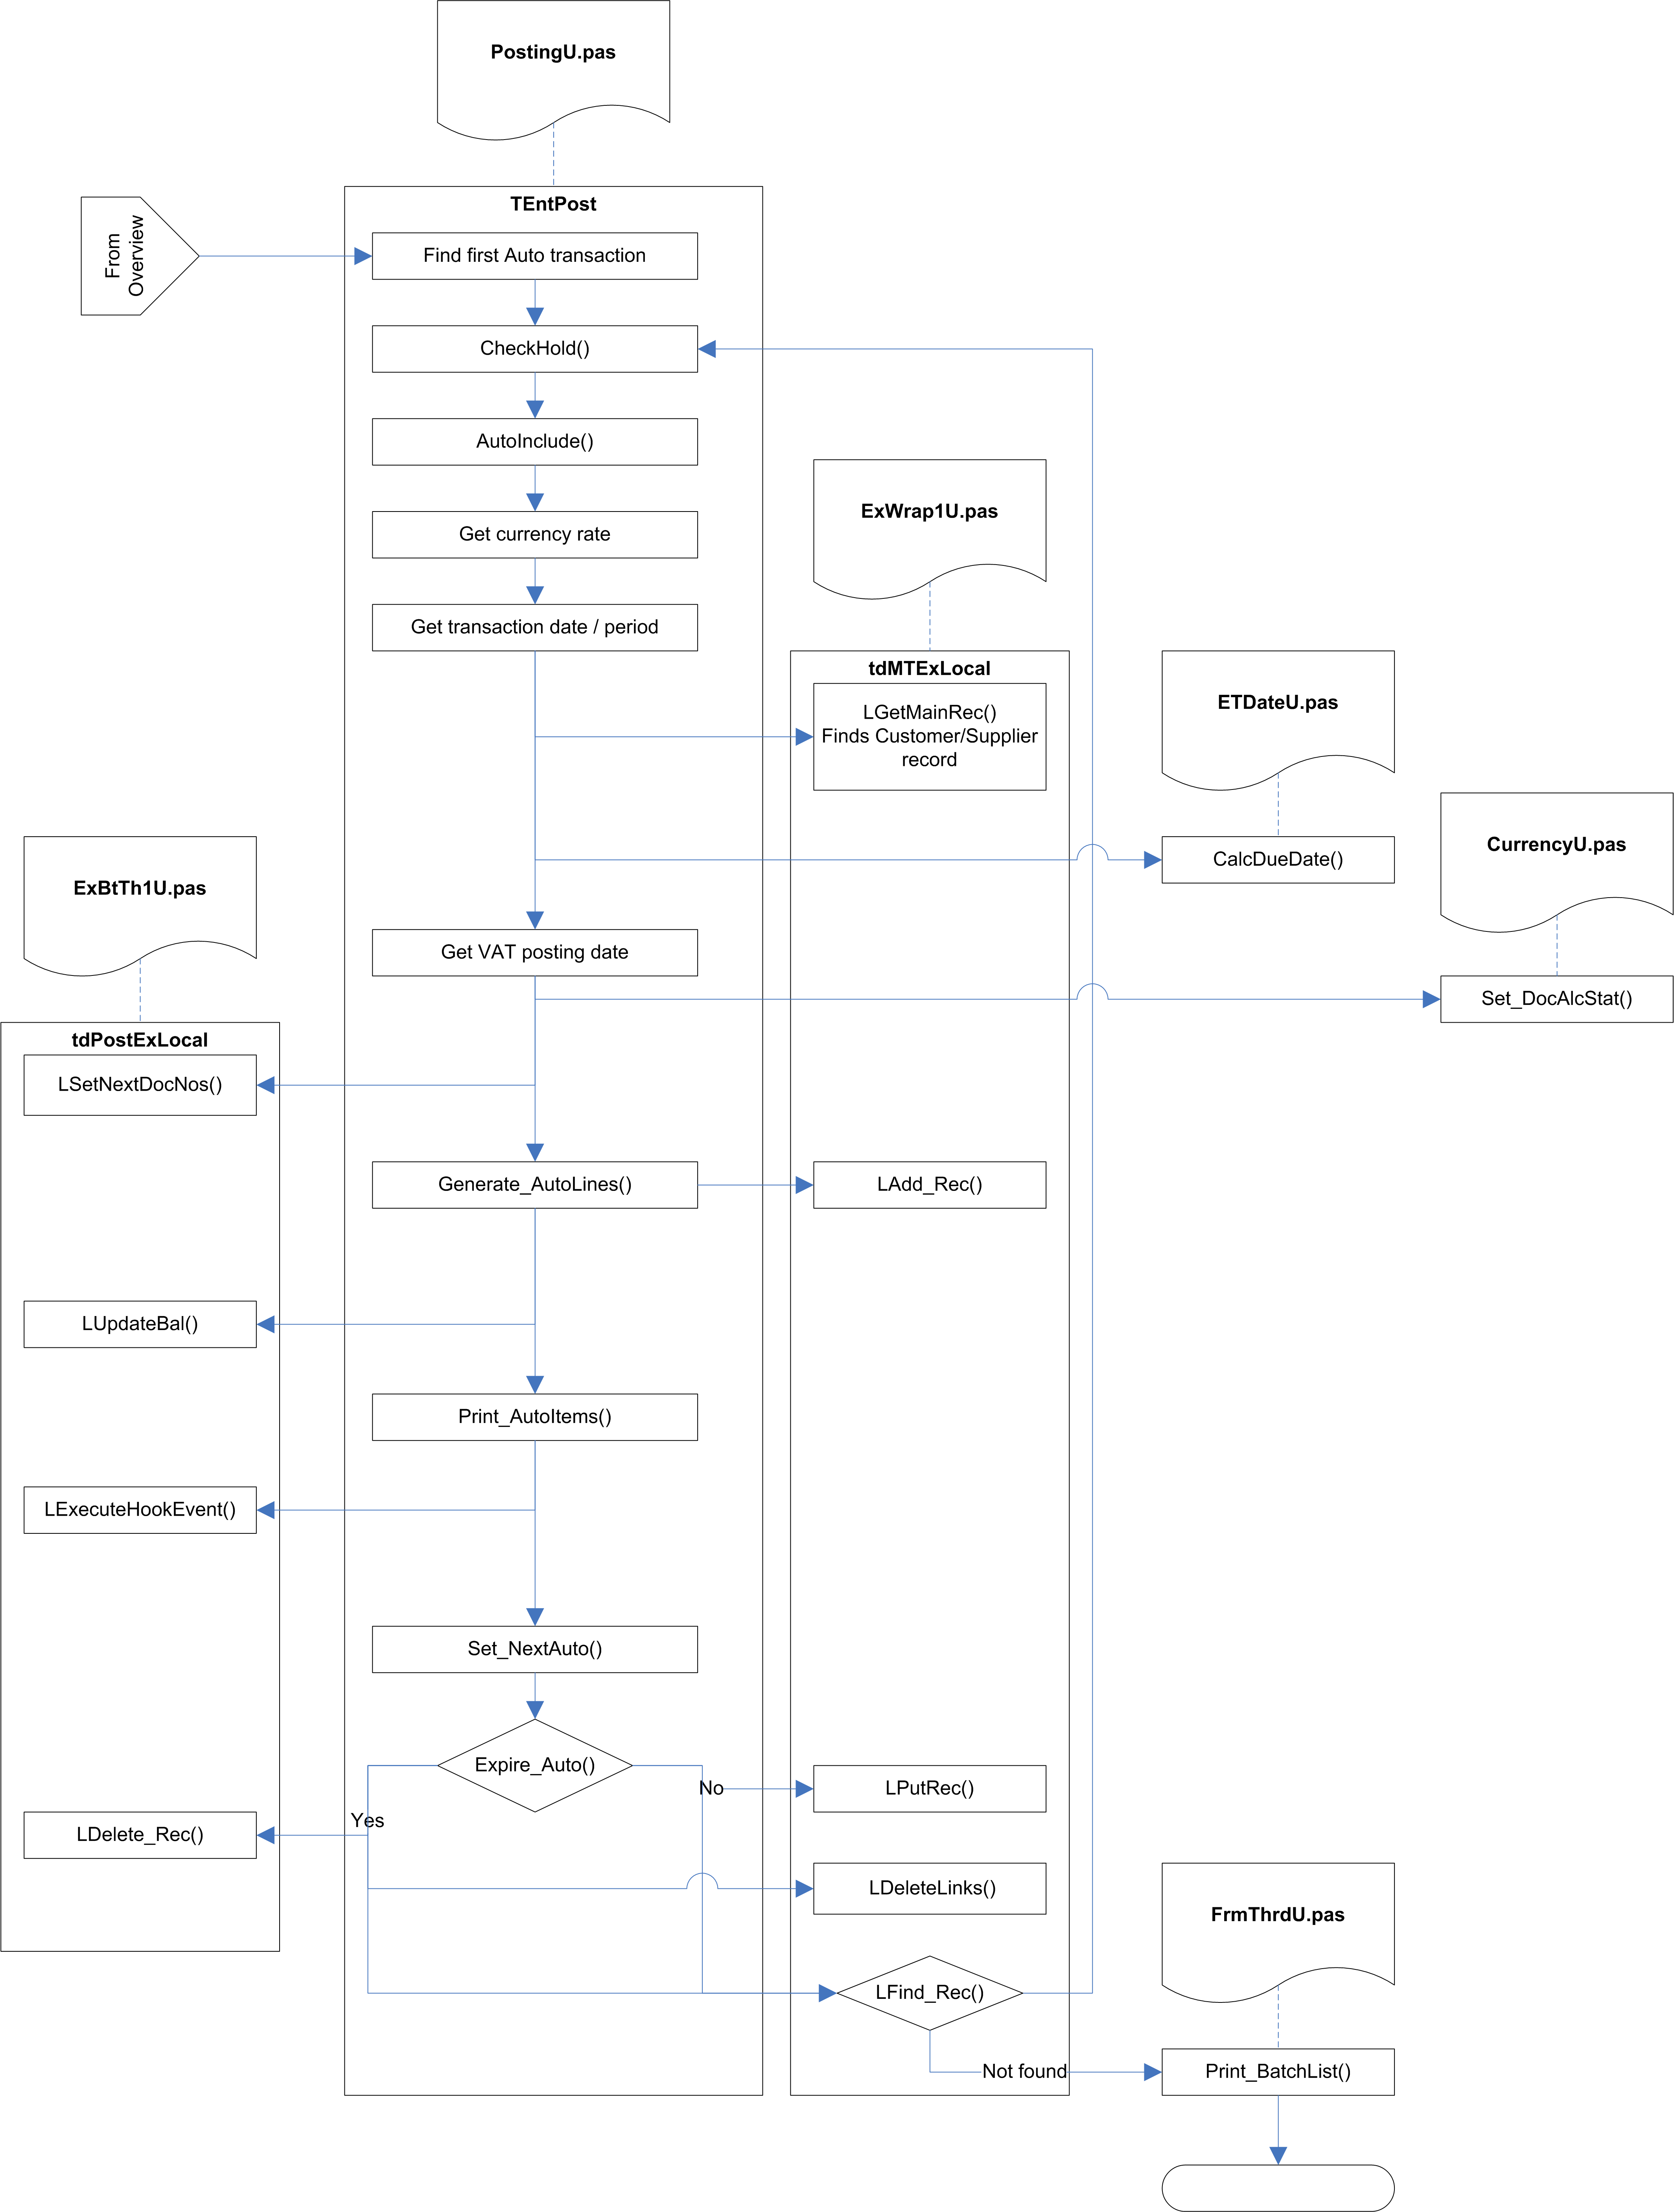

Fig.2 Post_ItAuto

TEntPost.Post_ItAuto (PostingU.pas)

Parameter | Comments
PostSet: DocSetType | Set of DocTypes
PrintToQueue: Boolean | Always False when called from Control_Posting
ItemsOnQ: Boolean | Always False when called from Control_Posting
Curr_Pno: Byte | Always 0 when called from Control_Posting
NormalPost: Boolean

Prepare job-costing
If the JobCostOn (VarConst.pas) global flag is set to True, a PostJobObj object is created. Subsequently, the MTExLocal record structure of TEntPost is copied to the MTExLocal field in the PostJobObj.

Prepare notification hook
The HookNotify flag is set to True if the Notify Auto SIN hook point is enabled.

Adjust list of document types
A copy is taken of the PostSet set of document types. If SIN transactions are included, the SQU document type is added both to this copy and to the IncDocFilt record in PostRepCtrl. If PIN transactions are included, the PQU document type is added both to this copy and to the IncDocFilt record in PostRepCtrl.

Prepare print forms
An instance of TPFormList is created, in a ThisFList local variable. This maintains a list of reports to be printed.

Locate first Auto record
It then searches for the first Auto transaction. It does this by looking for the first record in Document.Dat which has an Auto-Run number (-2), and a folio number greater than
-2147483647 (FirstAddrD constant in X:\SBSLib\Win32\Btrvu2.pas).

Check for on-hold or suspended
The CheckHold function is called to check if the current transaction record is on hold or suspended. This checks the HoldFlg pseudo-bitfield, to see if contains the HoldSuspend value (128). If so, the transaction is the point at which the posting run must be stopped, and the default set of document types is subtracted from the current set of document types.

[The HoldSuspend check is probably not relevant for Auto transactions, and the subtraction of document types at this point will end up with a set that potentially contains only SQU or PQU – this is probably wrong, but if Auto transactions cannot be suspended, then this situation will never actually occur.]

CheckHold then checks if the HoldFld field contains any of the On Hold values, and returns True if it does.

Save record position
The record position is now saved. This is because the following sections will be creating a new transaction record, based on the information stored in the Auto record. After this record is added to the file, the record position will be restored to take us back to the Auto record that was being processed.

Read and adjust currency rates
If the document type is not a nominal posting (NMT/NOM), the currency rates are read from the System Currency Setup (SyssCurr), along with the triangulation rates for Euro conversion. If the document type is not one of the direct payment types (SRF,SRI,PRF,PPI, read from the DirectSet constant in X:\SBSLib\Win\ExCommon\VarComnU.pas), then the Company Rate is set to zero.

Determine period/year or date
The AutoIncBy indicator is checked to determine whether we need to calculate the Transaction Date or the Period, and either converts the date to a period/year, or converts a period/year to a date. This triggers a hook point to allow the returned period/year or date to be amended.

Calculate the due date
The customer/supplier record is located and read. The due date is calculated based on the transaction date and the customer/supplier’s payment terms.

Payment terms usually hold the number of days credit for the customer/supplier. There is a special system in place for payment on a specific day of the month. This involves using a payment terms value greater than 500, in which case the correct value is calculated on the following basis:

900 + n = nth day of the following month.
800 + n = nth day of the second month following.
700 + n = nth day of the third month following.
600 + n = nth day of the fourth month following.
500 + n = nth day of the fifth month following.

Store operator name
The current log-in name is stored in the OpName field of the Document record.

Determine VAT date
If the VAT Scheme indicator in the System Setup indicates that VAT on Cash Accounting is in use (that is, if SyssVAT.VATRates.VATScheme holds ‘C’), and if the current document is one of the direct payment types (SRF,SRI,PRF,PPI), then the VAT date is calculated.

Currently, this is simply read from the System Setup (SyssVAT.VATRates.CurrPeriod), but in future it will be calculated using the CalcVATDate function in SysU1.pas – this function calculates and returns the VAT date based on the supplied transaction date. If the transaction date indicates a date in advance of the current period, it returns the last day of the month that the transaction date actually falls in.

The UntilDate is set to today, to indicate that this transaction was fully allocated at this date.

Set document allocation status
The Set_DocAlcStat procedure in CurrencyU.pas is called to the set the allocation status.

If the document is in the Allocation set (PIN,PCR,PJI,PJC,PPY,SIN,SCR,SJI,SJC,SRC), the AllocStat field is set to ‘S’ for supplier or ‘C’ for customer, and #254 is stored in the UntilDate field. For other document types the AllocStat field is set to #0, and the UntilDate field is left unchanged.

If the System Setup authorisation mode holds ‘A’, and the HoldFlg value does not indicate that the record in on hold, the HoldFlg value is set to HoldP – Authorise Payment.

Assign next document number
This calls the tdPostExLocal.LSetNextDocNos method in ExBtTh1U.pas to get the next available document reference for the current document type.

The tdPostExLocal.LGetNextCount method is called to locate and update the document number in the Increment table. The tdPostExLocal.FFullDocNum method builds a full reference based on this number.

The reference number is created using the following recipe:

- Get the next available document number (using LGetNextCount).
- Convert this to a string.
- If the string is more than 6 characters long:
    - Extract the first two characters of the string.
    - Convert them to a number.
    - If this number is less than 33 and greater than 10:
      - Subtract 10.
      - Use the result as an index into an array of characters (A to Z, excluding I, O, and S).
      - Store the indexed character as the suffix.
      - Copy the next 5 characters from the string, as the trailing string.
      - Convert them to a number.
      - Convert the result back into the trailing string.
    - Concatenate the document type string, the suffix, and the trailing string.
    - Return the result as the new reference.

[ If step 3.ii results in a number less than 10 or greater than 33, the returned reference will be in the normal format, but will be too long to be valid. ]

[Steps 5 and 6 seem redundant.]

[A ‘next count’ number greater than 10 000 000 will return the wrong reference (as step 4 will ignore characters beyond the seventh character in the string).]

The resulting reference is searched for in Document, to make sure it does not already exist. If it does exist, another next reference number is obtained – this continues until a unique reference is found.

Assign next folio number
This is done by the tdPostExLocal.LSetNextDocNos method in ExBtTh1U.pas, and works in a similar fashion to the document reference, but folio numbers are integers rather than strings, so the check for duplicate numbers is different.

The tdPostExLocal.LGetNextCount method is called to locate and update the folio number in the Increment table.

If the current document type is SBT, PBT, SQU, PQU, ADJ, SOR, POR, SDN, PDN, or TSH, then the Folio Type which is searched for by LGetNextCount is AFL, otherwise it is FOL.

The Document table is searched for a match with the Folio Number, using the Folio Index. Because this index is an integer, the folio number is converted into a string with an embedded binary number as the search key, with any trailing #0 bytes removed.

Generate transaction lines
The Generate_AutoLines method is called to add the transaction lines for the generated transaction.

The transaction lines against the original Auto transaction are located (using the Folio Number).

For each line, the record position is stored, and the line is then updated with the details from the generated transaction. If the transaction is a nominal transation (NMT/NOM), the currency rates are read from the system settings, along with the matching triangulation rates. If the transaction is not a nominal transaction, these rates are read from the transaction header record instead.

The transaction line is then saved as a new record, and the original record position is restored, ready to move on to the next Auto transaction line.

Save transaction
The transaction is now saved as a new record.

Update balance
If the System Setting UpBalOnPost is True (indicating that customer/supplier balances should only be updated on a post, rather than being updated straight away), this section is ignored.

This section is also ignored if the current document type is a quote (SQU or PQU), or is a Sales or Purchase Order transaction (SOR, POR, SDN, or PDN).

The tdPostExLocal.LUpdateBal method (see below) is called to update the customer/supplier balances and the history records.

Print report
If the transaction is one of the auto-print transactions (SIN, SCR, SRI, SRF, SQU, SOR, SDN, PPY, PQU, POR), a print task is added to ThisFList.

Call hook point
If the After Auto SIN Created hook point is enabled, the hook event is triggered.

Update or delete auto transaction
The transaction record is locked. [If the lock fails, the auto transaction is left unchanged.]

Set_NextAuto is called to move the auto transaction date/period forward. The AutoIncBy field of the transaction record is used to determine whether the date is advanced by period or by date, using the AutoInc field as the actual increment value (either periods or days).

The Until Year/Period or UntilDate is checked to see if the new period or date would be past the expiry date. If it is, the auto transaction record is deleted (along with its accompanying transaction lines), otherwise it is saved with new period/date and unlocked.

Locate next auto record
The routine looks for the next auto transaction record, and if it finds one it goes back to the Check for on-hold or suspended section.

Print reports
If there are no more auto transaction records, the list of reports in ThisFList is passed to the Print_BatchList function (in FrmThrdU.pas) for printing via the thread queue.

tdPostExLocal.LUpdateBal (ExBtTh1U.pas)

Parameter | From Post_ItAuto & Post_BatchDetails
UInv: InvRec | MTExLocal.LInv
BalAdj: Real | BaseTotalOS(LInv)
CosAdj: Real | ConvCurrICost(LInv,BOff,BOn)*DocCnst[InvDocHed]*DocNotCnst
NetAdj: Real | ConvCurrINet(LInv,BOff,BOn)*DocCnst[InvDocHed]*DocNotCnst
Deduct: Boolean | False
Mode: Byte | 2 (=’U’ and ‘W’ History types)

Locate the customer/supplier record
This first tries to find and lock the current customer/supplier record. If this fails, it assumes that this is because the lock failed (another user or process was editing the record). The routine still continues, as the record lock is only required to allow the ‘last edited’ details to be updated – if another user is editing the record, these details will be left alone.

[If the find and lock fails for some other reason, this too is ignored, and the routine carries on as if it had correctly found the customer/supplier record.]

Prepare the credit/debit amounts
A local array, CrDr[], is used to hold the credit and debit values.

If BalAdj is negative, the Credit element (CrDr[True]) is filled with the unsigned amount, otherwise the Debit element (CrDr[False]) is filled with the amount.

If the current document type is a direct transaction (SRF, SRI, PRF, PPI), then the opposite element of the CrDr[] array is filled with the unsigned amount as well.

Provided the Account Year for the transaction is after the last purge year, the history records can be posted.

Update the balance history
Several calls are now made to LPost_To_Hist and LPost_To_CYTDHist (see below).

First, the basic balance for the customer/supplier is updated, for the year and period concerned. The matching year to date balance is also updated.

The debtors/creditors control account is updated. If the customer/supplier has overridden the default debtors/creditors control account then this overriding account is used, otherwise the balance is stored against a control account of zero. The matching year to date balance is also updated.

For transactions which affect the Stock tree (SIN, SCR, SRF, SRI, SJI, SJC, SDN, PIN, PDN, PCR, PRF, PPI, PJI, PJC), the Customer/Supplier Gross Profit balance record for the year and period is updated. The matching year to date balance is also updated.

Update ‘last edited’ flag
If the Customer/Supplier record was successfully locked at the start of this routine, then the ‘Last Edited’ flag on the record is updated with the date and time. The record is then unlocked.

tdPostExLocal.LPost_To_Hist (ExBtTh1U.pas)
The history table contains a history of balances, split into multiple categories (e.g. by customer/supplier, by cost centre, by department). This routine updates the history table with the supplied balance details.

Note: this routine simply calls LPost_To_Hist2, passing an additional two parameters as zero. The actions detailed below are actually carried by LPost_To_Hist2.

Parameter | From LUpdateBal
NType: Char | ‘U’ or ‘V’ – for some postings LPost_To_Hist is called twice, once for each type.
NCode: Str20 | Account code
PPurch: Double | Debit
PSales: Double | Credit
PCleared: Double | Always 0
PCr: Byte | Always 0 (consolidated)
PYr: Byte | AcYr, from transaction line
PPr: Byte; | AcPr, from transaction line
var PrevBal: Double | Initially 0 (LPost_To_Hist updates this value).

Locate history record
This first tries to find an existing record against the type, code, currency, year, and period. If it cannot find an existing record, it adds a new one. If the period indicates that this is a Year To Date transaction (not possible for Daybook Posting?), Year To Date records will also be added for any years previous which do not yet have them.

The record is then locked.

Calculate balances
The Previous Balance is calculated from the existing Sales and Purchases values. These are then updated with the passed in values, rounded up to 2 decimal places.

The record is saved and unlocked.

Batch Transactions

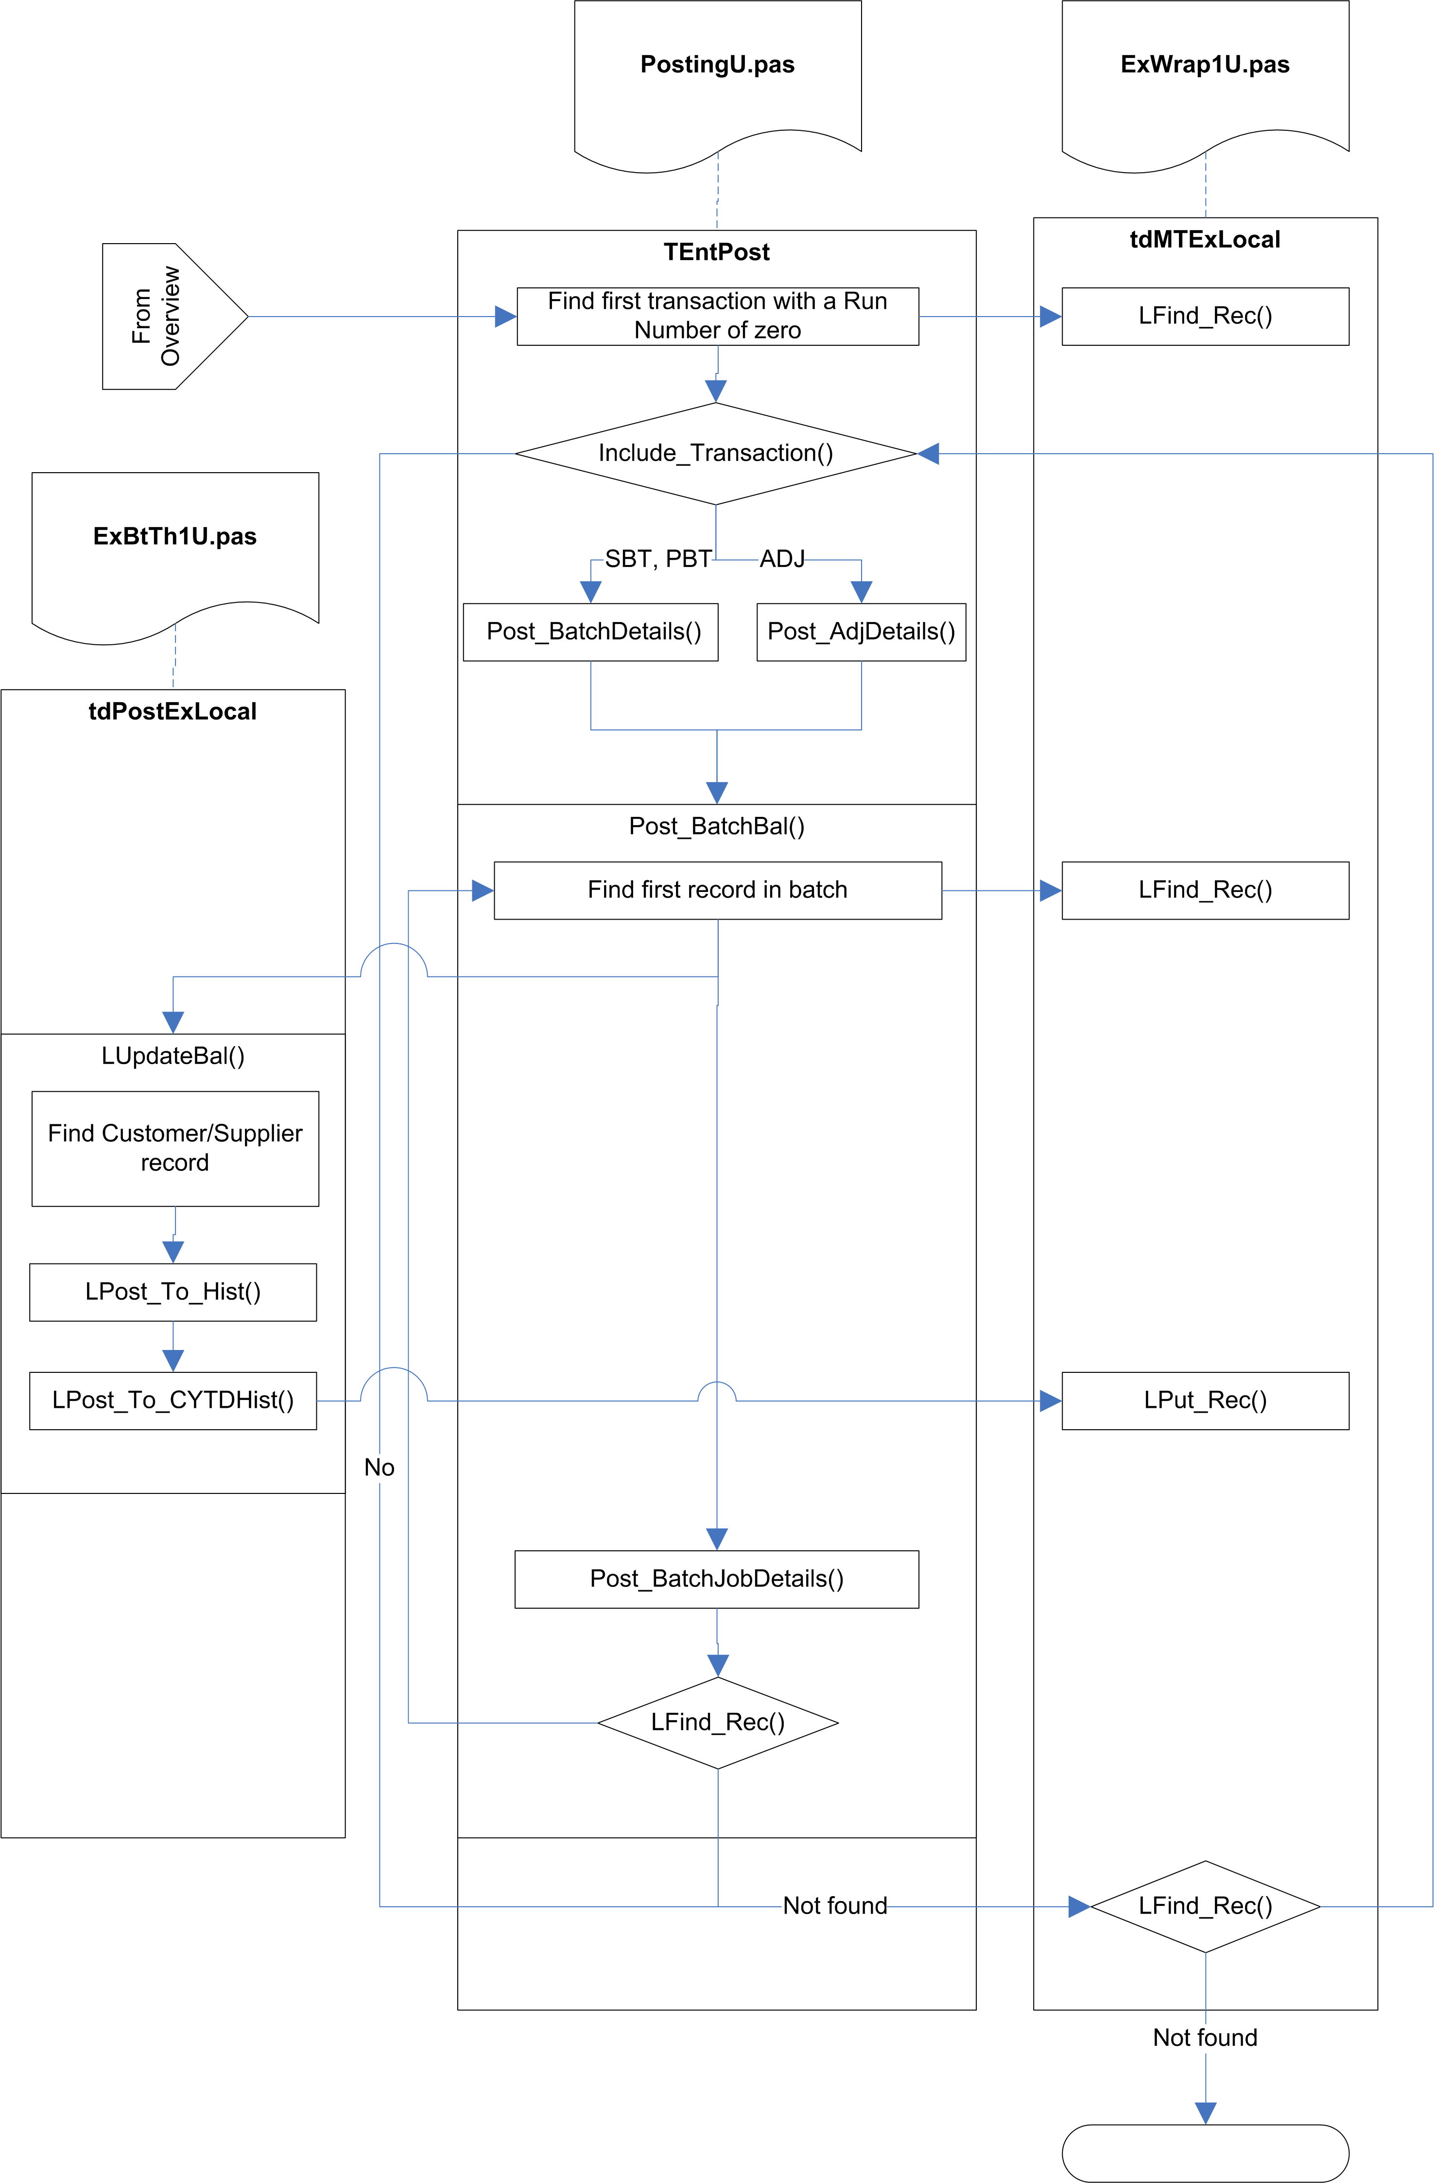

Fig.3 Post_ItBatch

TEntPost.Post_ItBatch (PostingU.pas)

Prepare job-costing
If the JobCostOn (VarConst.pas) global flag is set to True, a PostJobObj object is created. Subsequently, the MTExLocal record structure of TEntPost is copied to the MTExLocal field in the PostJobObj.

Locate first batch record
The routine searches for the first transaction with a run number of zero.

Increment PostingCount
The PostingCount variable keeps track of the number of transactions actually posted, and is eventually used to… ???

Update LastFolio
If the current transaction has a folio number greater than the current LastFolio number, LastFolio is updated with this folio number.

The LastFolio value will be used in the main posting routines to check for and ignore transactions that were added after the posting run was started.

Check transaction
The Include_Transaction routine is called to determine whether the current transaction should be included in the posting run.

Included transactions are:
- Document type SBT, PBT, or ADJ
- Not on hold or suspended
- Not for a future period
- Not for a past period, unless the system flag to allow posting into previous periods is set.
- Not for a future transaction date
- Not in a purged period
- Not before the last audit date

Lock record
The transaction record is locked. If it cannot be locked for any reason, it is simply ignored.

Post details
For document types SBT and PBT, the Post_BatchDetails routine is called. For document type ADJ, the Post_AdjDetails routine is called.

Save record
The current transaction record is locked, and the run number is updated. The record is then saved and unlocked.

Update customer/supplier balance
If the batch has not already been posted, Post_BatchBal is called to update the balances for each transaction in the batch. This in turn calls LUpdateBal to do the actual updating, and calls LUpdate_JobAct for each transaction line of the current transaction, to update Job Actuals.

Next record
The next batch transaction record is located and, if found, we loop back to Increment Posting Count.

TEntPost.Post_BatchDetails (PostingU.pas)

Parameter | From Post_ItBatch
BInv: InvRec | Current transaction record
TTEnabled: Boolean | False
PostOPtr: Pointer | PostJobObj (Job Posting object)

Locate batch transactions
The OurRef of the transaction record is used to find the first transaction for this batch.

Lock record
The record is locked. If this fails, the record is simply ignored.

If TranOk2Run is True, a Btrieve Transaction is started, to allow any changes to be rolled back if something goes wrong.

Determine VAT Date
If the VAT Scheme indicator in the System Setup indicates that VAT on Cash Accounting is in use (that is, if SyssVAT.VATRates.VATScheme holds ‘C’), and if the current document is one of the direct payment types (SRF,SRI,PRF,PPI), then the VAT date is calculated.

Currently, this is simply read from the System Setup (SyssVAT.VATRates.CurrPeriod), but in future it will be calculated using the CalcVATDate function in SysU1.pas – this function calculates and returns the VAT date based on the supplied transaction date. If the transaction date indicates a date in advance of the current period, it returns the last day of the month that the transaction date actually falls in.

The UntilDate is set to today, to indicate that this transaction was fully allocated at this date.

Set document allocation status
The Set_DocAlcStat procedure in CurrencyU.pas is called to the set the allocation status.

If the document is in the Allocation set (PIN,PCR,PJI,PJC,PPY,SIN,SCR,SJI,SJC,SRC), the AllocStat field is set to ‘S’ for supplier or ‘C’ for customer, and #254 is stored in the UntilDate field. For other document types the AllocStat field is set to #0, and the UntilDate field is left unchanged.

If the System Setup authorisation mode holds ‘A’, and the HoldFlg value does not indicate that the record in on hold, the HoldFlg value is set to HoldP – Authorise Payment.

Save record
The record is saved and unlocked.

If a Btrieve Transaction is active, it is either committed or (if the save failed) rolled back.

Update customer/supplier balance
If the System Setting UpBalOnPost is True (indicating that customer/supplier balances should only be updated on a post, rather than being updated straight away), or if a Btrieve Transaction was used, this section is ignored.

The LUpdateBal method is called to do the actual updating.

Update Job Costing
If we are not in a Btrieve Transaction, and Job Costing is active, the Post_BatchJobDetails method is called. This calls LUpdate_JobAct for each transaction line of the current transaction.

Find next record
The next transaction record is located, if any, and the routine loops back to Lock record.

TPostJob.LUpdate_JobAct (JobPostU.pas)

Parameter
Idr: IDetail | Transaction line record
InvR: InvRec | Transaction header record

Locate record
This locates a record which matches the Folio Number and Absolute Line Number of the transaction line. If no record can be found, a new record will be added, otherwise the record is locked.

Check transaction line
The Job Actual record will only be created or updated if the transaction line fulfils the following requirements:

- A Job Code is specified.
- NomAuto is set to True.
- The line number is greater than or equal to zero, or the document type is not one of JCT, JST, JPT, JSA, or JPA.
- The document type is not JPT.
- The document type is not JST, unless DeliverRef is non-empty.
- The document type is not one of JSA, or JPA, unless the line number is zero.
- The document type is not one of SRN, or PRN.

Assign/calculate values
The Job Actual values are copied from the transaction line. Qty, Cost, Charge, and Uplift values are recalculated, based on the document type and on additional information looked up in the JobMisc, Stock, and Customer/Supplier tables.

Save record
The Job Actual record is saved or added, and the lock is released.

TEntPost.Post_AdjDetails (PostingU.pas)

Parameter | From Post_ItBatch
BInv: InvRec | Current transaction record
Var GotHed: Boolean | Not Syss.AutoValStk
Var NInv: InvRec | Empty invoice record
PostOPtr: Pointer | Job Posting object

This routine creates a nominal transfer record, if required, for the current transaction. The new transaction header will be returned in NInv (if a new record was not created, NInv will hold a copy of BInv).

Note: this routine is extremely complex, and the following description skims over most of the details (largely because I do not understand the business rules that are being implemented).

Check Stock Valuation flag
The AutoValStk system setting is checked. If this is True, a Nominal Transfer record is required.

Create Nominal Transfer record
Create_NTHedInv (in RevalU2U.pas) is called to create the actual record, copying the details from BInv, and marking the transaction as external document (to prevent user-editing of it).

Locate transaction lines
The transaction lines against the current transaction are located and processed.

Update history
Stock_PostCtrl is called to add or update the various balance history records based on the current transaction line, using LPost_To_Hist2 and LPost_To_CYTDHist2. For some lines, the Customer / Supplier / CostCentre / Department balance history records are also updated, using Ctrl_CuStkHist.

Substitute stock parameters
The stock location record is found, and if necessary the nominal codes are copied across from the location record to the stock record.

Get nominal codes
The nominal codes are retrieved either from the Stock record or from the BOM parent record (if one exists).

Call hook point
If the Adjustment Nominal Code hook point is enabled, the hook point is called to allow the nominal codes to be changed.

Add stock valuation lines
Stock valuation lines are added via the Add_StockValue routine in RevalU2U.pas.

This searches all transaction lines for a match with the Stock Valuation Code (-21), the Nominal Code (either Closing Stock or BOM GL), and the Cost Centre and Department of the current stock item.

If a match is found, the Net Value is updated.

If no match is found, or if the Separate Control Posting system flag is set to True, a new Nominal Transfer transaction line is created and the values are copied into it.

Add Job Costing uplift
If the current transaction line has a Job Code, and the matching Job Actual record contains an Uplift value, a stock valuation line is added for this as well.

Finalise transaction line
The Folio Number of the transaction is copied to the B2BLink field of the line.

It then searches for the next transaction line and loops back to Update history.

Finalise transaction
If Auto Stock Valuation is active, Reset_NomTxfrLines in RevalU2U.pas is called to set the run number for the transaction lines.

Main Posting

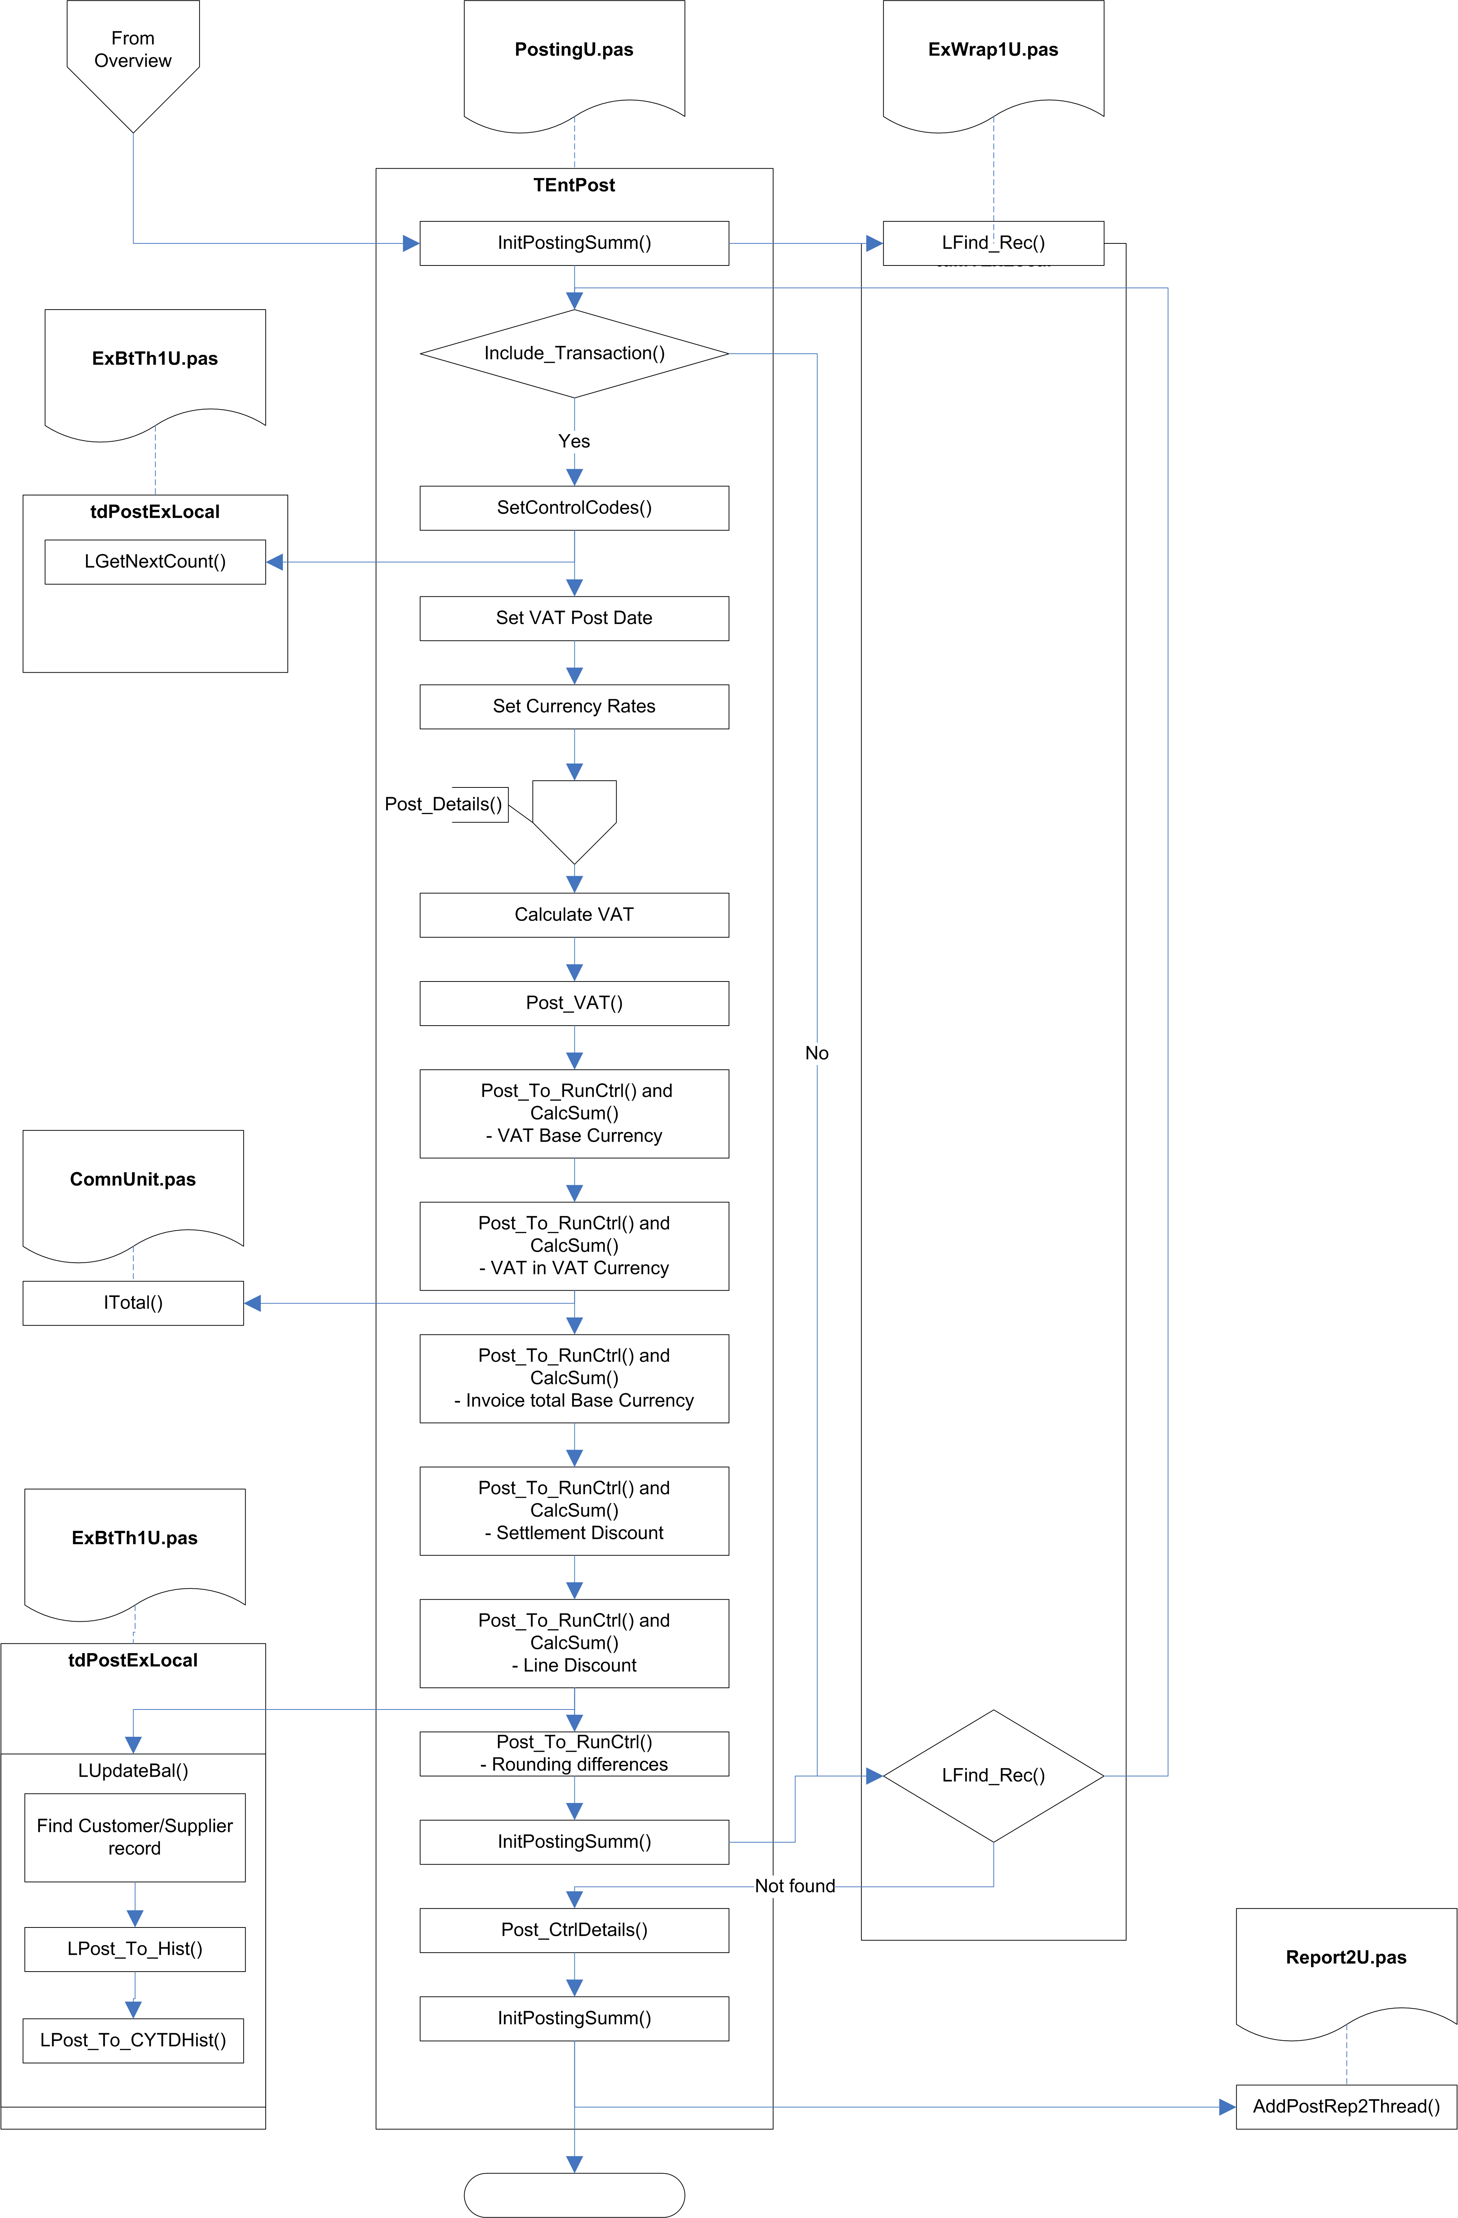

Fig.4 Post_It

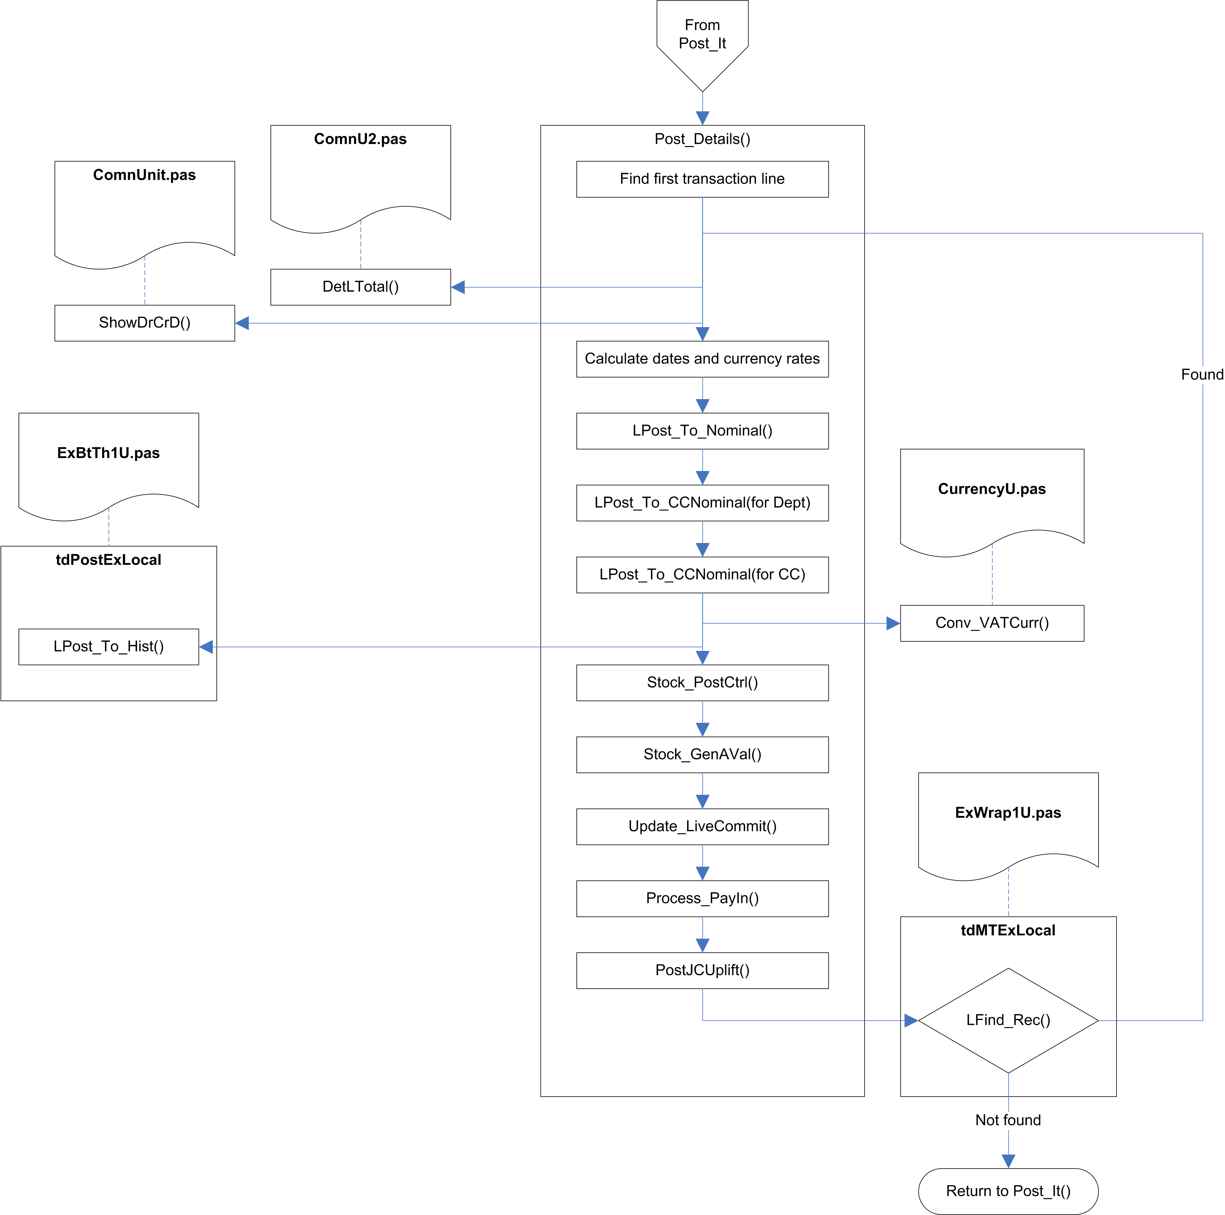

Fig.5 PostDetails

TEntPost.Post_It (PostingU.pas)
This is the main posting routine. It locates all the unposted transactions that meet the requirements for the current posting run and posts them, calling Post_Details() to handle the individual transaction lines.

It takes three parameters:

Parameter | Type | Description
PostSet | DocSetType | A set of the document types which should be posted
Mode | Byte | The posting mode:  0 : All daybooks  1 : Sales  2 : Purchases  3 : Nominal  4 : Adjustment
ItemTotal | LongInt | The total number of transactions that are likely to be posted. This number will have been calculated as part of the Post_ItBatch() routine.

TranOk2Run
This flag is set in TEntPost.Start(), and will be true if Protected Mode has been selected by the user, and a Begin Transaction was successfully called. It basically indicates that Btrieve Transactions should be used to protect all database updates.

The Post_It() routine attempts to start a Btrieve Transaction, and reports an error if this fails. Even if it fails it will allow the posting to continue. The Btrieve Transaction is ended (it is presumably used purely to check that database transactions are possible).

Call InitProgress(ItemCount)
This sets the total for the progress bar of the Thread Controller window. The ItemCount is actually initialised via an earlier call to Post_ItBatch(), which goes through all the transactions with a run number of zero, looking for batch transactions -- it updates the total count of transactions as it does so, and this is then passed to Post_It().

Call InitPostingSumm(PostSummary, False)
The Posting Summary array is initialised. These are separated into Sales and Purchases, where each element is a record holding the document type and three summary values.

The first and third summary values in each record are initially stored with the next available transaction number for the document type. The second value is set to zero.

AutoRecover
If the last run number in the Posting Control record is not 0, this indicates that the last posting run failed to complete correctly. If this is the case, and if the system setting PostProtect is True, the AutoRecover flag is set to True to indicate that the Posting routine should attempt to re-post any transactions which were not fully posted in the previous run.

SetCtrlCCDep - Hook Point
This flag is set to True if the Default Cost Centre/Department hook point is active.

Find first Transaction
The routine searches for the first Transaction with a Run Number of zero (which indicates an unposted Transaction). This is the start of the main processing loop, which will continue until all the Transactions with a run number of zero have been processed.

Call UpdateProgress()
A simple item counter is incremented and passed to UpdateProgress() to update the progress bar on the Thread Controller window.

Call Include_Transaction()
This is called for each Transaction, to determine whether or not it should be included in this posting run.

Lock record
The record is locked before performing any processing on it.

If the lock fails, a message is added to the posting lock, and the routine continues on to the next record.

Call SetControlCodes()
This populates the CtrlSet array with the correct G/L codes for the Transaction.

Prepare Run Number
If the next run number has not yet been set, then LGetNextCount() is called to retrieve the next available run number. It is checked here (inside the loop for processing the transactions) so that it will only be set if any transactions were actually included. It will be ignored if AutoRecover is active, as this will already have set the run number.

This number is then passed to PostUnlock(): TEntPost maintains LLockAddr array of addresses of lock records in EXSTKCHK. PostUnlock() goes through this array, and for every element which holds an address it updates the Run Number stored in the record with the new number.

Set VAT Date and Period
This is only done if Cash Accounting is not in use (which is determined by SyssVAT.VATRates.VATScheme -- this is 'C' for Cash Accounting).

If the VAT Post Date on the Transaction is not currently set, and either the document type is not one of SRC, PPY, or NMT, or the document type is NMT and the Nominal VATIO indicator is character zero, then the VAT Post Date is set by a call to LSetVATPostDate(). This either calls a hook point (if assigned), or gets the VAT Date from CalcVATDate (in SysU1.pas).

Assuming a VAT Post Date has now been set, the VAT Year and Period are extracted from the date.

Store Company and Daily Exchange Rates
This is only done if the Posting Date is today.

If the Company Rate in the OrigRates array on the Transaction is zero, the value is copied from the system setting company rate for the transaction currency.

The Daily Rate in the OrigRates array is copied from the CXRates array on the Transaction.

Call PostDetails()
This processes all the lines for the Transaction.

Post VAT History
VAT History is not posted if Cash Accounting is being used.

Lines are excluded using the following rules:

- Lines for transactions with a doctype of SRC, PPY, or NMT are ignored, except for NMT lines which have a NomVATIO value set.
- Lines without a VAT Code set are ignored.
- Hidden stock deduct lines (indicated by a LineNo of -1) are ignored.
- Lines for transactions which are Process or Triangulation transactions are ignored.

For all other lines, VAT history is calculated and posted. This requires the line total to be in VAT currency, so the routine first determines which exchange rate to use, based on whether the company or daily exchange rate is in use, and whether this is a nominal (NMT) transaction. The line total is recalculated in the VAT currency, and if the result is not zero, it is posted to the VAT History.

Post Reverse Change VAT
If Reverse Charge is in effect (this is a system setting, and will only be enabled for EC VAT), and is required for this transaction, the reverse charge VAT is posted to VAT History.

The EC VAT total is calculated in the VAT currency and in the base currency. Post_To_RunCtrl() is called to post the EC VAT input at base and VAT currency, and the EC VAT output at base and VAT currency. The Summary array is also updated with these values.

Post Totals
The Invoice Total is calculated, and any outstanding discount is applied to it. The result is added to the Summary array, and is then passed to Post_To_Ctrl() for both the base currency and the invoice currency (if it is not base).

The Discount total and Line Discount total are calculated, and Post_To_Ctrl() is called to post these to the discount control account and line discount control account.

Update Balance
The total amount, the discount amount, and the line discount total are calculated in the transaction currency. The account balance is updated with the total amount.

Post Rounding Differences
The system now has to account for any rounding errors that might have occurred (this would usually be a result of currency conversions). It takes the running total that has been calculated from the transaction lines, and subtracts the rounded equivalent of the total as calculated by adding the net value and the VAT value and subtracting the discount values. The result is posted to the Unrealised Currency Variance account (if it is zero this will have no effect).

Update CIS Date
If CIS is in used, and there is still a CIS amount outstanding, the CIS Date is set to either today’s date or the current period (depending on the CISRates.CISAutoSetPr system setting).

Create Auto-Reverse Nominal
If a database transaction is active, it is released.

If this is an auto-reversing nominal, the reverse transaction is created by copying the transaction and its lines, reversing the values. The PrePostFlg value on the current transaction is set to 1, to indicate that the reverse has been created.

The next record is navigated to.

Call Post_CtrlDetails()
Once all the transactions have been processed, Post_CtrlDetails() is called to do the final update of the G/L control accounts.

PostDetails()
This processes all the lines for the current Transaction.

Parameter | Notes
DocFno: LongInt | Folio number
RunNo: LongInt | Run number
VYr: Integer
VPr: Integer
CtrlSet: ControlAry | Array of nominal codes
LineTotal: Real | The line total is passed back via this parameter.
AutoRecover: Boolean

Locate first transaction line
The supplied Folio Number is used to locate the transaction lines for the current transaction.

The routine determines whether this line has already been posted (as a result of a failed previous posting run). If it has not yet been posted, and if database transactions are in use, a database transaction is started, and a check is made that no-one else is doing the same daybook post (in theory this check should be redundant because this posting run was locked when it started).

A BeenPosted flag is set to indicate that this transaction line was posted on a previously failed posting run. Much of the rest of the routine is passed over if this is set.

Calculate totals
The line total is calculated using DetLTotal (in ComnU2.pas). If this is not zero, or the Net Total on the line is not zero, or the line is a hidden stock deduction line (hidden BOM line?), the exchange rates are assigned, and if BeenPosted is False, the values are posted to the G/L, by a call to LPost_To_Nominal().

If Cost Centres and Departments are in use, and the Post To Cost Centres system flag is True, LPost_To_CCNominal() is called to post the values and the discount values, if require, to the cost centre and department accounts.

Save transaction line
If this transaction line was not previously posted, the LiveUplift flag on the line is set, and the record is saved.

If the Period or Year are zero on the Transaction line, this will abort the posting of the current Transaction.

Call LPost_To_Nominal()
This posts the values for the current Transaction Line to History

The Run Number is assigned to the PostedRun field on the Transaction Line.

Call LPost_To_CCNominal()
If the system is using Cost Centres and Departments, and if the Post To Cost Centres system flag is set, LPost_To_CCNominal() is called to update the History against the Cost Centre and Department for the current Transaction Line.

Additional control code lines
If Live Stock is used, additional lines need to be created for Cost Of Sales control codes.

If this is a Sales transaction and a hidden Stock Deduct (BOM) line the routine locates the matching parent line (the line number is assumed to be stored in the SOPLineNo field) and returns the details. The currency, cost centre/department, and Cost of Sales nominal code are copied from the parent line to the current line.

Call Stock_GenAVal()
Stock_GenAVal() is called to create the new lines.

Post Commitment Values
If Commitment Accounting is active, Update_LiveCommit() is called to update the commited values.

If database transactions are in use, a new one is started.

The commitment values are posted to the nominal account. If Cost Centres and Departments are in use, the amounts are posted to the nominal account, for the Cost Centre and Department (if any) from the line, and also for the combined Cost Centre and Department (if the Combined flag is set).

If a database transaction was started, it is closed, and for non-SQL versions the routine pauses for just over half a second (according to the comment in the code, this is to allow other workstations the chance to save transactions).

Call Process_PayIn()
If the PayIn flag on System Settings is set, the Process_PayIn() routine is called.

Call PostJCUplift()
If Job Costing is in use, the PostJCUplift() routine is called.

Finalise Post_Details
If a database transaction was started at the beginning of the Post_Details() routine, it is now released. For non-SQL versions the routine pauses for just over half a second.

Sub-Routines

Include_Transaction()
This determines whether or not the current Transaction should be included in the posting run.

Parameter | Notes
var PostSet : DocSetType | Document types to be processed
var AutoRecover: Boolean | Value of the AutoRecover flag (note: there doesn’t seem to be any reason for this to be a var parameter)
var PRunNo: LongInt | Number of the previously interrupted posting run, if any. This will be zero if there was no posting run to be recovered (note: there doesn’t seem to be any reason for this to be a var parameter)
BatchMode: Boolean | This is True if this function is called from Post_ItBatch()

It does multiple checks to determine whether the Transaction should be included.

The initial check passes if the following are True:

The Document type was in the list of types selected by the user,
OR
the Posting Run was called automatically (i.e. with no user interaction)
OR
AutoRecover is active.

If AutoRecover is active, the Transaction will be included if a call to LinesPartPosted() returns True (see below), indicating that unposted Transaction Lines were found from a previous posting run.

For Batch Mode only, the document type is checked to see that it is one of SBT, PBT, or ADJ, and the Transaction is excluded if it is not one of these.

The Hold flag is checked, using CheckHold(). This will return False if the current Transaction is on Hold. If the current Transaction has the Suspend flag set, then the set of document types being processed (PostSet) will be adjusted by CheckHold() to remove all document types for the same daybook, so that no further Transactions for this daybook will be processed.

If the document is on Hold, but would otherwise have been included in this posting run, an appropriate message is recorded in the posting log.

If the folio number of the Transaction is greater than the highest folio number recorded for this run (this is recorded by Post_ItBatch()), and we are not in AutoRecover mode, then the document will be excluded because it was added after the posting run was started, and a message is recorded in the posting log.

If the Transaction is for a future period, then it will be excluded, and a message is added to the posting log. If it is for a previous period, and posting to previous periods is not allowed (based on the system setting PrevPrOff), then the document will be excluded, and a message is added to the posting log.

If the daily exchange rate on the Transaction is zero, and this is not a nominal split document (NMT) then it will be excluded, and a message is added to the posting log.

If the Transaction is for a future date, then it will be excluded, and a message is added to the posting log.

If the Transaction date is previous to the last audit date, or the Transaction belongs to a purged year/period, it will be excluded, and a message is added to the posting log.

SetControlCodes()
This populates a supplied array of control codes with the G/L codes relevant to the specified document type (read from the system settings, Syss.NomCtrlCodes).

Parameter | Notes
DocHed : DocTypes | The Document type of the Transaction
var CtrlSet : ControlAry | Array of control codes

The array of control codes is of ControlAry type:

- ControlSet = (DebCred, VATCtrl, DiscCtrl, LDiscCtrl);
- ControlAry = array[ControlSet] of Longint;

For Sales transactions the entries from Syss.NomCtrlCodes will be Debtors, OutVAT, DiscountGiven, and LDiscGiven.

For Purchases transactions the entries from Syss.NomCtrlCodes will be Creditors, InVAT, DiscountTaken, and LDiscTaken.

These are NomCtrlType enumeration types.

LPost_To_Nominal()
Post values to Nominal Code history.

Parameter | Notes
NCode: Str20 | FullNomKey() of Nominal Code
PPurch: Double | Total Purchases value
PSales: Double | Total Sales value
PCleared: Double | Total Cleared value
PCr: Byte | Currency
PYr: Byte | Year
PPr: Byte | Period
Level: Longint | Recursion level (initially 0)
PostYTD: Boolean
AutoLZ: Boolean
PostYTDNCF: Boolean
CXRate: CurrTypes
var PrevBal: Double | Total Balance
var ActualNomCode: LongInt | Nominal Code posted to (if different to NCode)
UOR: Byte

If a Nominal record cannot be found for the Nominal Code on the line, or if it is a Header or Carry-Forward nominal, the Suspense Account nominal code is used instead. If this is also invalid, it will abort the posting of the current Transaction.

The actual nominal code which is used will be returned.

If the period being posted (this is passed in to this function) is not the YTD period (255) then the Transaction Line values are posted to History for the Transaction Line Currency.

If this is the first (i.e. non-recursed) call into this function, then the Transaction Line values are posted against the Transaction Line Currency to the Year to Date History, if the nominal code is one of the year to date codes, or to the Year to Date Carried-Forward History, if the nominal code is one of the year to date carried-forward codes.

- If the Transaction Line Currency is not Consolidated:

- If the period being posted (this is passed in to this function) is not the YTD period (255) then the Transaction Line values are posted to History for the Consolidated Currency.

- The running balance against the Transaction is updated.

- If this is the first (i.e. non-recursive) call into this function, then the Transaction Line values are posted against the Transaction Line Currency to the Year to Date History, if the nominal code is one of the year to date codes, or to the Year to Date Carried-Forward History, if the nominal code is one of the year to date carried-forward codes.

If this is the first (i.e. non-recursed) call into this function, and if the nominal code is one of the Profit Brought-Forward codes, then the Brought Forward balance is posted for the Profit Brought-Forward account.

This routine is then called recursively against the Nominal Code parent, if any (this means that it walks up the Nominal Code tree until it reaches the top).

The running line total is updated with the net total from the current line.

LPost_To_CCNominal()
Post values to Cost Centre/Department History.

Parameter | Notes
NCode: Str20 | FullNomKey() of Nominal Code
PPurch: Double | Total Purchases value
PSales: Double | Total Sales value
PCleared: Double | Total Cleared value
PCr: Byte | Currency
PYr: Byte | Year
PPr: Byte | Period
Level: Longint | Recursion level (initially 0)
PostYTD: Boolean
AutoLZ: Boolean
PostYTDNCF: Boolean
CXRate: CurrTypes
CCode: Str10 | Cost Centre/Department Code
UOR: Byte

This routine is very similar to the LPost_To_Nominal() routine, but it posts to the Cost Centre account, and it does not return the running balance or actual nominal code. It also calls the LPost_To_CCYTDHist() function to update the History records (again, the only difference is that this posts to the Cost Centre account).

Stock_PostCtrl()
Stock_PostCtrl() adds or updates the various balance history records based on the current transaction line.

Parameter | Notes
Idr: Idetail | Transaction Line record
CTot: Real | Unused (any value passed in via this parameter is overwritten)
PHOnly: Boolean | Post Header only (do not post for lines)

It first checks that there is a Stock Code on the line, that it is not a Pay-In Line (indicated by a Stock Code which begins with ASCII value 1 or 2), and that the transaction is not an SRC or PPY. If this check fails, the line is not included.

The line total is calculated (if this routine is called as part of an Unpost, this total will be inverted).

If the Transaction document type is one which affects the stock tree (SIN, SCR, SRF, SRI, SJI, SJC, or SDN), and if the line number is a valid visible line (i.e. at least zero or greater), and PHOnly is not true, then the total cost and quantity are calculated and passed to Post_To_Stock(). If Stock Locations are used, Post_To_Stock() is called again, to post the details to the Stock Location.

It then calculates the Deduct Quantity, and calls Post_To_Stock() again for this, and for the Stock Location if used.

If Customer Stock Analysis is being used, the Transaction Line is passed to Ctrl_CuStkHist() for the stock history to be updated against the customer.

Post_To_Stock()

Parameter | Notes
NCode: Str20 | Stock Code
PPurch: Double | Purchase value
PSales: Double | Sales value
PCleared: Double | Cleared value
PValue1: Double
PCr: Byte | Currency
PYr: Byte | Year
PPr: Byte | Period
Level: Longint | Recursion level
PostYTD: Boolean
AutoLZ: Boolean
PostYTDNCF: Boolean
QtyMode: Boolean
ChkMode: Boolean
CXRate: CurrTypes
LineCOSRate: Double
Locn: Str10
UOR: Byte

If the requested stock code is not the stock code on the currently selected Stock record, or if multiple stock locations are in use, the correct stock record is located.

If this is a Description-Only stock item it will be ignored unless the Analysis of Description Stock Items system flag is set.

If this is the first (i.e. non-recursed) call into this function, then the Transaction Line values are posted against the Transaction Line Currency to the Year to Date History, if the nominal code is one of the year to date codes, or to the Year to Date Carried-Forward History, if the nominal code is one of the year to date carried-forward codes.

- If the period being posted (this is passed in to this function) is not the YTD period (255) then the Transaction Line values are posted to History for the Currency.

- If this is the first (i.e. non-recursive) call into this function, then the Transaction Line values are posted against the Transaction Line Currency to the Year to Date History, if the nominal code is one of the year to date codes, or to the Year to Date Carried-Forward History, if the nominal code is one of the year to date carried-forward codes.

The exchange rate and the cost of sales rate for the consolidated currency are calculated, and the same history postings are made for the consolidated currency.

This routine is then called recursively against the Stock Code parent, if any (this means that it walks up the Stock tree until it reaches the top).

Stock_GenAVal()

Parameter | Notes
IdR: IDetail | Transaction Detail record
Fnum: Integer | File number (IdetailF)
Keypath: Integer | Index key
PRunNo: LongInt | Run Number
BOMCOSGL: LongInt | Cost of Sales G/L for Bill of Material items

The Cost of Sales exchange rates are read from the transaction header.

If there is a daily rate set on the transaction line, the Company/Daily Rate for Cost of Sales is replaced with this value, otherwise it is set to zero.

The routine makes sure that it has the correct Stock record, locating it if necessary (if this fails, it exits without doing any further processing).

If this is a Bill of Materials line on a Sales transaction, it calculates the total cost for the items on the line using the Deduct Quantity, otherwise it calculate this using the actual Quantity.

The appropriate nominal code is ready from the Stock record, based on whether this is a Bill of Materials item or not.

If this is a Sales transaction, the Customer record is located, and the Cost of Sales nominal code is determined. If there is one recorded against the transaction line record, and it is valid, it will be used. If not, it is read from the Customer record instead. If this is empty, the Nominal Code from the parent BOM line is read (the BOMCOSGL parameter passed to this routine). If this is also empty, the default nominal code for Cost of Sales nominal from the Stock record is used.

If a Cost of Sales G/L Hook is active, this is called to allow the Cost of Sales nominal code to be overridden. The returned nominal code is validated, and if it is invalid the original nominal code is used instead.

Additional run control lines are created, for both the currency on the line and the base currency. The control lines for the currency on the line are created first, and then the base currency, using Post_To_RunCtrl().

The total is also posted to a Stock Valuation run control line (which will be created if it does not exist. This control line will have a run number which is a specific offset from the actual run number.

Post_To_RunCtrl
Posting Control Lines are transaction lines which are not attached to an actual transaction, but which are used to maintain the details of each posting run.

Parameter | Notes
CtrlCode: LongInt | Nominal code
RunNo: Longint | Run number
PNm: Byte
PCr: Byte | Currency
PYr: Byte | Year
PPr: Byte | Period
CXRate: CurrTypes | Exchange rates
Amount: Real | Amount to post
MultiLine: Boolean | True if separate posting run control lines are required
LinkCCDep: Boolean
RCCDep: CCDepType
InvR: InvRec | Transaction Header record
ReverseCharge: Boolean | True if this is a Reverse Charge posting (this simply changes the description on the control line)

If the system is not using separate posting run control lines (indicated by the MultiLine parameter), all the transaction lines for the same nominal code, run number, nominal posting mode, currency, year, period, cost centre and department are consolidated onto one posting control line.

For consolidated lines it searches for an existing RUN transaction line against the nominal code, run number, nominal posting mode, currency, year, period, cost centre and department. If a matching line cannot be found, it is created.

For separate run control lines, a new RUN line is always created.

It attempts to lock the record, and then updates it with details from the Transaction and Transaction Line. The amount on the line is copied to a Debits/Credits array, and any Debits are added to the NetValue, and any Credits are added to the Discount.

For separate posting control lines it updates the description on the line. If the run number is for a Commitment posting (-53), the link back to the original transaction line is setup by assigning the folio number to SOPLink and the transaction line number to SOPLineNo, and a description is built based on the Stock Code and the Quantity O/S.

The record is saved and unlocked.

Ctrl_CuStkHist()

Parameter | Notes
IdR: IDetail | Transaction Line record
Reverse: Integer | Quantity multiplier for reversing

The routine makes sure that it has the correct Stock record, locating it if necessary (if this fails, it exits without doing any further processing).

The total quantity, total cost price, and total amount on the line are calculated and passed to Post_CuStkHist() to be posted to History.

If Cost Centres/Departments are in use, and the Post To Cost Centres flag is on, Post_CuStkHist() is called again, this time to post the values to History against the Cost Centre and the Department.

If Stock Locations are in use, and a Stock Location is specified for this line, Post_CuStkHist() is called again, this time to post the values to History against the Stock Location.

Post_CuStkHist

Parameter | Notes
NCode: Str20
PPurch: Real
PSales: Real
PCleared: Real
PCr: Byte
PYr: Byte
PPr: Byte
CXRate: CurrTypes
LineCOSRate: Double
UOR: Byte

This writes the supplied value to History against the year and period for the line, and against the non-carried forward year-to-date History. It writes this against the base currency first, and then against the actual currency (assuming that it is not using the base currency).

Process_Payin()

Parameter | Notes
CurrKeyPath: Integer | Index key number

The PayIn Ref is extracted from the Stock Code field (it is stored as #1 followed by the actual reference), and verified.

If no PayIn Ref is found, the line will be treated as a ‘single item’ and a separate pay-in line will be created for it, otherwise all the details of transaction lines against the same pay-in reference, nominal code, and currency will be collected together on a single transaction line. This will have a run number of -5, and the nominal code will be stored as a negative value.

PostJCUplift()

Parameter | Notes
Fnum2: Integer | File number (IdetailF)
Keypath2: Integer | Index key number
PRunNo: LongInt | Run number

The routine makes sure that it has the correct Job record, locating it if necessary (if this fails, it exits without doing any further processing).

For Jobs which are still in progress, the uplift total is calculated, and passed to Post_To_RunCtrl(), first at the base currency, and then against the line currency (if it is not base).

Post_CtrlDetails()

Parameter | Notes
RunNo: LongInt
AutoRecover: Boolean

This routine loops through all the G/L control accounts (with the exception of PLStart, PLEnd, SalesComm, and PurchComm).

For each control account, it locates all the transaction lines which match the current run number and the control account code (this should find the RUN control lines).

For each transaction line, it starts a database transaction (if protected mode posting is active), calls LPost_To_Nominal() to update the values on the G/L account, and stores the run number in the PDate field.

If a database transaction was used, it is ended, and the routine delays for just over half a second before continuing.

It then calls Stock_PostAValue() three times, for Stock Valuation, Multiple Debit/Credit movements, and Job costing uplift, passing the appropriate offset run number for each of these in turn.

Stock_PostAValue()

Parameter | Notes
RunNo: LongInt | Actual run number
SearchRunNo: LongInt | Offset run number
SMode: Byte
AutoRecover: Boolean

This routine is passed two run numbers. One is the actual run number, the other is an offset run number which is used to identify specific records within the run (see Post_CtrlDetails above).

It locates the first run transaction line which matches the offset run number.

If protected mode is in use, it starts a database transaction.

It then posts the transaction line values to the nominal account on that line. It updates the run number against that line with the actual run number (replacing the offset run number). It also puts the actual run number into the PDate field.

If Cost Centres and Departments are in use, it posts the values to the cost centre and departments for this nominal code.

If protected mode is in use, the database transaction is ended.

Assuming the user has not aborted the run, it does a search again for the first run transaction line which matches the offset run number.

If the user aborts, it instead simply moves to the next record (if this record matches with the offset run number, it will be processed, otherwise the routine will simply exit).

Update_LiveCommit()
Commits the outstanding amount from a Transaction Line.

Parameter | Notes
IdR: Idetail | Transaction Line record
DedMode: SmallInt)

This calculates the outstanding amount on the line, then works out the correct Year and Period to use (calculating this from the date on the line if it is not empty), and calls Post_Commited() with these values.

Code sample

From PostingU.pas

If (LStatusOk) and
((Not (LInv.InvDocHed In RecieptSet+NomSplit))
or ((LInv.InvDocHed In NOMSplit) and (LInv.NomVATIO<>C0)))
and (VATCode<>C0)
and (LineNo<>StkLineNo)
and (Not (LInv.SSDProcess In ['P','T']))
and (Not VAT_CashAcc(SyssVAT.VATRates.VATScheme)) then
Begin

{ ========= Post to VAT History for Line ========== }

If (Not (LInv.InvDocHed In NOMSplit)) then
Begin
If (LInv.OldORates[UsecoDayRate]<>0.0) then
{* We have been through a conversion, and this needs to be stated
in original currency *}
LineVATRate:=LInv.OldORates[UseCoDayRate]
else
If (UseCoDayRate) then
LineVATRate:=LId.CXrate[UseCoDayRate]
else
LineVATRate:=LInv.OrigRates[UseCoDayRate];
end
else
LineVATRate:=LId.CXrate[UseCoDayRate];

Cleared:=Conv_VATCurr(DetLTotal(LId,BOn,LInv.DiscTaken,LInv.DiscSetl),
LInv.VATCRate[UseCoDayRate],
LineVATRate,
LInv.Currency,
LInv.UseORate)*DocNotCnst;

If (Cleared<>0) then
LPost_To_Hist(IOVATCode(IdDocHed,LInv.NOMVATIO),
FullCustCode(SyssVAT.VATRates.VAT[GetVATNo(VATCode,VATIncFlg)].Code),
0,Cleared,0,0,VYr,VPr,
Cleared);
LStatus:=0;
end;

