Enterprise Cost Centre / Department Validation Plug-In

Introduction

This Plug-In is a validation Plug-In that allows / disallows specific combinations of Cost Centre, Department, and optionally GL Code entry. The Plug-In will allow you to specify which combinations are valid, and which are invalid. For Example you may want only allow department code DDD with cost centre code AAA, or you may want to allow any department code for Cost Centre code BBB. Alternatively you may want to allow any cost centre code with department code SSS, except Cost Centre code XXX. You can add as many rules as you like, but if they clash there is a precedence order, which will be covered later in this document.

The Validation of the Cost Centre and Department combination happens whenever you try to store a transaction line, which has a Cost Centre and Department. For example when adding a sales invoice transaction line, that line will be checked. When you store a whole sales transaction all the lines in that transaction will be checked.

The valid / invalid combinations of Cost Centres, Departments and GL Codes are stored in an INI file - CCDEPT.INI (there is one for each set of company data). Supplied, is a separate program to allow you to configure your combinations. It will populate this INI file for you.

NOTE : There is a maximum size limit of 64KB for the INI file that contains the configuration for this Plug-In. For this reason it is in your own interests to be as efficient as possible when defining the configuration of this Plug-In. For example if you define the same rule using 1 exclusion, as you can with 9 inclusions, it is better to do the 1 exclusion.

Configuring the Plug-In

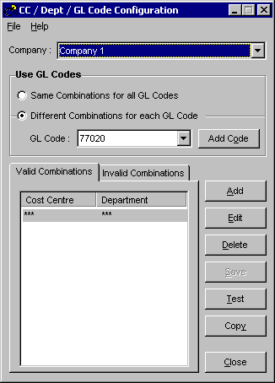
Run the file CCDept.exe that you copied into your enterprise directory (you can add this into your 'Tools' menu in enterprise if you wish). This will present you with the main screen for the setup of this Plug-In :

Firstly you need to select the appropriate company that you wish to edit from the top of the screen. Next you can choose whether to have different combinations for different GL codes (if this is the case you may have to use the 'Add Code' button to add the code you are configuring), or have the same combinations for all the codes. You can then change the view between Valid and Invalid combinations, by clicking on the appropriate tab. To add, Edit or delete a combination you can click on the corresponding button. The Add / Edit dialog is shown below :
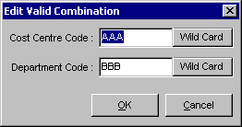
If you wish to enter a wild card (***) for either the cost centre or department, just click on the button next to the edit box. A wild card entry means 'any' Cost Centre / Department.

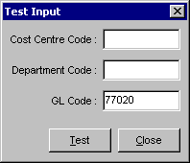
Clicking on the save button will save the current settings to the INI file, whilst Test will show the following screen, allowing you to test your configuration.

When you click on 'Test' it will tell you whether your entered combination is valid or not.

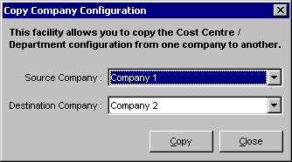
The 'Copy' function is used to copy the configuration form one set of company data, to another. When you click on copy you will get the following dialog :

Just pick the source and destination companies, and click on the 'Copy' button.

When you are happy with you configuration, simply click on close (if you have not saved your configuration, you will be prompted).
Plug-In Logic

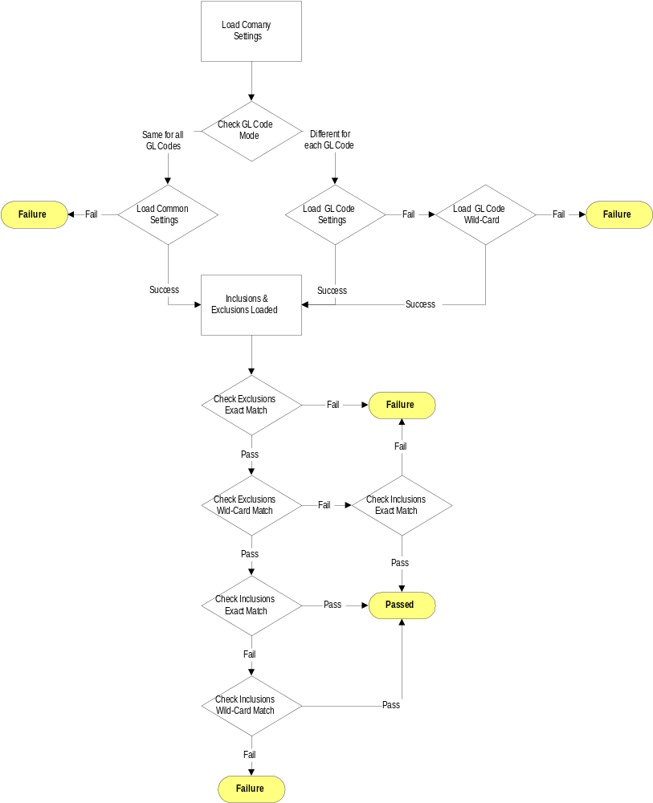There are a set of rules which are used to determine whether a combination of Cost Centre / Department / GL Code will pass the check. The logic of this is shown in the flow diagram below :

