The Enterprise Contacts Plugin

The Contacts Plugin for Enterprise allows you to maintain a list of contacts against your suppliers and customers. The purpose of this is two-fold :
- It is a convenient way or retrieving the information of the contacts for a customer or supplier.
- When you are adding a transaction, you can select a contact, which then means that the delivery address is taken from that contact, rather than the customer record.

Installing the Contacts Plugin

- Copy the following supplied file into your Exchequer Enterprise directory:-

Contacts.dll

- In the Enterprise directory, edit EntCustm.Ini and add the following section:-

[HookChain]
ENTCUSTM=CONTACTS

If an ‘ENTCUSTM=’ entry already exists then contact your technical support for advice.

- Run Enterprise, and from the menu, select the option : Help - About. This will open up the version dialog. If you scroll to the bottom of this dialog you should find the following lines of text :

Contacts Plugin
Copyright Exchequer Software Ltd. 1986 - 2001.
Version 1.1

The presence of this text indicates the Plugin is installed and working and you can proceed, if this text is not present then something has gone wrong in a preceding step.

Releasing the Contacts Plugin

The Contacts Plugin has a security feature, which means that it requires a release code to run. The first time you try and run part of this Plugin you will be prompted to enter a release code as shown below :

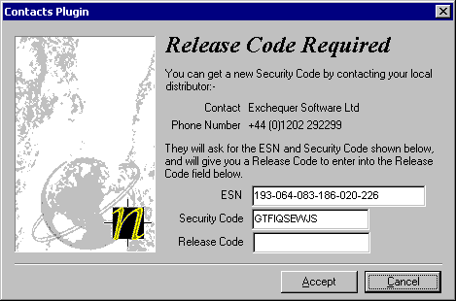
You must get a release code from your local dealer / distributor, quoting your ESN and Security code, so that you can use the Contacts Plugin.

Editing / Viewing the contacts list for a Customer / Supplier

The Contacts Plugin will have added a new button to both the Customer list and the Supplier list. This button is entitled Contacts and will be the last button in the list.

To bring up a list of contacts for a customer / supplier, first select the trader that you require, then click on the Contacts button. You will be presented with a window similar to the one show below :
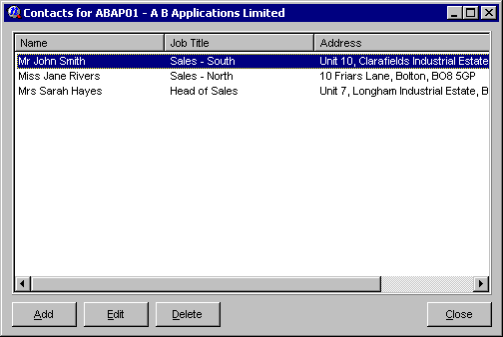
You can add a new contact by clicking on the Add button, or edit an existing contact by selecting the contact, then clicking on the Edit button. You can also delete a contact by selecting the contact, and clicking on the Delete button.

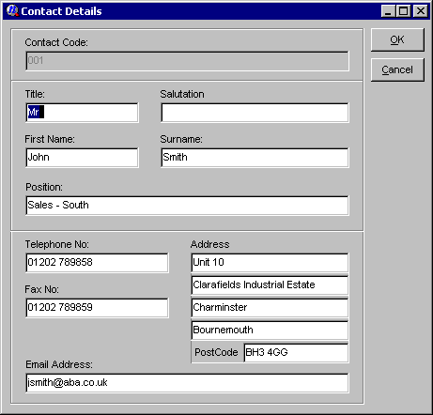
When adding or editing a contact the following screen will be shown :

Enter the details required, then click on the OK button to save them.
When does the contacts list pop-up ?

The contacts list will pop-up after you select or change the account code for a transaction of the following types : SIN, SOR, SDN, SRI, SQU. The contacts pop-up will look like this (please note that if there are no contacts for the selected account, this window will not appear) :
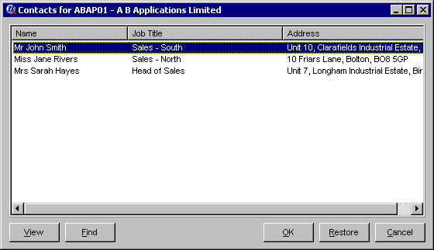

To select a contact you can double click on the contact, click on OK with the contact selected, or press return when the correct contact is highlighted. When you select a contact, the address of the contact will be used as the delivery address for this transaction.

You can also view the details of the contact from here using the View button, or find a contact in the list (by any field) by clicking on the Find button. When using the find function you just need to fill in the first few letters of whichever field you wish to search by, and then click on OK to do the find.

The only other option available to you in this window is to restore the delivery address from the customer record. This is done by clicking on the Restore button.

