Enterprise Freight Hook

The Enterprise Freight Hook places a Freight button at the end of the button list in Purchase Transactions, this allows the user to update costs on POR, PIN, PDN, PJI and PPI transactions, with automatic updating of costs on Serial/Batch Number and LIFO/FIFO items.

Clicking the Freight button will display the following dialog, allowing the freight cost to be specified and the details of how it is to be applied.

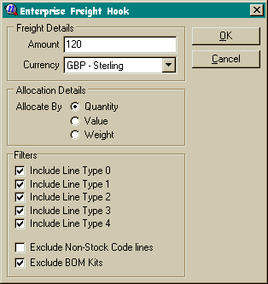

Freight Details

This section specifies the charge to be applied to the transaction.

Amount | This is the total charge for the transaction, this can be specified in the in any Currency. It will automatically be converted into the transactions Currency, using the Transaction Rate, when the freight charge is applied.
Currency | The currency of Amount.

Allocation Details
This section specifies how the charge is to be split amongst the transaction lines, it is split on a ratio on either the line quantities, the line value (including discount) or by the line weight.

Filters

This section allows the specification of which lines will be included in the charge ration.

Include Line Type 0  ..  Include Line Type 4 | These allow the lines to be included/excluded by line type.  If you have once calculated freight including all the line types and subsequently decide to exclude any line type you must manually clear the uplift from the lines types excluded, as it is impossible to decide if the uplift had been entered manually or calculated by the uplift hook. It is safer, if you are going to recalculate, to clear all uplift before you start.
Exclude Non-Stock Code lines | This excludes any lines that don’t have a stock code on them, this would include description only lines entered manually that may have quantity and cost on them.
Exclude BOM Kits | If ticked this will exclude any BOM’s that have been exploded onto the purchase transaction, but will include the stock item that represents the kit. If unticked it will cause the stock item representing the kit to be filtered out, and the kit items themselves will be included.

