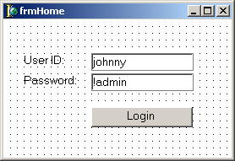
lblUserID
lblPassword
edUserID
edPassword
bnLogin

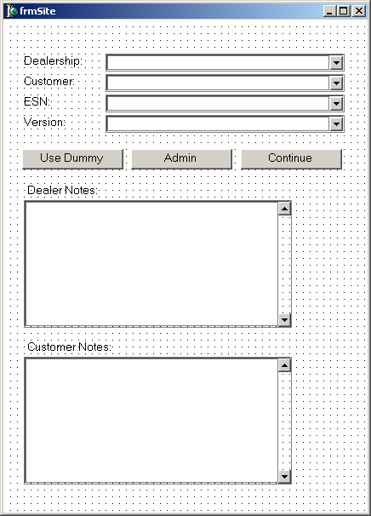
lblDealership
lblCustomer
lblESN
lblVersion
cbDealership cbCustomer
cbESN
cbVersion
bnDummy bnAdmin
bnContinue
lblDealerNotes memoDealer
lblCustNotes memoCustomer

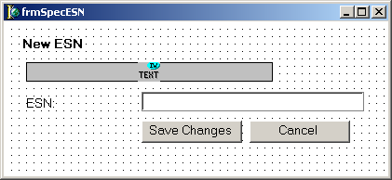
lblNewESN txtESN
lblESN
edESN
bnSaveChanges
bnCancel

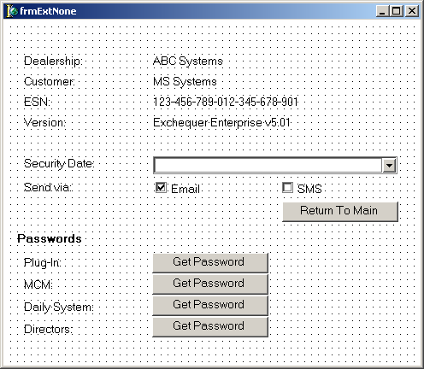
capDealership
lblDealership
capCustomer
lblCustomer
capESN
lblESN
capVersion
lblVersion
lblDate
cbDate
lblSendVia
cbEmail
cbSMS
bnReturnMain
lblhdrPasswords
lblPlugIn
lblMCM
lblDaily
lblDirectors
bnPlugIn
bnMCM
bnDaily
bnDirectors

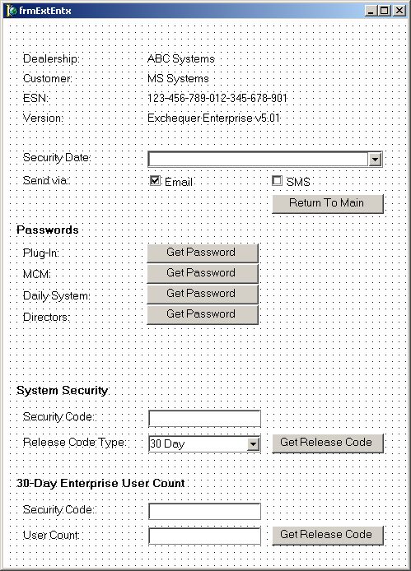
capDealership
lblDealership
capCustomer
lblCustomer
capESN
lblESN
capVersion
lblVersion
lblDate
cbDate
lblSendVia
cbEmail
cbSMS
bnReturnMain
lblhdrPasswords
lblPlugIn
lblMCM
lblDaily
lblDirectors
bnPlugIn
bnMCM
bnDaily
bnDirectors

lblhdrSecurity lblSecCode
edSecCode
lblRelCodeType
cbRelCodeType
bnRelCode
lblhdrUserCount
lbl30SecCode
ed30SecCode
lbl30UserCount
ed30UserCount
bn30RelCode

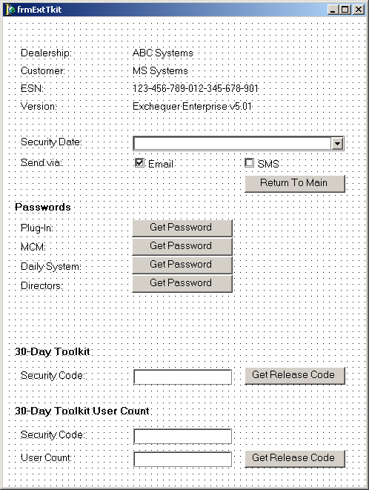
capDealership
lblDealership
capCustomer
lblCustomer
capESN
lblESN
capVersion
lblVersion
lblDate
cbDate
lblSendVia
cbEmail
cbSMS
bnReturnMain
lblhdrPasswords
lblPlugIn
lblMCM
lblDaily
lblDirectors
bnPlugIn
bnDaily
bnMCM
bnDirectors

lblhdrToolkit
lblSecCode
edSecCode
bnRelCode
lblhdr30UserCount
lbl30SecCode
ed30SecCode
lbl30UserCount
bn30RelCode

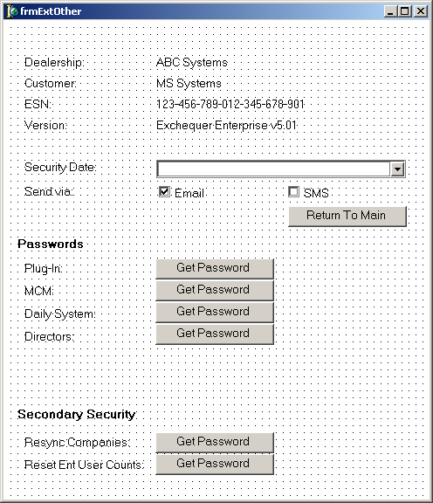
capDealership
lblDealership
capCustomer
lblCustomer
capESN
lblESN
capVersion
lblVersion
lblDate
cbDate
lblSendVia
cbEmail
cbSMS
bnReturnMain
lblhdrPasswords
lblPlugIn
lblMCM
lblDaily
lblDirectors
bnPlugIn
bnMCM
bnDaily
bnDirectors

lblhdrSecurity
lblResync
bnResync lblResetEnt
bnResetEnt

