A REPORT

HISTORICAL AND PARAMETRIC VALUE AT RISK (VaR)
ANALYSIS OF A FIVE-STOCK EQUITY PORTFOLIO
By
Advait Srivastava 2022A4PS1181H
BIRLA INSTITUTE OF TECHNOLOGY & SCIENCE, PILANI
Jun 2025 - Jun 2026
ON
PORTFOLIO RISK MEASUREMENT USING HISTORICAL SIMULATION AND THE VARIANCE-COVARIANCE METHOD, BUILT ON DAILY EQUITY DATA FROM S&P CAPITAL IQ (WILP FINANCE LAB)
Prepared as part of the
WILP Finance Lab, Risk Management Theme

1. Introduction
This report measures the market risk of a five-stock equity portfolio using two well known methods: Historical Simulation and the Parametric (Variance-Covariance) method. Both estimate Value at Risk, or VaR, which is the loss the portfolio is not expected to exceed over a set period at a chosen confidence level. For example, a one-day 95% VaR of INR 11,684 means that on 95 days out of 100 the portfolio is not expected to lose more than that amount in a single day. The portfolio holds five large Indian companies in equal amounts, spread across information technology, telecom, infrastructure, and diversified industry. All figures are based on daily price data pulled from S&P Capital IQ through the WILP Finance Lab.

2. Portfolio Composition
The portfolio uses equal weights. Each of the five stocks receives INR 100,000, giving a total value of INR 500,000. Equal weighting keeps the setup simple and makes it easy to see how each stock and the links between them drive total risk.
Asset | Stock | Amount (INR) | Weight
Asset 1 | TCS | 100,000 | 20%
Asset 2 | Wipro | 100,000 | 20%
Asset 3 | Bharti Airtel | 100,000 | 20%
Asset 4 | Adani Enterprises | 100,000 | 20%
Asset 5 | Godrej Industries | 100,000 | 20%
Total |  | 500,000 | 100%
Table 1. Portfolio holdings and weights.

3. Data and Methodology
The analysis uses about one year of daily closing prices, from 13 June 2025 to 11 June 2026, giving roughly 244 daily returns per stock. Closing prices were rebuilt from the cumulative percentage data supplied by S&P Capital IQ using the formula Price = Base Price multiplied by (1 + CIQ Percentage / 100). Daily returns were then found as log returns, the natural log of today's price divided by yesterday's price.
Two methods are used. Historical Simulation takes the actual past returns, sorts them from worst to best, and reads off the loss at the chosen confidence level, making no assumption about the shape of the distribution. The Parametric method instead assumes returns follow a normal distribution and uses the portfolio standard deviation together with a z-score. Both one-day and ten-day figures are reported, where the ten-day numbers are scaled from the one-day figure using the square root of time rule, that is by multiplying by the square root of ten.

4. Stock Price Behaviour
Before looking at risk numbers, it helps to see how the five stocks moved over the year. The chart below rebases every stock to a starting value of 100 so they can be compared on the same scale. A value above 100 means a gain over the period, while a value below 100 means a loss.
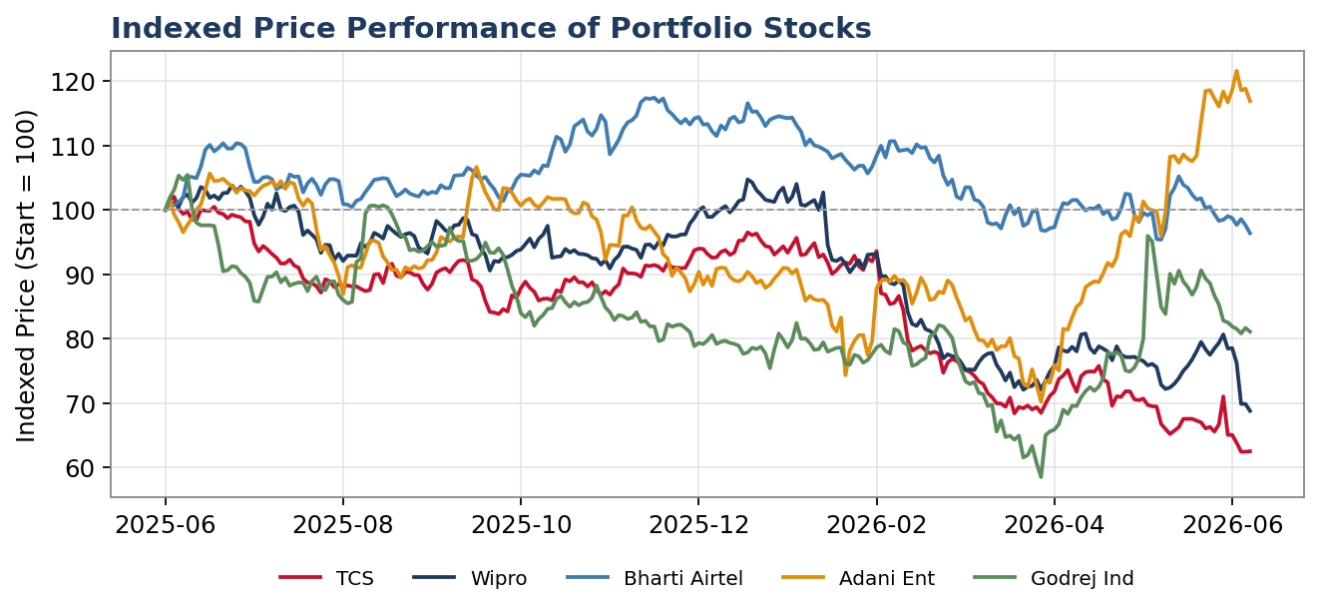
Figure 1. Indexed price performance, all stocks start at 100.
The stocks did not move together in a tight pack. Some names trended down for long stretches while others held up better, and the paths cross many times. This spread is what gives a portfolio its diversification benefit, because a gain in one stock can soften a loss in another on the same day.

5. Individual Risk Statistics
Annualized volatility scales the daily return swings up to a yearly view by multiplying by the square root of 252 trading days. Godrej Industries and Adani Enterprises are the most volatile, near 38% and 35%. Bharti Airtel is the calmest at about 20%, while the two IT names, TCS and Wipro, sit in the middle around 25%. The riskier stocks pull overall portfolio risk up, while the steadier names help bring it down.
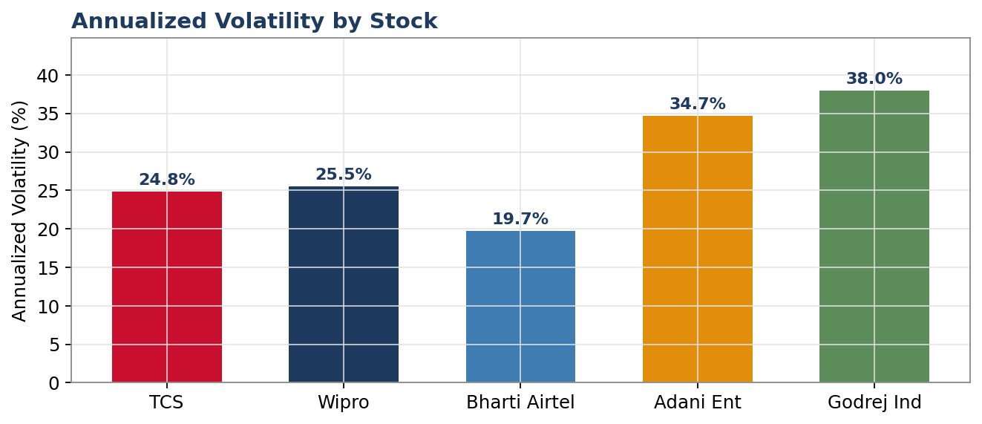
Figure 2. Annualized volatility by stock.

6. How the Stocks Move Together
Risk in a portfolio depends not only on how risky each stock is on its own, but also on how the stocks move in relation to each other. In the matrix below, a value near 1 means two stocks rise and fall together, while a value near 0 means they move largely on their own.
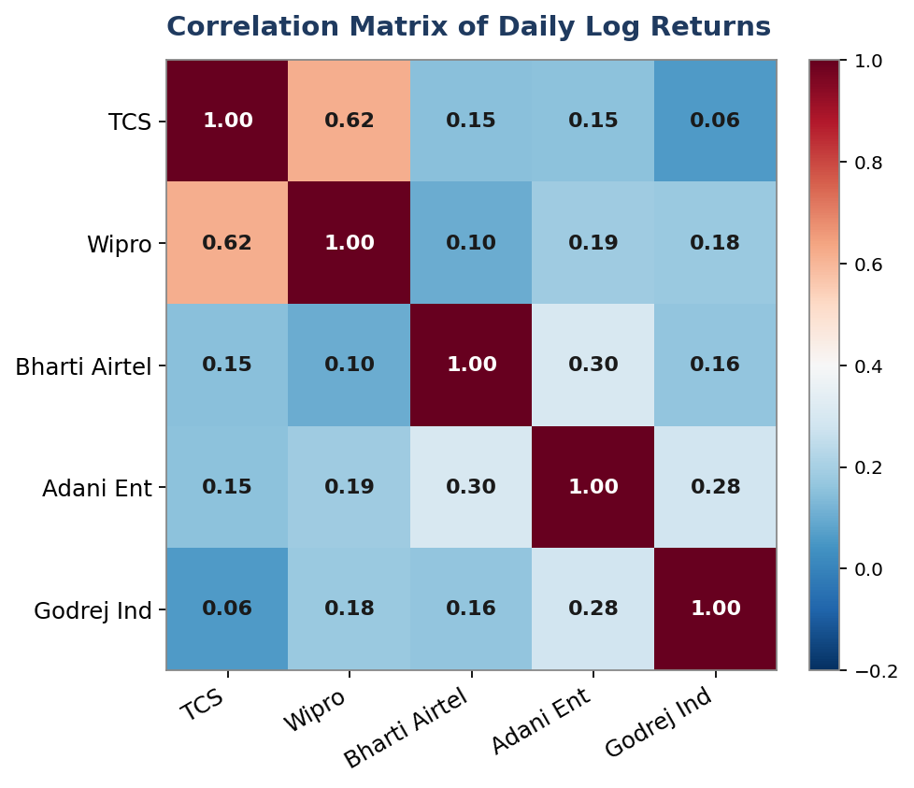
Figure 3. Correlation of daily log returns.
The strongest link is between TCS and Wipro at 0.62, which makes sense as both are large IT services firms. Every other pair is low, mostly between 0.05 and 0.30. These low values are good news, because when stocks do not move in lockstep their swings partly cancel out, leaving the portfolio steadier than the average of its parts.

7. Historical Simulation VaR
The Historical Simulation method ranks the actual daily portfolio returns and reads the loss at each confidence level. The chart below shows the spread of daily returns, with the 95% and 99% VaR points marked. Most days cluster near zero, but a tail of larger losses on the left drives the VaR figures.
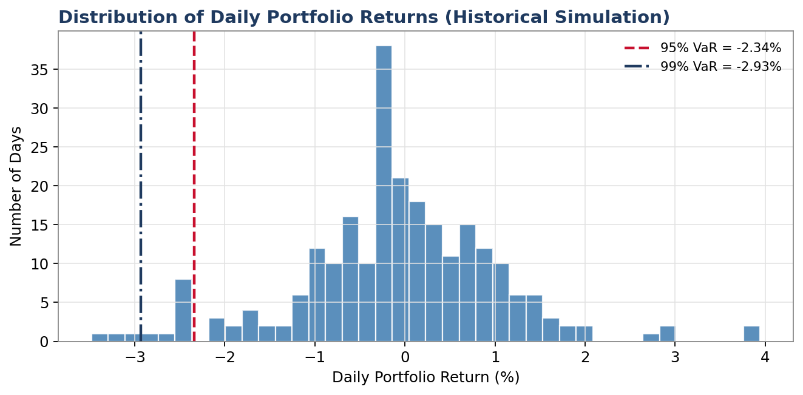
Figure 4. Distribution of daily portfolio returns with VaR levels.
On a one-day view, the portfolio shows a 95% VaR of INR 11,684 (about 2.34%) and a 99% VaR of INR 14,648 (about 2.93%), which grow to roughly INR 36,948 and INR 46,320 over a ten-day period.

8. Parametric VaR
The Parametric method works from the portfolio standard deviation rather than the raw history of returns. Using the weights and the covariance matrix, the daily portfolio standard deviation comes out to about 1.11%, or roughly 17.65% on an annual basis. VaR is then found by multiplying this standard deviation by the portfolio value and by a z-score, namely 1.645 for 95% and 2.326 for 99%. This gives a one-day 95% VaR of INR 9,142 and a one-day 99% VaR of INR 12,927, rising to about INR 28,911 and INR 40,880 over ten days.

9. Comparing the Two Methods
The chart and table below place the two methods side by side. The pattern is clear: the Historical Simulation figures are higher than the Parametric figures in every case.
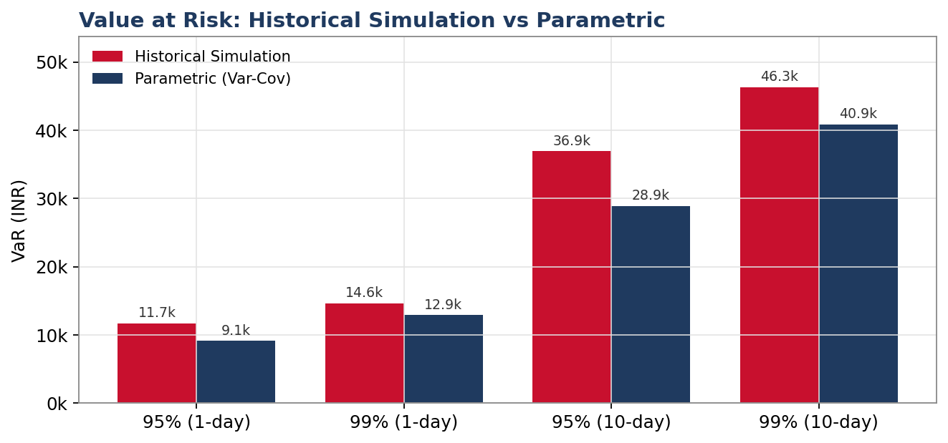
Figure 5. Historical Simulation VaR against Parametric VaR.
Method | 95% 1-day | 99% 1-day | 95% 10-day | 99% 10-day
Historical Simulation | 11,683.91 | 14,647.67 | 36,947.77 | 46,319.99
Parametric (Var-Cov) | 9,142.48 | 12,927.30 | 28,911.05 | 40,879.70
Difference (HS - Parametric) | 2,541.43 | 1,720.37 | 8,036.72 | 5,440.29
Table 2. Side-by-side comparison of VaR estimates (INR).
The gap between the methods is the most useful result. Historical Simulation is larger because the actual returns have fatter tails than a normal distribution assumes, a feature known as leptokurtosis. In plain terms, big down days happened more often than a bell curve would predict, so the Parametric method understates how bad the worst days can be.

10. Conclusion and Recommendations
Both methods agree on the broad scale of risk but differ on the tails. For this portfolio the Historical Simulation method gives a more cautious and realistic picture, since it captures the larger losses that actually occurred, while the Parametric method remains useful as a quick, clean estimate. Going forward, the portfolio could be back tested to check how often real losses breached the VaR levels, an Expected Shortfall measure could be added to capture the average loss beyond the VaR point, and the weights of the most volatile names, Godrej Industries and Adani Enterprises, could be reviewed to lower overall risk if desired.

